|  |  |
| --- | --- |
| **How to use APIs to create an invoice and invoice lines** |  |



**Yoel Kortick**

**Senior Librarian**

In addition to this document see also the blog [Creating an Invoice Using APIs](https://developers.exlibrisgroup.com/blog/Creating-an-invoice-using-APIs)

In this workflow we will use APIs to

1. Create an invoice
2. Create invoice lines linked to the invoice.

This is the correct and intended flow for using the "Create Invoice" APIs.

The input for creating the invoice should **not** have both general invoice information **and** invoice line information.

It is a two-step process: First the invoice then the invoice lines.

In this particular flow we will use the API console and also point out the full API syntax.

**Step one**

Create an invoice for example with this Representation (Content-Type) application/xml

|  |
| --- |
| <invoice>  <number>20190122-001</number>  <invoice_date>2019-01-22</invoice_date>  <total_amount>120</total_amount>  <currency>USD</currency>  <vendor>JS</vendor>  <vendor_account>JS_MAIN</vendor_account>  <payment_method>ACCOUNTINGDEPARTMENT</payment_method>  <owner>ULINC</owner>  <invoice_vat>  <vat_per_invoice_line>false</vat_per_invoice_line>  <percentage>10.00</percentage>  <type>INCLUSIVE</type>  <expended_from_fund>true</expended_from_fund>  </invoice_vat>  </invoice> |

If you wish to run this in the developer network do as follows:

In API console choose:

API = Acquisitions

Invoices POST Create Invoice

Click "Try it out"

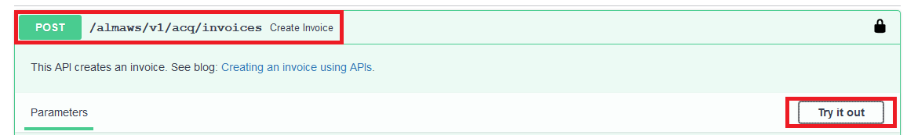

Put in the representation from above and execute

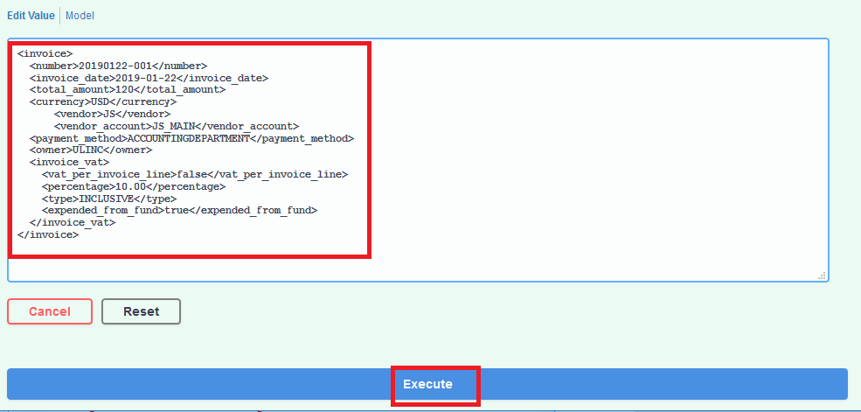

If you wish to run this in the Advanced REST client do as follows:

Use POST with https://api-eu.hosted.exlibrisgroup.com/almaws/v1/acq/invoices?apikey=1234

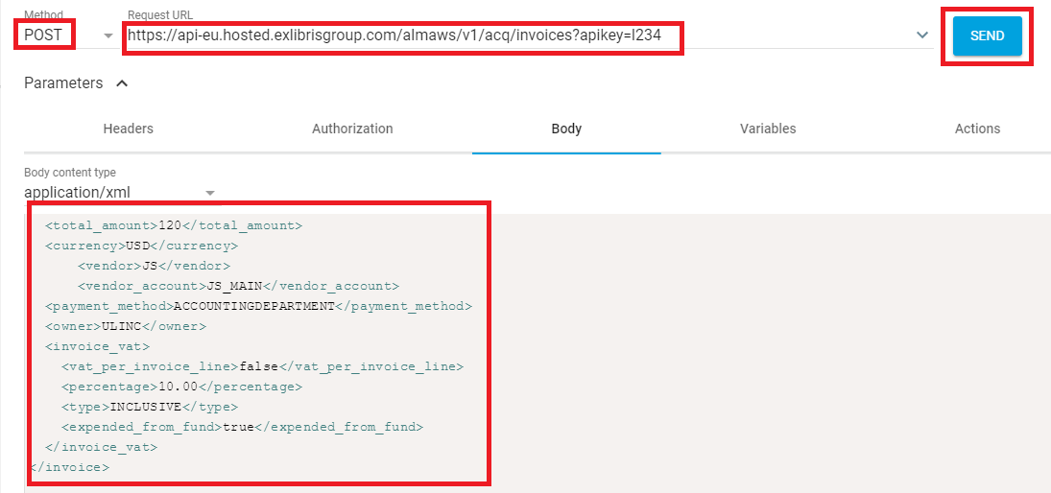

Get back Unique ID (in this case 5492066480000121)

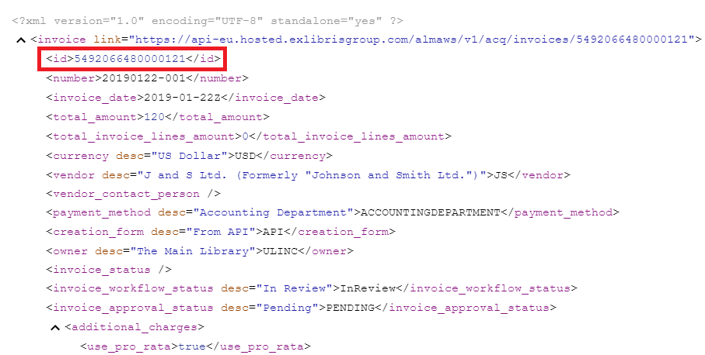

See in Alma that the invoice was created

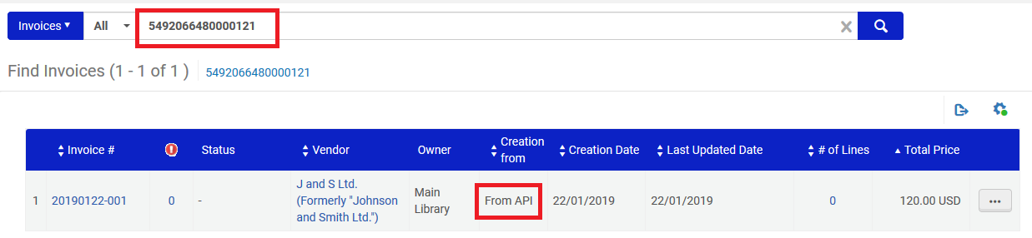

**Step two**

Use the unique ID returned above and add an invoice line to the invoice.

Create an invoice line for example with this Representation (Content-Type) application/xml.

In this example the invoice line is linked to POL-44778

|  |
| --- |
| <invoice_line>  <id></id>  <type>REGULAR</type>  <number>1</number>  <status>READY</status>  <po_line>POL-44778</po_line>  <price>12</price>  <total_price>12.00</total_price>  <quantity>1</quantity>  <vat_note></vat_note>  <check_subscription_date_overlap>false</check_subscription_date_overlap>  <fully_invoiced>true</fully_invoiced>  <additional_info/>  <release_remaining_encumbrance>false</release_remaining_encumbrance>  <reporting_code></reporting_code>  <secondary_reporting_code></secondary_reporting_code>  <tertiary_reporting_code></tertiary_reporting_code>  <note>Overhead</note>  <invoice_line_vat>  <vat_code/>  <percentage>0.00</percentage>  <vat_amount>0</vat_amount>  </invoice_line_vat>  <fund_distributions>  <fund_distribution>  <fund_code>LIS</fund_code>  <percent>100.00</percent>  <amount>12</amount>  </fund_distribution>  </fund_distributions>  </invoice_line> |

If you wish to run this in the developer network do as follows:

In API console choose:

API = Acquisitions

Invoices POST Create Invoice Lines

Click "Try it out"

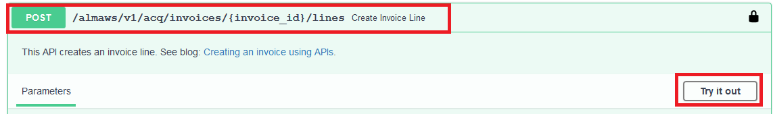

In the "invoice id" field put the invoice identifier received in step one

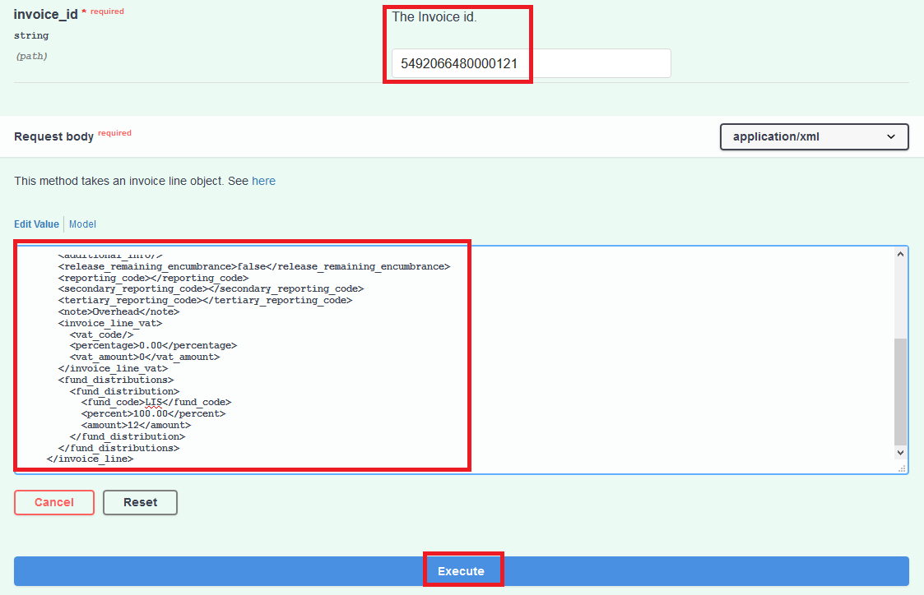

If you wish to run this in the Advanced REST client do as follows:

Use POST with

https://api-eu.hosted.exlibrisgroup.com/almaws/v1/acq/invoices/5492066480000121/lines?apikey=1234

The invoice line is added. Here it is in the Advanced REST Client.

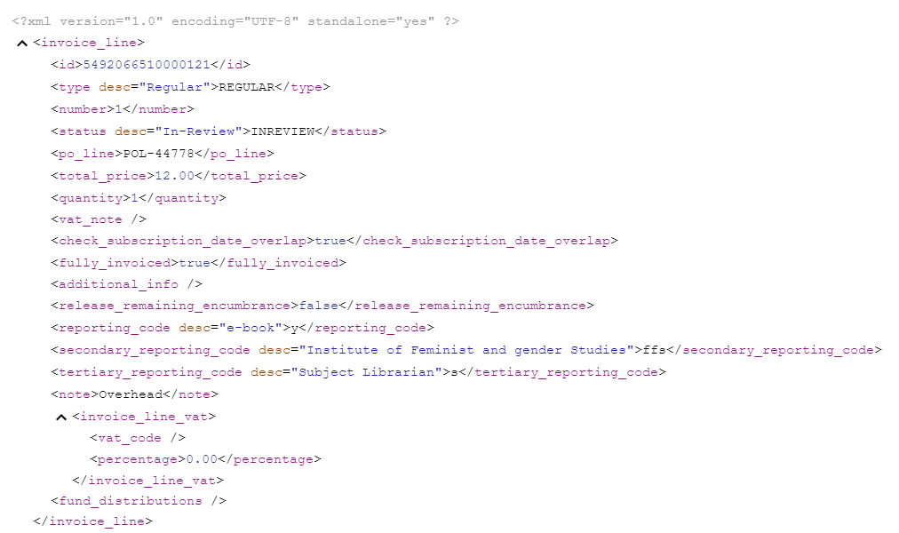

See in Alma that the invoice line was created

