|  |  |
| --- | --- |
| **How to separate the semicolon delimited network number into separate fields** |  |



When there is a "one to many" relationship between fields of the bibliographic record, such as the case of the network number to the MMSID, the "many" fields are separated by a semicolon.

For example in the screenshot below

* Title "French women in politics : writing power, paternal legitimization, and maternal legacies" has 4 network numbers
* Title "The other Enlightenment : how French women became modern" has 3 network numbers

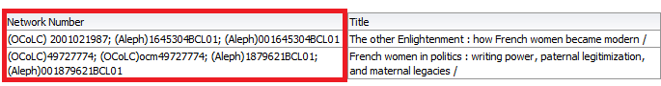

We will use a regular expression to separate these network numbers into separate fields.

The same syntax can be used to separate other fields as well, such as ISBN and ISSN.

The syntax is as follows:

**For the first occurrence of the network number:**

evaluate('regexp_substr(%1,''[^\;]+'', 1,1)',REPLACE("Bibliographic Details"."Network Number",';','\;'))

**For the second occurrence of the network number:**

evaluate('regexp_substr(%1,''[^\;]+'', 1,2)',REPLACE("Bibliographic Details"."Network Number",';','\;'))

**For the third occurrence of the network number:**

evaluate('regexp_substr(%1,''[^\;]+'', 1,3)',REPLACE("Bibliographic Details"."Network Number",';','\;'))

**For the fourth occurrence of the network number:**

evaluate('regexp_substr(%1,''[^\;]+'', 1,4)',REPLACE("Bibliographic Details"."Network Number",';','\;'))

We will first display the network number four times, and then on each one do "edit formula" in the criteria tab and put the above formula.

Here we have four occurrences of the network number in the criteria tab:

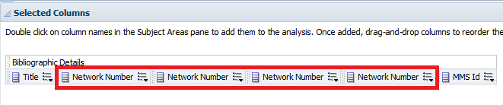

Here we do "edit formula" on the first occurrence

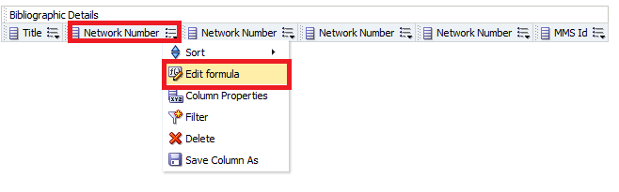

Now we rename the column and put in the formula as supplied above

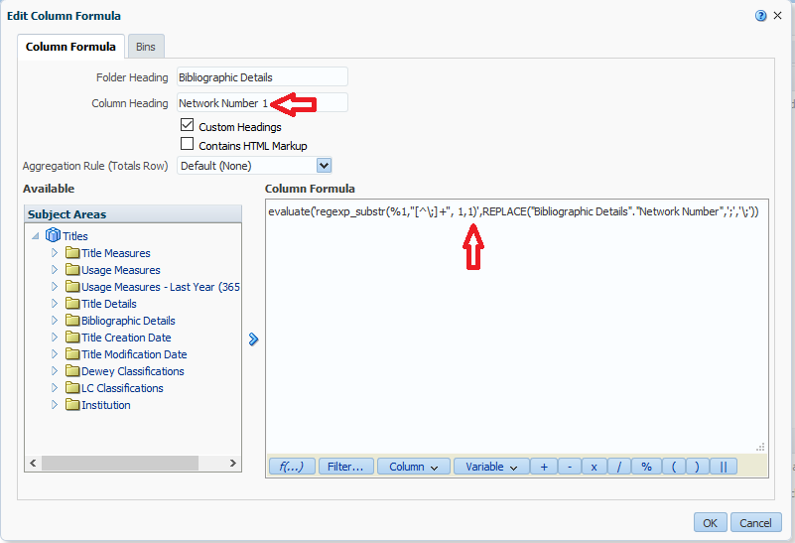

Now for the second occurrence

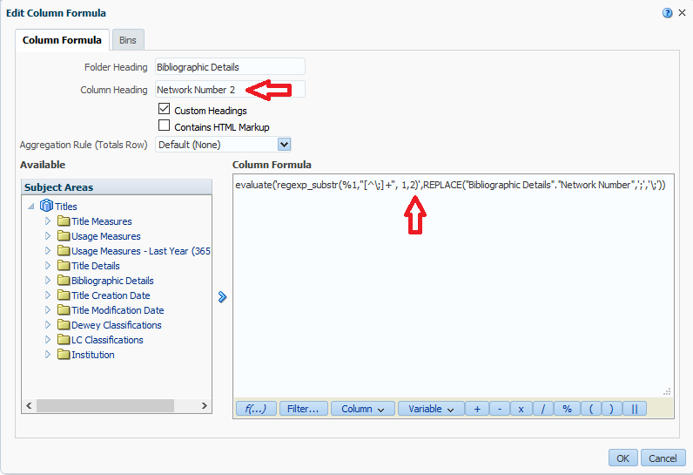

The third and fourth occurrences are done in the same manner. Here we see them all renamed in the criteria tab.

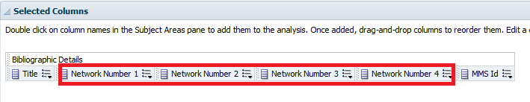

Now we look at our results and see that the network numbers have been separate into separate fields

