|  |  |
| --- | --- |
| **How to link a local portfolio to a Community Zone Record** |  |



**Question**

Can you demonstrate the linking of local portfolio to community zone portfolio?

**Answer**

**ONE**

Search for electronic portfolio in Institution and see that for local portfolios there is a link ‘Link to Community’

(Obviously there will be no such link for portfolios linked to CZ because they are already linked).

Additionally, the link will appear when the local portfolio is standalone (and not part of a collection).

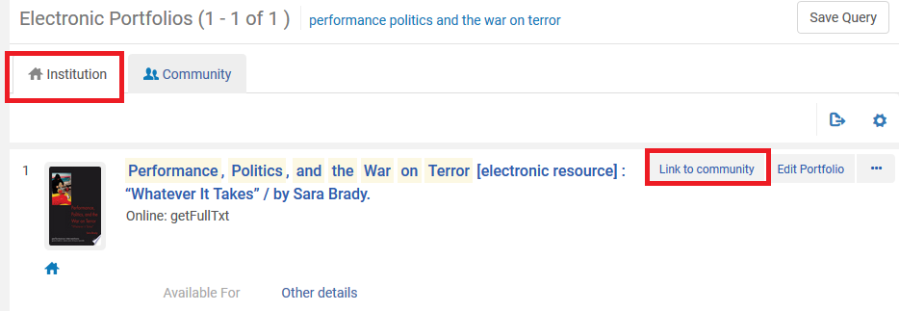

**TWO**

In this case note that the local portfolio ‘Performance, Politics, and the War on Terror 'Whatever it Takes'’ has ISBN 9786613900036 and ISBN 9786613900036 **does** exist in the CZ.

Here we can see that it is found when searching by the ISBN in both tine institution and in the CZ

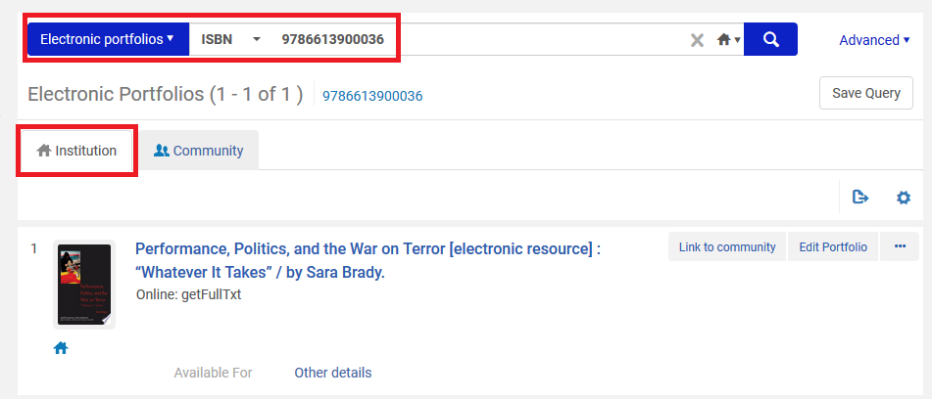

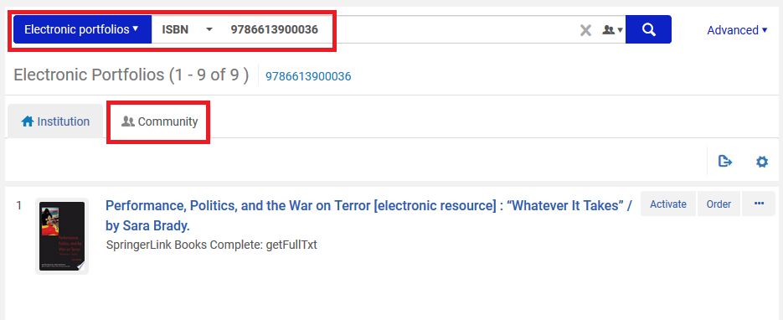

**THREE**

Click ‘Locate and Link’ from the institution electronic portfolio repository search results

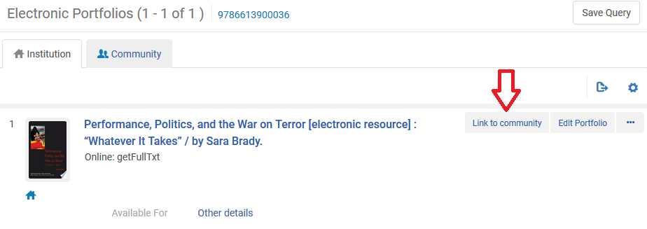

**FOUR**

The ‘Link Standalone Portfolio to Community Zone Collection' page will open with a list of portfolios from the Community Zone which match the local portfolio. Select the CZ portfolio to which you want to link your local portfolio and click ‘Next’

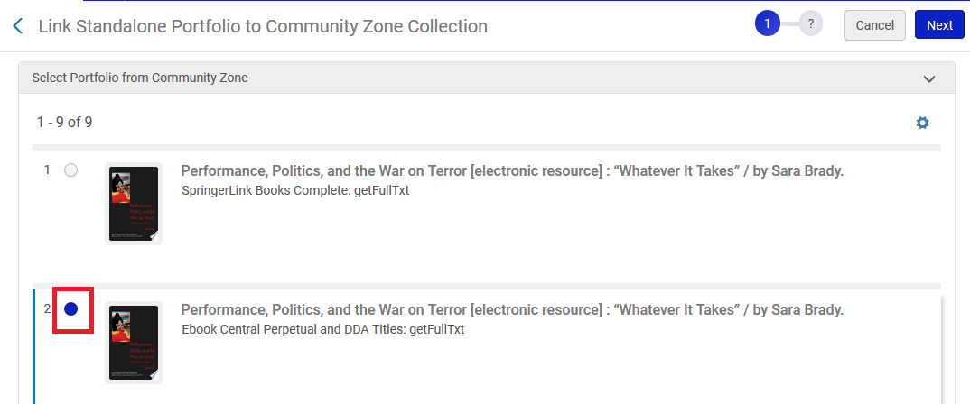

**FIVE**

On next page only the selected portfolio appears. Confirm by clicking ‘next’

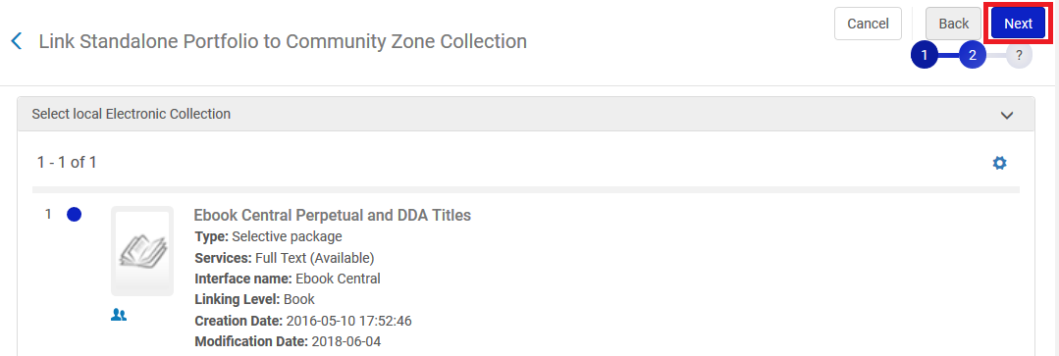

**SIX**

Select the desired source of descriptive metadata information

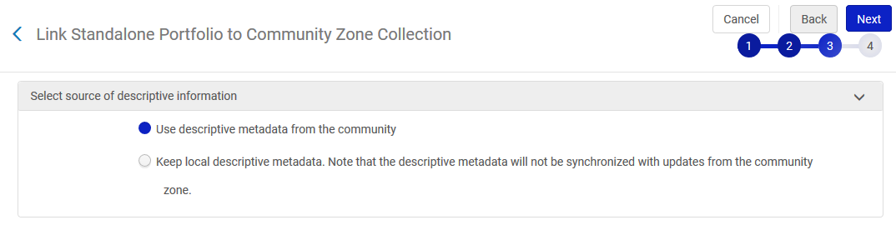

**SEVEN**

Review the information and click "Link to community"

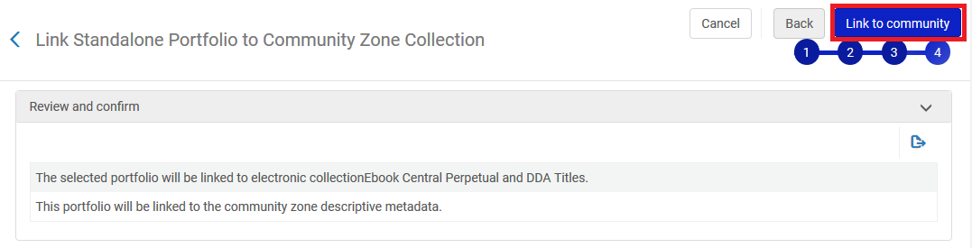

**EIGHT**

See that in the institution the portfolio is now linked to the CZ.

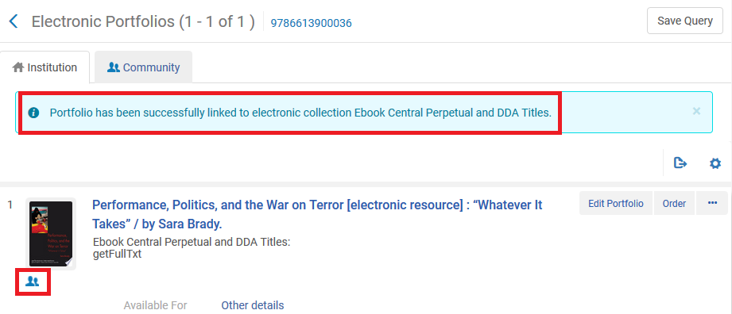

Linking this record to the community zone has also updated the corresponding linking information of the portfolio

