GUIDE TO THE PIVOT FUNDING DATABASE
ADD YOUR LOGO
How to Perform a Customized Search for Funding Opportunities

About Pivot®
Pivot is a database containing funding opportunities for all disciplines and project types. It includes information on federal, private, and international funding options all in one easy to search tool. With your personal Pivot account, you can:
- Sign up to receive customized funding alerts
- Save and return to previous funding searches
- Share funding opportunities directly from Pivot
- Track individual funding opportunities

Where to Begin
Access Pivot here: Pivot Homepage
- To create an account, click on Sign Up in the upper right corner of the screen
- Fill in all required fields
- Use your institutional-assigned email address (this will be your User ID)
- Select our institution from the Institution pull-down menu
To activate your account, wait for an email from Pivot: remember to check your spam folder if you do not see the email in your inbox

Starting a Basic Search
Under the Funding tab, you will see the main search box where you can enter free text search terms, or, search by Sponsor or Keywords. It can be a good idea to start with keywords which are pre-defined terms that Pivot editors match to funding opportunities.

By hovering over the Browse by Keyword wheel you can see approximately how much funding is available for a given term. Selecting a term from the wheel will return results for all the funding opportunities matching that term.

When running free-text searches from the main search box, you can get more precise results by:
- Using quotes for an exact phrase search (example, “childhood obesity” returns results that have that exact phrase)

- Using an asterisk to search word variants (example, using child* returns results with the terms child, childhood, children, etc.)

- Using proximity limiters (example, using childhood w/5 obesity returns results where both terms are within 5 words of each other)

The Search by Keyword feature allows you to easily find keywords that align with your research interests and quickly build a query that searches one or more keywords.

Tip: if you start with broad keywords first, then you can always narrow your results on the results screen or refine your query by adding more specific terms based on the results you receive

The Search by Sponsor feature allows you to search for specific sponsors and funding agencies, or, you can browse an A-to-Z list of all the sponsors that Pivot is tracking. Just click on a sponsor name to see all of the active funding opportunities for that sponsor in Pivot.

Performing an Advanced Search
On the Funding tab, click on Advanced Search. You will see a variety of options for searching specific fields and for pre-scoping your search by specific criteria including by:
- Funding type
- Sponsor type
- Award amounts
- Upcoming deadline
- Applicant type

There are also two other important parameters related to eligibility:

- Activity location – specifies where the research or activity must take place. As you type Pivot will auto-populate locations or you can browse from a list.
- Citizenship – specifies any citizenship requirements or restrictions

Note: These filters may already be applied by default by our institution’s Pivot administrators. If this is the case, you can toggle off or modify these limiters.

Search Tip: Some research topics may not get any results in searching, but that does not necessarily mean there are no grants for which your project may be eligible. If this happens, try searching for grants in the broader field(s) within which your project falls.
For example, a project to study zebra mussels may be eligible under a grant looking to fund projects in the broader fields of Biological Sciences, Marine Biology, or Environmental Biology, etc.

Pivot offers multiple ways to save searches, track results and get automatic alerts for funding of interest.

Saving or Modifying a Search
After initiating your search, three links appear on the top of your search results screen: Advanced Search, Save Search, and Refine Search.
- Advanced Search starts a new, blank search screen.
- Save Search allows you to name and save your search. On the Saved Searches screen, you can specify whether you want to receive weekly funding alert emails that highlight any
new opportunities that match your search criteria.

  - You can find and manage your saved searches by clicking on the ‘home” icon in the top left corner of the screen.

- Refine Search returns you to the search screen with your criteria still entered so you can easily add or modify keywords or search parameters.

You may also narrow your results using the faceted search results on the left side of the search results screen

Tracking and Sharing Funding Opportunities
After initiating your search, three links appear on the top of your search; Track, Set to Active & Share. You can save and share an unlimited number of opportunities.

Your tracked list will be a longer list of opportunities that you still wish to keep track of.
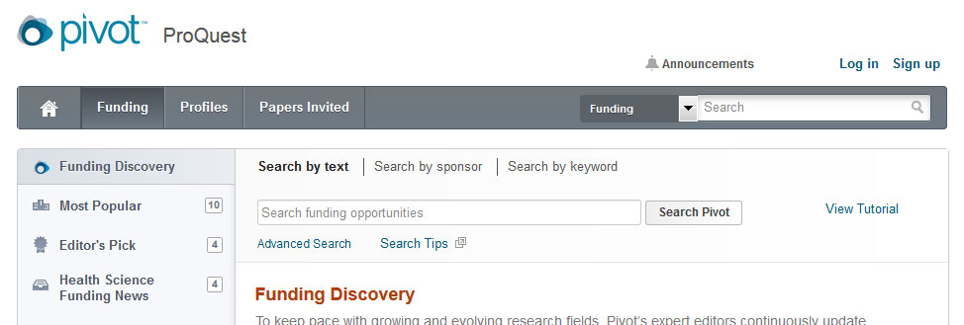

Your active list will be a shorter list of your very important opportunities or those you are definitely planning to apply for

Sharing an opportunity is easy. Enter the name or the email address of the person(s) that you wish to share this opportunity or search with. Pivot will attempt to auto-populate names of others at your institution, so you don’t need to type in their email addresses. You can include an optional message and then Click Send.

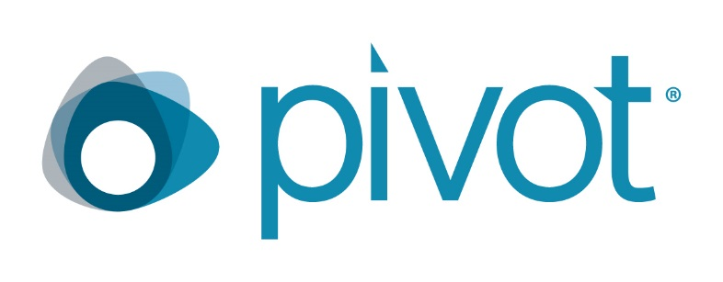
ADD YOUR LOGO

Questions and Trainings
If you encounter issues using Pivot, please contact: Customize for the institution
email: Customize for the institution
phone: Customize for the institution

Note: Pivot provides key resources and helpful, short tutorial videos

Detailed documentation and other resources
https://knowledge.exlibrisgroup.com/Pivot

Pivot tutorial videos can be found on YouTube:
https://www.youtube.com/user/ProQuestPivot

Any questions, contact the Pivot Support team
https://supportcase.exlibrisgroup.com/?product=Pivot

YouTube Channel
- Knowledge Center
- Pivot Support

ADD YOUR LOGO

