|  |  |
| --- | --- |
| **How to add a logo to the top of an Alma Analytics report** |  |



**To add a logo to the top of an Alma Analytic report, follow these steps:**

We have this logo:



And we want to add it to the top of this report with the title:

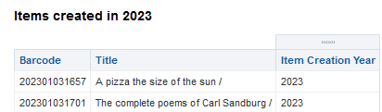

**ONE**

While focused on the Institution Folder Create a new folder and name it **Images**:

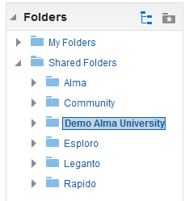

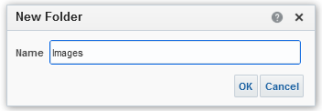

**TWO**

Select the **Images** folder and select **Upload**:

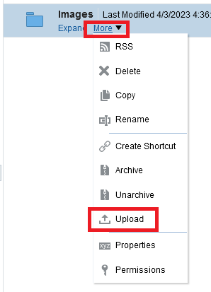

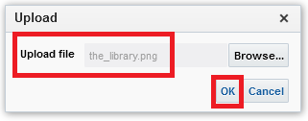

**THREE**

From the uploaded image, select **More > Properties**:

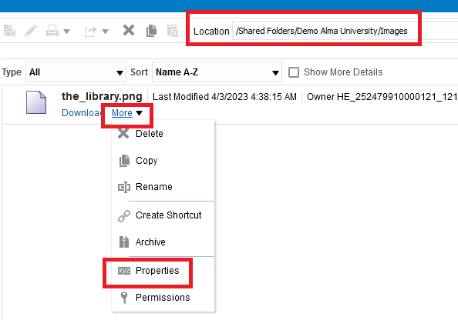

**FOUR**

Copy the name and location of the image because we will need it later:

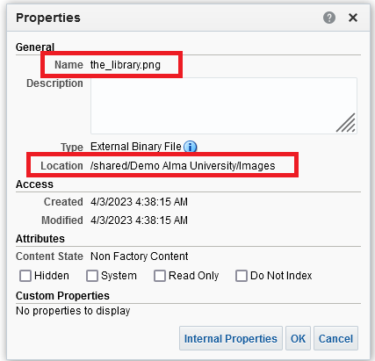

|  |
| --- |
| Name the_library.png  Location /shared/Demo Alma University/Images |

**FIVE**

Create or edit an analytics report to which you want to add the image and select the edit icon (the pencil) of the title:

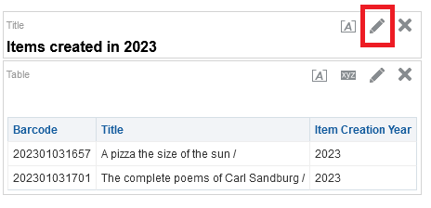

**SIX**

Select the **Logo** checkbox and select the **Select Image** button:

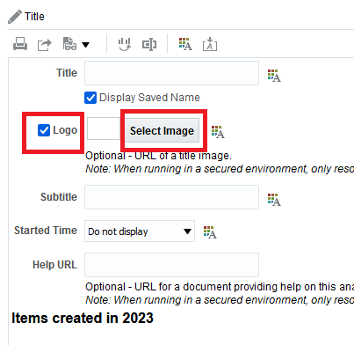

**SEVEN**

In the **Custom Image** box, enter the name and location of the image in the format: cmap:Location/Name

For example, if this is our location and name

|  |
| --- |
| Name the_library.png  Location /shared/Demo Alma University/Images |

Then this is what we will add:

|  |
| --- |
| cmap:/shared/Demo Alma University/Images/the_library.png |

Select **OK**

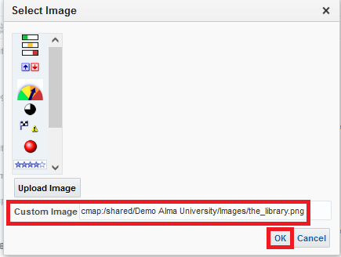

**EIGHT**

Select **Done** and save the report.

The image is added to the report.

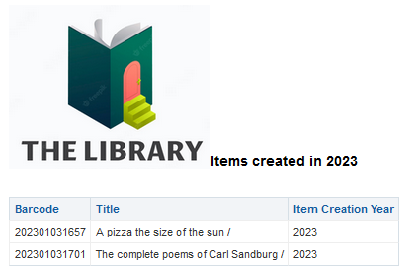

**NINE**

You could also put the image in a another title by adding another title and not including the title of the report in the new title so that it will only have the image:

We have this:

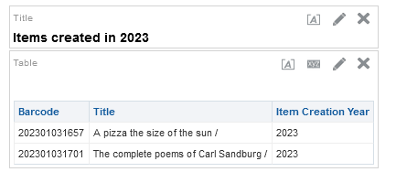

We add another title:

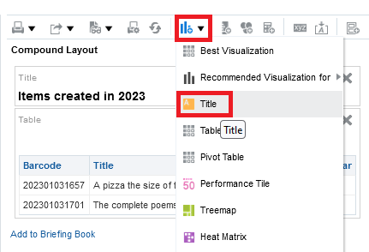

We move the new title to the top

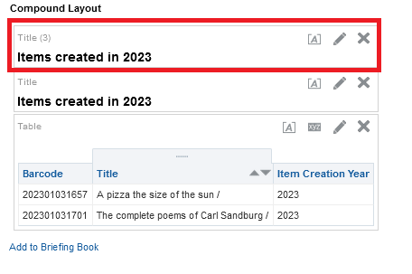

We edit the new title

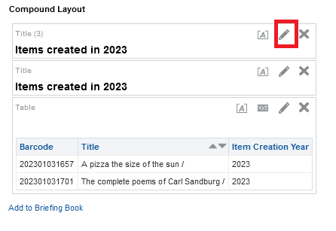

We uncheck the “Display saved name”

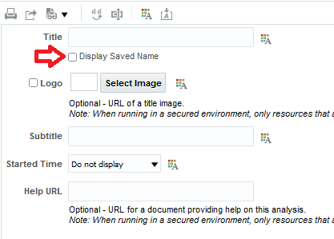

Then we add the logo as we prevoiously addded it, and the report will appear like this:

