|  |  |
| --- | --- |
| **An example of a related record which is one child with two parents using a 773 and 830** |  |



**Yoel Kortick**

**Senior Librarian**

In this case the child record has:

o A field 773 with subfield w which points to the parent record **superordinate multivolume title**

o A field 830 with subfield w which points to the parent record **serial**

In the example here, we will look at title "Rescuing Creusa: new methodological approaches to women in antiquity".

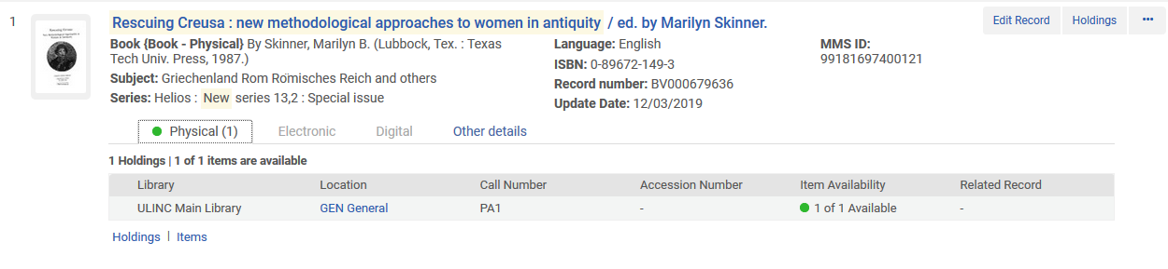

If we look at the bibliographic record we can see that it points to two other related records.

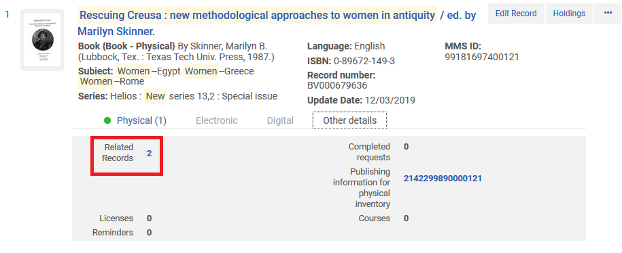

Now we will see

* A field 773 with subfield w which points to the parent record **multivolume title**
* A field 830 with subfield w which points to the parent record **serial**

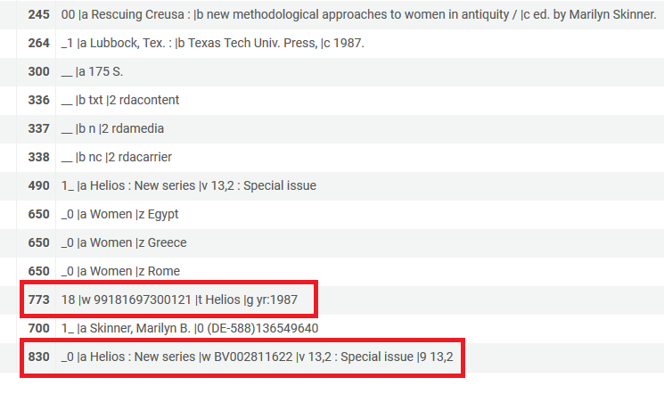

Now we will click the "Related Records" link and we see both related records each with a "Contains" relation.

* The superordinate multivolume title "Helios: journal devoted to critical and methodological studies of classical culture, literature and society" whiuch was linked from the 773 subfield w is the first record.
* The series" Helios. New series. Helios. New series" whiuch was linked from the 830 subfield w is the second record.

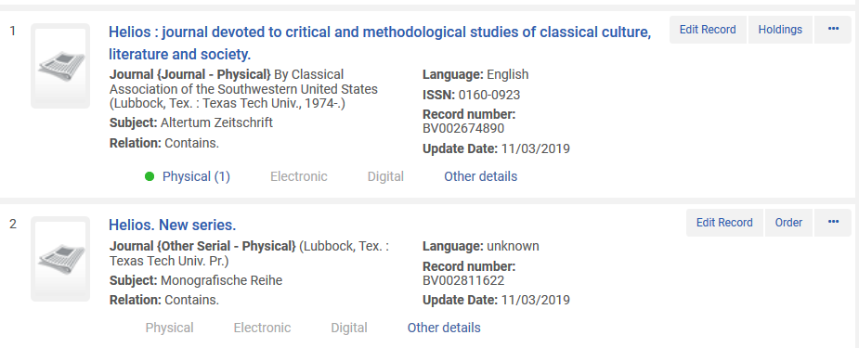

Regarding item notes, please note the following.

Related bibliographic record above title “Helios : journal devoted to critical and methodological studies of classical culture, literature and society. Helios : journal devoted to critical and methodological studies of classical culture, literature and society” has 1 item which is barcode which is AU45105:

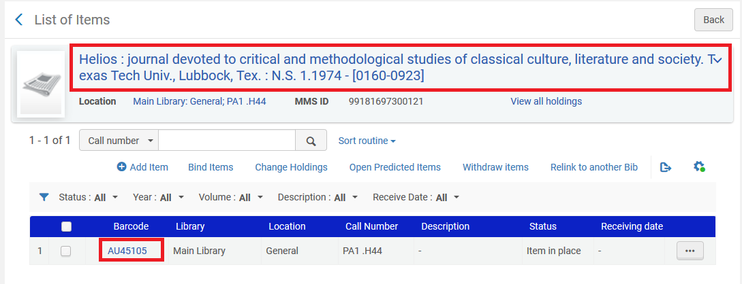

It has a public item note which is “Includes article by Madeline Meydansky signed by the author”

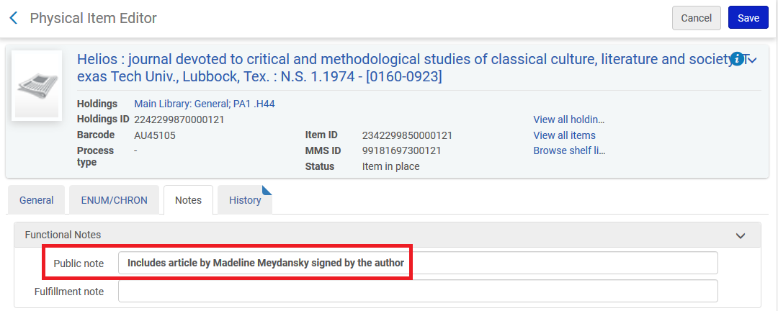

Main bibliopgraphjic title “Rescuing Creusa : new methodological approaches to women in antiquity / ed. by Marilyn Skinner. Rescuing Creusa : new methodological approaches to women in antiquity” has one itrem and it is barcode AU45104

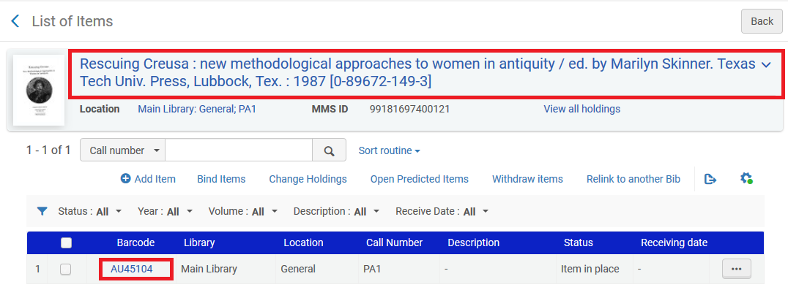

It has a public item note which is “Includes many articles for course “Feminism in antiquity””

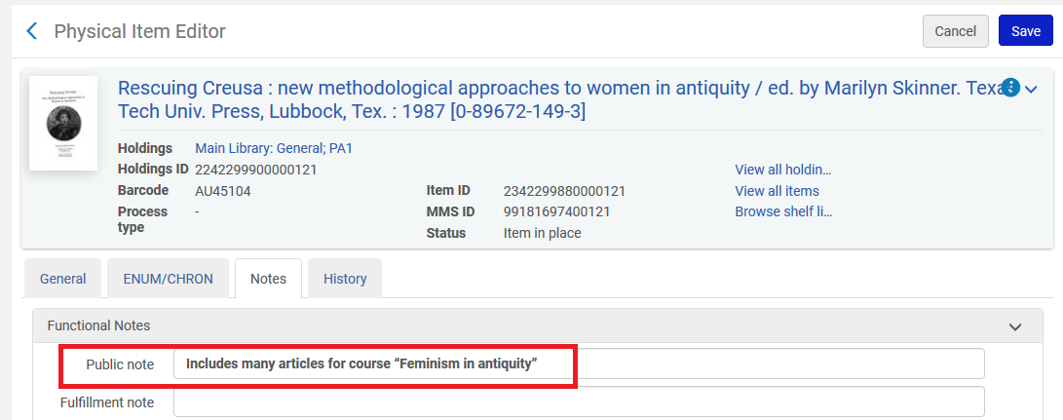

When searching Primo for one of these recorfs the related titles are clearly labeled and present

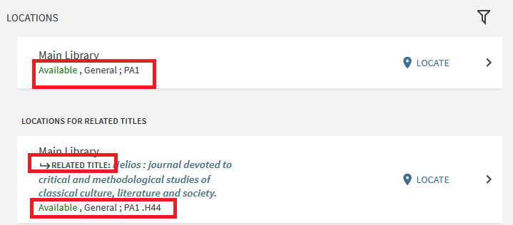

It is very clear that item note “Includes many articles for course “Feminism in antiquity”” is for title “Rescuing Creusa : new methodological approaches to women in antiquity”.

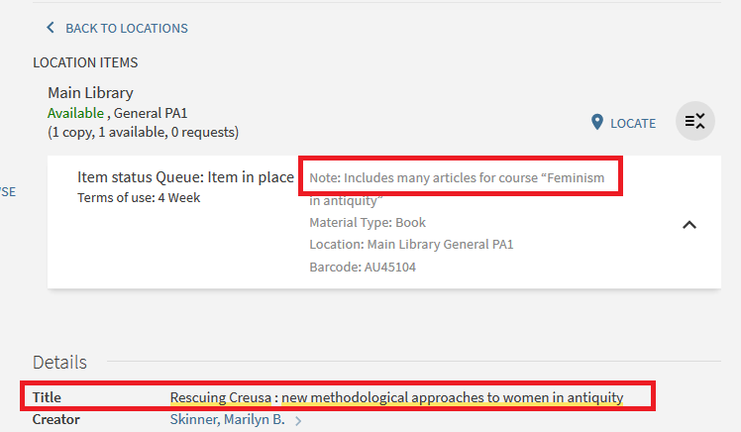

It is also very clear that item note “Includes article by Madeline Meydansky signed by the author” is for title “Helios : journal devoted to critical and methodological studies of classical culture, literature and society. Helios : journal devoted to critical and methodological studies of classical culture, literature and society.”.

