|  |  |
| --- | --- |
| **User statistical categories and Alma Analytics** |  |



**Yoel Kortick**

**Senior Librarian**

See also [Configuring Statistical Categories for Analytics](https://knowledge.exlibrisgroup.com/Alma/Product_Documentation/010Alma_Online_Help_(English)/050Administration/040Configuring_User_Management/040User_Details_Configuration#Configuring_Statistical_Categories_for_Analytics)

The Users subject area of Alma Analytics allows for the creation of reports of users by several fields, such as user group and job category, job description, campus code and more.

In addition to this, it is possible for the institution to create its own statistical categories which can be assigned to users specifically for this purpose.

This may be, for example, by country of origin (for overseas students) or academic degree.

There are statistical types, statistical categories, and then a table linking the relevant type of category to the corresponding category.

This is done and used as follows:

**Step one**

Define the Category Types at Configuration > User Management > User Details > Category Types.

While it is possible to display any number of category types five of them are available in Alma Analytics

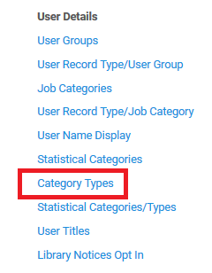

These are the types we have created. In our example here we will be focusing on “Country of Origin” and “Discipline”.

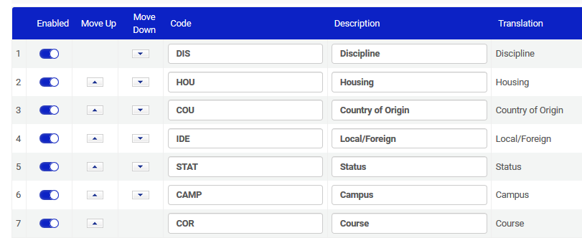

**Step two**

Define the Categories at Configuration > User Management > User Details > Statistical Categories.

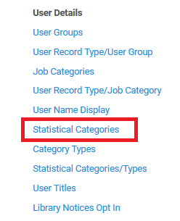

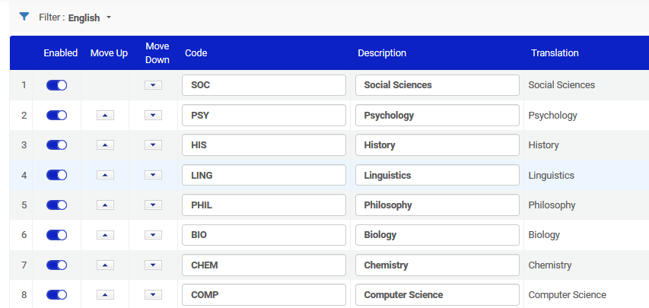

**Step three**

Attribute the statistical categories to the statistical types at Configuration > User Management > User Details > User Record Type/Job Category.

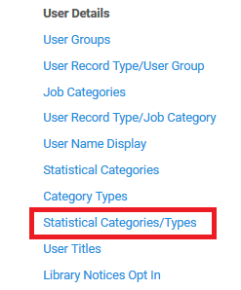

Here we see categories for types “Country of Origin” and “Discipline”.

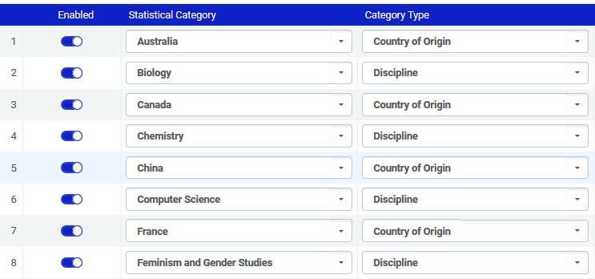

**Step four**

Attribute the statistical categories to the statistical types at Configuration > User Management > User Details > User Record Type/Job Category.

Select up to five statistical categories to appear in Alma Analytics.

This is done at Analytics > Analytics Objects > Analytics User Statistics.

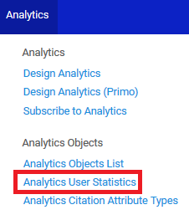

In our case we see that statistics_1 is the discipline and statistics_2 is the country of origin.

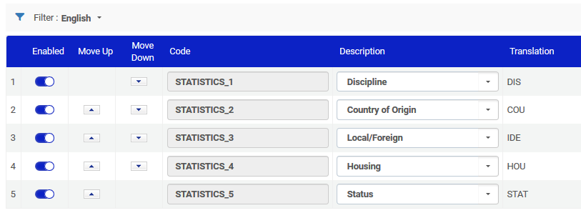

**Step five**

Attribute the relevant statistical categories to the relevant user. This can be done in the “User” integration, via APIs or manually. Manually this is done in the “Statistics” tab of the user record.

Here for user Elia Zafrani we are adding “Country of Origin” = “France”.

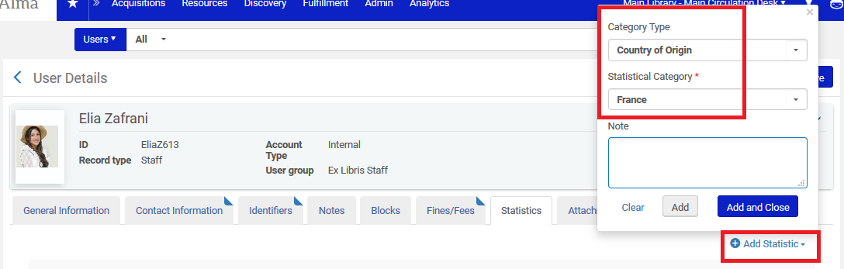

Here for user Elia Zafrani we are adding “Discipline” = “Computer Science”.

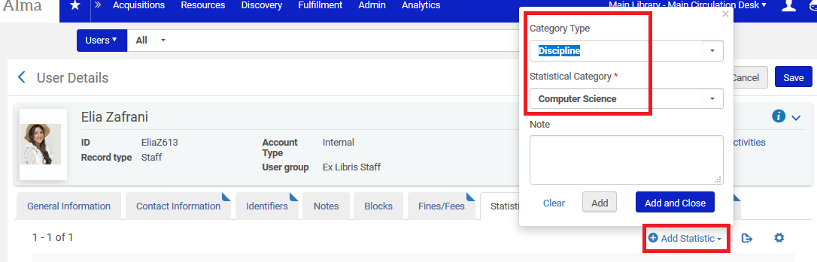

Here are the statistics for Elia Zafrani:

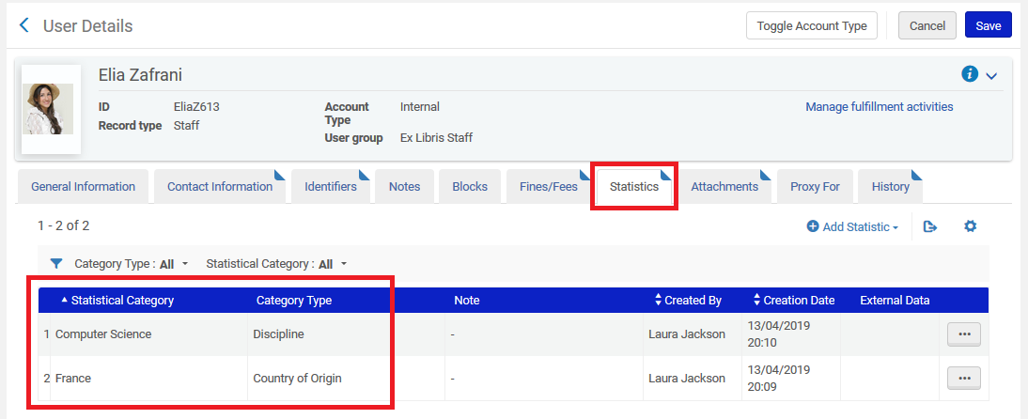

Here are the statistics for Alicia Chen:

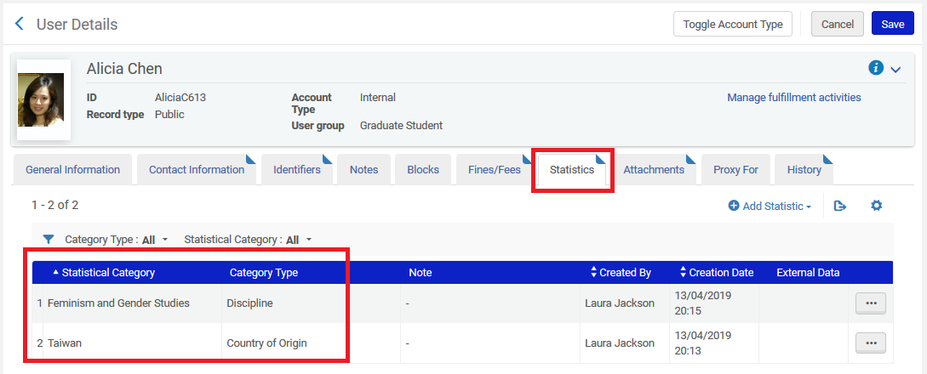

**Step Six**

In Alma Analytics Fulfillment subject area we will make the following report for the above two users:

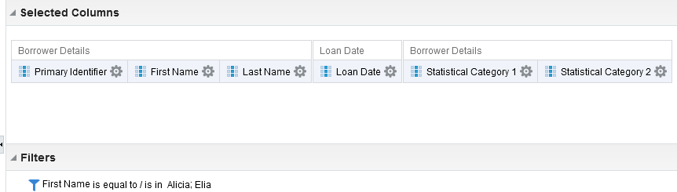

Here are the results. As defined above we see the discipline in statistical category 1 and the country of origin in statistical category 2.

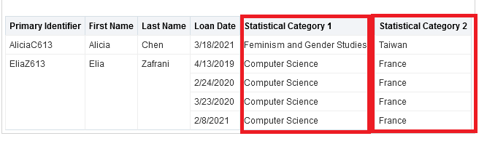

**Step Seven**

In Alma Analytics Users subject area we will make the following report for the above two users:

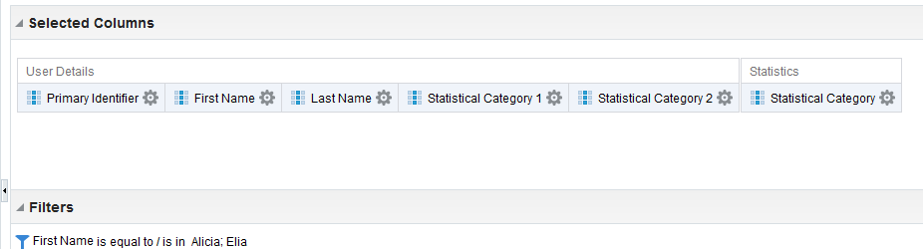

Here are the results. As defined above we see the discipline in statistical category 1 and the country of origin in statistical category 2.

