How to create/import OCLC numbers from an Excel file into existing Alma records

Create an import file in Excel containing the MMS ID (001) and the OCLC number (035). It should look like this
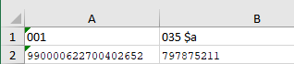

Existing record in Alma has 2 035 fields
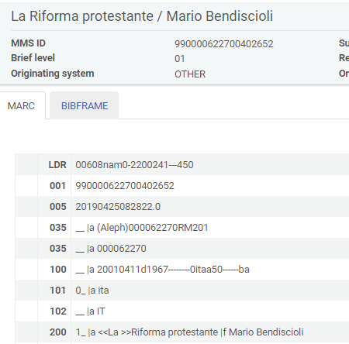

A merge rule is needed in order to add field 035 from the loading file to the existing record
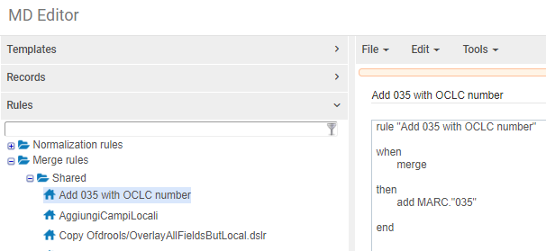

A normalization process/rule is needed in order to add prefix (OCoLC) to the 035 field to load

Normalization process >Configuration >Resources >Cataloging >Metadata Configuration >UNIMARC Bibliographic >Normalization Processes
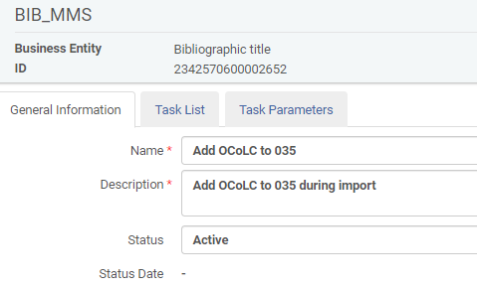

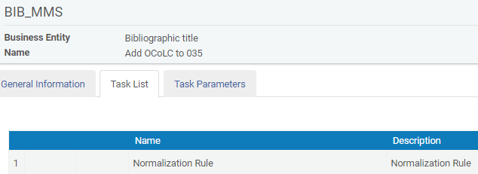

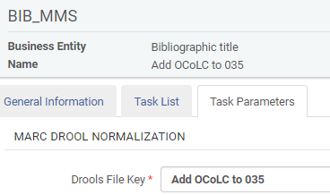

Normalization rule
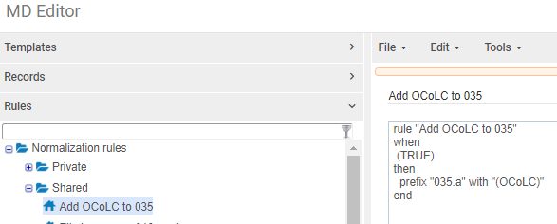

Import profile
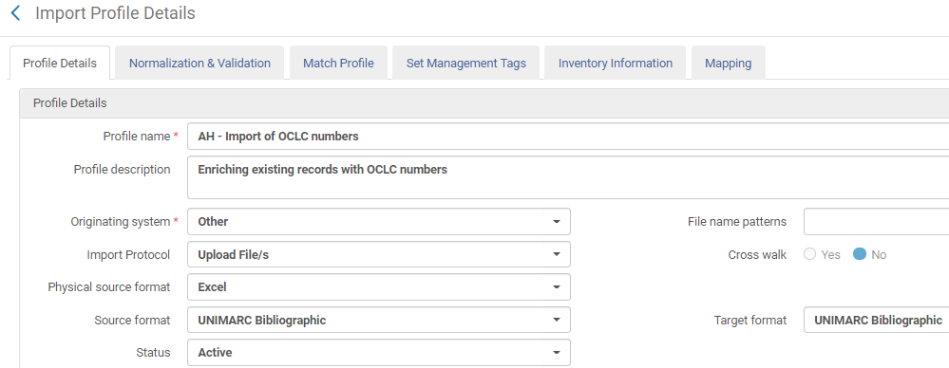

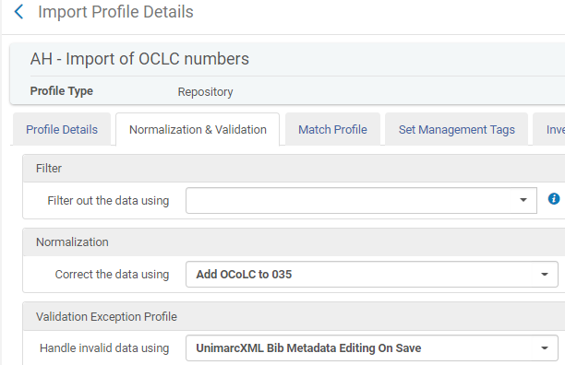

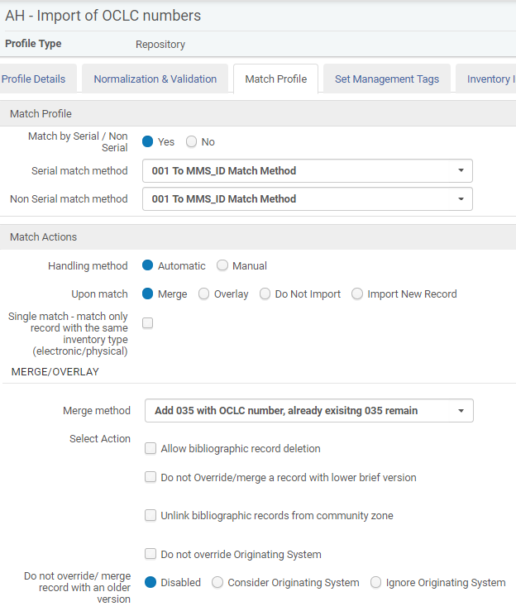

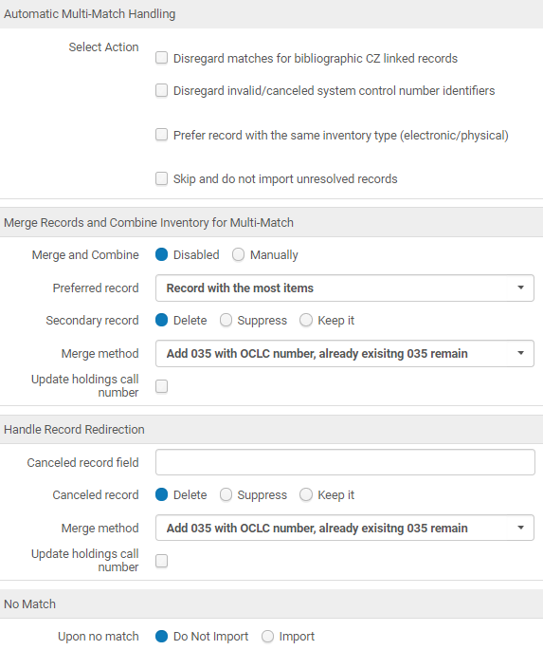

Run the import

During the import a XML file will be created
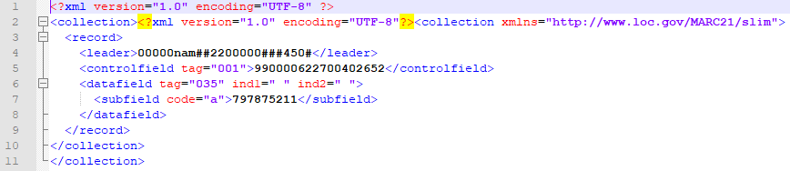

The record afterwards contains the 035 field with OCLC number. The existing 035 fields remain also in the record
