How to make a check on the uniqueness of the 090 call number when saving a record in the metadata editor

In the example below, we will show to configure Alma to give a warning message when a record is saved with a 090 call number which is the same as that of an existing record. A similar procedure can be used for other local call number fields as well.

ONE
There are two bibliographic records with same exact 090 $$a which is:
090 $$a EliaZ YLK 201904171641

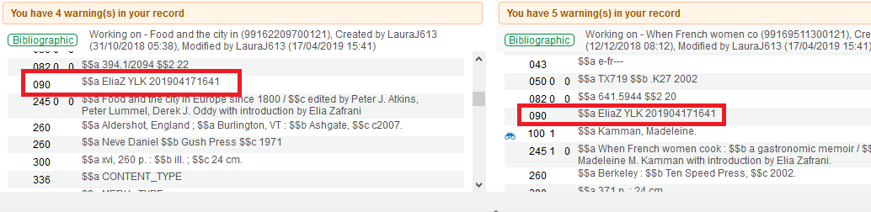

Currently when saving the record there is no message.

TWO
Do as follows:

- Go to “Configuration > resources > Cataloging > Metadata Configuration > Marc 21 Bibliographic > Validation Processes”
- Edit “Marc21 Bib validation on save”
- Click “add task” and add “Validate Local Call Number Uniqueness MARC21” (if it is not already there in list)
- Switch to task parameters and for “VALIDATE LOCAL CALL NUMBER UNIQUENESS” add field 090

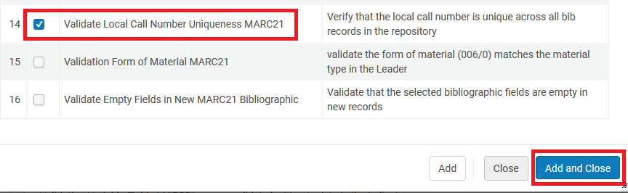

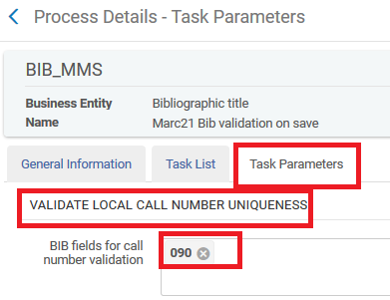

THREE

Now open in metadata editor and try to save one of the two records which has
090 $$a EliaZ YLK 201904171641

Try to save one of the records and get message:
The call number is already in use in the record/s [99169511300121]

