|  |  |
| --- | --- |
| **How to make the primary identifier appear together with the first name and last name** |  |



**Question:**

We need the Primary Identifier and not just the user first name and last to appear when we do ”Find and manage users”

**Answer:**

This can be done by adding a value to the table User Name Display. See also [Configuring the Display of User's Names](https://knowledge.exlibrisgroup.com/Alma/Product_Documentation/010Alma_Online_Help_(English)/050Administration/040Configuring_User_Management/040User_Details_Configuration#Configuring_the_Display_of_User's_Names).

Possible values which can be added to the display are:

* first Name
* lastName
* middleName
* userName (primary identifier)
* jobDescription
* userTitle

**Sample record**

In our example we are using user “Alia Chen” who is record type “Public” and has Primary Identifier “Alicia C613”

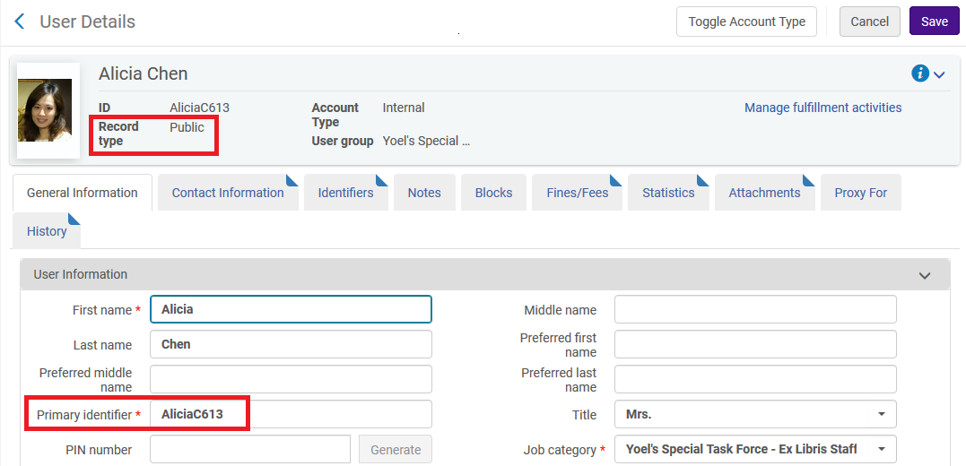

Now in the “Find and Manage Users” she appears as follows:

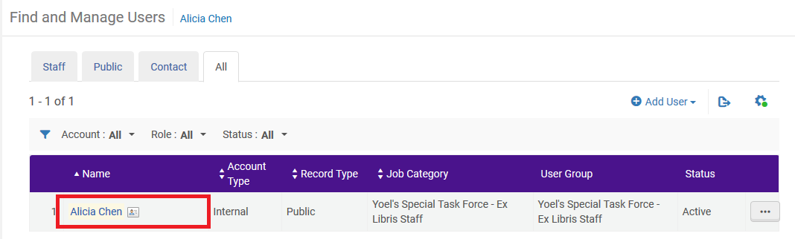

**Make the Change**

Access table “User Name Display” at “Configuration > User Management > User Details > User Name Display” and for the line of user type “Public” (and other types of users you want to change) add **userName**

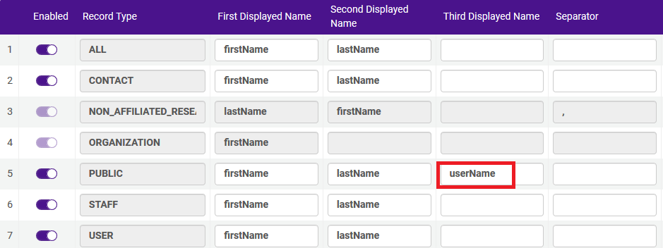

Now access the user again in “Find and Manage Users” and see this (The Primary Identifier) also appears:

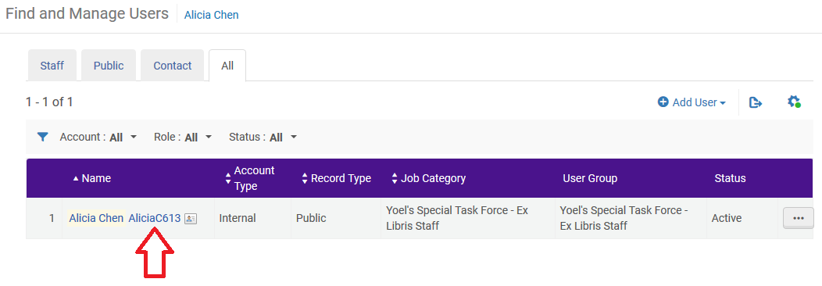

Note that other places in the system are also affected, for example when retrieving a user and displaying for loans (Manage Patron Services):

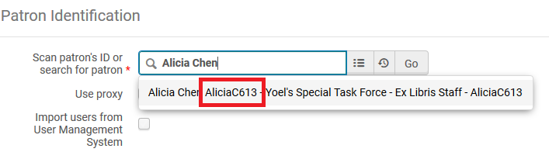

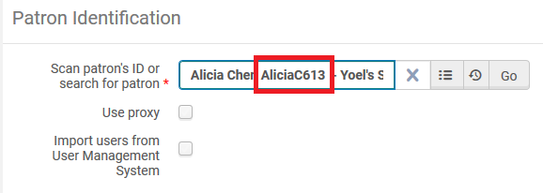

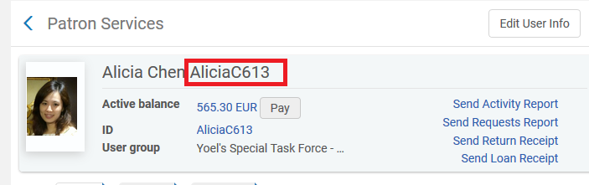

Note also that if a user of type Staff is changed then the display also appears in the Alma Home Page.

For example, here is user Laura Jackson with Primary Identifier LauraJ613 on the Alma Home Page, after configuring that **userName** will appear for record type staff.

