|  |  |
| --- | --- |
| **How to create a measure from textual alpha numeric values** |  |



**Yoel Kortick**

**Senior Librarian**

In the example here, we have a field which consists of numbers as well as textual values. From this field we will extract only the numbers (including decimal points) and then create a measure. In this way we will

1. See only the numerical values
2. Be able to perform mathematical operations on the field including, for example, a SUM

ONE

The field " Inventory Price” in the "Physical Item Details” folder of the "Physical Items" subject area is an alpha numeric field.

Thus, it can appear as follows in Alma and in Alma analytics.

The first example has a comma, the second example has a period, the third example has neither a comma nor a period, the last two examples have has neither a comma nor a period nor a currency abbreviation.

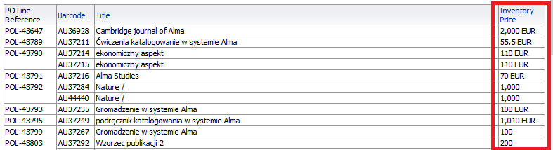

Here is the first example in Alma

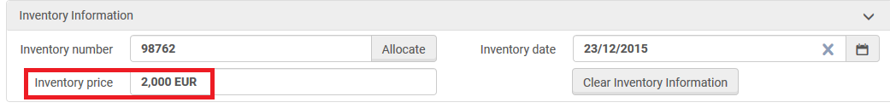

TWO

Now we want to take these value and get only the numers and decimal points. Therefore:

2,000 EUR will become 2000

55.5 EUR will become 55.5

1,000 will become 1000

110 EUR will become 110

In order to do this we can change

**"Physical Item Details"."Inventory Price"**

To

**SUM(CAST(EVALUATE('REGEXP_REPLACE(%1, ''[^0-9.]'','''')',"Physical Item Details"."Inventory Price") as NUMERIC))**

And then we will need to modify the column properties.

For an explanation of what this formula means see below at end of this document “additional explanation of the REGEXP_REPLACE”

THREE

Change the field as follows:

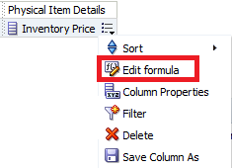

Replace the column formula with the text from above

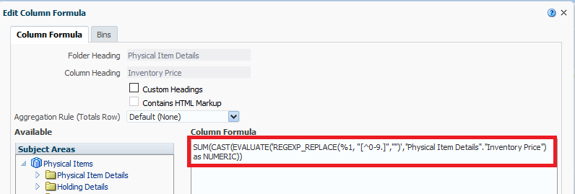

FOUR

Now we have this:

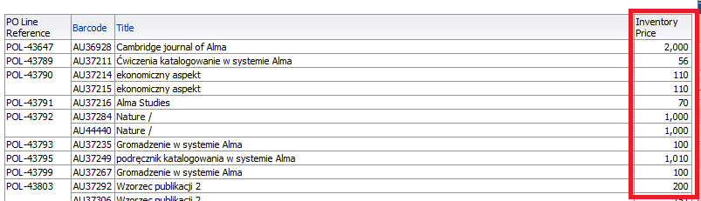

Two issues: We still have the comma and the values after the decimal point have been lost.

2,000 should be 2000

56 should be 55.50

FIVE

We can determine the display of decimal values and commas as follows:

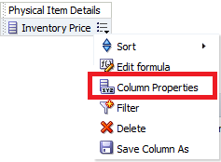

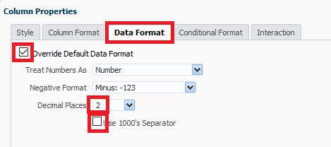

SIX

View the results

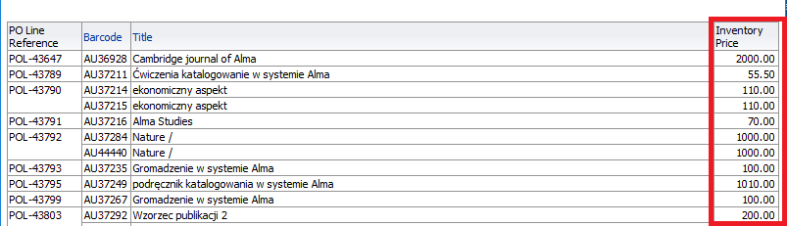

SEVEN

See that now you can make a SUM of the column. For example in the results tab right click the top of the column and choose this:

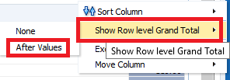

Now there is a SUM

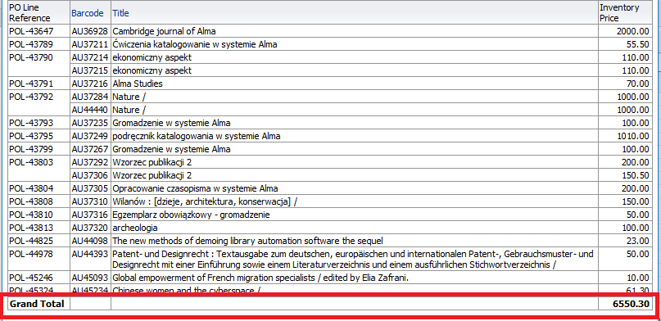

Additional explanation of the REGEXP_REPLACE

**SUM(CAST(EVALUATE('REGEXP_REPLACE(%1, ''[^0-9.]'','''')',"Physical Item Details"."Inventory Price") as NUMERIC))**

* The first part (yellow) means: From the beginning to the end of the field get only the numbers and periods.
* The second part (green) makes the textual value be a numeric value
* The third part (turquoise) makes it a SUM so that it can be used as a measure

There are two types of functions that we can use inside reports.

1. **OBIEE functions:**

All functions which you can find when you click on “*F(…)*”  from “edit formula”.

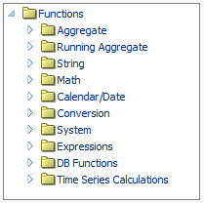

1. **ORACLE functions:**

Functions which exists in Oracle Database, but you can’t find them in OBIEE.

The OBI function “EVALUATE” enables the use of the Oracle functions.

The “EVALUATE” wraps the Oracle function.

Here is a description:

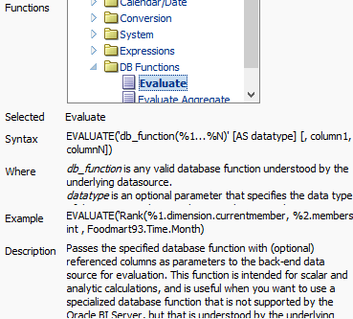

Regarding your question:

On database the function is:  **REGEXP_REPLACE(*<column_name>*, ‘[^0-9]’,’’)**

In OBI you need to write it on a different way. Instead of the column name you put **%1**, and then you add: **comma +** ***<column_name>***

