|  |  |
| --- | --- |
| **How to separate a large Alma Analytics report into separate smaller reports** |  |
|  | |



**Yoel Kortick**

**Senior Librarian**

There may be cases where a user will want to separate large analytics report into separate smaller reports which will then be processed by a “third party”.

In other cases, there may be a need to separate a large report that exceeds the 500,000 row limit to which a report can be exported to csv format.

This may be done by using the row count (RCOUNT) and then creating separate reports by spans of row numbers.

For example, if we export to csv a report of all active item barcodes we will see that we will reach the limit

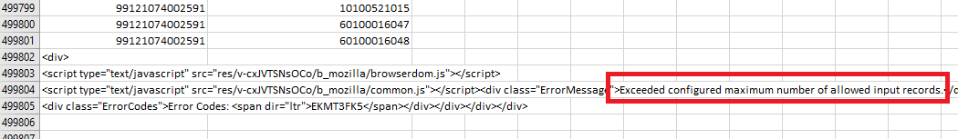

We can however take this report and separate it into separate reports of, for example, 400,000 lines each. Here are the steps. Steps three to fifteen just repeats itself and all of the steps are not necessary depending on how many rows of data there are.

Below it is shown in depth

1. Add a column to the existing report (can be any criteria)
2. Edit the column properties and change the formula to be " RCOUNT(1)" and the header to be “Data Row Number”
3. Filter this new column which we called “Data Row Number” to be between 1 and 400,000. Call results “All item barcodes rows 1 – 400000”
4. Duplicate the report and filter the column which we called “Data Row Number” to be between 400,001 and 800,000. Call results “All item barcodes rows 400001 – 800000”
5. Duplicate the report and filter the column which we called “Data Row Number” to be between 800,001 and 1,200,000. Call results “All item barcodes rows 800001 – 1200000”
6. Duplicate the report and filter the column which we called “Data Row Number” to be between 1,200,001 and 1,600,000. Call results “All item barcodes rows 1200001 – 1600000”
7. Duplicate the report and filter the column which we called “Data Row Number” to be between 1,600,001 and 2,000,000. Call results “All item barcodes rows 1600001 – 2000000”
8. Duplicate the report and filter the column which we called “Data Row Number” to be between 2,000,001 and 2,400,000. Call results “All item barcodes rows 2000001 – 2400000”
9. Duplicate the report and filter the column which we called “Data Row Number” to be between 2,400,001 and 2,800,000. Call results “All item barcodes rows 2400001 – 2800000”
10. Duplicate the report and filter the column which we called “Data Row Number” to be between 2,800,001 and 3,200,000. Call results “All item barcodes rows 2800001 – 3200000”
11. Duplicate the report and filter the column which we called “Data Row Number” to be between 3,200,001 and 3,600,000. Call results “All item barcodes rows 3200001 – 3600000”
12. Duplicate the report and filter the column which we called “Data Row Number” to be between 3,600,001 and 4,000,000. Call results “All item barcodes rows 3600001 – 4000000”
13. Duplicate the report and filter the column which we called “Data Row Number” to be between 4,000,001 and 4,400,000. Call results “All item barcodes rows 4400001 – 4800000”
14. Duplicate the report and filter the column which we called “Data Row Number” to be between 4,800,001 and 5,200,000. Call results “All item barcodes rows 4800001 – 5200000”
15. Etc. etc. etc.

**ONE**

Here is the “Data Row Number” field

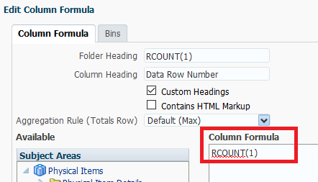

**TWO**

Here is the filter on the first report

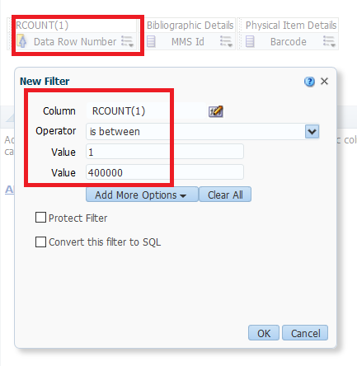

**THREE**

Here is the first report

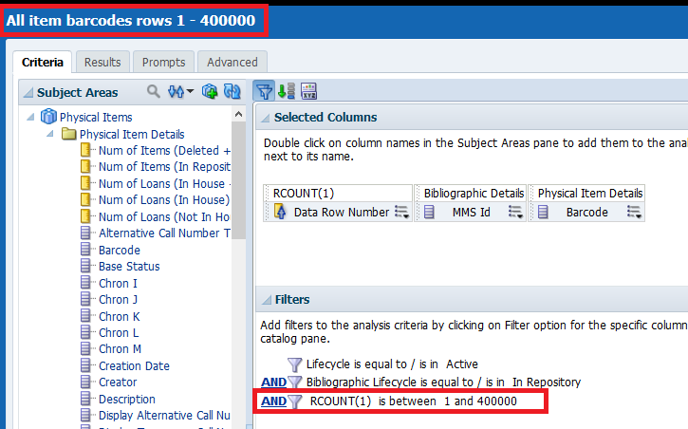

**FOUR**

Here is the filter on the second report

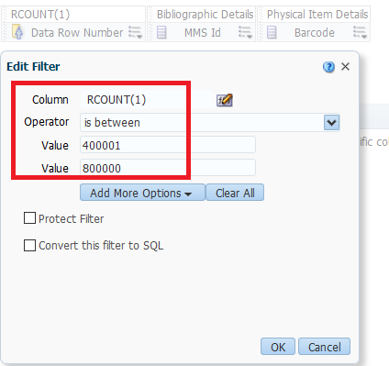

**FIVE**

Here is the second report

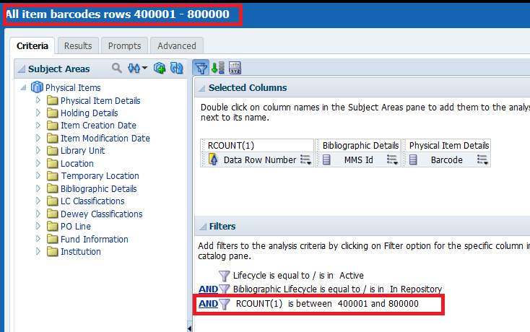

**SIX**

Run the reports and see that they are broken down by row number

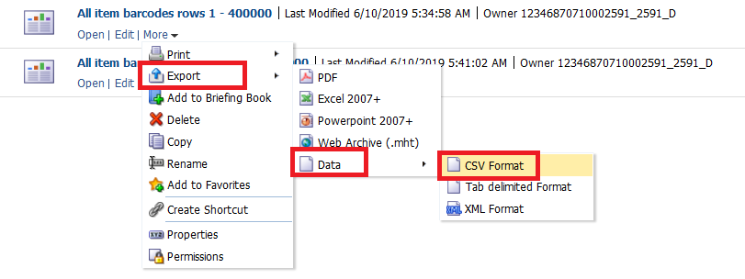

**SEVEN**

Here is top and bottom of first report

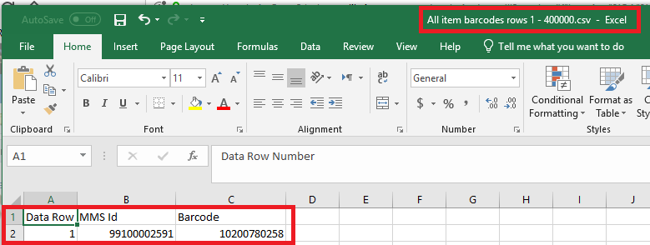

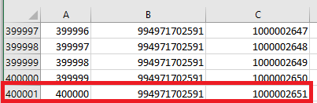

**EIGHT**

Here is top and bottom of second report

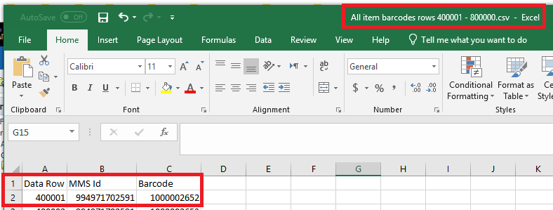

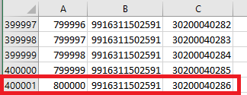

**NINE**

Here is the last report “All item barcodes rows 4800001 – 5200000”. It starts at row 4800001 and goes up to row 4,869,307

Here is the top of the report

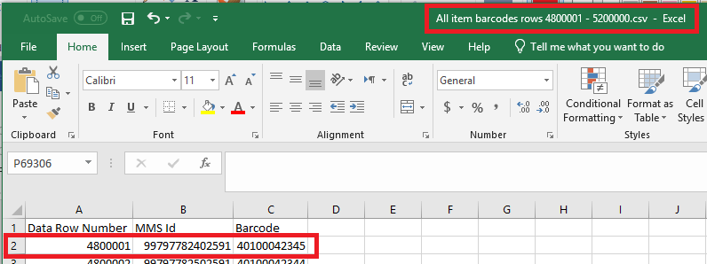

Here is the end of the report:

