|  |  |
| --- | --- |
| **Accessing Creating Editing and Running Normalization Rules and Processes with Varied Cataloging Roles** |  |
|  | |

**Yoel Kortick.**

**Senior Librarian**

This document will explain the different user roles relating to normalization rules and normalization processes.

By having one user with one or a combination of the following roles the institution can be very specific about what each user can and cannot do.

The role “Cataloger” can:

* Create new normalization **rules**
* Edit existing normalization **rules**
* Run a normalization process on one record from within the metadata editor

The role “Catalog Manager” can:

* Create new normalization **rules**
* Edit existing normalization **rules**
* Run a normalization **process** on one record from within the metadata editor
* Run a normalization **process** on a set

The role “Catalog Administrator” without checkbox “Read Only” can:

* View and Edit existing normalization **processes**
* Add new normalization **processes**

The role “Catalog Administrator” with checkbox “Read Only” can:

* View existing normalization **processes**

**ONE**

User Madeline Matar, ID MadelineM613, has only roles “Cataloger” and “Patron”

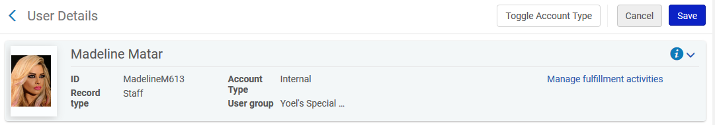

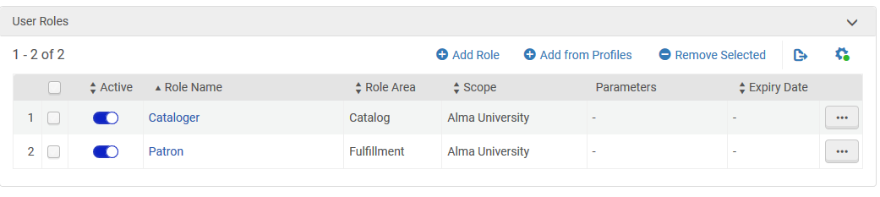

She does not have these roles:

* Catalog Administrator
* Catalog Manager

**TWO**

We see that Madeline can edit existing normalization rules and add new normalization rules

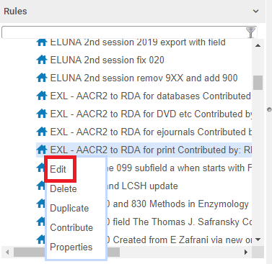

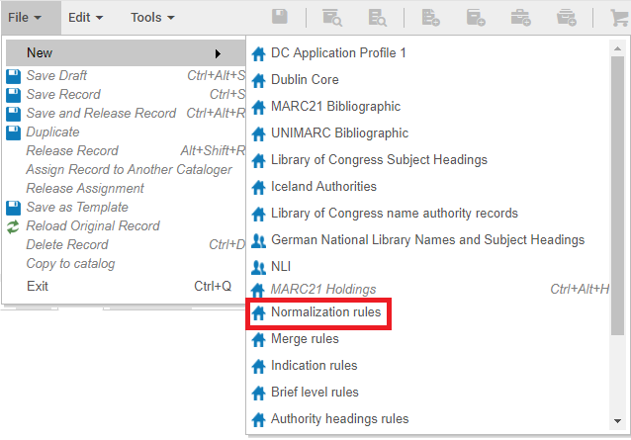

**THREE**

On a single open record in the metadata editor Madeline can do “Edit > Enhance the record” and run a normalization process on a record and save it.

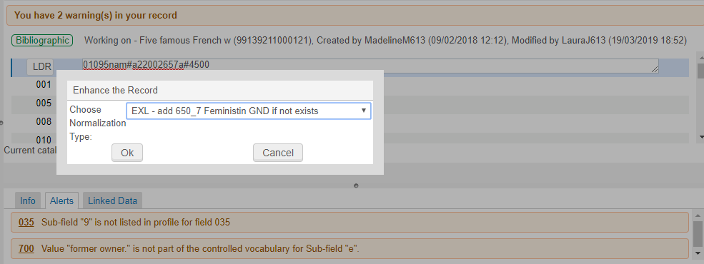

**FOUR**

Madeline cannot run a normalization job on a set, because role “Cataloger” cannot run jobs:

Under “Admin > manage Jobs and Sets” Madeline cannot “Run a job”



**FIVE**

Now instead of role “Cataloger” we give Madeline role “Catalog Manager”.

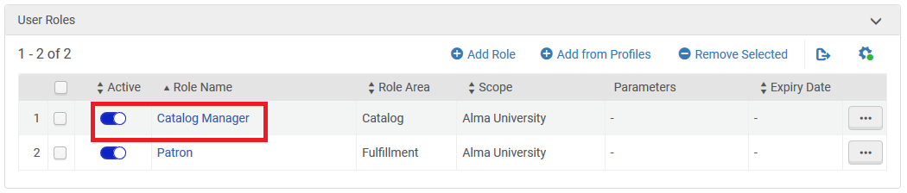

**SIX**

Now in addition to adding new normalization rules, editing existing normalization rules and running normalization processes in the metadata editor on a single record: Madeline can run a normalization process job on a set.

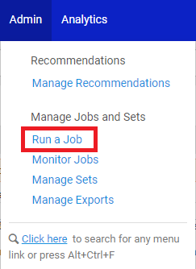

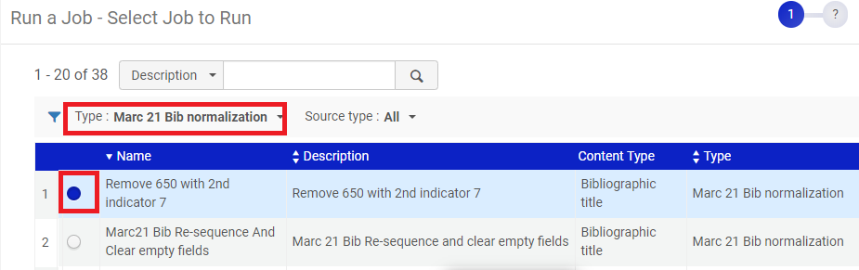

**SEVEN**

Note however that Madeline still has no access to edit configuration for normalization processes.

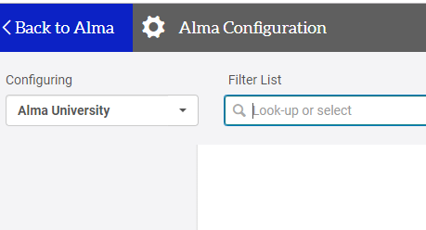

**EIGHT**

Now we give Madeline role “Catalog Administrator” instead of “Cataloger or Catalog manager”.

We are not including “Read Only” on this role. More on that later.

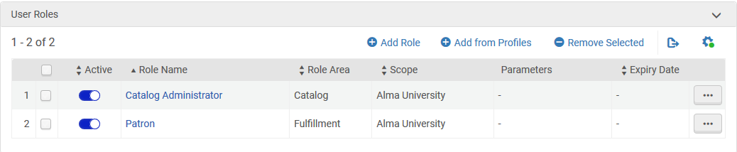

**NINE**

Now Madeline can edit and view normalization processes.

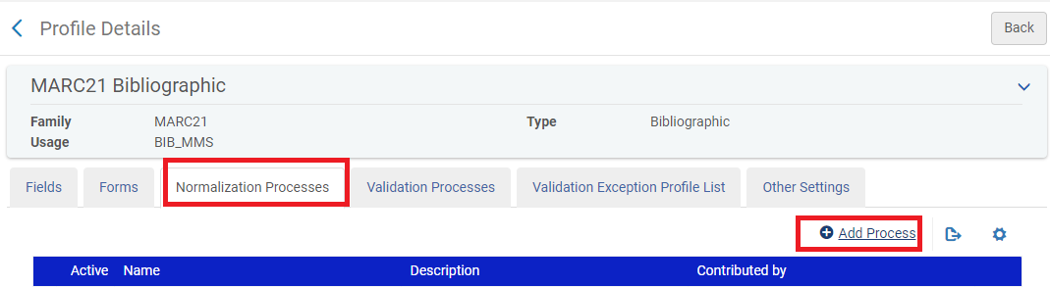

**TEN**

Note that as previously stated the “Catalog Administrator” could have been defined as “Read Only”.

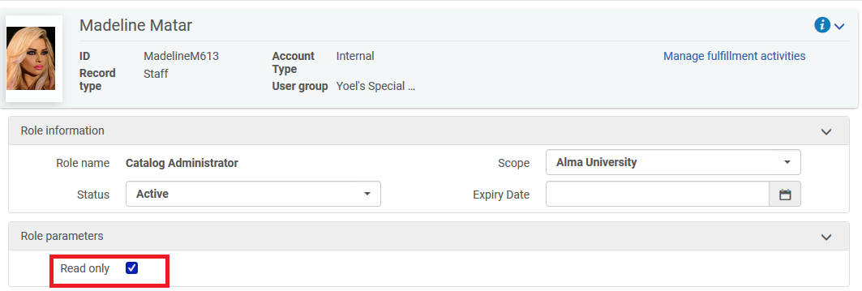

**ELEVEN**

When having role “Catalog Administrator” with checkbox “Read Only” Madeline can only view normalization process but not add or edit normalization processes

