|  |  |
| --- | --- |
| **Ordering an eBook from OASIS using the Real Time Ordering (RTO)** |  |



**Yoel Kortick**

**Senior Librarian**

**Question:**

Can eBooks be ordered from OASIS using the Real Time Ordering (RTO) integration with Alma

**Answer:**

Yes, eBooks van be ordered from OASIS using the Real Time Ordering (RTO) integration with Alma

**ONE**

Log into OASIS at <https://oasis.proquest.com>

**TWO**

Search for an eBook such as title “Power Electronics in Renewable Energy Systems and Smart Grid: Technology and Applications” ISBN 9781119515661.

**THREE**

Select the record and click “Edit Order Info”

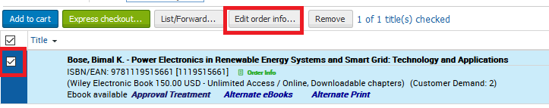

**FOUR**

In lower pane choose desired options such as selector, owner (library), quantity and fund. Click “save”

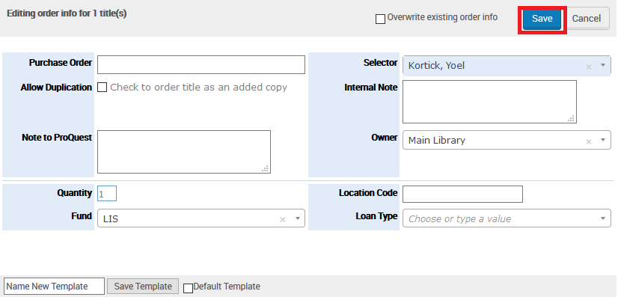

**FIVE**

In upper pane, with record selected, click “Express Checkout”

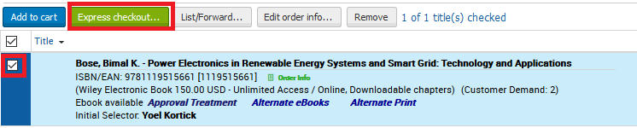

**SIX**

See that “Format Electronic” is selected and choose “Order All” and click “Submit All”

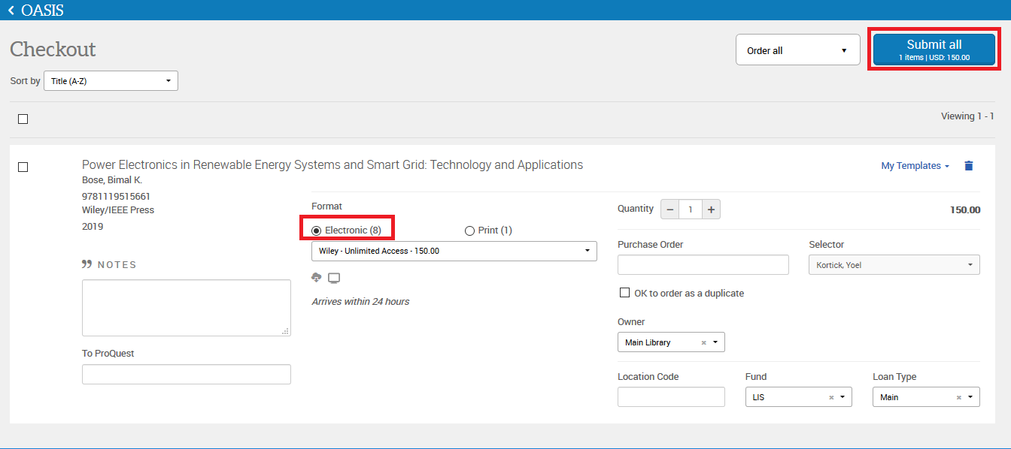

**SEVEN**

Check Alma and see that an order of type “Electronic Book - One Time” is created in Alma

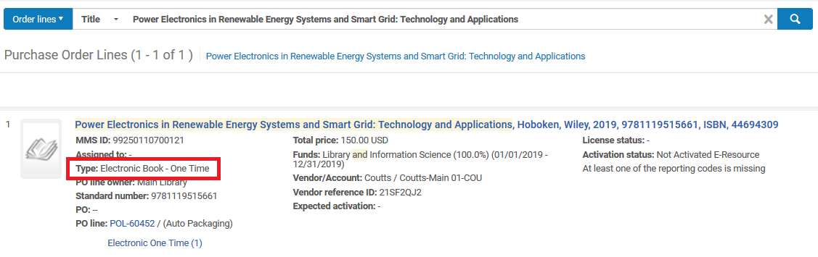

**EIGHT**

We see that the order was created from the API and has one non-active portfolio

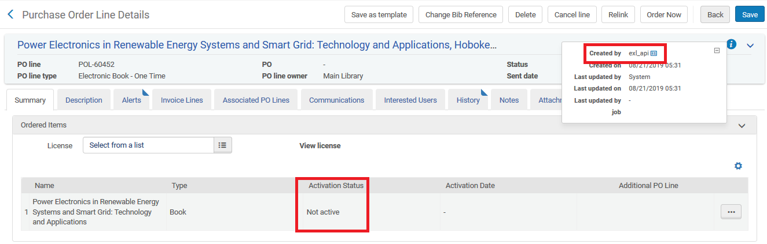

**NINE**

Here is the portfolio in a portfolio search

