|  |  |
| --- | --- |
| **How to remove COUNTER report data loaded via Alma** |  |



**Introduction**

There may be cases where COUNTER report data loaded via Alma needs to be removed. This may be done for both reports loaded manually as well as for reports loaded via SUSHI harvesting. The steps below explain how this may be done.

**ONE**

Identify the data which you want to remove. The easiest way to do this is to find the Load file ID of the data which you want to remove. To do this include the “Load File ID” field from the “Usage Data Details” folder in your Alma analytics report.

For example here we retrieve all reports for Platform ACS Publications (American Chemical Society) for 2015 which have JR1 measure **and we include the Load File ID**.

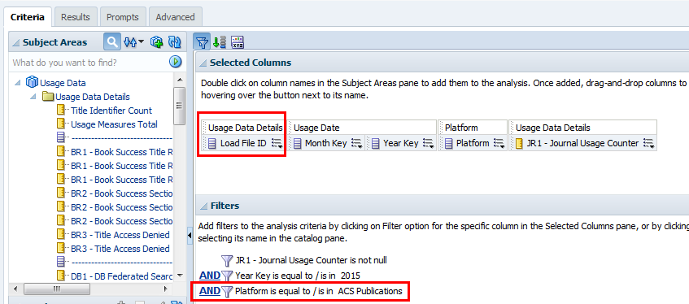

**TWO**

In the results we identify the Load File ID which we want to remove. In this case we want to remove the one with JR1 data from Sept. 2015 and we see that the load file ID is 2166305550002341 with a value of 2748 JR1 measure

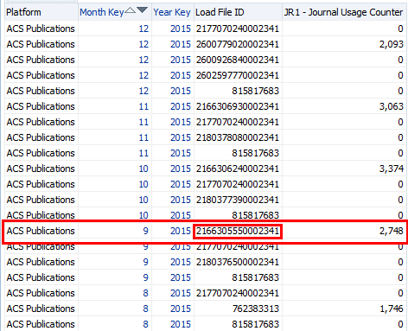

**THREE**

Via Alma user interface in Acquisitions > Import > Load Usage Data we retrieve this Load File ID. We see that it is for the same period as in Analytics: Sept. 2015

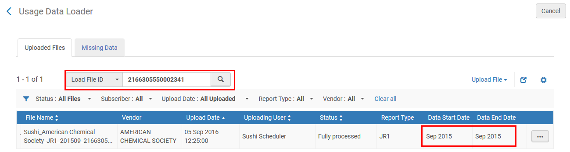

**FOUR**

We choose to delete it

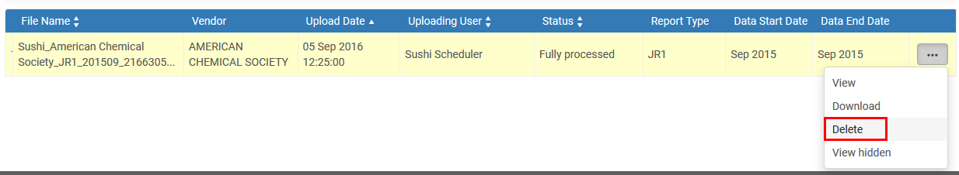

**FIVE**

We confirm the confirmation message

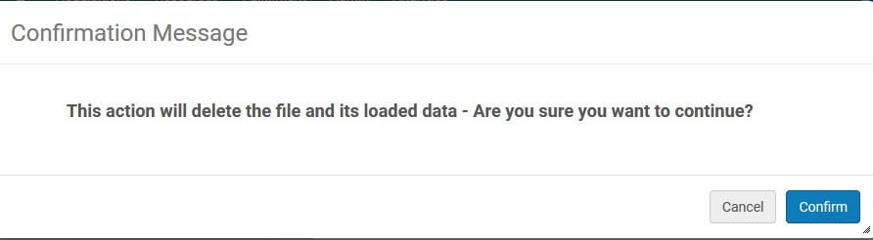

**SIX**

The data is deleted. After the next ETL from Alma to analytics (which occurs every night) this file and all related data will not be in analytics. We see that the load file ID 2166305550002341 with a value of 2748 JR1 measure no longer appears for Sept. 2015.

