|  |  |
| --- | --- |
| **Linking local portfolios in CZ Collection to CZ – what is overridden** |  |



**Yoel Kortick**

**Senior Librarian**

**Question:**

When using “Link Local Portfolios to Community” from the electronic service editor as described here:

<https://knowledge.exlibrisgroup.com/Alma/Product_Documentation/010Alma_Online_Help_(English)/040Resource_Management/050Inventory/020Managing_Electronic_Resources#Linking_a_Local_Portfolio_that_is_part_of_a_Community_Zone-Linked_Collection_to_the_Community_Zone>

There is a confirmation message which states “The local portfolios information may be overridden”.

What is overridden? Are the following overridden: Internal notes, General notes, Associated POL, Coverage and Library?

**Answer:**

* The “Library” of the portfolio is not removed
* The local coverage remains, and global coverage is added.
* All acquisition POLs remain.
* The parts of the portfolio which change can be seen in the history tab changed by “System”.
* The parts that are changes are the parser parameters in the “Linking” tab and the electronic material type in the general tab.

**Live demo showing the above:**

**ONE**

“Red Book” is part of electronic collection “Women’s magazine Archive” is an electronic collection linked to the Community Zone

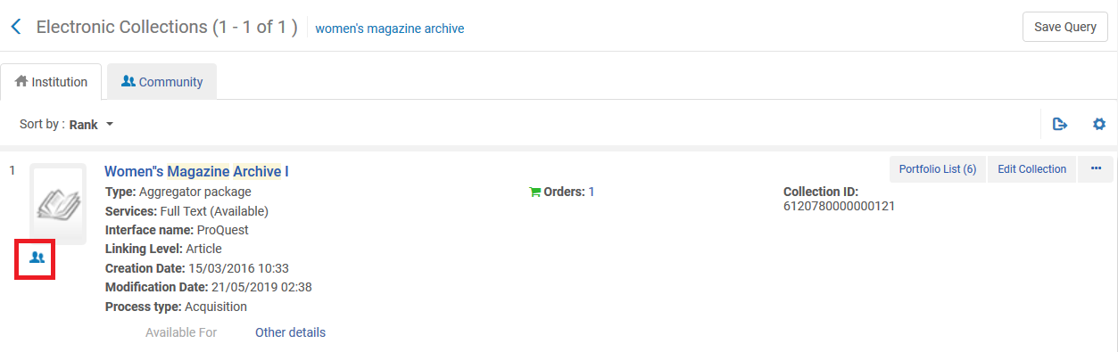

**TWO**

One of the portfolios in the collection, “Red Book”, is a local portfolio.

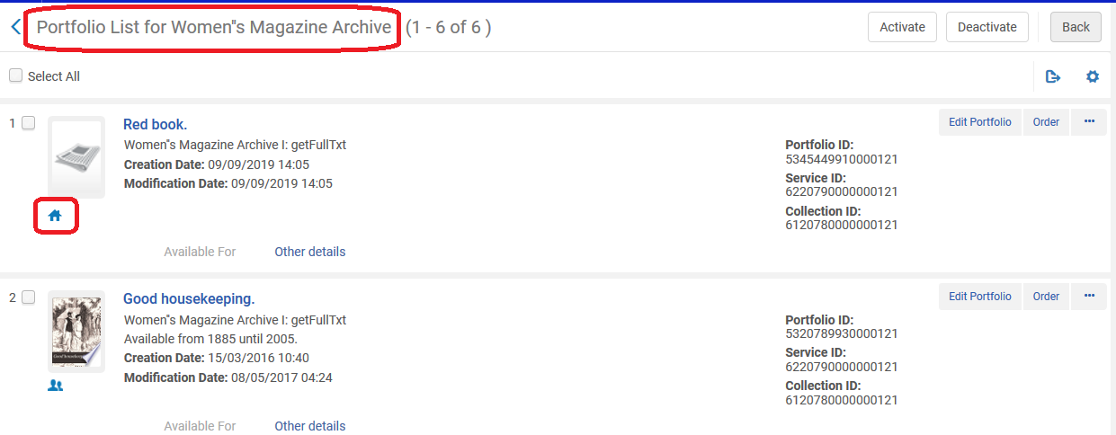

**THREE**

The portfolio has a library

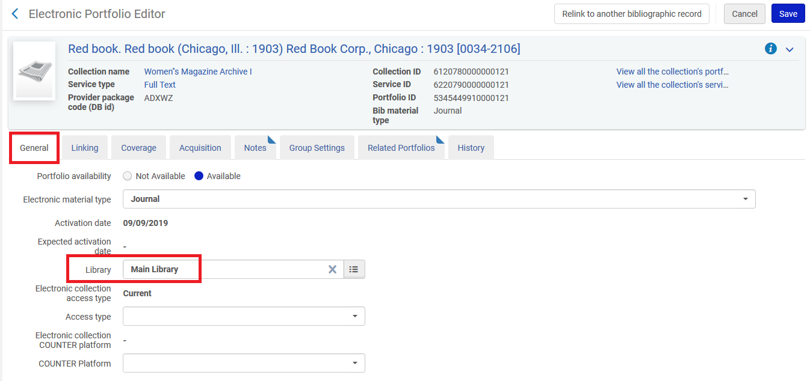

**FOUR**

The portfolio has coverage

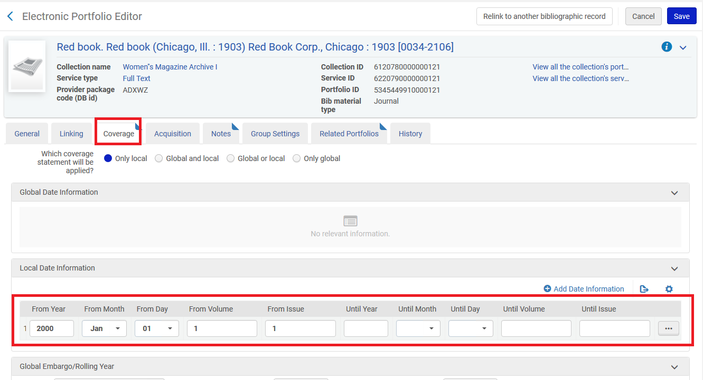

**FIVE**

The portfolio has an electronic collection POL, a POL, and an additional POL

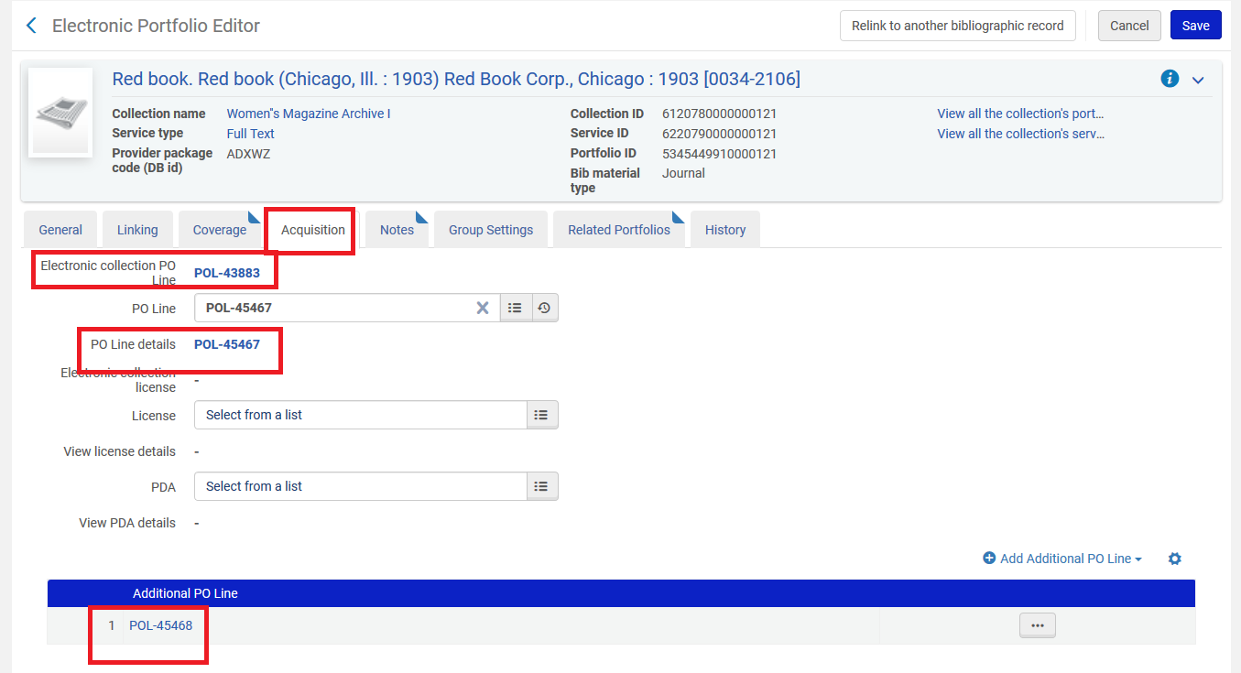

**SIX**

The portfolio has functional notes and general notes

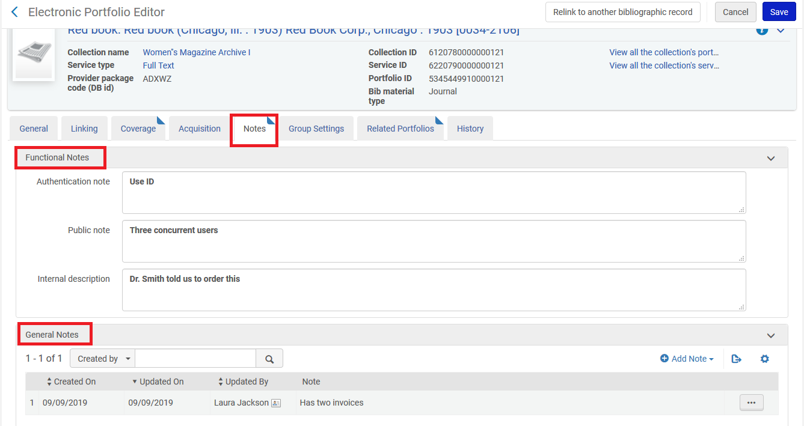

**SEVEN**

From the portfolios list of the electronic collection service editor we choose “Link Local Portfolios to the Community”

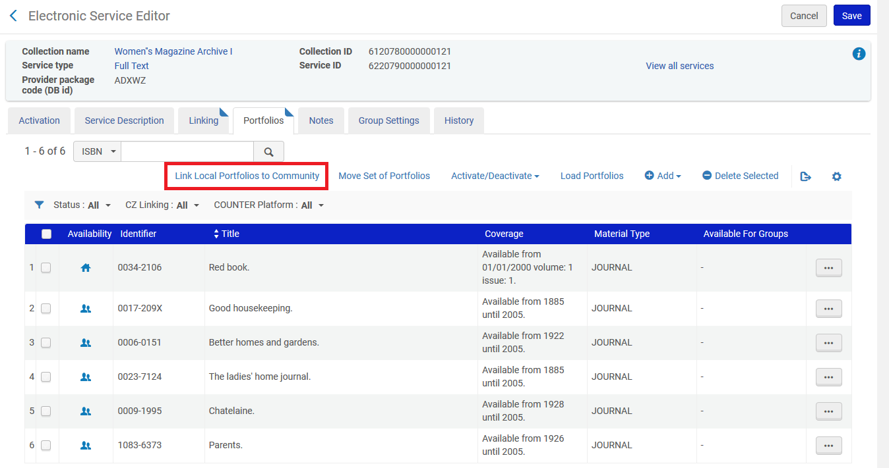

**EIGHT**

We get this message and confirm

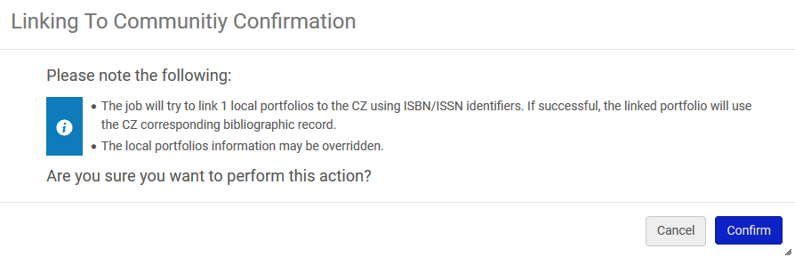

**NINE**

The linking job runs



**TEN**

The portfolio is linked

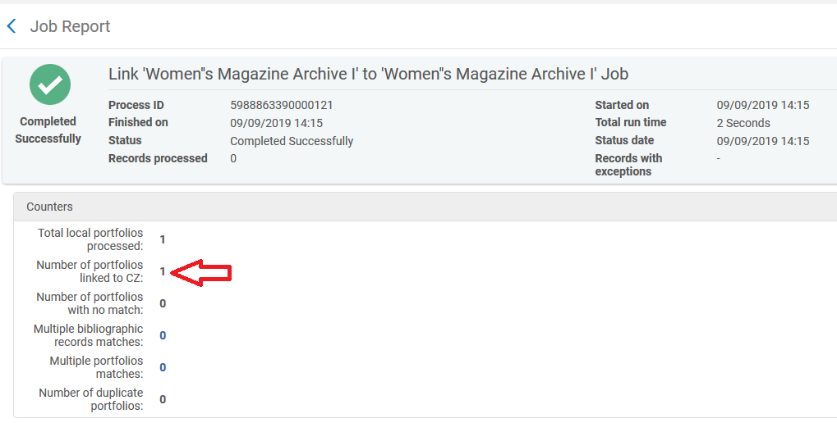

**ELEVEN**

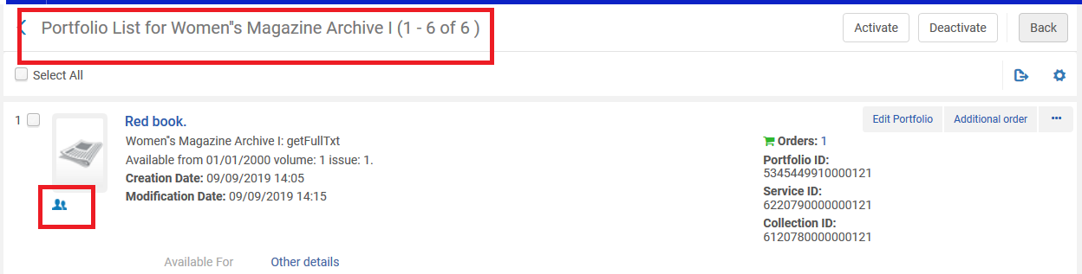

**TWELVE**

The library is still there

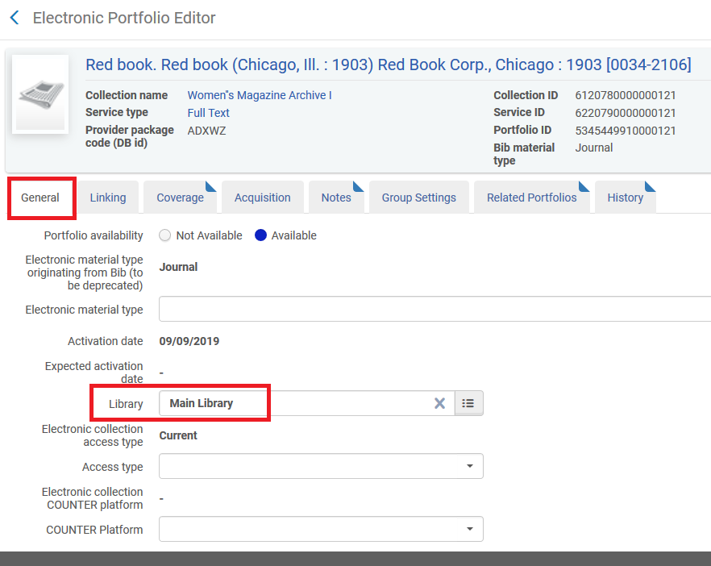

**THIRTEEN**

The local coverage is still there and global coverage has been added

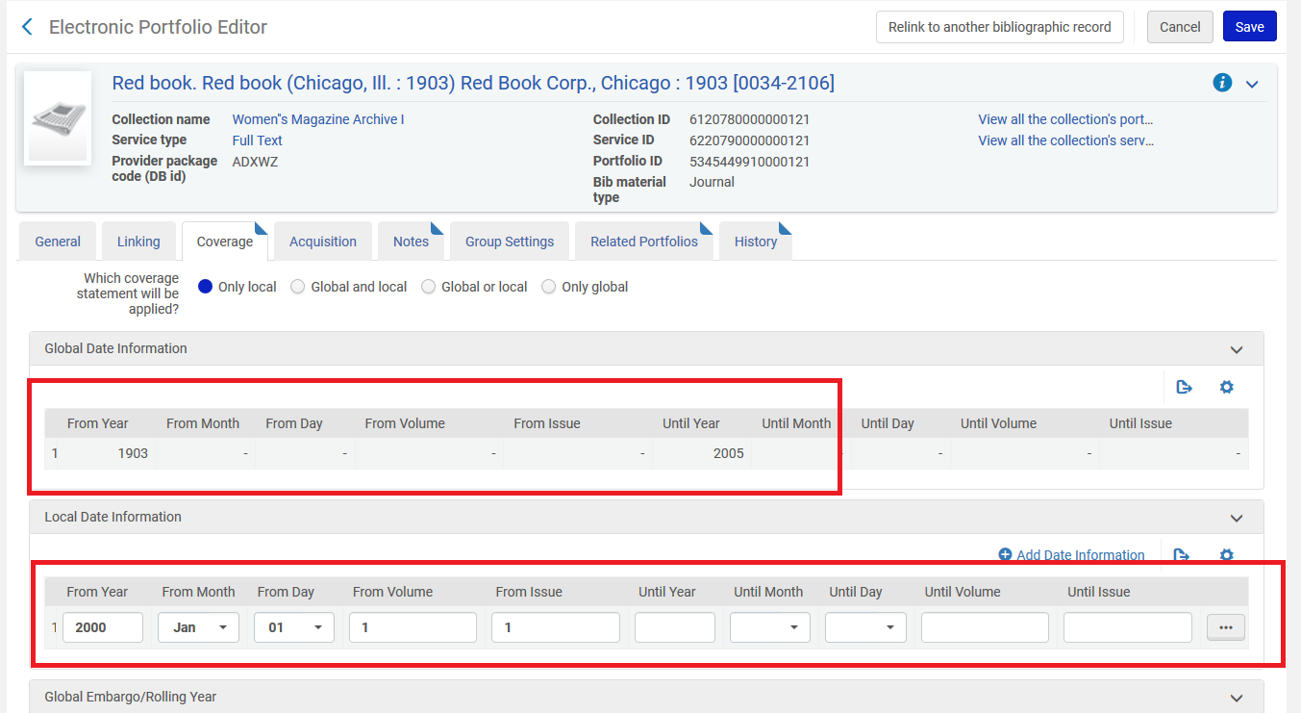

FOURTEEN

All acquisition POLs remain

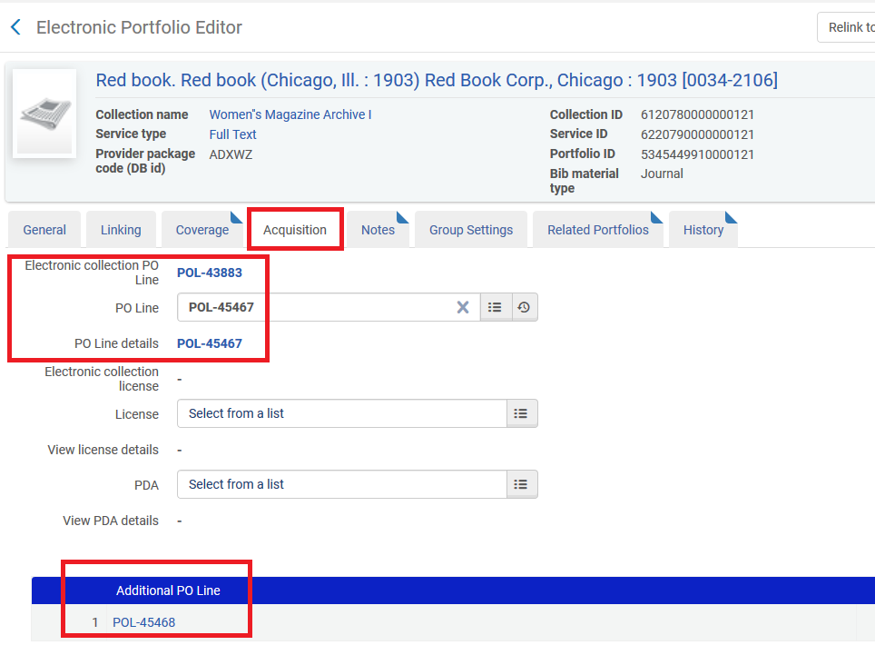

**FIFTEEN**

All notes remain

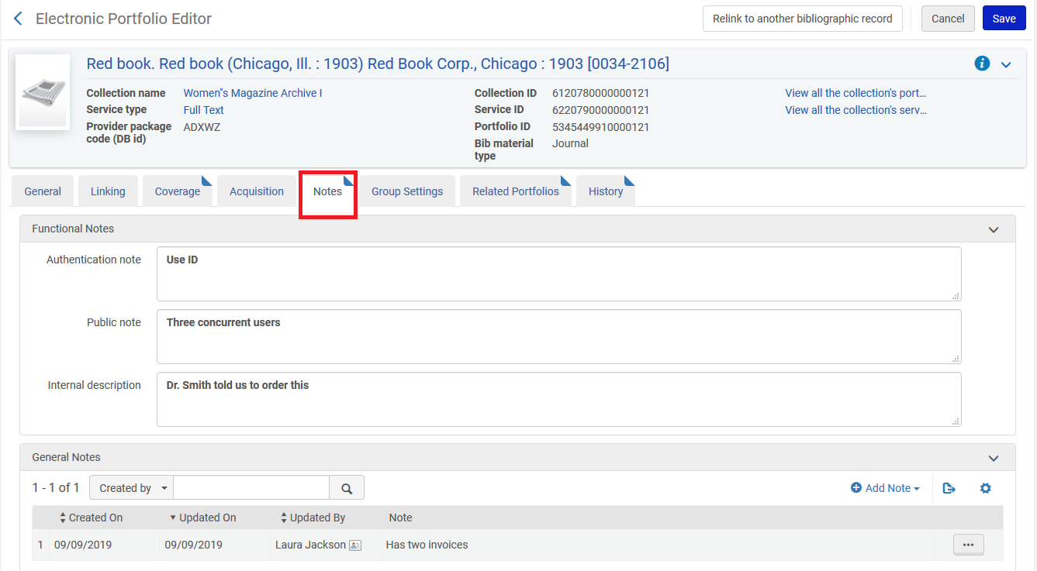

**SIXTEEN**

The parts of the portfolio which change can be seen in the history tab changed by “System”.

The parts that are changes are the parser parameters in the “Linking” tab and the electronic material type in the general tab.

