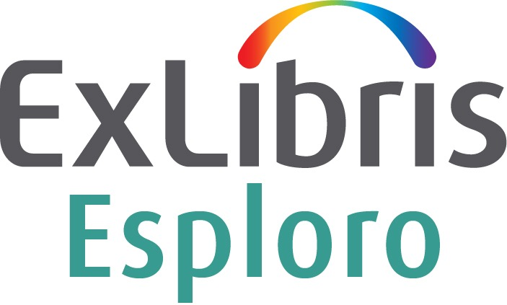

Customer Implementation Form

Customer:
Customer Code:
Project Manager:
Email To:

CONFIDENTIAL INFORMATION
The information herein is the property of Ex Libris Ltd. or its affiliates and any misuse or abuse will result in economic loss. DO NOT COPY UNLESS YOU HAVE BEEN GIVEN SPECIFIC WRITTEN AUTHORIZATION FROM EX LIBRIS LTD.
This document is provided for limited and restricted purposes in accordance with a binding contract with Ex Libris Ltd. or an affiliate. The information herein includes trade secrets and is confidential.
DISCLAIMER
The information in this document will be subject to periodic change and updating. Please confirm that you have the most current documentation. There are no warranties of any kind, express or implied, provided in this documentation, other than those expressly agreed upon in the applicable Ex Libris contract. This information is provided AS IS. Unless otherwise agreed, Ex Libris shall not be liable for any damages for use of this document, including, without limitation, consequential, punitive, indirect or direct damages.
Any references in this document to third-party material (including third-party Web sites) are provided for convenience only and do not in any manner serve as an endorsement of that third-party material or those Web sites. The third-party materials are not part of the materials for this Ex Libris product and Ex Libris has no liability for such materials.
TRADEMARKS
"Ex Libris," the Ex Libris Bridge to Knowledge, Primo, Aleph, Voyager, SFX, MetaLib, Verde, DigiTool, Rosetta, bX, URM, Alma, Leganto, Esploro and other marks are trademarks or registered trademarks of Ex Libris Ltd. or its affiliates.
The absence of a name or logo in this list does not constitute a waiver of any and all intellectual property rights that Ex Libris Ltd. or its affiliates have established in any of its products, features, or service names or logos.
Trademarks of various third-party products, which may include the following, are referenced in this documentation. Ex Libris does not claim any rights in these trademarks. Use of these marks does not imply endorsement by Ex Libris of these third-party products, or endorsement by these third parties of Ex Libris products.
Oracle is a registered trademark of Oracle Corporation.
UNIX is a registered trademark in the United States and other countries, licensed exclusively through X/Open Company Ltd.
Microsoft, the Microsoft logo, MS, MS-DOS, Microsoft PowerPoint, Visual Basic, Visual C++, Win32, Microsoft Windows, the Windows logo, Microsoft Notepad, Microsoft Windows Explorer, Microsoft Internet Explorer, and Windows NT are registered trademarks and ActiveX is a trademark of the Microsoft Corporation in the United States and/or other countries.
Unicode and the Unicode logo are registered trademarks of Unicode, Inc.
Google is a registered trademark of Google, Inc.
Copyright Ex Libris Limited, 2020. All rights reserved.
Document updated: March 2020
Web address: http://www.exlibrisgroup.com

Table of Contents

- Introduction 4
- General Questions 5
- Research Repositories and Assets 6
- Additional Data Migration Questions 7
- Esploro Project Team Information 8
Team Member Contact Information 8

Introduction
Dear Esploro Customer,
This questionnaire is designed to help the Implementation Consultants at Ex Libris evaluate your current environment and provide you with the most suitable implementation for your current and future needs. Please complete this questionnaire as fully and accurately as possible.
If you have any questions about completing this questionnaire, contact your Ex Libris Account Manager. Once you have completed the questionnaire, send it back to your Ex Libris Account Manager.
Thank You.

General Questions
1 | Describe your current workflow(s) for adding research assets to the repository/ies (e.g. batch load, staff mediated deposit, end user deposit, review/approval, etc.)
2 | - Describe your current workflow(s) for adding ETD (electronic theses and dissertations) to your research repository. If you do not plan to manage your ETD in Esploro, please indicate this.
 | - Do you currently use ProQuest ETD Administrator in your ETD submission and approval process?
3 | After going live with Esploro, will you continue depositing research assets in non-Esploro systems and want to import them to Esploro? If so, please list the non-Esploro system(s).
4 | Do you mint DOIs for your research assets?  - If yes, what DOI registration agency/ies do you work with?
5 | Upon go live, your Esploro research assets will be published to your Esploro Research Portal.  - Do you plan to publish your research assets to additional external sites or systems (e.g. Google Scholar)?  - Do you plan to publish your research assets to your library’s Primo?
6 | Indicate whether your organization is planning any projects that can either impact the Esploro implementation timeline or introduce dependencies into Esploro implementation planning.

Research Repositories and Assets

Research Repositories
Please answer each question with the requested information. You may find it helpful to refer to the document Getting Ready for Esploro Implementation, available in the Ex Libris Knowledge Center.
Repository System to be Migrated to Esploro | Will you require ongoing import to Esploro after initial migration? (Y/N) | If your system is accessible via OAI, please provide the base URL (For actual migration, you will be asked to provide an extract of all your data – metadata, file streams, access rights, etc.) | Approximate Number of Assets | Asset may contain files in addition to metadata? (Y/N) | File sizes (approximate total of all files per asset type)

Additional Data Migration Questions

Organization Units
Ex Libris will provide you with format requirements for organization units extraction (see Getting Ready for Esploro Implementation). Please answer the following questions:
1 | How do you plan to create Organization Units in Esploro?  ☐ Provide Ex Libris with input: XML or via spreadsheet. (This is the preferred method)  ☐ Manually via the Esploro user interface (UI)  ☐ Other (please explain)
2 | Are there any specific issues that you would like Ex Libris to be aware of concerning organization units?

Researchers
1 | Do your researchers have individual profiles in Pivot?
2 | Which systems are used today to store information about researchers?
3 | - Can you provide a list of the Alma primary identifiers for your institution’s researchers in advance of the implementation project?
 | - If not, can your researchers be identified as such by Alma user group?
 | - If so, what user group(s) may contain researchers?
4 | Are there any specific issues that you would like Ex Libris to be aware of concerning researchers?

Esploro Project Team Information
Please refer to the Getting Ready for Esploro Implementation document, available in the Ex Libris Knowledge Center, for a description of the roles and responsibilities of your Esploro implementation team members.

Team Member Contact Information
Provide the contact information for each member of your Esploro project team.
Name | Title and Role | Email | Phone Number | Requires Support Portal Access?

