|  |  |
| --- | --- |
| **How to filter a report by the Unicode value of a character or string** |  |
|  | |



**Yoel Kortick**

**Senior Librarian**

**ONE**

Display the Unicode value of a field so that it can later be filtered. After putting in the filter the display can be removed (if not needed). To display the title for example add the field “title” then do edit formula:

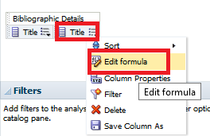

**TWO**

Instead of

"Bibliographic Details"."Title"

Put

evaluate('ASCIISTR(%1)',  "Bibliographic Details"."Title")

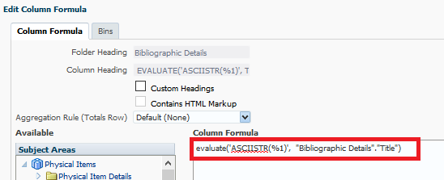

**THREE**

Above we displayed both the title and the Unicode value of the title. So now we can see them both:



**FOUR**

The Unicode value of the two dots above the u in **ü** (known as “COMBINING DIAERESIS”) is U+0038.

See for example <https://www.fileformat.info/info/unicode/char/0308/index.htm>

Therefore when there is a **ü** it appears as **u\0308**

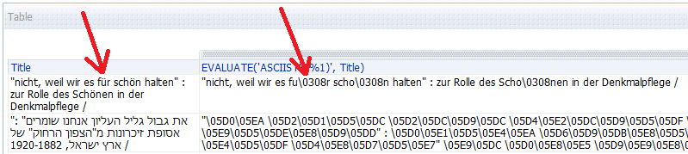

The Unicode value of the word **ארץ** in Hebrew is a combination of the following three letters:

* א (Alef) which is U+05D0.
  + See <http://www.fileformat.info/info/unicode/char/5d0/index.htm>
* ר (Resh) which is U+05E8.
  + See <https://www.fileformat.info/info/unicode/char/05e8/index.htm>
* ץ (Final Tzadi) which is U+05E5.
  + See <https://www.fileformat.info/info/unicode/char/05e5/index.htm>

Thus the Unicode value of **ארץ** appears as **\05D0\05E8\05E5**

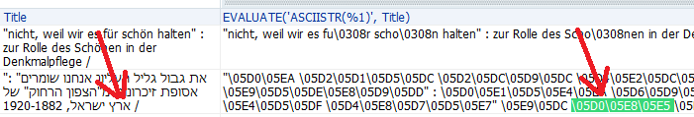

**FIVE**

Therefore

If we want to search all titles whiuch have a **ü** then we can filter by the column

evaluate('ASCIISTR(%1)',  "Bibliographic Details"."Title")

for

contains any u\0308

If we want to search all titles whiuch have a **für** then we can filter by the column

evaluate('ASCIISTR(%1)',  "Bibliographic Details"."Title")

for

contains any fu\0308r

If we want to search all titles whiuch have a **ארץ** then we can filter by the column

evaluate('ASCIISTR(%1)',  "Bibliographic Details"."Title")

for

contains any \05D0\05E8\05E5

**SIX**

This will find all titles with **für**

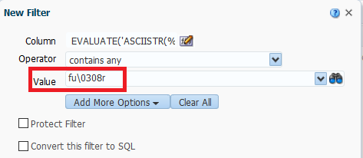



**SEVEN**

This will find all titles with ארץ

