|  |  |
| --- | --- |
| **How to Change the On Hold Shelf Letter Depending on the Library of the Requested Item** |  |



**Question:**

How can I change the ‘FulPlaceOnHoldShelfLetter’ based on the library of the item being requested? For example I want different text in the letter if it will be an item in the Art library than if it will be an item in a different library.

**Answer:**

In this document we will change the xsl of the letter letter “Ful IPlace On Hold Shelf Letter”

We will focus on the change to the xsl.

Regarding how to access and change the xsl see [Letters - Letter Configuration in Alma.pptx](https://knowledge.exlibrisgroup.com/@api/deki/files/74499/Letters_-_Letter_Configuration_in_Alma.pptx)

**ONE**

In the xml of a sent letter take note that the name of the library of the item states ‘Art Library’ and is in field ‘library_name’ in path /notification_data/phys_item_display.

So the whole path is /notification_data/phys_item_display/library_name

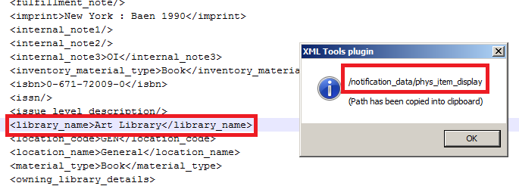

**TWO**

Here is what the actual letter looks like now:

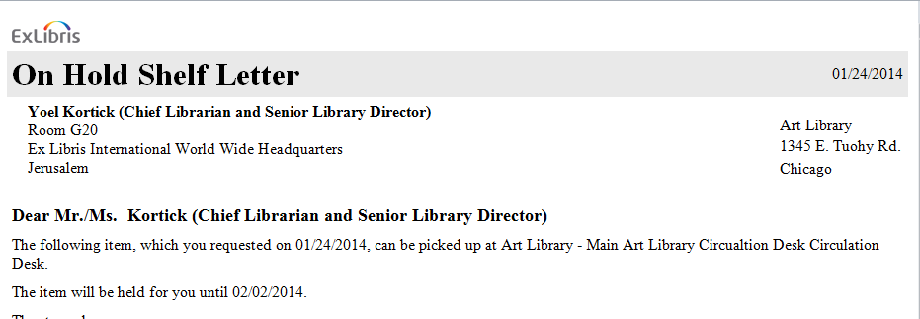

**THREE**

Now we will change the xsl to sate:

If the /notification_data/phys_item_display/library_name = ‘Art Library’

Then put a big red message on the top “This request is for an item from the Art Library”

All other cases (items from other libraries) will not change

We will customize the ‘FulPlaceOnHoldShelfLetter’.

Here is the condition we will add to the letter to out the large message on top (after the head and before the body)

|  |
| --- |
| <xsl:for-each select="notification_data">  <xsl:if test="/notification_data/phys_item_display/library_name ='Art Library'">  <center>  <span style="font-family:Arial; font-weight:bold">  <FONT COLOR="#FF0000">  <B>This request is for an item from the Art Library</B>  </FONT>  </span>  </center>  </xsl:if>  </xsl:for-each> |

**FOUR**

Now see that letter arrives like this with added note

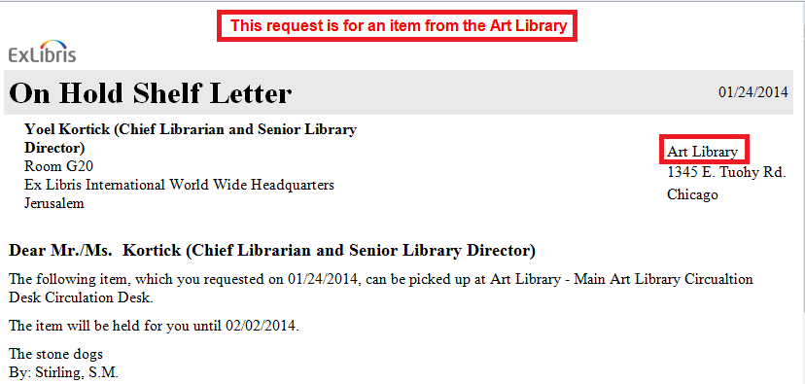

**EIGHT**

Now try it for a different library and see that the note will not appear.

