|  |  |
| --- | --- |
| **How to use COUNT BY to create an Alma Analytics report of users who have at least two barcodes** |  |



**Yoel Kortick**

**Senior Librarian**

**ONE**

Create a new analysis in the Users subject area

Add the following to the criteria tab:

1. User Details . Primary Identifier
2. Identifier . Identifier Value (add this field twice)
3. Other fields you might want to display such as User Details first name and last name

**TWO**

Filter by “Identifier . Identifier Type” = Barcode

So now the criteria tab looks like this:

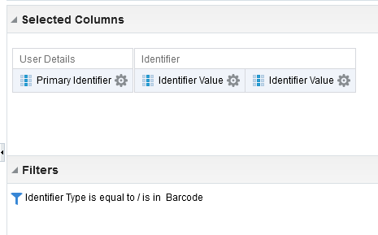

**THREE**

In one of the fields “Identifier . Identifier Value” do “edit formula” and get a COUNT of unique values for each Primary Identifier. Do this by using this formula:

|  |
| --- |
| COUNT("Identifier"."Identifier Value" BY "User Details"."Primary Identifier") |

Note:

Depending on specific use you may need to use:

|  |
| --- |
| COUNT(DISTINCT "Identifier"."Identifier Value" BY "User Details"."Primary Identifier") |

Name the column “Num. of Identifiers

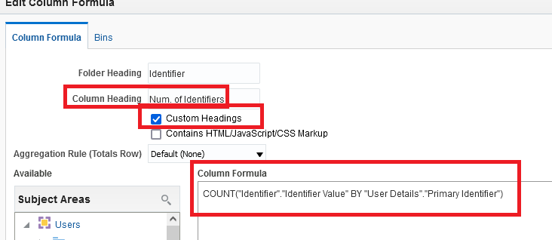

**FOUR**

Filter by this field to get only values which are 2 or greater

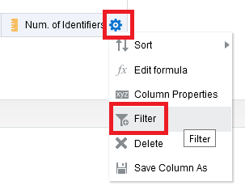

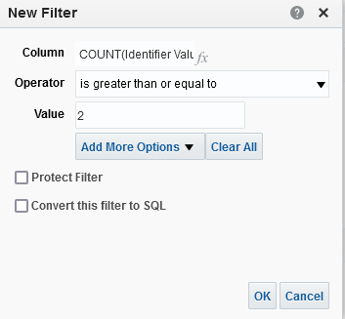

**FIVE**

Check results:

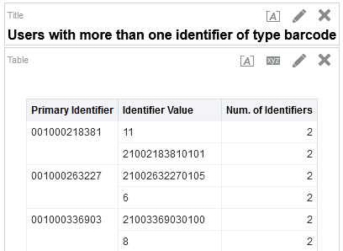

**SIX**

Confirm that these users really do have more than one identifier of type barcode. Let’s check the first example, Primary Identifier 001000218381. This user has two identifiers of type barcode:

