|  |  |
| --- | --- |
| **How to use COUNT DISTINCT BY to create an Alma Analytics report of all portfolios which exist in multiple collections** |  |
|  | |



**ONE**

Create a new analysis in the E-Inventory subject area and add the following to the criteria tab:

1. Bibliographic Details . Title
   1. Below we have sorted it ascending thus there is an “up arrow” to the left of “Title”
2. Electronic Collection . Electronic Collection Public Name
3. Any other field (does not matter what because we will change it)
   1. Below our “Any other field” is “Portfolio . Expected Activation Date”

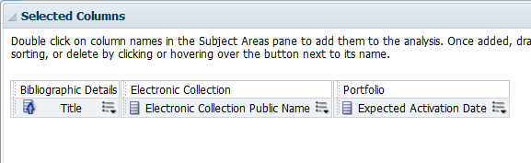

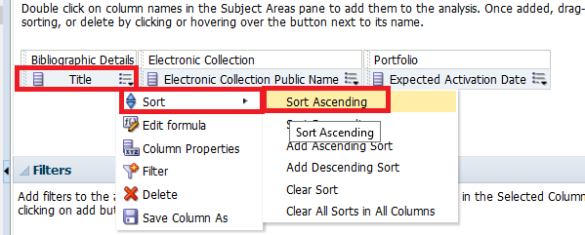

**THREE**

In the column with “any other field” (which in our example is “Portfolio . Expected Activation Date”) do “edit formula” and put the following which tell us how many times the Portfolio ID

of the title exists per MMSID

|  |
| --- |
| COUNT(DISTINCT "Portfolio"."Portfolio id" BY "Bibliographic Details"."MMS Id") |

Change the column heading to be “Num. of electronic collections per title”

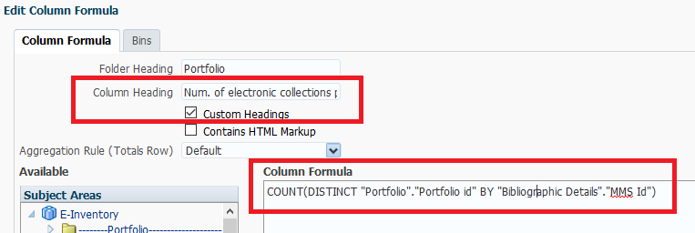

**FOUR**

Filter this column to give results only where the value is greater than or equal to whatever number you are looking for. For example if you want only titles which are in at least two electronic collections then filter by “is greater than or equal to 2”

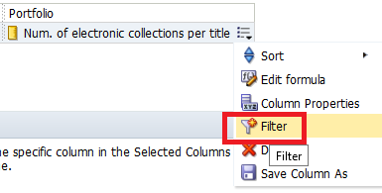

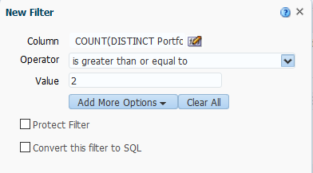

**FIVE**

Depending on the data you are looking for you may wish to also filter the Public name to not be NULL

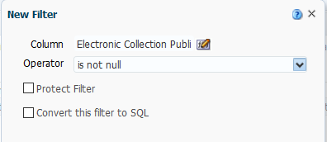

**SIX**

So now we have these columns and these filters

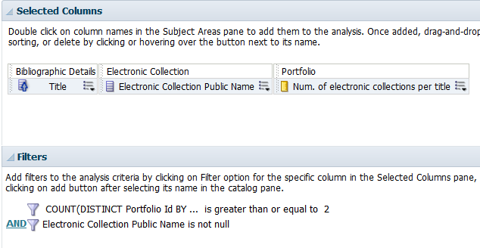

**SEVEN**

Depending on additional criteria such as overall amount of portfolios, or whatever purpose you have in performing this report, you may also wish to limit the results to a certain subject or the creation date of the electronic collection.

For example here we state that we want only collections created in the last three months and portfolios with Law or law in the subject

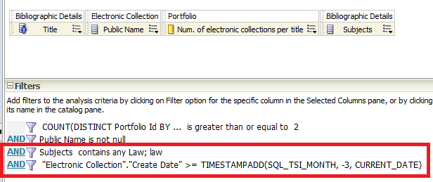

Then, to be sure we will not also retrieve deleted bibliographic records and deleted electronic collections we will filter by

* Bibliographic lifecycle = In Repository
* Electronic Collection lifecycle = In Repository
* Portfolio Lifecycle = In Repository

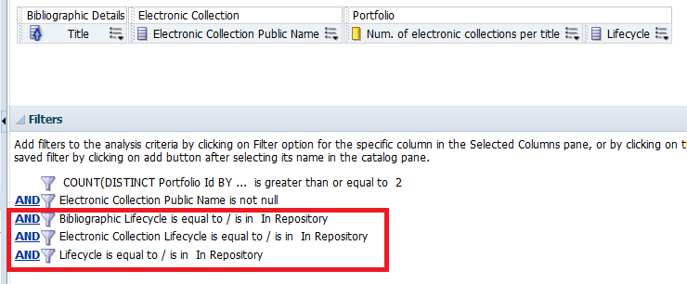

Now look at results tab and see results.

According to the first result the title “3D Cell Culture Methods and Protocols /” is in two electronic collections:

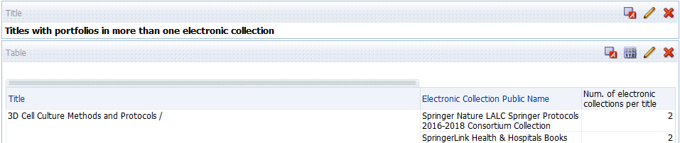

If we check Alma we see that this is true:

