|  |  |
| --- | --- |
| **How to use RCOUNT to add a running number to each row of a report in Alma Analytics** |  |



**Yoel Kortick**

**Senior Librarian**

It may be desired to number each row of a report in an Alma analytics report which contains a table. Here we refer to a running number which has no connection to the number of the row if the table were exported to Excel.

This is done and used as follows:

**Step one**

Add any column to the table. Here we have a report “Electronic portfolios activated in the last 365 days”.

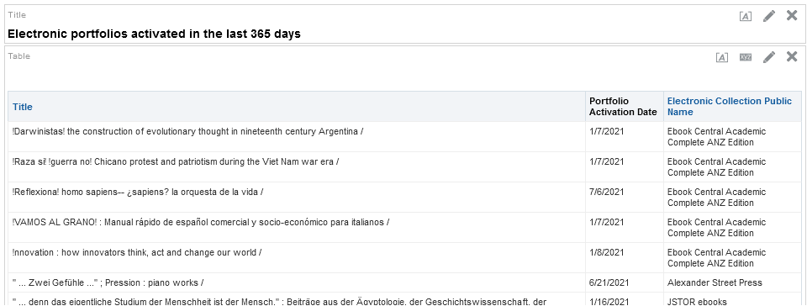

Add any column to the table. It does not matter what column because later we will change it. Here we add “Portfolio Availability”.

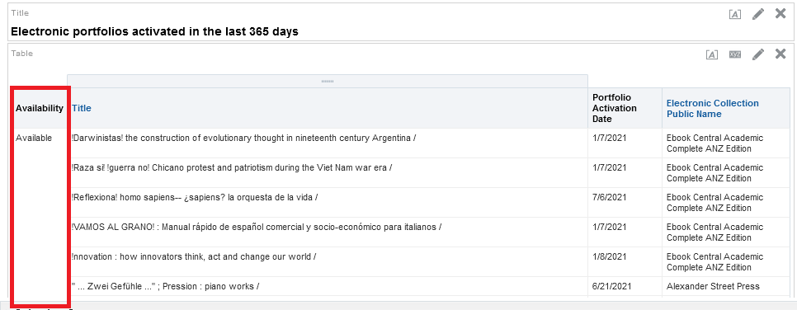

**Step two**

In the “Criteria” tab do “Edit formula” on the column which was added and change the formula to

RCOUNT(1)

as follows, and then change the column heading to whatever you want by fill in in desired name in the “Column Heading” field and checking box “Custom Headings”

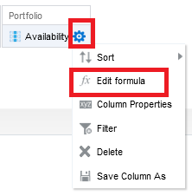

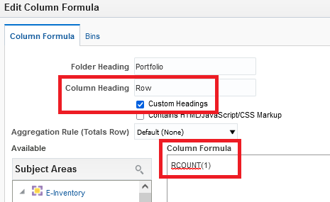

**Step three**

Now switch back to the “Results” tab and see that you have the row number.

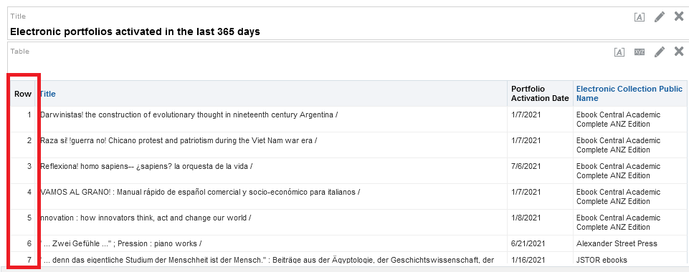

**Step Four**

Here it is with the report exported in a different format

