|  |  |
| --- | --- |
| **The behavior of the 001 and 003 fields of a MARC record when it is imported to Alma** |  |
|  | |



**Yoel Kortick**

**Senior Librarian**

1. If a MARC record has a value in the 001 field and there is no 003 field then when it is imported to Alma the value from the 001 moves to the originating system id and the 001 is replaced with the MMSID.
   1. See steps one and two below.
2. If a MARC record has a value in the 001 field and there is a 003 field then when it is imported to Alma the value from the 001 moves to the 035 and is prefixed with the value of the 003 in parentheses, and also the value from the 001 moves to the originating system id.
   1. See steps thee and four below.

**ONE**

Input file has a MARC record with title “Cracking the digital ceiling” and 001 field with value “9424969Laurie9938512Yoel”. There is no 003 field.

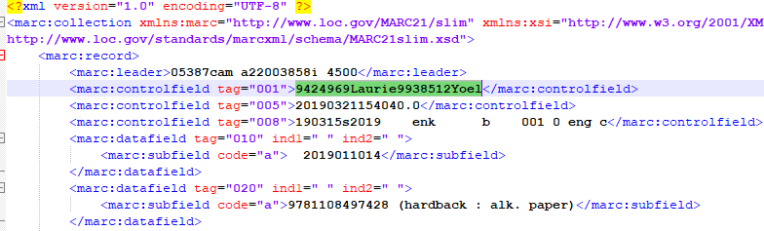

**TWO**

After the record is imported into Alma the following happens:

the value from the 001 moves to the originating system id and the 001 is replaced with the MMSID

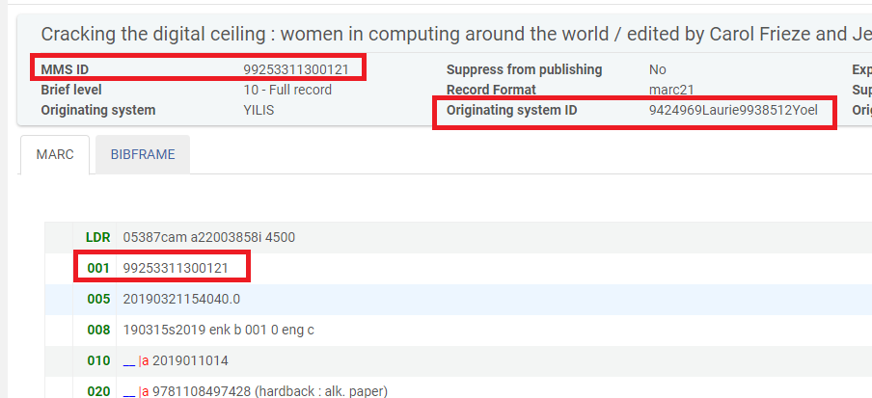

**THREE**

Input file has a MARC record with title “Better together” and 001 field with value “248365613”. There is 003 field with value “LaurieYoel”.

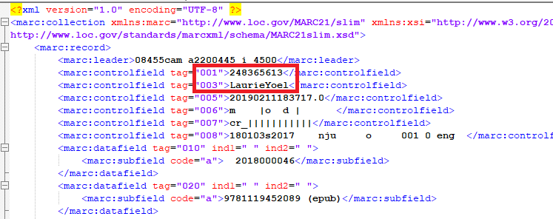

**FOUR**

After the record is imported into Alma the following happens:

the 001 moves to the 035 and is prefixed with the value of the 003 in parentheses, and also the value from the 001 moves to the originating system id

