|  |  |
| --- | --- |
| **How to identify which reading list citations are from a specific electronic collection** |  |
|  | |



**Yoel Kortick**

**Senior Librarian**

**Question:**

Hello. How can I identify which reading list citations are from a specific electronic collection?

For example, I want to get all reading list citations which are part of the following electronic collection:

* SAGE Research Methods Entire Platform

**Answer:**

In the step by step detailed answer below we will first make a report in the E-Inventory subject area of all MMSIDs of records (electronic titles) in the designated electronic collection.

Note that in this example we are using one electronic collection but we could also make the report to use a Boolean OR operator and filter by multiple electronic collections.

The output of this report will then be used as input to another report in the Course Reserves subject area, in which the MMSID of the report in the E-Inventory subject area will match the MMSID of the report in the Course Reserves subject area.

While step three below is the "critical" part of the answer, it is advised to read the entire answer in detail.

Regarding using the output of one report as input to another report you may wish to also see [How to use the output of one Alma Analytics report as the input for a subsequent Alma Analytics report](https://knowledge.exlibrisgroup.com/@api/deki/files/48629/Analytics_-_How_to_use_the_output_of_one_Alma_Analytics_report_as_the_input_for_a_subsequent_Alma_Analytics_report.pptx) .

**ONE**

In the E-Inventory subject area create a report with the following fields:

* "MMS Id" from the "Bibliographic Details" folder
* "Electronic Collection Public Name" from the "E-Inventory" folder

Filter by "Electronic Collection Public Name" to be the desired electronic collection(s).

Save it as "Input MMSIDs in desired electronic collection"

Here is the criteria tab of the report:

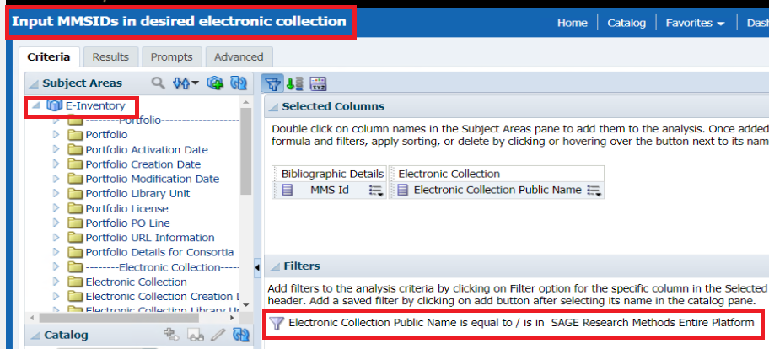

The results tab of the report includes MMSIDs of title in the electronic collection (this is just the beginning of the report)

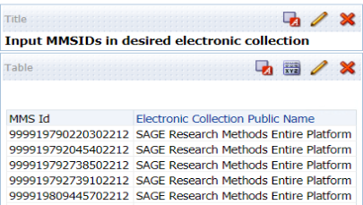

**TWO**

In the Course reserves subject area create a report of whatever fields you want. Be sure to also include the "MMS Id" from the "Bibliographic Details" folder because we will filter on it using the input report from the E-Inventory subject area.

In our example we include these fields and save the report as "Citations for course year 2020 in desired electronic collection"

* "MMS Id" from the "Bibliographic Details" folder
* "Citation Metadata Details"."Author" from the "Course Reserves" folder
* "Citation Metadata Details"."Title" from the "Course Reserves" folder
* "Course Name" from the "Course Reserves" folder
* "Course Year" from the "Course Reserves" folder

**THREE**

Now we will filter the MMS ID to be the same as the MMS ID in the input report. On the field "MMS Id" do a filter and choose “Is based on results of another analysis”.

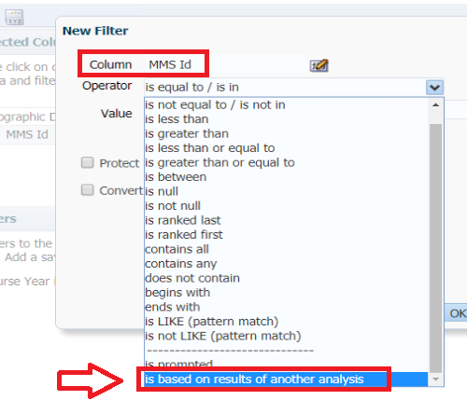

Choose the input report and match MMS ID to MMS ID

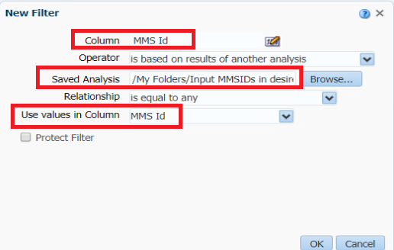

Here is the criteria tab of the report. We see the filter based on another report to match the MMS ID.

(It is not necessary for our case here, but we have also filtered by "Course Year" = 2020)

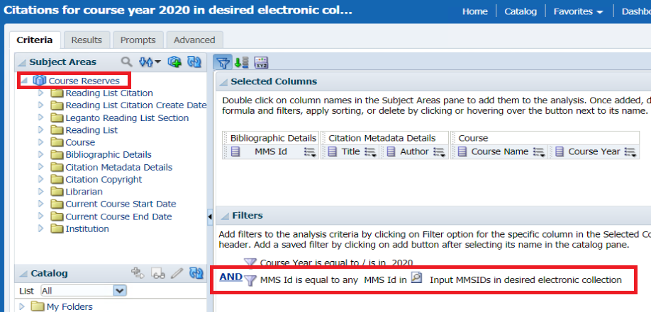

**FOUR**

Check results and see that they all belong to the desired electronic collections.

Let’s examine for example MMS ID 999919826924002212 title “Interpretive phenomenology embodiment, caring, and ethics in health and illness”

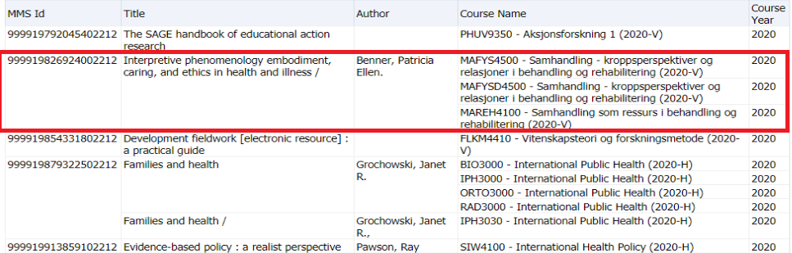

If we check Alma we see that it is in electronic collection "SAGE Research Methods Entire Platform"

