Possible actions for libraries to consider in resource sharing
As the global community continues to monitor the impact of COVID-19, many libraries are taking proactive actions like closing libraries or reducing service hours.
We created this document to help resource sharing librarians Alma in order to answer specific use cases that may arise.
What changes should you consider for Alma resource sharing?
- General
  - You may want to consider changing eligibility and policies for different users
  - Closing completely for borrowing \ lending
- Borrowing
  - Set your borrowing request rules to stop any new request for mediation – so it is not sent to any lender without review
  - Prevent borrowing requests for physical items
  - Cancel loan requests that have already been submitted to lenders and not supplied.
  - Send email to all patrons that have a loaned item, asking them not to return the book until libraries are operating again
- Lending
- Stop overdue messages from being sent
- Prevent lending requests for physical items and continue to review and supply copy requests for online articles and other electronic resources
- Extend due dates for all items on loan
- Relax any overdue penalties.

Changing the limits and polices for resource sharing request eligibility
In order to allow patrons to rely more on resource sharing services, you may change the Borrowing Resource Sharing Request terms of use to allow unlimited resource sharing requests, and to remove fees, as shows below.
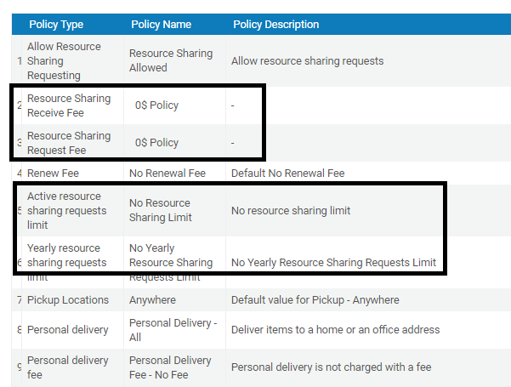

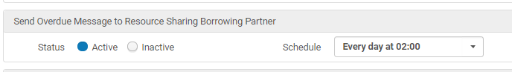

Closing resource sharing libraries for borrowing/lending
You can stop borrowing requests from being placed at your library by using the ‘temporary inactive for borrowing’ check mark on the Borrowing Setup section of the Resource Sharing Library. The result will be that the patrons will not have a resource sharing link for placing borrowing requests.

You can stop lending requests from being received at your library by using the ‘temporary inactive for lending’ check mark on the Lending Setup section of the Resource Sharing Library. The result will be that any lending request that will be received will be automatically rejected.
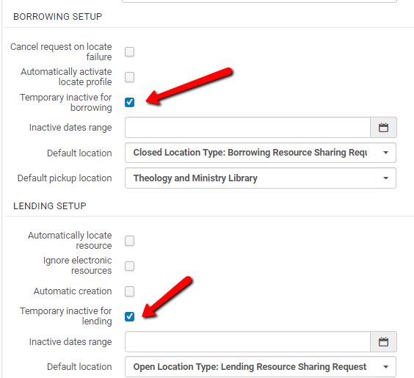

How to prevent borrowing requests for physical items
There are two options to prevent your patrons from placing requests for physical items.

Option one: using terms of use
You can set the ‘Borrowing Resource Sharing’ rules in the Resource Sharing Library’s Fulfillment Unit, so that it will prevent placing requests for physical items.
Using the below rules makes all requests for physical delivery be considered not allowed.
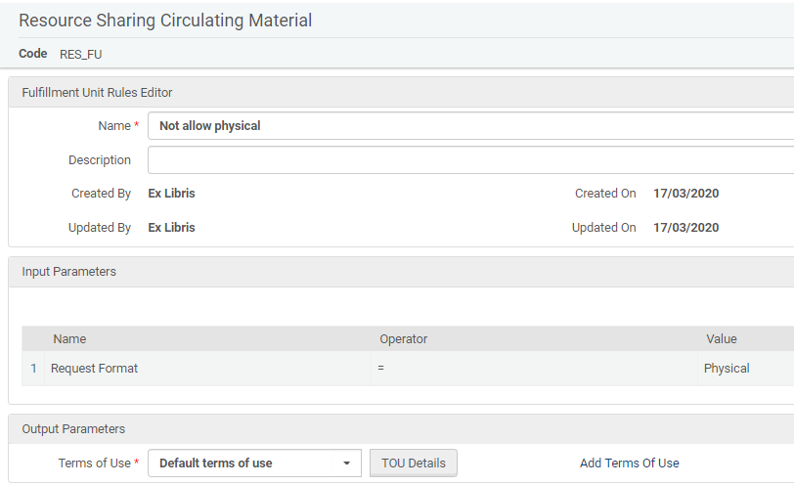
The result of this set up will be that the Primo form will not include an option for a physical request.

Option two: using configured locate profiles
This option will require two steps:
- Set the locate profile to ignore physical resource and no ignore electronic
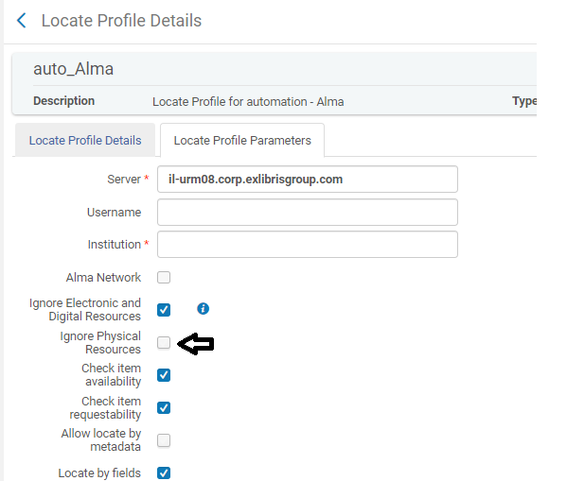
- In the “Fulfillment Configuration” > “Other Settings” menu, you can set up the rs_uresolver_locate parameter to true. In that case, Alma’s locate profiles will search the Alma lenders on the rota trying to locate electronic resources using Alma’s link resolver.

This setup option is relevant only for Alma to Alma locate processes and should be done for each partner locate you have

How to stop overdue notices from being sent
Resource sharing overdue notices are triggered by a job that runs on the lender side. As a lender, you can stop these notices from being sent by deactivating the job. Use the ‘Fulfillement Configuration>Fulfillment Jobs Configuration’ menu to deactivate the ‘Send Overdue Message to Resource Sharing Borrower Partner’ job.

How to prevent lending requests for physical items
As a lender, you can set Alma so that incoming requests that match against local physical holdings will be automatically rejected.
When setting up the Lending Setup section of the Resource Sharing Library, you can set it up to automatically reject a request that comes in for an item that is not requestable.
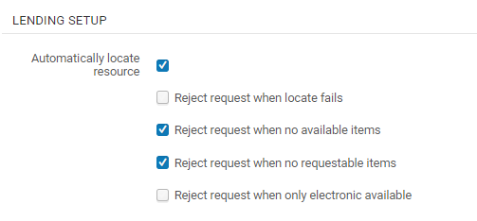

A simple way to make all of you physical items not requestable is to change the ‘Is requestable for physical resource sharing’ policy, so that it is always false. In other words, changing the definition of the policy that is ‘true’ to false, will change all the otherwise requestable items to be considered not requestable. This policy can be reverted in one action when you would like to re-instate physical items requesting.
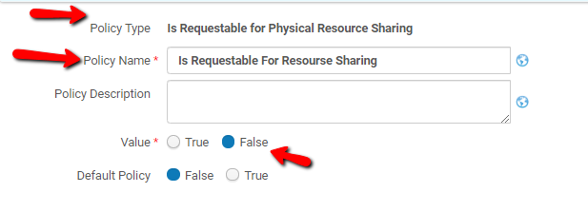

You can continue to supply electronic resources. Your resource sharing library configuration controls whether or not you receive requests for electronic resources. If you keep the ‘Ignore electronic resources’ switch off, Alma will not reject requests for electronic resources.
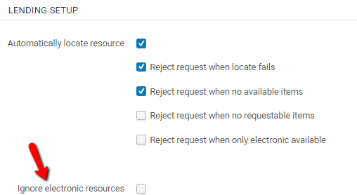

Stop New Requests for Mediation
You can set up Alma so that borrower requests will not be automatically sent to the lenders. Rather, all requests will remain in the Borrowing Requests task list with a status of ‘Ready to be Sent’, and require staff consider the request and send it only if it meets your define criteria.
The Alma tool for this purpose is the ‘Sending Borrowing Request Rules’ that are configurable from the Fulfillment Configuration > Resource Sharing menu. Setting the default rule to ‘false’ will result in all requests not being sent automatically after the locate process is run. If their locate process has succeeded, they will remain in the ‘Ready to be sent’ status. And can be cancelled or sent manually.
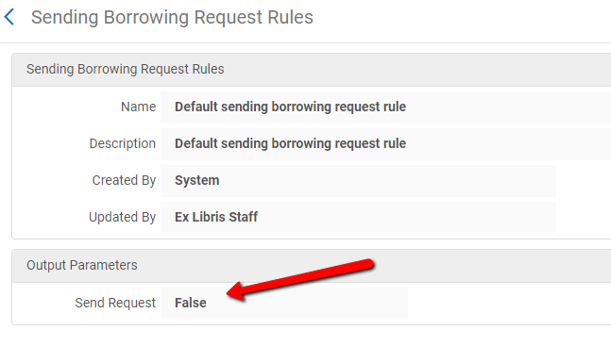
You can also set specific rules that will mediate only specific types of requests. For example, you can set the system to require mediation of requests made by specific user types, as shown below.

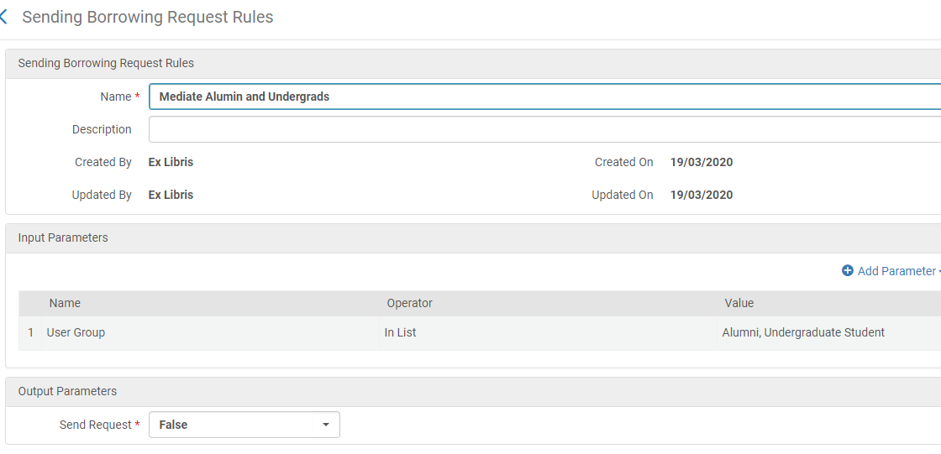

Bulk Cancelling Unreceived Requests
The new March 2020 ‘Claim Resource Sharing Request’ feature enables setting up the system to automatically cancel any borrowing request that has been sent to lender but not shipped or otherwise responded to within a configurable number of days.
You can set up the partner record so that a given number of days after the request has been sent it will be cancelled if not fulfilled, as shown below. If there is another partner in the rota, the request will propagate to that next partner.
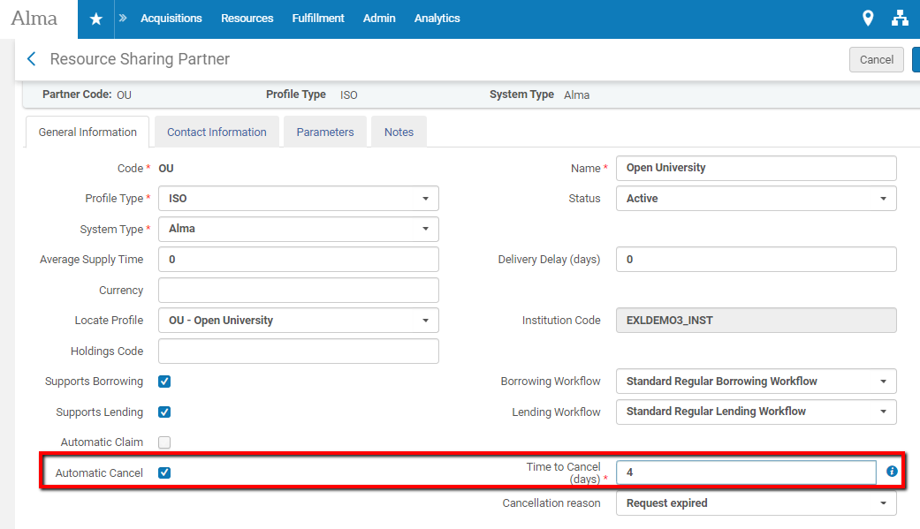

Send Email to All Patrons
There are a number of methods to send notices to all of the patrons that have active loans in Alma.

Borrower Activity Letter

The Borrower activity letter is sent to any patron that has an active fulfillment service, such as loans, requests or fees with a summary of their current activities. The letter can be customized to include a notice that you would like to send. Use the General Configuration>Letters>Letters Configuration menu option to configure the Borrowing Activity Letter
The below example shows the default letter, with a highlighted insert that will result in a letter such as –
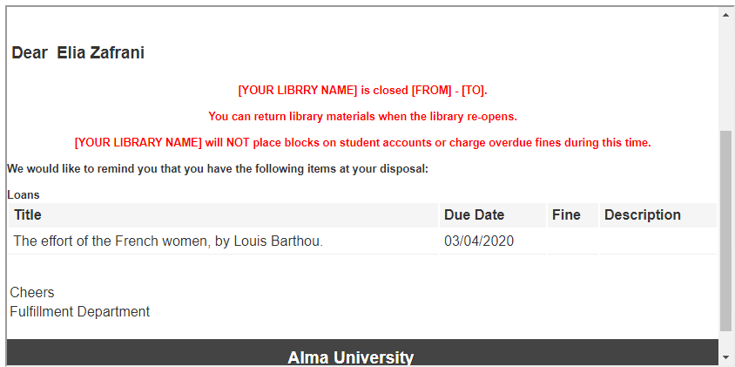
<?xml version="1.0" encoding="utf-8"?>
<xsl:stylesheet version="1.0"
xmlns:xsl="http://www.w3.org/1999/XSL/Transform">

<xsl:include href="header.xsl" />
<xsl:include href="senderReceiver.xsl" />
<xsl:include href="mailReason.xsl" />
<xsl:include href="footer.xsl" />
<xsl:include href="style.xsl" />
<xsl:include href="recordTitle.xsl" />

<xsl:template match="/">
<html>
<head>
<xsl:call-template name="generalStyle" />
</head>
<body>
<xsl:attribute name="style">
<xsl:call-template name="bodyStyleCss" /><!-- style.xsl -->
</xsl:attribute>

<xsl:call-template name="head" /><!-- header.xsl -->
<xsl:call-template name="senderReceiver" /> <!-- SenderReceiver.xsl -->

<br />
<xsl:call-template name="toWhomIsConcerned" /> <!-- mailReason.xsl -->

<div class="messageArea">
<div class="messageBody">

<table cellspacing="0" cellpadding="5" border="0">
<table>
<center>
<span style="font-family:Arial; font-weight:bold">
<FONT COLOR="#FF0000">
<B>[YOUR LIBRRY NAME] is closed [FROM] - [TO].
<br/><br/>
You can return library materials when the library re-opens.
<br/><br/>
[YOUR LIBRARY NAME] will NOT place blocks on student accounts or charge overdue fines during this time.
<br/><br/> </B>
</FONT>
</span>
</center>
</table>

….
<table>
<tr><td>@@sincerely@@</td></tr>
<tr><td>@@department@@</td></tr>
</table>
</div>
</div>

<!-- footer.xsl -->
<xsl:call-template name="lastFooter" />
<xsl:call-template name="myAccount" />
<xsl:call-template name="contactUs" />
</body>
</html>
</xsl:template>
</xsl:stylesheet>

Customized Letter
It is possible to create a set of users you want to send the message to via an analytics report. For example, a report in the Fulfillment SA such as -
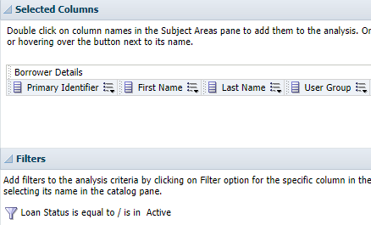

You can then create a set of users in Alma from that analysis to use with the Update/Notify Users job, see https://knowledge.exlibrisgroup.com/Alma/Knowledge_Articles/Create_Users_Set_for_expired_patrons_based_on_Analytics.
You can also create the set directly from the Analytics report. More information on that can be found in the below links:
- Analytics - Creating sets in Alma from Alma Analytics Reports.pptx.
- Create a Set in Alma from an Alma Analytics Report.

Now, you can customize a letter to be sent to the set of users. This is described in -https://knowledge.exlibrisgroup.com/Alma/Product_Documentation/010Alma_Online_Help_(English)/050Administration/040Configuring_User_Management/070Configuring_User_Notification_Types
Running the Update/Notify Users job on the created set will send the message to the requires set of patrons, for example –
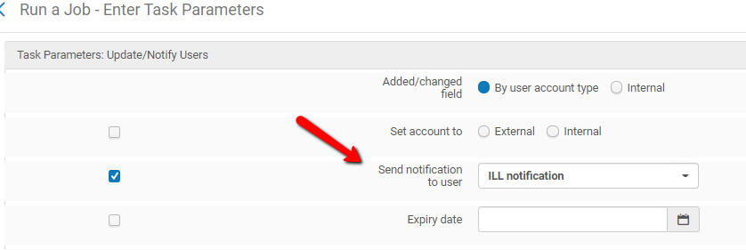

Extend Due Dates for All Items on Loan

All loans’ due dates may be extended so that they will be due only after the library re-opens. This can be done using the Bulk Change Due Dates utility that is available in the Fulfillment>Advanced Tools menu.
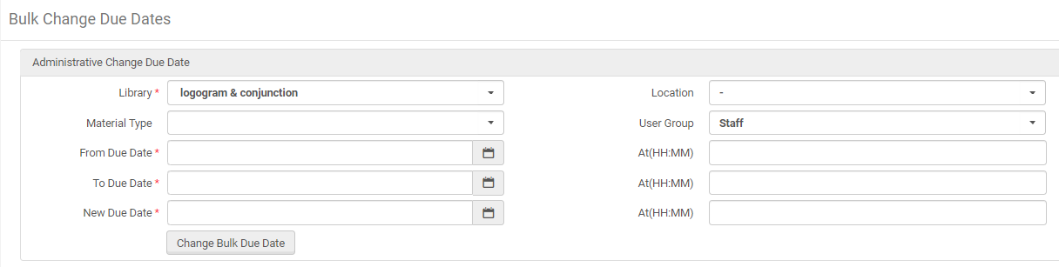

You can run the job for specific libraries and for only those loans that have a due that falls within the time period that the library will be closed. The due date change will trigger a ‘Loan Status Notice’ to the relevant patrons, with the update about the change in due dates.

Relax Any Overdue Penalties
Changing the due dates on loans will cause Alma to automatically drop any calculated overdue loans, unless the patrons fail to return the items by the new due dates.
It is also possible to use the Bulk Fine Waiving Utility that is found in the Admin>User Management menu. This utility can be used if you’d like to waive already charged fines. It can be used to waive specific fine types only, and for specific user types only. The utility can be set to waive up to a defined threshold.

