Student Discussions in Leganto
In the move to online learning, instructors may be looking for new ways to communicate with students.
Options for the Instructor:
Instructors can choose to hide or show the Leganto student discussion thread, and can also edit the header which will display to students.
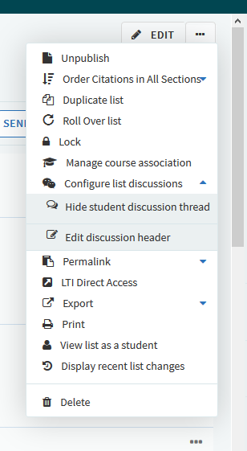
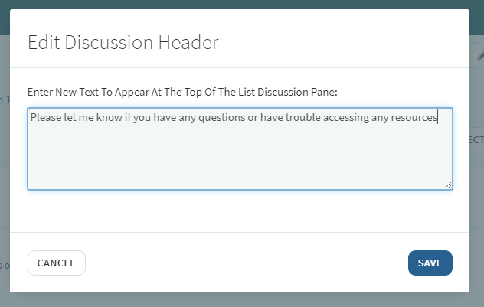
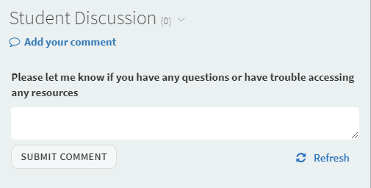

Library Configurations:
Note that student discussions can be enabled or disabled at the institution level.
In the Leganto Features table (Configuration Menu > Leganto > Features > Leganto Features), set the parameter student_discussions to enabled, disabled, or instructor_enabled. When set to instructor_enabled, the instructor can enable or disable the student discussion for each list and its citations, as shown above.

The library can also configure the default header that appears in the student discussion panels:
To enable/disable student discussion headers in all reading lists, in the Leganto Features table (Configuration Menu > Leganto > Features > Leganto Features), configure the parameter discussion_header_enabled (true/false).
To set the default value of the student discussion header for all reading lists, configure the parameter discussion_header_default_text (Configuration Menu > Leganto > Features > Leganto Features). Enter the text you would like as the default. This is the text that will display if the instructor doesn’t change it. You can also leave this blank.
Examples:
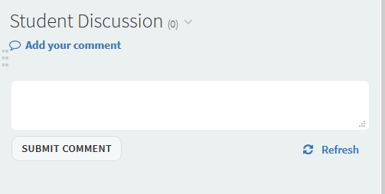

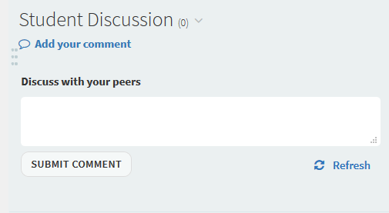

You may also want to remind instructors that the library can’t see this discussion. If students are having trouble accessing resources, they (students or instructors) can use the Mark as Broken link, or the instructor can add a comment in the library discussion.

