|  |  |
| --- | --- |
| **How to determine the value of LDR pos. 17 when a brief record is created from a purchase request** |  |
|  | |



**Yoel Kortick**

**Senior Librarian**

**Question**

Hi. When a purchase request is made and there is no match for it in Alma a new record is created with an LDR which has a hardcoded value in position 17. How can we change the default value of LDR position 17?

**Short Answer:**

Change it in the default cataloging template

**Full (recommended) answer:**

**ONE**

Let’s answer this with a real life example:

An end user creates a purchase request in Primo

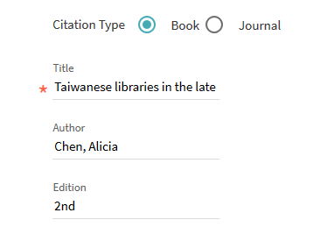





**TWO**

A bibliographic record is created in Alma (because there was no match on an existing record).

See that pos. 17 of the LDR has #.

See also that there are these other defaults:

040 has $$b eng $$e rda ?

082 has $$2 23

300 has $$a pages : $$b illustrations ; $$c cm. ?

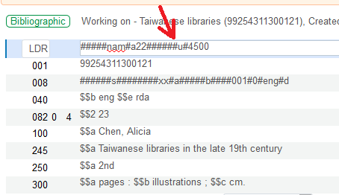

**THREE**

The defaults come from the default cataloging template for the MARC type of the record which is created, in this case MARC21:

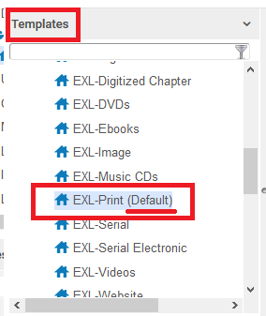

**FOUR**

Note the contents of the template (including pos. 17 of LDR as “#”):

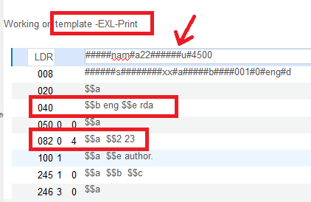

**FIVE**

Now in the default template we change LDR pos. 17 from “#” to “5” and save the template

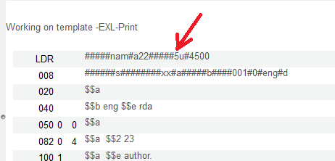

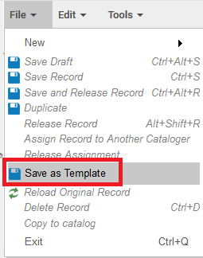

**SIX**

Now again we create a new purchase request in Primo, which will not match a record in Alma

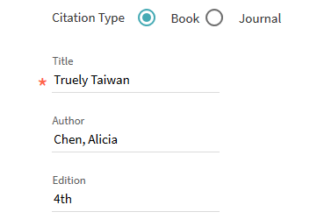

**SEVEN**

Check the record in Alma and see that LDR position 17 is now “5”:

