Publishing Options for Reading Lists
Publishing Reading Lists:
Reading lists must be published for students to view them and access the resources. There are several options for publishing:
- Anyone Restricted - Anyone with a permalink can view the list as a syllabus, but only course students can access the course materials.
- All Students Full - All students can view the list and access the uploaded or electronic citations.
- All Students Restricted - All students can view the list as a syllabus, but only course students can access the course materials.
- Anyone Restricted, All Students Full - Anyone with a permalink can view the list as a syllabus; all students can access the course materials.
- Course Students - Course students (only) can view the list and access the course materials (electronic citations and uploaded files).
- Anyone Full - Anyone with a permalink can view the list and access the course materials.
"Student" here means anyone who can log in to Leganto and who has the Patron role. "Course student" means a student who accessed Leganto from the course on the CMS, or a student listed as enrolled in the course in Alma.
More about managing course enrollments in Alma:
See: Configuring importing course enrollment jobs
See: Managing user and course enrollment information in Alma
Either instructors or the library can publish reading lists, or they can be published automatically.
Instructors:
You can configure the publishing options that appear to instructors.
- Publish only in default mode (no publishing options): Instructors have the option to publish the list, but only in the default mode as configured by the library.
- Basic publishing options:
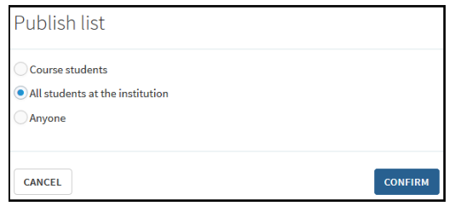
- Full publishing options:
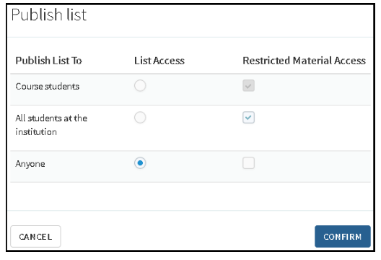
Note that the language of these options, like all other UI elements, can be adjusted in the Labels configuration menu (Alma Configuration—Leganto—General—Labels).
See: Configuring publishing options for instructors.
Additionally, as described in the link above, it is also possible to configure that the publishing option appears as a button, instead of a menu item.
By default, Leganto updates a reading list and its citations' statuses from Being Prepared to Ready for Processing when a list is published even if the instructor has not sent the list to the library. This can be turned off.
Library Staff:
Library staff can publish reading lists in Alma.
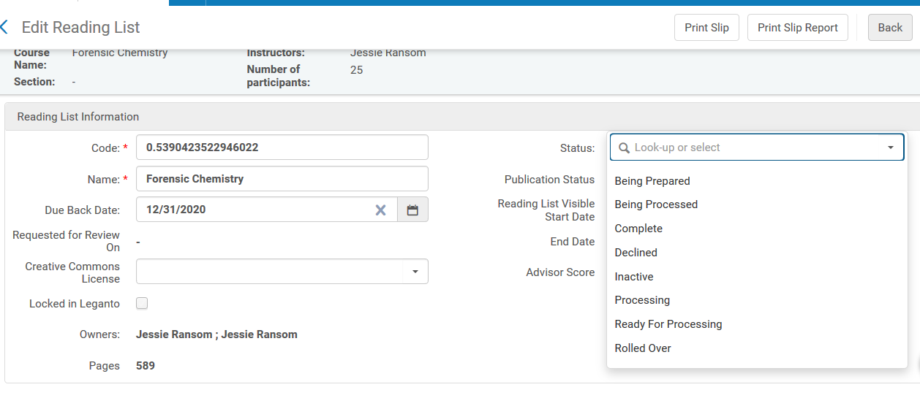
Reading lists can also be published in bulk.

Automatic Publishing:
Reading lists can be published (and unpublished) automatically based on the start and end dates of the course. See: Automate reading list status while course active or inactive
