|  |  |
| --- | --- |
| **How to create a report of all loans with due dates within a certain date range** |  |



**Yoel Kortick**

**Senior Librarian**

**Question**

Hello. We need to unexpectedly close the library. We plan to run the job “Bulk Change Due Dates”. But we want to first see what items are on loan and have due dates during the period for which we will run “Bulk Change Due Dates”. So my question is: how can I create an analytics report of all loans with due dates within a certain date range? I want to make an analytics report which will correspond to the “From Due Date” and “To Due Date” which I will enter in the job “Bulk Change Due Dates”.

**Answer**

1. Create a new analysis in the “fulfillment” subject area.
2. Display whatever fields you want, for example you may want to display:
   1. Field "MMS Id" from the "Bibliographic Details" folder
   2. Field "Title" from the "Bibliographic Details" folder
   3. Field "Due Date" from the "Due Date" folder
   4. Field "Loan Date" from the " Loan Date " folder
   5. Field "Barcode" from the "Loan Details" folder
   6. Field "Primary Identifier" from the "Borrower Details" folder
3. Filter for active loans
   1. Field "Loan Status" from the "Loan Details" = 'Active'
4. Filter by “From Due Date” and “To Due Date”. For example if we want to filter by “From Due Date” = April 29, 2021 and “To Due Date” = May 29, 2021 we could do as follows:
   1. We are using the “is Between” parameter  
        
      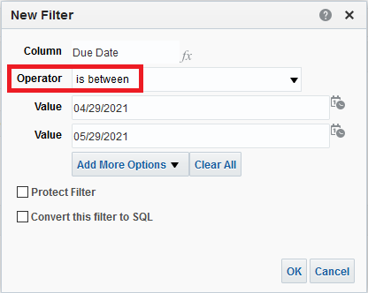
5. Now we have this:  
     
   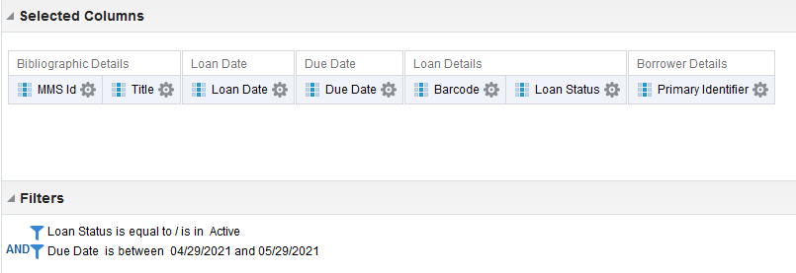
6. See results:

