|  |  |
| --- | --- |
| **How to test the Alma BCC letter functionality for campusM** |  |



**Yoel Kortick**

**Senior Librarian**

**Question**

How can I set up Alma to send a “BCC” of Alma letters to CampusM

**Answer**

In the example below we

1. Assume that you already know the email to which you will send the letter for campusM
2. Will use Alma letter “Borrowing Activity Letter” because it is very easy to check for one user
3. Navigate to the desired letter in Alma via ‘Configuration > General > Letters > Letters Configuration’
4. From the list of letters make sure the letter for which you desire to have a BCC email is “enabled” for channel “email”  
     
   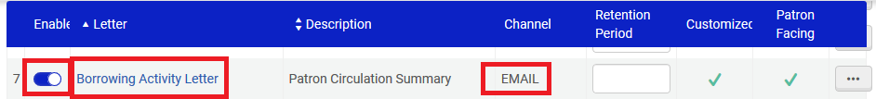
5. From the list of letters edit the letter for which you desire to have a BCC email  
     
   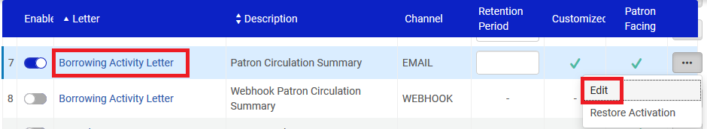
6. Scroll down to the BCC field and put in your desired BCC email  
     
     
     
   
7. To test it do “Fulfillment > Checkout/Checkin > Manage Patron Services” and retrieve a patron who has at least one item on loan. Click “Send Activity Report”. This will print the “Borrowing Activity Letter”  
     
   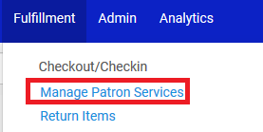  
     
   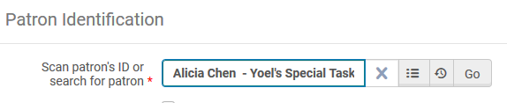  
     
   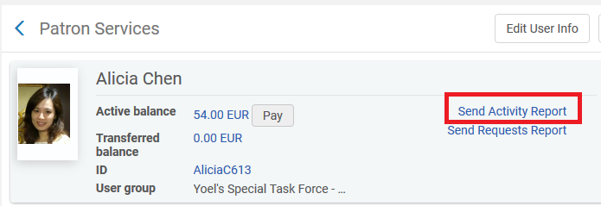
8. Check to see if mail arrived. If so the BCC worked.  
     
   