“We need to be able to report across reading lists to identify active lists, with lots of student engagement, and then see essential print items on those lists.”
The following report shows the Citation Title and MMS Ids for all physical items tagged as essential across all active reading lists.
The number of reading list views will highlight reading lists with high engagement, but it is not possible to filter out reading lists with low engagement and still see the relevant information about the citations. Therefore, the report marks in bold reading lists with more than 50 views.
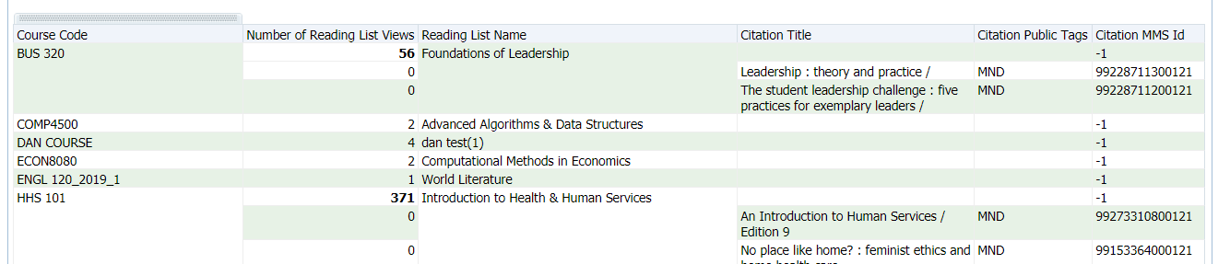
The number of reading list views is the top number for each course. For the BUS 320 course below, there were a total of 56 views and there are 2 physical items on this list that are tagged as essential (MND in our example).

The report is in the Community Zone:
/shared/Community/Reports/Shared Reports/Reports/Leganto Course Reading Lists
Name: Ex Libris – Physical items on highly used reading lists
It uses another report in the same folder as a filter for print items:
Name: Ex Libris – Physical items with active course code
Once you have the report, customize your essential tags:
- Add a filter for items tagged as essential:
  - Click on the icon next to Citation Public Tags
  - Click Filter
  - Select all the options that include your “essential” tag. And choose ok.
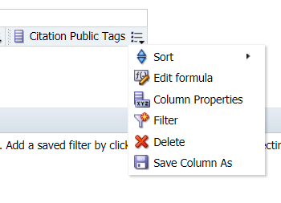
Note: If you have a lot of tags you can search the list:
  - Click the binoculars
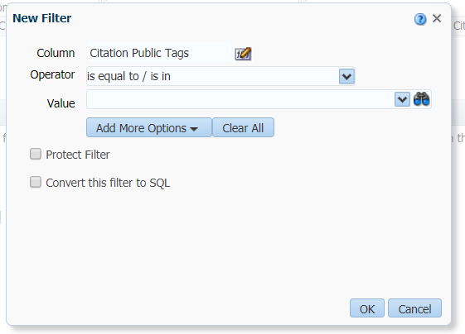
  - Change the dropdown option next to Name to “contains”.
  - Search your tag. Pay attention to the case or uncheck the box for “Match Case”.
  - Use the double arrow to add all.
  - Click OK.
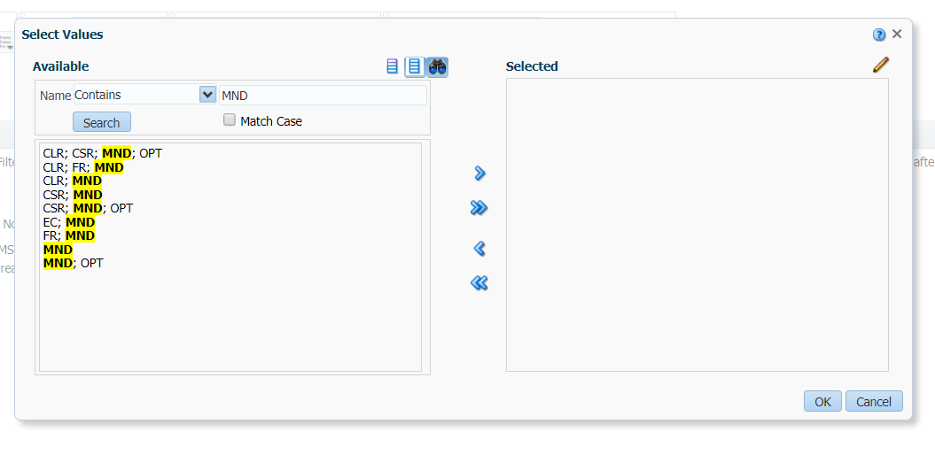
Define high usage:
The report is set to mark reading lists where there have been more than 50 reading list views. To change this number:
- Click on the icon next to “Reading list views”
- Click column properties
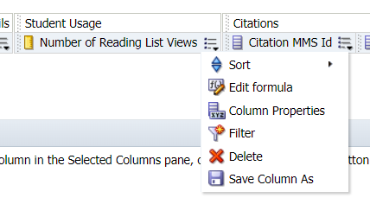
- Click on the “Conditional Format” tab.
- Click on the filter to the right of “50”
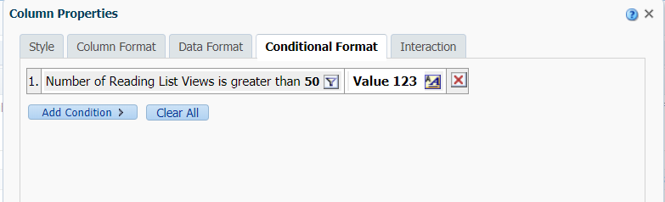
- Change to a different number
- Click Ok
