|  |  |
| --- | --- |
| **How to determine the name and path of a specific field in the xml of a letter** |  |



**Yoel Kortick**

**Senior Librarian**

**Question:**

I was going through your powerpoint slides on Letters Configuration in Alma.pptx found at  <https://knowledge.exlibrisgroup.com/Alma/Training/Extended_Training/Presentations_and_Documents_-_Letters> . I find your explanations clear and extremely useful.

I have a question. On slide 57 it was shown that the phone number of the institution was not shown on the letter. On slide 58 you were able to quickly locate the phone number and, on slide 59, the path to the phone number. I presumed you were able to locate the phone number field because you knew the phone number of the institution, i.e. 972-883-2908. Assume that if the user had the same phone number 972-883-2908 and it appears in the phone number field for the user. How would you know which of the two fields belongs to the institution? Or if there the institution has no phone number, which means <phone></phone> would be empty, but you'll like to include it anyway, how would you know which field is the field for the institution phone number?

**Answer:**

One way to figure out where and how a certain and how a certain field appears in the raw xml of a letter is to temporarily fill in a specific value and then print the letter once and then look for the value.

For example, in the case of the borrowing activity on the slides you refer to below, if we wanted to know where the phone number is coming from and if it is for the institution, library or patron I would do as follows:

ONE

At "configuration > General > Configuring for the Institution > Libraries > Add a Library or Edit Library Information > Contact Information Tab" fill in phone number 1-800-1234567

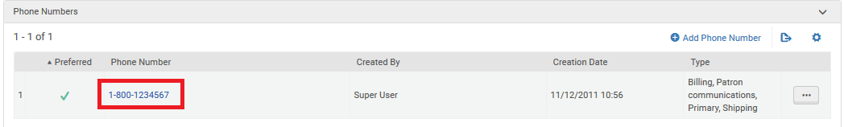

TWO

At "configuration > General > Configuring for the Institution > Libraries > Add a Library or Edit Library Information > Libraries Tab > Edit a specific Library such as Main Library> Contact Information tab" fill in phone number 1-230-976-421

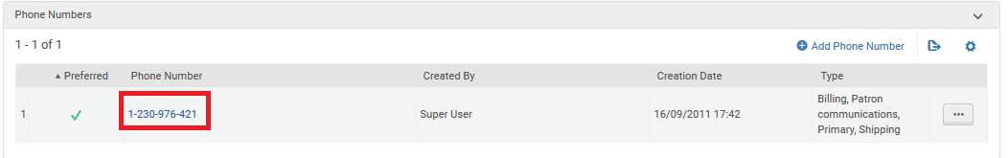

THREE

In a patron for whom I would send the borrowing activity letter fill in a phone number in the user "contact information" tab fill in phone number 886-2-6499369

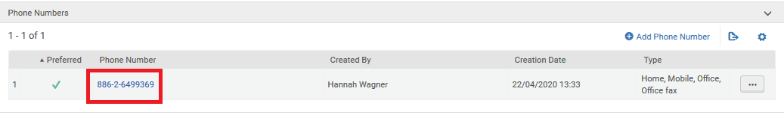

FOUR

Send the borrowing activity letter

FIVE

Access the "letters Configuration" at “General > Letters” and edit the "Borrowing Activity letter".

Switch to "Letter Examples" tab and do "Add from System Letters"

Choose the letter sent above after filling in the three phone numbers.

Click “Edit” and “Download XML”

Find each of the fields you are looking for by searching for the data you entered above.

Below we have copied the xml to notepad ++ and use a plugin to get the path. This can also be done manually.

Here is what was entered for the institution phone number.

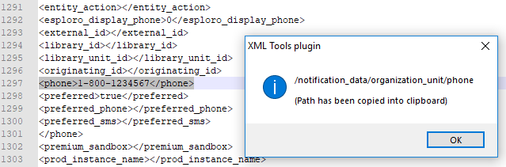

Here is what was entered for the library phone number.

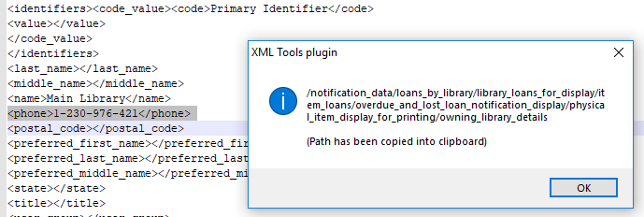

Here is what was entered for the user phone number.

