This session will explore Analytics for Fulfillment. We assume some familiarity with common Alma Analytics tasks such as creating a new report, adding fields and filters, and saving modified reports, but will review some of these key concepts in this document. If you are new to creating reports in Analytics or need a refresher we recommend reviewing our Introduction to Analytics presentation slides.

During this session, the focus will be on creating and working with reports that will become part of a dashboard, largely in association with the COVID-19 pandemic. Overall, the reports are simple and intended to remind operators of actions that may need to be taken while the libraries of universities, colleges and other research institutions remain closed.

Table of Contents

Copying the Example Reports 2
Users with Expiration Dates Before 30 June 2020 4
Creating the Analytics Report 4
Creating a User Set in Alma from the Analytics Report 9
Running the Update/Notify Users Job to Update the Expiration Date 11
Active Requests to be Cancelled 13
Items on Loan and Overdue or Soon-to-be Overdue 17
Dashboard: Change from Physical to Electronic Fulfillment During COVID-19 20
Reviewing the Reports 21
Creating the Dashboard Prompt 24
Modifying the Reports to Use Presentation Variables 30
Creating the Dashboard 34
Steps to Copy or Move Dashboards 41

Copying the Example Reports

You will be able to find copies of these example reports saved to the Community folder. The example reports for this session can all be found under the Shared Folders/Community/Reports/Shared Reports/Knowledge Days 2020/Fulfillment folder (please note that the synchronization among data centers may not yet have occurred, so the reports may not appear in this folder yet). If you would like to follow along and complete the exercises, we ask that you first copy these reports to your My Folders section or a folder under your institution’s directory in the Shared Folders section and work on the copies. To do this, click on the Catalog link in Analytics:

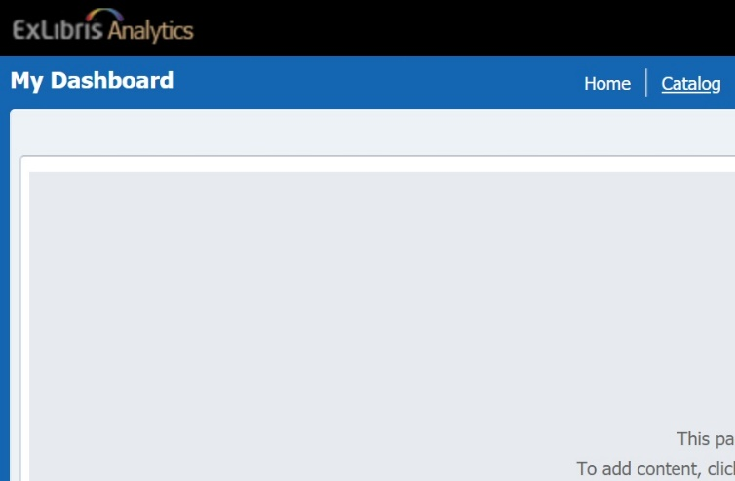

Navigate to the Shared Folders/Community/Reports/Shared Reports/Knowledge Days 2020 folder:

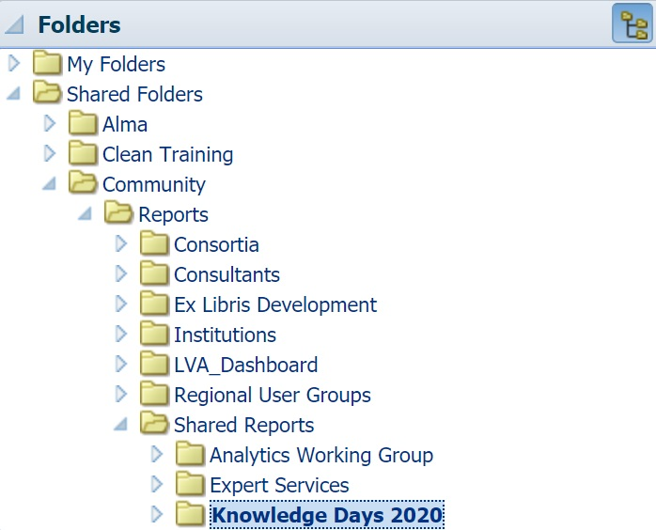

Under the Fulfillment folder, click More and then Copy:

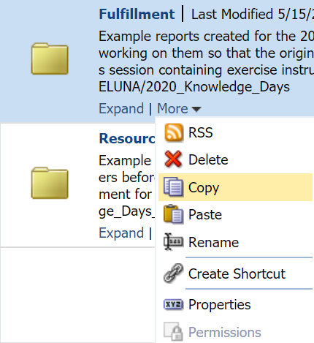

Navigate to a directory in your institution’s folder (our training environment’s institution name is “Clean Training”) and click on the Paste icon to copy the folder and all the reports inside to the desired directory:

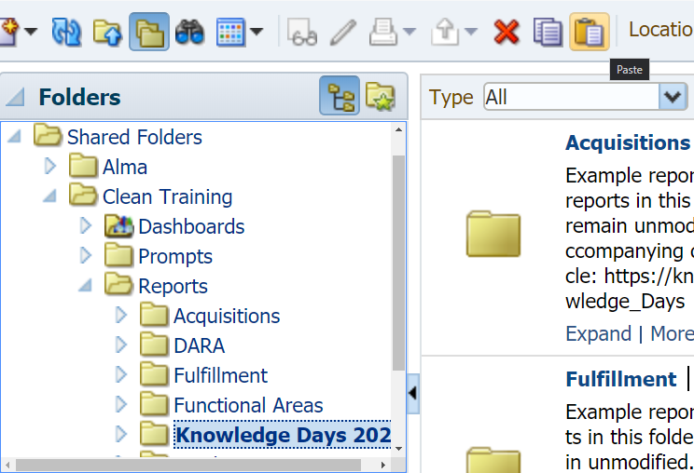

Please note that when you copy dashboards to a new location (such as the Physical and Electronic Usage Dashboard under the Completed Exercises folder) there are additional changes you will want to make that we will demonstrate at the end of this document.

Users with Expiration Dates Before 30 June 2020

A common task during the COVID-19 pandemic has been to extend the expiration date of patron and staff user accounts while the library is closed or so that they can take advantage of extended loans. In our first report we will show how to create a report that identifies users with expiration dates that are coming up soon (before June 30th in our example) and how to use this Analytics report in Alma to extend the expiration date of these users.

Creating the Analytics Report

Start by creating a new Analytics report in the Users subject area. In Analytics click New, then under Analysis and Interactive Reporting click Analysis (do not click Report as this uses a different Oracle service not available to Alma Analytics):

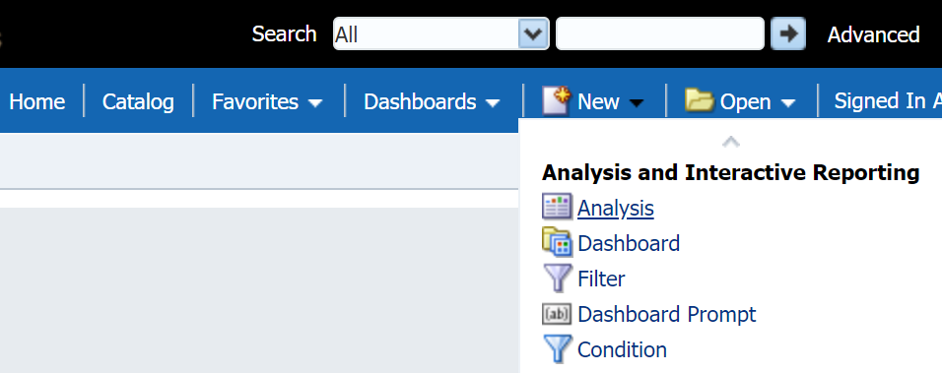

In the Select Subject Area menu scroll to the very bottom and click Users:

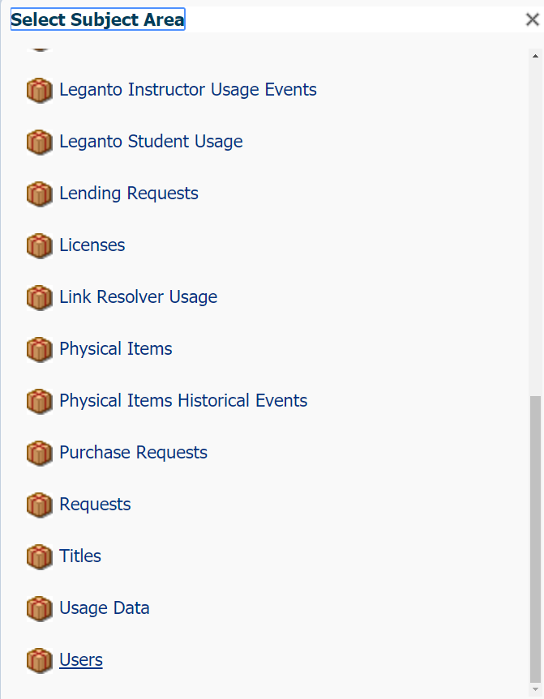

Add the Primary Identifier, Last Name and Expiry Date fields to the report (these fields can be found in the User Details folder). Double click or drag and drop to add them to the report:

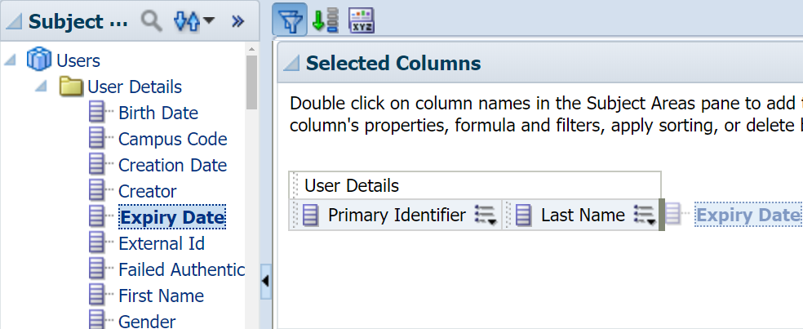

Add a filter for Expiry Date. Open the drop-down menu next to Expiry Date and click Filter:

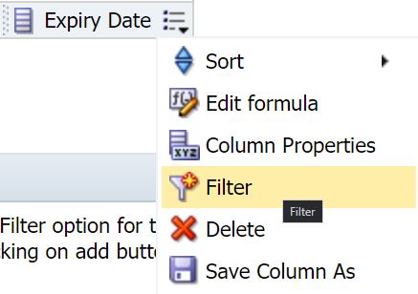

In the New Filter menu, select the “is less than” operator, select June 30th from the calendar icon (or type it in to Value) and click OK:

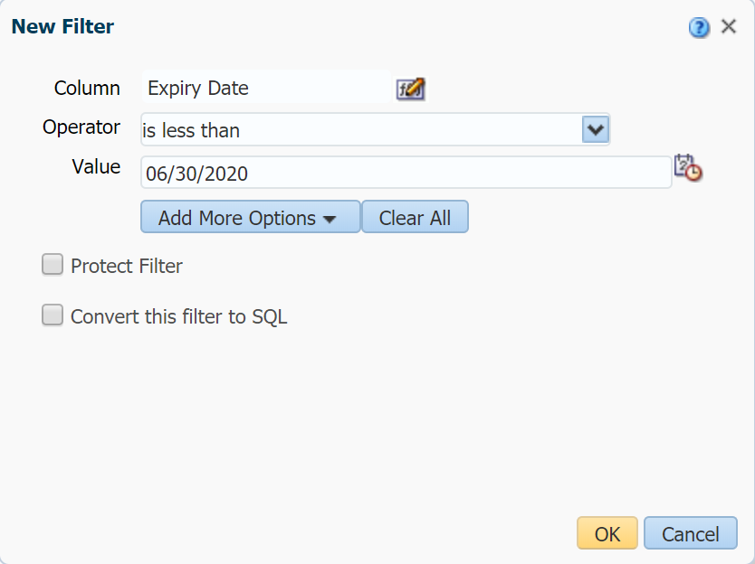

Your report should now look like this:

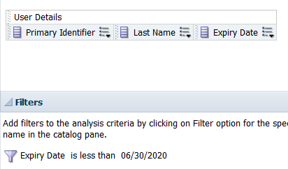

Click the Save Analysis icon in the top right corner:

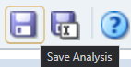

And save your report to one of the directories under your institution’s folder in the Shared Folders section. our training environment’s institution name is “Clean Training” and we are saving our report as “1. Users with Expiration Dates Before 30 June 2020” to the Shared Folders/Clean Training/Reports/Knowledge Days 2020/Fulfillment folder:

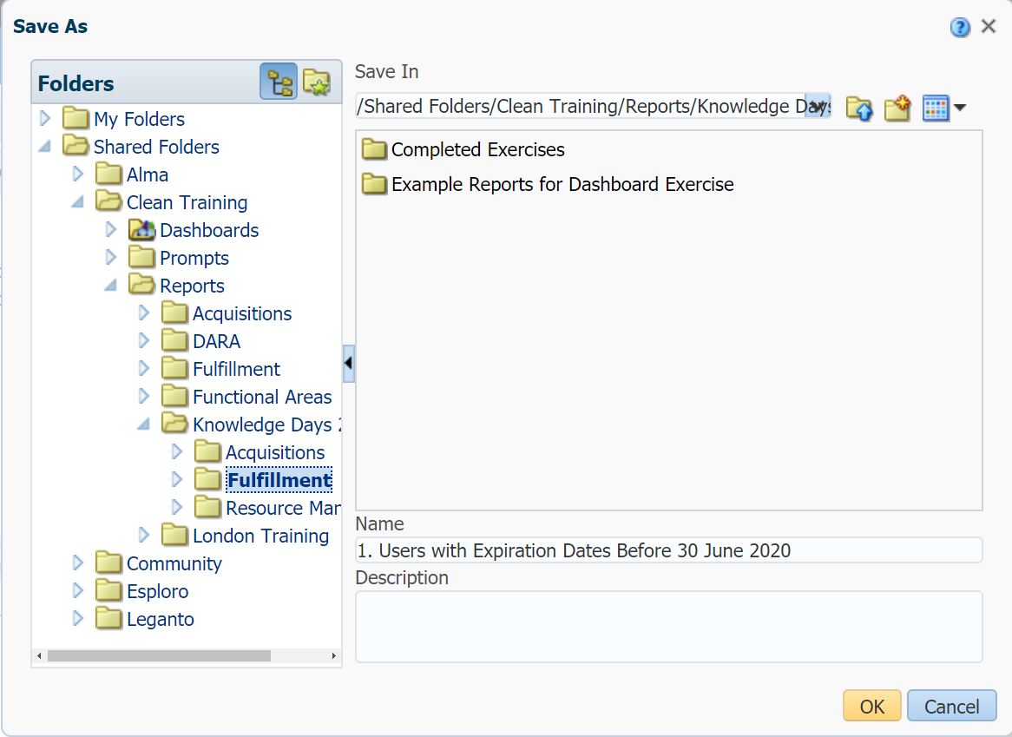

Click the Results tab to view the results of your report:

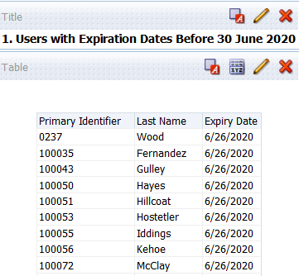

Creating a User Set in Alma from the Analytics Report

In Alma, go to Admin > Manage Jobs and Sets > Manage Sets, click Add Set > Itemized and create an itemized User set with your report.

Give your set a name and change the Set content type to User.

Under the Add Contents from File to Set section select From Analytics. In the Analytic Folder field select the folder where you saved your report, then in the Name field select the name of your report. Finally, click Save:

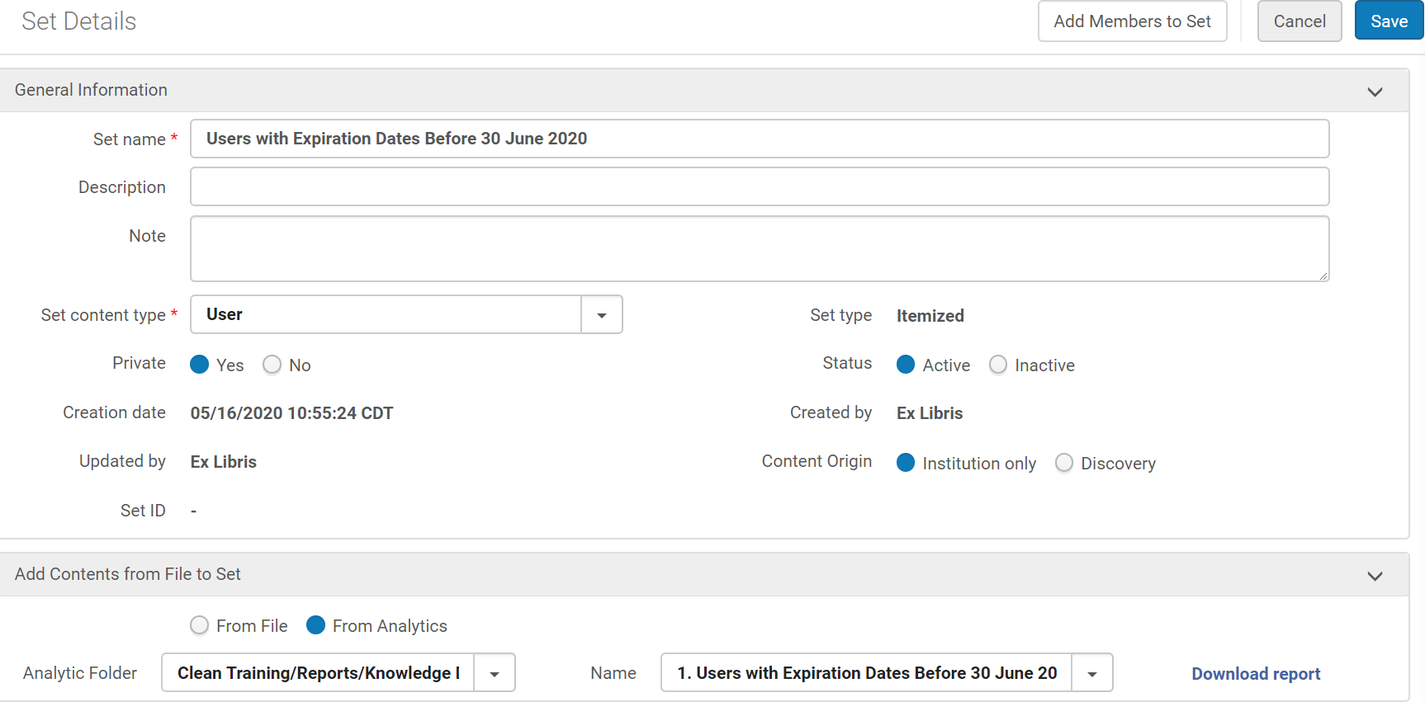

After you click save you should see a confirmation message such as this:

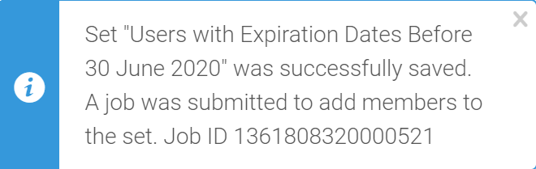

Once Alma has created the set it will appear in Manage Sets under the appropriate tab (you may need to switch between tabs to refresh the page). You can select Members from the action menu to view the members of the set:

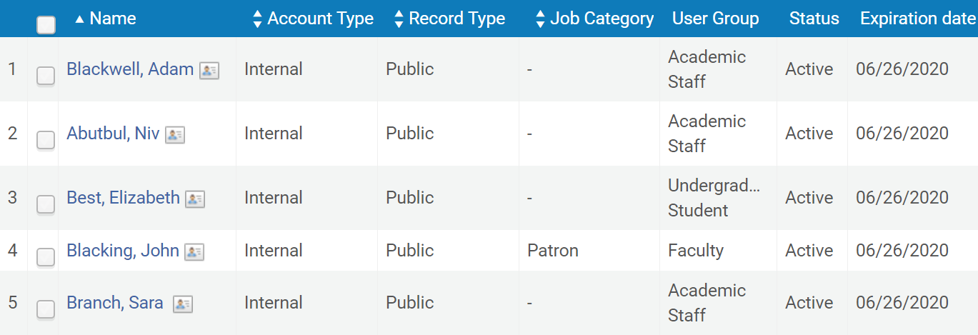

Running the Update/Notify Users Job to Update the Expiration Date

Now we want to update the expiration date of these users to 30 September 2020. To do this, go to Admin > Manage Jobs and Sets > Run a Job and select the Update/Notify Users job, then click Next:

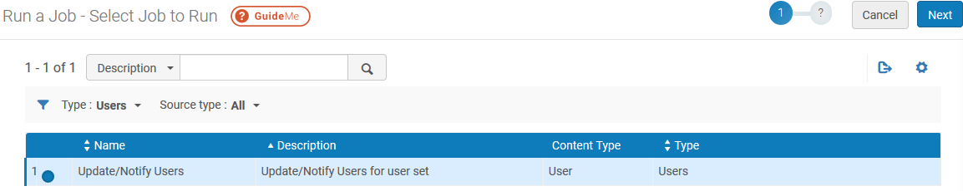

Select your User set and click Next:

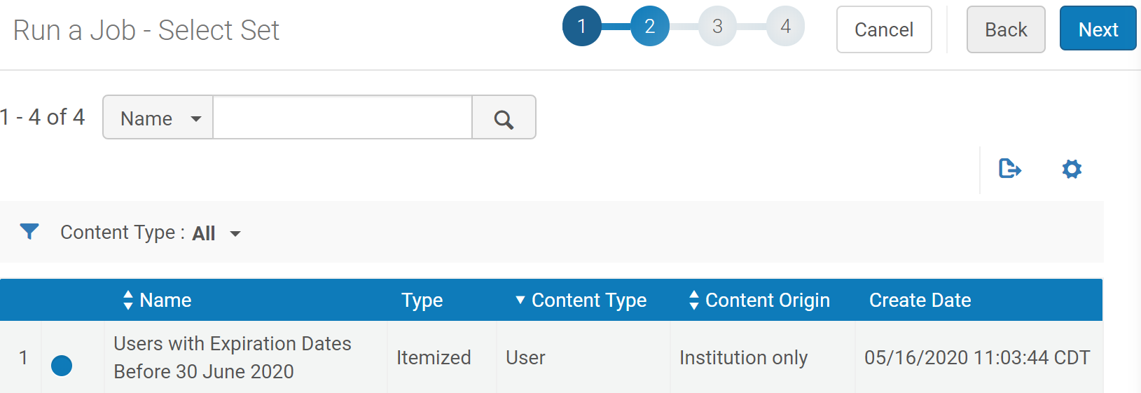

In the Task Parameters section check the box next to Expiry date and select September 30th from the calendar icon:

Review and confirm your settings then click Submit to run the job. While the job is running you can view it from the Admin > Manage Jobs and Sets > Monitor Jobs > Running tab:

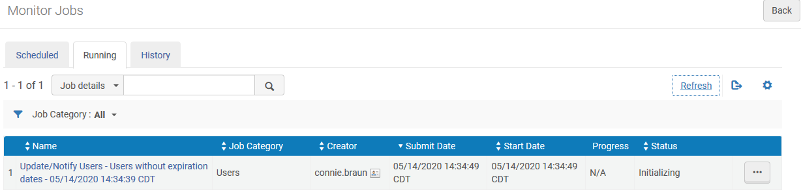

And once the job has completed you can find it in the History tab to confirm it completed successfully:

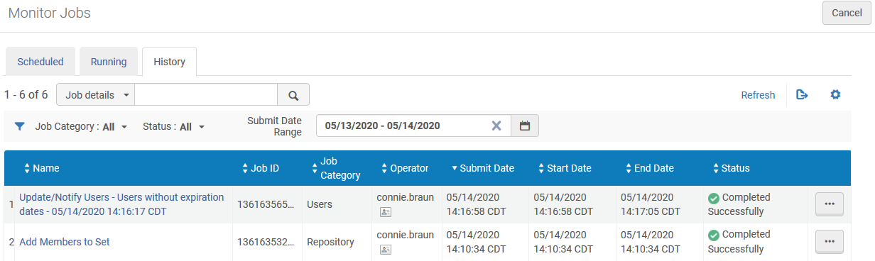

If you check the members of your User set again their Expiration date should have been updated:

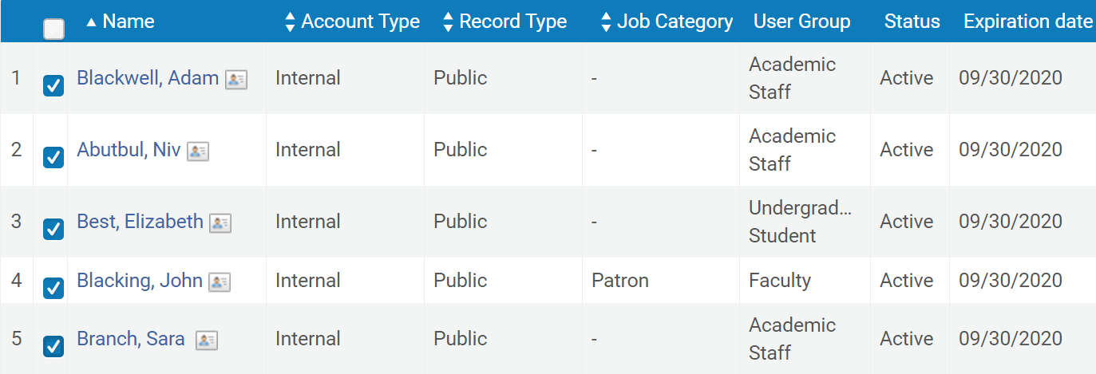
One day later (after the next full database refresh) the new expiration dates for these users will be reflected in Analytics and they should no longer appear in your report.

Active Requests to be Cancelled

In our next report, we will identify patron physical item requests that are still active and need to be cancelled. As with the previous example, we will create the Analytics report, use it to create a set in Alma and then run the Cancel Physical Item Requests job on that set to cancel the requests.

Create a new Analytics report, this time selecting the Requests subject area:

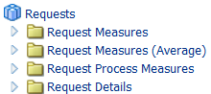

Add the following fields to your report: Barcode (found under the Physical Item Details folder), Title (Complete) (under the Bibliographic Details folder), Request Date (found under the Request Date folder), Pickup Location (found under the Request Details folder), First Name and Last Name (found under the Requester folder). As in the previous example, you can double click or drag and drop the fields into the report. Once they are all added the Selected Columns section should look like this:

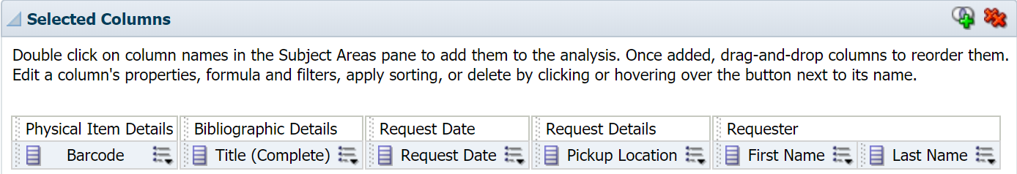

We also want to add some filters for fields that will not be displayed in the report. To do this, click the funnel icon to the right of the Filters section and select More Columns …:

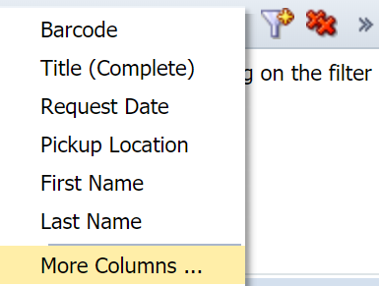

Open the Request Status folder in the Select Column menu that appears and select Request Status, then click OK:

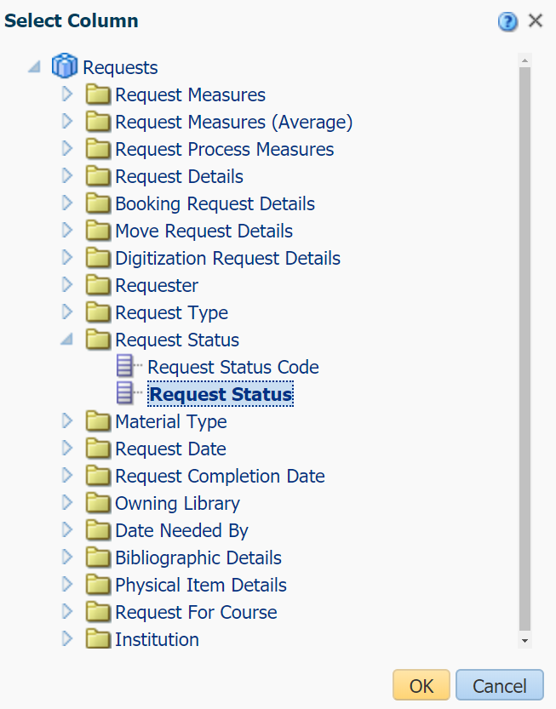

The New Filter menu will appear. Set the Value field to Active by selecting it from the drop-down menu, searching for it with the binoculars icon or typing it in, then click OK:

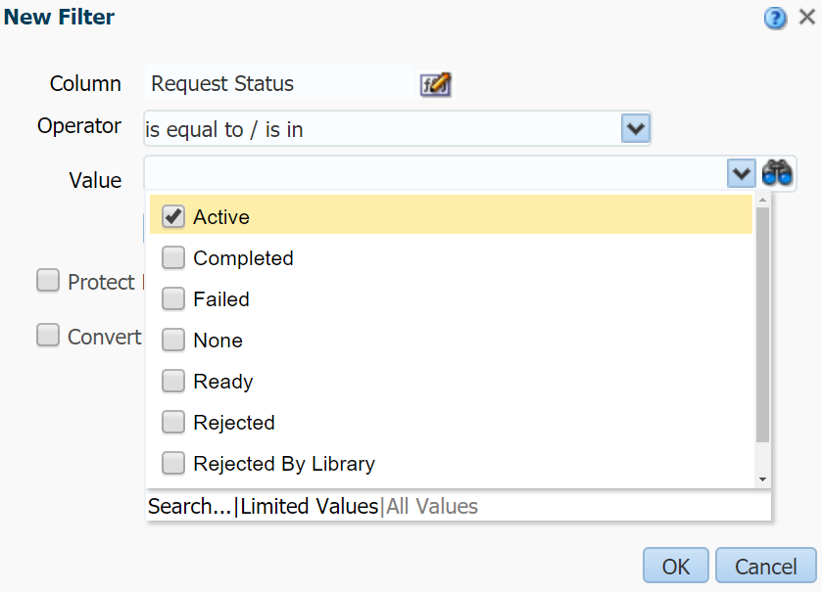

Add a filter for the Request Date field (you can select Filter from the drop-down menu next to this field since it appears as a column in this report or use the funnel again). Set the filter operator to “is greater than or equal to” and enter a date (in our example we assume that there could be some active requests from last month and select April 1st for our filter.

Also add a filter for the Request Type Description field (which can be found under the Request Type folder) using the funnel. Set the Value for this filter to “Patron physical item request” which is the only type of request we want to cancel.

When you have added these filters, your report should look like this:

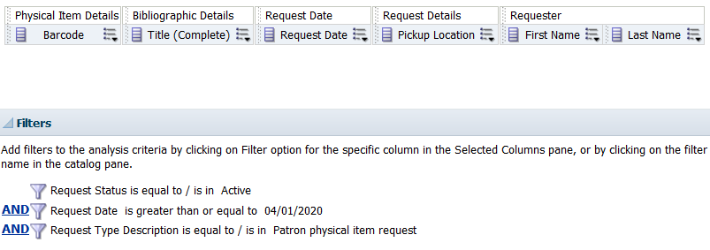

Save this report to a directory in your institution’s folder under the Shared Folders section (we called our report “2. Active Requests to be Cancelled”). Go to the Results tab to see the active requests we want to cancel:

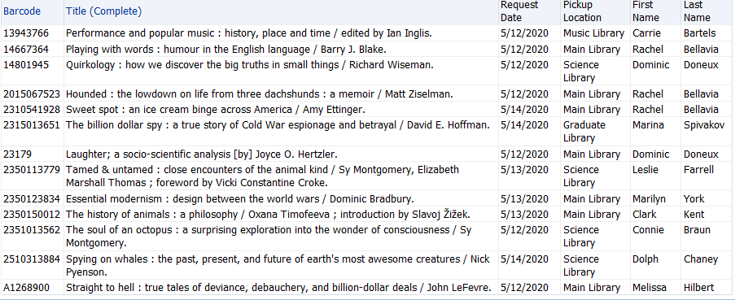

As long as your report includes the Barcode field (you could also use the Physical Item ID field) it will be possible to create a Physical items set in Alma following the same steps as in our previous example but choosing Physical items instead of User for the Set content type field. You can then run the Cancel Physical Items Requests job to cancel any active requests associated with these items.

Items on Loan and Overdue or Soon-to-be Overdue

In our next report, we will identify loans that are overdue or will become overdue soon. Create a new Analytics report, this time selecting the Fulfillment subject area:

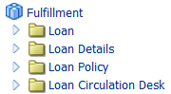

Add the following fields to your report: Due Date (under the Due Date folder), Library Name and Location Name (under Item Location at time of loan), User Group and Primary Identifier (under Borrower Details), and Title (Complete) (under Bibliographic Details). As in the previous examples, you can double click or drag and drop the fields into the report. Once they are all added the Selected Columns section should look like this:

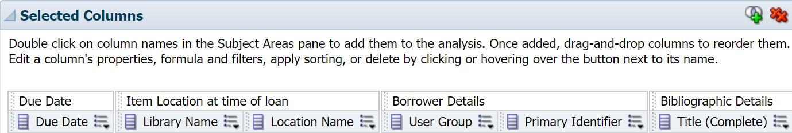

Add a filter to this report for the Due Date filter (you can select Filter from the drop-down menu next to the field or use the funnel icon in Filters). Change the filter operator to “is between” and choose a range of dates: we have chosen to filter our report from the beginning of April to the end of May.

Use the funnel icon in the Filters section to add a filter for the Loan Status field (under the Loan Details folder). Set the Value for this filter to “Active” so that only active loans appear in our report. After adding these filters your report should look like this:

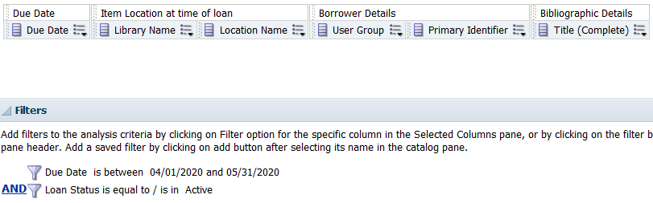

Save your report (we called our report “3. Items on Loan and Overdue or Soon-to-be Overdue”). Go to the Results tab and view the active loans that are overdue or will be due soon:

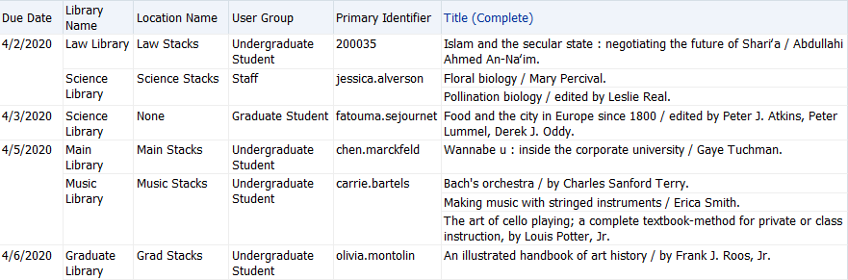

In Alma it is possible to update the due date for many loans at once, however unlike the previous examples you do not need to create a set first. Instead, you can go to Fulfillment > Advanced Tools > Bulk Change Due Dates and update all of the loans associated with a particular Library, Location, Material Type, and/or User Group, as well as restrict the loans that are updated to those with due dates within a specific range (using the From Due Date and To Due Date fields). The above Analytics report contains the Due Date, Library Name, Location Name, and User Group fields to make it easier to identify which settings you should choose for the Bulk Change Due Dates tool. You may need to run Bulk Change Due Dates multiple times using different Library values to update all of the loans in your report:

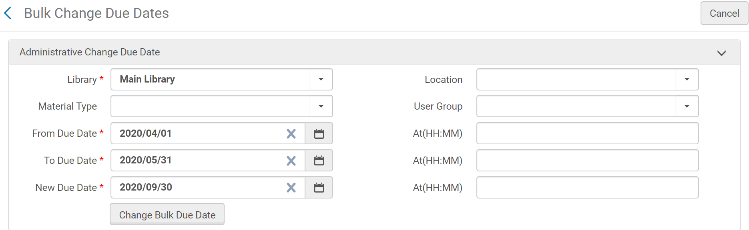

Dashboard: Change from Physical to Electronic Fulfillment During COVID-19

For our final example, we would like to see how the usage of our physical and electronic resources has changed as a result of the COVID-19 pandemic. In general, we would expect to see the number of loans of physical items decrease substantially or even reach 0 at institutions that have had to close. We would also expect to see a corresponding (though smaller) increase in the usage of our electronic resources. However, if your data does not fit this story that would be useful to know as well; for example, if there is no corresponding increase in the usage of electronic resources this might indicate that patrons are unaware these resources exist or are having trouble finding them.

It is possible to report on this data in Analytics, but the data appears in multiple subject areas which means that we could not view it all at once from a single report. Instead, we will demonstrate how to create a dashboard that allows you to display multiple reports on a page and filter all of them at once using a dashboard prompt.

Please note that what you will see when running these reports in your Alma environment may differ significantly from the example data in our training environment. In particular, the COUNTER Usage of Electronic Resources report will not show data if you are not uploading any COUNTER usage reports to your Alma environment or do not have any SUSHI accounts configured to harvest this data automatically (please see this article for more information about entering your COUNTER usage data into Alma).

Reviewing the Reports

Instead of creating the reports for our example dashboard from scratch, we will be using and later modifying some existing reports that can be found in the Shared Folders/Community/Reports/Shared Reports/Knowledge Days 2020/Fulfillment/Example Reports for Dashboard Exercise folder (if you have not already done so, please copy these reports to a directory in your institution’s folder under the Shared Folders section and work with the copies so that these original reports will remain unmodified). Each of these reports are relatively simple as we want a high-level overview of our data to appear in the dashboard.

First, Loans Per Month is a Fulfillment report that shows the total number of loans per month (excluding in house loans). The Loan Fiscal Month Key field appears in the Selected Columns but is hidden from the results as it is used only to ensure the Loan Month field is sorted properly (without this field appearing in the report, Loan Month would display months alphabetically starting with April and ending with September). There is a Loan Date filter with specific dates that we will be replacing later so that a dashboard prompt can be used to limit the dates:

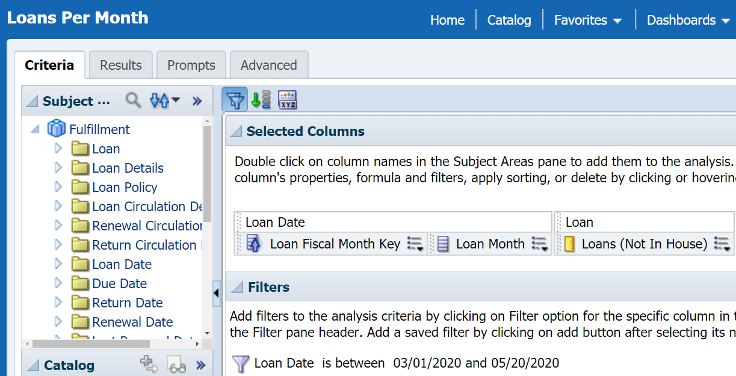

Going to the Results tab, we can see that loans have gone down sharply (at least in our training environment). Also, a simple line graph has been added to each of these reports to show trends (please see this article for more information about adding graphs to your reports):

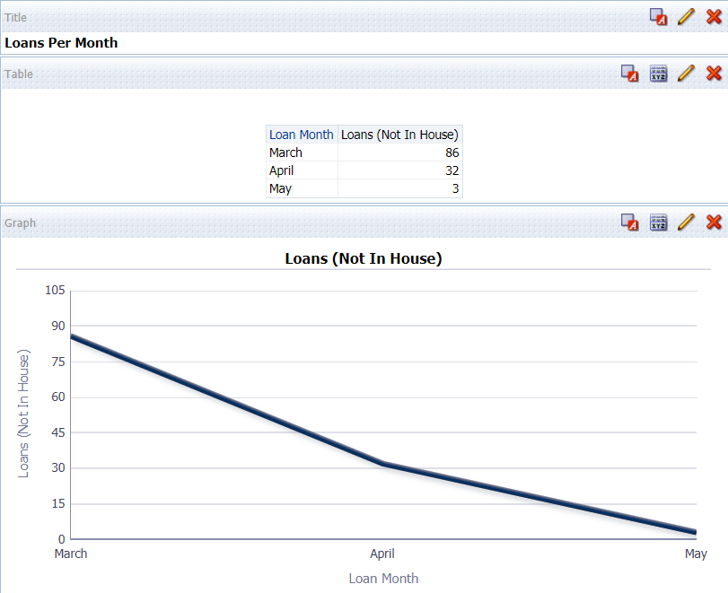

The Link Resolver Usage Per Month report has the same format as the previous report but uses the Link Resolver Usage subject area and displays the number of requests sent to the Alma link resolver per month. Request Month Key is hidden but included to sort the Request Month field properly. A Request Date filter appears with specific dates that we will also replace later with the dashboard prompt:

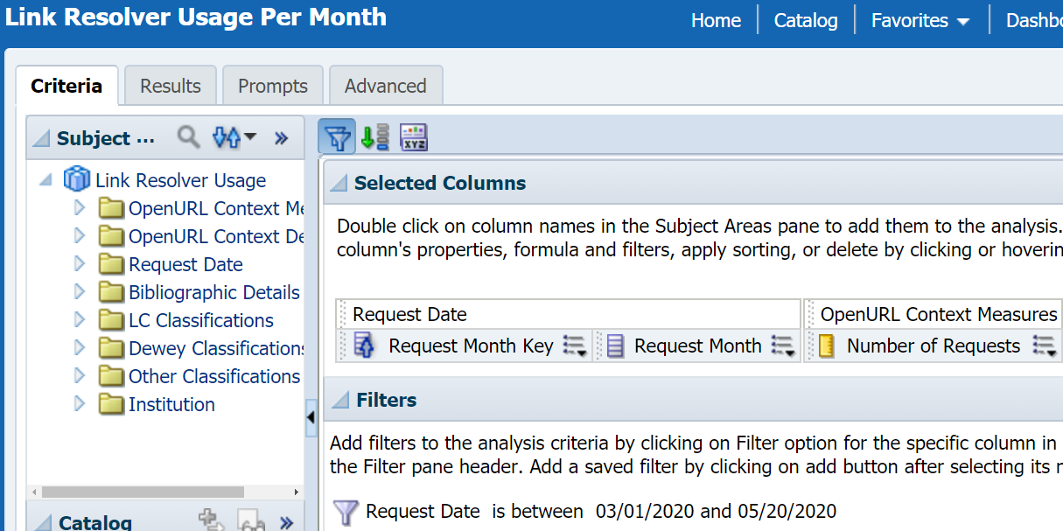

Finally, the COUNTER Usage of Electronic Resources report uses the Usage Data subject area and displays the total amount of usage (from any COUNTER reports) by date. COUNTER usage is monthly, so the Usage Date field is used, and since this field sorts properly we do not need to use a “key” field like we do in the other reports. You may want to add other measures to this report to distinguish between different COUNTER report types, if you do please note that you may need to use measures in the Usage Data Details folder or Usage Data Details – Release 5 folder since the Release 4 and Release 5 reports are structured differently and use different names. As with the other reports there is a Usage Date filter with static dates that we want to replace with our dashboard prompt:

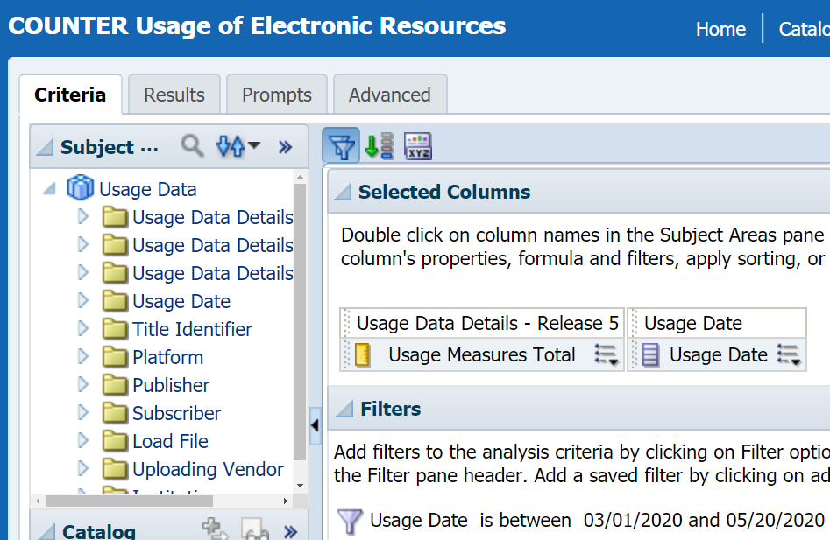

Creating the Dashboard Prompt

The Example Reports for Dashboard Exercise folder also contains an empty dashboard prompt called Date Prompt that you can use for this example or you can create your own. To create your own, click New and select Dashboard Prompt under the Analysis and Interactive Reporting section:

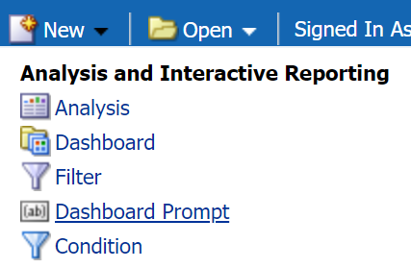

Our dashboard prompt uses the Fulfillment subject area, although you could select another subject area with date fields since we will be creating a dashboard prompt that can work across multiple subject areas. After opening Date Prompt or creating a new Dashboard Prompt, you should see a Definition section where the prompt(s) for your dashboard can be added and a Display section where you can preview how the prompt(s) will be displayed:

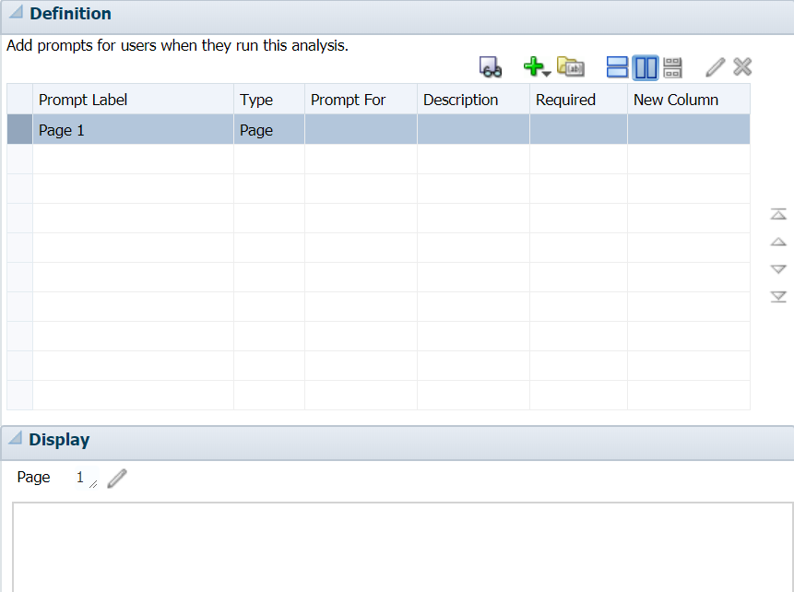

When creating a dashboard for reports that all belong to the same subject area and will be filtered by the same field, you can click the green plus (+), select the Column Prompt and choose the field that all of your reports will be filtered by (this article shows how to create one of these column prompts for use in a simpler dashboard). However, our example is a little more complicated: each of our three Analytics reports belong to a different subject area and even though the date values have the same format there are three separate fields being used (Loan Date, Request Date and Usage Date). While we could create three separate prompts for each of these fields, we would need to enter our six dates every time we wanted to change the date range. It would be preferable to enter the dates once and have each filter the appropriate date field for each report.

We can do this using a Variable Prompt that sets what is called a presentation variable. This presentation variable can then be referenced in each of our reports so that the dates we choose will filter the date field appropriate for that report. Click the green plus icon and select Variable Prompt:

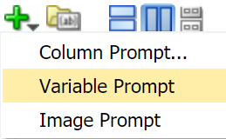

The Edit Prompt menu will appear. In the first field that appears (Prompt for Presentation Variable) enter the name of your presentation variable; this will be the first date of our date range, so we have decided to name ours “StartDate”. The Label field determines what text will be displayed for the prompt in your dashboard, we have entered “Physical and Electronic Usage From” but you can enter anything you want without needing to change any of the next steps:

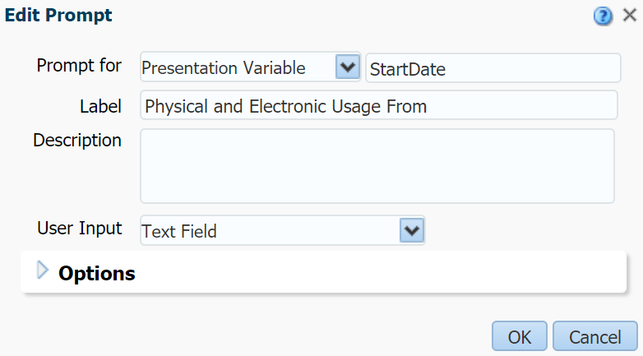

Set the User Input field to Choice List and new fields will appear. Set the Choice List Values field to “All Column Values” (it may already be set to this value) and click Select Columns:

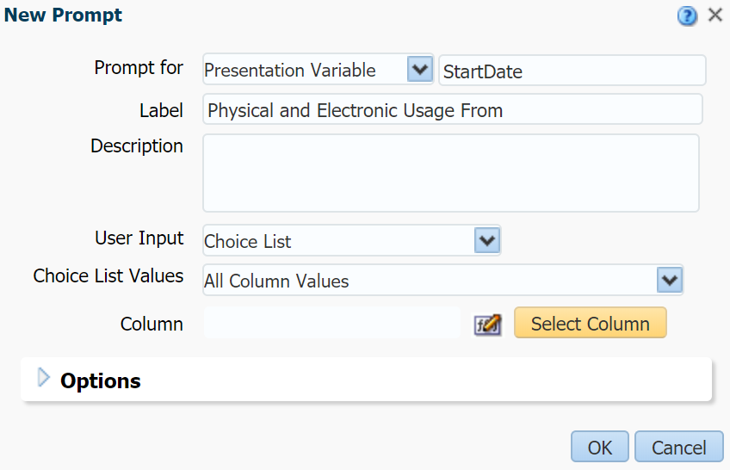

In the Select Column menu open the Loan Date folder and select Loan Date, then click OK:

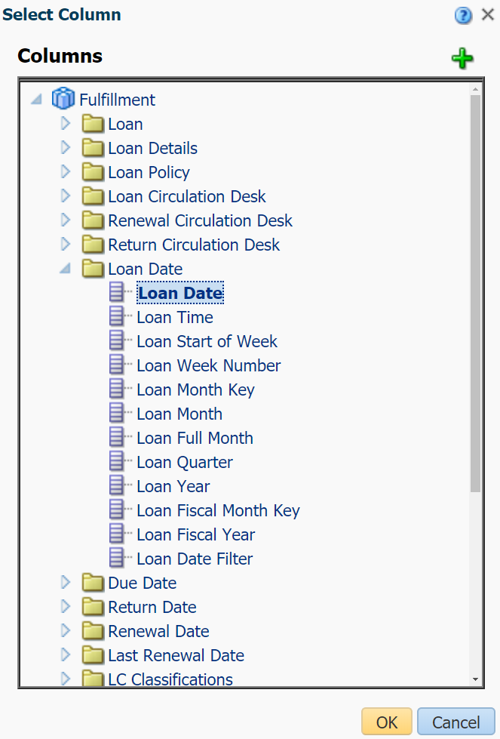

Expand the Options section by clicking on the triangle next to Options. There are optional settings in this section that we would like to use for our prompt. Check the “Enable user to type values” option so that you can type the desired date instead of selecting it from a list. Check the “Require user input” checkbox to ensure that the date cannot be empty. Select Specific Value in the Default selection field and use the plus icon on the right to set a default value (this is a good idea for these date prompts so that Analytics does not try to load the data from all time when you first open the dashboard). Once you select a value from the Select Values menu and click OK it will appear in the box under Default selection (we chose the beginning of March for our example). Finally, when your prompt looks like this click OK:

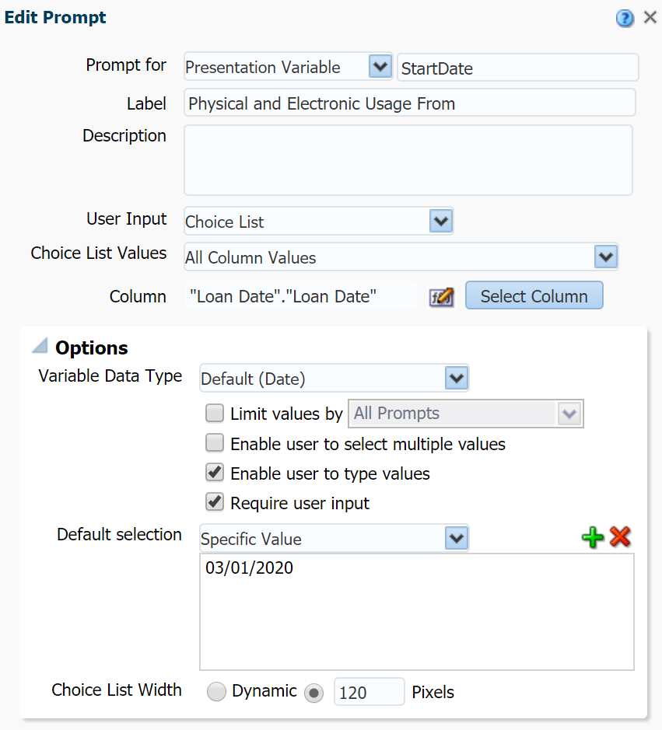

The Display section will now show a preview of your first prompt and you can interact with it in this section to see how it will work in your dashboard:

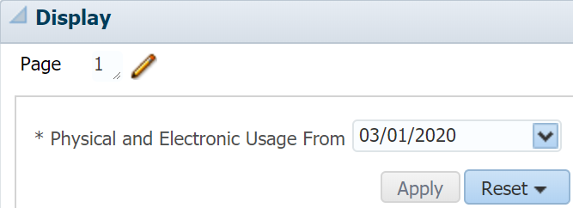

Repeat the above steps to create a second Variable Prompt for the presentation variable that will define the end of our desired date range. We have chosen to name this presentation variable EndDate and gave it the label “Until” so that both prompts read “Physical and Electronic Usage From ____ Until ____”. Also ensure that you have entered a date into the Default selection section (we entered today’s date but the beginning or end of the month might make more sense for your data):

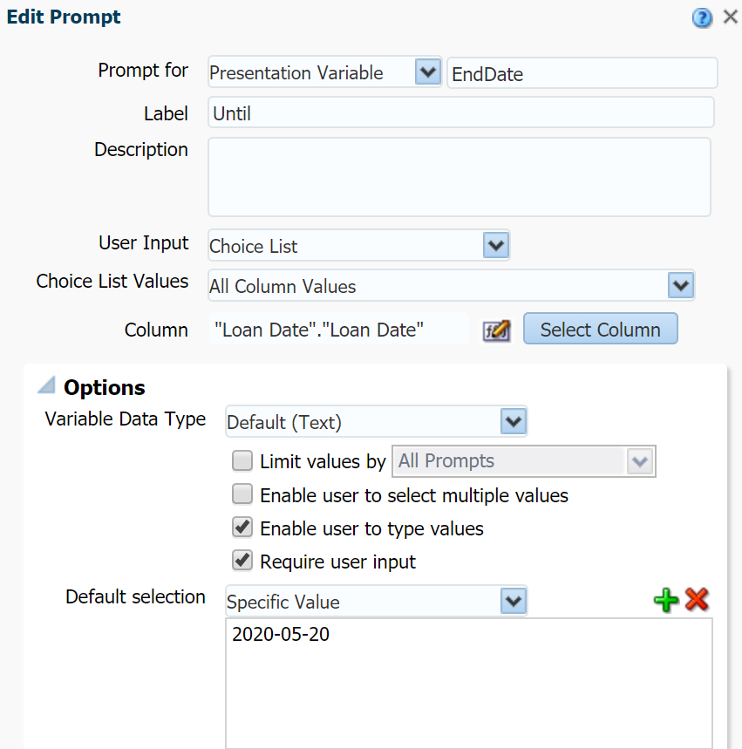

Both Variable Prompts should now appear. One optional step you can take is to check the New Column box for the second prompt so that both appear on the same line. Click the Save icon to save your prompt. We chose to call our prompt Date Prompt:

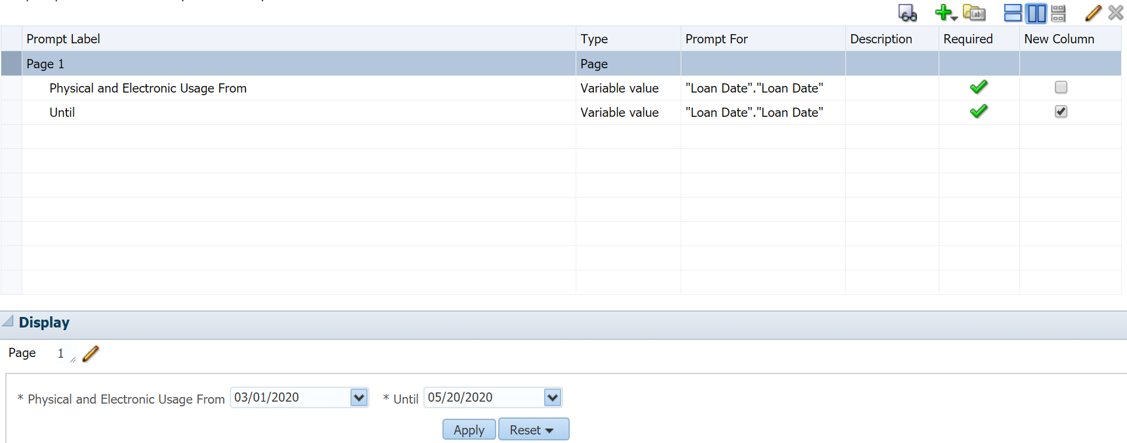

Modifying the Reports to Use Presentation Variables

Now that we have defined StartDate and EndDate presentation variables, we will need to modify our three reports to use them. Open one of the three reports (in our screenshots we start with the Link Resolver Usage Per Month report but the order does not matter), go to the Criteria tab and hover over the date filter. Click the pencil icon to edit the filter:

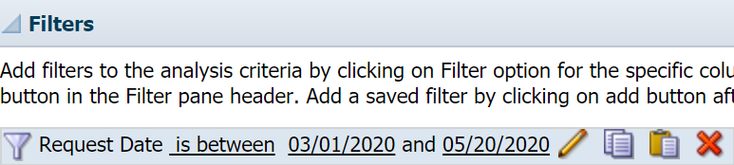

In the Edit Filter menu click the Add More Options button and select Presentation Variable:

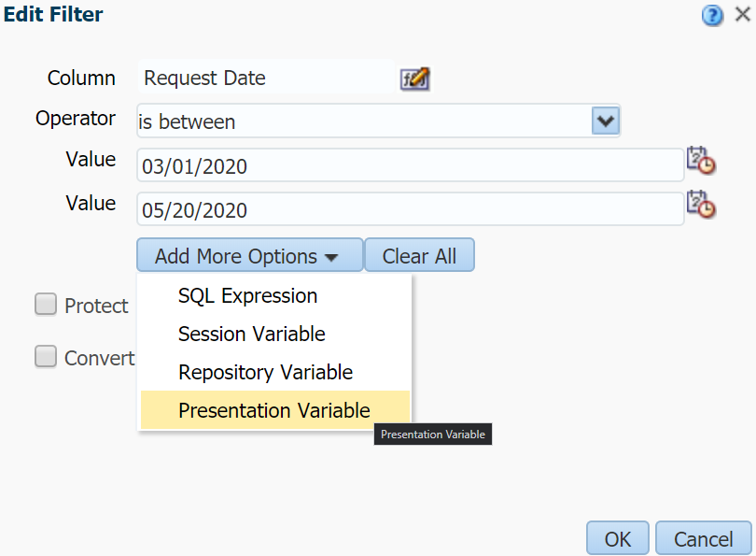

This will cause a Variable Expr and (default) field to be added to the filter. In the Variable Expr field enter the name of the first presentation variable you defined (i.e. StartDate). (default) will be the default value for this presentation variable if it is not defined, for example when you run the report outside of the dashboard. It is recommended to always set a default value so that you do not receive an error. We are going to reuse the first Value as our default value for StartDate, so we have moved it from Value to the (default) field; you can enter a different default value but make sure to delete the Value fields regardless.

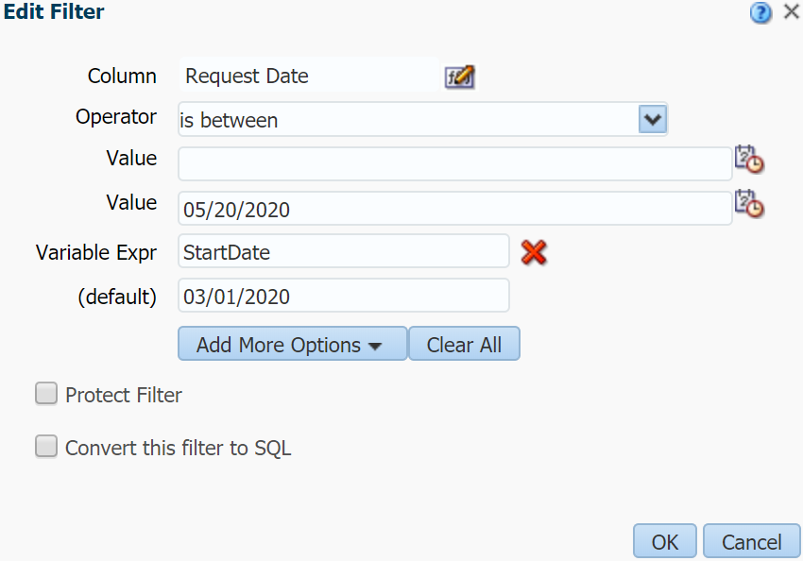

Click Add More Options and select Presentation Variable again to make a second Variable Expr and (default) field appear. Enter your second presentation variable (i.e. EndDate) and a default value in (default). Delete any values in the Value fields before clicking OK:

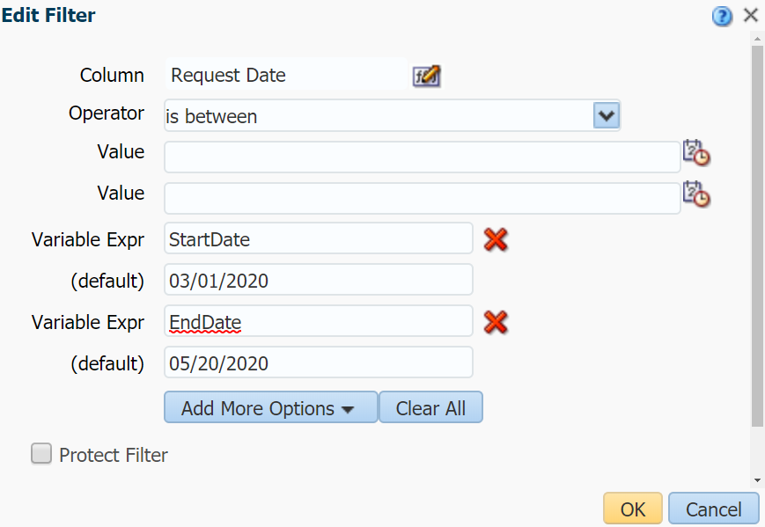

The presentation variables now appear in the filter surrounded by brackets and with an ampersand at the beginning; the optional (but strongly recommended) default values also appear afterwards in brackets. This syntax can be used to refer to presentation variables in other parts of Analytics reports:

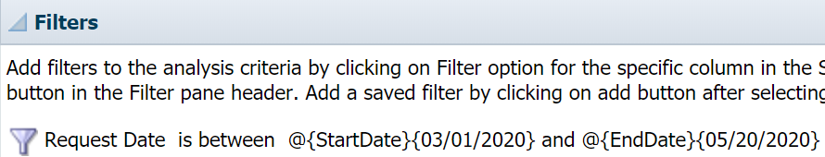

This next step is optional but encouraged. When you go to the Results tab you should see that the default values for the presentation variables is being used to filter the report, but our report does not display anything to indicate that this is happening. One way to confirm the value of the presentation variables as they are being used is to include them in the Title of our report. In the Results tab click the Edit View button (pencil icon) in the Title section to edit the Title of our report:

Uncheck the Display Saved Name checkbox, which will allow you to edit the Title field. Enter a title for your report that includes your presentation variables in the syntax shown above (e.g. @{StartDate}{03/01/2020} and @{EndDate}{05/20/2020}). Not specifying default values will not cause an error in this case, but you would see “@{StartDate}” or “@{EndDate}” in the report. Click Done when you have entered your desired title:

The Title will show the default values while you are viewing the report. However, once we add these reports to the dashboard and change the dates this text will change with it:

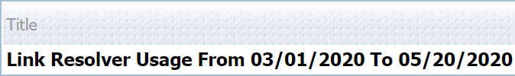

We need to repeat the above steps for the other two reports. Here is what the filters should look like for the Loans Per Month and COUNTER Usage of Electronic Resources reports after modifying them (you may also want to add the presentation variables to the Title):

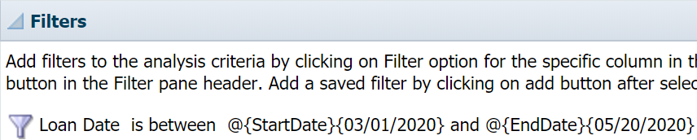

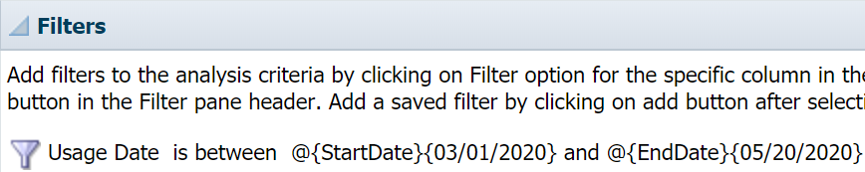

Creating the Dashboard

All the components of our dashboard are now ready, so we can begin to create the dashboard itself. Click New and select Dashboard from the Analysis and Interactive Reporting section:

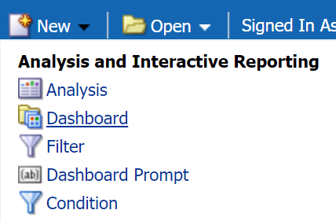

The New Dashboard menu appears. Enter a name for your dashboard in the Name field and choose a location to save the dashboard from the Location menu. We strongly recommend using the default dashboards location for your institution folder (for our training environment this is /shared/Clean Training/Dashboards). You can specify other locations using the Browse Catalog… option but will receive a warning message that your dashboard will not appear in the Dashboards menu in Analytics. More importantly, if you want to save the dashboard to another location later (e.g. creating a dashboard in My Folders first to test it before moving it to Shared Folders to share with others) you will need to update the file paths of all the reports and prompts in your dashboard (see the end of this document for instructions on how to make these changes). Thus, it would be best to save the dashboard where everyone in your institution can access it so that you do not need to move it later.

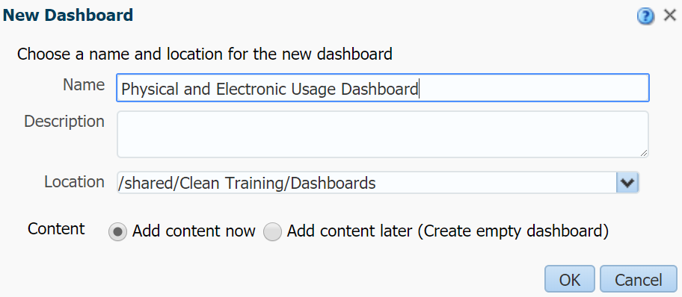

After clicking OK, you will see the page below. When you create a new dashboard, a new page (i.e. tab) is created called “page 1”. If you would like to add additional pages to your dashboard you can click the Add Dashboard Page button (the icon on the right that looks like a document with a green plus next to it). The Dashboard Objects section contains various visual elements that you can add to your dashboard page by dragging and dropping it into the Drop Content Here section. The main object we will use is Column to organize where our reports appear on the page. Reports and dashboard prompts can be added to the page from the Catalog section by navigating to the folder where the reports are saved, then dragging and dropping them into the desired area of the page:

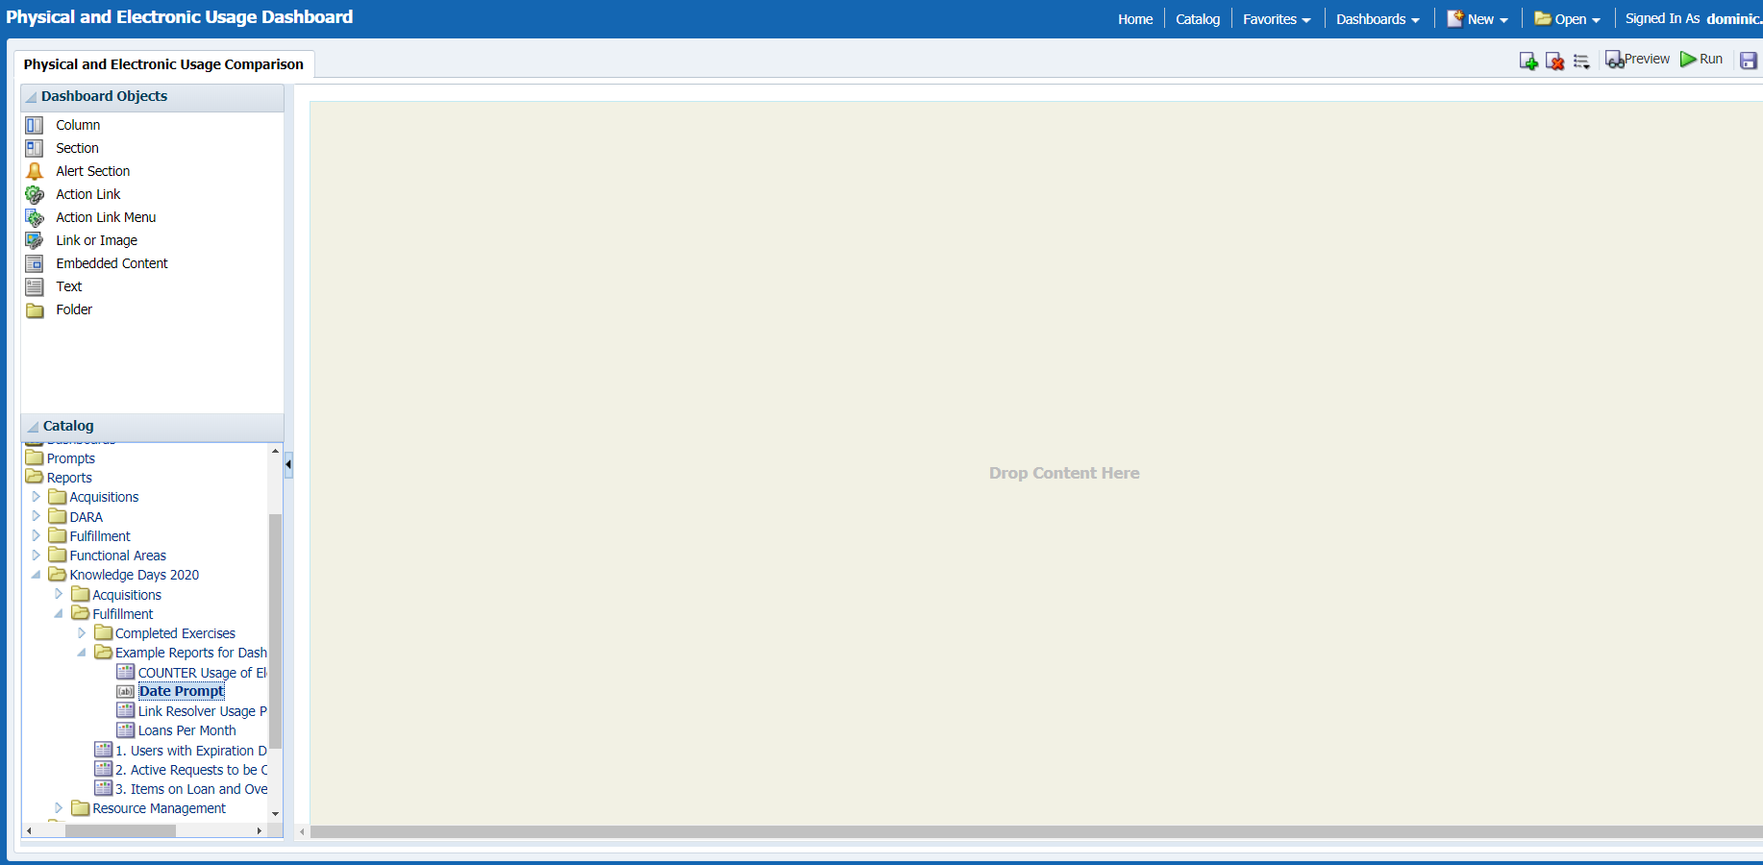

As a quick aside before we begin creating this dashboard: if you navigate to the dashboard you have saved in the Catalog menu you will see that they are treated like folders. If you expand the dashboard’s folder you will see the pages associated with the dashboard and can even save reports and prompts to this folder (doing so does not affect the behavior of the dashboard but can make it easier to copy or move the dashboard if you must do so later). We have done this with the completed version of the dashboard we are about to build so that it is easier to copy from the Completed Exercises folder (note that the file paths to the reports and prompt still need to be updated after copying, please see the end of this document for instructions):

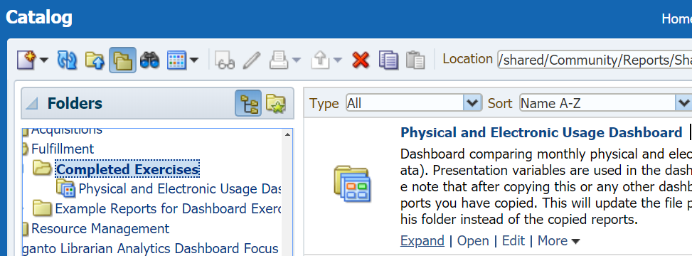

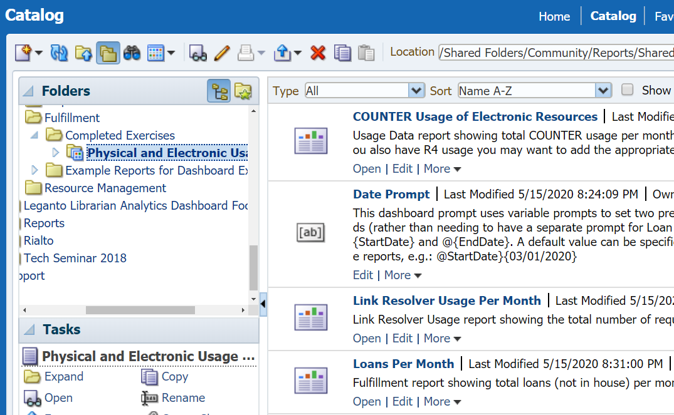

Going back to our example, we are going to organize this dashboard so that the prompt is on top, the physical usage (i.e. loans) report is on the left and the electronic usage reports are on the right; however, you can organize your dashboard however you would like. The Column object can be dragged and dropped from the Dashboard Objects to the middle section (that displays “Drop Content Here until something is added) to create a layout. We have added one column at the top and two below that split the page:

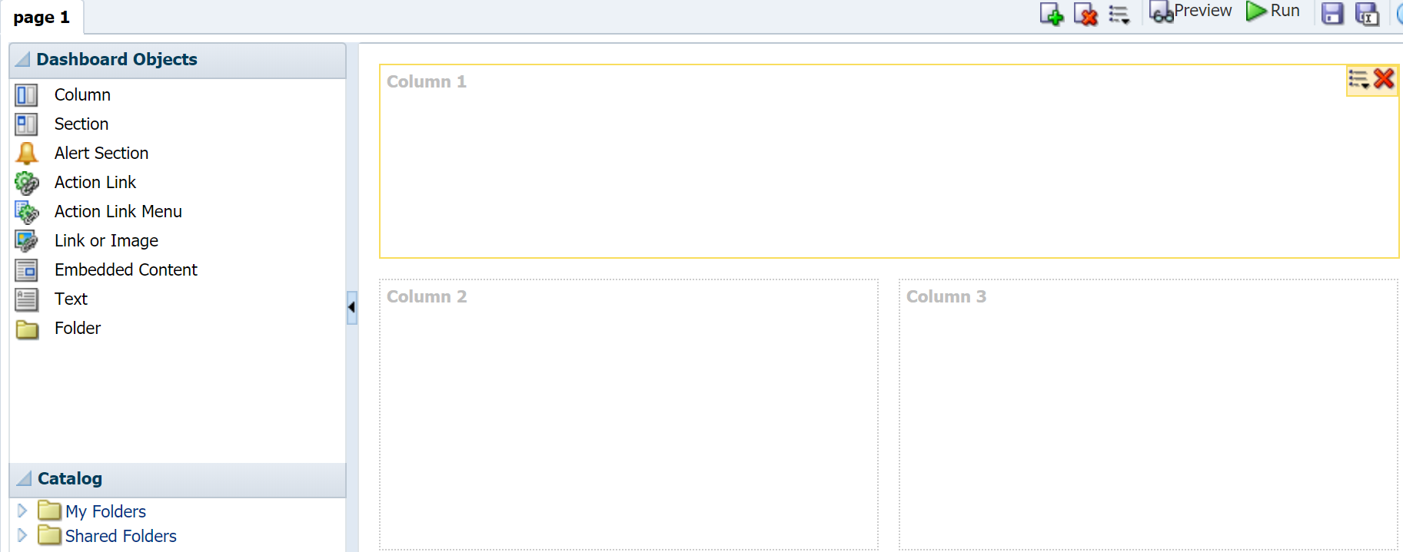

Next, we drag and drop the Date Prompt into Column 1, the Loans Per Month report into Column 2, and the Link Resolver Usage Per Month and COUNTER Usage of Electronic Resources reports into Column 3. Sections are automatically added around the prompt and reports which determine where they will appear inside the columns:

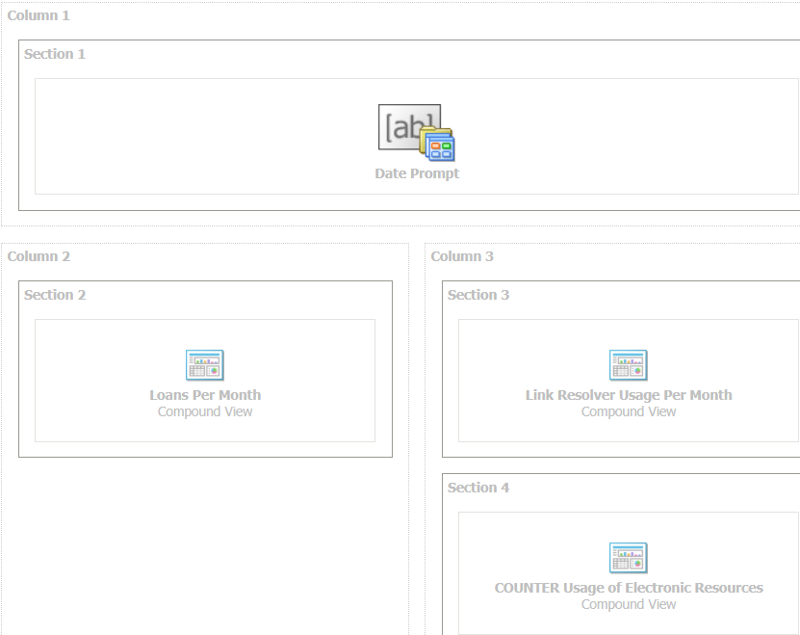

You can use the Preview button to preview what the dashboard layout will look like once data from the reports has populated it; however, the dashboard prompt will not be selectable. It is recommended to save your dashboard by clicking the Save button before using the Run button as this will run the dashboard but discard your changes if you did not save them.

Here is what our completed dashboard looks like when we run it:

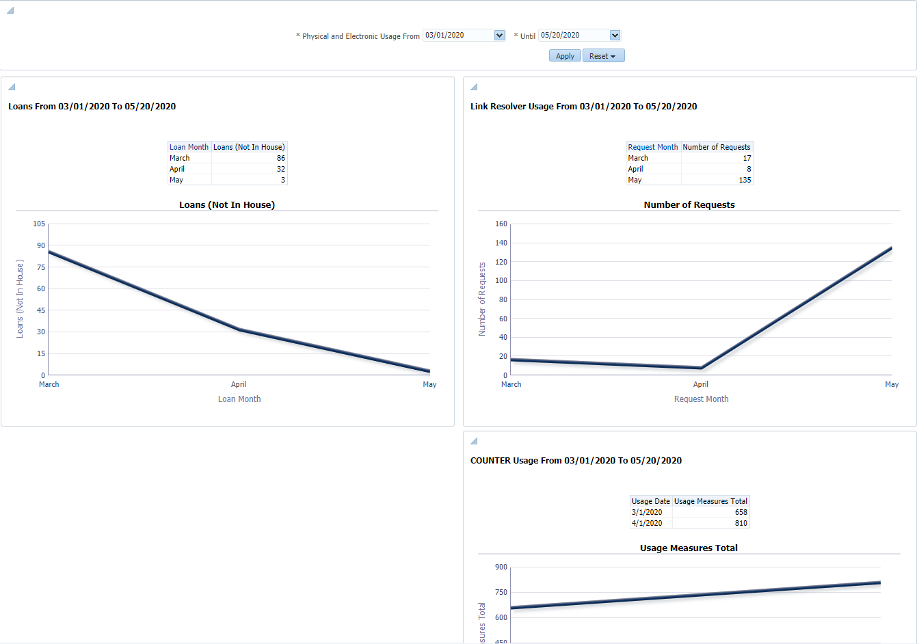

And if we change the date range in the prompt and click Apply, we can see that all the reports update at once:

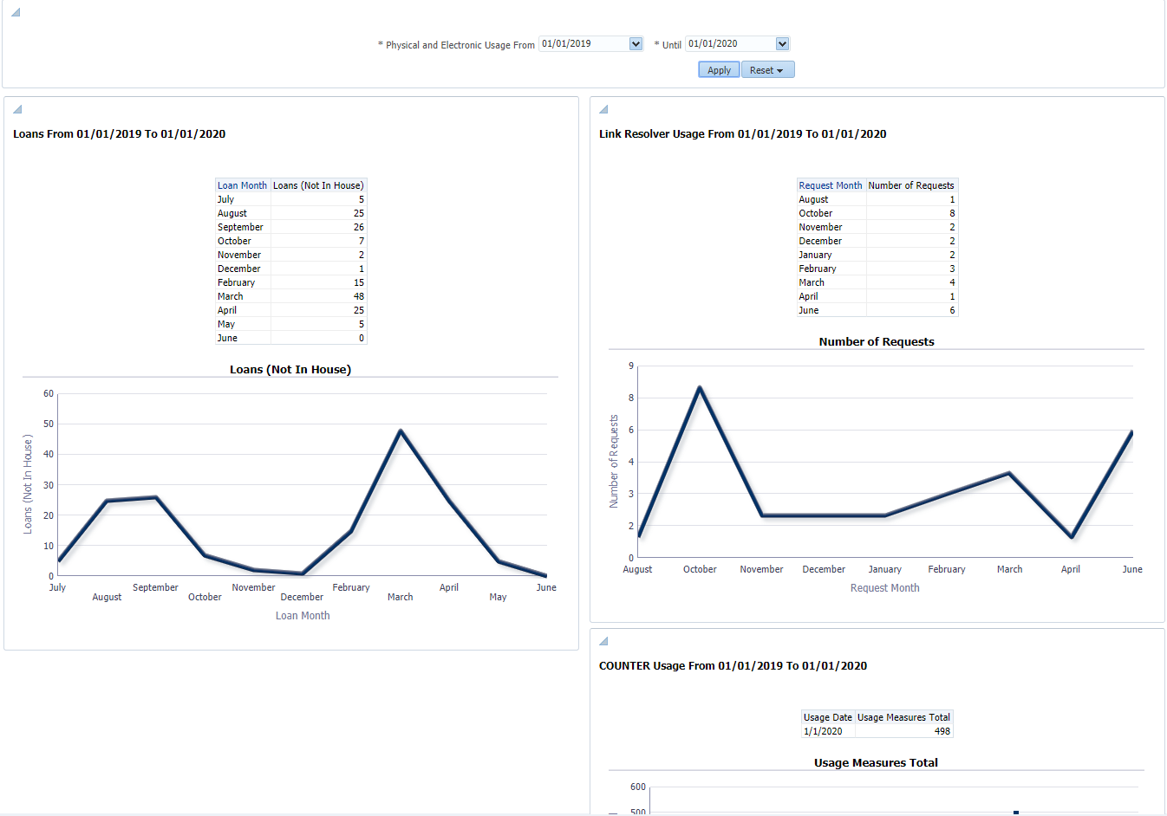

Steps to Copy or Move Dashboards

This section contains instructions on how to successfully copy or move a dashboard to another folder, ensuring that all the reports and prompts in the dashboard are updated properly. These steps are necessary because dashboards rely on “absolute” rather than “relative” file paths to any reports or prompts that appear in a page. Thus, when the dashboard is moved these file paths still refer to the original locations that these reports or prompts appeared.

There are a couple different problems that can occur if these file paths are not updated. If the reports and prompts are moved along with the dashboard then error messages will appear indicating that the reports and prompts cannot be located (even if they appear next to the dashboard or inside its folder). If the dashboard copied or moved but the reports and prompts remain in the original location, the dashboard will continue to use those original reports and prompts instead of any copies you may have made. This will happen when copying our Physical and Electronic Usage Dashboard as well as any “out-of-the-box” dashboard you copy from the Shared Folders/Alma folder. Finally, if the reports and prompts are saved to your My Folders section and the dashboard is copied into the Shared Folders section, it will continue to use the reports and prompts in your My Folders section rather than any copies you made. Since only you can access your My Folders directory, you will be able to run the dashboard in the Shared Folders section without encountering any issues but others trying to use it will see a permissions error.

We will copy the Physical and Electronic Usage Dashboard (the completed version of the example dashboard in the previous section) in the Shared Folders/Community/Reports/Shared Reports/Knowledge Days 2020/Fulfillment/Completed Exercises folder to our institution folder as an example. If you have not already copied the Fulfillment folder to your institution folder or would prefer to only copy the dashboard, go to the Shared Folders/Community/Reports/Shared Reports/Knowledge Days 2020/Fulfillment/Completed Exercises folder and select More > Copy under the dashboard:

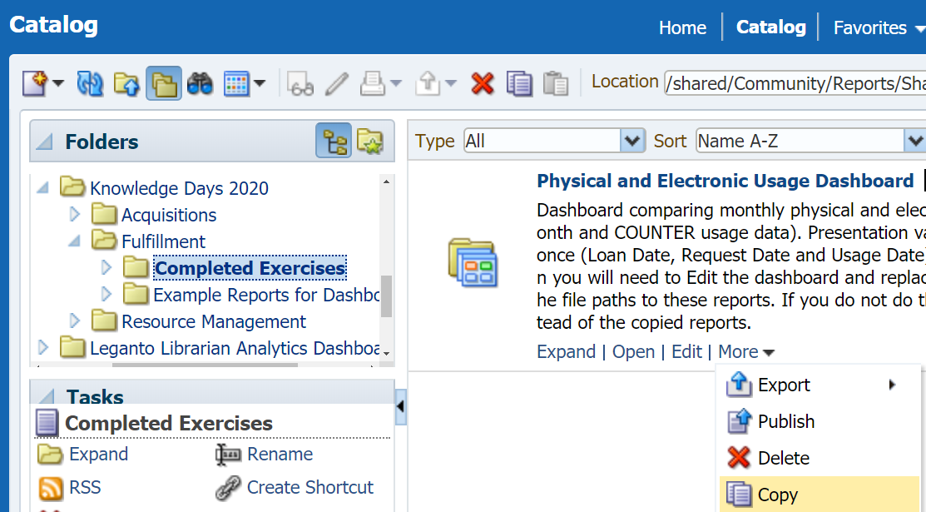

Go to the folder you want to copy the dashboard into and click the Paste icon:

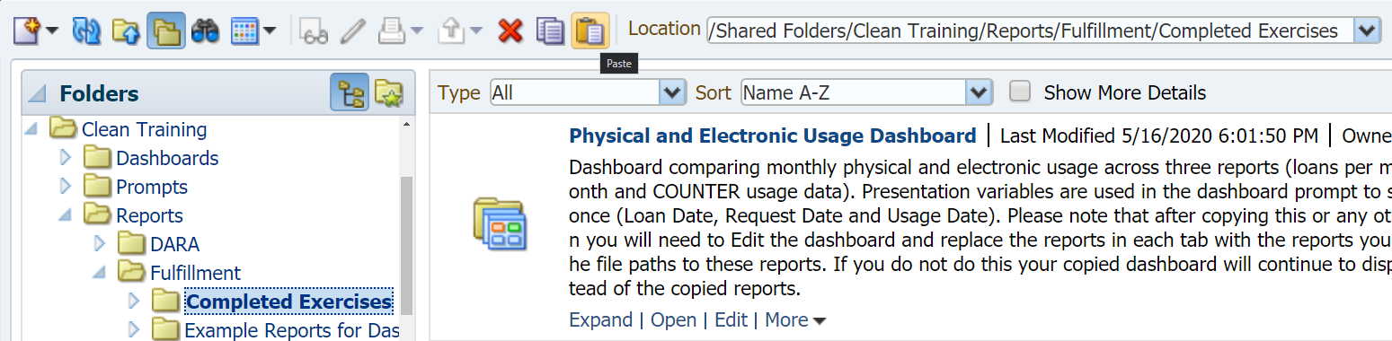

At first glance the dashboard may seem fine, however if you highlight one of the reports, click Properties (the XYZ icon), select Edit Analysis and then check the URL of the report you are redirected to you will find that the original report is still being used:

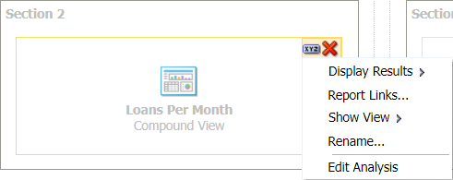

Even though we copied Physical and Electronic Usage Dashboard from the Community folder to our institution folder, the links to these reports are still going to the reports in the Community folder. As a result, we would not see any changes in our dashboard if we modified the copied reports.

To fix this issue we need to add the copied versions of our prompts and reports to the dashboard and then remove the original prompts and reports (the originals can be deleted first, but adding the copied reports and prompts first makes it easier to preserve the way that our dashboard was organized). In the screenshot below we have added our copied reports and prompt from Shared Folders/Clean Training/Reports/Fulfillment/Completed Exercises/Physical and Electronic Usage Dashboard into the dashboard (the original reports and prompt saved to the Community folder appear on top in each section):

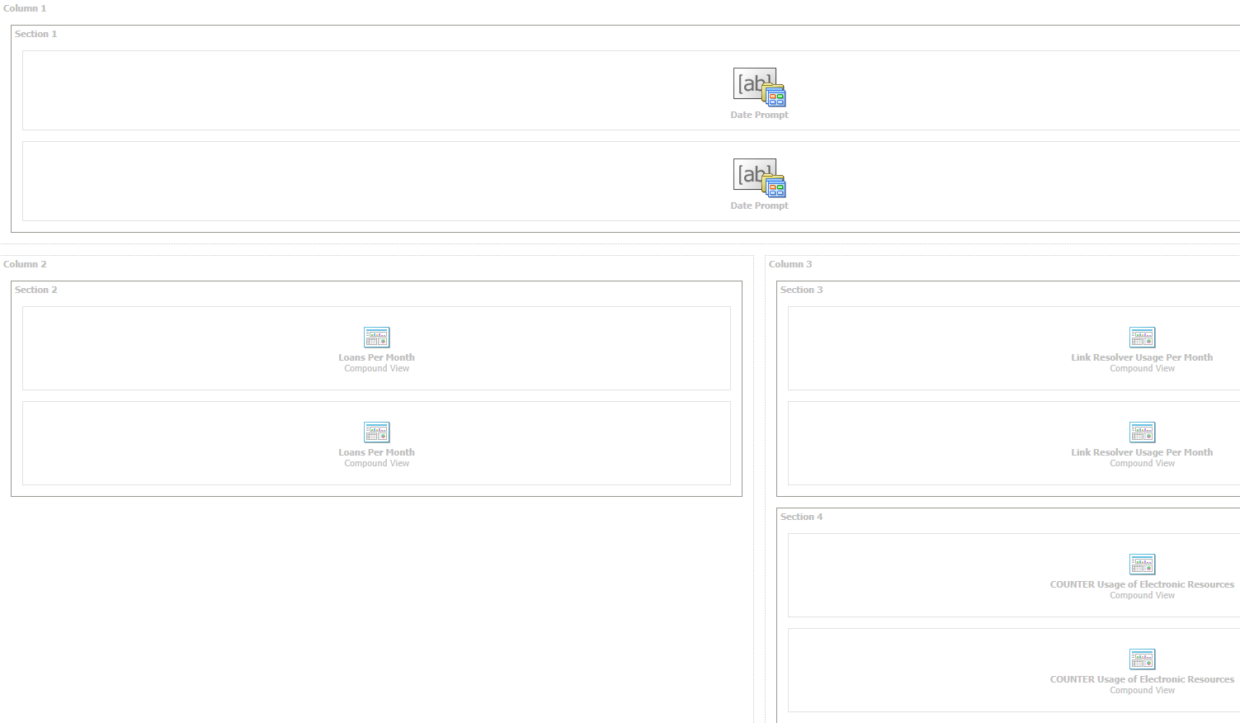

Next, hover over the original reports and prompts until a red X appears. Click the X to delete the report or prompt, leaving only the copied versions of the reports and prompts. In this screenshot we have removed all but the original Date Prompt to show the delete icon:

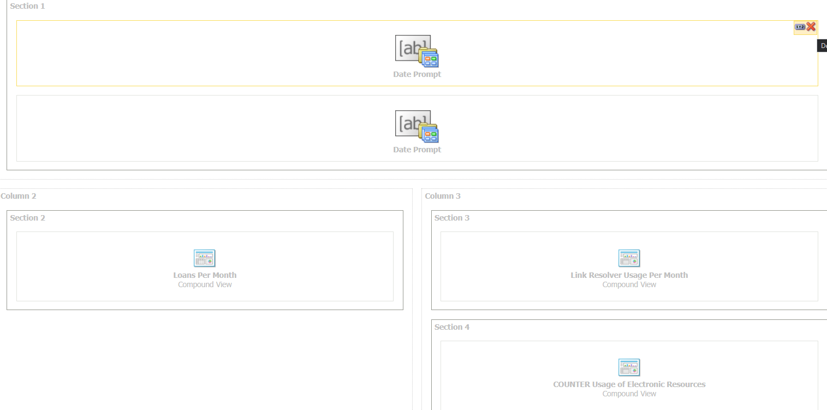

Save these changes and the dashboard will now use the versions of the reports and prompt that you copied to the new location. You will need to repeat these steps any time you copy or move the dashboard unless you do not want to move the reports and prompt with it.

