Alma Collaborative Networks: Introduction

1. Alma Collaborative Networks - Introduction

1.1 Alma Collaborative Networks: Introduction
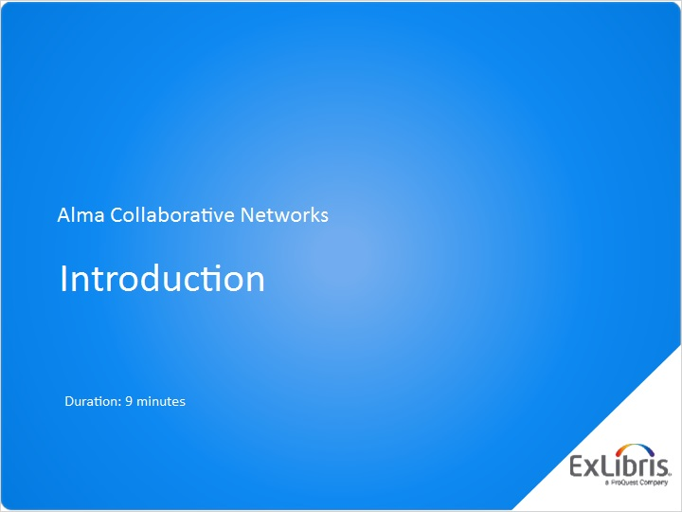
Notes:
Hello, and welcome to this introductory session on Alma Collaborative Networks.

1.2 Collaborative-Network Structure and the Network Zone
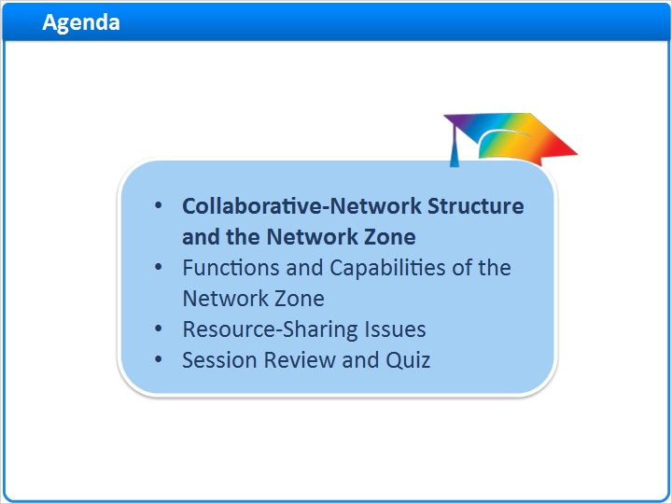
Notes:
In this session, we’ll start by looking at the structure of a collaborative network in Alma, which is sometimes called a consortium, and how the Network Zone works.

Next we’ll examine the functions and capabilities of the Network Zone.

Then we’ll discuss some key issues in resource sharing in a collaborative network.

Finally, after a session review, there will be a short quiz to test your knowledge.

1.3 Collaborative-Network Organizational Structure
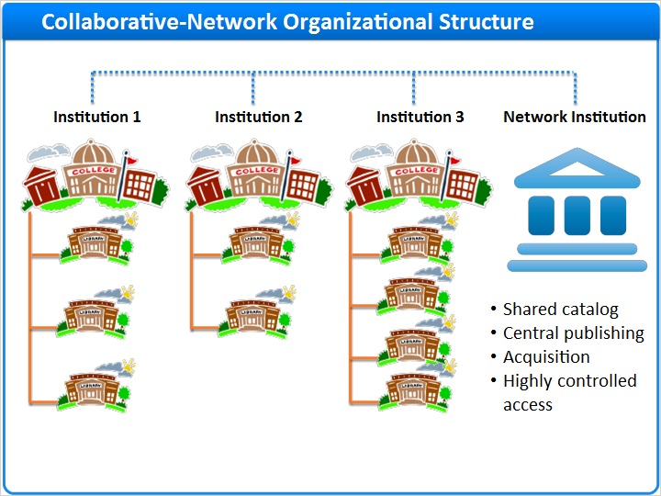
Notes:
All institutions that use Alma are made up of several levels in an organizational hierarchy.

Each institution has their own Alma instance, provided by Ex Libris.

Institutions contain libraries, each of which has locations that provide items for fulfillment, and so on.

However, when institutions choose to organize as a collaborative network within Alma, Ex Libris will create a new, “virtual” institution: The Network Institution.

Only member institutions in your collaborative network will have access to this network institution. Institutions will be able to easily share resources with each other, and the Network Institution can be a central place to share a catalog, publish centrally to a discovery service, collaborate on acquisition, and much more.

While all member institutions will have access to content in the Network Institution, only a few staff members in your collaborative network will be able to log in to the Network Institution as though it was an institution itself. Other staff at member institutions will access the Network Institution through the Network Zone. So let’s talk about the Zones.

1.4 The Zones
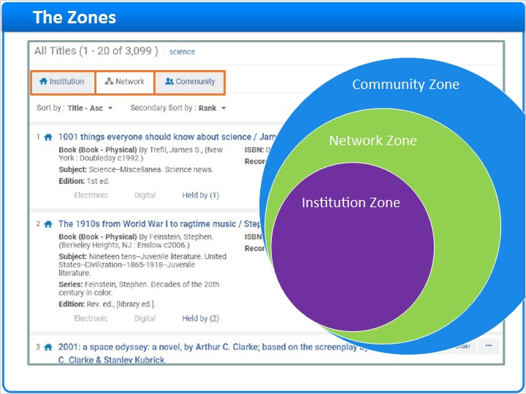
Notes:
You are probably familiar with your Institution Zone … that is, the biblographic records, holding records, and item records of your institution’s inventory and subscriptions.

You may also be familiar with the Community Zone, which is the Alma Knowledge Base from which you can get bibliographic data - mostly for electronic resources - shared by both Ex Libris and other Alma institutions throughout the world.

In Alma Collaborative Networks, there is a third zone: The Network Zone. This is the manifestation of your Network Institution. where member institutions of an Alma collaborative network can share the management of metadata records and acquisitions, and can choose to share other Alma services, such as fulfillment, resource sharing, vendor information, and administration tables.

When searching for resources in Alma, you can choose whether your search will look in your own Institution Zone, your collaborative Network Zone, or the Alma Community Zone.

1.5 Functions and Capabilities of the Network Zone
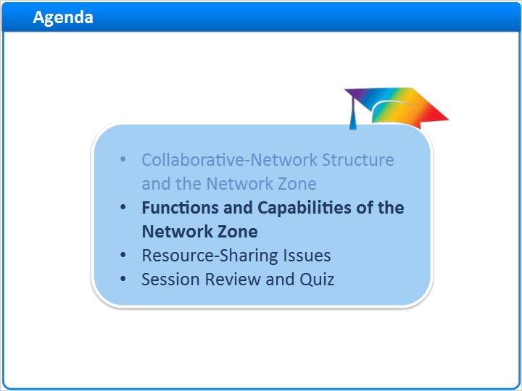
Notes:
Now let’s examine the functions and capabilities of a Network Zone.

1.6 Synchronized Bibliographic Records
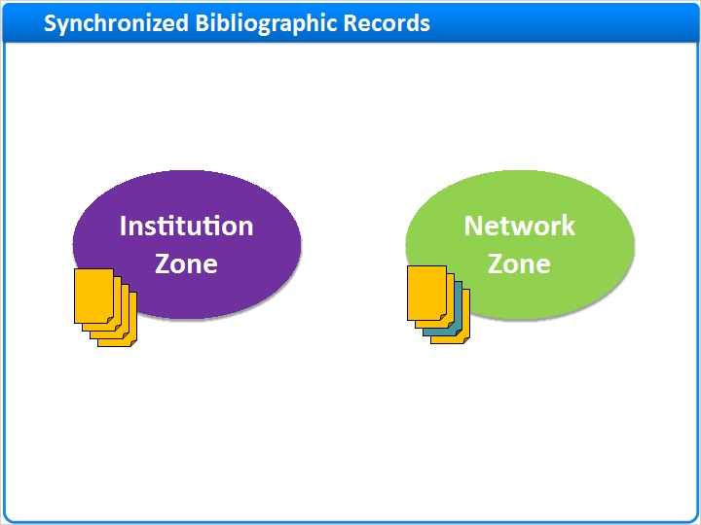
Notes:
In the same way that you can link bibliographic records in your Institution Zone with those in the Community Zone, Institution Zone bibliographic records that are linked to bibliographic records managed in the Network Zone are automatically updated with any modifications that take place in the Network Zone.

1.7 Centralized Publishing
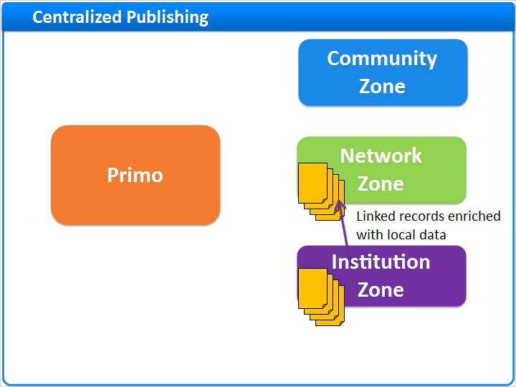
Notes:
The Network Zone also can provide centralized publishing. The Network Institution can publish into Primo the following types of bibliographic records for the member institutions:

- All records that are managed by the network only.

- All records to which one or more members are linked. The network records are enriched with local data from members, such as course information, local fields, availability, electronic availability, and so on.

- Each member’s local bibliographic records. The ability to run the job from the Network Zone institution helps prevent duplication of records that may occur in Primo if each institution in the network were to run publishing separately.

1.8 OpenURL Link-Resolving
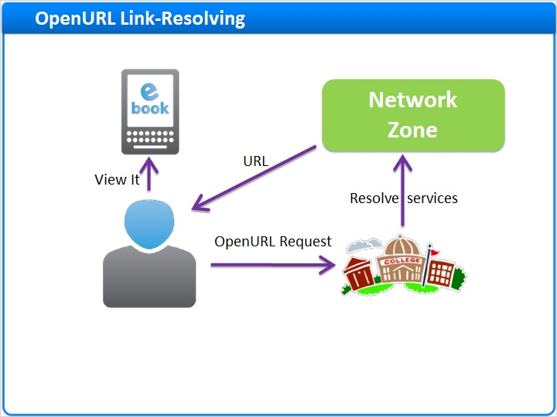
Notes:
You can also configure OpenURL link-resolving to include electronic services for electronic resources managed in the Network Zone.
When enabled, any OpenURL request to the Alma Link Resolver checks the Network Zone to resolve electronic services that are available for the institution. The electronic services are presented in the View It tab of the Alma Link Resolver's services page.

1.9 Acquisitions
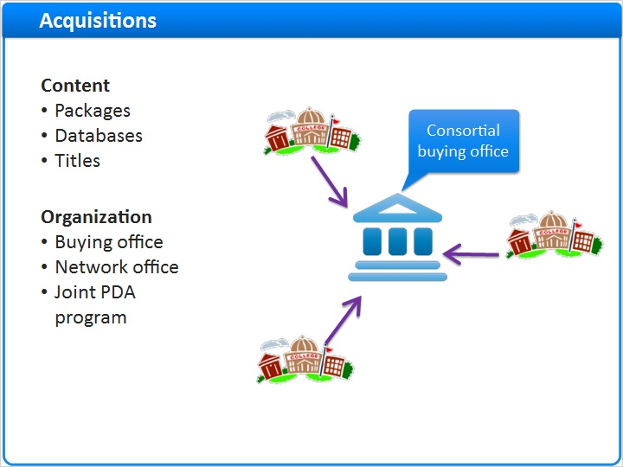
Notes:
Member institutions of a network can collaborate on acquisitions by purchasing and negotiating e-resources jointly, such as packages, databases, and individual titles.

These collaborative networks usually have some organization supporting the joint acquisitions activities, such as a consortial “buying” office, or a Cataloging Network “office,” and so on.

You can also use an institution-level patron-driven acquisitions program in the context of the Network Zone. Candidate bibliographic records can be imported from the Institution Zones and uploaded or linked to the Network Zone bibliographic records.

1.10 Managing E-Resources
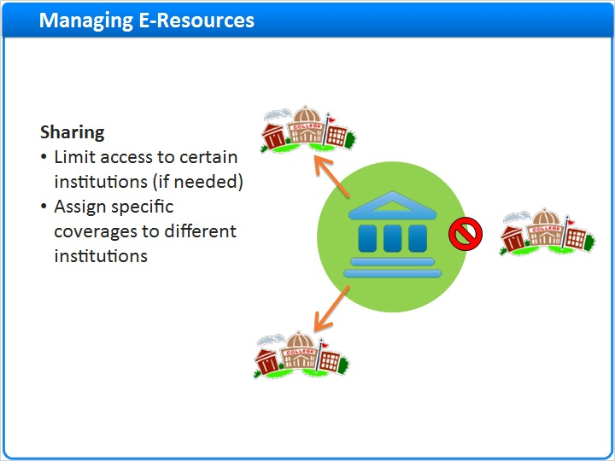
Notes:
In a collaborative environment, electronic resources can be managed centrally in the Network Zone. In some cases, there are requirements to limit access to electronic resources to a certain group of member institutions within the collaborative network. That is, the electronic resources in the Network Zone are not available to all the patrons across the entire collaborative network, or specific coverages are assigned to different institutions.

In order to address this requirement and manage which members in the Network Zone have access to the electronic resources, Alma provides the “Available For” functionality; that is, configurable inventory-management groups. The purpose of inventory management groups is to provide the capability of limiting access to identified electronic resources.

Inventory Management Groups (Slide Layer)
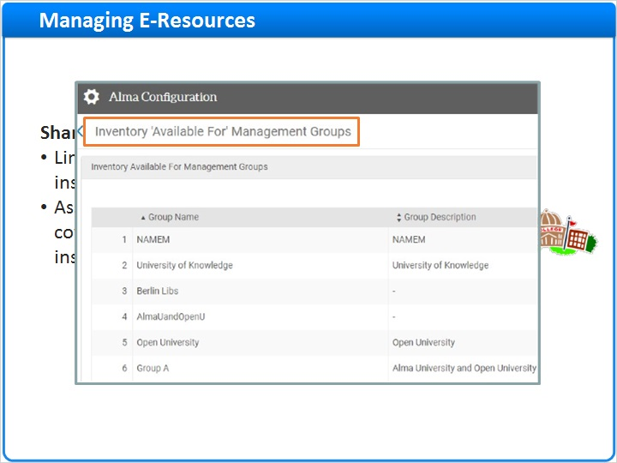

1.11 Network Functions
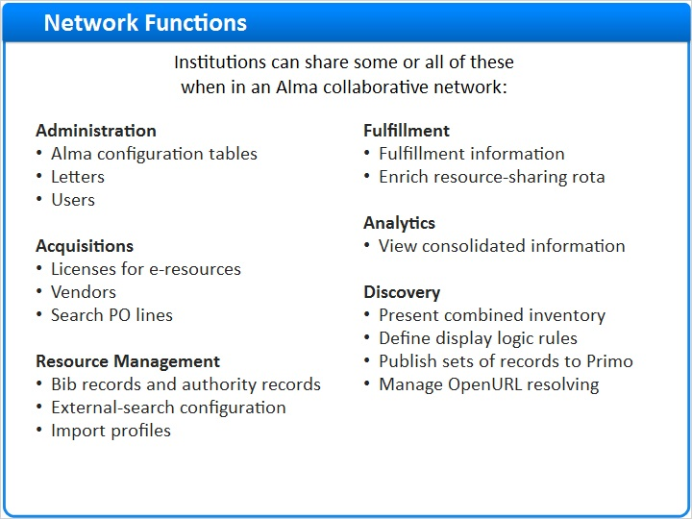
Notes:
Network Zones have many capabilities:

For Alma administrators, institutions can share Alma configuration tables, letters, and - perhaps most importantly - user information.

In Acquisitions, institutions can share licenses for e-resources, vendor data, and provide visibility to purchase-order lines.

In Resource Management, cataloging staff can share bib records and authority records, external search configurations, and import profiles.

Fulfillment information can be shared, and institutions can enrich resource-sharing rota.

When analytics are needed, institutions can view consolidated information.

And patrons trying to discover resources are especially helped with a collaborative network, because they can be presented with combined inventory; display-logic rules can be defined throughout the network; you can publish to Primo much more easily and with fewer duplication errors; and you can manage OpenURL resolving.

1.12 Resource-Sharing Issues
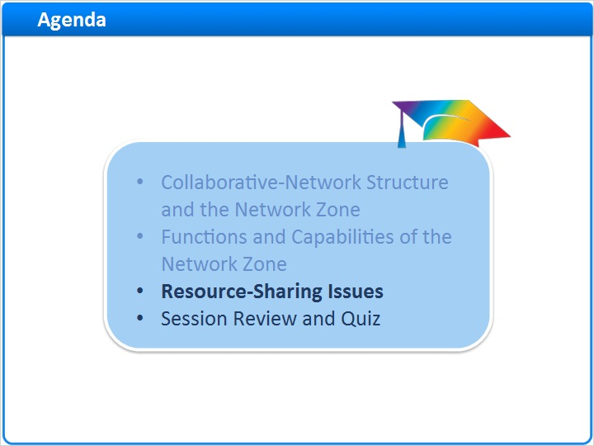
Notes:
Next, we’ll discuss some key issues in resource sharing in a collaborative network.

1.13 Resource Sharing
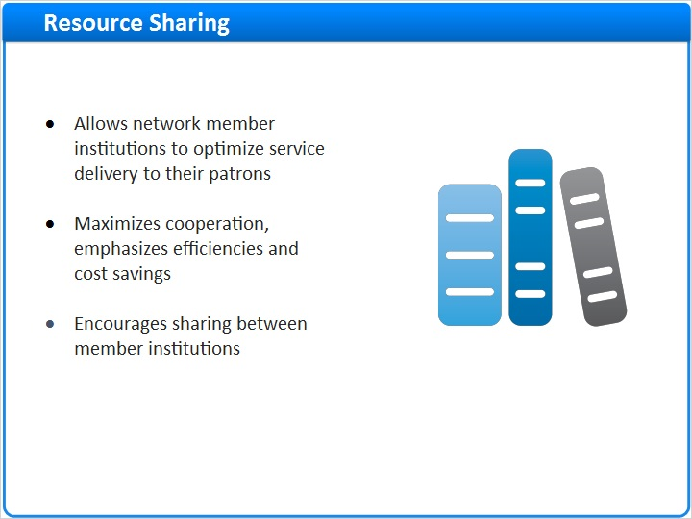
Notes:
In a broad sense, resource sharing is just a way for institutions to allow their patrons to have access to resources outside the patrons’ home institution.

Alma helps institutions maximize cooperation and save costs: Instead of purchasing resources every time a patron wants something the institution currently does not have, an institution can find another source that is less expensive.

And Alma encourages this sharing because Alma’s tools speed up workflow and reduce staff effort.

1.14 General Requirements
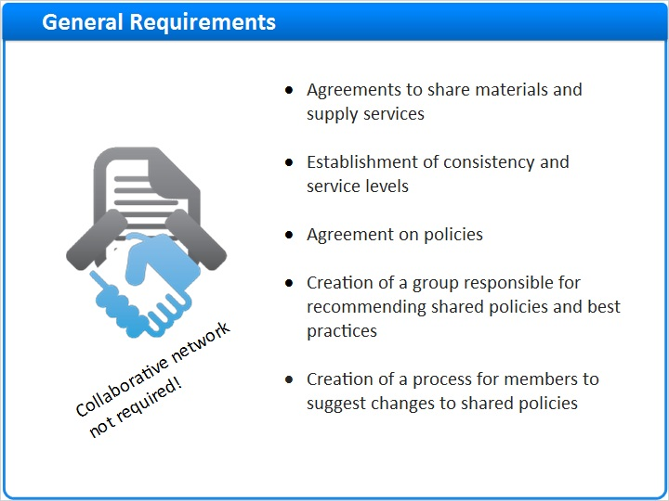
Notes:
Resource sharing does not require that institutions belong to a collaborative network with a network zone. But it does require some things to be worked out in advance, and here are a few of the key ones:

Institutions have to agree how they will share materials and supply services.

They will need to establish service levels, and agree on lending policies.

The institutions need to create a group responsible for recommending those shared policies and best practices.

And there needs to be a process for institutions to suggest changes to those shared policies.

There is much more information about resource sharing in the next training session in this series.

1.15 Session Review and Quiz
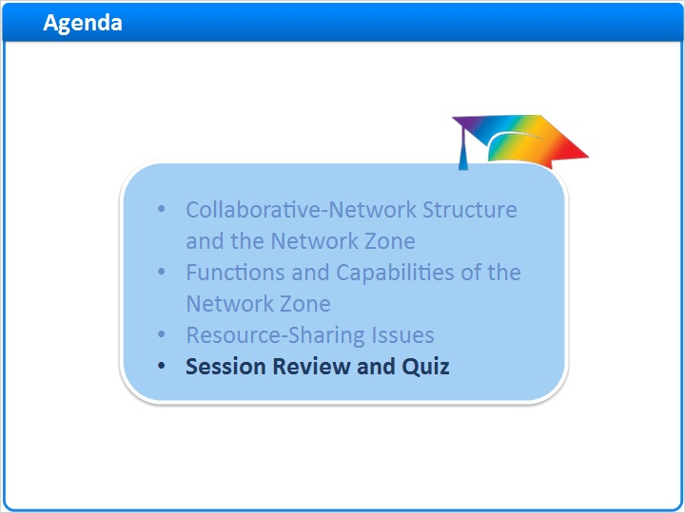
Notes:
That concludes the main portion of this training session. Let’s briefly review what was covered and then proceed to a short quiz.

1.16 Session Review
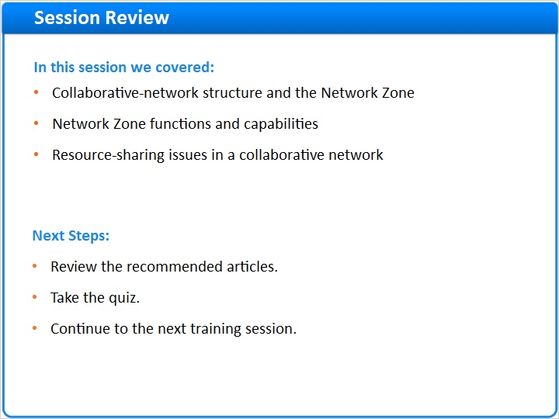
Notes:
In this session we began by showing the structure of collaborative networks, including use of the Network Zone.

Next we examined the functions and capabilities of a Network Zone.

Finally, we discussed some key issues in resource sharing in a collaborative network.

Please refer to the Recommended Articles section where you launched this training session for additional information.
After the short quiz that begins on the next page, you can continue on to the next training session in this series.

1.17 Quiz: Linking Records to Network Zone
(True/False, 10 points, 1 attempt permitted)
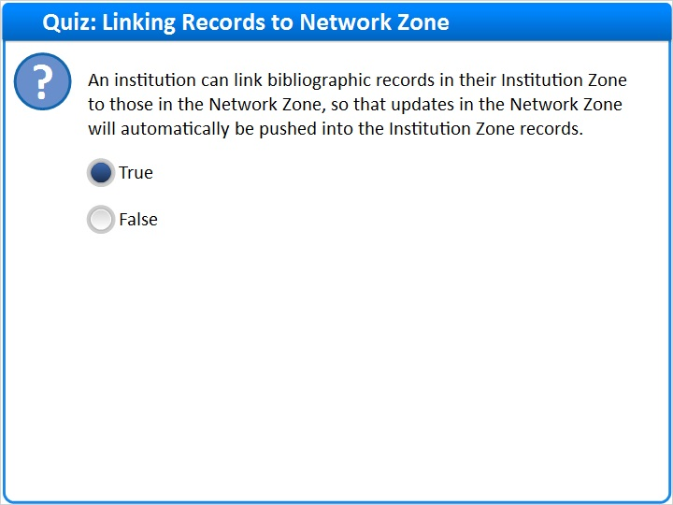
Correct | Choice
X | True
 | False
Feedback when correct:
Yes, this statement is true. Bibliographic records in an Institution Zone can be linked to matching records in the Network Zone, so that updates in the Network Zone will automatically be pushed into the Institution Zone records.
Feedback when incorrect:
That is not correct. This statement is actually true. Bibliographic records in an Institution Zone can be linked to matching records in the Network Zone, so that updates in the Network Zone will automatically be pushed into the Institution Zone records.

Notes:

Correct (Slide Layer)
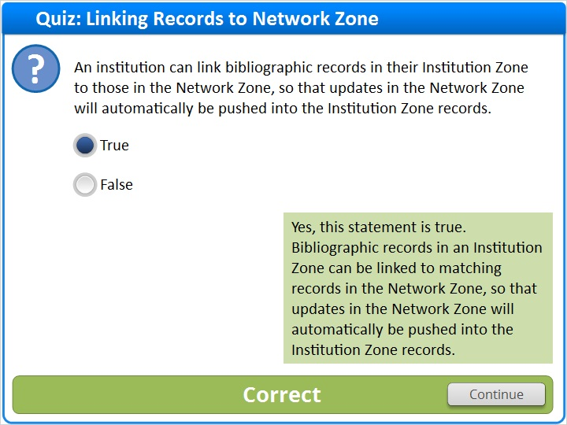

Incorrect (Slide Layer)
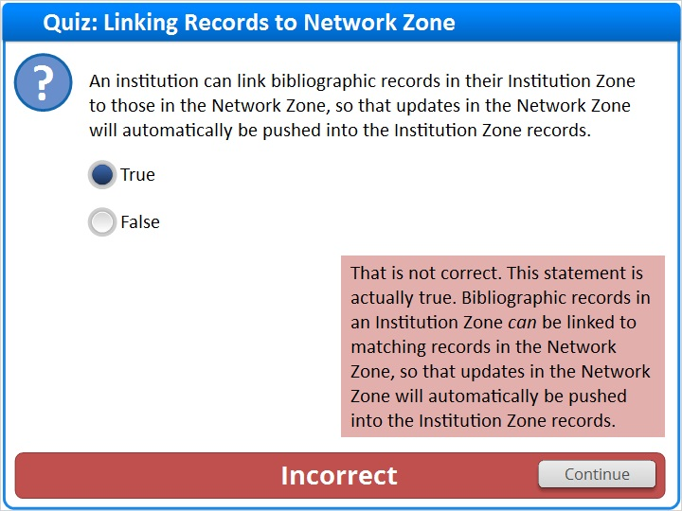

1.18 Quiz: Collaborative Networks and Resource Sharing
(True/False, 10 points, 1 attempt permitted)
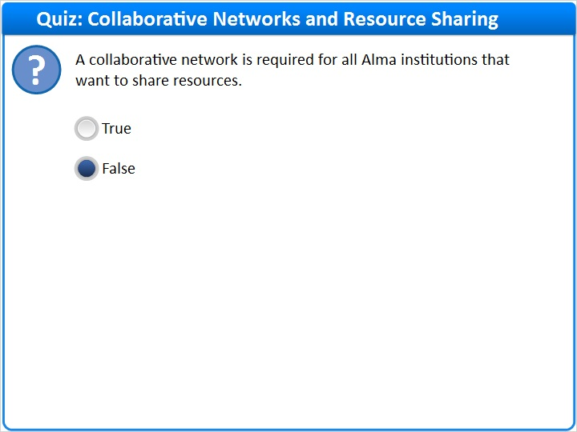
Correct | Choice
 | True
X | False

Feedback when correct:
Correct, this statement is false. Institutions that want to share resources do not need to be in a collaborative network. Sharing resources can occur inside and outside a collaborative network.
Feedback when incorrect:
That is not correct: This statement is false. Institutions that want to share resources do not need to be in a collaborative network. Sharing resources can occur inside and outside a collaborative network.

Notes:

Correct (Slide Layer)
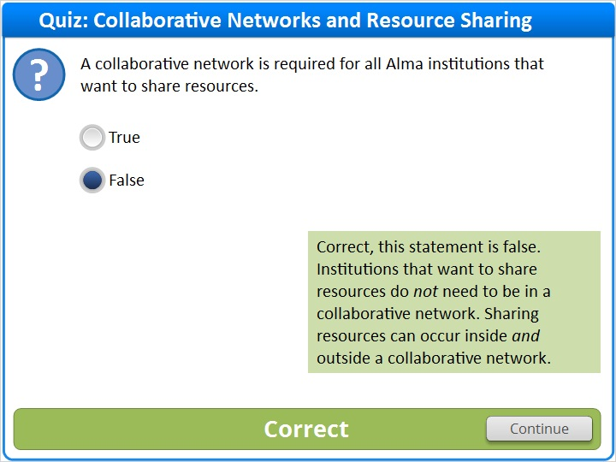

Incorrect (Slide Layer)
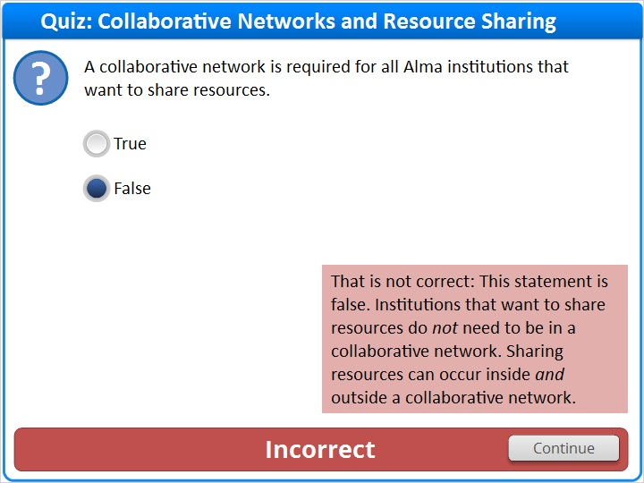

1.19 Thank You!

Notes:
Thank you for joining this session!

1.20 Copyright
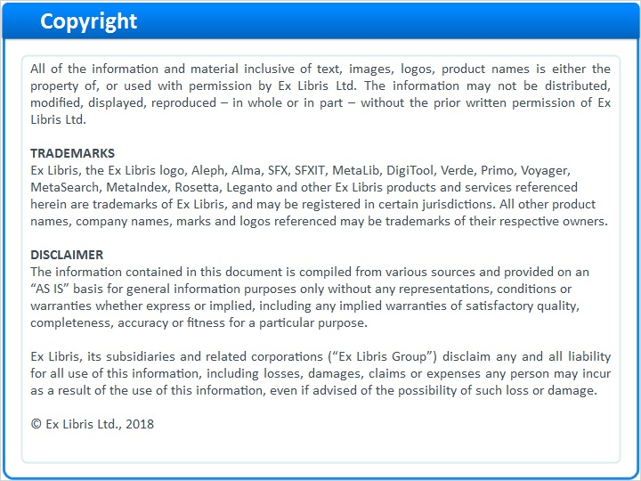
Notes:

1.21 Results Slide
(Results Slide, 0 points, 1 attempt permitted)
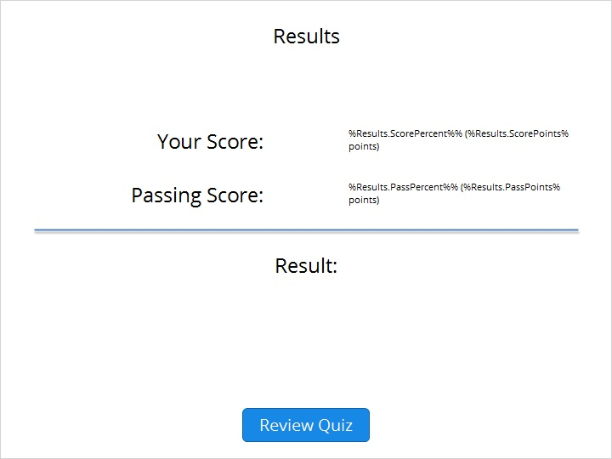

Results for
1.17 Quiz: Linking Records to Network Zone
1.18 Quiz: Collaborative Networks and Resource Sharing

Result slide properties
Passing  Score | 80%

Success (Slide Layer)
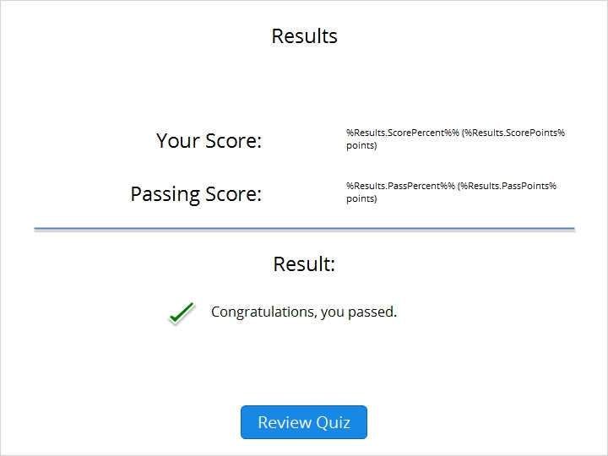

Failure (Slide Layer)


