Cataloging Activities in the Network Zone - Part 1 - Edit, Copy, Share Records

1. Cataloging Activities in the Network Zone - Part 1 - Edit, Copy, and Share Records

1.1 Alma Collaborative Networks: Cataloging Activities in the Network Zone, Part 1: Edit, Copy, and Share Records
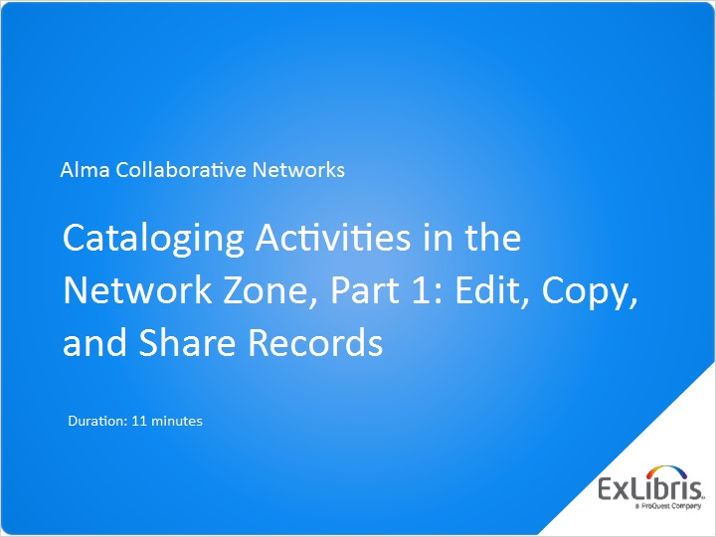
Notes:
Hello, and welcome to this Alma Collaborative Networks session, where we will discuss cataloging activities in the Network Zone.

1.2 Caution: These Changes Affect Everyone!
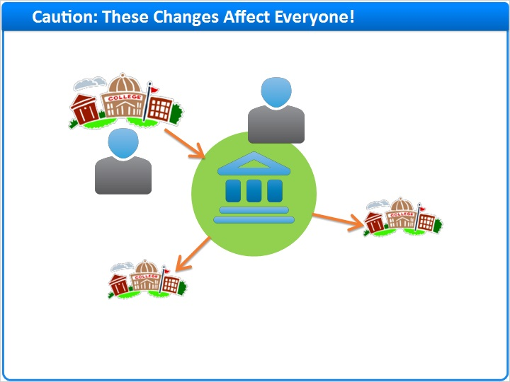
Notes:
Before we get started, there is one important caution to remember:

When you make changes to a bibliographic record in the Network Zone, those changes affect all the member institutions that use that Network-Zone record.

And, because catalogers at member institutions have the ability to change records in the Network Zone from within the Alma of their institution, your collaborative network should define procedures and rules about how such changes are made.

Many of the cataloging activities described in this training session can easily be done in the Alma service of the Network Institution itself, at least for those staff members of the collaborative network who have authorization to log in to the Network Institution. But that is no different than cataloging activities done within Alma for any individual institution, and so that won’t be covered in this session. Instead, we’ll be concentrating on how catalogers can make changes to Network-Zone records while logged into their member institution’s Alma service.

1.3 Edit Records
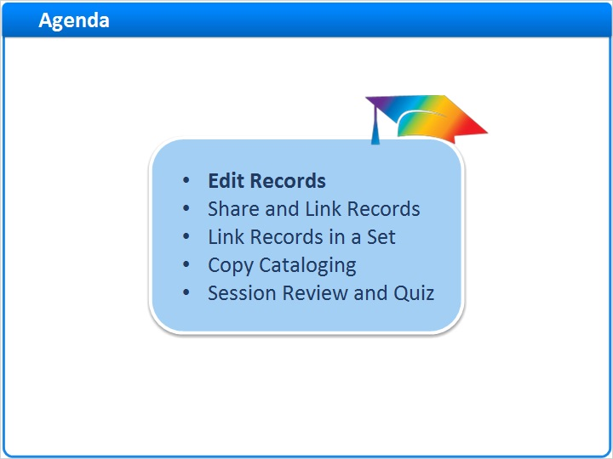
Notes:
This session will cover several areas of cataloging in the Network Zone, including editing, sharing, linking, and copying bibliographic records.

Let’s begin with editing records in the Network Zone.

1.4 Find Bibliographic Record in Network Zone
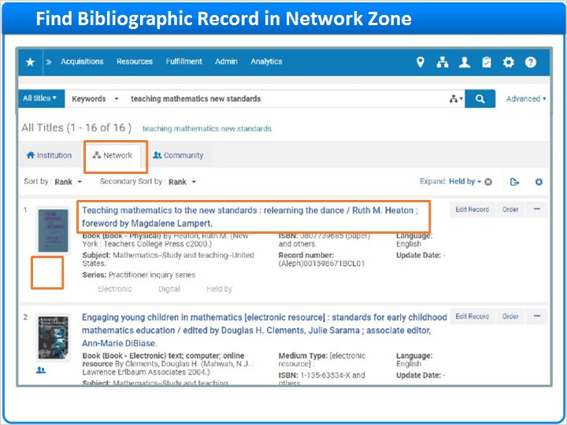
Notes:
First, from within your institution’s Alma, search your collaborative-network’s Network Zone.

You can see that this item is not part of your institutional holdings, because there is no institution icon.

To view the bibliographic record before editing, click on the title of the item.

1.5 Edit the Record
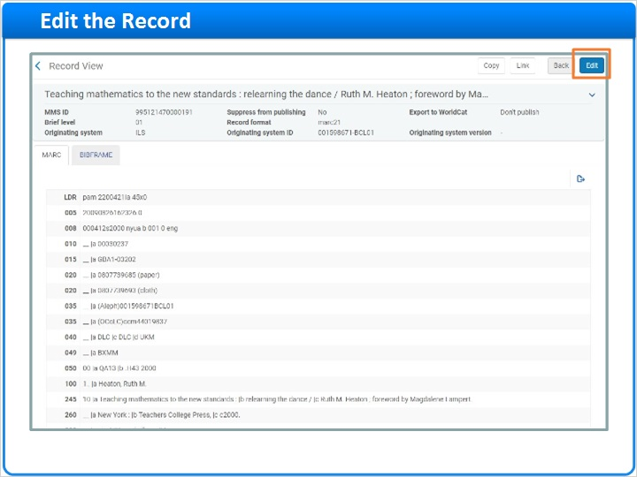
Notes:
After you confirm that this bib record is the one that you want to work on, click Edit in the upper-right corner.

The bib record opens in the Metadata Editor and is ready for editing. All of the usual cataloging activities may occur: Fields may be deleted or added; corrections may be made; and local information may be added.

In this example, the author’s name has been edited to include a full middle name rather than the middle initial only.

After making the changes, Save the Record.

Edit (Slide Layer)
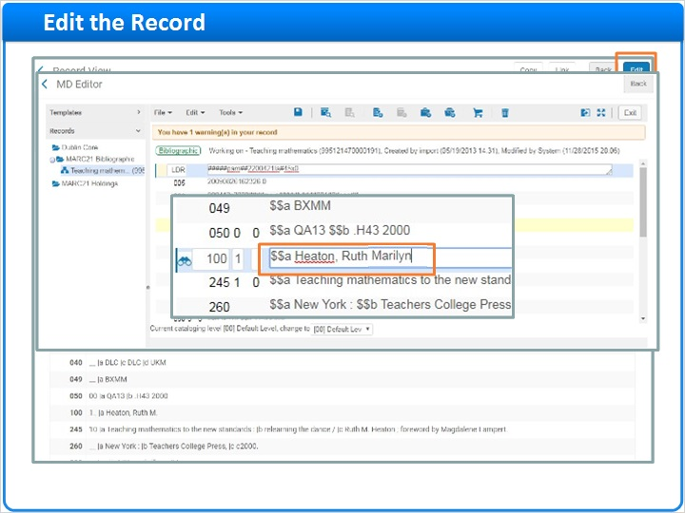

Save (Slide Layer)
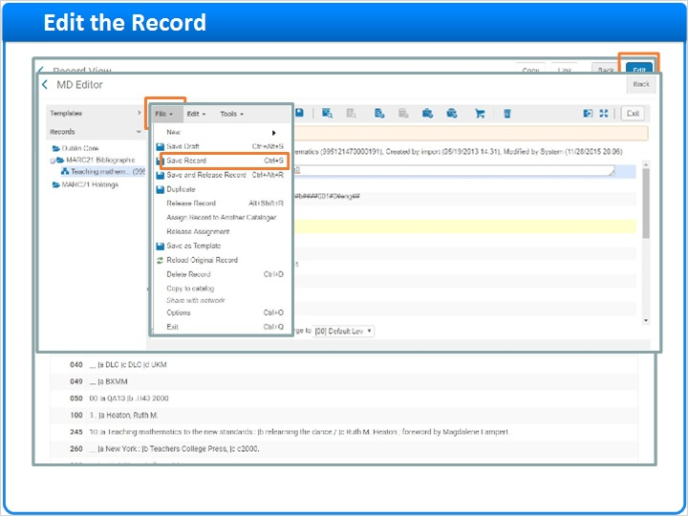

1.6 Updated Record in Repository
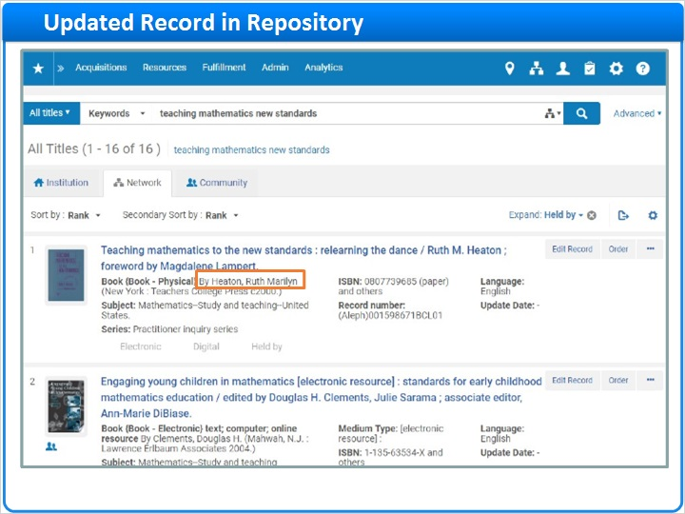
Notes:
Here you can see the results of the updated record when you search again in the Network Zone.

Any other institutions in your collaborative network that use this record now have those changes.

1.7 Share and Link Records
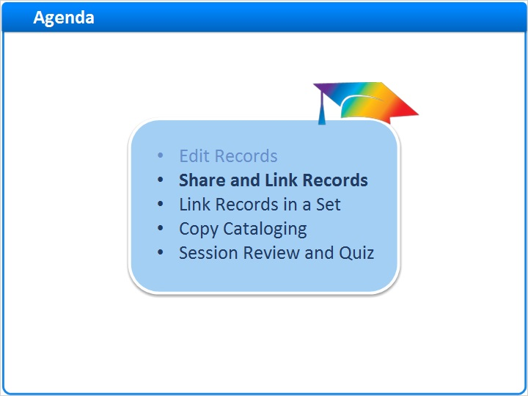
Notes:
Now, let’s discuss sharing and linking records with the Network Zone.

1.8 Sharing Records with Network
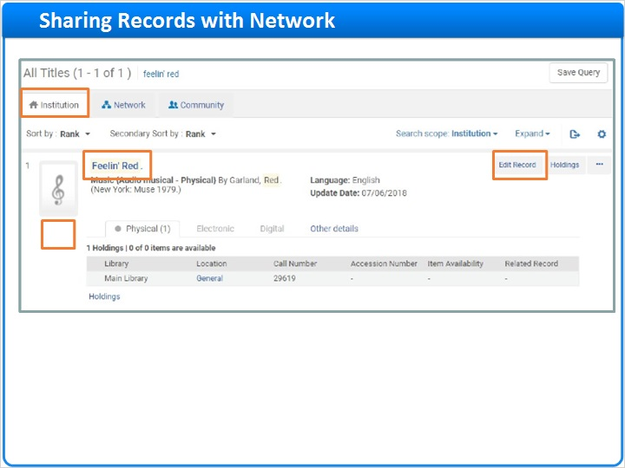
Notes:
If you have a bibliographic record in your Institution Zone that doesn’t exist in the Network Zone, you can share it, so that other member institutions in your collaborative network can use it.

From within the Alma service of your member institution, find the record in your Institution Zone. Note that it doesn’t link to any records in the Network Zone, and when you switch to the Network tab, it isn’t there, either.

Back on the Institution tab, click Edit Record to go to the Metadata Editor.

Select File menu, Share with network.

Alma will move the bib record to the Network Zone, and then the Metadata Editor screen will clear. Now, your Institution-Zone bib record is really just a reflection of the Network-Zone record. Any changes made to the Network-Zone record will be reflected in your Institution-Zone record. Other institutions in your collaborative network can use the bib record by searching the Network Zone.

Network Tab (Slide Layer)
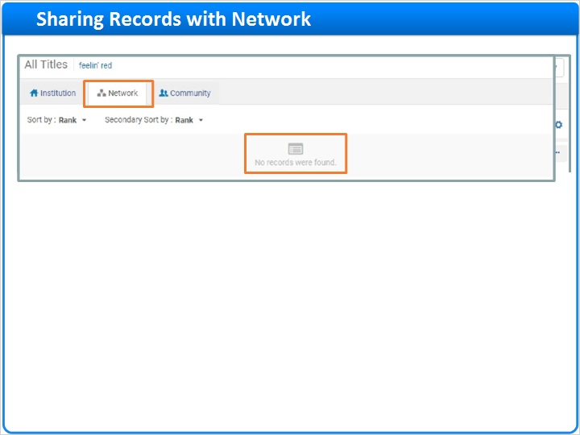

Metadata Editor (Slide Layer)
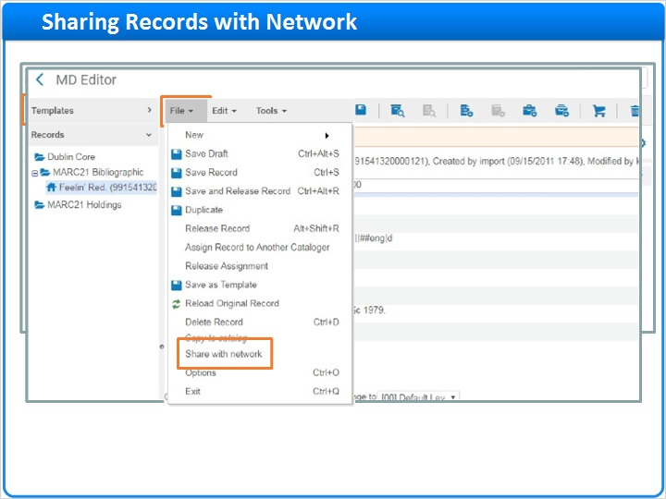

Metadata Editor after Sharing (Slide Layer)
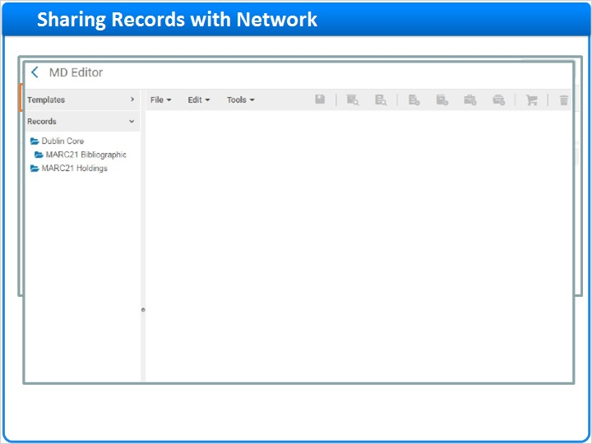

Search IZ (Slide Layer)
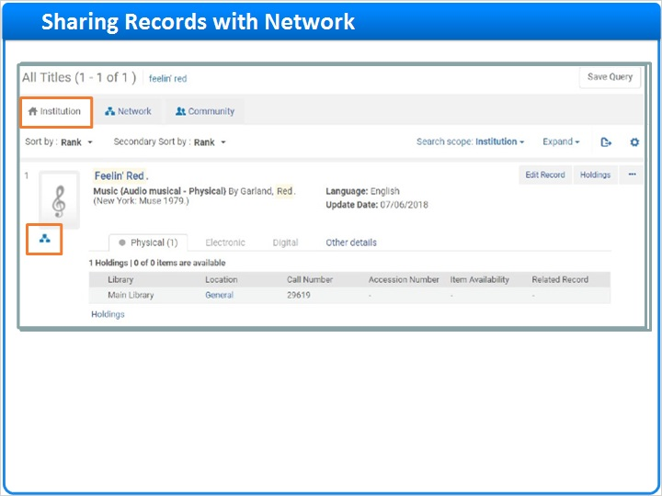

1.9 Linking Records to Network
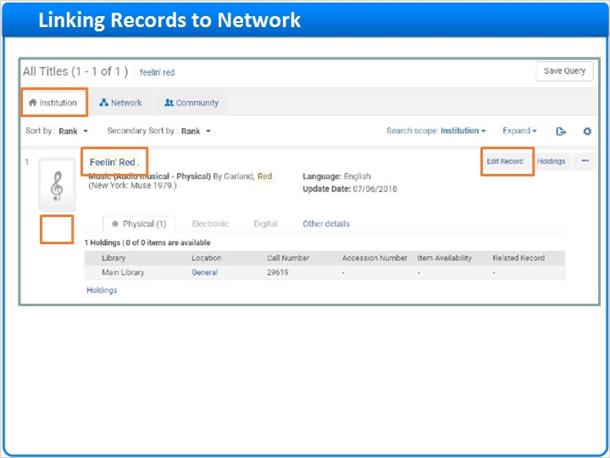
Notes:
On the other hand, if the Network Zone already has the bib record, but your Institution-Zone bib record isn’t connected to it, you can link them together.

Again, from within the Alma service of your member institution, find the record in your Institution Zone. Note that it doesn’t link to any records in the Network Zone, but when we switch to the Network tab, it is there.

Back on the Institution tab, click Edit Record to go to the Metadata Editor.

Select File menu > Share with network.

This time, instead of just moving the bib record to the Network Zone, Alma finds the matching record, and asks whether you want to view it before saving. If you choose No, then another copy of the bibliographic record -- not necessarily an exact duplicate -- would be added to the Network Zone, and your record in the Institution Zone will be associated with that new record.

Instead, choose Yes, to view the matching records.

The matching record in the Network Zone appears in the split-screen view. To confirm the match, View the record. When you are satisfied that the records match, click Link to associate the Institution version of the record with the Network version of the record.

Searching the Institution Zone and the Network Zone again, we see that the record is, indeed, linked. Again, your Institution-Zone record becomes just a reflection of the Network-Zone record, and any changes made to the Network-Zone record will instantly be reflected in your Institution-Zone record.

Network Tab (Slide Layer)
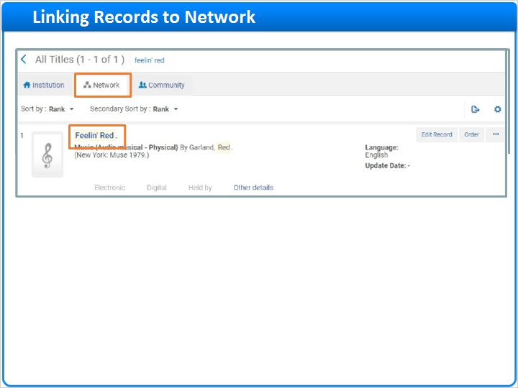

Metadata Editor (Slide Layer)
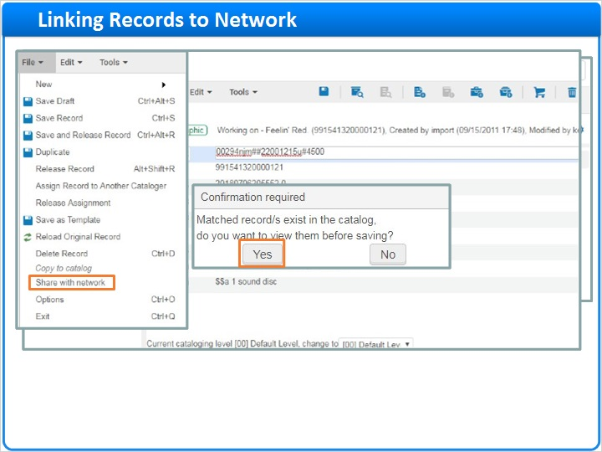

Matching (Slide Layer)
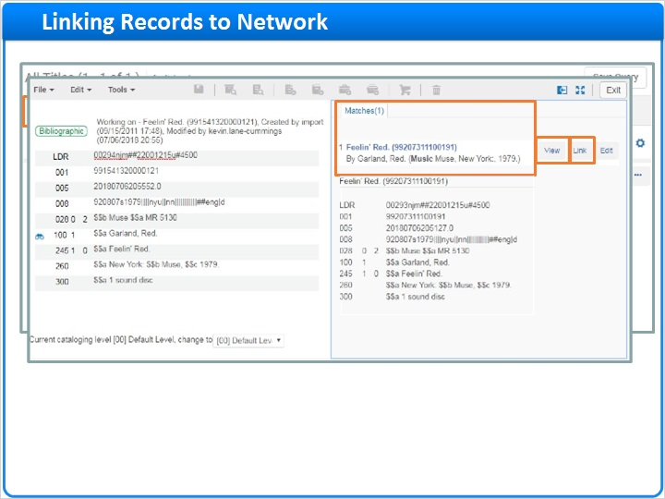

Confirmation (Slide Layer)
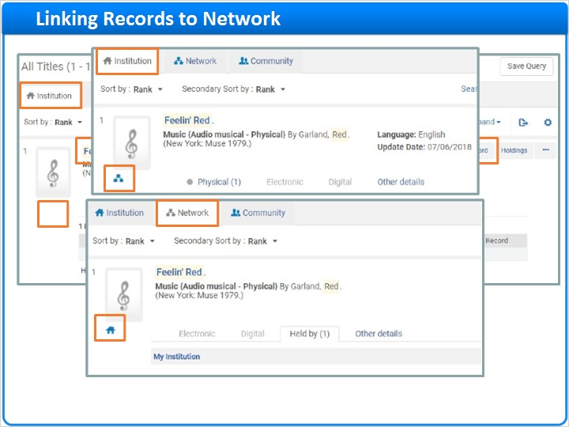

1.10 Link Records in a Set
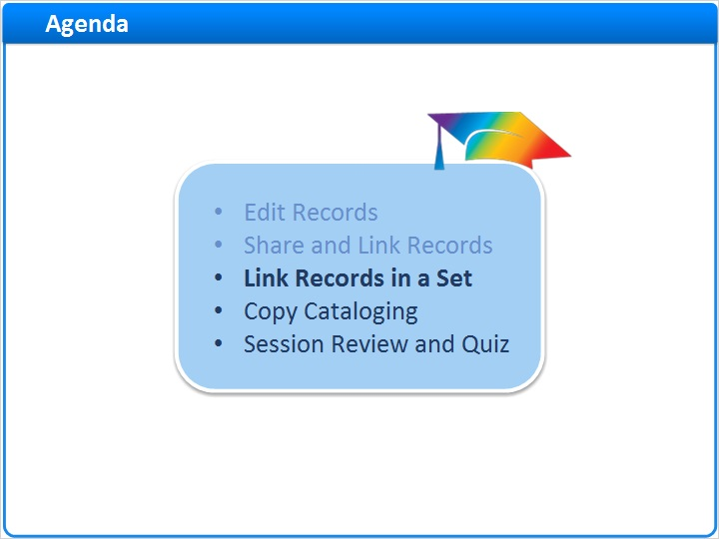
Notes:
Next, we will discuss linking records in a set.

1.11 Sets and Linking
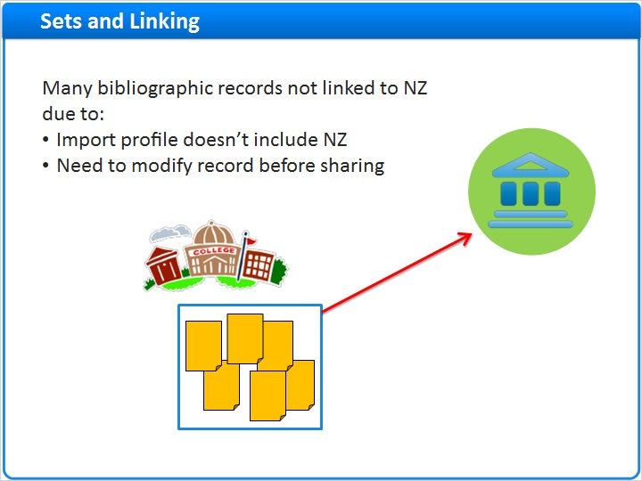
Notes:
There will be situations when many bibliographic records in your Institution Zone are not linked to the Network Zone. Reasons why this might occur include: An import profile is being used that does not include the Network Zone; or institutional import is used intentionally so that records may be modified before sharing with the Network.

When a large number of records requires linking, you can create a set of bibliographic records, which include local extensions, and then run a linking job.

1.12 Create the Set
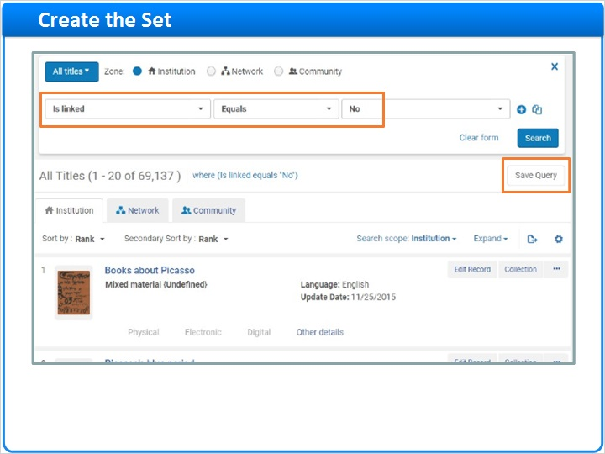
Notes:
Conduct searches to find items that are not linked to the Network Zone, by doing an Advanced Search for resources with the field “Is linked” equals “No.” Then Save the Query into a set.

Set Details (Slide Layer)
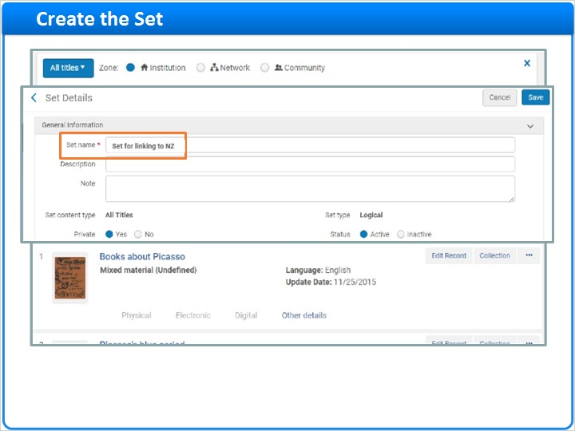

1.13 Run the Linking Job
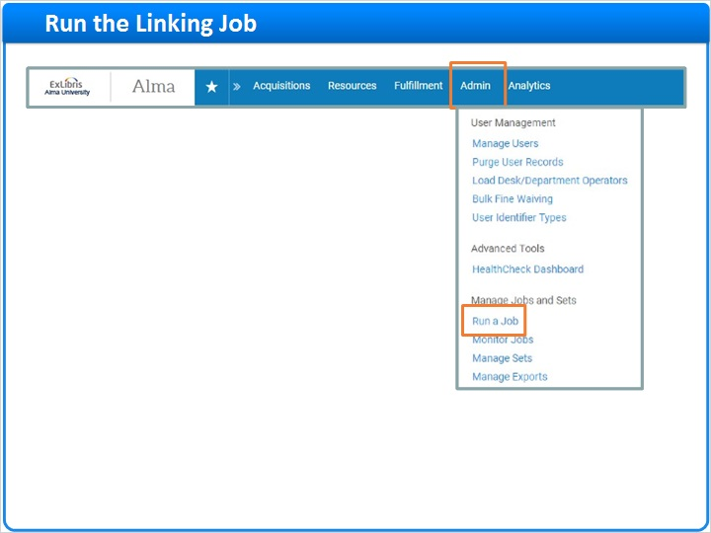
Notes:
Next, go to the Admin menu and choose Run a Job.

On the first page of the Run a Job wizard, find the job called Link a set of records to the Network Zone and click on the Next button. By the way, you may need to search for that job, because it might not be on the first page of jobs.

On the second page of the wizard, select your set of records that needs to be linked, and then click on the Next button again.

Now, select the match method you want to employ.

Also, notice the checkbox, Upon No Match - Contribute IZ. Place a check in this box if you wish to contribute records that fall in this category to the Network.

Click on the Next button.

Review and confirm your choices, and then click on the Submit button.

Select Job (Slide Layer)
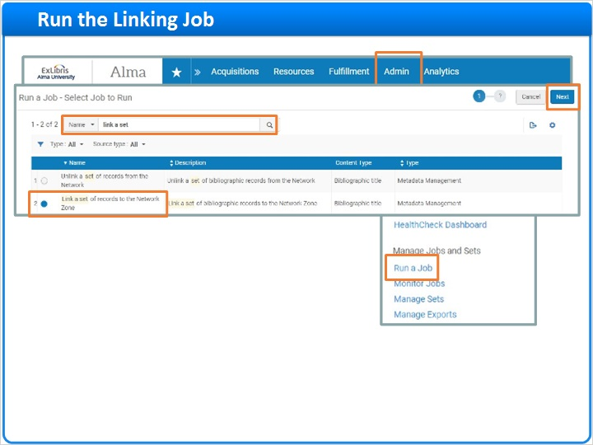

Select Set (Slide Layer)
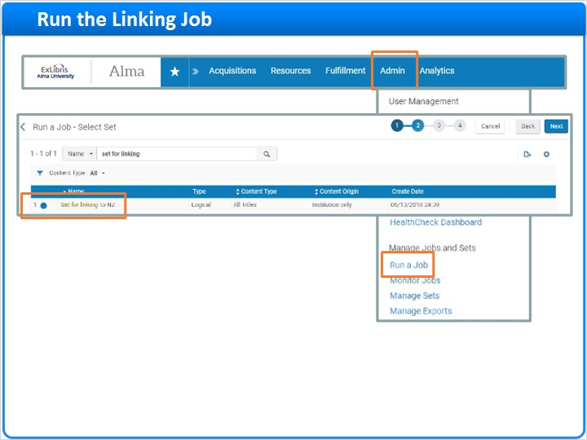

Enter Task Parameters (Slide Layer)
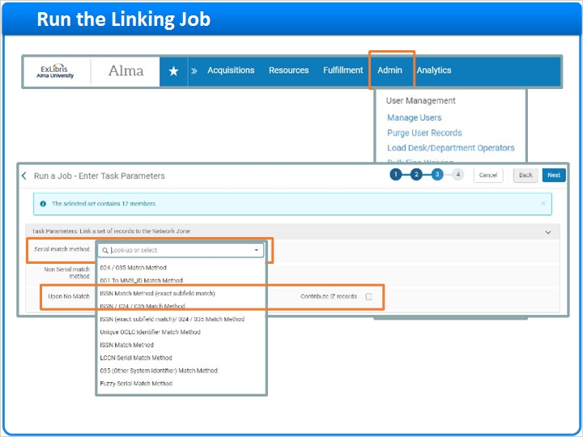

Review and Confirm (Slide Layer)
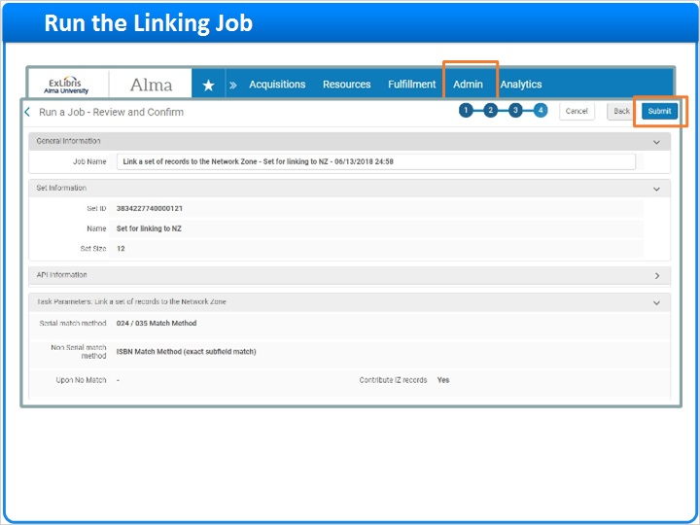

1.14 Review the Report
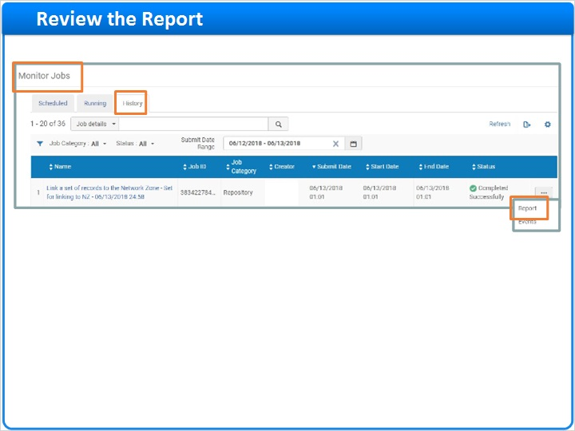
Notes:
Once the job has completed, go to the Monitor Jobs - History tab and select the report. You’ll learn how many records successfully linked and how many failed to link.

Job Report (Slide Layer)
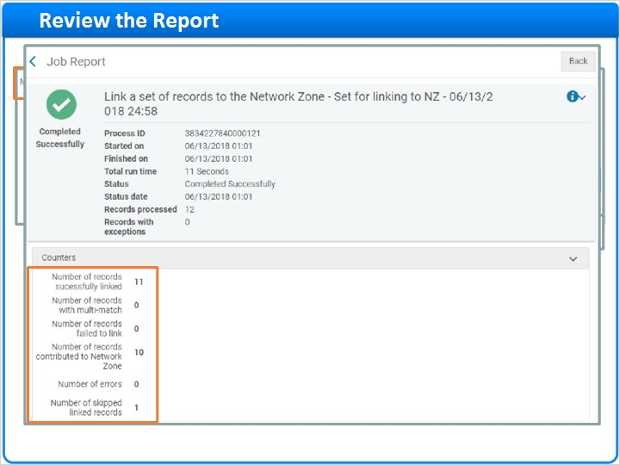

1.15 Copy Cataloging
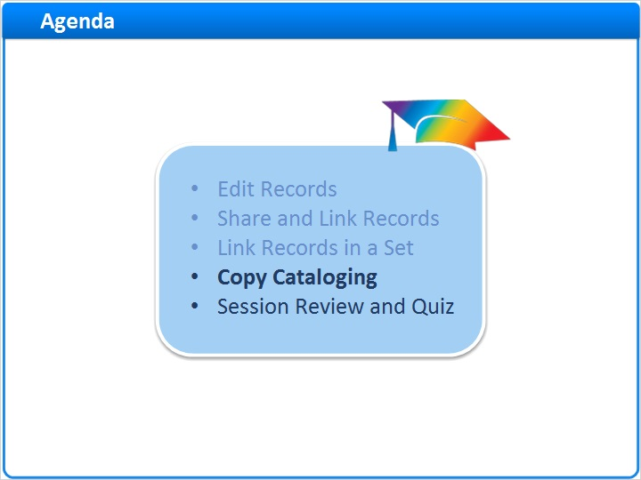
Notes:
Copy cataloging is another activity that occurs frequently in many collaborative networks.

1.16 External Source
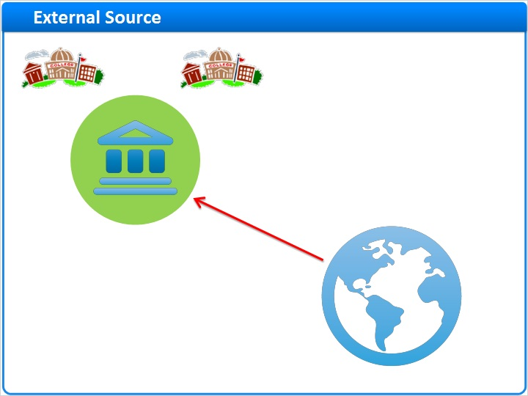
Notes:
There are times when you need to obtain a record that doesn’t exist in any institution in your collaborative network. In this situation, you may perform copy cataloging by importing records directly to Alma from an external source.

1.17 Choice of Workflows
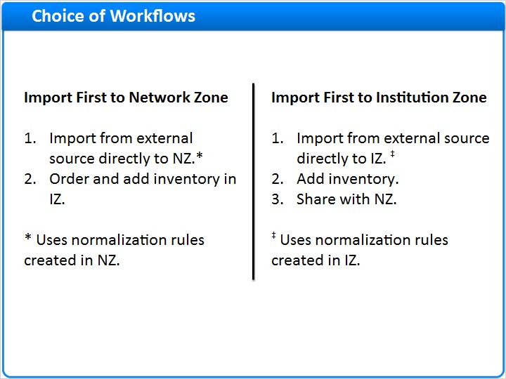
Notes:
There are two options available for copy cataloging with the Network Zone.

One option starts by importing the bibliographic record from the external source and saving it directly to the Network Zone. Then, at the member institutions, staff can order items to add holdings and inventory.

The other option starts by importing a bib record from the external source into the Institution Zone of one of the member institutions. You might use this if the external record is brief and your collaborative network has a policy of not contributing brief records to the Network Zone. Then edit the bib record as needed, and add inventory if the institution has some. And finally, when the bib record is complete, you can share the record with the Network Zone, so that other member institutions have access to the bib record.

Note that whenever you import records to the Network, normalization rules created in the Network Zone are used to standardize the records. When importing records to the Institution, normalization rules created at the Institution Zone are used to standardize the records. We will discuss creating and using import profiles in the Network Zone in Part 2 of this training session.

Because of this, a best practice is to create a policy that all members of your collaborative network will follow one of these workflows rather than the other. For example, if you have created normalization rules in the Network Zone, you may choose that all imported records will go into the Network Zone first, except perhaps for equipment.

1.18 Import First to Network Zone
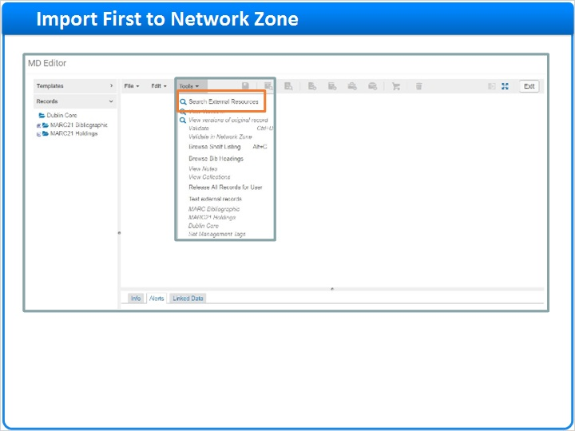
Notes:
Here’s how to import external-source records directly into the Network Zone, so that member institutions can use those bibliographic records:

Start in the Metadata Editor. Make sure that you’ll be saving new bibliographic records in the Network.

In the Tools menu, Search External Resources.

Choose which external resource you want to search, add any appropriate search terms, and click Search.

When you see the results, you can View the bibliographic record to confirm it is the correct one, and then click Import.

Save the Record, which will save it to the Network Zone, including all the normalizations set up for Network Zone imports.

After that, use the regular acquisition process to order inventory at member institutions, using the bibliographic record found in the Network Zone.

File - Options - Network (Slide Layer)
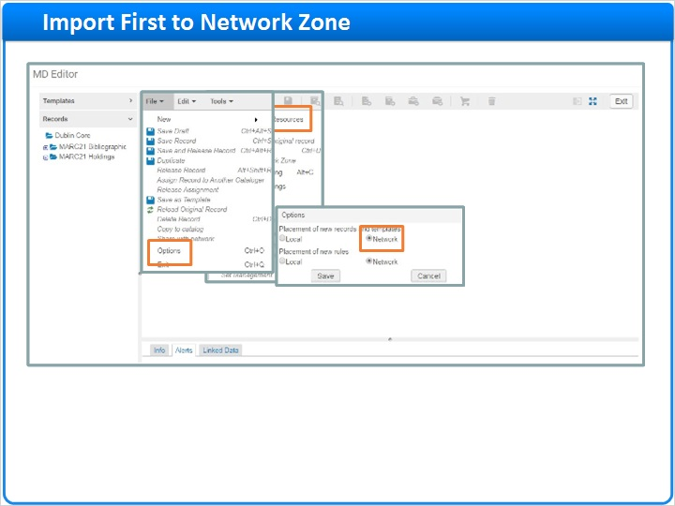

Search External Resource (Slide Layer)
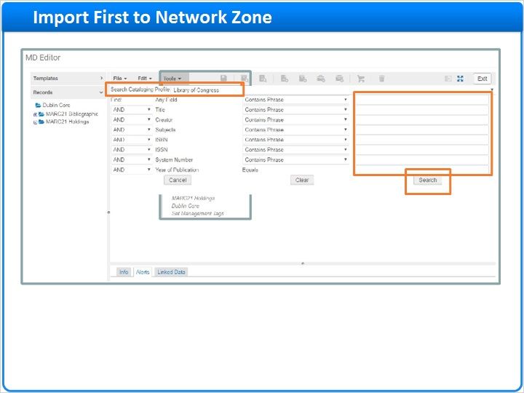

Search Results (Slide Layer)
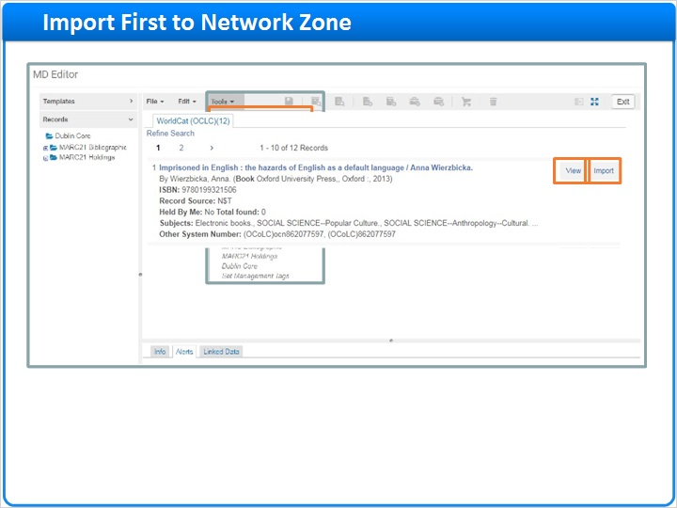

Bibliographic Record (Slide Layer)
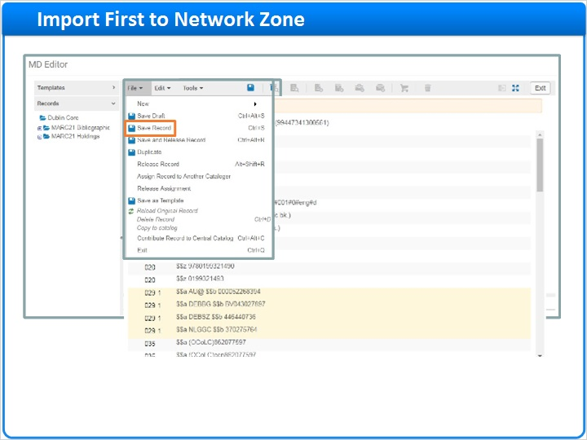

Repository Search (Slide Layer)
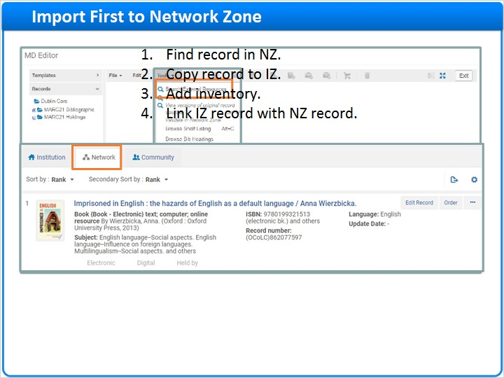

1.19 Import First to Institution Zone
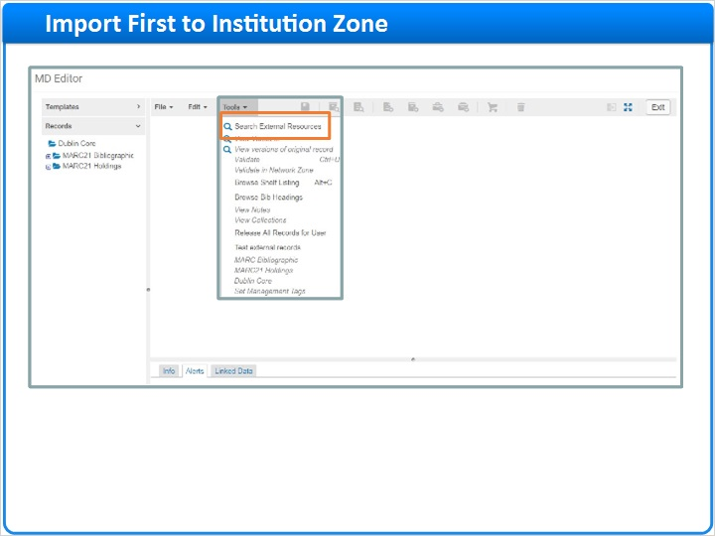
Notes:
Here’s how to import external-source records first into the Institution Zone, before you share them into the Network Zone:

Start in the Metadata Editor. Make sure that you’ll be saving new bibliographic records in the Local zone.

In the Tools menu, Search External Resources.

Choose which external resource you want to search, add any appropriate search terms, and click Search.

When you see the results, you can View the bibliographic record to confirm it is the correct one, and then click Import.

Save the Record, which will save it to your Institution Zone, including all the normalizations your institution has set up for importing records.

Then you can edit the bib record as discussed earlier, and add inventory as needed.

Finally, Share with Network, as we did before … although you won’t be matching this to an existing record in the Network Zone because there isn’t one there yet.

File - Options - Local (Slide Layer)
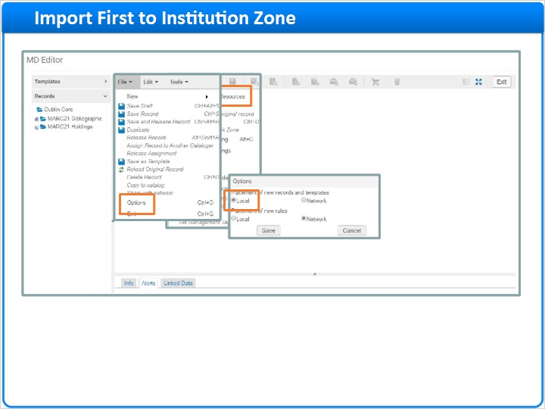

Search External Resource (Slide Layer)
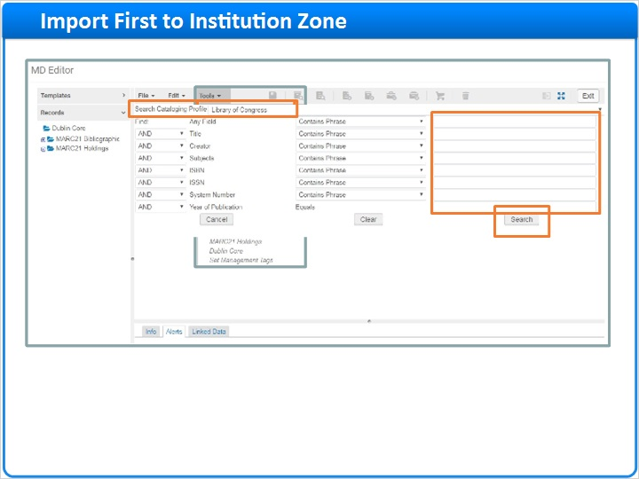

Search Results (Slide Layer)
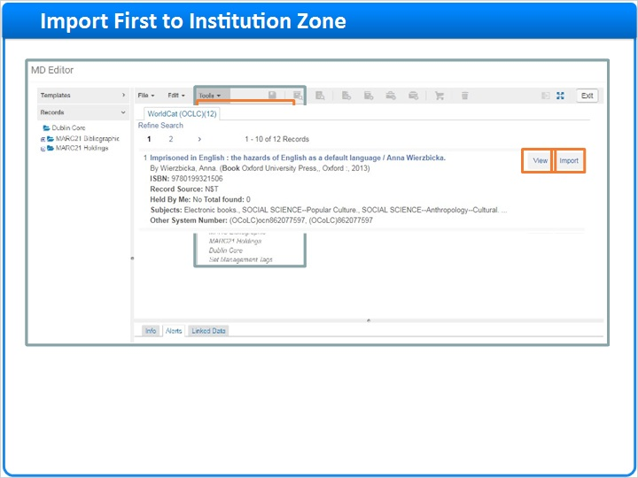

Bibliographic Record (Slide Layer)
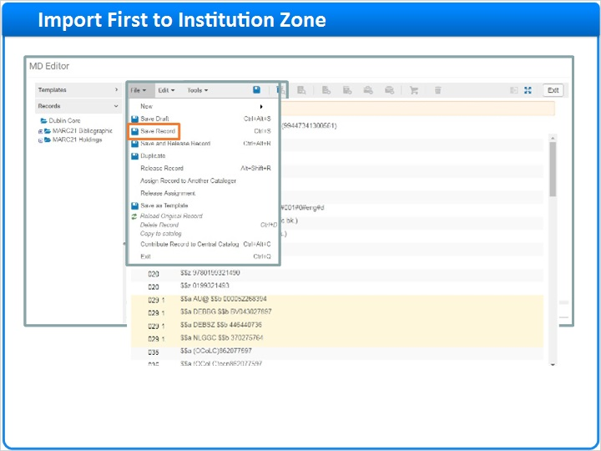

Inventory and Share with Network (Slide Layer)
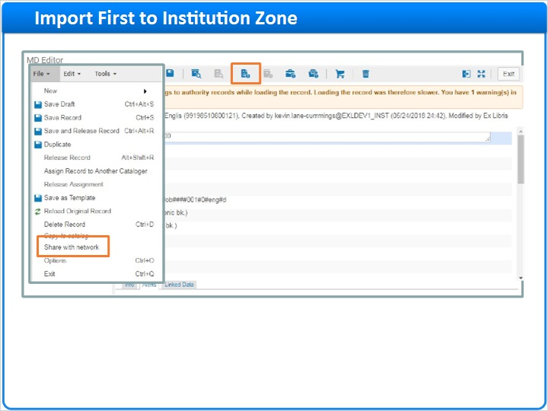

1.20 Session Review and Quiz
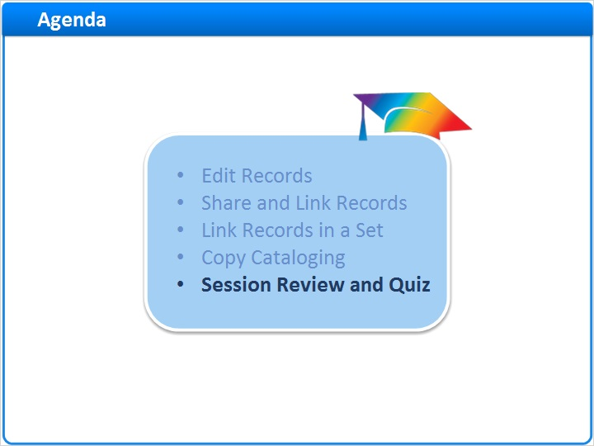
Notes:
That concludes the main portion of this training session. Let’s briefly review what was covered and then proceed to a short quiz.

1.21 Session Review
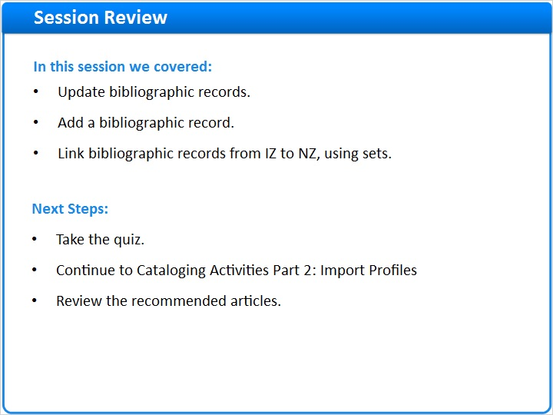
Notes:
In this session, we learned how to update bibliographic records requiring corrections or in need of local extensions; add a bibliographic record when it does not exist, including copying from the Network Zone and copy cataloging from an outside source; and link bibliographic records found in the Institution Zone with matching records in the Network Zone by creating a set and running the linking job.

After the short quiz that begins on the next page, you can continue on to Part 2 of Cataloging Activities in the Network Zone, where we will discuss using import profiles.

If you want more information about cataloging activities in the Network Zone, please see the Recommended Articles section where you launched this training session.

1.22 Quiz: Propagation of Changes to Network Zone Records
(True/False, 10 points, 1 attempt permitted)
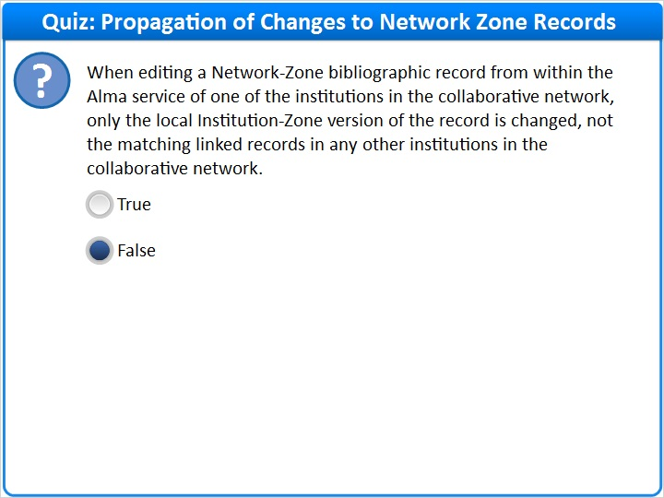
Correct | Choice
 | True
X | False
Feedback when correct:
Yes, the correct answer is False. Changes made to a Network-Zone bibliographic record affect all institutions in the collaborative network that use that Network-Zone record, whether the changes were made from within the Alma of a member institution or the Alma of the Network Institution itself. There is no local Institution-Zone bibliographic record in this circumstance.
Feedback when incorrect:
Incorrect; the correct answer is False. Changes made to a Network-Zone bibliographic record affect all institutions in the collaborative network that use that Network-Zone record, whether the changes were made from within the Alma of a member institution or the Alma of the Network Institution itself. There is no local Institution-Zone bibliographic record in this circumstance.

Notes:

Correct (Slide Layer)
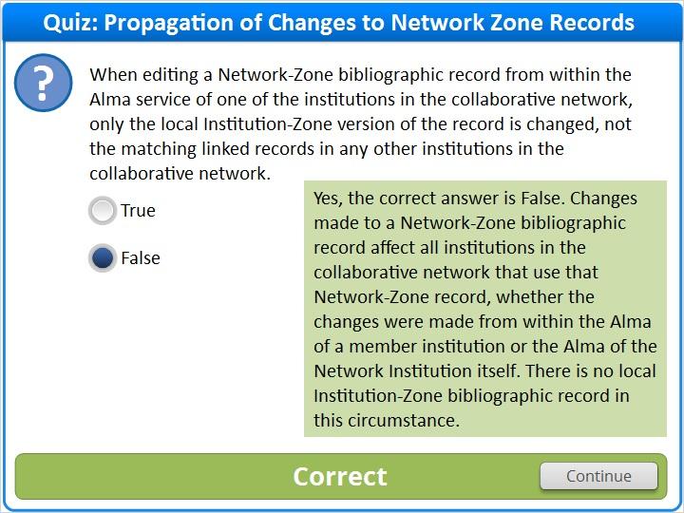

Incorrect (Slide Layer)
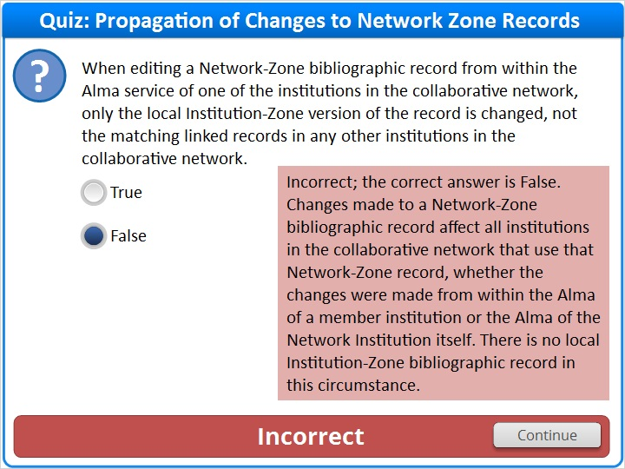

1.23 Quiz: Network Zone Bibliographic Records
(Multiple Response, 10 points, 1 attempt permitted)
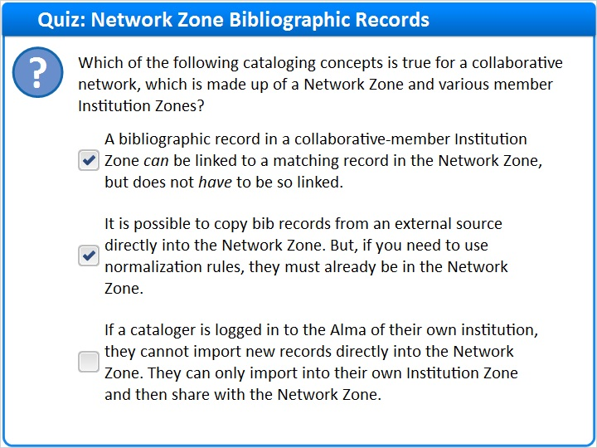
Correct | Choice
X | A bibliographic record in a collaborative-member Institution Zone can be linked to a matching record in the Network Zone, but does not have to be so linked.
X | It is possible to copy bib records from an external source directly into the Network Zone. But, if you need to use normalization rules, they must already be in the Network Zone.
 | If a cataloger is logged in to the Alma of their own institution, they cannot import new records directly into the Network Zone. They can only import into their own Institution Zone and then share with the Network Zone.

Feedback when correct:
Correct. These two statements are true: (1) A record in a collaborative-member Institution Zone can be linked to a matching record in the Network Zone, but does not have to be so linked. (2) It is possible to copy bib records from an external source directly into the Network Zone. But, if you need to use normalization rules, they must already be in the Network Zone.
The third statement is false. If a cataloger is logged in to the Alma of their own institution, they can import new records directly into the Network Zone.
Feedback when incorrect:
Incorrect. These two statements are true: “A record in a collaborative-member Institution Zone can be linked to a matching record in the Network Zone, but does not have to be so linked.” “It is possible to copy bib records from an external source directly into the Network Zone. But, if you need to use normalization rules, they must already be in the Network Zone.”
The third statement is false: If a cataloger is logged in to the Alma of their own institution, they can import new records directly into the Network Zone.

Correct (Slide Layer)
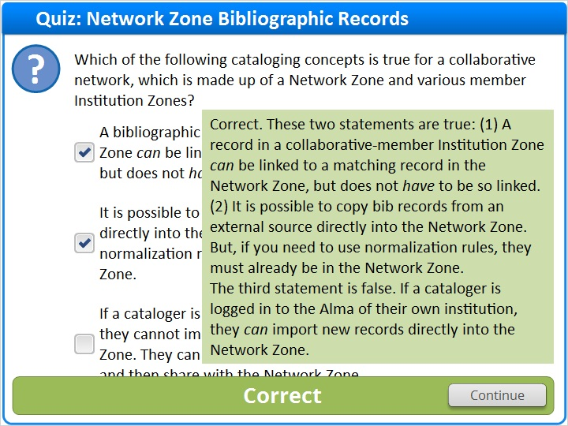

Incorrect (Slide Layer)
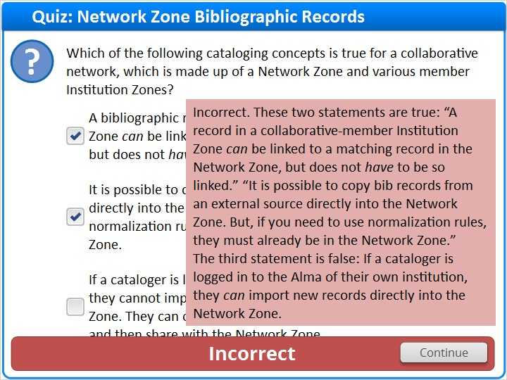

1.24 Thank You!

Notes:
Thank you for joining this session!

1.25 Copyright
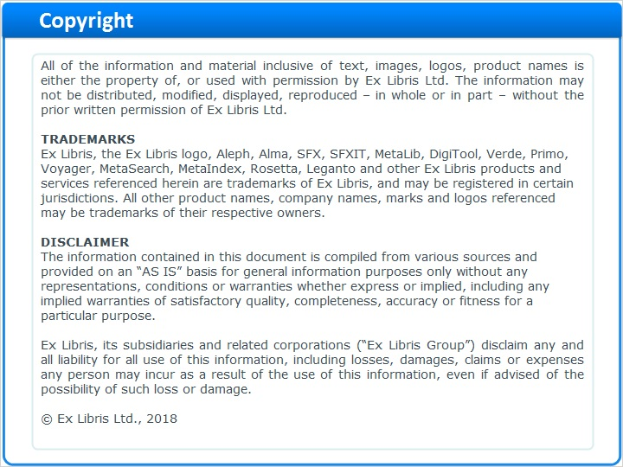
Notes:

1.26 Results Slide
(Results Slide, 0 points, 1 attempt permitted)
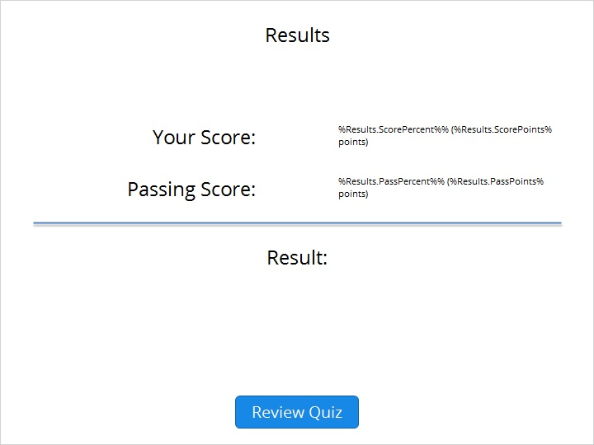

Results for
1.22 Quiz: Propagation of Changes to Network Zone Records
1.23 Quiz: Network Zone Bibliographic Records

Result slide properties
Passing  Score | 80%

Success (Slide Layer)
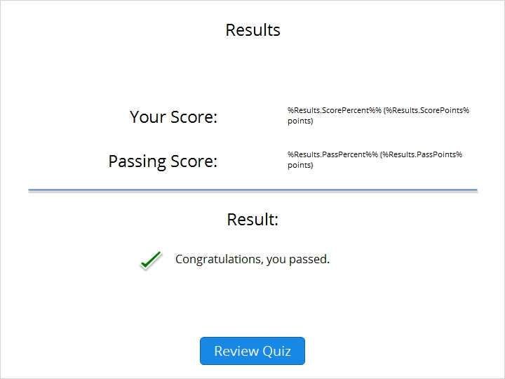

Failure (Slide Layer)


