PDA Management in the Network Zone

1. PDA Management in the Network Zone

1.1 PDA Management in the Network Zone
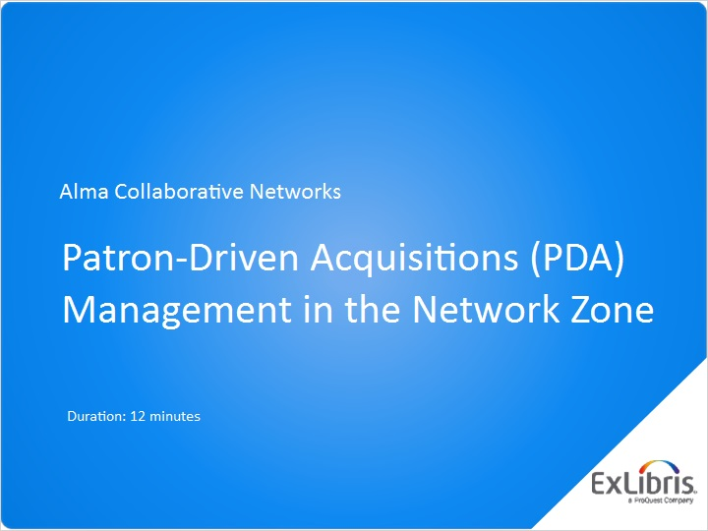
Notes:
Hello, and welcome to this Alma Collaborative Networks training session, where we will discuss how to manage patron-driven acquisitions - or PDA - in the Network Zone.

1.2 Configuring PDA
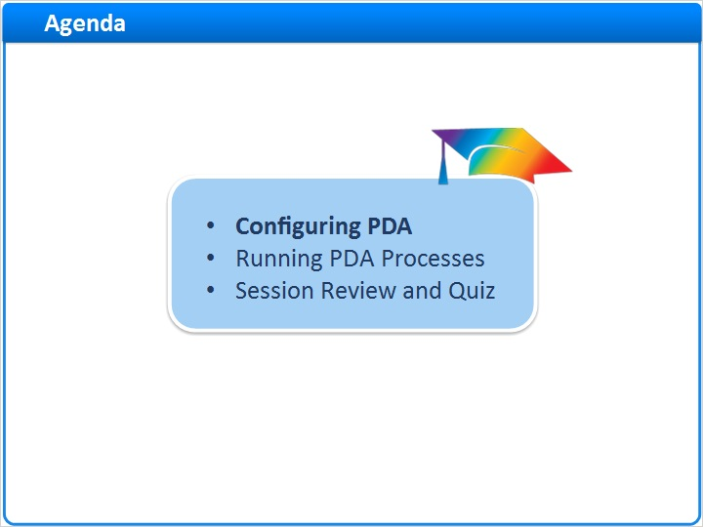
Notes:
In this session, we’ll show how to configure PDA for a collaborative network, and then run through several PDA processes.

After a session review, there will be a short quiz to test your knowledge.

1.3 PDA in a Collaborative Network
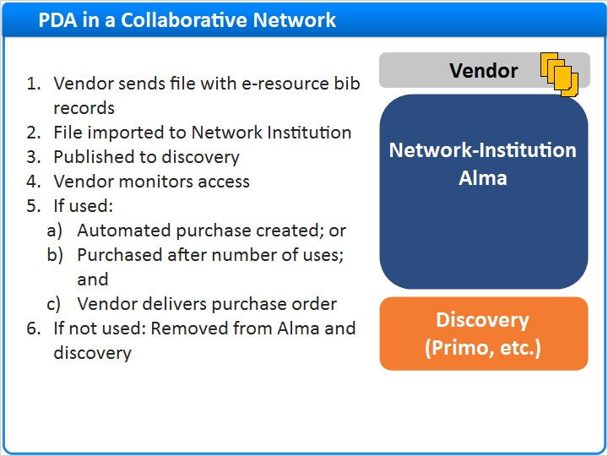
Notes:
Procedures for setting up PDA in Alma for an individual institution are discussed in other training sessions.

This session addresses the situation where Alma institutions in a collaborative network share the same PDA profile and, in this way, share the costs.

Here is the overall workflow:

A vendor sends a file with bibliographic information for electronic resources (typically e-books) that may be of interest to the collaborative network.

The e-resources are imported as a repository file into the network institution and published to your discovery service, to be accessed by patrons throughout the collaborative network.

The vendor monitors which e-resources are accessed by patrons.

If a candidate e-resource is used, then an automated purchase is created; or, your collaborative network may decide that purchasing will happen after patrons have accessed the e-resource a certain number of times.

If an e-resource is purchased, the vendor delivers a purchase order via EOD and can invoice via EDI.

If an e-resource is not purchased due to little or no usage, the e-resource is removed from the repository and from your discovery service.

1.4 Prerequisites
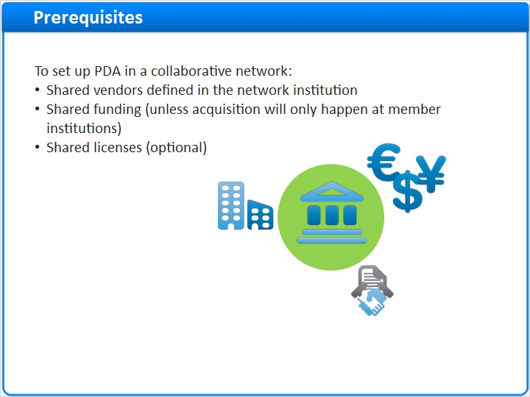
Notes:
Before you set up PDA in a collaborative network, there are several elements of the acquisition infrastructure that need to be defined in the network institution:

Shared vendors. These vendors can also be defined in the member institutions of the network, with elements such as an institution’s own contact person. But the core of the record must be in the network institution.

Shared funding. This is not a requirement, and some collaborative networks choose to do acquisition at the member institutions themselves. But, the network institution does not have access to funds in the member institutions. So if the network institution will be doing acquisitions, then funds must be defined and allocated in the network institution.

Shared licenses. Again, this is optional, but many collaborative networks negotiate licenses on behalf of the member institutions and, therefore, must configure them in the network institution.

Configuring vendors, funding, and licenses in the network institution is the same as configuring them in the individual member institutions, and will not be discussed in this session.

1.5 PDA Configuration
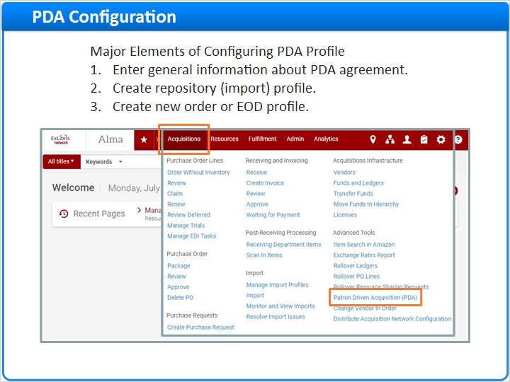
Notes:
Now, we will go through the three major elements of configuring a PDA profile in a network institution:

First, enter general information about the PDA agreement with the vendor, including how many times an e-resource has to be accessed in order to constitute a purchase of it.

Next, create a repository profile, which is an import profile that will load candidate resources into the network repository.

And finally, create a new order or EOD profile, which is an import profile that will create purchase orders for e-resources that were used by patrons.

To begin, log in to the network institution’s Alma service, and in the Acquisitions menu, choose Patron Driven Acquisition.

1.6 Create PDA Profile
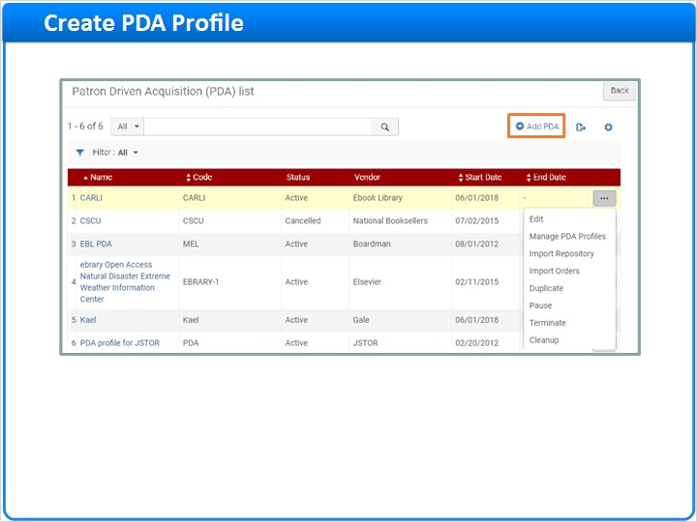
Notes:
On the Patron Driven Acquisition List, you may see some PDA profiles already created. You can edit a PDA profile by choosing the row-action Edit. But for this training session, we’re going to Add PDA using the link in the upper-right.

The Summary tab contains the key information about this PDA agreement with the vendor:

The Name of the PDA profile and the unique Code associated with it.

The Status, which can be Draft, Active, Paused or Cancelled. To continue with the PDA configuration process, the status must be Active.

The Vendor for which the PDA profile is being created. Again, this must have already been set up in the network institution.

A Start Date and End Date for the PDA program; only the start date is required.

The Access Threshold, which is the number of access requests made for the e-resource after which the collaborative network agrees to purchase the resource. This is for your information only; the vendor actually keeps track of usage and proceeds with ordering based on that.

The Budget Threshold, which is the maximum amount of money the collaborative network is willing to pay for an e-resource after the access threshold has been reached. This is just informational only; Alma won’t prevent resources from being accessed, even if the threshold has been reached.

Alert Percentage: When the PDA usage exceeds the alert percentage of the budget threshold, an email notification is sent to the contact person. (And at that point, the Contact has been notified box will be automatically checked.)

The Contact is the Alma user (institution or network staff) you want to associate the PDA program.

License: Choose from the list, if you want to associate a shared license from the Network Zone with the PDA profile.

When you’re done creating the PDA profile and you click Save in the upper-right corner, Alma will create two more tabs, for Attachments and Notes, to let you add reference information as needed.

Back on the PDA profiles list, you’ll see the new PDA profile.

Summary Tab (Slide Layer)
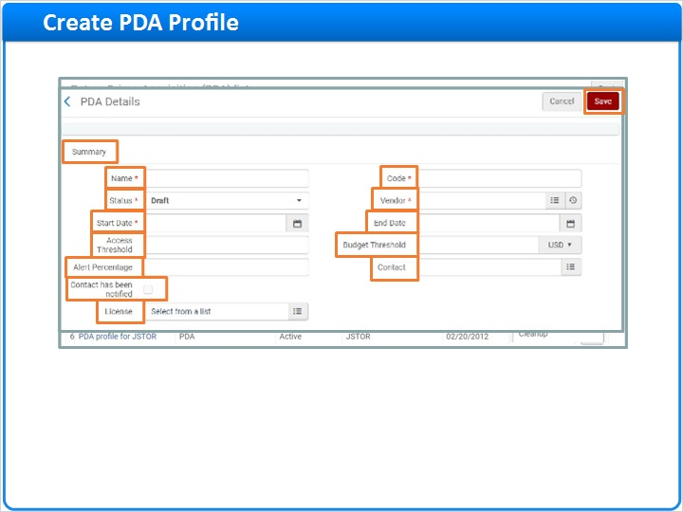

More Tabs (Slide Layer)
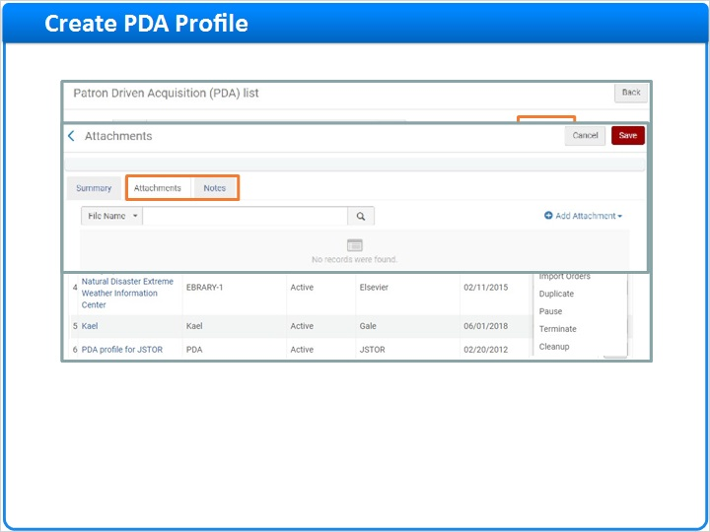

PDA Profiles List (Slide Layer)
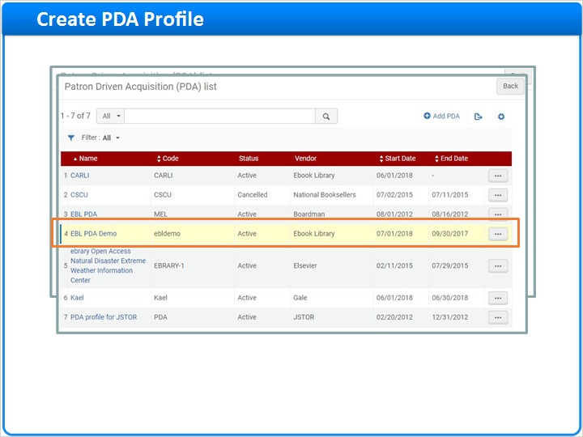

1.7 Create Import Repository Profile
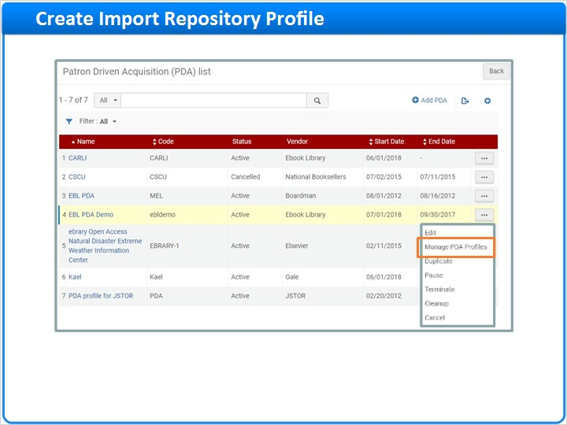
Notes:
For the second major element of a PDA profile, we need to configure and activate the two import profiles.

On the row-action list, choose to Manage PDA Profiles.

Here we see the two import profiles we need to configure and activate.

Let’s start by Editing the Import Repository profile.

The Import Repository profile is used to define details for how to load or import candidate e-resource records to the network institution’s repository.

Make sure that the following tabs are configured correctly for your collaborative network:

Normalization & Validation, which is used to normalize and validate candidate records.

Match Profile, which is used to match candidate records to existing catalog records.

Set Management Tags, where you can suppress records from publishing and delivery. Leave it unchecked to publish the candidate e-resources to your discovery service.

And Inventory Information, which is used to map inventory information to Alma based on how it’s coming in the import file. This tab requires a bit of explanation.

It is a best practice to set the Portfolio Type to be Part of an electronic collection. This will organize the imported records into one electronic collection and make maintenance easier. For example, if you set up inventory network groups so that only some member institutions have access to these PDA e-resources, you could assign just certain groups to this collection.

Also here, you may define some other mappings between the imported data and the settings in Alma, such as which field to extract the access url, various note fields (or text for default notes if the import file doesn’t have any notes); and finally, whether you want the records to be activated or not as soon as they are imported.

On the other hand, if you choose to activate the records as standalone portfolios, the Inventory Information form will be extended with another mapping section. By default, the imported records will be available for all member institutions. So, if you want to restrict access to some member institutions, the input file needs to contain information about this, and the mapping should be done here in the import profile.

Import Profiles (Slide Layer)
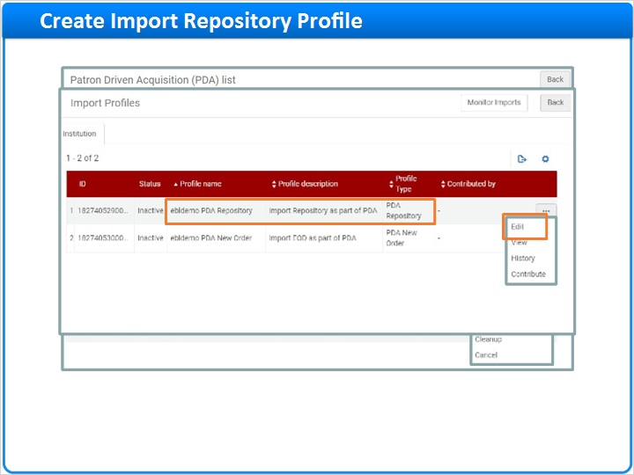

Profile Details (Slide Layer)
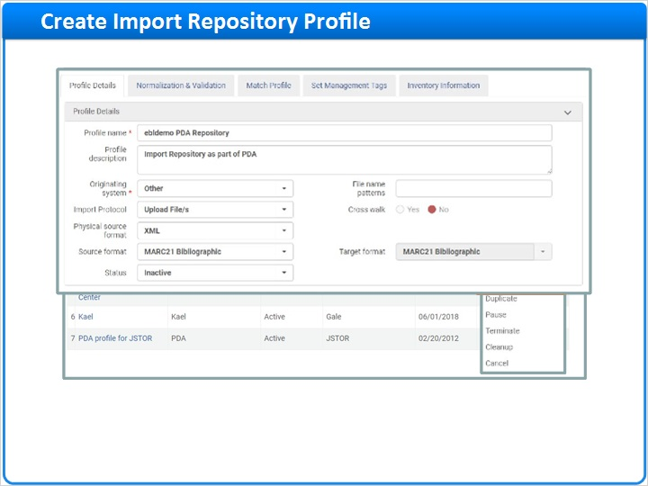

Normalization and Validation (Slide Layer)
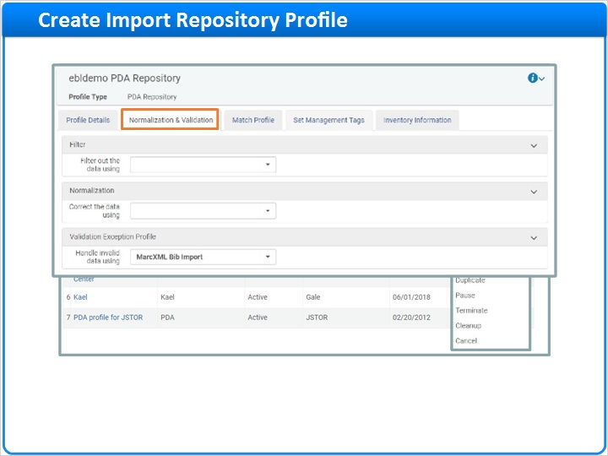

Match Profile (Slide Layer)
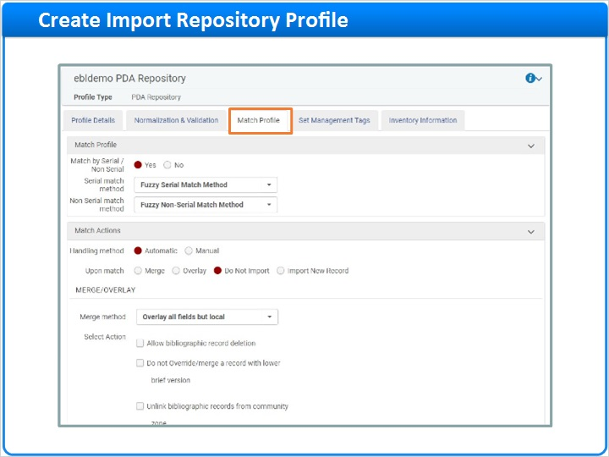

Set Management Tags (Slide Layer)
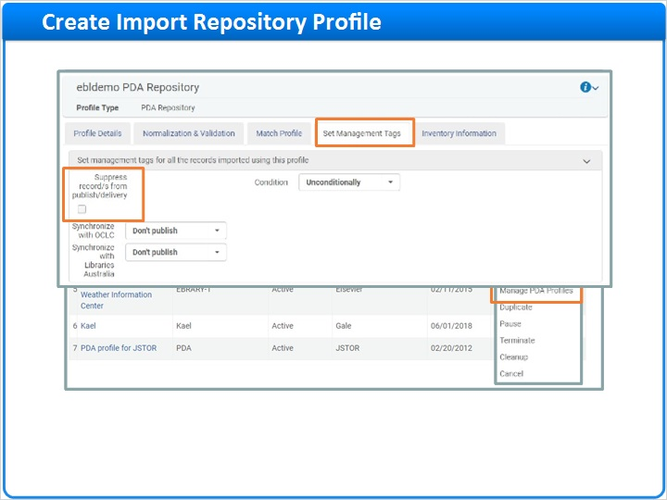

Inventory Information (Slide Layer)
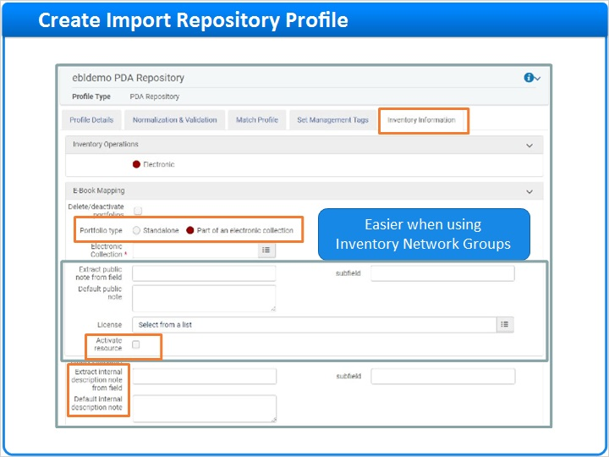

Inventory - Standalone (Slide Layer)
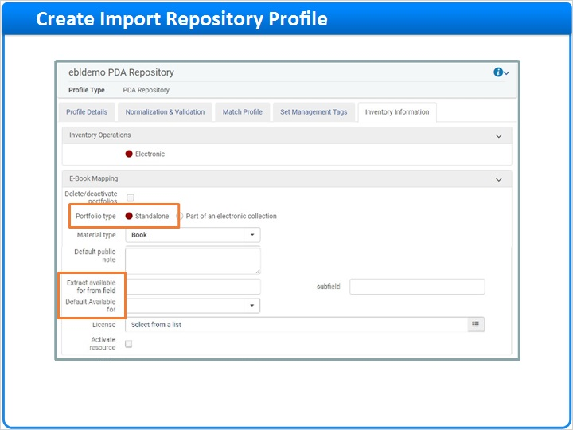

1.8 Create New Order (EOD) Import Profile
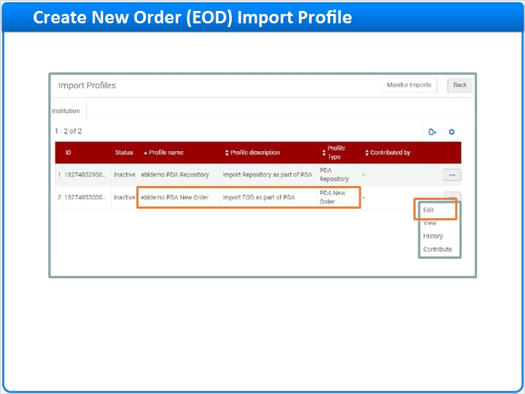
Notes:
The second import profile is for importing new orders using an EOD file or Embedded Order Data file.

Here, you’ll also want to check the tabs and, in particular, check the PO Line Information tab. Make sure everything is mapped correctly based on the EOD information provided by the vendor and how you want it to be mapped to Alma for purchase+order details.

Profile Details (Slide Layer)
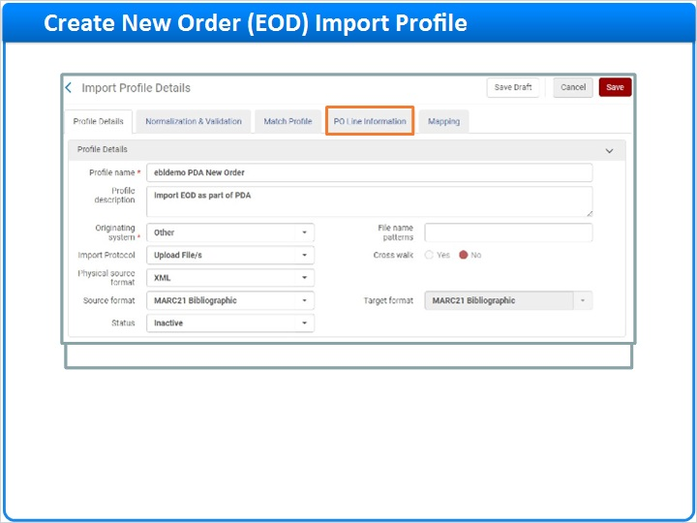

PO Line Information (Slide Layer)
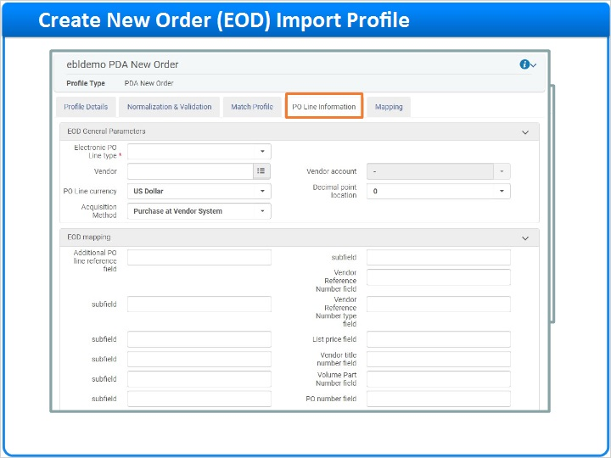

1.9 Activate PDA Import Profiles
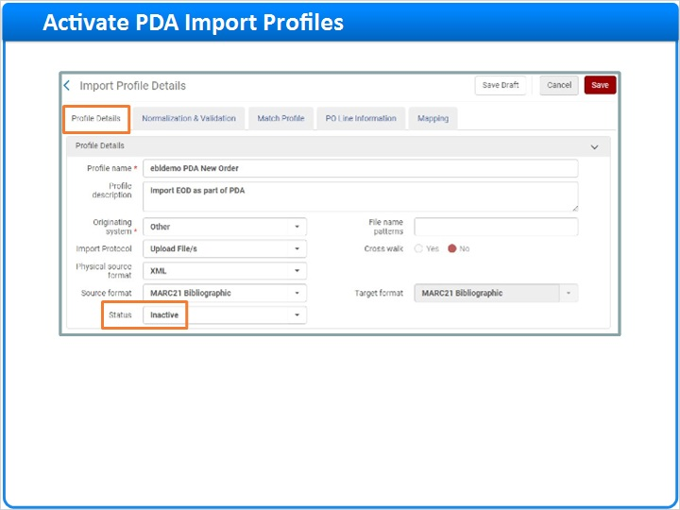
Notes:
Lastly, back on the Profile Details tab, activate your PDA New Order import profile, and the PDA Repository import profile, once they’re ready to use. They will be in a draft status up until that point.

By the way, it’s not mandatory to activate and run the EOD import; if you have agreed with the vendor on other ways for dealing with purchases, you may leave this un-activated.

1.10 Running PDA Processes
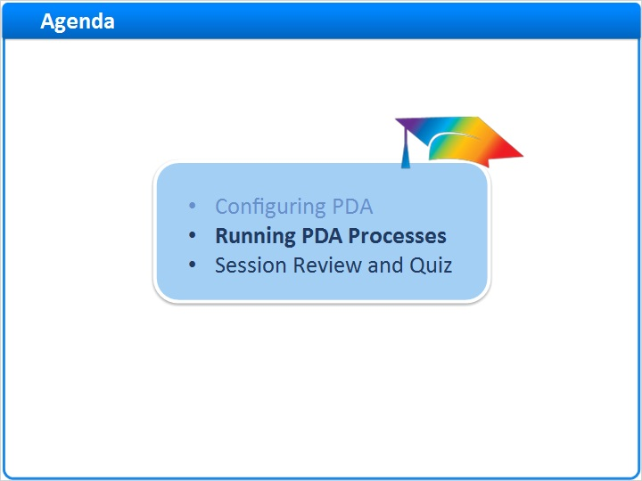
Notes:
Now, let’s go through how to run a PDA in the network institution.

1.11 Run Repository Import
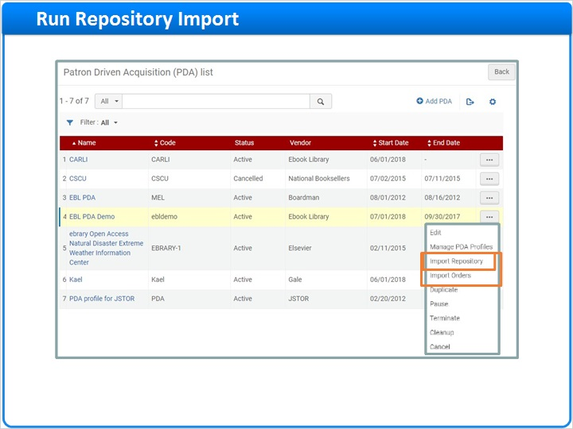
Notes:
Because you’ve activated the PDA import profiles, you’ll now see two new actions appear in the PDA Actions menu: Import Repository, and Import Orders.

The first step is to run the Repository import. Do that by clicking Import Repository, which will allow you to upload the vendor’s file of candidate e-resources and then run the import process. You’ll also be able to monitor the import process with the Monitor Jobs tool.

Start New Import (Slide Layer)
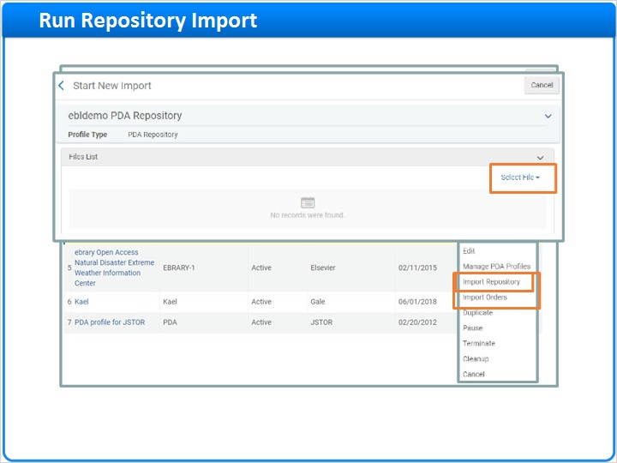

1.12 Candidate Records Published in Primo
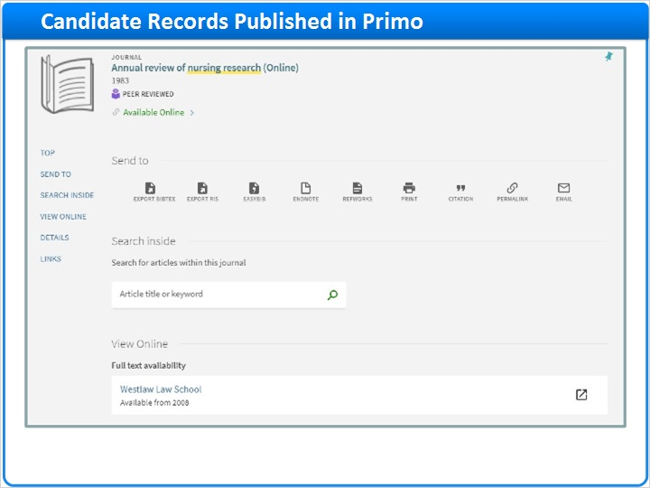
Notes:
After the repository import is run, candidate records will be published to your discovery service so users can find them.

1.13 Order Triggered
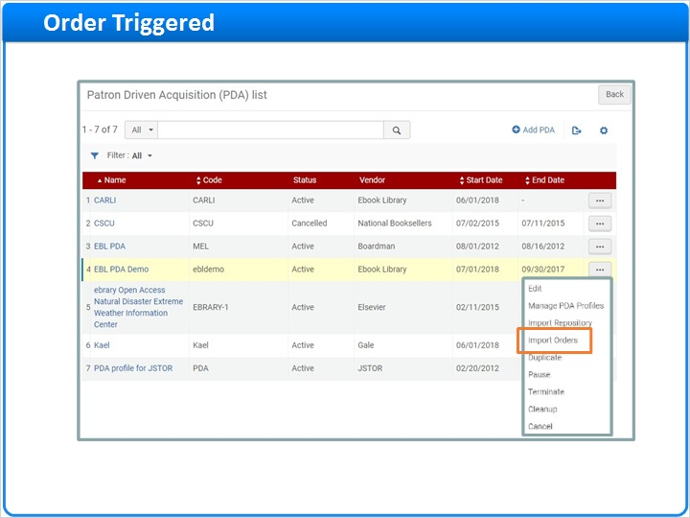
Notes:
Once a resource has been accessed (or when the access threshold that you indicated in the PDA Details screen is reached), it will trigger an order.

The vendor then may provide you with an EOD file for the resources that were accessed.

At that point, you would run the EOD import using the Import Orders option from the PDA actions menu, which will create the purchase order in Alma.

1.14 Automating Purchases
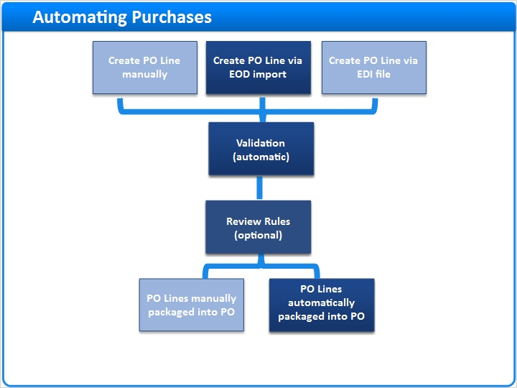
Notes:
Just a quick word on automated purchasing:

You may remember from the acquisitions sessions in the Alma Essentials training kit that purchase orders can be automatically created using embedded-order data (which is what you’re doing with the PDA new-order import process). And you can apply rules so the purchase orders are automatically approved, sending the purchase order to the vendor automatically. You can apply that automated approval and purchase process to the purchase of a candidate e-resource from a PDA.

1.15 End of PDA Program
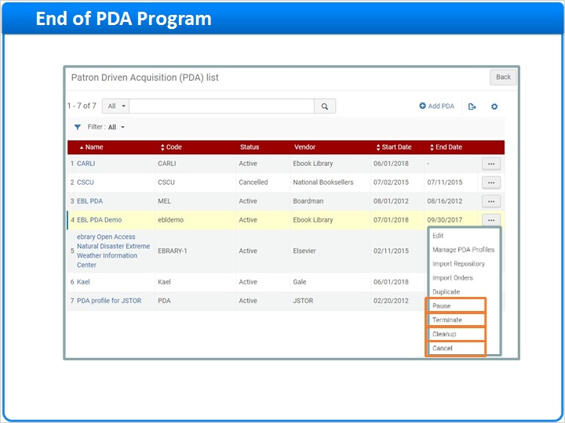
Notes:
The end of the program could come when the timeline (end date on PDA Details screen) was reached, or when the budget exceeds or is about to exceed the monetary threshold. At that time, the repository can be cleaned up so that any candidate records (or resources) that were accessed less than the access threshold and never got ordered are removed from the repository.

You do this from the row-actions menu for the PDA profile. The options here are:
- Pause: If funds for a PDA program are entirely expended, this will suppress all bibliographic records that were already loaded for this PDA program but not yet ordered, and prevent new bibliographic records from being loaded for the PDA program.
- Terminate: Sets the end date to the current date.
- Cleanup: Checks that the end date was passed and deletes from the repository any resources that were not ordered.
- Cancel: Terminates and does cleanup, and then sets the PDA profile status to Cancelled.

1.16 Session Review and Quiz
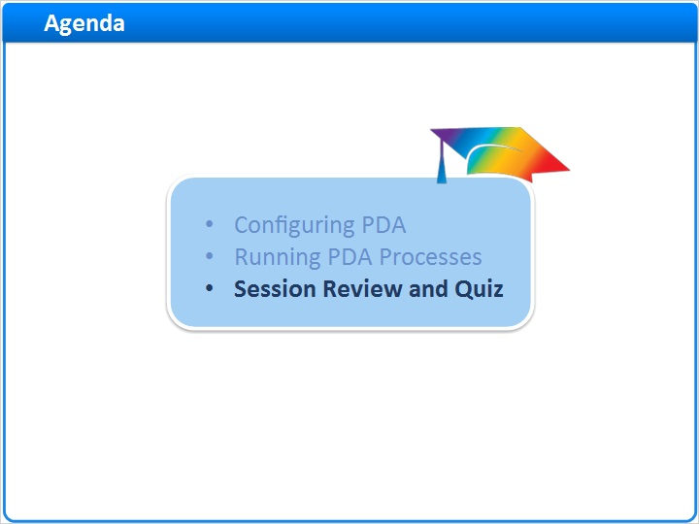
Notes:
That concludes the main portion of this training session. Let’s briefly review what was covered and then proceed to a short quiz.

1.17 Session Review
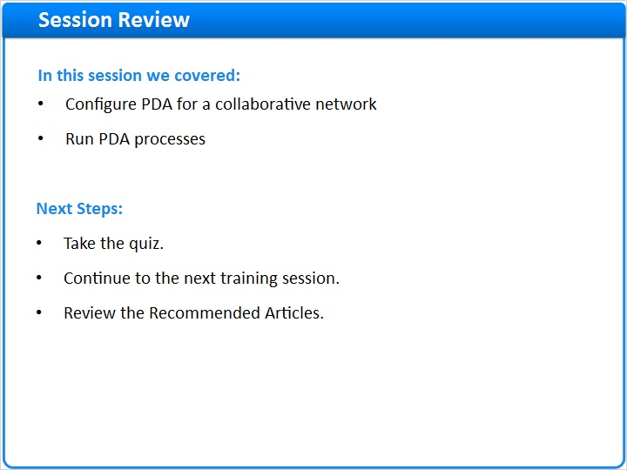
Notes:
In this session we began by showing how to configure patron-driven acquisition for a collaborative network, and then we showed how to run PDA processes.

After the short quiz that begins on the next page, you can continue on to the next training session in the Alma Collaborative Networks series.

If you have any questions or want more information, please see the Recommended Articles section where you launched this training session.

1.18 Quiz: Network Zone Acquisitions Infrastructure
(True/False, 10 points, 1 attempt permitted)
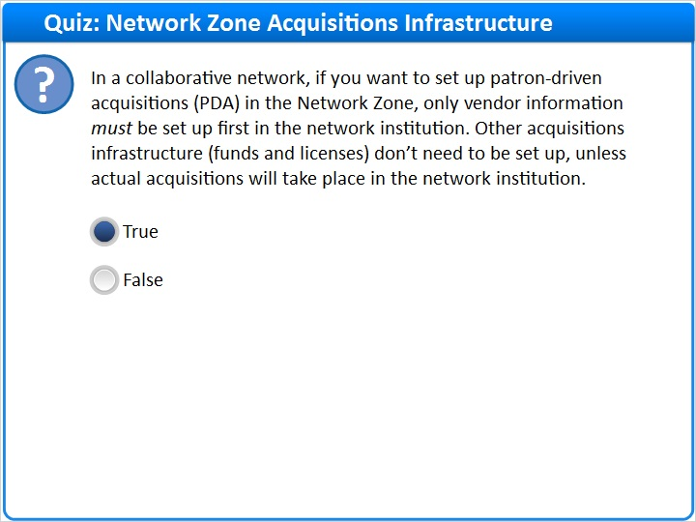
Correct | Choice
X | True
 | False
Feedback when correct:
Correct, this statement is true. Only the core information on vendors must be set up in the network institution. Funds and licenses are optional; they only need to be set up in the network institution if acquisitions will actually take place there.
Feedback when incorrect:
Incorrect, this statement is true. Only the core information on vendors must be set up in the network institution. Funds and licenses are optional; they only need to be set up in the network institution if acquisitions will actually take place there.

Notes:

Correct (Slide Layer)
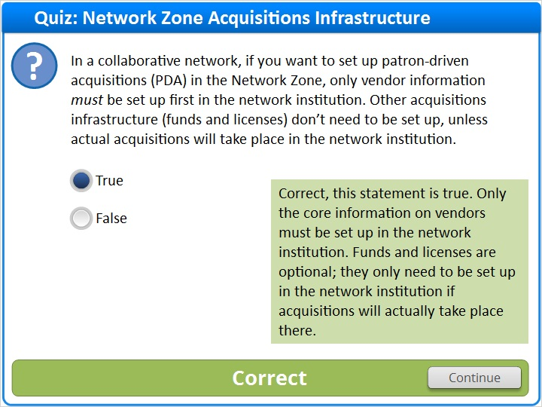

Incorrect (Slide Layer)
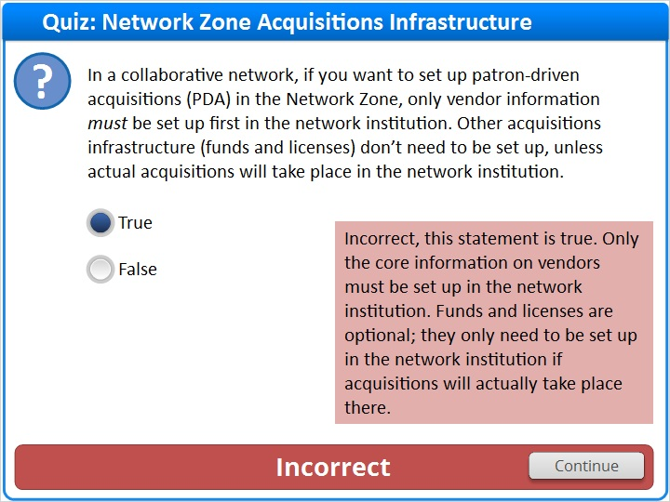

1.19 Quiz: Import Repository Profile
(True/False, 10 points, 1 attempt permitted)
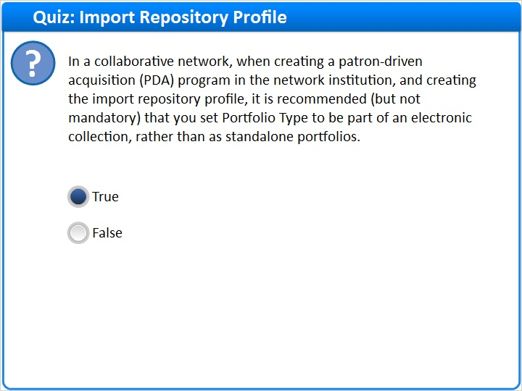
Correct | Choice
X | True
 | False

Feedback when correct:
Correct, this is true. This will organize the imported records into one electronic collection and make maintenance easier, but it isn’t mandatory.
Feedback when incorrect:
Incorrect, this is a true statement. This will organize the imported records into one electronic collection and make maintenance easier, but it isn’t mandatory.

Notes:

Correct (Slide Layer)
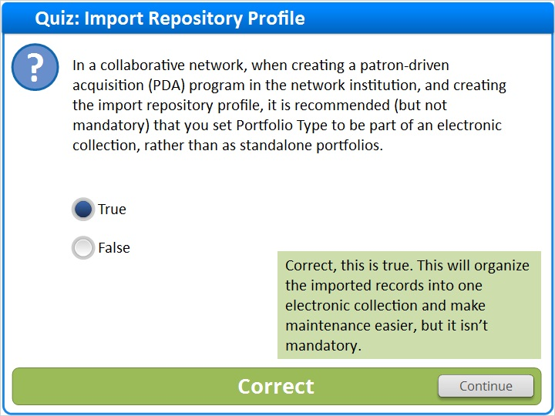

Incorrect (Slide Layer)
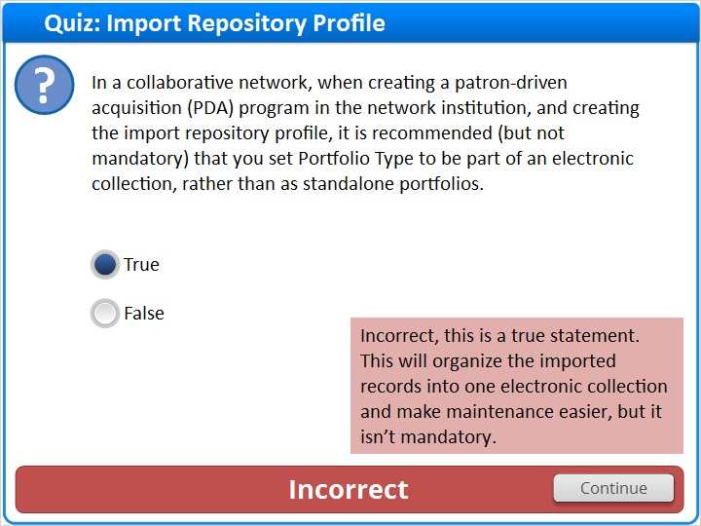

1.20 Thank You!

Notes:
Thank you for joining this session!

1.21 Copyright
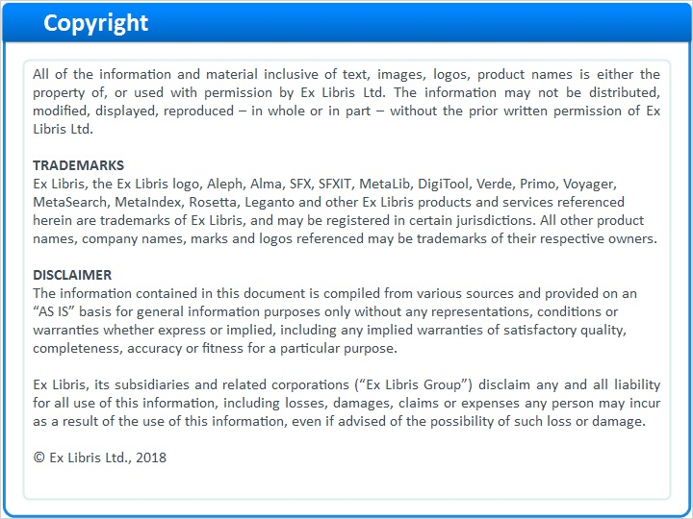
Notes:

1.22 Results Slide
(Results Slide, 0 points, 1 attempt permitted)
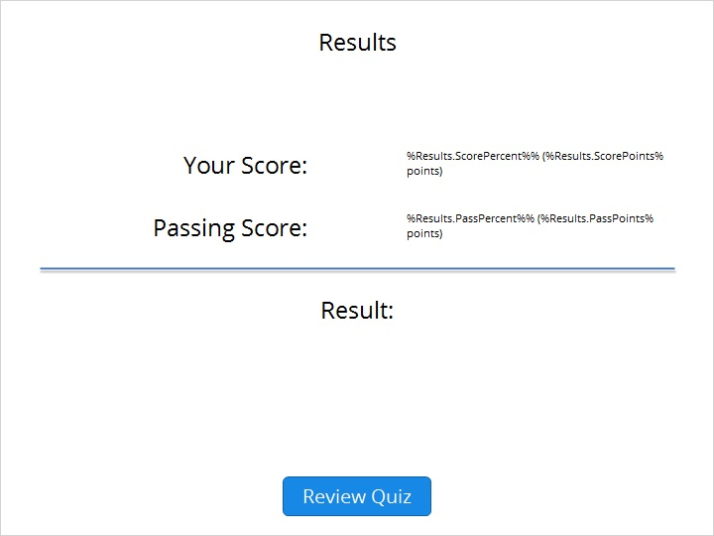

Results for
1.18 Quiz: Network Zone Acquisitions Infrastructure
1.19 Quiz: Import Repository Profile

Result slide properties
Passing  Score | 80%

Success (Slide Layer)
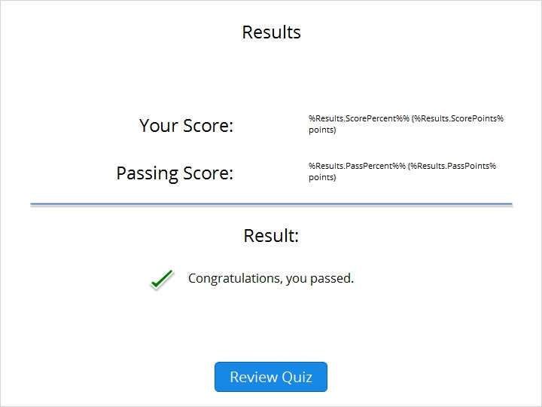

Failure (Slide Layer)


