Institution-Level Configurations for Peer-to-Peer Resource Sharing

1. Institution-Level Configurations for Peer-to-Peer Resource Sharing

1.1 Institution-Level Configurations for Peer-to-Peer Resource Sharing
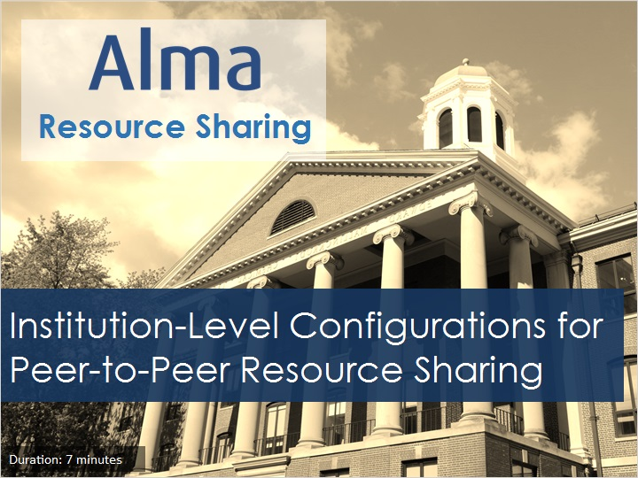
Notes:
Hello, and welcome to this session on configurations at the institution level for peer-to-peer resource sharing with your Alma service.

1.2 Objective
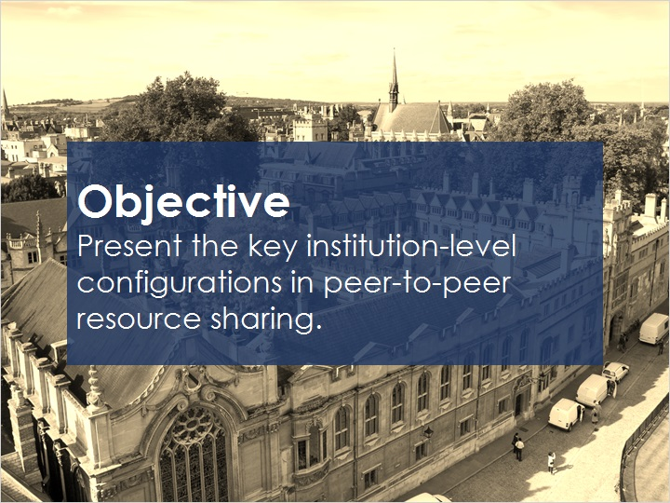
Notes:
This session will present the key configurations that need to be set up at the institution level in Alma for participating in resource sharing with a peer institution. We’ll be covering rota, rules for sending borrowing requests, display logic rules, configuring a resource sharing partner, workflow profiles, and item-policy exceptions.

Many of these configurations are similar to those you would set up for broker-based resource sharing. So if you’ve already seen the training session on that subject, you’ll notice some similarities. However, there are differences, including the first subject: rota.

1.3 Rota
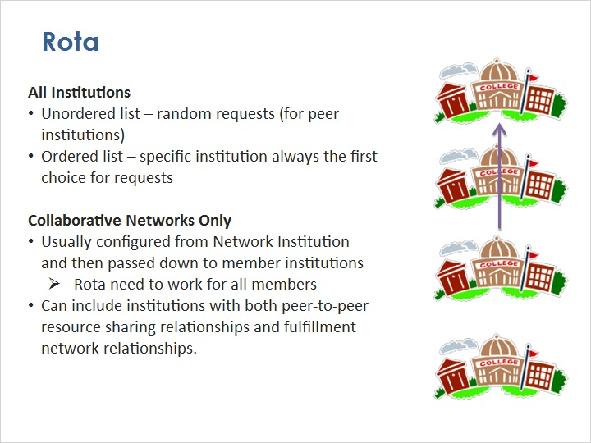
Notes:
All institutions that have resource sharing relationships with more than one other institution need to set up Alma so it can automatically choose the preferred institution to supply an item to be shared.

That’s the purpose of a rota.

Without a rota, library staff must check peer institutions one by one until the item is found.

Rota are discussed in detail elsewhere, but the most important issue to consider is whether the rota template will use an unordered list or an ordered list of partners.

With an unordered list of partners, requests are sent to a random institution on the list of partners.

With an ordered list of partners, you indicate that you’d like Alma to always check the first partner on the list to see if it has the item available. If not, Alma moves on to the second partner on the list, and so on until Alma finds a partner that can fulfill the request. You might choose to use an ordered list if, for example, there are some institutions that you regularly work with, and others that you only want to submit a request if you can’t find it from one of your preferred partners.

For institutions that are in a collaborative network - in other words, an Alma consortium - there are a couple other things to consider:

Most collaborative networks choose to configure rota at the Network Zone institution itself and then pass the rota down to member institutions.

In that situation, you’ll want to create rota that work for all members. For example, you might choose to make a rota template with an unordered list of partners, so that no single institution has to fulfill a lot of requests. Or, if you want to actively balance the amount of borrowing and lending institutions do, you might use an ordered list and then adjust the order every year or so based on request usage.

A rota within a collaborative network can include institutions with both peer-to-peer resource sharing relationships and fulfillment network relationships.

1.4 Rules for Sending Borrowing Requests
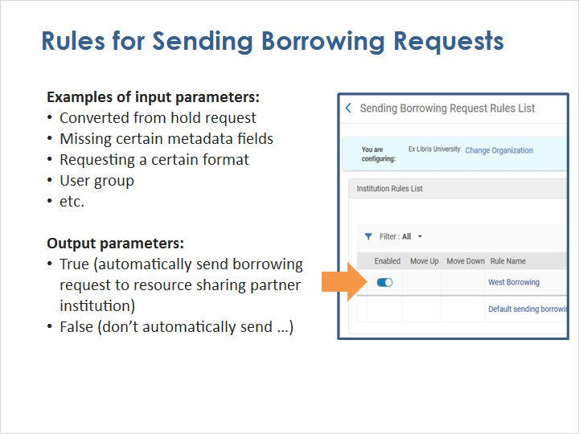
Notes:
You may want Alma to automatically send certain borrowing requests from your patrons to other institutions in the rota, without staff intervention. On the other hand, there may be certain borrowing requests that you want your staff to handle first.

The Sending Borrowing Request Rules can be used to define either of those situations.

Examples of input parameters for these rules include a resource sharing request that was converted from a hold request; a resource sharing request that is missing certain metadata fields; a request for an item in a certain format; a request from a certain user group; and more.

The output parameters are either True, meaning the borrowing request will automatically be sent by Alma to the resource sharing partner; or False, meaning the borrowing request will require staff intervention at your institution.

Like most rules lists in Alma, this one is processed from top to bottom. The first rule whose input parameter applies to a resource sharing request will have its output parameter executed, and then Alma will stop checking the remaining rules for that request.

1.5 Display Logic Rules
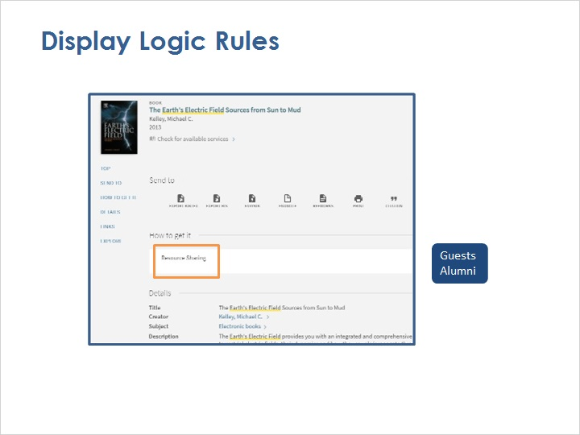
Notes:
As we discussed in a previous session, when a patron finds an item in Primo that they’d like to request, but it isn’t available (for example, they want a physical item but you only have it as an electronic resource), the link to the Resource Sharing service can appear.

However, there may be some user groups for whom you don’t want resource sharing to be available; for example, guests or alumni. In those cases, you’ll want the Resource Sharing service to be hidden.

You do that by creating a display logic rule. Details for how to create that kind of rule - and which staff members are allowed to create it - are found in other training sessions; see the Recommended Articles section where you launched this training session for details. But you’ll find the list of rules on the Discovery Interface Display Logic page, where you can add rules as needed for particular user groups and particular services.

And you’ll want to create these rules before you start making resource sharing available to your patrons.

Hide Resource Sharing Link (Slide Layer)
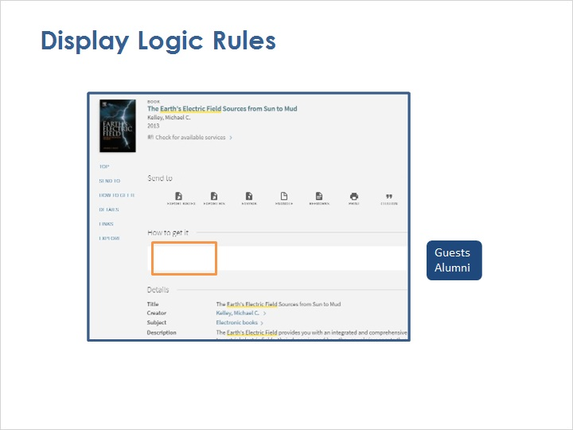

Discovery Interface Display Logic page (Slide Layer)
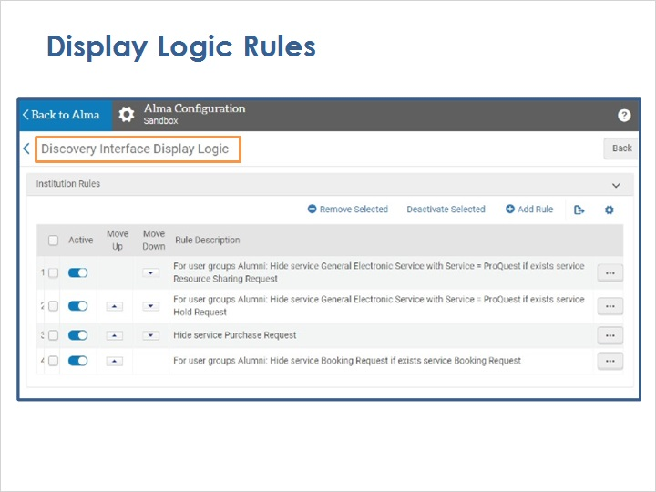

1.6 Resource Sharing Partner
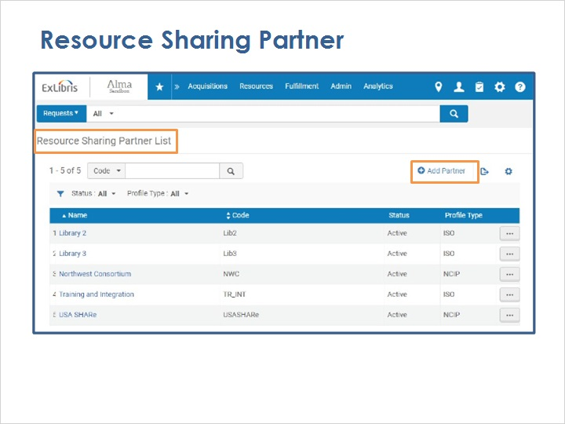
Notes:
You will need to configure the peer institution as a resource sharing partner in Alma, which defines the type of communication between Alma and that institution.

We won’t go through all the fields here on the configuration page, because we’ll do that in a later training session. But the key ones include the Profile Type (such as NCIP or ISO), and the System Type (such as Alma). Be sure to select the checkboxes indicating whether the peer Supports Borrowing or Lending or both. We’ll come back to the Workflow fields shortly.

On the Parameters tab, the fields are different depending on the Profile Type and System Type, but usually include things like the server URL and port of the peer institution’s ILS, whether and when requests can expire, whether you will send requester information to the lender, and so on.

Add Partner (Slide Layer)
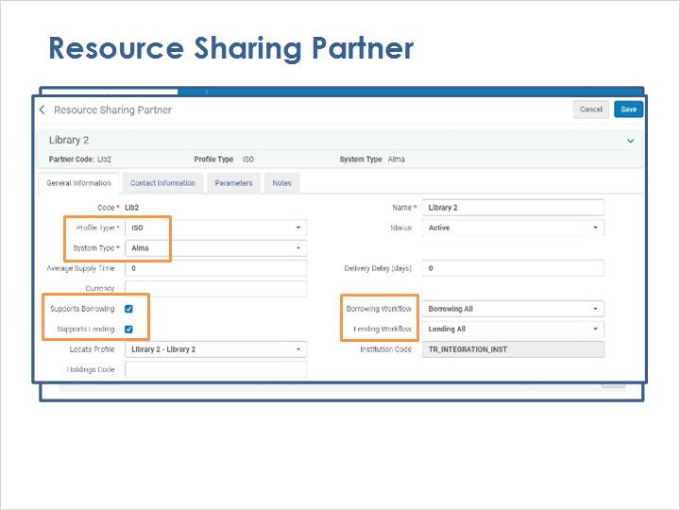

Parameters (Slide Layer)
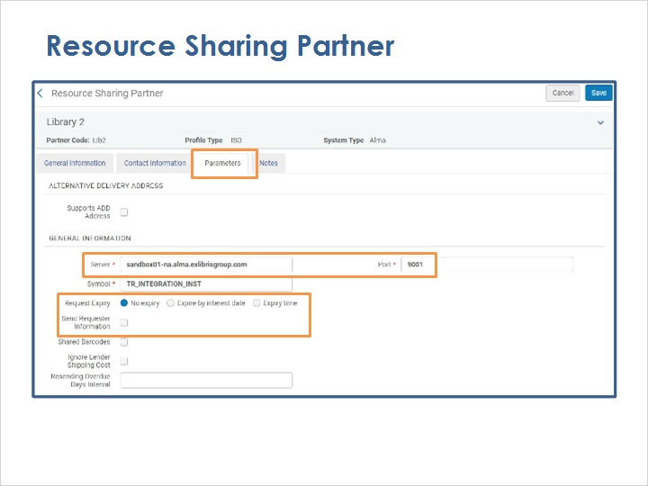

1.7 Wokflow Profiles
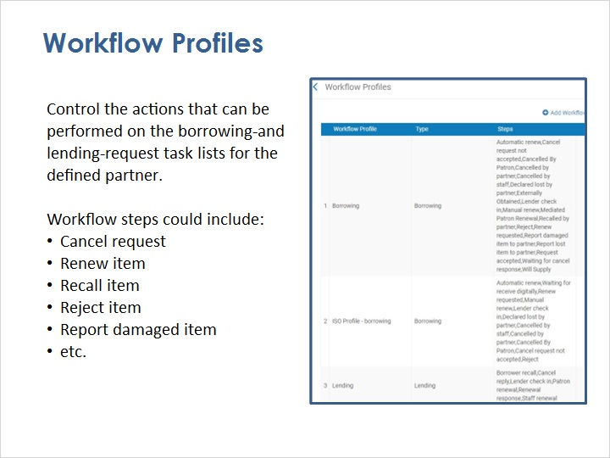
Notes:
Workflows, defined by workflow profiles, control the actions that can be performed on the borrowing-request and lending-request task lists for each resource sharing partner.
For example, a workflow profile may include that a patron can cancel a request or renew an item; that a resource-sharing partner can recall an item; that your institution can reject an item; report a damaged item; and many more.
You can set up workflow profiles for different types of lending and borrowing, such as NCIP lending, ISO profile borrowing, and any others you choose to define. Then, when adding or editing a resource sharing partner, you choose which borrowing and lending workflow profiles to use with that partner.

Workflow Profiles page (Slide Layer)
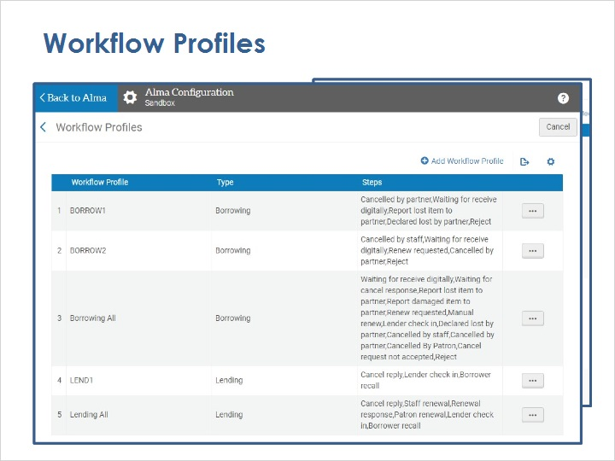

Resource-Sharing Partner page (Slide Layer)
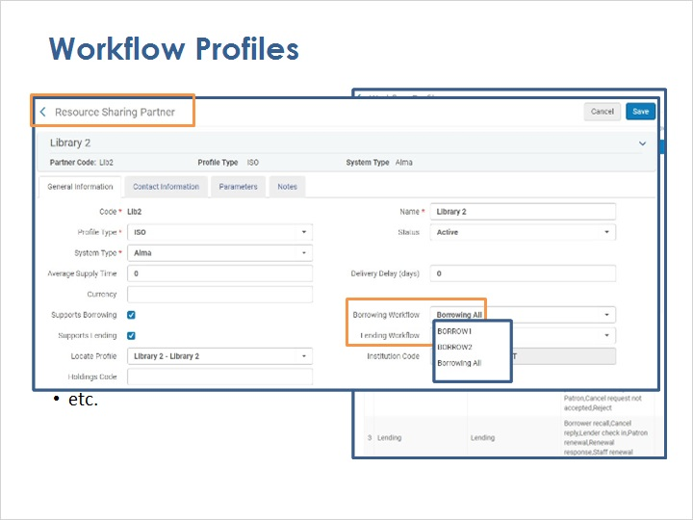

1.8 Item-Policy Exceptions
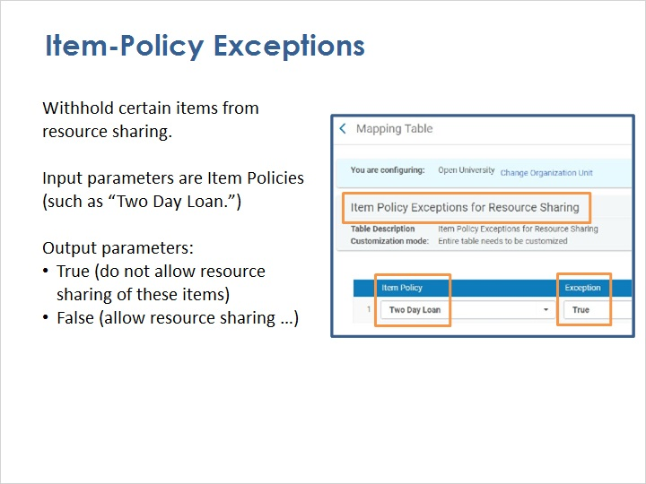
Notes:
Item-policy exceptions are rules to withhold certain types of items from being made available for resource sharing with any partners, including peers, brokers, and even fulfillment networks.

When defining these exceptions, the input parameters are the item policies, such as the “two-day loan.”

The output parameters are either True, meaning the exception is turned on and the items with this item policy cannot be shared with any other resource sharing partner; or False, meaning the item can be shared.

1.9 Review
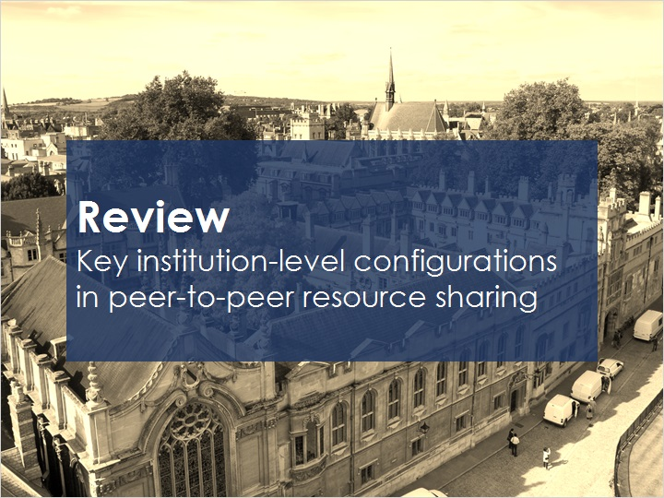
Notes:
This session has shown the key institution-level configurations in peer-to-peer resource sharing.

Please refer to the Recommended Articles section where you launched this training session for additional information.

Then, you can continue on to the next training session, which will cover configuration of a resource sharing library.

1.10 Thank You!

Notes:
Thank you for joining this session!

1.11 Copyrights

Notes:

