Direct Patron Requests in a Fulfillment Network

1. Direct Patron Requests in a Fulfillment Network

1.1 Direct Patron Requests in a Fulfillment Network
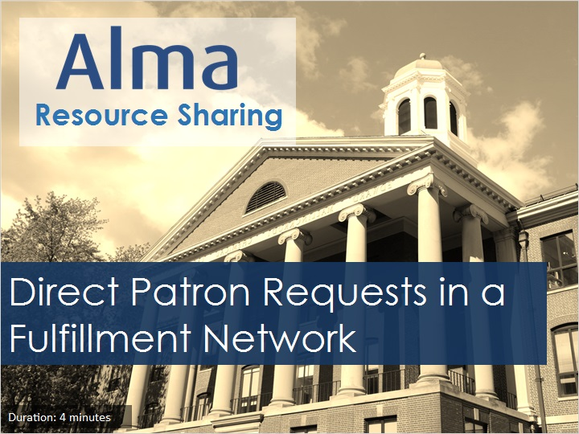
Notes:
Hello, and welcome to this session examining direct patron requests in an Alma Fulfillment Network.

1.2 Objectives
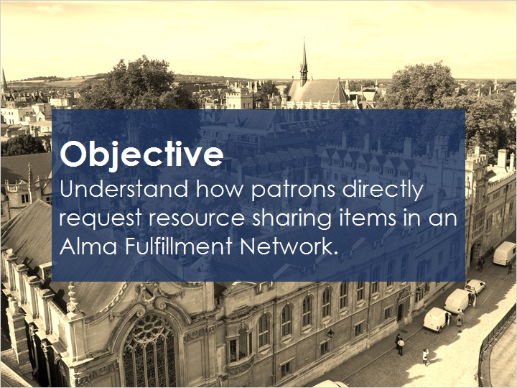
Notes:
This session will you will help you understand how patrons directly request resource sharing items in an Alma Fulfillment Network.

We’ll be covering discovery from institutions that share a Primo environment, from institutions that do not share a Primo environment, and some considerations for a rota.

1.3 Discovery and Request - Shared Primo
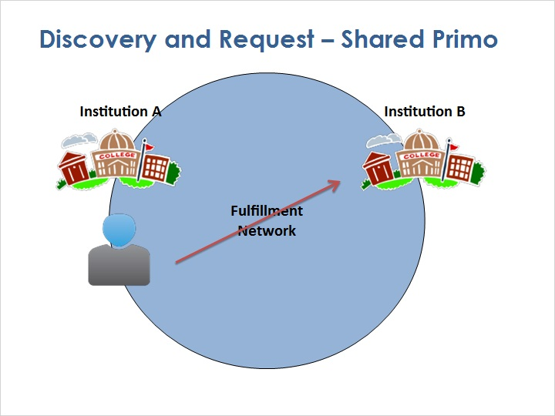
Notes:
There are two primary ways for a patron to get a resource from another institution in a fulfillment network. The first way - walking into another institution in-person - was discussed in a previous training session. In this session, we’ll explore the details of remotely requesting an item from another institution in the fulfillment network.

A patron of Institution A wants to request an item owned by Institution B.

Instead of visiting Institution B, the patron wants to place the request remotely.

If the two institutions share a common Primo environment, then when the patron discovers a Primo record that has inventory at more than one institution, the patron can view the inventory of other institutions by scrolling down to the Get It From Other Institutions section and selecting the Available link.

When the patron discovers an available item, the patron clicks the Request link, which does two things: First, if the patron is not already registered as a user at that institution, they will be registered, by copying the user record as described previously. Then Primo allows the patron to submit the request to that institution, for pickup at that institution or elsewhere.

Shared Primo Environment (Slide Layer)
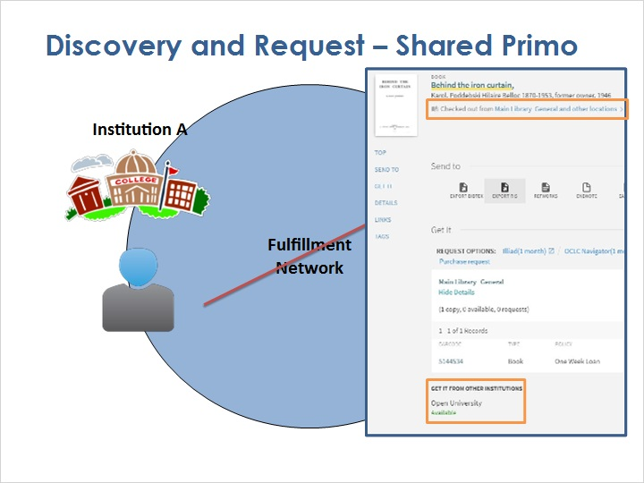

Get it from Other Institutions (Slide Layer)
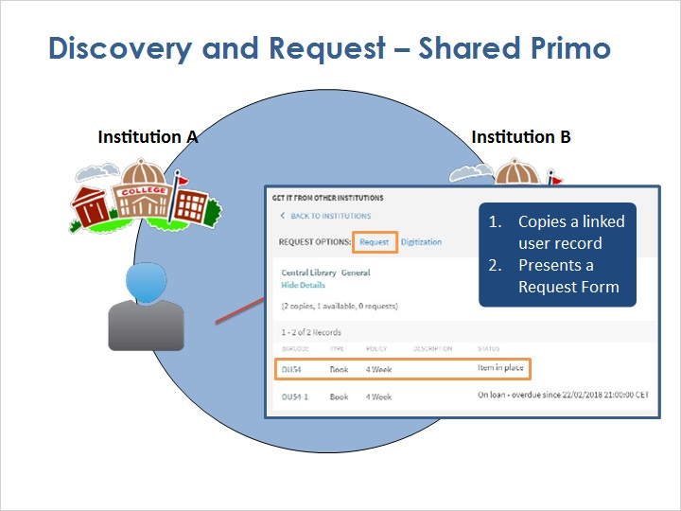

1.4 Discovery and Request - Separate Primos
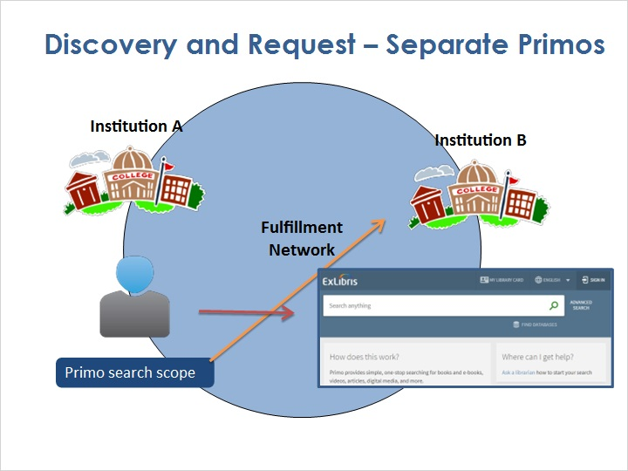
Notes:
In a fulfillment network that doesn't share a Primo environment, institutions can create shared search scopes, which at least allow patrons to search the other institutions from within their home institution’s Primo.

After that, the process is similar to the one with shared Primo, with the patron requesting the item from the other institution, and becoming automatically registered as a user at that other institution.

From then on, they’ll be able to directly log into the other institution’s Primo to conduct a search, or even walk into a library at that institution.

1.5 Rota
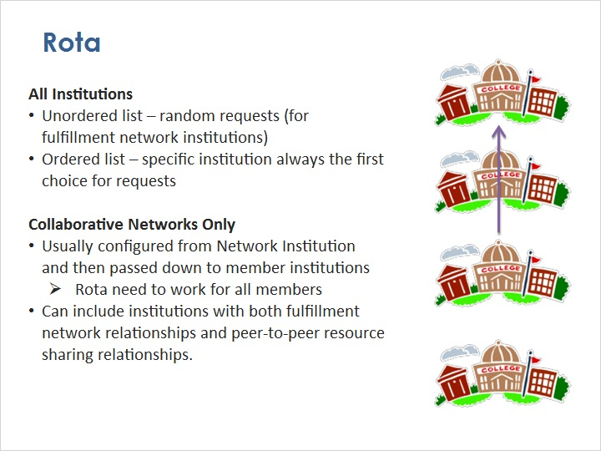
Notes:
As mentioned earlier, it’s possible for patrons to request a title instead, and let Alma automatically choose the institution in the fulfillment network that will supply the actual item.

But to do this, Alma needs to know your institution’s preferences for which partner to choose. That’s the purpose of a rota.

Rota are discussed in detail in another training session in this series, and rota in a Fulfillment Network work the same as they do with peer-to-peer resource sharing. The most important thing to consider is whether the rota template will use an unordered list or an ordered list of partners.

With an unordered list of partners, Alma checks a random institution on the list of partners until it finds the item, and then places the request.

With an ordered list of partners, you indicate that you’d like Alma to always check the first partner on the list to see if it has the item available. If not, Alma moves on to the second partner on the list, and so on until Alma finds a partner that can fulfill the request. You might choose to use an ordered list if, for example, there are some institutions that you regularly work with, and others that you only want to submit a request if you can’t find it from one of your preferred partners.

For institutions that are in a collaborative network - in other words, an Alma consortium - there are a couple other things to consider:

Most collaborative networks choose to configure rota at the Network Zone institution itself and then pass the rota down to the member institutions.

In that situation, you’ll want to create rota that work for all members. For example, you might chose to make a rota template with an unordered list of partners, so that no single institution has to fulfill a lot of requests. Or, if you want to actively balance the amount of borrowing and lending institutions do, you might choose an ordered list and then adjust the order every year or so based on request usage.

A rota within a collaborative network can include institutions with both fulfillment network relationships and peer-to-peer resource sharing relationships.

1.6 Review
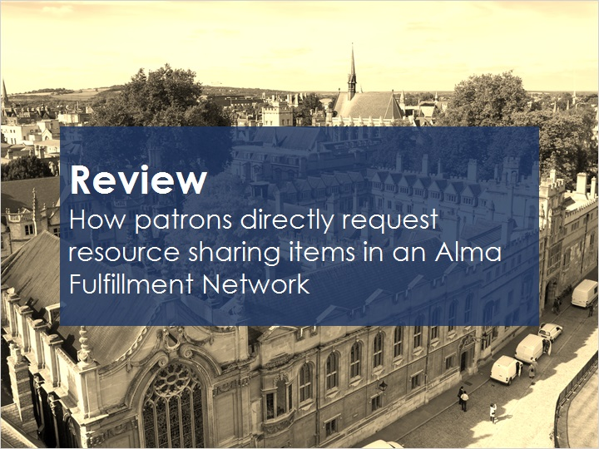
Notes:
This session has presented information to help you understand how patrons directly request resource sharing items in an Alma Fulfillment Network.

Please refer to the Recommended Articles section where you launched this training session for additional information.

Then, you can continue on to the next training session, which covers the end-to-end staff workflows for fulfilling these direct patron requests.

1.7 Thank You!

Notes:
Thank you for joining this session!

1.8 Copyrights

Notes:

