End-to-End Staff Workflows for Direct Patron Requests

1. End-to-End Staff Workflows for Direct Patron Requests

1.1 End-to-End Staff Workflows for Direct Patron Requests
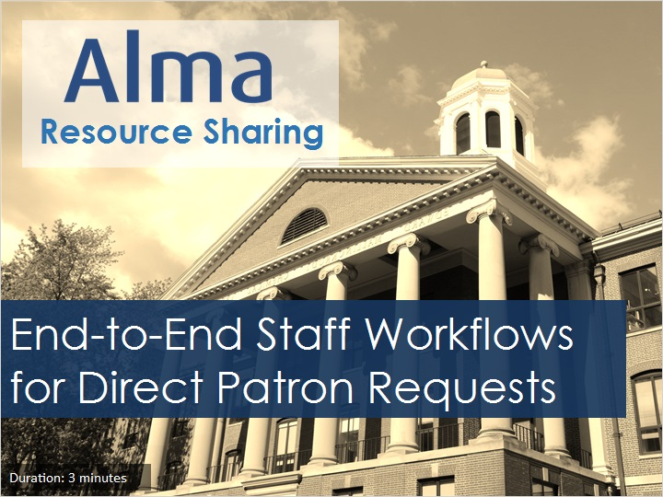
Notes:
Hello, and welcome to this session examining the staff workflow to fulfill direct patron requests in an Alma Fulfillment Network.

1.2 Objectives
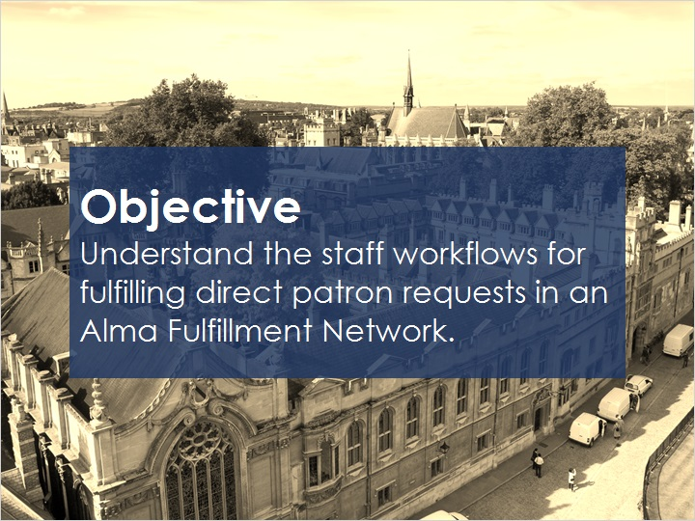
Notes:
In an earlier training session, we introduced the direct-patron-request fulfillment scenario, which can be used by patrons to request items in a fulfillment network.

This session will help you understand the staff workflows for fulfilling those direct patron requests.

We’ll be covering tasks the lending institution performs, and then responsibilities at the pickup institution, and finally how the item is returned to the lending institution.

1.3 Lending-Institution Tasks
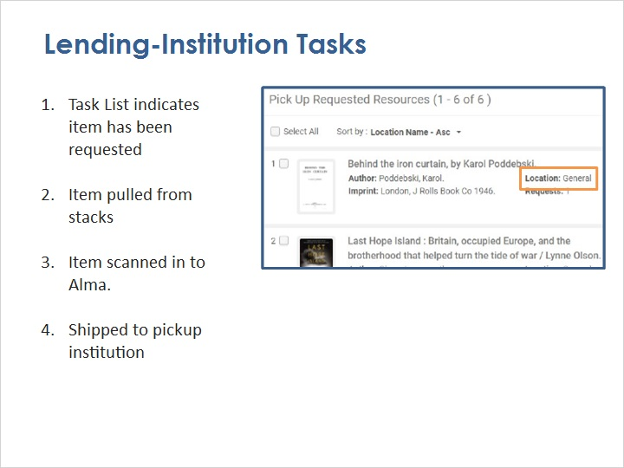
Notes:
First, the institution that owns the requested item - the lending institution - is notified of the request the same way as all requests: On the Task List at the appropriate circulation desk, an item indicates it needs to be picked up from a specific location … for example, from the General stacks.

Once it is brought to the circulation desk and scanned in, Alma indicates the next step is to ship the item to the patron’s chosen institution and pickup library.

By the way, if the circulation desk is not part of a library configured as a resource sharing library, then Alma will add the step of transferring the item to a resource sharing library before shipping to the pickup institution.

Ship to Pickup (Slide Layer)
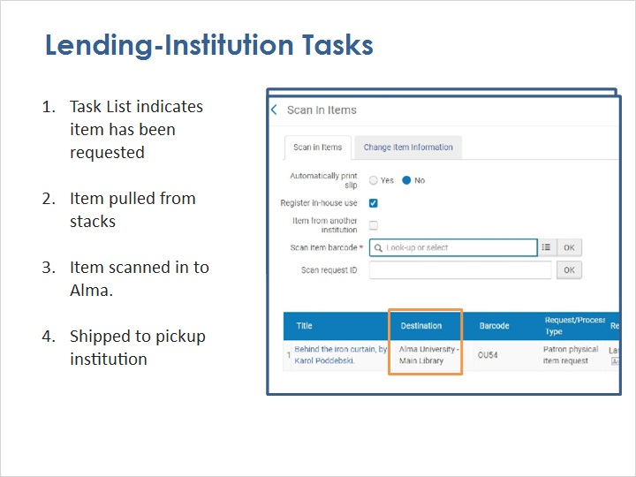

Transfer to Resource Sharing (Slide Layer)
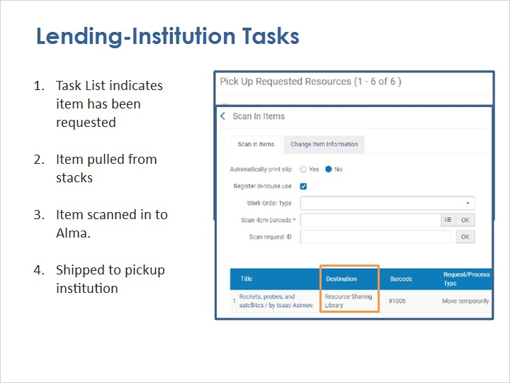

1.4 Pickup-Institution Tasks
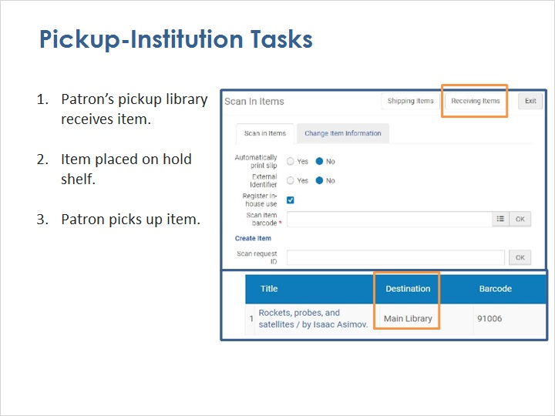
Notes:
When the item arrives at the library the patron chose for pickup, it is scanned in. The circulation-desk operator needs to indicate to Alma that the item came from another institution, and then Alma knows what to do with this item, thanks to the fulfillment network.

Alma indicates the item needs to be placed on the hold shelf for the patron to pick up at that final library, and Alma sends notification to the patron that the item is ready.

Place on Hold Shelf (Slide Layer)
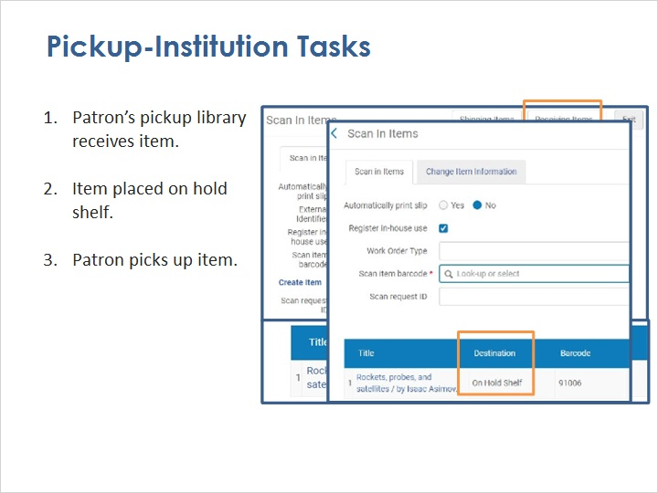

1.5 The Return Trip
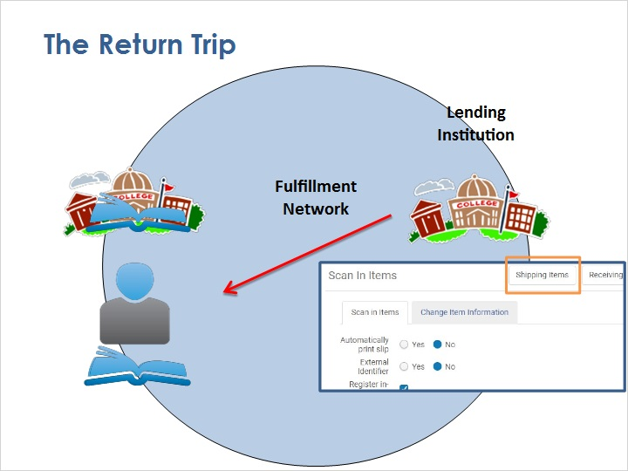
Notes:
While the patron has the item, the lending institution is the one that manages the loan: sending due-date reminders, recalling the item if necessary, and so on … just as though the patron walked in there and picked it up.

When the patron is ready to return the item, they can return it to any institution in the fulfillment network. When a circulation desk operator scans in the item, they indicate to Alma that the item isn’t from their institution. Then Alma will let the operator know where the item needs to go, and the process just repeats itself, but in reverse.

At each step along the way, Alma can tell any operator what needs to be done with the item, because all the institutions share information in the fulfillment network.

1.6 Review
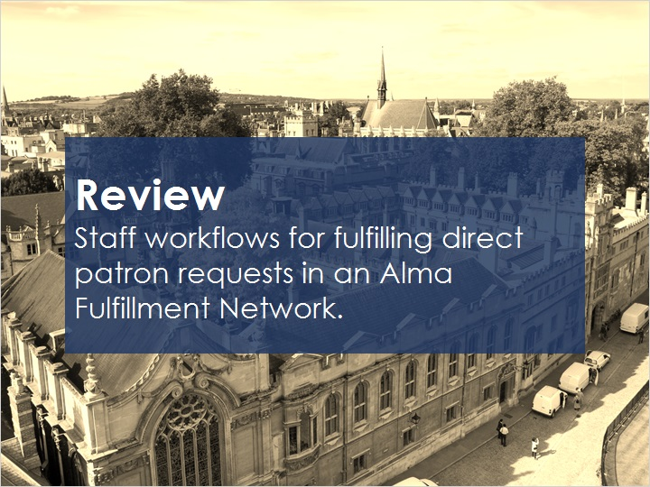
Notes:
This session has presented information on staff workflows for fulfilling direct patron requests in an Alma Fulfillment Network.

Please refer to the Recommended Articles section where you launched this training session for additional information.

Then, you can continue on to the next training session, which covers how to keep track of patrons’ resource sharing activities when they borrow items from another institution in the fulfillment network.

1.7 Thank You!

Notes:
Thank you for joining this session!

1.8 Copyrights

Notes:

