Configuring a Fulfillment Network

1. Configuring a Fulfillment Network

1.1 Configuring a Fulfillment Network
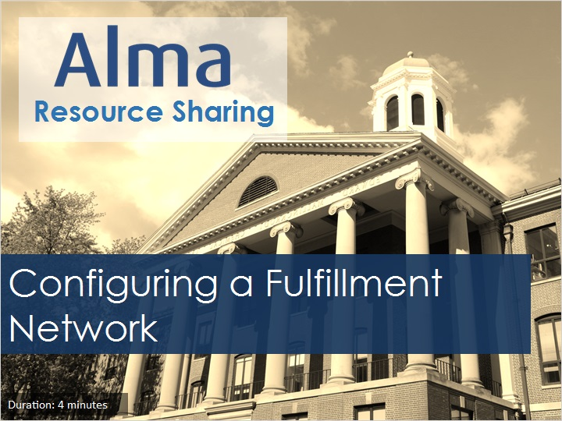
Notes:
Hello, and welcome to this session on Alma resource sharing, where we will discuss how to configure key elements of a Fulfillment Network, including the network search password, fulfillment network members, fulfillment network groups, and institution relationships.

1.2 Network Search Password
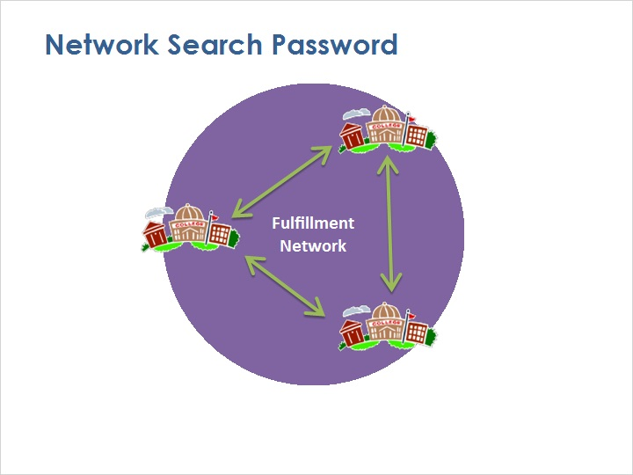
Notes:
When joining a fulfillment network, you need to set the Alma Network Search Password to be the same as all the other institutions in the network. This allows your Alma service to communicate with the Almas at the other institutions, to share user information, resources, and so on.

To configure this password, go to the Alma Configuration Menu, on the Resources tab, in the General Section, and select Other Settings.

This Mapping Table is used for many different types of Alma customer parameters. Scroll down the page to find the row with networkSearchPassword.

In the parameter value field, enter your fulfillment network’s search password, then click Save in the upper-right corner.

By the way, if your fulfillment network is being configured for institutions in a collaborative network - that is, an Alma consortium with a Network Zone - then the Password will already have been set for your collaborative network in the first place and should not be changed.

Configuration Menu (Slide Layer)
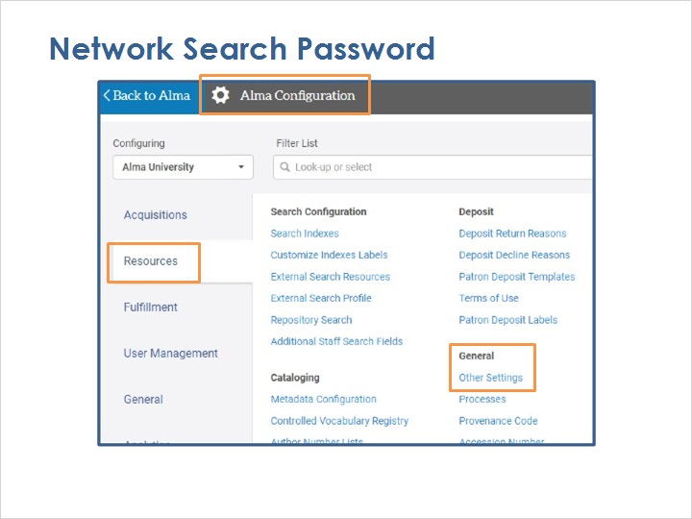

Mapping Table (Slide Layer)
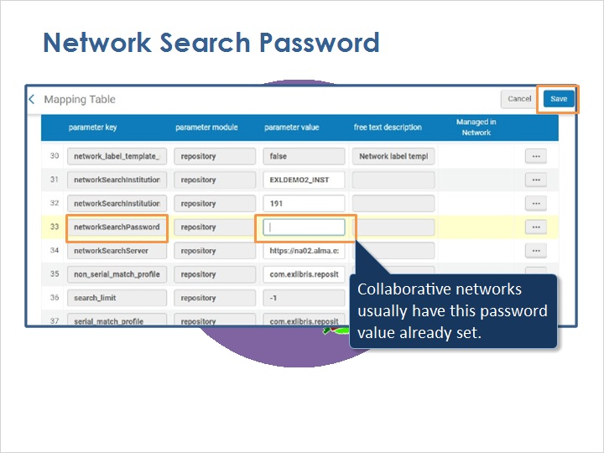

1.3 Fulfillment Network Members
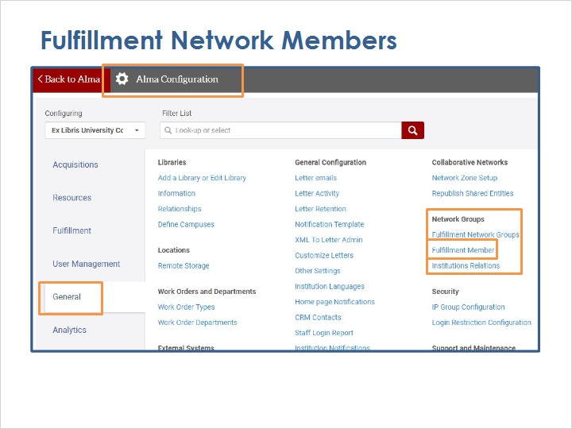
Notes:
Next, you need to tell your Alma service which other institutions are members of the fulfillment network.

If you’re part of a collaborative network, only the Network Zone institution does this configuration, which is discussed on the next slide.

If you’re not part of a collaborative network, then go to the Alma Configuration Menu, on the General tab, in the Network Groups section, and select Fulfillment Member.

On the Fulfillment Members Mapping Table, start by selecting Add Row.

The first field, Customer Code, is the Alma institution code of that member.

The URL is the base URL that staff at that other institution use to access Alma (that is, the URL through exlibrisgroup.com, not the part after that).

The Display Name is the name of the other institution as you want it to appear in your Alma service.

Then select Add Row, and the member will be added to the list.

Continue to add fulfillment network members and, when you’re done, click Customize in the upper-right corner.

Fulfillment Members Mapping Table (Slide Layer)
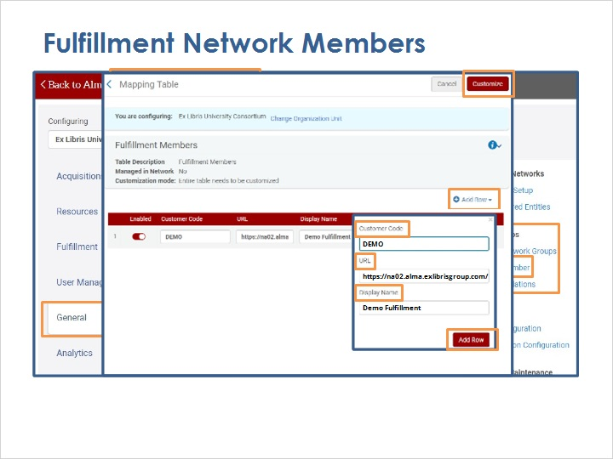

1.4 Fulfillment Network Members - Collaborative Network
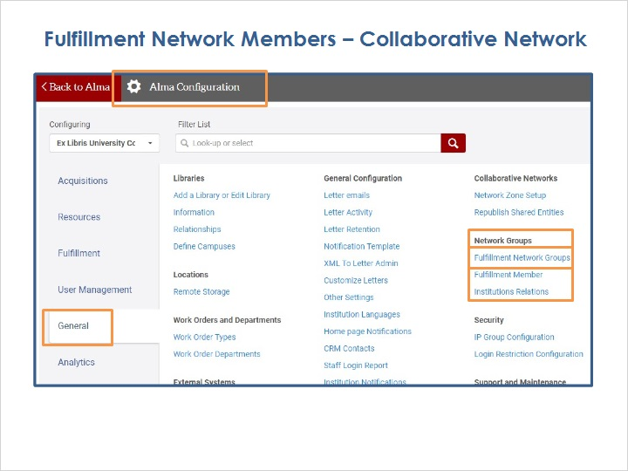
Notes:
On the other hand, institutions that are part of a collaborative network don’t configure fulfillment network members themselves. Instead, staff members who have access to the Network Zone Institution will use the following steps to define institutions that are part of the fulfillment network.

Go to the Alma Configuration Menu, on the General tab, in the Network Groups section, and select Fulfillment Network Groups.

On the Groups page, start by selecting Add Group.

Give the group a name and an optional description, and then click Add and Close.

Your new group will appear on the list, and now you need to add members to the list.

Select the row-action item Edit.

On the list of members, choose an institution, campus, or library from the dropdown menu and then click Add Institution (or Add Campus or Add Library). Continue adding members to complete the group.

List of Groups - add group (Slide Layer)
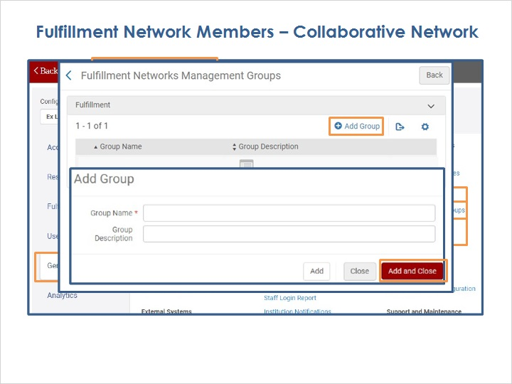

List of Groups (Slide Layer)
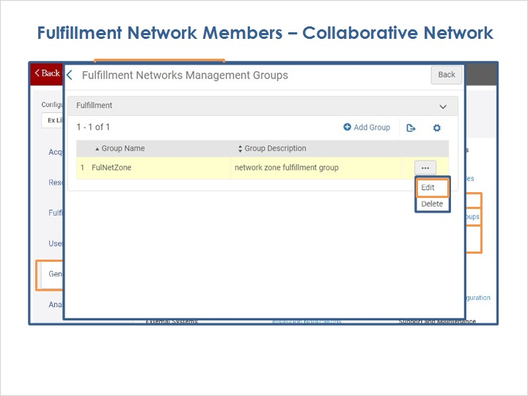

Add members (Slide Layer)
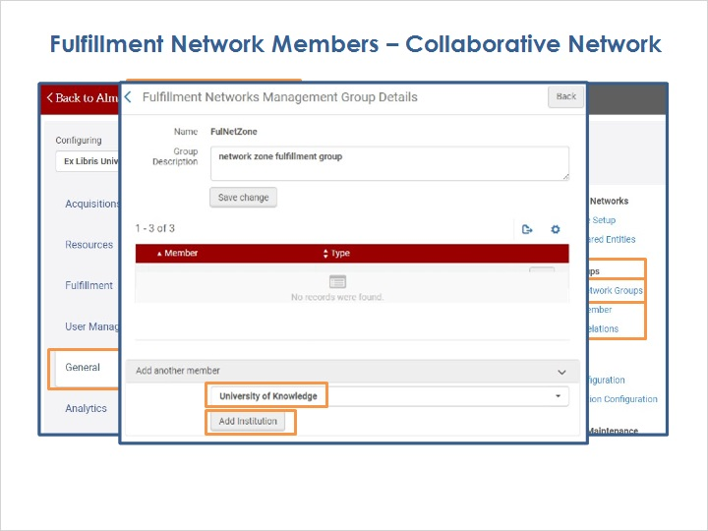

Member list complete (Slide Layer)
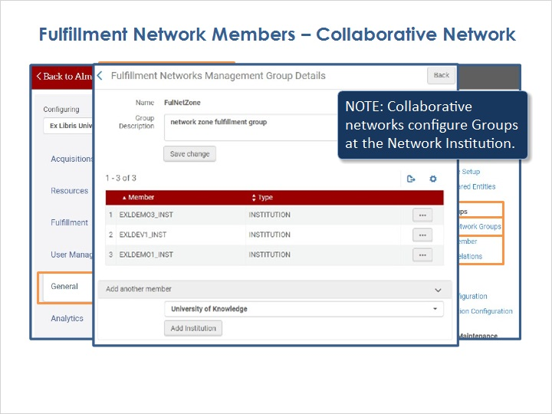

1.5 Institution Relationships
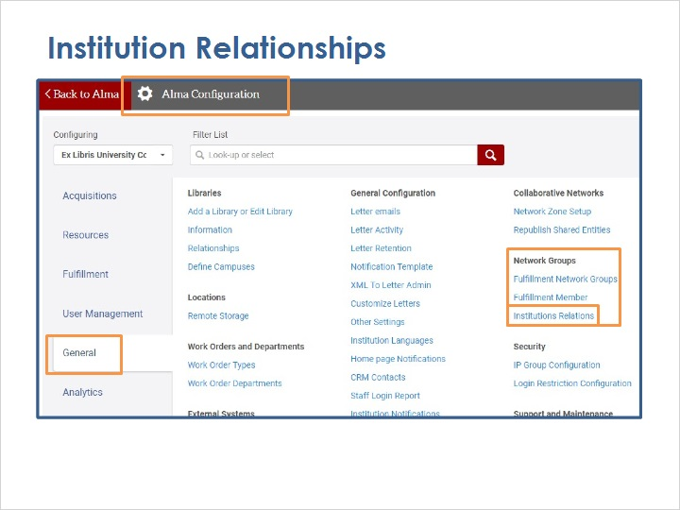
Notes:
Finally, you need to set up relationships between institutions.

Go to the Alma Configuration Menu, on the General tab, in the Network Groups section, and select Institution Relations.

This page shows some of the relationships already set up, but if you’re starting out, select Add Relation.

On the popup, choose an institution in the From dropdown.

For the To dropdown, you can choose another institution in the network, or you can choose All.

Then, indicate whether the From institution can circulate material for the To institution, and whether the From institution can deliver items to the other institution.

Then click the Add Relation button.

Continue to Add Relations for all members of the fulfillment network.

Institutions Relations Setup (Slide Layer)
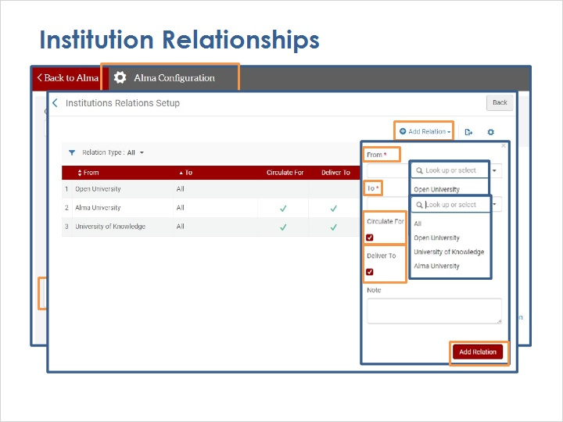

1.6 Review
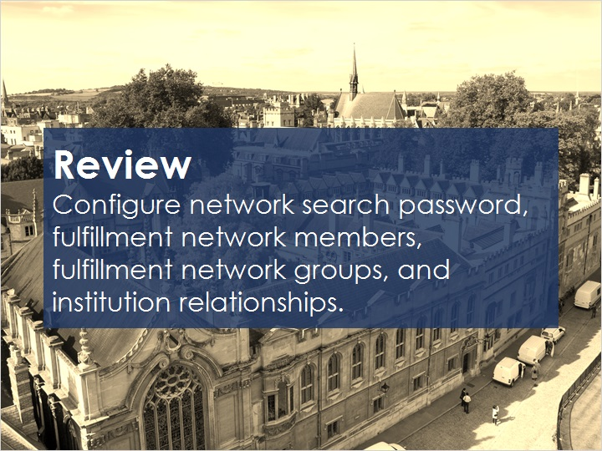
Notes:
This session has presented information on how to configure key elements of a Fulfillment Network, including the network search password, fulfillment network members, fulfillment network groups, and institution relationships.

Please refer to the Recommended Articles section where you launched this training session for additional information.

Then, you can continue on to the next training session, which covers how to link users in a fulfillment network.

1.7 Thank You!

Notes:
Thank you for joining this session!

1.8 Copyrights

Notes:

