Alma Digital: Managing Collections

1. Alma Digital: Managing Collections

1.1 Alma Digital: Managing Collections
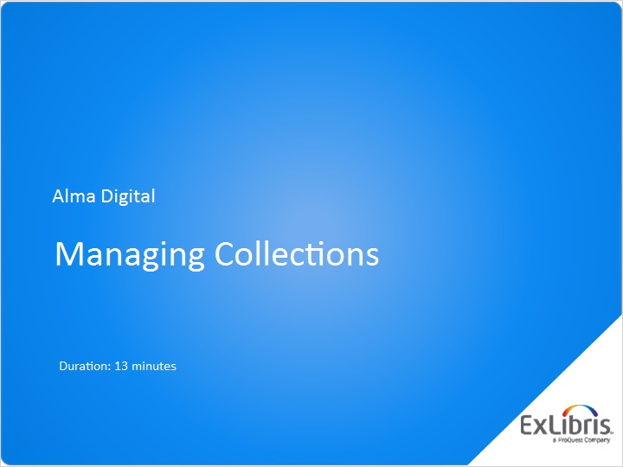
Notes:
Hello, welcome to this session on Managing Collections in Alma. To get the most out of this session, you need to have watched the Alma Digital overview session first.

1.2 What are Collections?
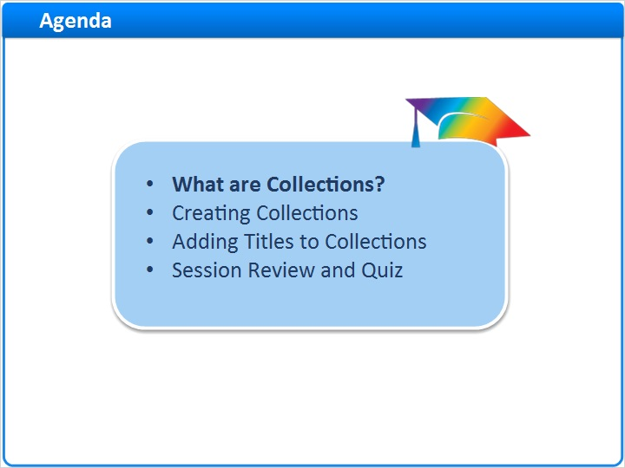
Notes:
In this session, we’ll learn what collections are. Then, we’ll look at how to create collections and sub-collections. And, we’ll
learn how to add titles to collections.
After a brief session review, there will be a short quiz to test your knowledge.

1.3 Collections in Alma
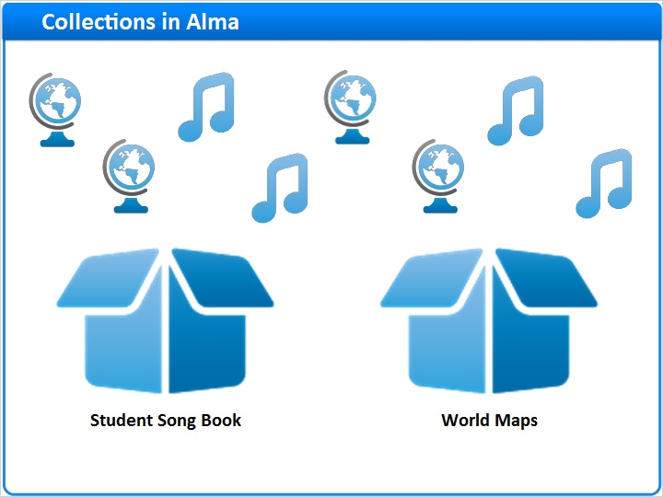
Notes:
Collections form the foundation of Alma Digital by allowing related titles to be grouped together. For example, you might create a Student Song Book Collection to hold musical scores and sound recordings by students at your university. And you might create a separate World Maps Collection for your digitized maps.
Grouping related resources into collections is important not only for managing your resources, but also to present those resources in a logical way to patrons during discovery.
And, remember, each digital resource managed in Alma must belong to one or more collections. So, the first step in managing digital resources is creating a Collection to hold them.

1.4 Collection Hierarchy
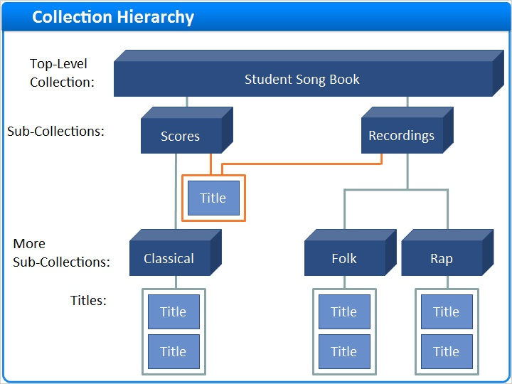
Notes:
Collections can be nested to better organize your digital resources. In this example, there’s a top-level collection called Student Song Book which contains two sub-collections, Scores and Recordings.

In turn, the Scores sub-collection contains another sub-collection, Classical. And the Recordings sub-collection contains both a Folk and Rap sub-collection. In this example, it is this lowest level that contains titles.

But, if you wanted, you could mix titles in with sub-collections at any level, like this.

And, a title can belong to more than one collection. For example, you may have a title with both a Score and a Recording.

1.5 Creating Collections
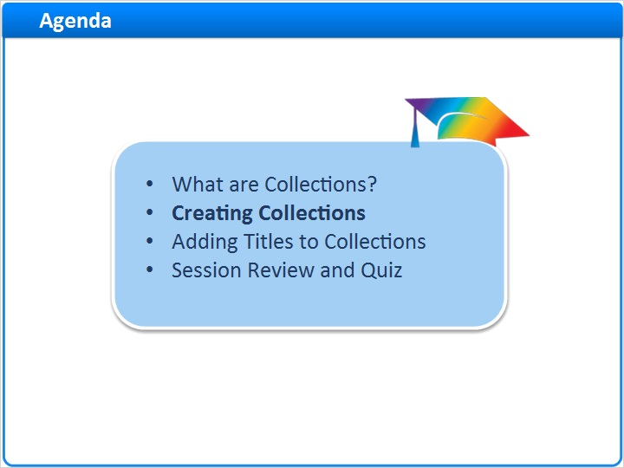
Notes:
So, how do you create collections?

1.6 Practice Creating Collections
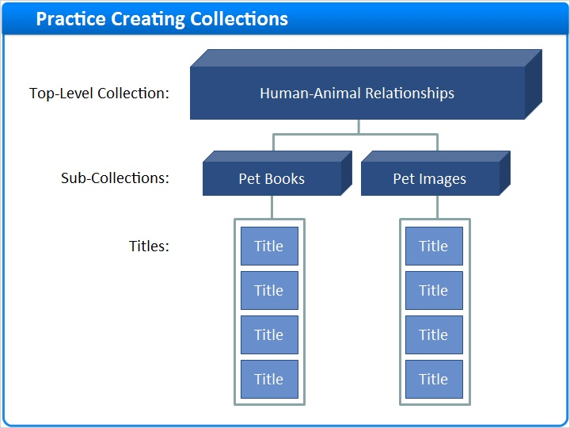
Notes:
Let’s practice by creating a top-level collection called Human-Animal Relationships and two sub-collections: Pet Books and Pet Images. We’ll learn about adding titles later in the session.

1.7 Navigate to Top-Level Collection List
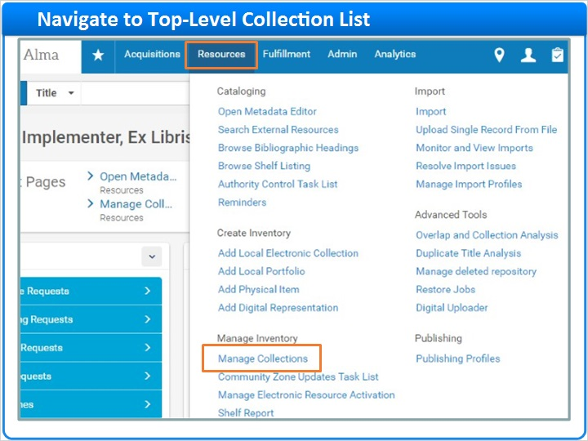
Notes:
To get started, click Resources on the main menu bar in Alma. Then, locate the Manage Inventory section and click Manage Collections.
Here, you’ll see the list of top level collections already created by your institution. Now, click Add Top-Level Collection.

Top-Level Collections (Slide Layer)
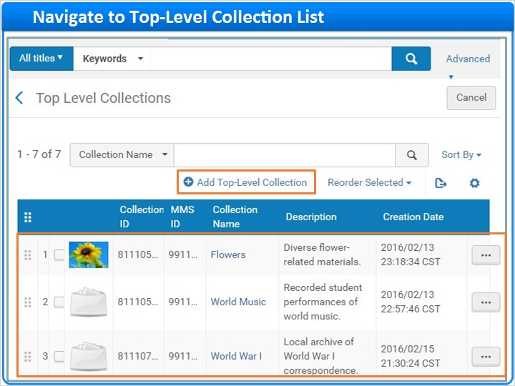

1.8 Create Top-Level Collection
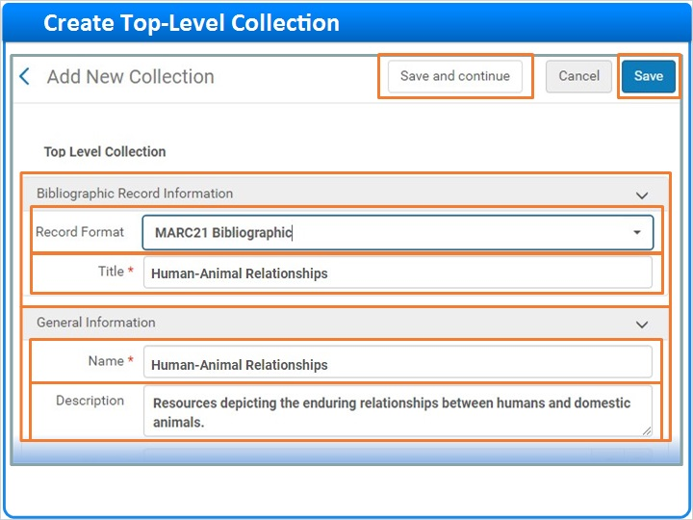
Notes:
Complete the form starting with the Bibliographic Information. If your library supports more than one format, select a Record Format for the collection record itself (not necessarily the record type for the collection’s titles). Here, we’re using MARC 21.
Then, enter a Title which will be stored in the MARC field 245 subfield a. (We’ll talk about why this is important later.) For example, enter Human-Animal Relationships. The Title is internal to Alma and appears in Alma search results.
The Name field under General Information, on the other hand, is published to Primo and appears in the Collection Lobby. The Name must be unique among top-level collections. Best practice is for the collection Title and Name to match, so enter Human-Animal Relationships again.
The optional Description also appears in Primo and can be helpful for patrons exploring your collections.
Toward the bottom of the form, select the owning Library for the collection, for example, the Science Library.
If you like, use the Thumbnail Upload field to upload an image like this.
And, use the Place at/before field to choose where in your list of your top-level collections you want this one to appear both in Alma and in Primo.
If we were done with our work for now, we would click Save at the top of the page. But, we want to add two sub-collections, so let’s click Save and Continue instead.

General Information Continued (Slide Layer)
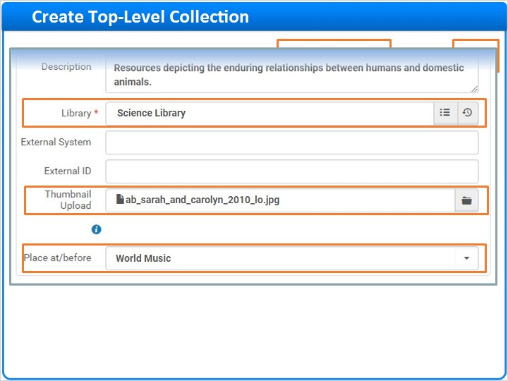

Thumbnail (Slide Layer)
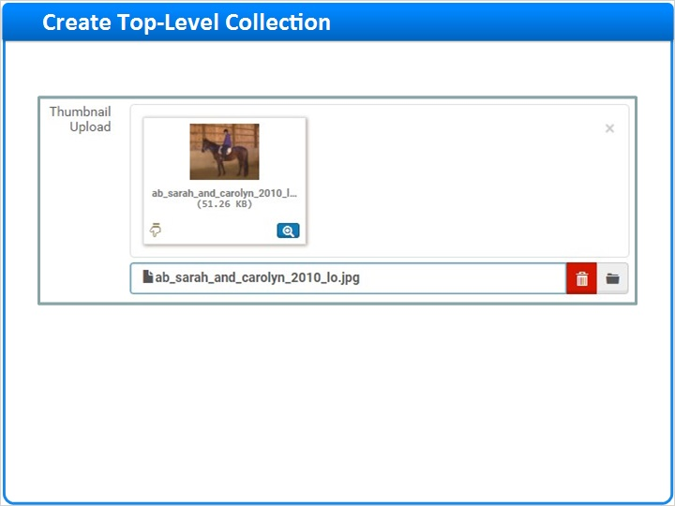

1.9 Create Sub-Collection
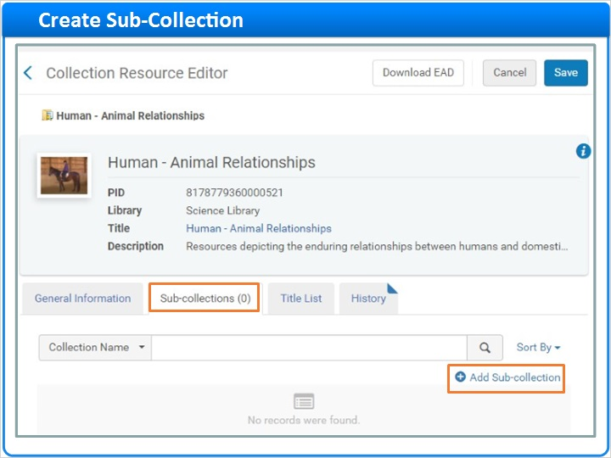
Notes:
Conveniently, we land on the Sub-collections tab of the Collection Resource Editor. We’ll look at the other tabs later.
For now, click Add Sub-collection, and complete the form to create a sub-collection called Pet Images. The process is the same as for creating top-Level collections, with a few minor differences:
- The name needs to be unique among sub-collections that share the same parent, but not across all sub-collections.
- Also, the Library is inherited from the parent collection.
We are done with this sub-collection for now, so click Save.
And, here’s our new Pet Images sub-collection. You can see by the breadcrumb trail that Pet Images is under the top-level parent collection Human - Animal Relationships.
Click Add Sub-collection again to repeat the process for a Pet Books sub-collection.

Add Sub-Collection (Slide Layer)
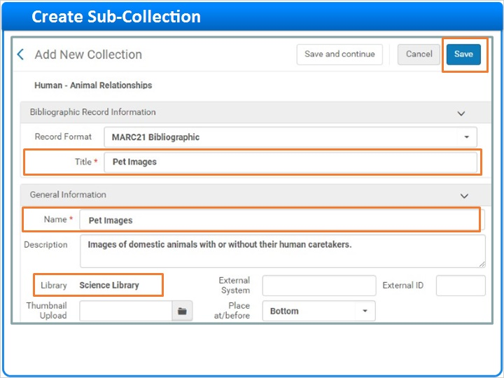

New Sub-Collection (Slide Layer)
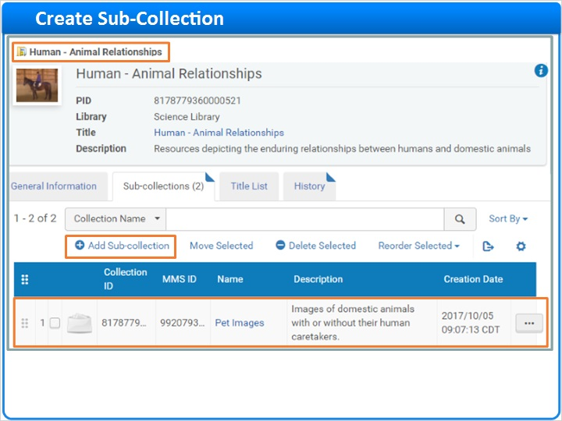

1.10 Working with Sub-Collections
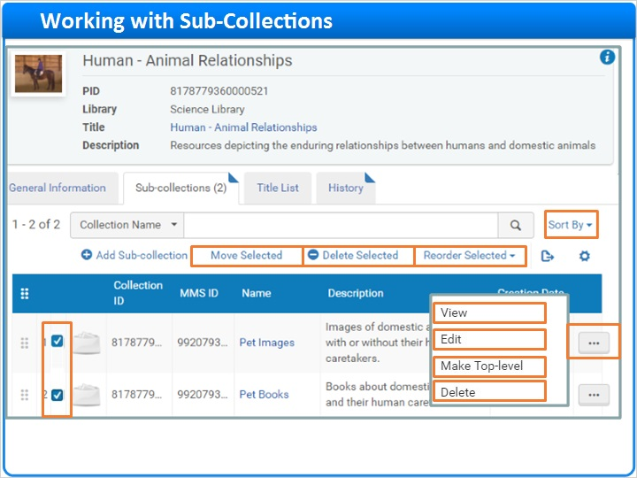
Notes:
Now we have two sub-collections to work with. Click the Row Actions List to View, Edit or Delete a sub-collection. Remember that the Delete option is not available for sub-collections that contain contents; you must remove all contents before deleting a collection. You can also change the sub-collection into a Top-level collection.
To perform bulk operations on sub-collections, check the boxes next to the desired sub-collections and select an option.
For example, click Move Selected to move the sub-collections under a different parent collection. Then, search on one of these fields to locate the new parent. Here, I searched for a collection with a title containing the word mammals. Click in a search result row to complete the move.
Or, click Delete Selected to delete any empty collections.
Click Reorder Selected to change the order in which the sub-collections appear within the parent collection. Or, click Sort By to reorder the sub-collections by Name or Creation Date, but remember, the order specified in Alma also appears in Primo.

Move Sub-Collections (Slide Layer)
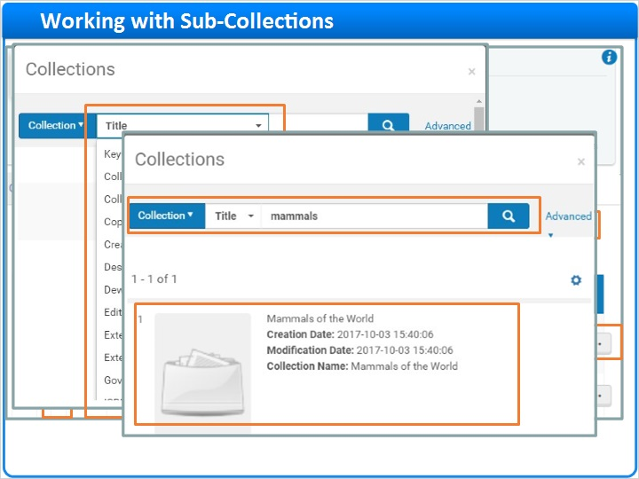

Sort Sub-Collections (Slide Layer)
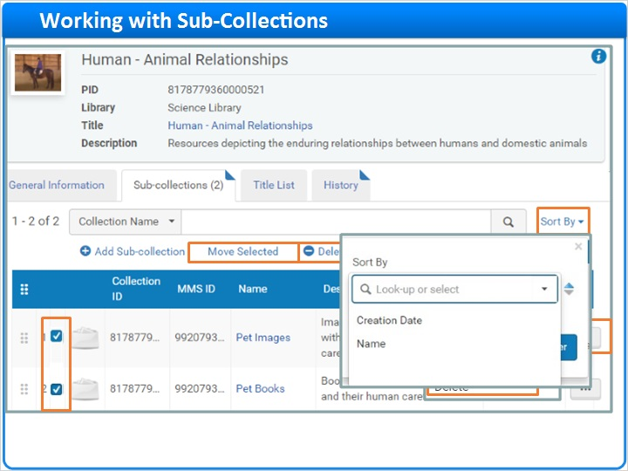

1.11 Working with Top-Level Collections
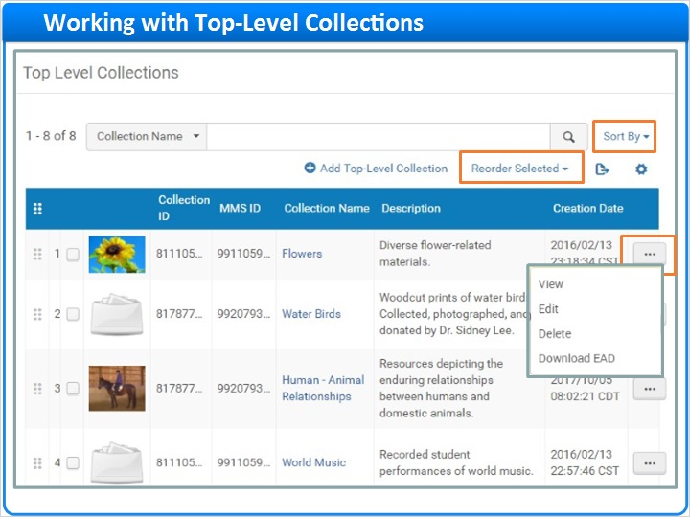
Notes:
Working with top-level collections is very similar to working with sub-collections. Just as with sub-collections, you can click to see the Row Actions List for a top-level collection. And you can reorder or sort top-level collections for display in both Alma and Primo.

But, unlike sub-collections, you cannot move a top-level collection under a new parent.

1.12 Finding and Modifying Your Collections in Alma
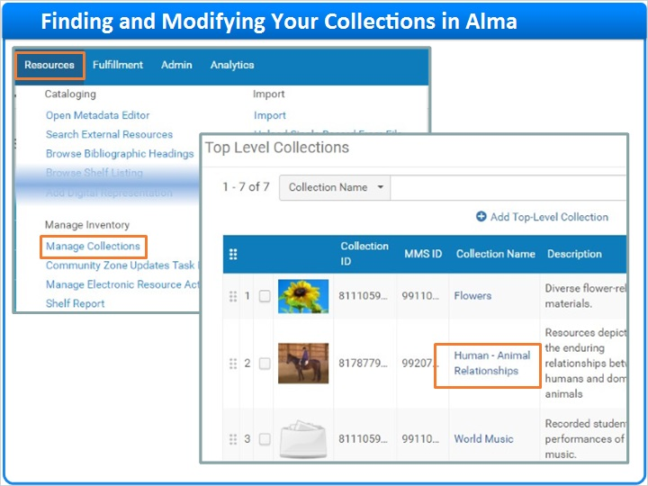
Notes:
Once you’ve created collections or sub-collections you can find them later by navigating to the Manage Collections page under the Resources menu. Here, you will see your top-level collections.
Click on a collection name to access the Collection Resource Editor and view any sub-collections. Since there can be multiple levels of nesting, finding sub-collections this way can be tedious.
Instead, you may want to search the repository for collections at any level. Here, I searched Collections for Titles containing the word pet.
From the search results page, you can click the Row Actions List to Delete any empty collections. Click Edit Record to launch the Metadata Editor where you can change the collection’s bibliographic metadata, including the title (which, as we noted earlier, is in the MARC 245 subfield a field). Or, click Collection to modify the collection using the Collection Resource Editor.
By the way, you can launch the Metadata Editor by clicking on the collection Title in the header area of the Collection Resource Editor.

Collection Resource Editor - Sub-Collections Tab (Slide Layer)
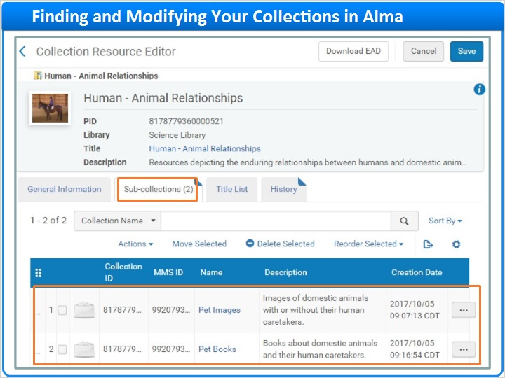

Search Repository (Slide Layer)
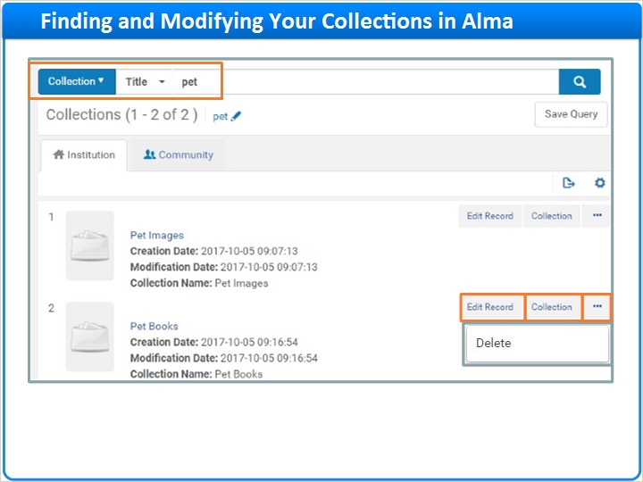

Metadata Editor (Slide Layer)
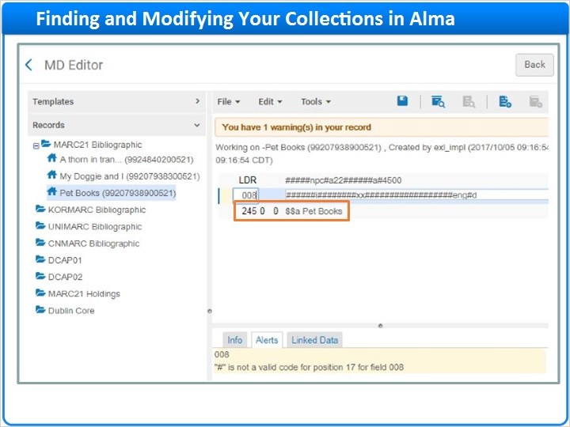

Collection Resource Editor - Title (Slide Layer)
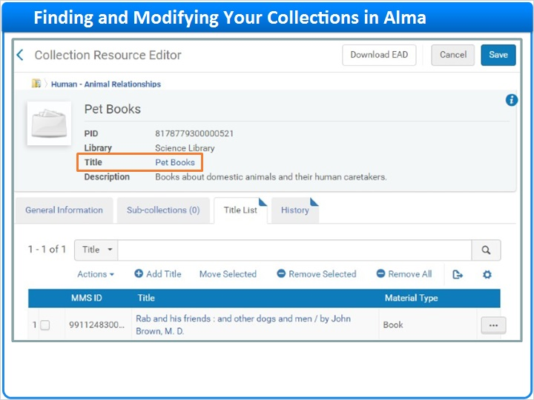

1.13 Collection History
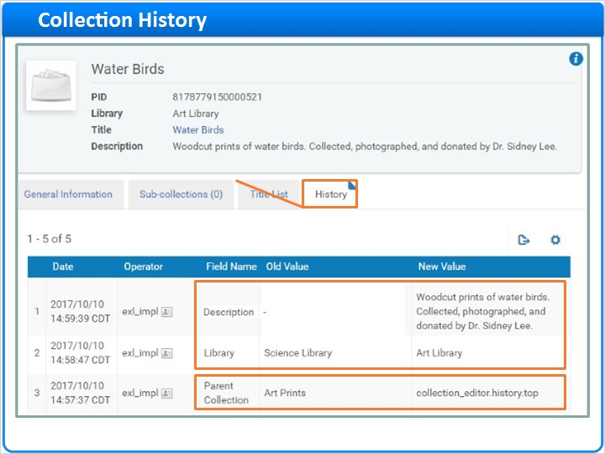
Notes:
To review a list of the changes made to a collection, go to the History tab on the Collection Resource Editor.

Here, Alma logs changes made to the Description, Library, and other fields on the General Information tab. Alma also logs when sub-collections are moved under a different Parent Collection. Title List changes, however, are not logged.

1.14 Adding Titles to Collections
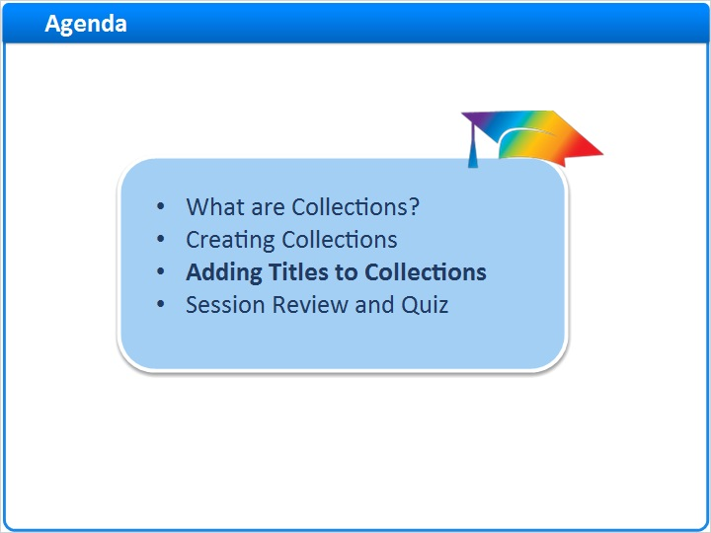
Notes:
Now that we have some collections in place, let’s learn how to use the Collection Resource Editor to add titles to a collection. We’ll learn about other techniques in future training sessions.

1.15 Navigate to Collection Resource Editor
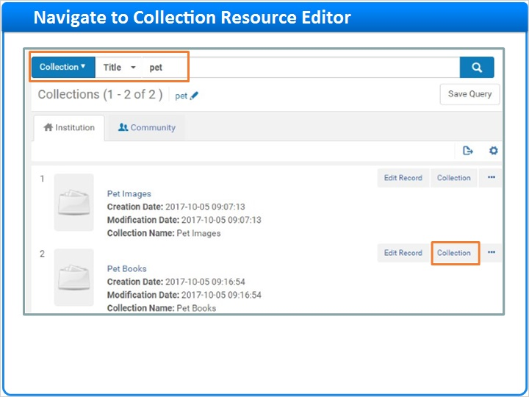
Notes:
Once again, search the repository for the two pet collections we just created. Then, click Collection on the row for Pet Books to launch the Collection Resource Editor.

1.16 Add Titles via Repository Search
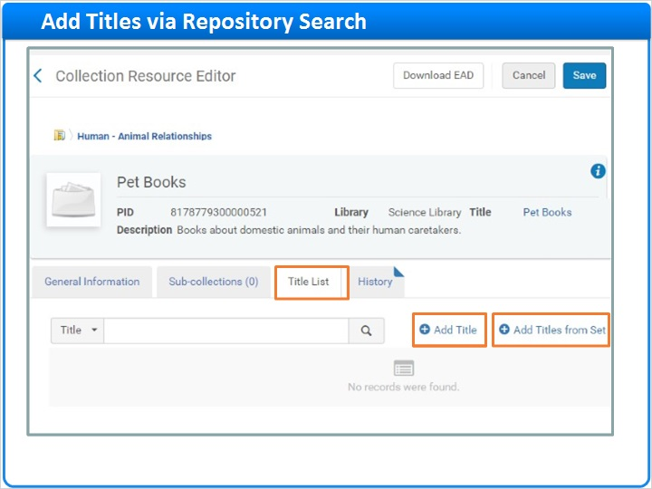
Notes:
To add titles, click on the Title List tab. The list is empty but there are two options for adding titles: Add Title and Add Titles from Set.

Let’s start by clicking Add Title so we can search the repository for one or more titles to add. For example, search on the word cats. Then, on the search results page, select the desired titles and click Add Titles.

And, here are your newly added titles.

Search Repository (Slide Layer)
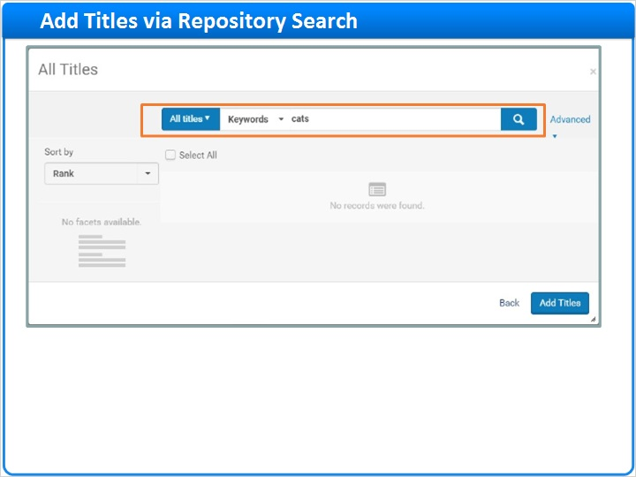

Add Titles from Search Results (Slide Layer)
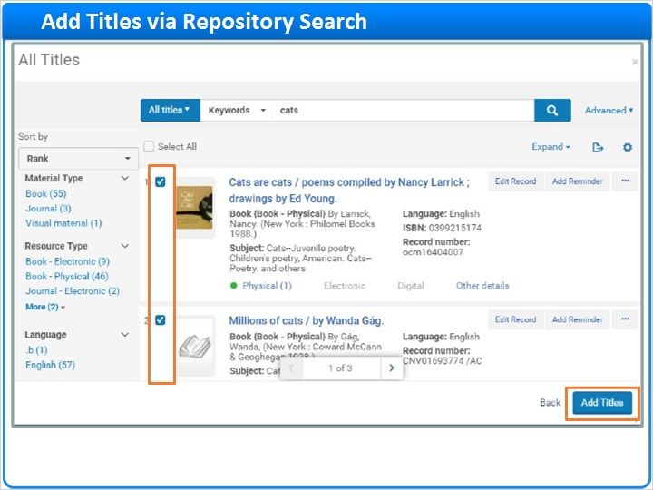

Titles Added (Slide Layer)
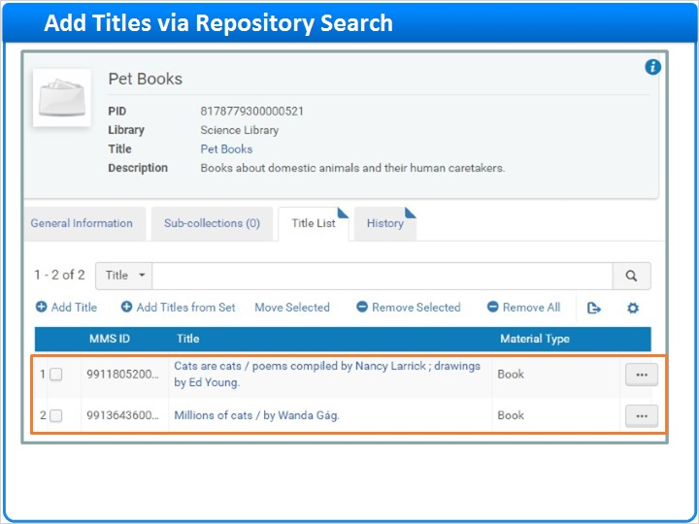

1.17 Add Titles from Set
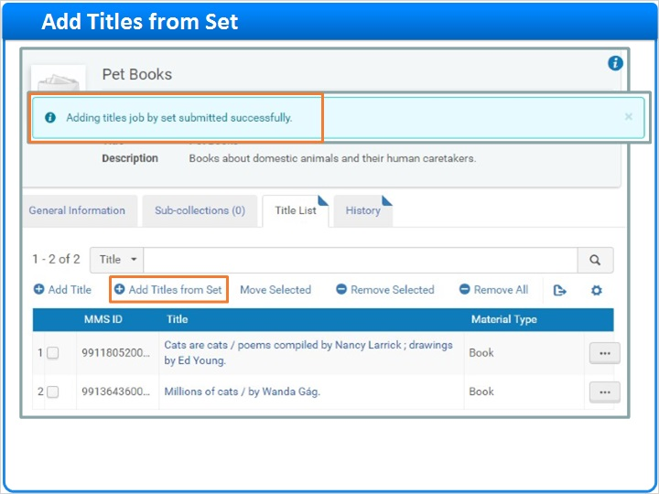
Notes:
Now, let’s look at how to add a predefined set of titles all at once. You can learn about defining sets in a separate training session. For now, we’ll assume that we already have a saved set to use, so click Add Titles from Set.

On the Manage Sets page, select the set of titles to add, and click Add Set Titles. Since there could be thousands of titles in the set, this action submits a job that adds the titles while you continue to work.

You can learn all about running and monitoring jobs in a separate training session. After the job has been completed, revisit the Title List tab in the Collection Resource Editor to see any newly added titles.

Manage Sets Page (Slide Layer)
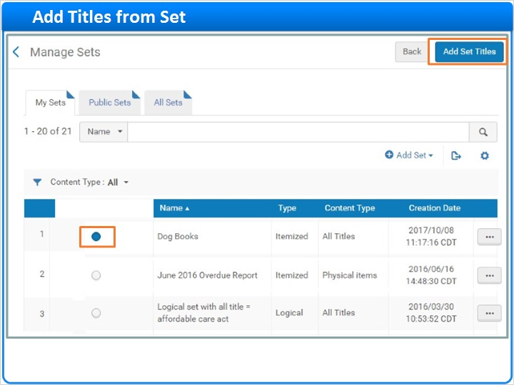

Set Titles Added (Slide Layer)
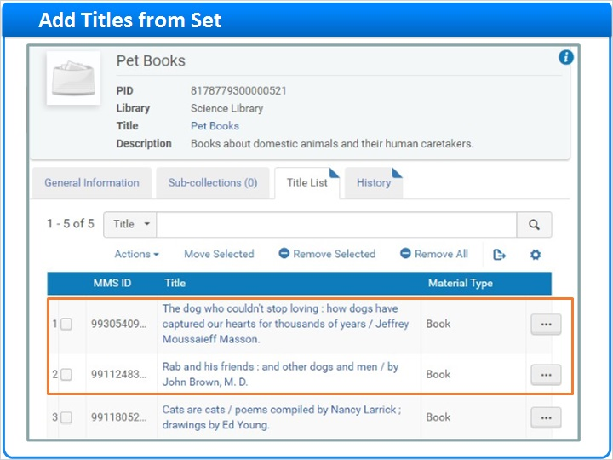

1.18 Assign Title from Metadata Editor
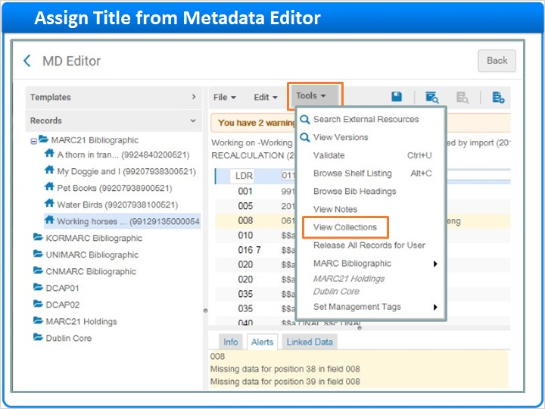
Notes:
Here’s yet another way to add a title to a collection. When working on a title in the Metadata Editor, click the Tools menu and select View Collections to expose a Collections pane.

Then, click Assign. Now, you can choose the collection to which you want to assign the title, and click Select.

Collections Pane (Slide Layer)
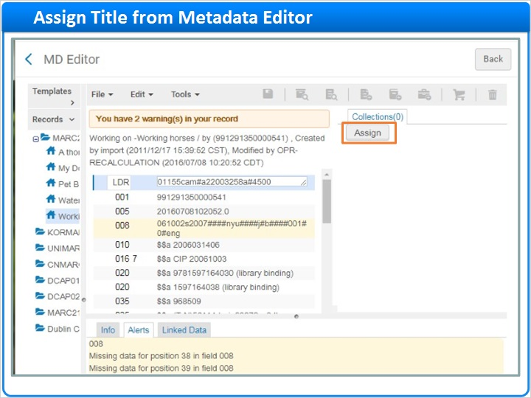

Collections (Slide Layer)
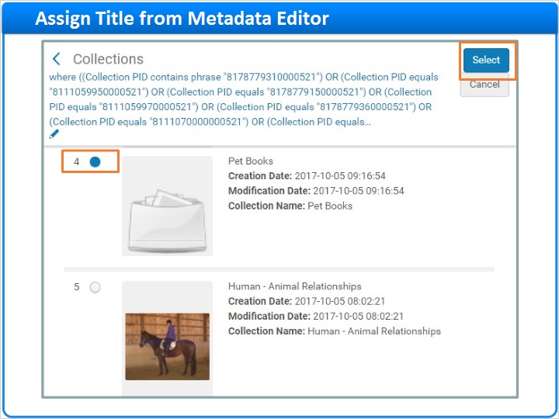

1.19 What Happens When You Add a Title?
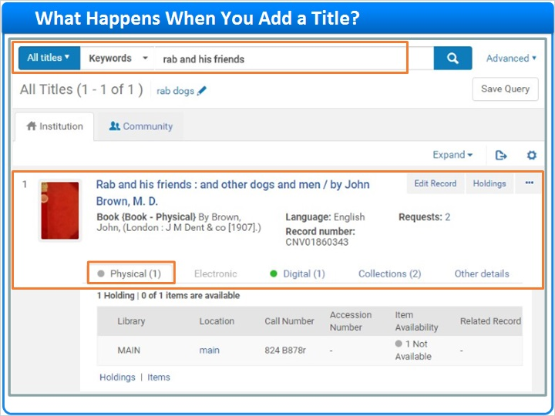
Notes:
So, what happens when you add titles to a collection? Let’s search the repository for a title we just added, Rab and His Friends, so we can take a closer look.

Here’s the title on the search results page. We can see that the library holds a Physical copy. However, using the Digital tab, we see that there’s already a master digital representation associated with this title. You can even click to see the representation in the Viewer.

And, on the Collections tab, we see that the title belongs to two collections: Pet Books, the collection to which we just added the title, and Mammals of the World, the collection to which the title already belonged. Remember, every digital representation must be in at least one collection, so this title had to be in a collection before we added it to Pet Books.

Digital (Slide Layer)
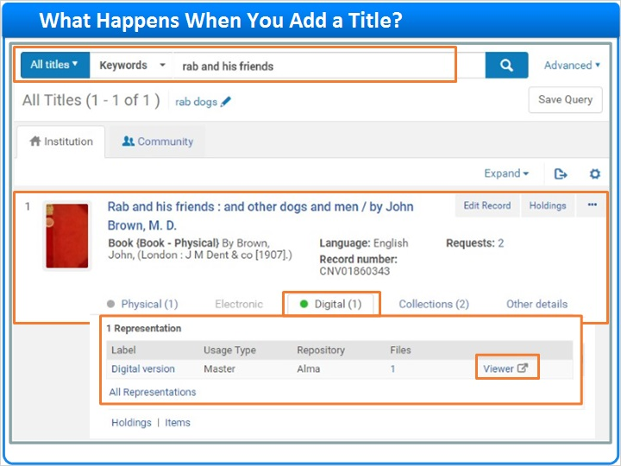

Viewer (Slide Layer)
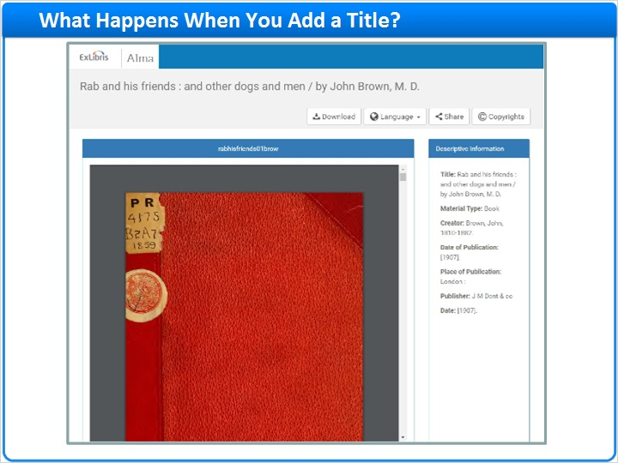

Collections (Slide Layer)
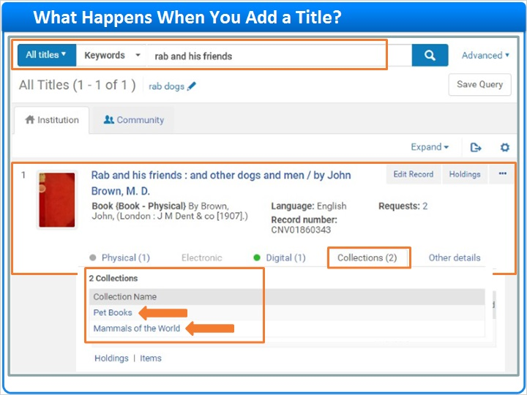

1.20 Another Example of an Added Title
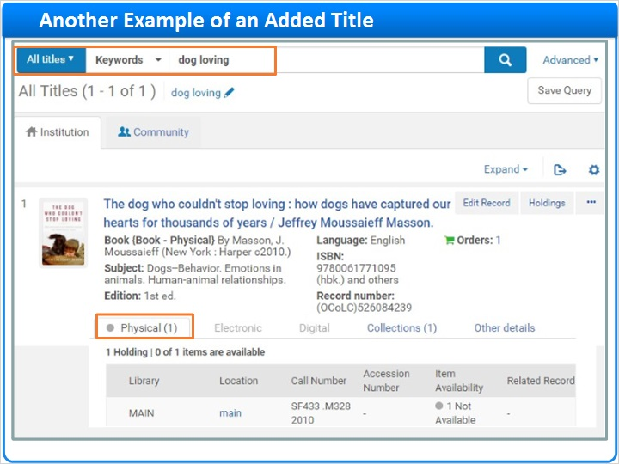
Notes:
Let’s search the repository for one of the other titles we just added, The Dog Who Couldn’t Stop Loving.

Once again, we see that the library has a Physical copy. And, we see that the title has been added to the Pet Books collection. But, this time, there are no digital representations associated with the title. You’ll learn how to add digital resources to titles in an upcoming training session.

Collections (Slide Layer)
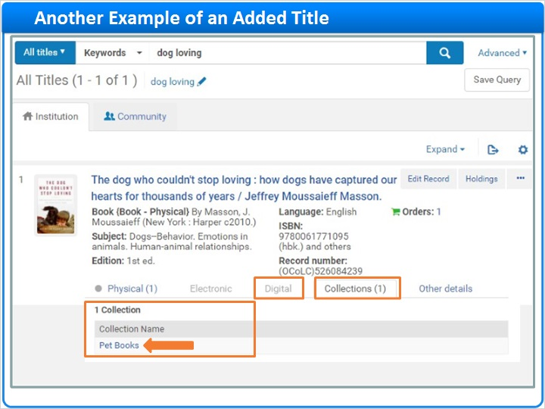

1.21 Working with Titles in a Collection
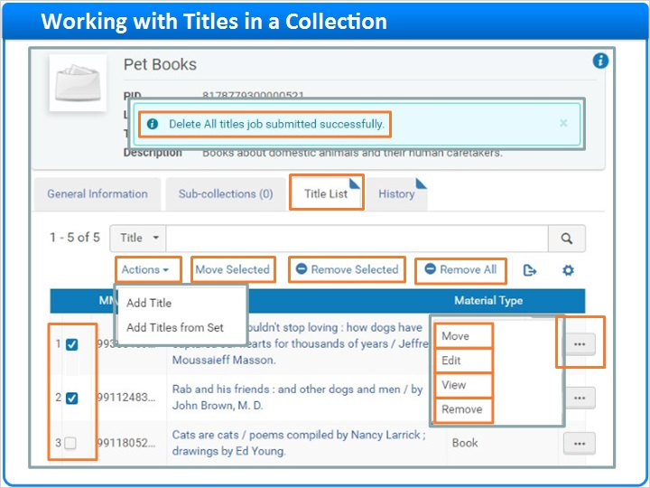
Notes:
For now, go back to the Pet Books collection in the Collection Resource Manager. Then, go to the Title List tab so we can look at some ways to work with titles in a collection.

Click the Row Actions List to Move a title to another collection, Edit or View the title’s bibliographic record, or Remove the title from the collection.

If a digital resource is already associated with the title, the Row Actions List will include two additional options. You can access the Representations associated with the title, or click Deliver to see the digital resource in the Viewer.

To perform an action on multiple titles, select the desired titles and click to Move Selected to a different collection or Remove Selected from this collection without adding them elsewhere.

You can also choose to Remove All titles. Since there could be thousands of titles in a collection, this action submits a job that removes the titles while you continue with other work.

One last note, depending the width of your browser, you may need to click Actions to see additional options. In this example, we see the Add Title and Add Titles from Set actions we discussed earlier.

Actions (Slide Layer)
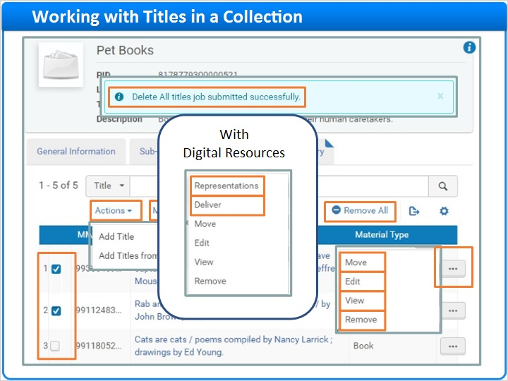

1.22 Encoded Archival Description (EAD)
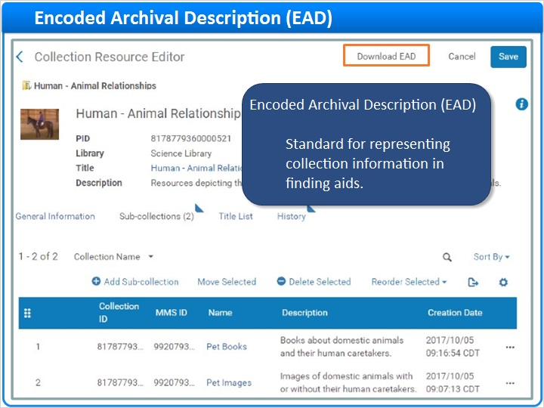
Notes:
Once a collection is populated, click Download EAD to export descriptive information about the collection and its contents to an Encoded Archival Description XML file.

EAD is a standard for representing collection information in finding aids such as inventories, indexes or research guides.

Here’s what part of the downloaded EAD file for Human-Animal Relationships collection looks like when viewed in an XML editor. Note that the EAD includes metadata about nested sub-collections and their contents too.

EAD XML File (Slide Layer)
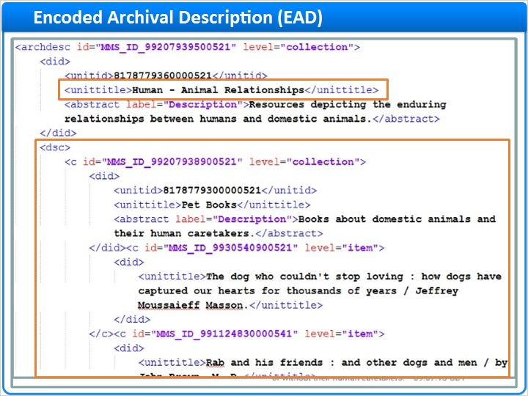

1.23 Session Review and Quiz
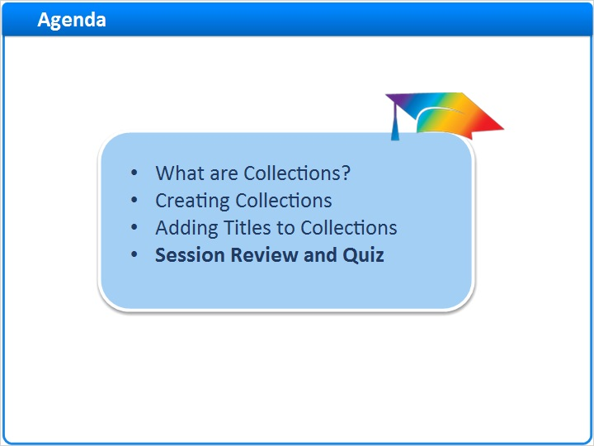
Notes:
That concludes the main portion of this training session. Let’s briefly review what was covered and then proceed to a short quiz.

1.24 Session Review
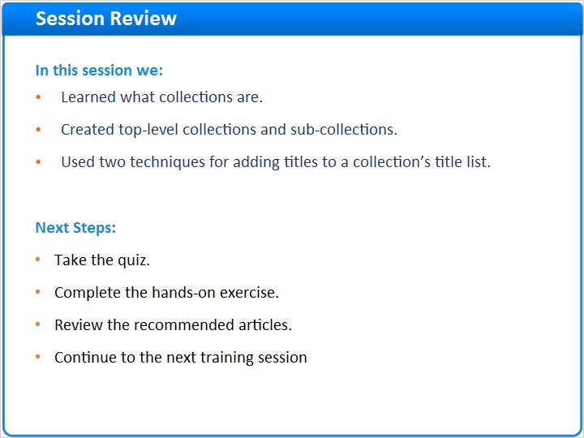
Notes:
In this session, we:
- Learned what collections are.
- Created top-level collections and sub-collections.
- And used two techniques for adding titles to a collection’s title list.

What are your next steps?

After the short quiz that begins on the next page, complete the hands-on exercise for this session.

Please refer to the Recommended Articles section where you launched this training session for additional information. Then, continue on to the next training session in this series.

1.25 Quiz: Working with Collections
(Multiple Response, 10 points, 1 attempt permitted)
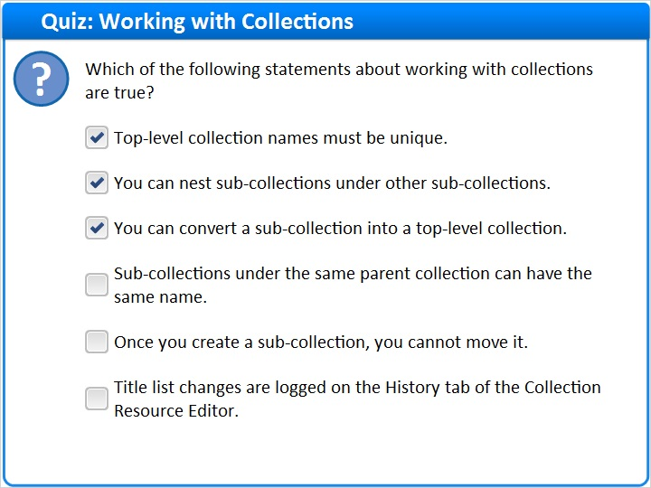
Correct | Choice
X | Top-level collection names must be unique.
X | You can nest sub-collections under other sub-collections.
X | You can convert a sub-collection into a top-level collection.
 | Sub-collections under the same parent collection can have the same name.
 | Once you create a sub-collection, you cannot move it.
 | Title list changes are logged on the History tab of the Collection Resource Editor.
Feedback when correct:
Right! These three statements are true:
Top-level collection names must be unique.
You can nest sub-collections under other sub-collections.
You can convert a sub-collection into a top-level collection.
These three statements are false:
Sub-collections under the same parent collection can have the same name. Explanation: Collection names must be unique when under the same parent.
Once you create a sub-collection, you cannot move it. Explanation: You can move a sub-collection at any time.
Title list changes are logged on the History tab of the Collection Resource Editor. Explanation: Alma logs changes made to fields on the General Information tab and when sub-collections are moved, but Alma does not log title list changes.
Feedback when incorrect:
These three statements are true:
Top-level collection names must be unique.
You can nest sub-collections under other sub-collections.
You can convert a sub-collection into a top-level collection.
These three statements are false:
Sub-collections under the same parent collection can have the same name. Explanation: Collection names must be unique when under the same parent.
Once you create a sub-collection, you cannot move it. Explanation: You can move a sub-collection at any time.
Title list changes are logged on the History tab of the Collection Resource Editor. Explanation: Alma logs changes made to fields on the General Information tab and when sub-collections are moved, but Alma does not log title list changes.

Correct (Slide Layer)
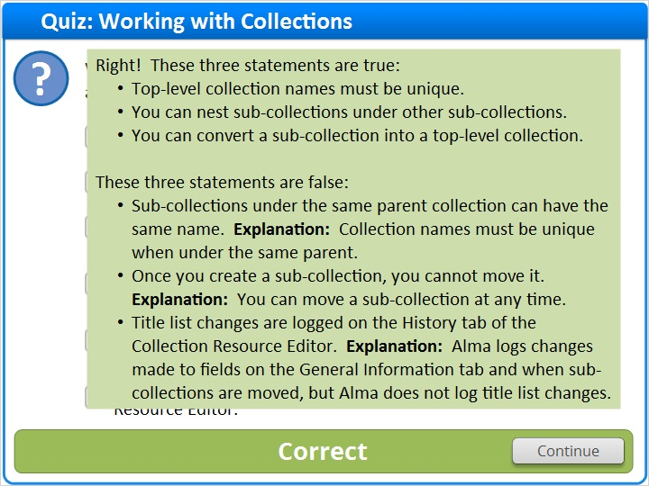

Incorrect (Slide Layer)
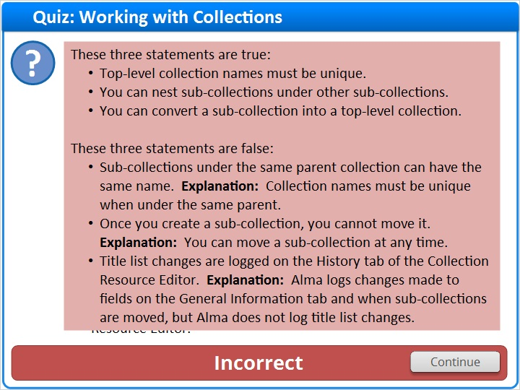

1.26 Quiz: Working with Titles
(Multiple Response, 10 points, 1 attempt permitted)
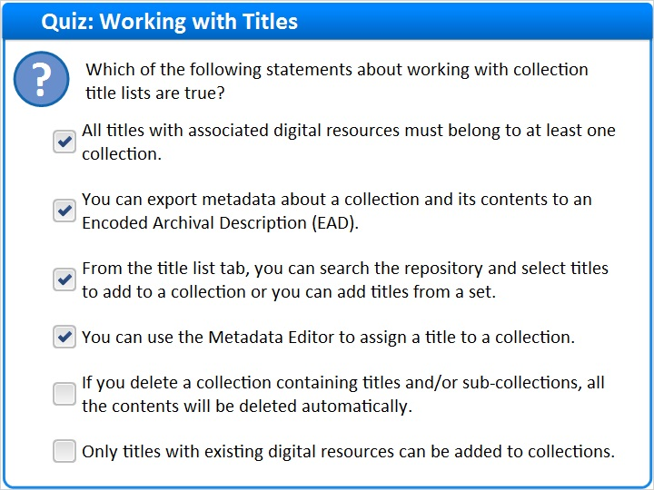
Correct | Choice
X | All titles with associated digital resources must belong to at least one collection.
X | You can export metadata about a collection and its contents to an Encoded Archival Description (EAD).
X | From the title list tab, you can search the repository and select titles to add to a collection or you can add titles from a set.
X | You can use the Metadata Editor to assign a title to a collection.
 | If you delete a collection containing titles and/or sub-collections, all the contents will be deleted automatically.
 | Only titles with existing digital resources can be added to collections.

Feedback when correct:
Right! These four statements are true:
All titles with associated digital resources must belong to at least one collection.
You can export metadata about a collection and its contents to an Encoded Archival Description (EAD) file.
From the title list tab, you can search the repository and select titles to add to a collection or you can add titles from a set.
You can use the Metadata Editor to assign a title to a collection.

These two statements are false:
If you delete a collection containing titles and/or sub-collections, all contents will be deleted automatically. Explanation: You must remove all contents before you can delete a collection.
Only titles with existing digital resources can be added to collections. Explanation: You can add any title to a collection.
Feedback when incorrect:
These four statements are true:
All titles with associated digital resources must belong to at least one collection.
You can export metadata about a collection and its contents to an Encoded Archival Description (EAD) file.
From the title list tab, you can search the repository and select titles to add to a collection or you can add titles from a set.
You can use the Metadata Editor to assign a title to a collection.

These two statements are false:
If you delete a collection containing titles and/or sub-collections, all contents will be deleted automatically. Explanation: You must remove all contents before you can delete a collection.
Only titles with existing digital resources can be added to collections. Explanation: You can add any title to a collection.

Correct (Slide Layer)
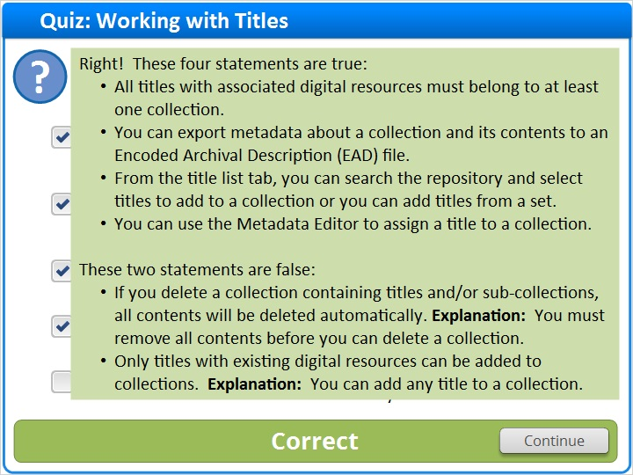

Incorrect (Slide Layer)
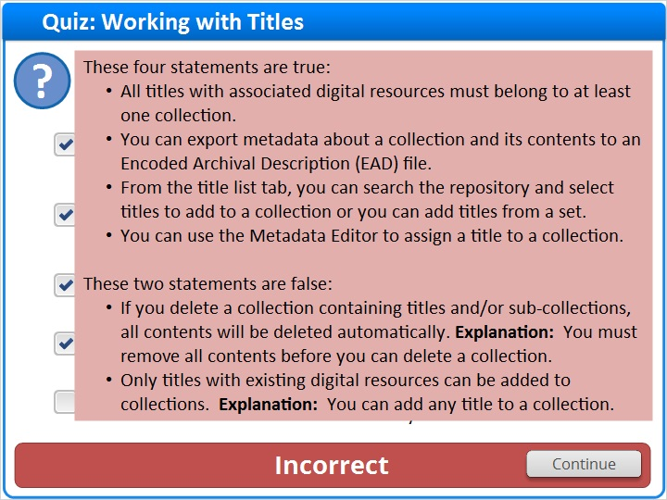

1.27 Quiz: Processing of Actions on Collections
(True/False, 10 points, 1 attempt permitted)
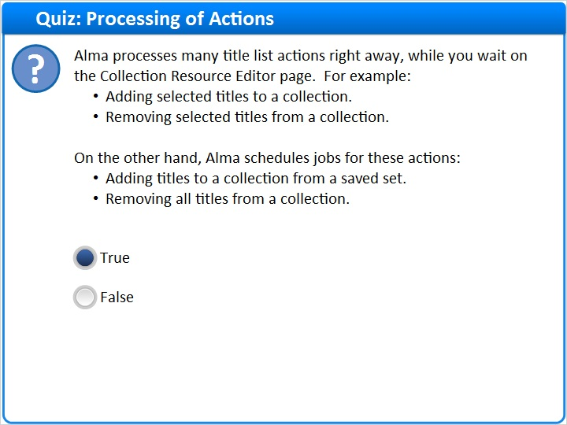
Correct | Choice
X | True
 | False

Feedback when correct:
Right! These statements are true.

Many title list management actions only take a moment or two to process. So, you can easily wait at the Collection Resource Editor page while these actions complete.

But, when you add titles from a set to a collection, or you remove all titles from a collection, thousands of titles could be impacted and take a while to process. Alma schedules jobs for these actions so you can continue your work in Alma without having to wait for the action to complete.
Feedback when incorrect:
These statements are true.

Many title list management actions only take a moment or two to process. So, you can easily wait at the Collection Resource Editor page while these actions complete.

But, when you add titles from a set to a collection, or you remove all titles from a collection, thousands of titles could be impacted and take a while to process. Alma schedules jobs for these actions so you can continue your work in Alma without having to wait for the action to complete.

Notes:

Correct (Slide Layer)
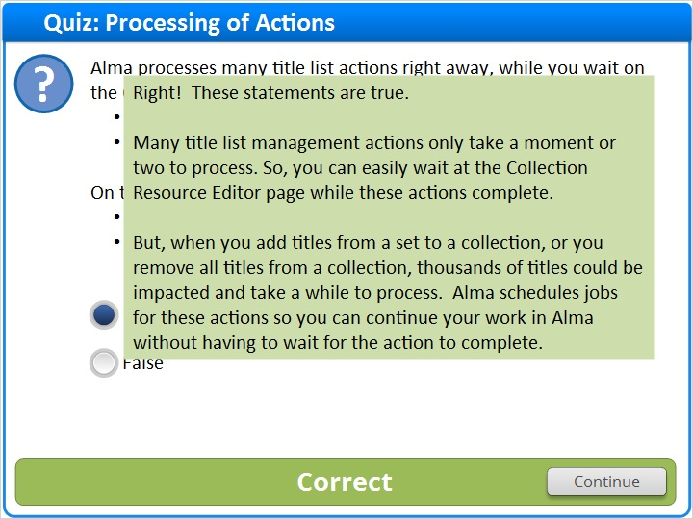

Incorrect (Slide Layer)
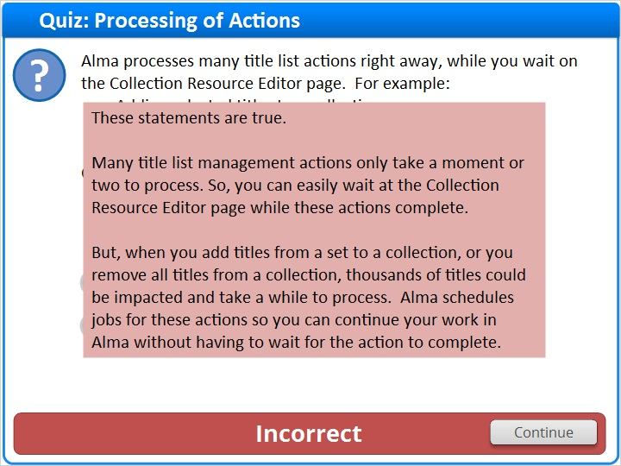

1.28 Thank You!

Notes:
Thank you for joining this session!

1.29 About this Training

Notes:

1 (Slide Layer)
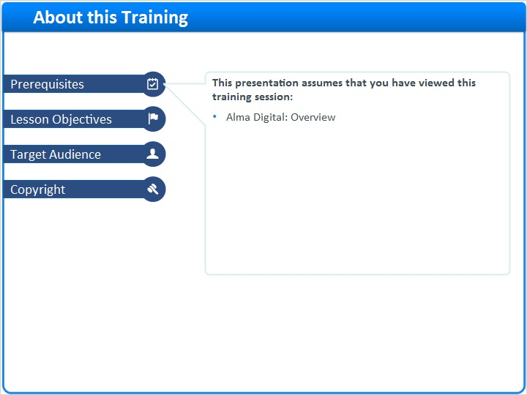

2 (Slide Layer)
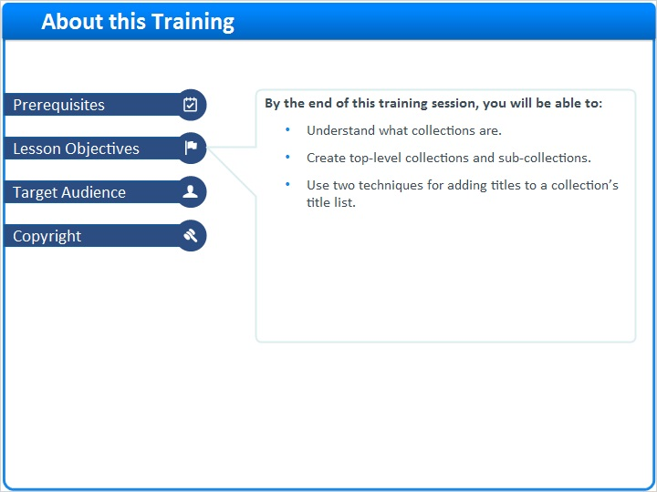

3 (Slide Layer)
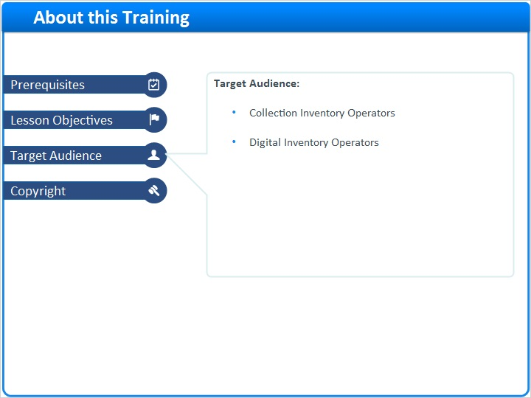

4 (Slide Layer)


