Alma Digital: Bulk Workflow - Asset File Naming Conventions

1. Alma Digital: Bulk Workflow - Asset File Naming Conventions

1.1 Alma Digital: Bulk Workflow - Asset File Naming Conventions

Notes:
Hello, and welcome to this training about asset file naming conventions. To get the most out of this session, you need to have watched the Alma Digital import profiles introduction session.

1.2 Asset File Naming Conventions
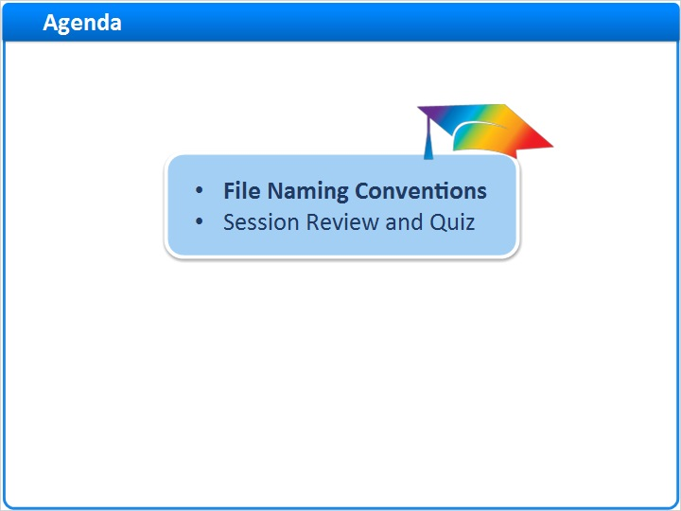
Notes:
In this session, we’ll discuss some file naming convention ideas for your digital resource asset files.

And, after a brief session review, there will be a short quiz to test your knowledge.

1.3 Why Use File Naming Conventions
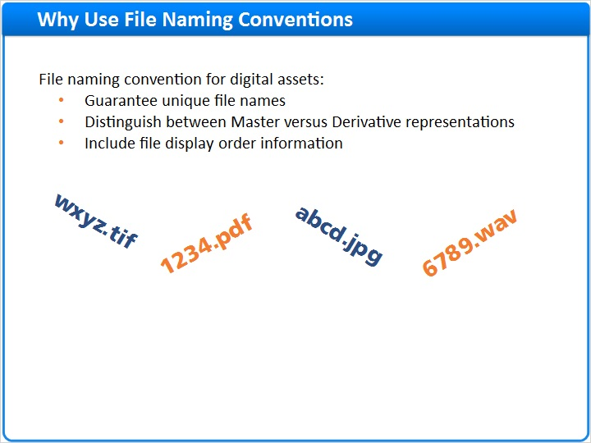
Notes:
Before you start loading your digital assets and metadata into Alma, you need to develop a standard naming convention for your asset files. Your naming convention should:
- Ensure that you have unique file names.
- Help you manage master versus derivative representations of your digital resources.
- And, if you like, include information for controlling file display order.

1.4 Working Example: Collections
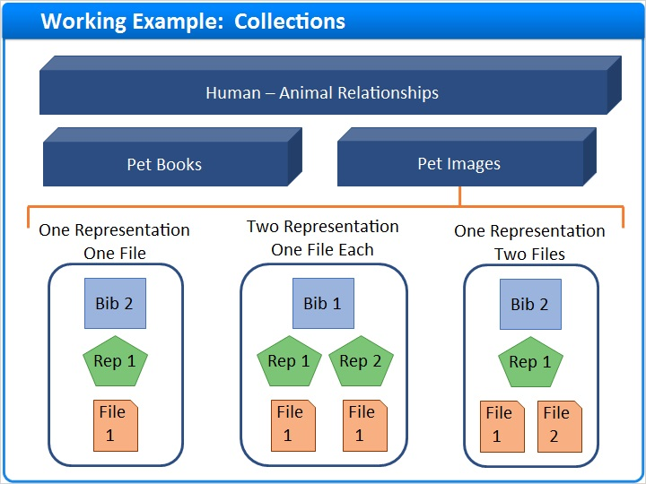
Notes:
To help understand the importance of naming conventions, let’s look at a working example. In this example, I want to upload three digital resources into a sub-level collection called Pet Images. Each digital resource is structured a bit differently.

1.5 Ex. 1: One Bib, One Representation, One File
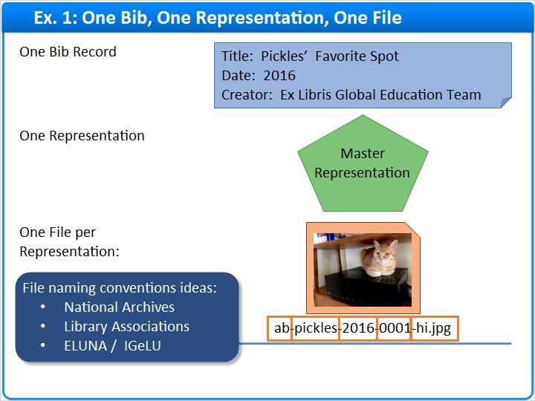
Notes:
The first resource has a single bibliographic record describing a photo of Pickles the cat. There is just one representation of this resource, a high-resolution image. The representation has one file, a jpeg with the filename shown here.

In this example, the file name is composed of a prefix used for all resources in the collection, some descriptive text pertaining to this representation, the year the photo was taken, a number which can be incremented if more files are added to the representation, and an indication that this is a high-resolution image.

This is just one idea for a file naming convention. Consult your national archives, library associations, or library user groups for additional ideas.

1.6 Ex. 2: One Bib, Two Representations, One File per Rep.
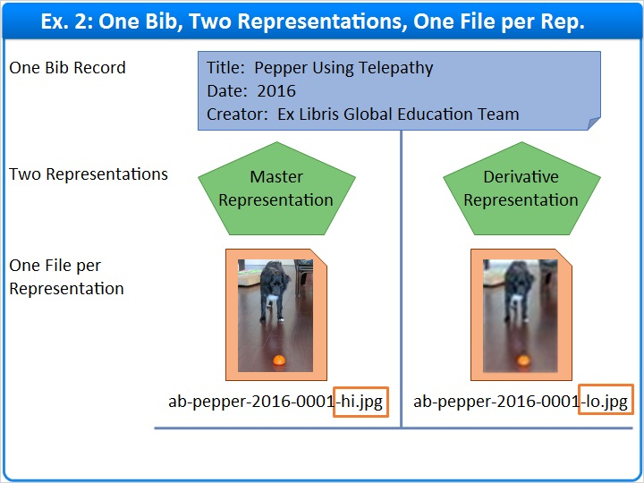
Notes:
The second resource has a single bibliographic record describing a photo of Pepper the dog. In this case, there are two representations, a high-resolution master image, and a low-resolution derivative image. Each of these representations has a single file as shown here.

But, how will Alma know which of these files is the master and which is the derivative? When we learn about import profiles, we’ll see that we can tell Alma to watch for patterns in file names. For example, we can tell Alma that any file with a name containing -hi.jpg belongs to a master representation. And, any file containing -lo.jpg belongs to a derivative.

In other words, you need to set a consistent naming pattern for specifying which file names are masters and which are derivatives.

1.7 Ex. 3: One Bib, One Representation, Two Files
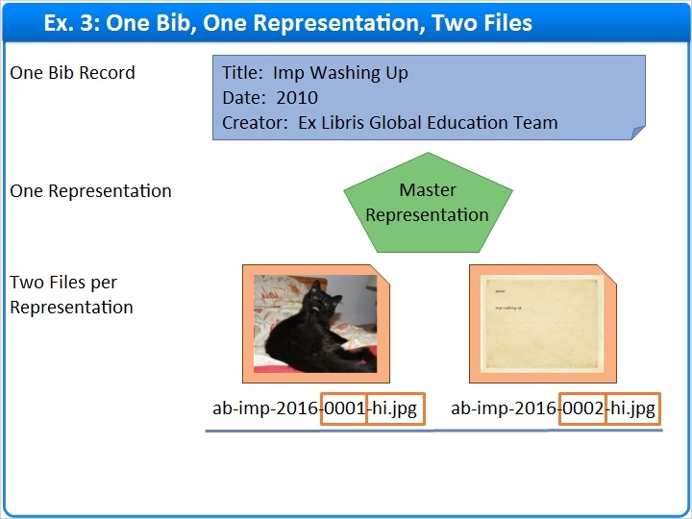
Notes:
Here’s one last example that exemplifies this concept.

This resource has a single bibliographic record describing a scanned photo of Imp the cat. This resource has a single representation, but there are two files associated with that representation. The first file is a scan of the front of the photo, and the second file is a scan of back of the photo.

Both files have the -hi jpeg indicator in the file name, so my import profile will allow both images to be imported as parts of the master representation.

And, embedded in the file name is information that Alma can use when sorting the files for display to patrons. For this example, if you configure Alma to sort on filename, the photo front, numbered triple zero one, will appear before photo back, numbered triple zero two.

1.8 Session Review and Quiz
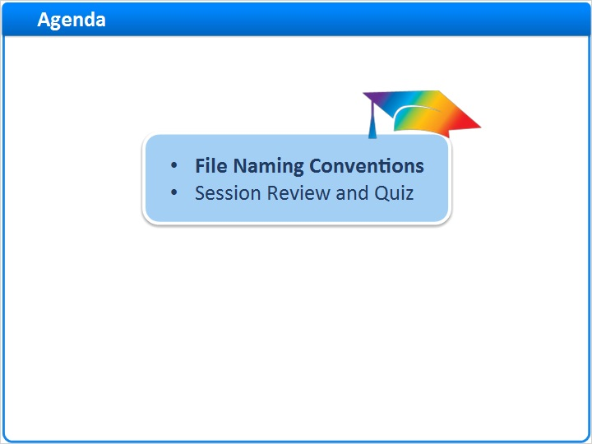
Notes:
That concludes the main portion of this training session. Let’s briefly review what was covered and then proceed to a short quiz.

1.9 Session Review
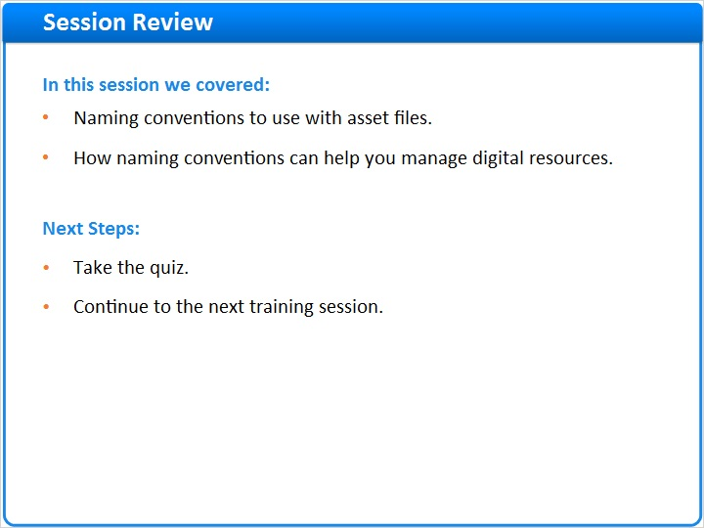
Notes:
In this session, we considered:
- Some naming conventions to use with your asset files.
- And how the naming conventions can help you manage digital resources.

What are your next steps?

After the short quiz that begins on the next page, complete the hands-on exercise for this session.

Please refer to the Recommended Articles section where you launched this training session for additional information. Then, continue to the next training session in this series.

1.10 Quiz: File Naming Conventions
(Multiple Choice, 10 points, 1 attempt permitted)
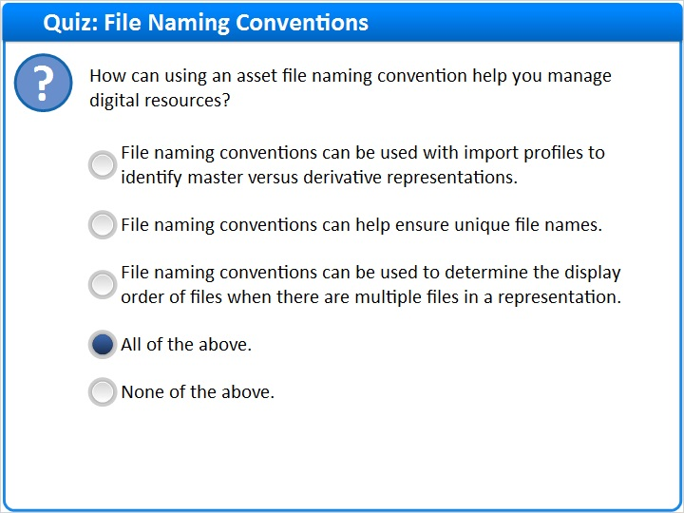
Correct | Choice
 | File naming conventions can be used with import profiles to identify master versus derivative representations.
 | File naming conventions can help ensure unique file names.
 | File naming conventions can be used to determine the display order of files when there are multiple files in a representation.
X | All of the above.
 | None of the above.
Feedback when correct:
Right, the correct answer is: All of the above.

File naming conventions can:
Be used with import profiles to identify master versus derivative representations.
Help ensure unique file names.
Be used to determine the display order of files when there are multiple files in a representation.
Feedback when incorrect:
The correct answer is: All of the above.

File naming conventions can:
Be used with import profiles to identify master versus derivative representations.
Help ensure unique file names.
Be used to determine the display order of files when there are multiple files in a representation.

Notes:

Correct (Slide Layer)
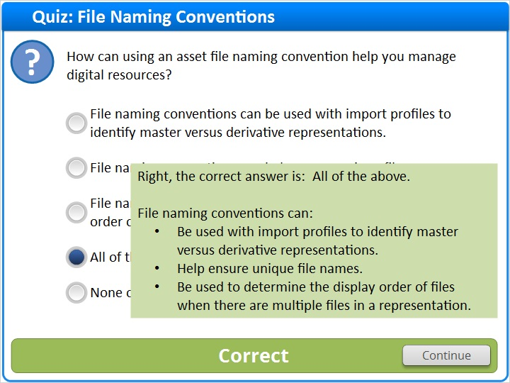

Incorrect (Slide Layer)
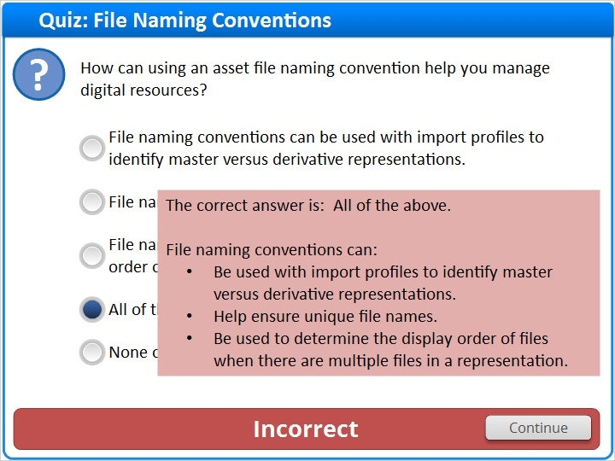

1.11 Thank You!

Notes:
Thank you for joining this session.

1.12 About this Training

Notes:

1 (Slide Layer)
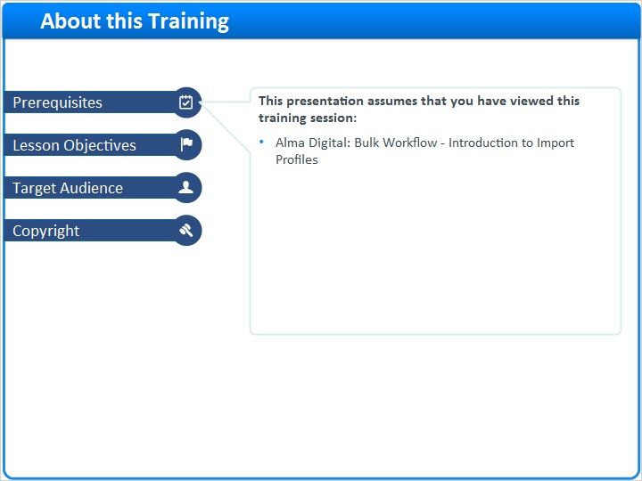

2 (Slide Layer)
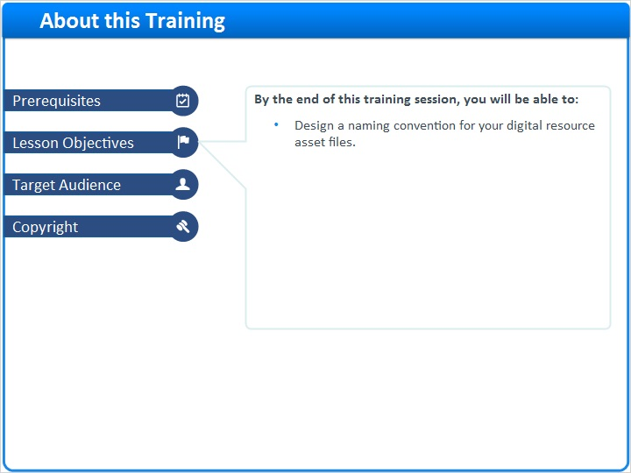

3 (Slide Layer)
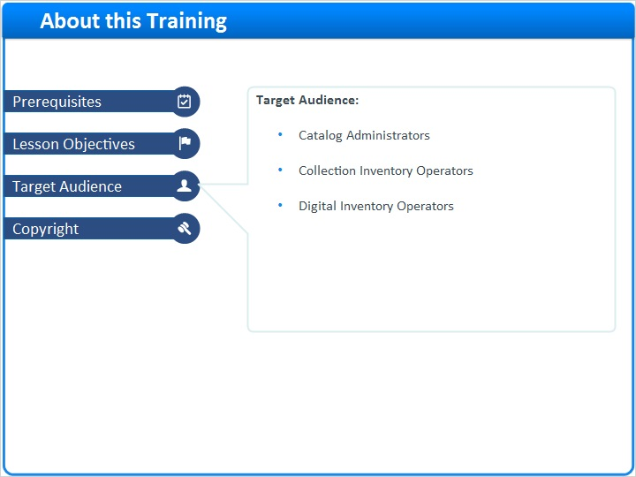

4 (Slide Layer)


