Alma Digital: Bulk Workflow - Preparing CSV Files

1. Alma Digital: Bulk Workflow - Preparing CSV Files

1.1 Alma Digital: Bulk Workflow - Preparing CSV Files

Notes:
Hello, and welcome to this session about preparing Comma Separated Value metadata files for upload into Alma Digital. To get the most out of this session, you need to have watched the Alma Digital session about asset file naming conventions.

1.2 Comma Separated Values (CSV) Files
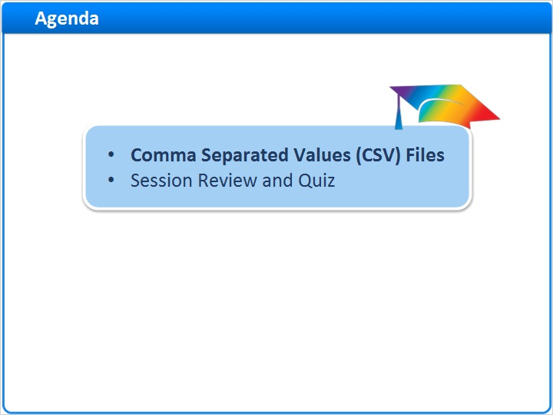
Notes:
In this session, we’ll explore some requirements for preparing CSV metadata files for upload into Alma Digital.

After a brief session review, there will be a short quiz to test your knowledge.

1.3 Comma Separated Values (CSV) Template
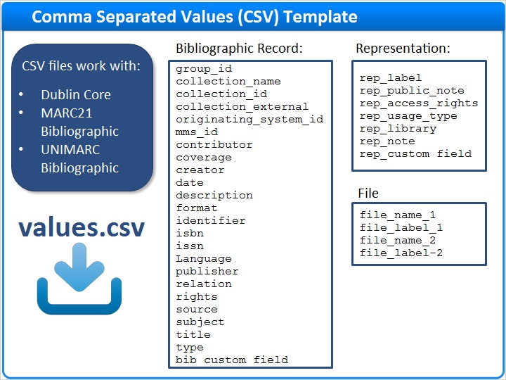
Notes:
If you choose CSV as your physical source format, you can choose any of the supported metadata formats in Alma.

To get started working with a CSV file, download the template called values.csv from the Managing Import Profiles article in the Knowledge Center. You can find a link to the article in the Recommended Articles area of the web page where you launched this training.

The CSV template includes fields that pertain to all three levels of the digital resource hierarchy, the bibliographic record, the representation, and the file. Some of these fields, such as those pertaining to files, are repeatable.

1.4 Alma Digital CSV Template with Metadata
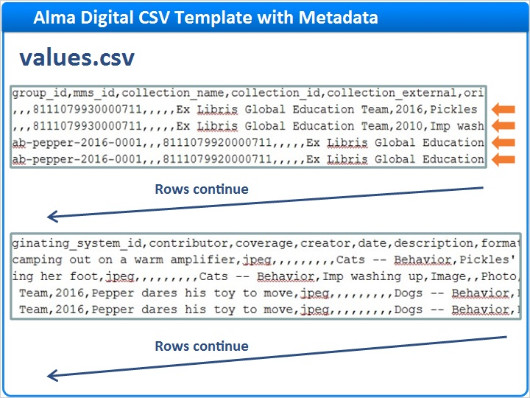
Notes:
Here’s an example of a populated Alma CSV template. Each row pertains to a specific representation and contains metadata for all three levels of the digital resource hierarchy.

And, here’s how it might look when opened in Excel. Most of the columns are self-explanatory, so we’ll focus on just a few that need special attention for Alma Digital. We’ll hide the other columns to make things easier to see in the upcoming examples.

Excel (Slide Layer)
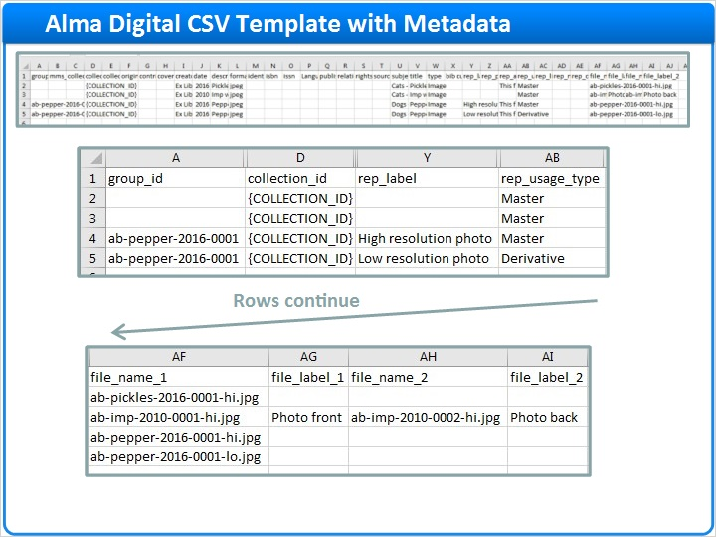

1.5 One Bib, One Representation, One File
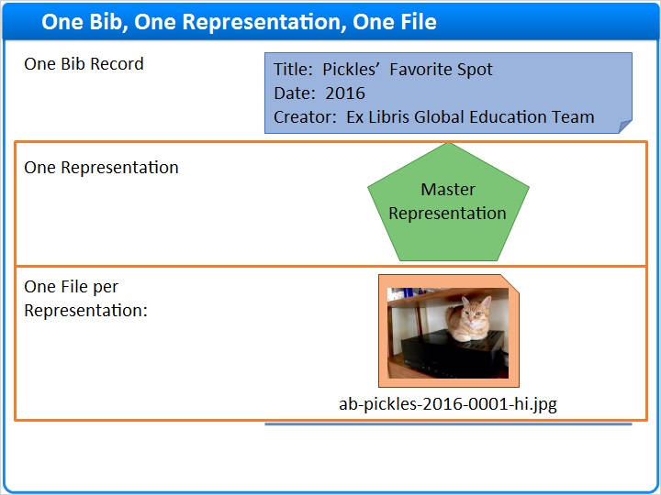
Notes:
Let’s consider a digital resource that has one representation and one file.

1.6 CSV: One Bib, One Representation, One File
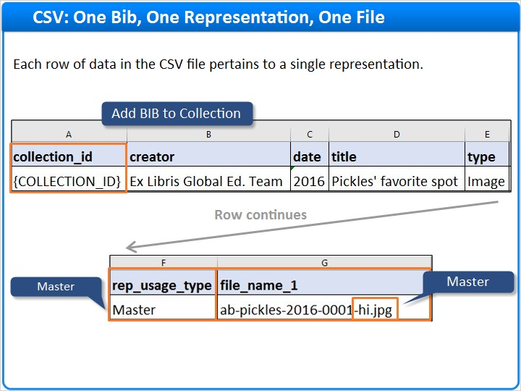
Notes:
Here’s how CSV metadata for this example might look in Excel. This row is for a resource that has a single representation and a single file.

Here’s the file name. Note that it uses the -hi.jpg naming convention to show that this is a high-resolution file that belongs to a master representation. But, with CSV files, Alma does not use the file name to assign the Master versus Derivative usage types. Instead, you need to enter the word Master or Derivative in the rep_usage_type field.

The collection_id field is where you can tell Alma which collection this resource belongs to. Remember to replace the place-holder text with your collection ID.

If your target format is one of the MARC schemas, Alma will add the record to the specified collection only if the Add BIB to Collection normalization process is activated in the import profile. You’ll learn more about this setting in the training session about import profiles for MARC. You don’t need to worry about this setting for Dublin Core.

1.7 One Bib, Two Representations, One File per Rep.
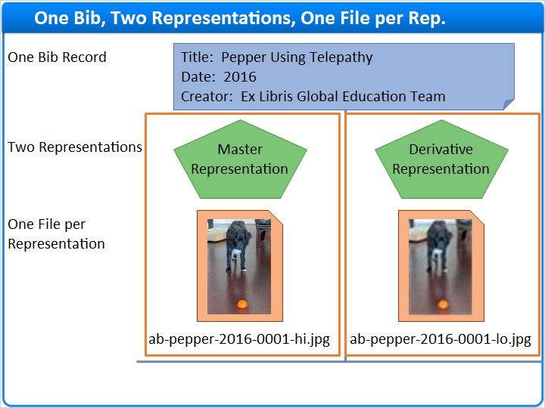
Notes:
Here’s a digital resource with two representations. The high-resolution representation has one file and the low-resolution representation has one file.

1.8 CSV: One Bib, Two Representations, One File per Rep.
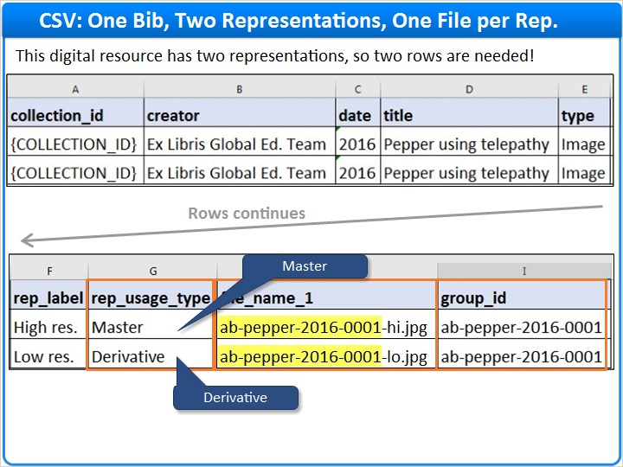
Notes:
Notice that there are two rows for this resource because each representation needs its own row of metadata. Then, you need a group_id to tell Alma which representations, or rows, belong to the same bibliographic record.

The group_id can be any text you like. For convenience, this example uses the base file name (excluding the high or low-resolution indicator) as the group_id.

But, remember, for CSV files, Alma does not use the file name to determine usage type. You must use the rep_usage_type field to designate the master and the derivative representation.

1.9 One Bib, One Representation, Two Files
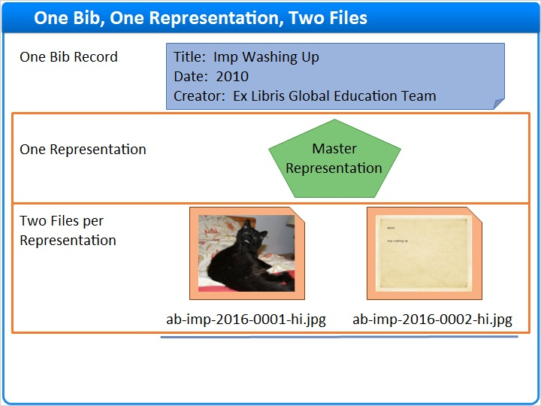
Notes:
Here’s our last example, a digital resource that has one representation, but this representation has two files, a photo front and a photo back.

1.10 CSV: One Bib, One Representation, Two Files
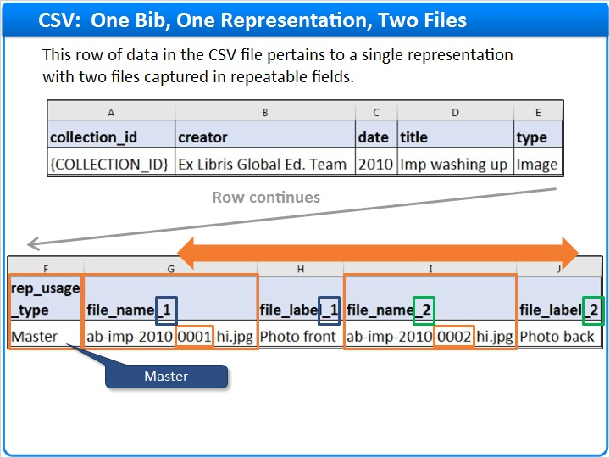
Notes:
Since both files belong to the same representation, both files need to be listed on the same row. Simply repeat your file level fields to capture additional file names. Differentiate the additional file level fields by increasing the number at the end of each field name.

And, as always with CSV, remember to indicate the usage type.

When you have multiple files in a single representation, the files will be displayed in the order they appear in your metadata file, so be sure to list them in the desired order.

Alternatively, you can select a different sort routine in the Digital Representation Resource Editor for the specific resource. In this example, if you choose the File Name sort routine, the file with the name containing triple zero one will appear before the file containing triple zero two.

1.11 Session Review and Quiz
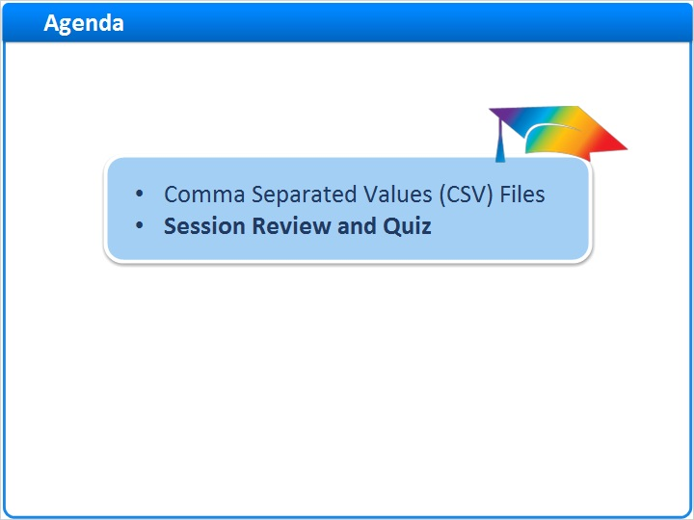
Notes:
That concludes the main portion of this training session. Let’s briefly review what was covered and then proceed to a short quiz.

1.12 Session Review
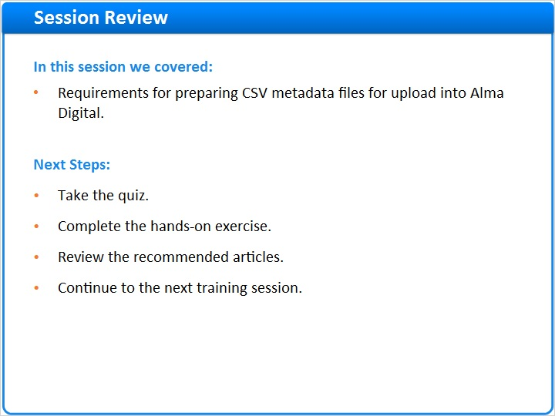
Notes:
In this session, we:
- Discussed requirements for preparing CSV metadata files for upload into Alma Digital.

What are your next steps?

After the short quiz that begins on the next page, complete the hands-on exercise for this session.

Please refer to the Recommended Articles section where you launched this training session for additional information. Then, continue to the next training session in this series.

1.13 Quiz: Representations and Files
(Multiple Response, 10 points, 1 attempt permitted)
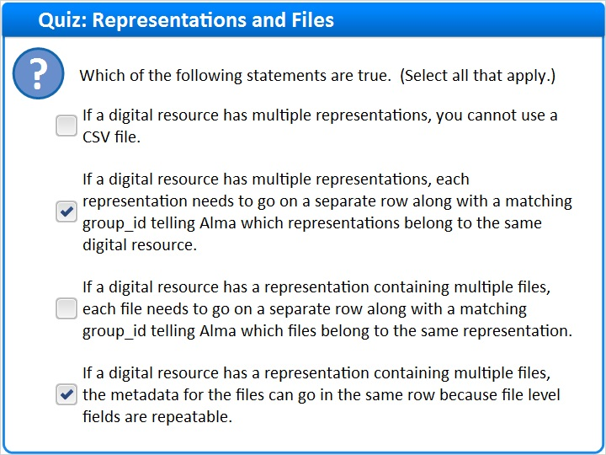
Correct | Choice
 | If a digital resource has multiple representations, you cannot use a CSV file.
X | If a digital resource has multiple representations, each representation needs to go on a separate row along with a matching group_id telling Alma which representations belong to the same digital resource.
 | If a digital resource has a representation containing multiple files, each file needs to go on a separate row along with a matching group_id telling Alma which files belong to the same representation.
X | If a digital resource has a representation containing multiple files, the metadata for the files can go in the same row because file level fields are repeatable.
Feedback when correct:
Right! There are two true statements:

If a digital resource has multiple representations, each representation needs to go on a separate row along with a matching group_id telling Alma which representations belong to the same digital resource.
If a digital resource has a representation containing multiple files, the metadata for the files can go in the same row because file level fields are repeatable.
Feedback when incorrect:
There are two true statements:

If a digital resource has multiple representations, each representation needs to go on a separate row along with a matching group_id telling Alma which representations belong to the same digital resource.
If a digital resource has a representation containing multiple files, the metadata for the files can go in the same row because file level fields are repeatable.

Correct (Slide Layer)
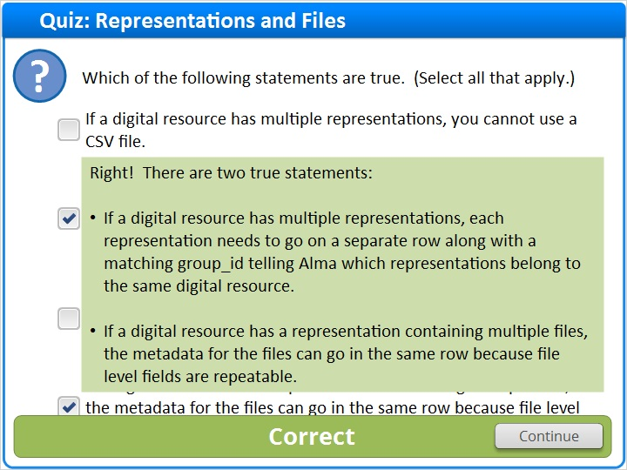

Incorrect (Slide Layer)
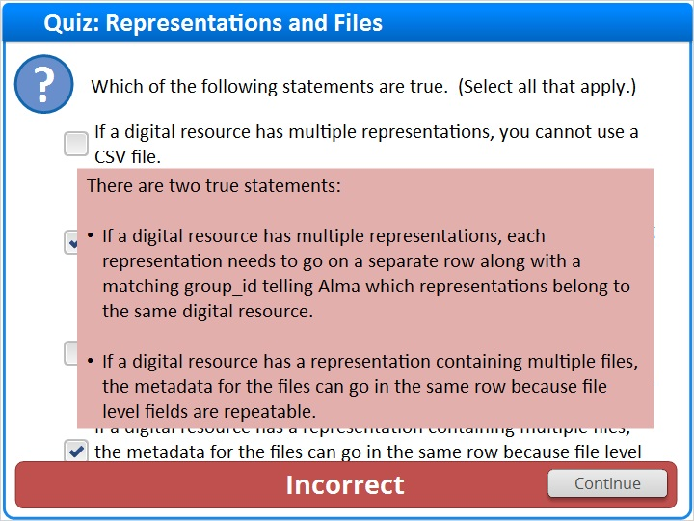

1.14 Quiz: Display Order for Files
(Multiple Choice, 10 points, 1 attempt permitted)
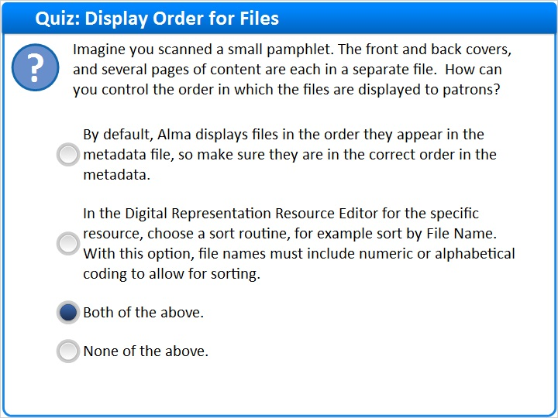
Correct | Choice
 | By default, Alma displays files in the order they appear in the metadata file, so make sure they are in the correct order in the metadata.
 | In the Digital Representation Resource Editor for the specific resource, choose a sort routine, for example sort by File Name. With this option, file names must include numeric or alphabetical coding to allow for sorting.
X | Both of the above.
 | None of the above.

Feedback when correct:
Right! The correct answer is: Both of the above.

To make sure files in the same representation are displayed in the correct order, you can either order the files correctly in your metadata file, or use the Digital Resource Representation Editor to choose a sort routine such as File Name.
Feedback when incorrect:
The correct answer is: Both of the above.

To make sure files in the same representation are displayed in the correct order, you can either order the files correctly in your metadata file, or use the Digital Resource Representation Editor to choose a sort routine such as File Name.

Notes:

Correct (Slide Layer)
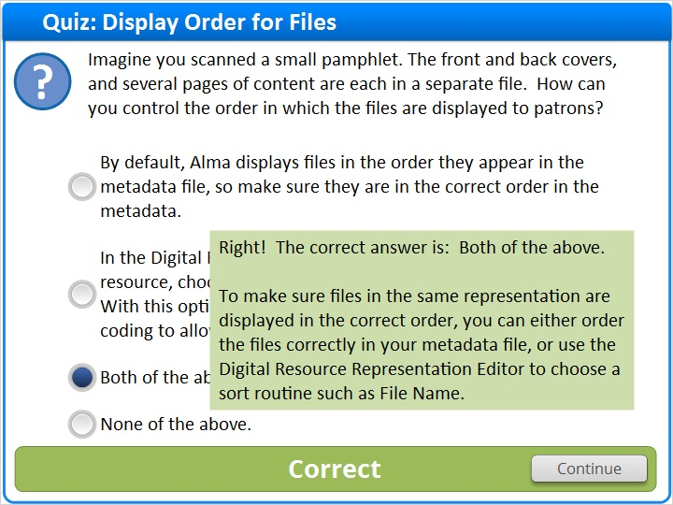

Incorrect (Slide Layer)
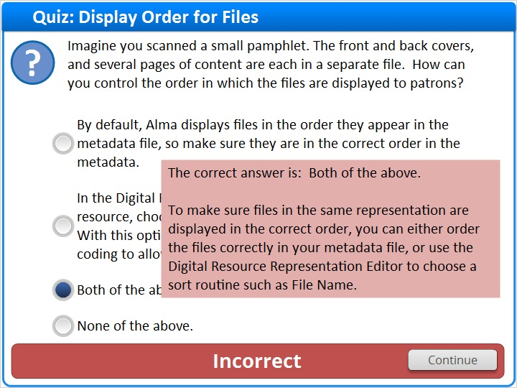

1.15 Thank You!

Notes:
Thank you for joining this session.

1.16 About this Training

Notes:

1 (Slide Layer)
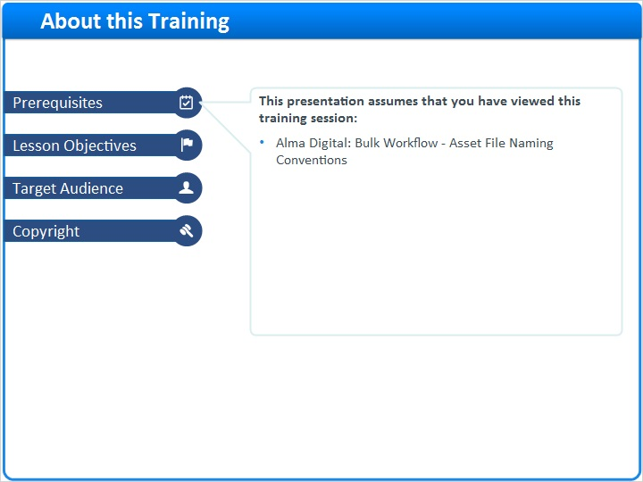

2 (Slide Layer)
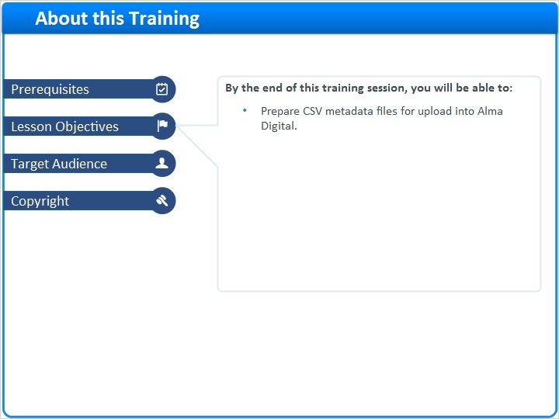

3 (Slide Layer)
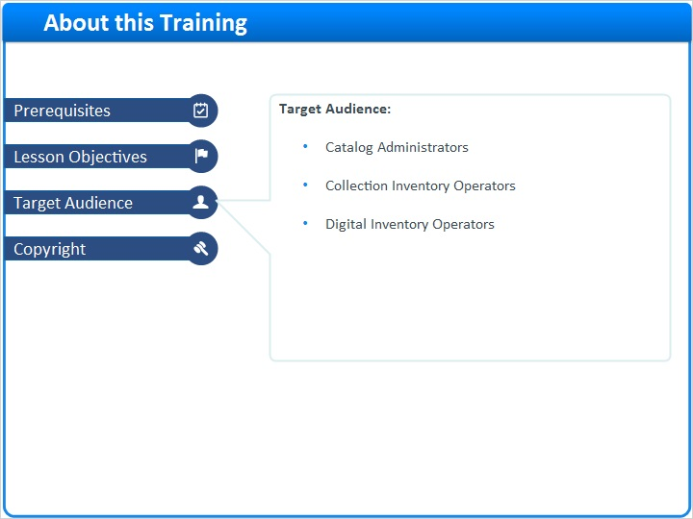

4 (Slide Layer)


