Alma Digital: Bulk Workflow - Creating Import Profiles for Dublin Core

1. Alma Digital: Bulk Workflow - Creating Import Profiles for Dublin Core

1.1 Alma Digital: Bulk Workflow - Creating Import Profiles for Dublin Core

Notes:
Hello, and welcome to this training session about creating digital-resource import profiles for Dublin Core records.

To get the most out of this session, you should have already watched the session about preparing metadata files.

1.2 Getting Started
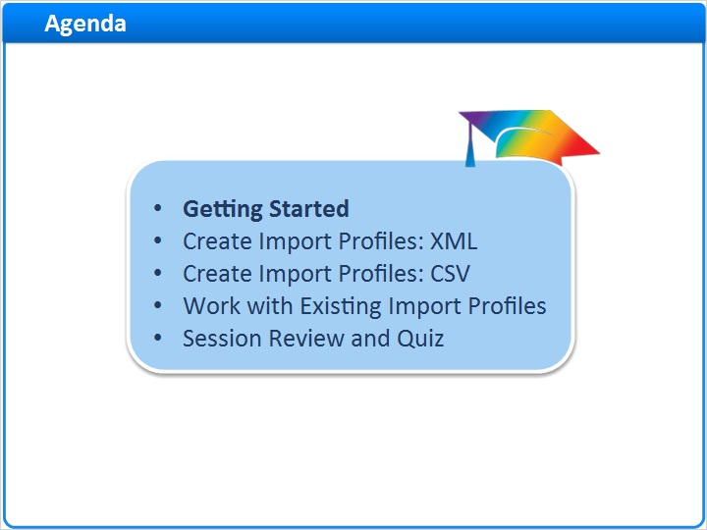
Notes:
We’ll start this session with some basic information on getting started with digital import profiles.

Then we’ll learn how to create digital import profiles for Dublin Core when your physical file format is XML. The process is almost identical with CSV files, but we’ll look at a few differences. And, then we’ll take a quick look at your options for working with existing import profiles.

After a brief session review, there will be a short quiz to test your knowledge.

1.3 Working Example: Pet Images Collection
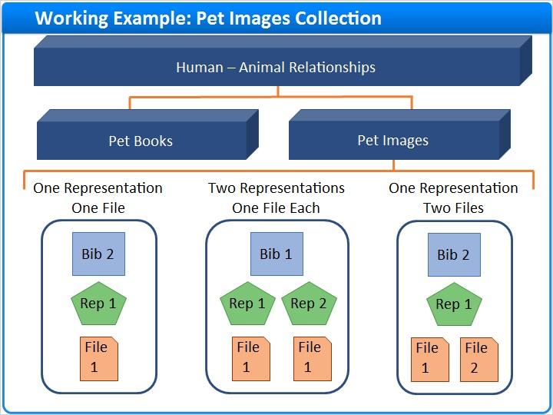
Notes:
To help understand the concepts, we’ll build on the example used in the session on preparing metadata. We’ll create an import profile that adds new digital resource metadata and asset files to the Pet Images collection. And, this import profile will work when various combinations of representations and files are associated with a single bibliographic record.

Metadata and Asset Files (Slide Layer)
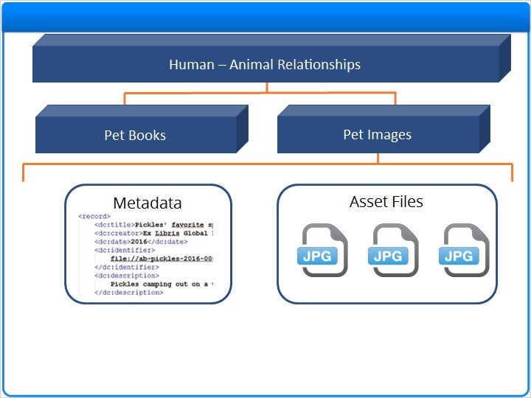

1.4 Import Profiles Navigation
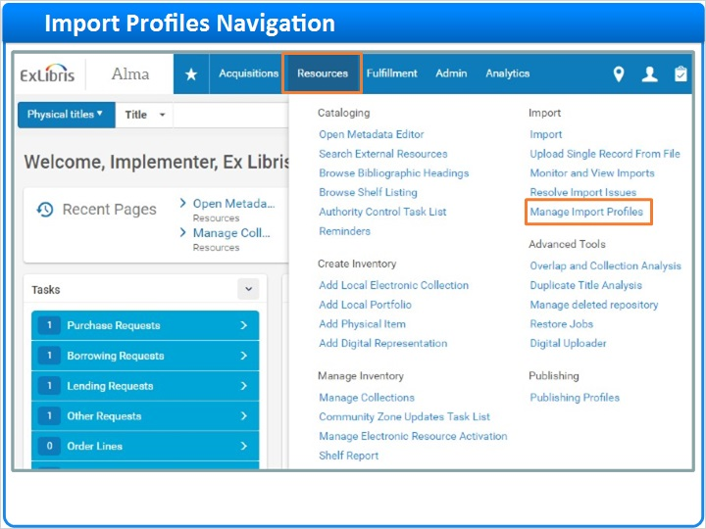
Notes:
To get started, click Resources on the Main Menu bar in Alma. Then click Manage Import Profiles under the Import section.

1.5 Launch Import Profile Wizard
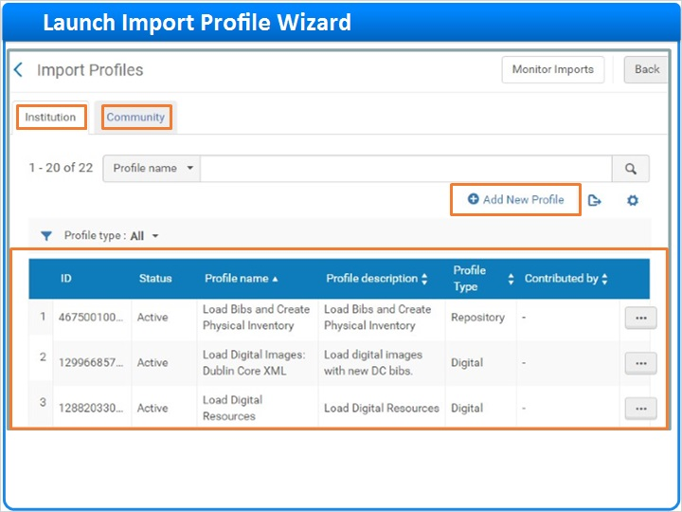
Notes:
The Import Profiles home page lists the import profiles saved by your institution. Here, you can also access import profiles shared to the Community Zone. To create a new import profile for your institution, click Add New Profile on the Institution tab.

1.6 Step 1: Import Profile Type
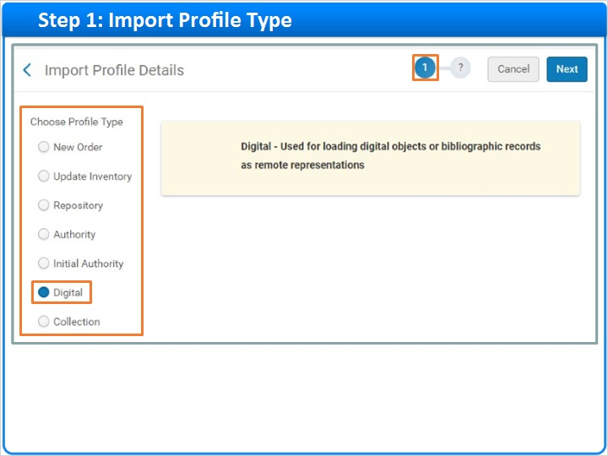
Notes:
Now, we’ll work our way through the import profile wizard. Begin Step 1 by choosing Digital as your Profile Type. This part of Step 1 will be the same for every digital-resource import profile you create.

1.7 Create Import Profiles: Dublin Core XML and CSV
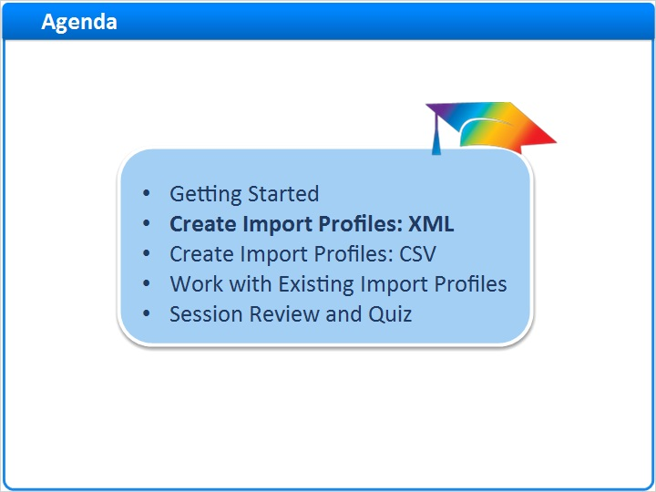
Notes:
Now, we’re ready to dig into the details about creating digital import profiles for Dublin Core when your physical file format is XML.

1.8 Step 1: Source and Target Formats
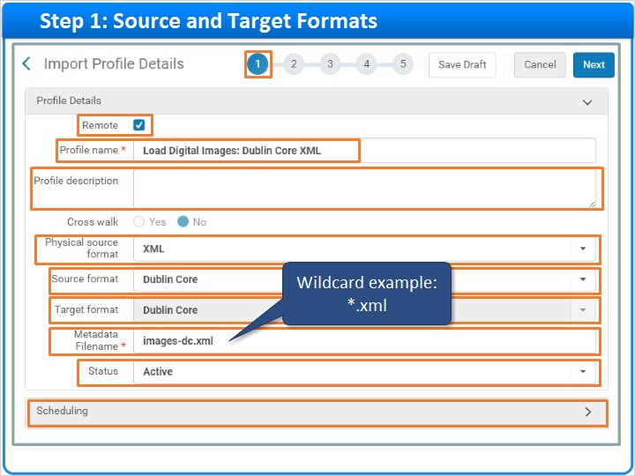
Notes:
So, let’s continue with the rest of Step 1. First, uncheck the Remote box because you're creating an import profile for storing asset files right in Alma, not in a remote repository.
Give your profile a meaningful name so that it can be reused in the future. This profile name, Load Digital Images: Dublin Core XML, offers a good idea of how to use this import profile. The Profile description is optional.
The next few settings are the most critical ones.
Start by selecting the Physical source format of the metadata files you want to upload: CSV or, in this case, XML.

Then choose your source file’s metadata schema as the Source format. If you choose Dublin Core, Alma will choose the matching Target format automatically. So, in this case, your digital resources’ bibliographic records will be Dublin Core records.
If you want to make sure that only files with a specific name are processed with this profile, you can specify a Metadata Filename. But, this field also supports wildcards. For example, if you want this profile to work with any XML filename, you can enter *.xml.
Next, if you're not ready for this profile to be used when you save it, you can set the profile to Inactive instead of Active. We’ll keep this one Active.
In the next training session, you’ll learn how to use the Digital Uploader to upload and process digital resources using import profiles. If you use the Digital Uploader, you can skip scheduling.
But, if you plan on uploading files directly to Amazon Web Services without using the Digital Uploader, and you want the files to be processed periodically, you can schedule the import profile to run according to one of these schedules. You can also configure Email Notifications to report on the outcome of scheduled imports.
Let’s skip Scheduling and click Next.

Physical source format (Slide Layer)
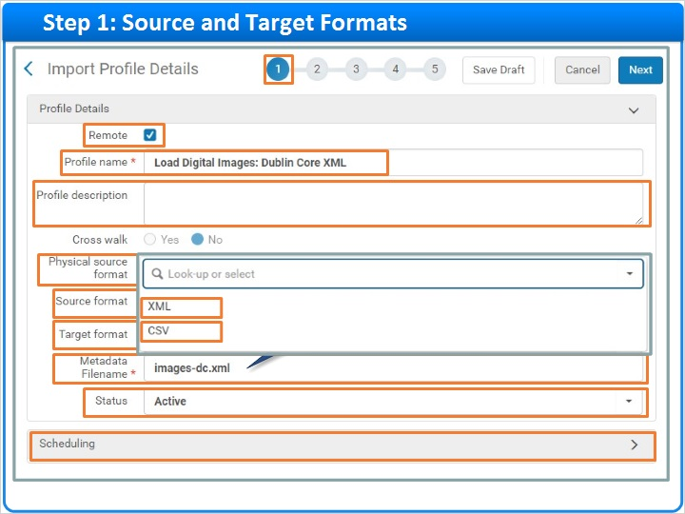

Source format (Slide Layer)
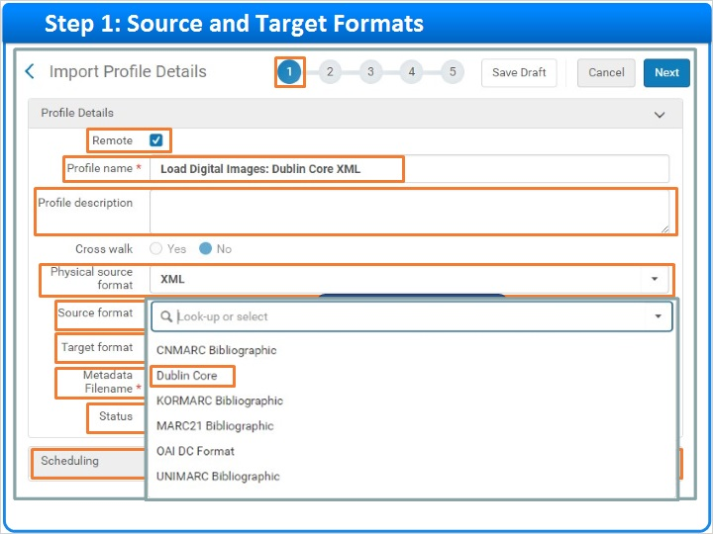

Status (Slide Layer)
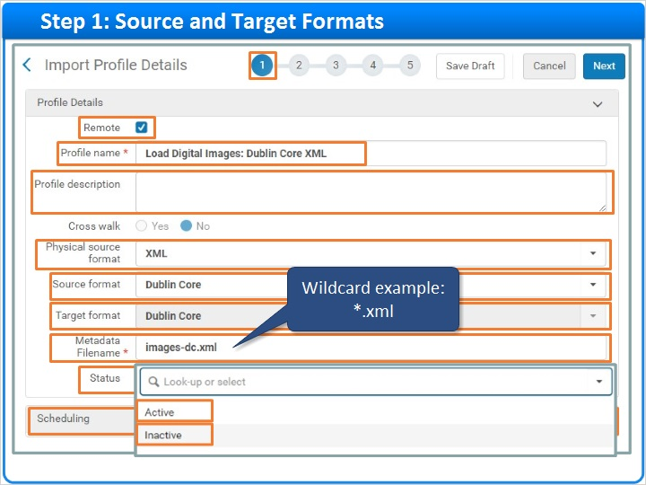

Scheduling (Slide Layer)
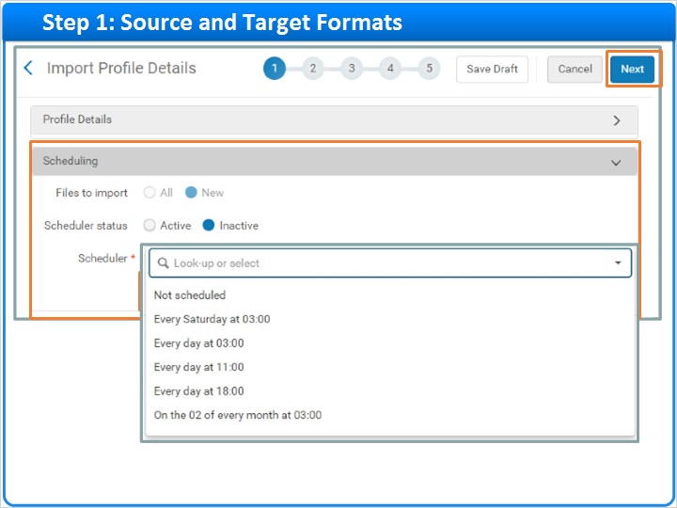

1.9 Step 2: Normalization and Validation
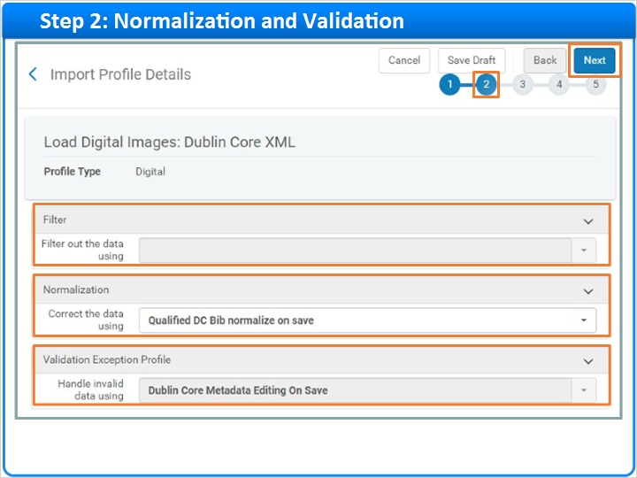
Notes:
Step 2 allows you to select rules for filtering and correcting imported metadata. For Dublin Core, however, you do not need to select a filter. And, the invalid-data handling option is already selected for you.

But, you can choose one of two Normalization rules for correcting data: Qualified DC Bib normalize on save or Qualified DC Bib Resequence And Clear empty fields.

We’ll select the first option and click Next.

Normalization Rules (Slide Layer)
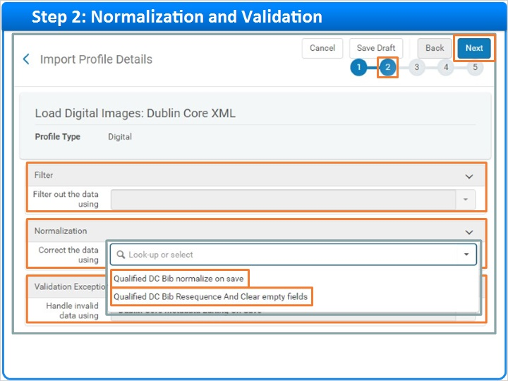

1.10 Step 3: Match Profile and Actions
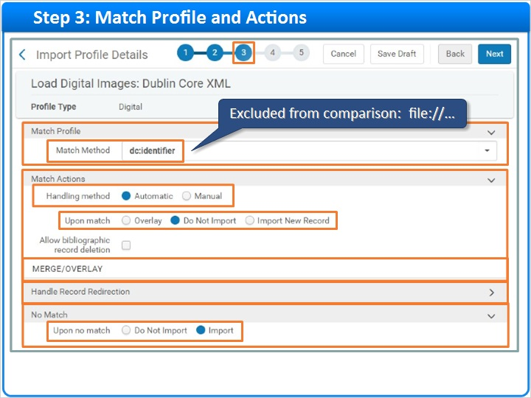
Notes:
Step 3 is where you tell Alma what to do if your uploaded metadata file contains bibliographic records that match records in your catalog.

The Match Profile section determines how Alma identifies matching records. For Dublin Core, Alma uses dc:identifier values to find matches. But, dc:identifier values starting with the reserved text “file://” are excluded from comparisons.
The Match Actions section controls what happens when matches are found. For our example, the defaults will work nicely. Keep the Handling Method set to Automatic so Alma will handle matches without manual intervention. And, keep the default Upon Match setting set to: Do Not Import matching records.
Since we are not importing matching records, Alma will not use any MERGE/OVERLAY settings for this profile. Likewise, we can skip over the Handle Record Redirection section.
But in the No Match section, keep the default Upon no match setting so Alma will Import records when there are no matches. In this way, only new content is loaded.

1.11 Step 4: Management Tags for Publishing
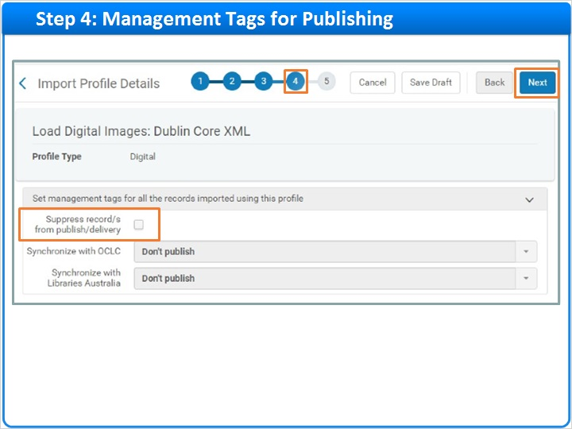
Notes:
For Dublin Core, there is only one choice to make on Step 4. If you want to prevent the imported records from being published for discovery, check the box called Suppress records from publish/delivery.

The other options on this screen are not available for Dublin Core. So, click Next to continue.

1.12 Step 5: Define Master Representation
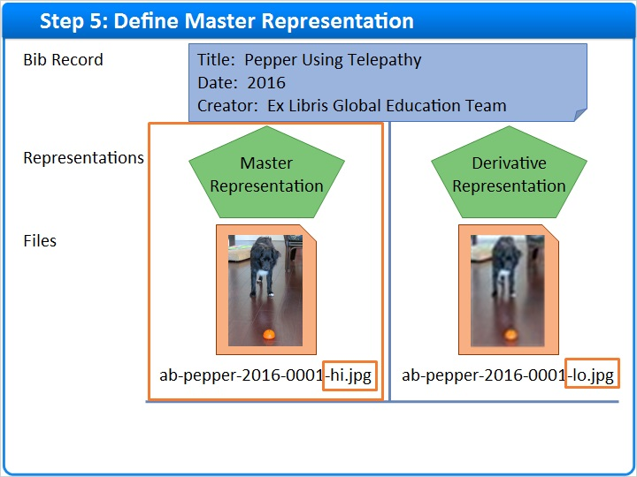
Notes:
Before we dig into Step 5 of the wizard, let’s have a little refresher from the Preparing Metadata Files training. In that session, you learned that file-naming conventions can help you manage master and derivative representations.
We looked at some examples where the text “-hi.jpg” in a file name indicated that the file belonged to a master representation. And, a file name containing -lo.jpg marked a derivative representation.
At last, in Step 5, you get to tell Alma how to use this information when processing your metadata and asset files.
Let’s start with instructions for master representations.

1.13 Step 5: Bibliographic Record Level
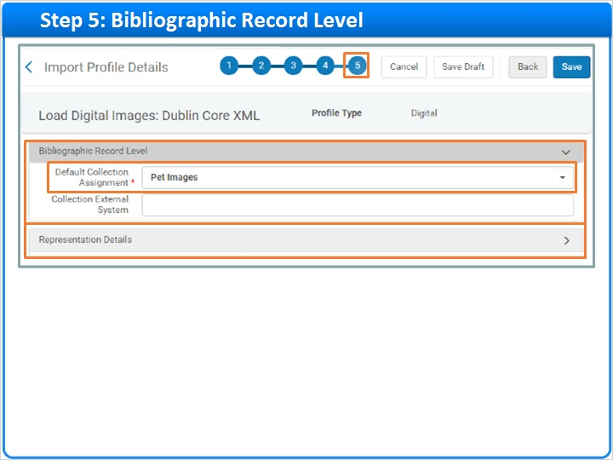
Notes:
In Step 5, you’ll define how Alma processes metadata about your digital representations. But, first you need to fill in one important detail at the Bibliographic Record Level.
Here, you need to select a Default Collection to which imported records will be assigned when no collection is specified in your metadata.

1.14 Step 5: Representation Details - Usage Type
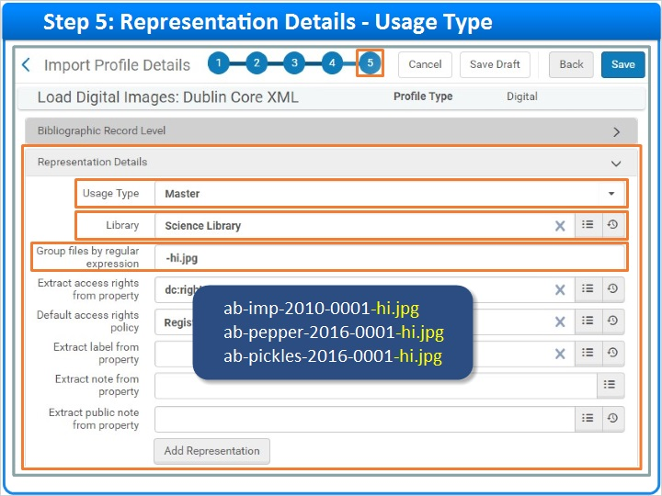
Notes:
Now, let’s move onto the representation level and give Alma instructions for processing master representations. Select the Usage Type, Master. Then, choose a Library as the owner of the master representations processed with this profile.
Next, tell Alma how to identify your master representations based on file names. In the Preparing Metadata Files training session, all of the high-resolution, master representations had the text “-hi.jpg” in their file names. So, we’ll enter ”-hi.jpg” in the Group files by regular expression text box. This tells Alma that, if a file name contains the text, “-hi.jpg”, the file belongs to a master representation.

Usage Type (Slide Layer)
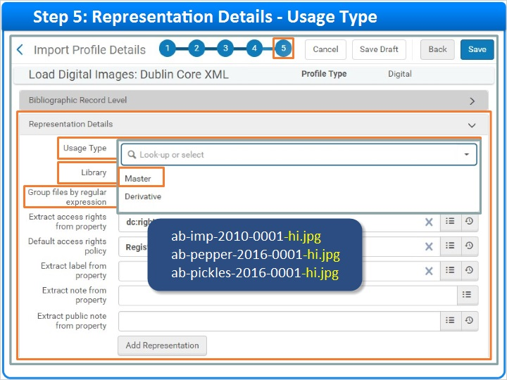

1.15 Step 5: Representation Details – Access Rights
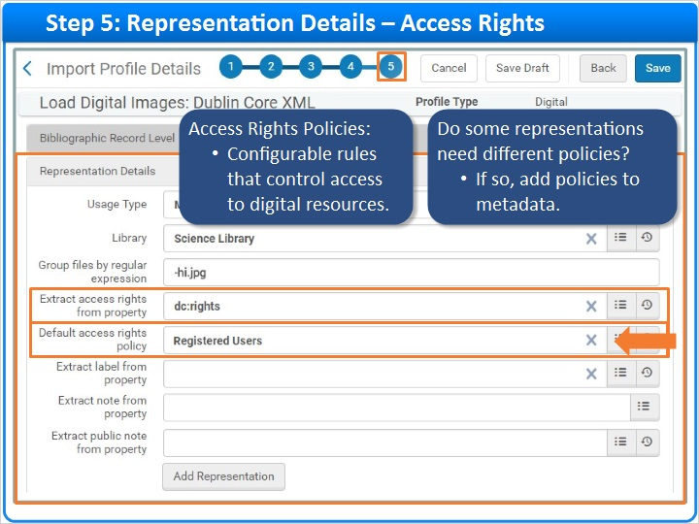
Notes:
Access-rights policies are configurable rules detailing which user groups can access your digital resources.

If your institution has access-rights policies configured:

- You can select a Default access rights policy for all representations that match this representation definition. In this example, the selected default requires patrons to log in for access to master representations.
- But, if some of the matching representations need different policies, you need to add this policy information to the representations in your metadata. Then, you need to tell Alma where to find the policy. So, start typing in the Extract access rights from property field, and select a property from the Dublin Core property-chooser tool.
- It’s a good idea to select a default even if you’re extracting rights from the metadata. That way, if any representations are missing the information, the default policy will apply.

For information on how to configure access-rights policies for your institution, see the Recommended Articles area for this training.

Default Access Rights (Slide Layer)
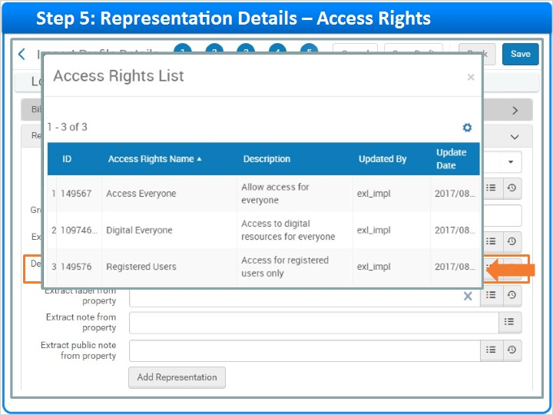

Rights from Property (Slide Layer)
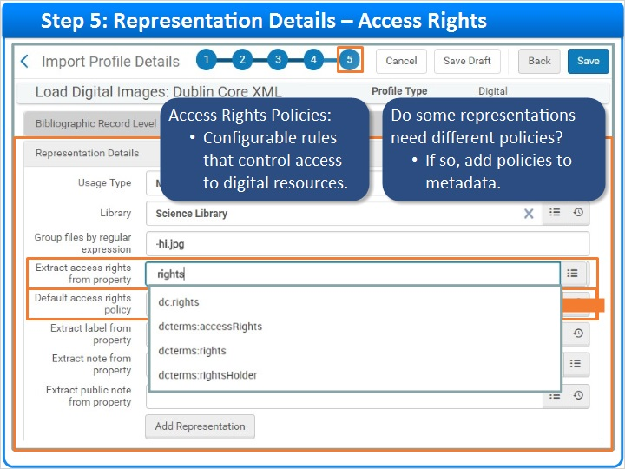

1.16 Step 5: Representation Details – Labels and Notes
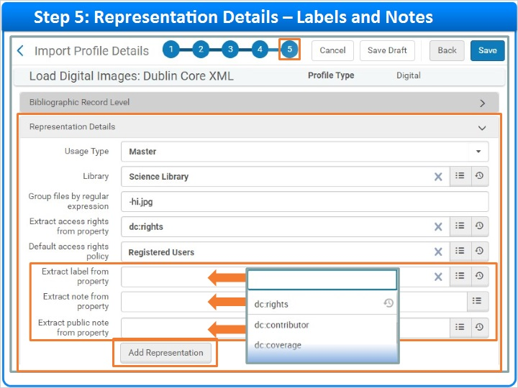
Notes:
For convenience, the Dublin Core property-chooser tool is also available for telling Alma where to extract representation labels, notes, and public notes from your metadata.

When done, click Add Representation. And, here’s the representation we just defined. Now, you can complete the Representation Details section again to define another representation if needed.

Saved Representation (Slide Layer)
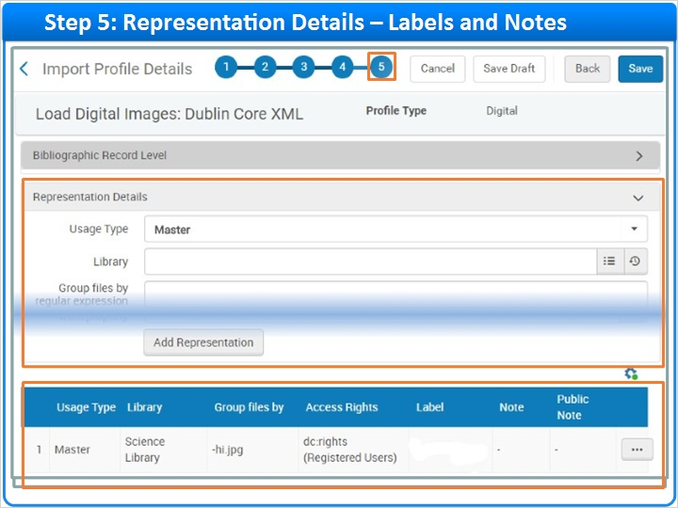

1.17 Step 5: Define Derivative Representation
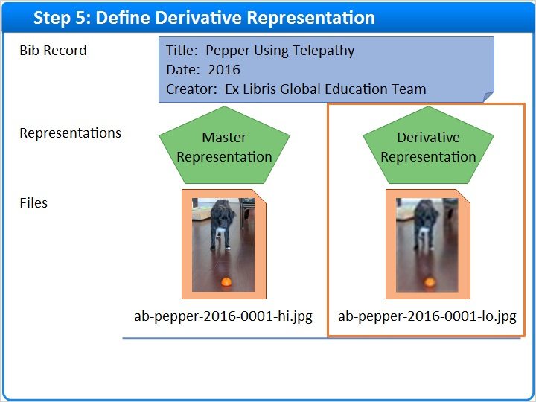
Notes:
For our working example, we still need to define a derivative representation.

1.18 Step 5: Derivative Representation Differences
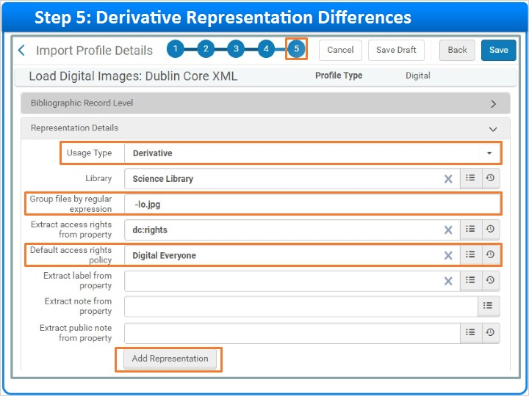
Notes:
Defining a derivative representation is just like defining a master. Most likely the key difference will be the Group by regular expression value telling Alma that, for example, derivative representations contain the text, “-lo.jpg” in their file names.
Next, let’s imagine your low-resolution derivative representations have copyright watermarks. In this case, perhaps you could allow anyone to access your derivative representations even though your master representations are only accessible to registered users.
Remember to click the Add Representation button when done with your selections.

1.19 Step 5: Save Import Profile
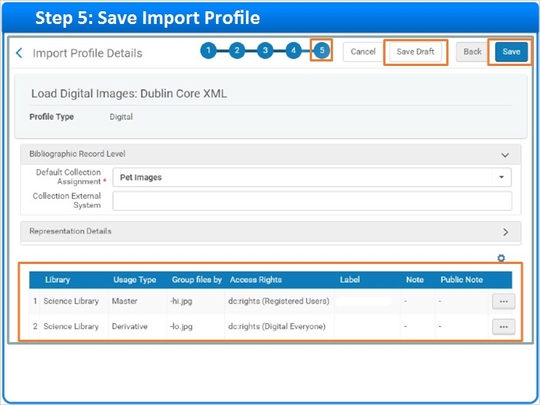
Notes:
Your saved representation definitions will look like this.

This is the last step in the import-profile wizard, so you can click Save. If you are not quite ready for this profile to be used, click Save Draft to save your work in an inactive state. You can always activate the import profile later.

1.20 Create Import Profiles: CSV
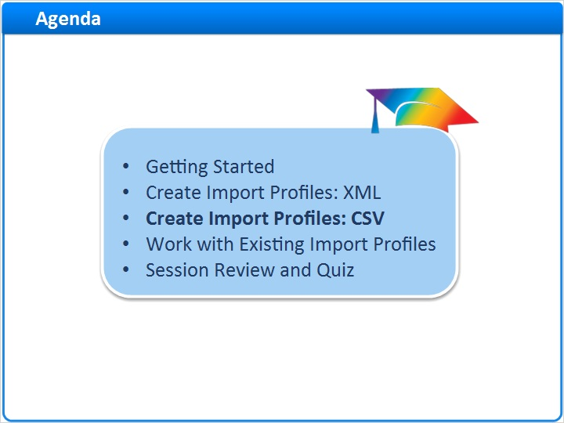
Notes:
Now that we know how to create import profiles for loading Dublin Core XML files into Alma, let’s consider CSV files.

1.21 Step 1: Source and Target Formats
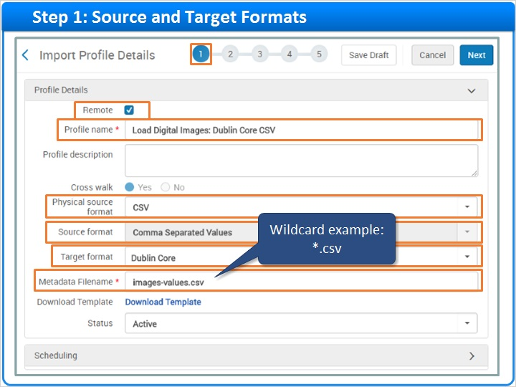
Notes:
Creating an import profile for CSV files is very similar to creating an import profile for XML. For example, on Step 1 of the wizard, you still need to:
- Uncheck the Remote box
- Enter a meaningful Profile name
- Select your Target format
- And add a Metadata Filename that can include wildcards.

The big difference is the Physical source format. This time, you need to select CSV instead of XML. Alma will select the Source format for you.

1.22 Step 5: Simplified for CSV
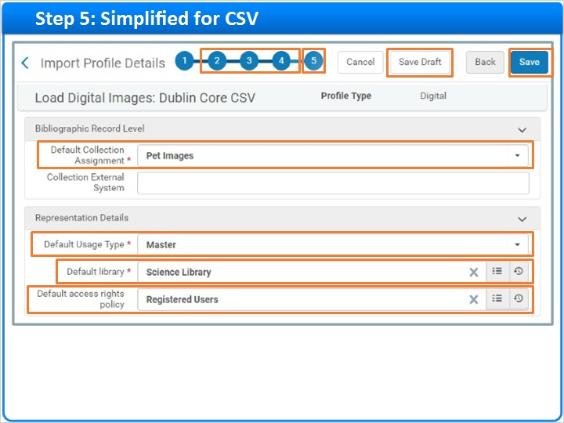
Notes:
Steps 2 through 4 of the wizard are the same for CSV as for XML. So, we’ll jump right over to Step 5 where there are some real differences.

With CSV, the import profile does not need to tell Alma how to use file names to figure out master versus derivative usage types. Instead, you can include this information in the CSV metadata file. Just fill in the rep_usage_type field for each representation in the file.

Having usage types in your metadata means that this step of the wizard is simplified for CSV files.

Simply select four default property values that Alma can use for records that do not include the relevant metadata.

The first three are mandatory:
Default Collection
Default Usage Type (Master or Derivative)
And, Default library
The fourth property, Default Access Rights policy is optional, but a good idea to complete.
This is the last step of the wizard, so click Save when done. Or, if the import profile is not ready to use, click Save Draft to save the profile with the status set to inactive.

CSV File (Slide Layer)
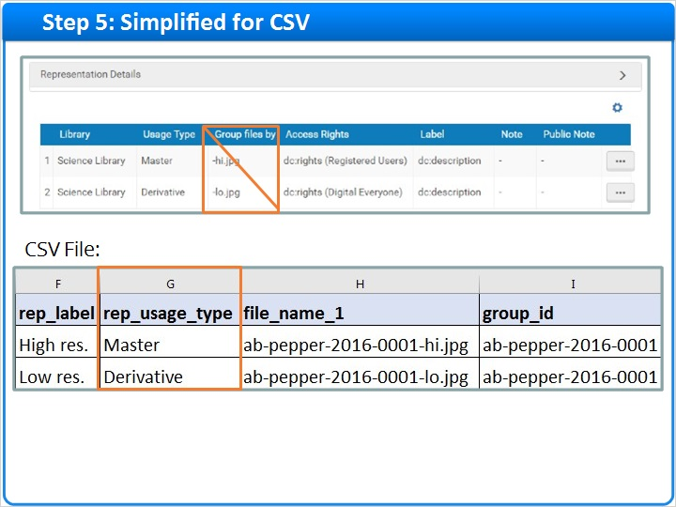

1.23 Work with Existing Import Profiles
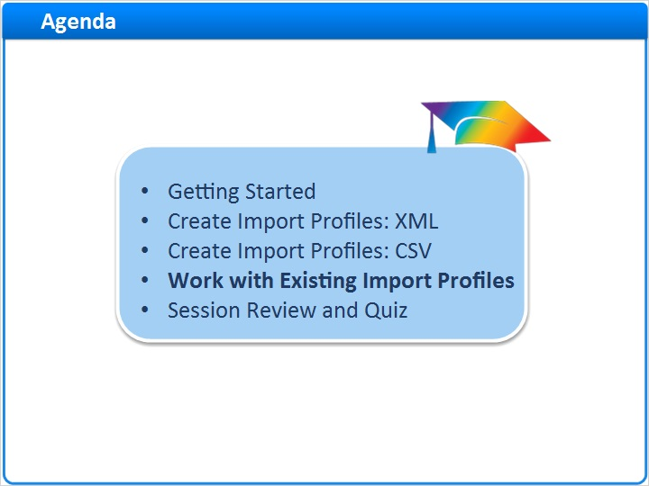
Notes:
Let’s wrap up with a few notes on working with existing import profiles.

1.24 Go to Import Profiles Home Page
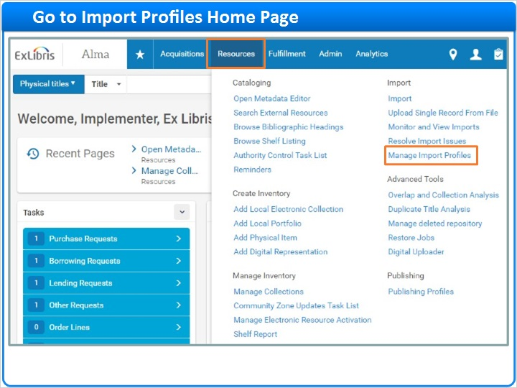
Notes:
To work with existing import profiles, click Resources on the Main Menu bar. Then click Manage Import Profiles under the Import section.

1.25 Import Profile Row Actions
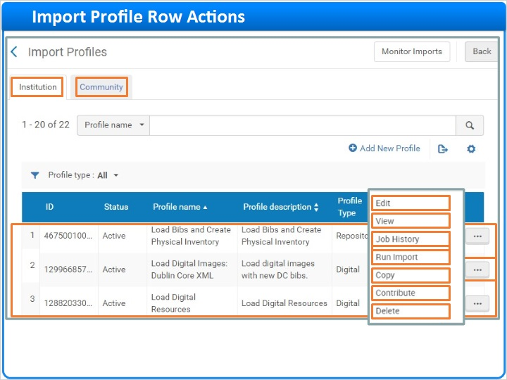
Notes:
As noted earlier, the Import Profiles home page lists all of your saved import profiles on the Institution tab. If you need to work with an existing profile, click one of the options in the Row Actions List.
You can Edit an existing profile, or just View it.
If you find a useful import profile, you can Copy it, and Edit the copy to suit your needs. And, if you no longer need a profile, you can Delete it.
On the other hand, if you have an import profile that could be useful to others, you can Contribute that profile Community Zone.
You can browse Community Zone profiles on the Community tab and use the Profile type filter to locate Digital import profiles. If you find one you like, copy it to your institution for editing and use.
Back on the Institution tab, you can look at a profile's Job History or Run an import using a profile. You’ll learn more about these activities in your next session, Using the Digital Uploader.

Community Zone (Slide Layer)
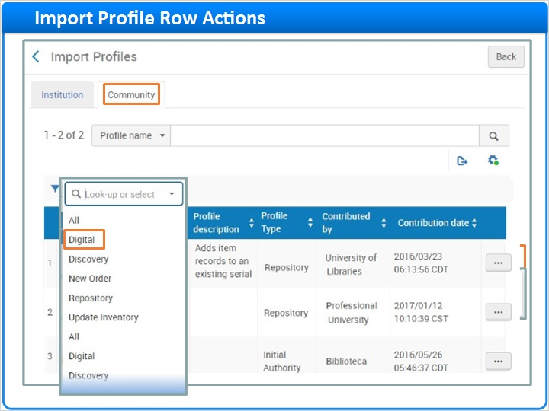

1.26 Session Review and Quiz
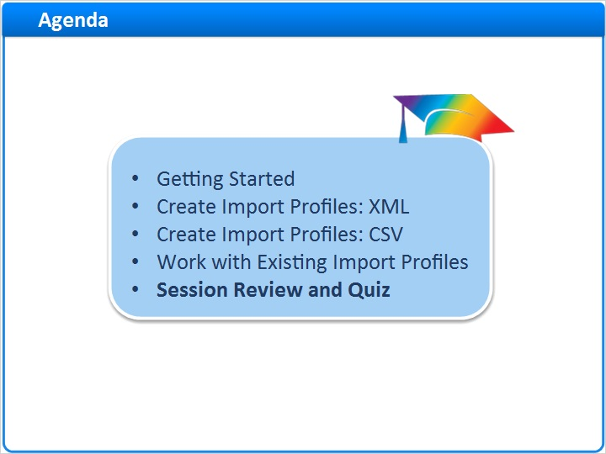
Notes:
That concludes the main portion of this training session. Let’s briefly review what was covered and then proceed to a short quiz.

1.27 Session Review
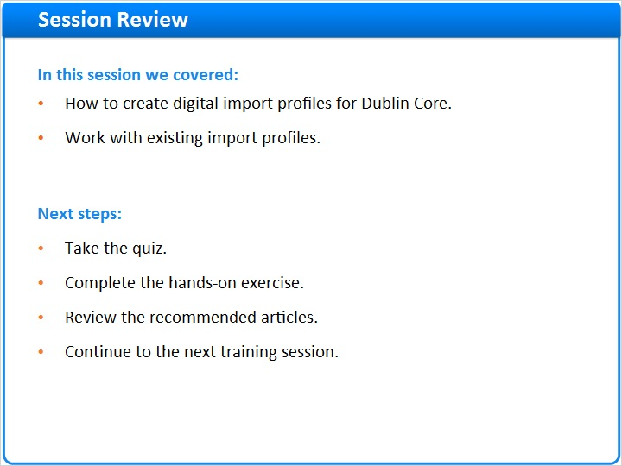
Notes:
In this session, we:
- Learned how to create digital import profiles for Dublin Core.
- And we looked at how to work with existing import profiles.

What are your next steps?

After the short quiz that begins on the next page, complete the hands-on exercise for this session.

Please refer to the Recommended Articles section where you launched this training session for additional information. Then, continue to the next training session in this series.

1.28 Quiz: Managing Digital Resource Asset Files
(True/False, 10 points, 1 attempt permitted)
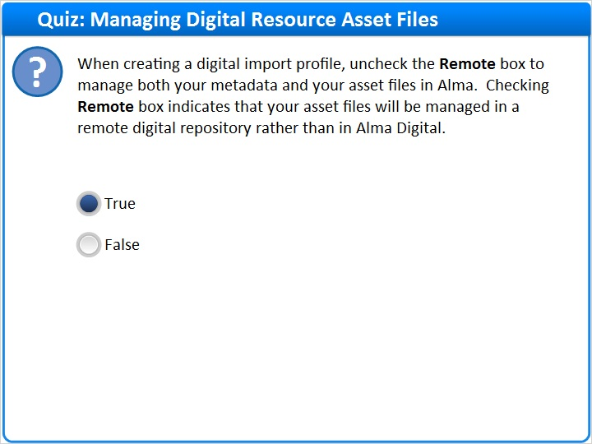
Correct | Choice
X | True
 | False
Feedback when correct:
Right! The correct answer is: True.

When creating a digital import profile, uncheck the Remote box to manage both your metadata and your asset files in Alma. Checking Remote box indicates that your asset files will be managed in a remote digital repository rather than in Alma Digital.
Feedback when incorrect:
The correct answer is: True.

When creating a digital import profile, uncheck the Remote box to manage both your metadata and your asset files in Alma. Checking Remote box indicates that your asset files will be managed in a remote digital repository rather than in Alma Digital.

Notes:

Correct (Slide Layer)
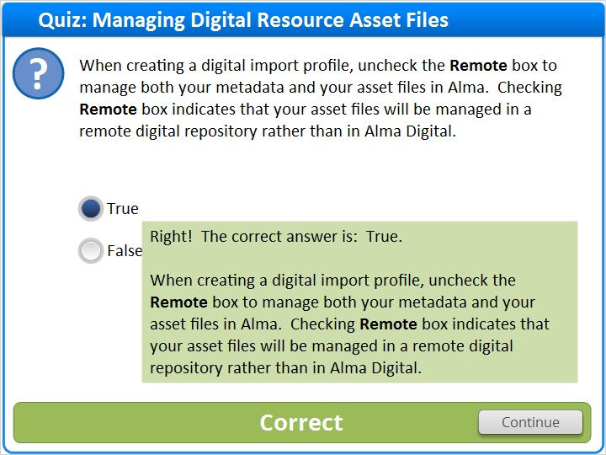

Incorrect (Slide Layer)
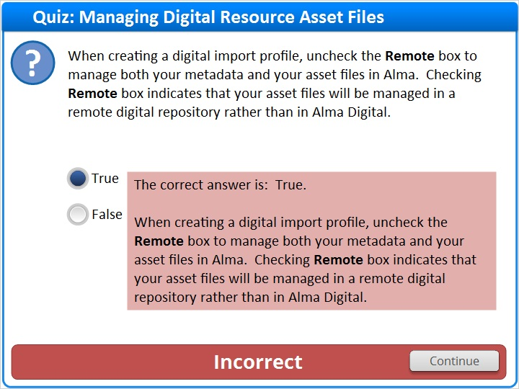

1.29 Quiz: Collections
(Multiple Response, 10 points, 1 attempt permitted)
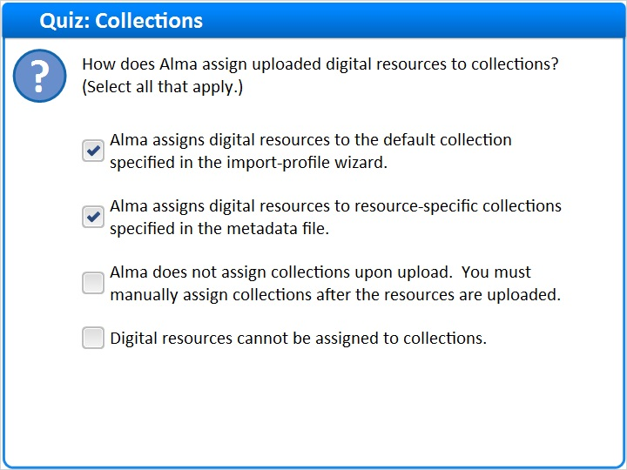
Correct | Choice
X | Alma assigns digital resources to the default collection specified in the import-profile wizard.
X | Alma assigns digital resources to resource-specific collections specified in the metadata file.
 | Alma does not assign collections upon upload. You must manually assign collections after the resources are uploaded.
 | Digital resources cannot be assigned to collections.

Feedback when correct:
Right! There are two correct answers:

Alma assigns digital resources to the default collection specified in the import profile wizard.
Alma assigns digital resources to resource-specific collections specified in the metadata file.

Selecting a default collection is mandatory, but it will only be used if there is no collection information in the metadata for a given resource.
Feedback when incorrect:
There are two correct answers:

Alma assigns digital resources to the default collection specified in the import profile wizard.
Alma assigns digital resources to resource-specific collections specified in the metadata file.

Selecting a default collection is mandatory, but it will only be used if there is no collection information in the metadata for a given resource.

Correct (Slide Layer)
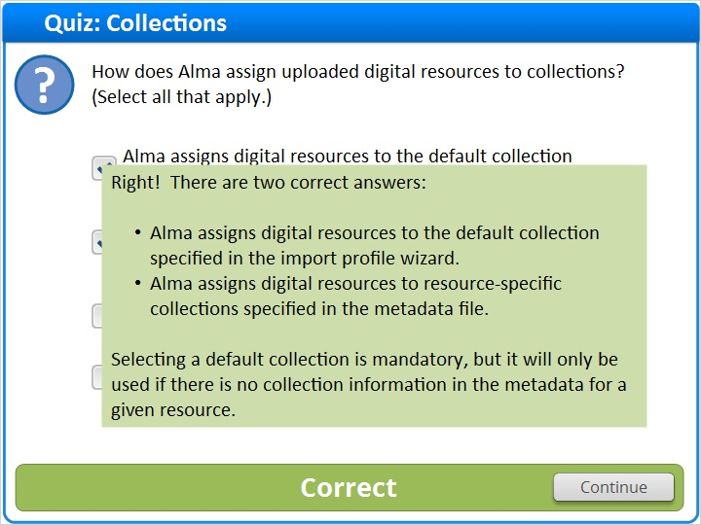

Incorrect (Slide Layer)
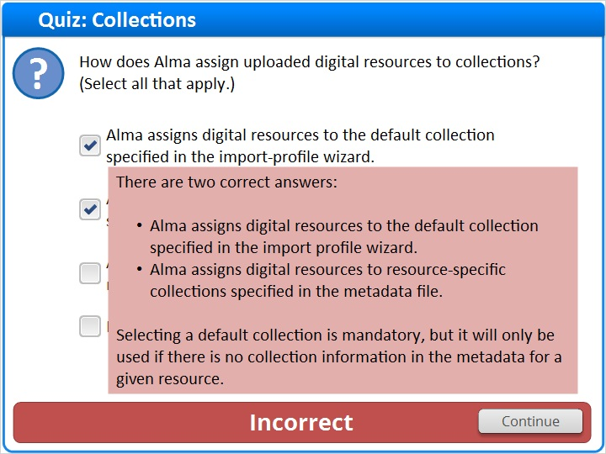

1.30 Quiz: Match Profiles and Match Actions
(Multiple Response, 10 points, 1 attempt permitted)
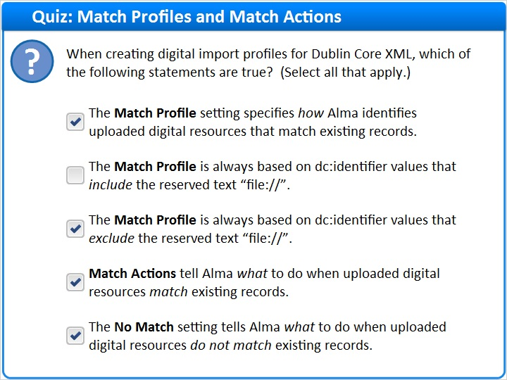
Correct | Choice
X | The Match Profile setting specifies how Alma identifies uploaded digital resources that match existing records.
 | The Match Profile is always based on dc:identifier values that include the reserved text “file://”.
X | The Match Profile is always based on dc:identifier values that exclude the reserved text “file://”.
X | Match Actions tell Alma what to do when uploaded digital resources match existing records.
X | The No Match setting tells Alma what to do when uploaded digital resources do not match existing records.

Feedback when correct:
Right! There are four true statements:

The Match Profile setting specifies how Alma identifies uploaded digital resource records that match existing records.
For Dublin Core, the Match Profile is always based on dc:value values that exclude the reserved text “file://”.
Match Actions tell Alma what to do when uploaded digital resources match existing records.
The No Match setting tells Alma what to do when uploaded digital resources do not match existing records.
Feedback when incorrect:
There are four true statements:

The Match Profile setting specifies how Alma identifies uploaded digital resource records that match existing records.
For Dublin Core, the Match Profile is always based on dc:value values that exclude the reserved text “file://”.
Match Actions tell Alma what to do when uploaded digital resources match existing records.
The No Match setting tells Alma what to do when uploaded digital resources do not match existing records.

Correct (Slide Layer)
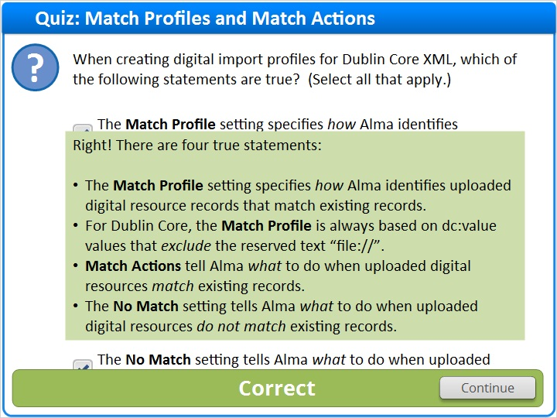

Incorrect (Slide Layer)
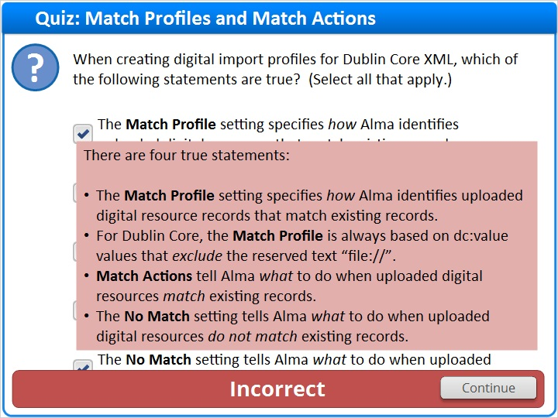

1.31 Quiz: Access Rights Policies
(Multiple Choice, 10 points, 1 attempt permitted)
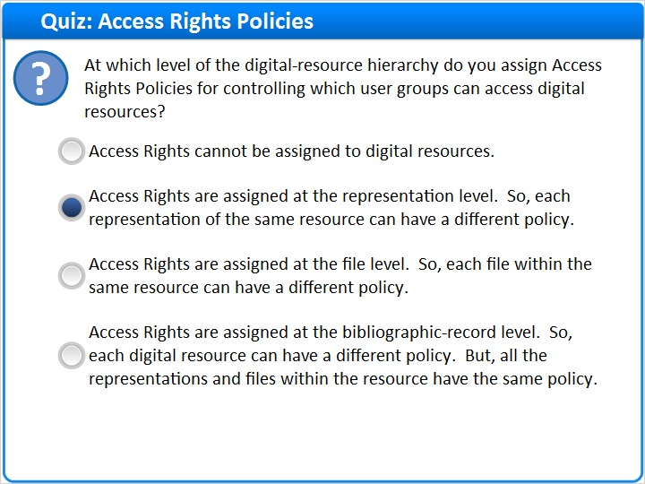
Correct | Choice
 | Access Rights cannot be assigned to digital resources.
X | Access Rights are assigned at the representation level. So, each representation of the same resource can have a different policy.
 | Access Rights are assigned at the file level. So, each file within the same resource can have a different policy.
 | Access Rights are assigned at the bibliographic-record level. So, each digital resource can have a different policy. But, all the representations and files within the resource have the same policy.

Feedback when correct:
Right! The correct answer is:

Access Rights are assigned at the representation level. So, each representation of the same resource can have a different policy.
Feedback when incorrect:
The correct answer is:

Access Rights are assigned at the representation level. So, each representation of the same resource can have a different policy.

Notes:

Correct (Slide Layer)
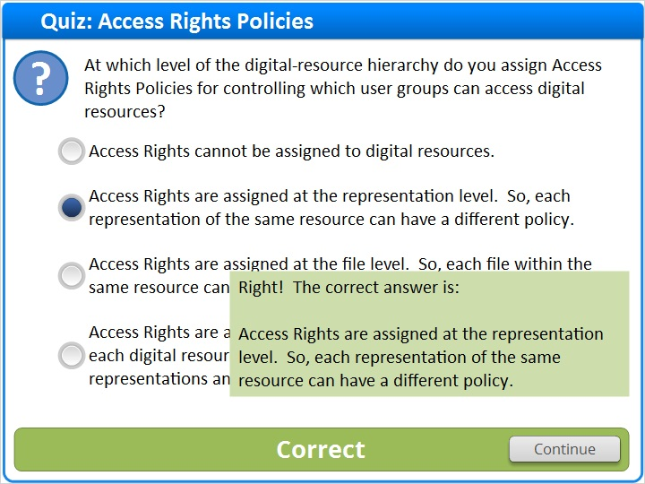

Incorrect (Slide Layer)
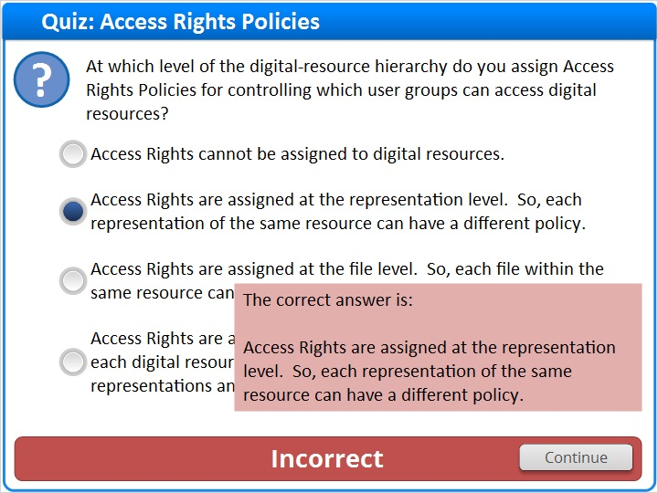

1.32 Thank You!

Notes:
Thank you for joining this session.

1.33 About this Training

Notes:

1 (Slide Layer)
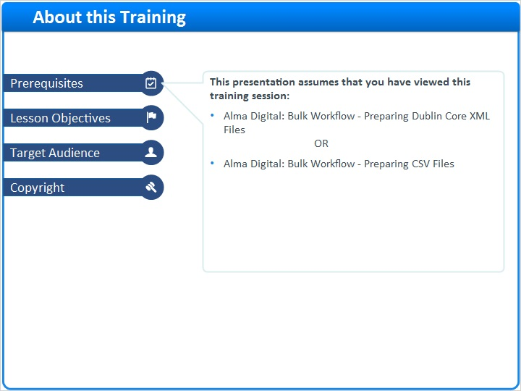

2 (Slide Layer)
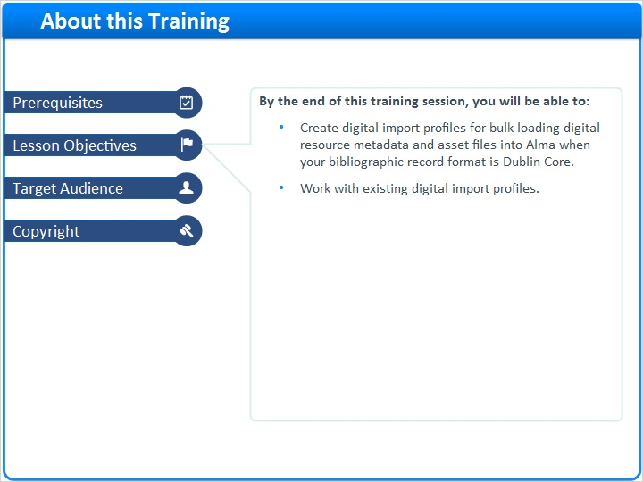

3 (Slide Layer)
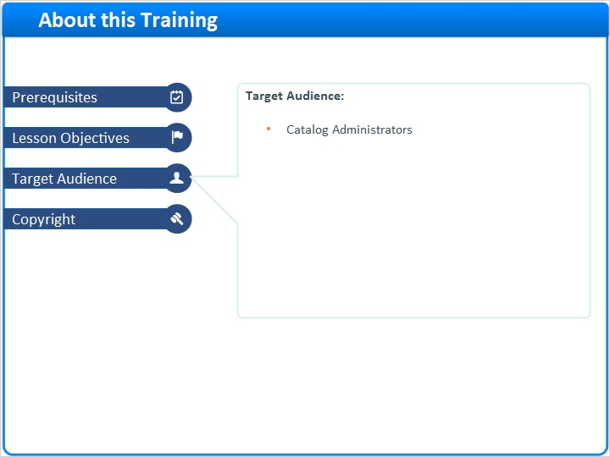

4 (Slide Layer)


