Alma Digital: Bulk Workflow - Using the Digital Uploader

1. Alma Digital: Bulk Workflow - Using the Digital Uploader

1.1 Alma Digital: Bulk Workflow - Using the Digital Uploader
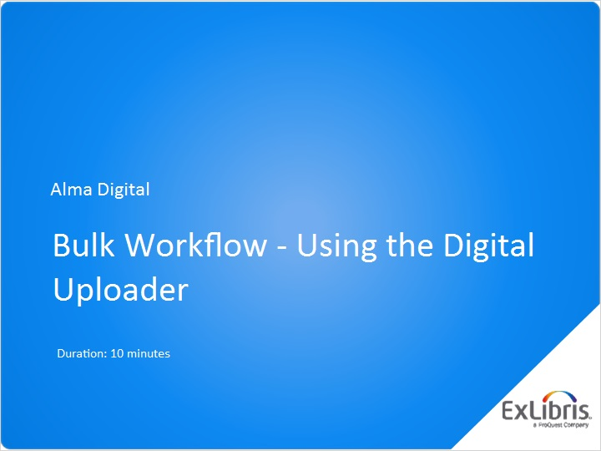
Notes:
Hello, and welcome to this session about using the Digital Uploader.

To get the most out of this session, you should have already watched the session about creating import profiles for either Dublin Core or MARC.

1.2 Workflow Overview
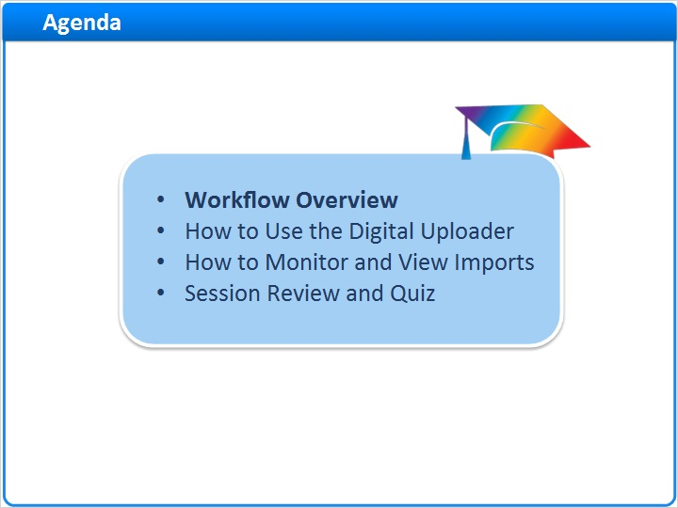
Notes:
We’ll begin this session with a quick review of the overall workflow for creating digital resources in bulk. Then we’ll consider how to use Alma’s Digital Uploader to import digital resources. And we’ll look at how to monitor and view your imports.

After a brief session review, there will be a short quiz to test your knowledge.

1.3 Creating Digital Resources in Bulk
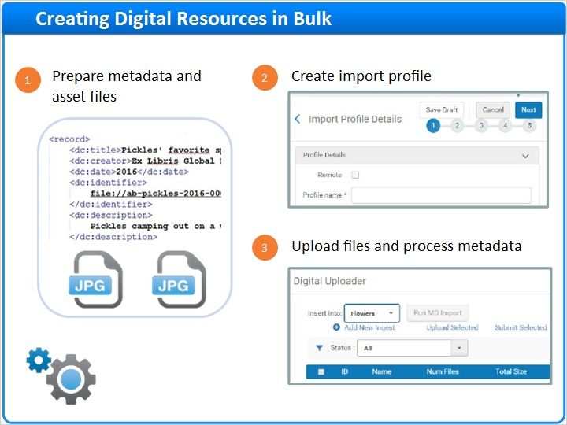
Notes:
As you may recall, the workflow for creating digital resources in bulk entails three steps. The first two steps were covered in previous sessions:
- Preparing your metadata and asset files.
- And, creating an import profile that tells Alma how to process your files.

This session is all about step 3, using the Digital Uploader to upload and process your digital resources.

Three Steps (Slide Layer)
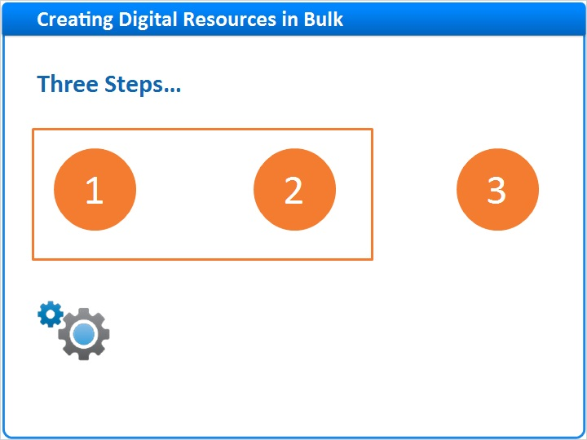

1.4 Four Steps to Using the Digital Uploader
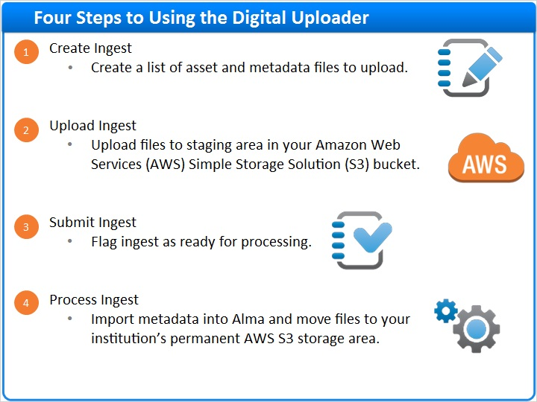
Notes:
Using the Digital Uploader requires four easy steps:

- First, create an ingest. An ingest is a list of asset and metadata files to be uploaded.
- Next, use the Digital Uploader to upload the files to a staging area in your Amazon Web Services Simple Storage Solution bucket.
- Once all the files have been uploaded, submit the ingest to indicate that it is ready for processing.
- And finally, process the ingest to import the metadata into Alma and move the asset files to your permanent AWS S3 storage area.

Four Steps (Slide Layer)
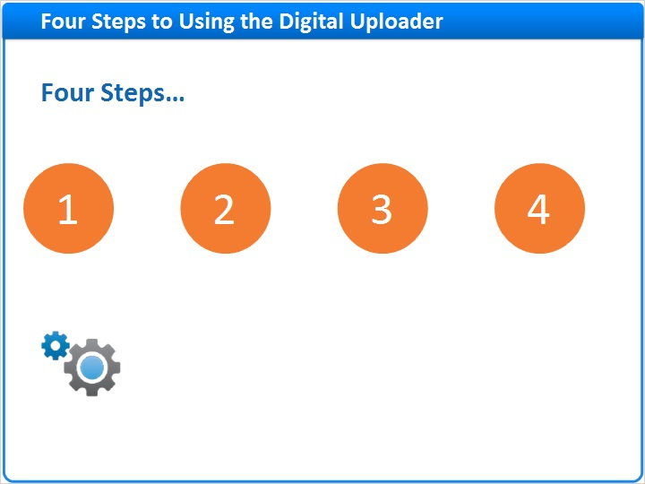

1.5 How to Use the Digital Uploader
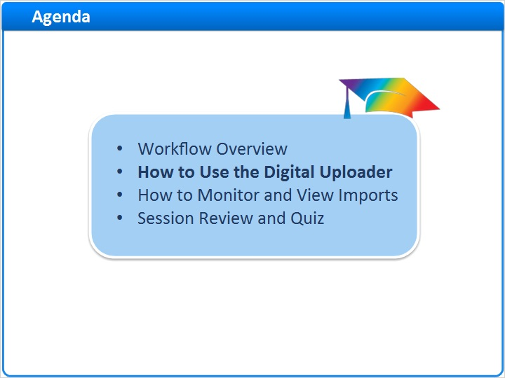
Notes:
Now, let’s learn how to use the Digital Uploader. For practice, we’ll use an example from the session on creating import profiles for Dublin Core. The process is same for MARC, so don’t worry if we don’t cover your format here.

1.6 Working Example
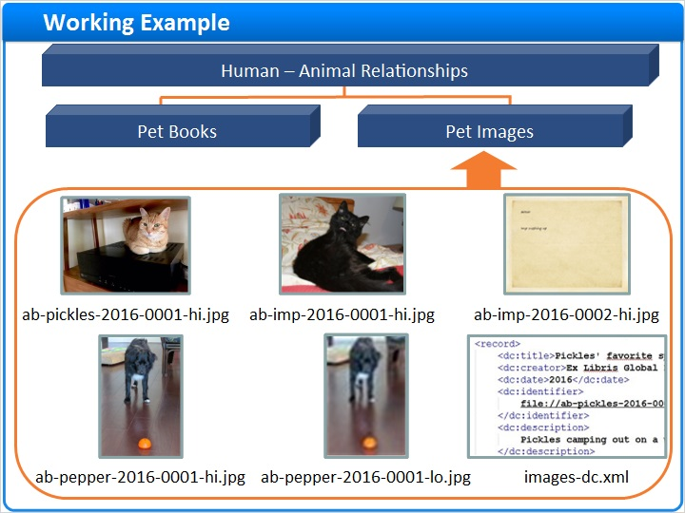
Notes:
In this example, we’ll use the Digital Uploader to add a group of images to a collection called Pet Images. And, we’ll process the resources’ Dublin Core XML file using the import profile we created in an earlier session: Load Digital Images: Dublin Core XML.

Processing (Slide Layer)
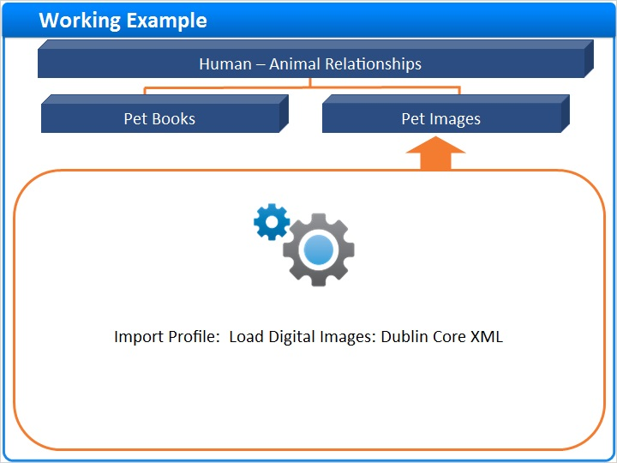

1.7 Digital Uploader: Navigation
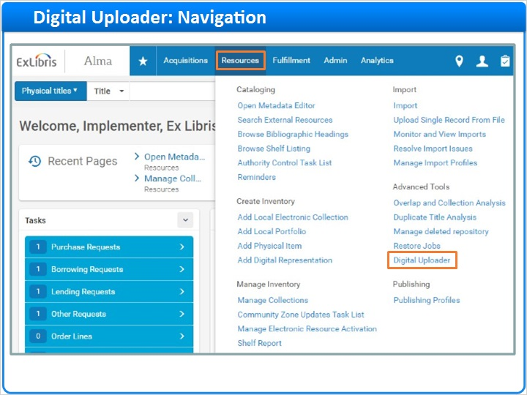
Notes:
To get started, click Resources on the main menu bar in Alma. Then click Digital Uploader under the Advanced Tools section.

1.8 Step 1: Create Ingest (Select Collection & Import Profile)
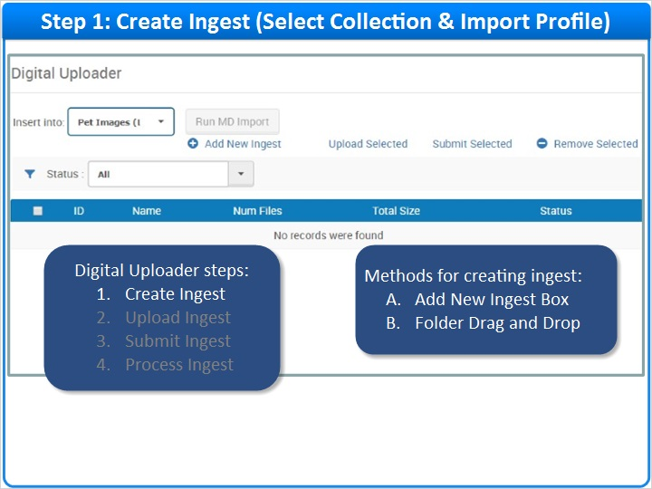
Notes:
For Step 1, we need to create an ingest, or list of files to upload.

But first, we need to specify a default collection and the correct import profile for processing the ingest. So, select a value from the Insert Into field where each where each option includes a collection name followed by an import profile name in parentheses. For our example, select Pet Images (Load Digital Images: Dublin Core XML).

Now, we can create the ingest using one of two methods: the add new Ingest Box method, or the Folder Drag and Drop method.

Default Collection and Import Profile (Slide Layer)
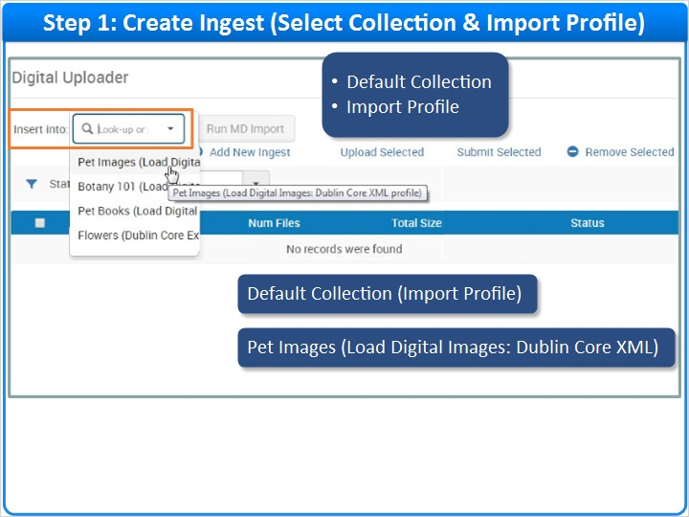

1.9 Step 1: Create Ingest (Add New Ingest Box Method)
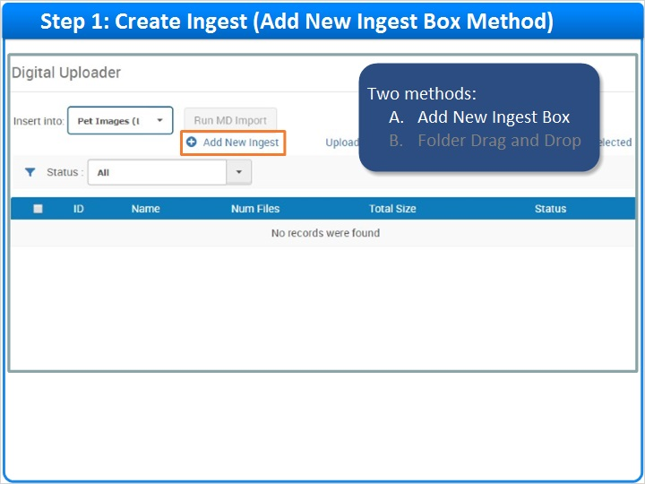
Notes:
We’ll look at the Add New Ingest Box method first. Click Add New Ingest, and, in the box that appears, enter a name for your ingest. Then, click Add files and navigate to the files you want to upload. Select both the asset files and the metadata file to include in the ingest.

Review the list of files, and click OK to save the list for upload in Step 2.

Or, if you prefer, you can move to Step 2 now. Click an Upload button to upload an individual file. Or, click Start Upload to upload all files in the ingest. Then, click OK to return to the Digital Uploader page where you can watch your upload’s progress.

Here you can see that, for the Pet Images ingest, eight files have been uploaded, and the upload is Complete.

Name Ingest and Add Files (Slide Layer)
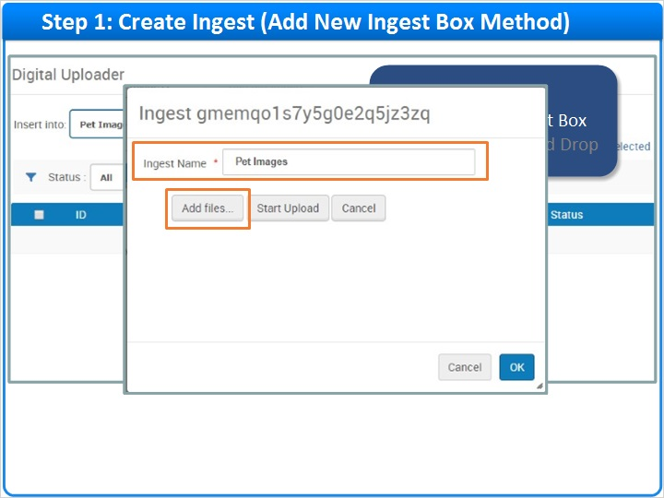

Select Files List (Slide Layer)
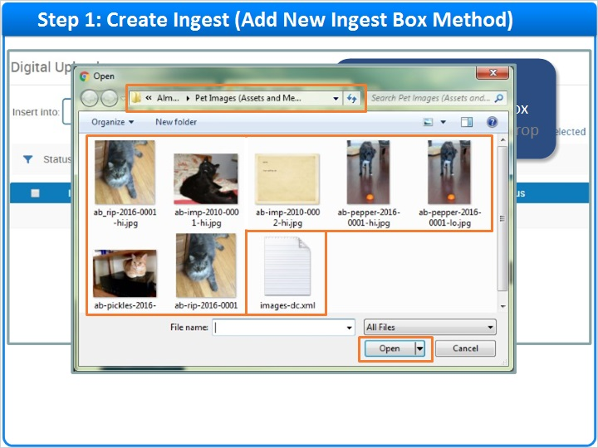

Upload Files (Slide Layer)
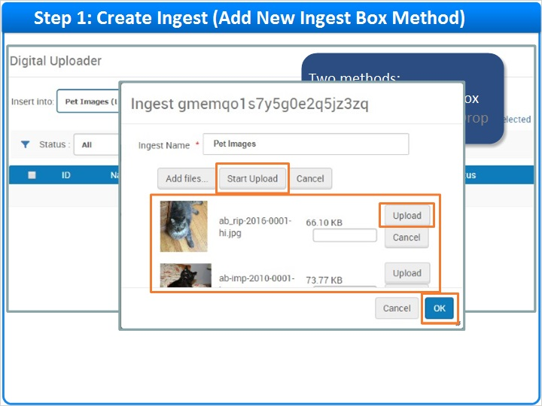

Upload Complete (Slide Layer)
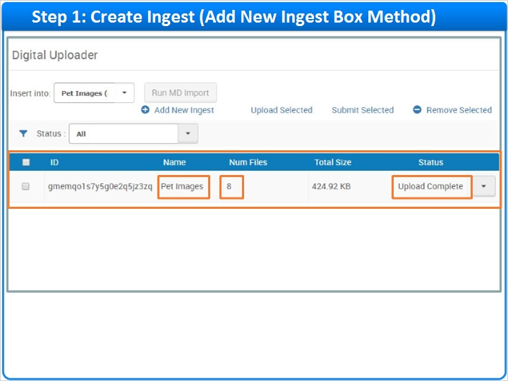

1.10 Step 1: Create Ingest (Drag and Drop Method)
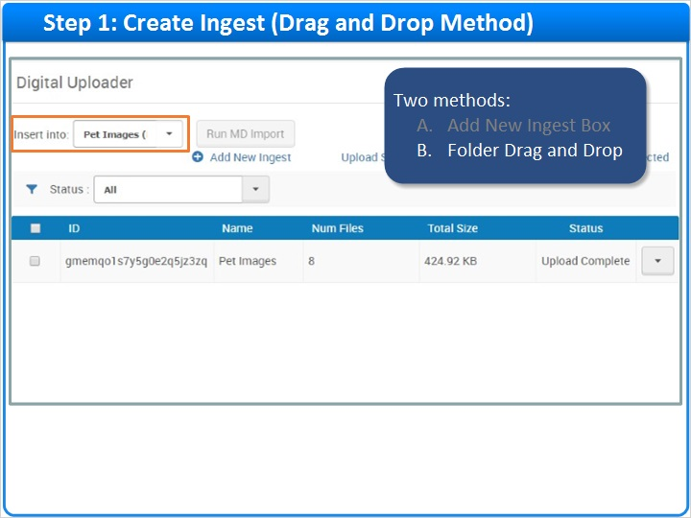
Notes:
Now, let’s consider the Folder Drag and Drop Method which is currently supported by Chrome and Firefox.

As before, select the default collection and import profile from the Insert Into field.

Then, use your computer’s file system to locate the folder containing the files you want to upload. Drag and drop the folder into the blank space at the bottom of the ingest table to create an ingest that includes all files in the folder.

Here you can see that the ingest was automatically given the folder name. And, the ingest includes 8 files, but the Pending Uploads status tells us that we still need to upload the ingest.

Drag and Drop (Slide Layer)
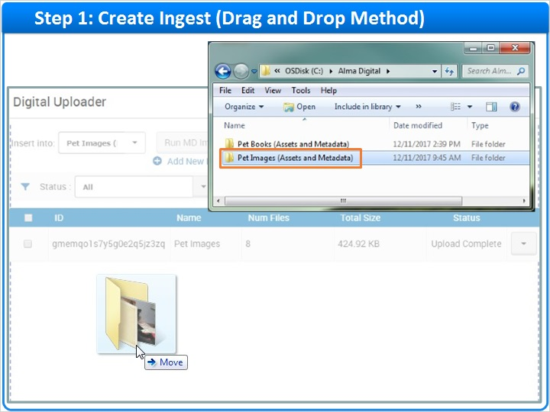

New Ingest (Slide Layer)
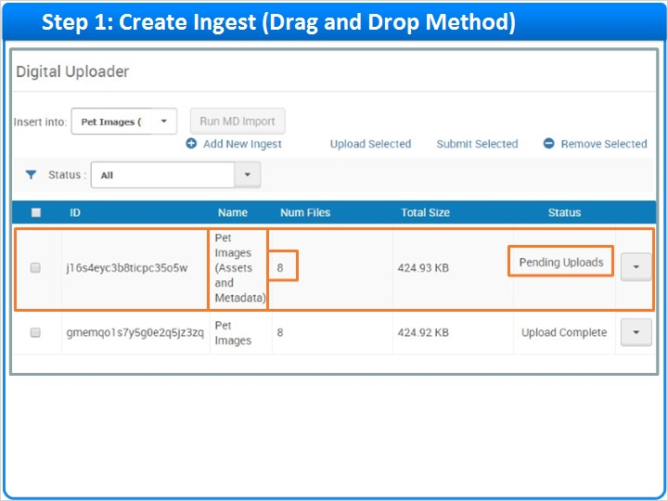

1.11 Step 2: Upload Ingest
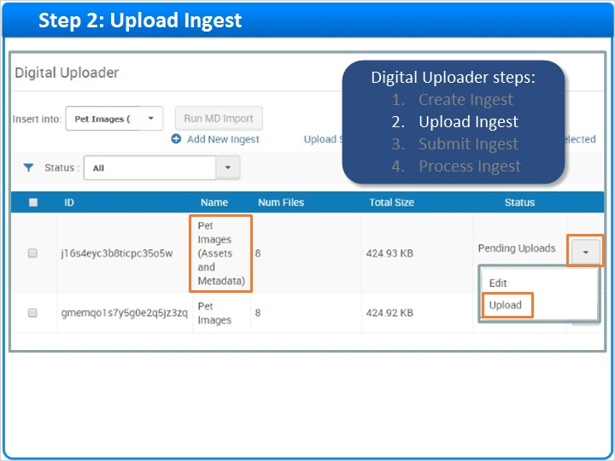
Notes:
So, let’s move on to step 2, Upload Ingest. Select Upload from the row actions list for the ingest called Pet Images (Assets and Metadata), and watch for the upload to complete.

Upload Complete (Slide Layer)
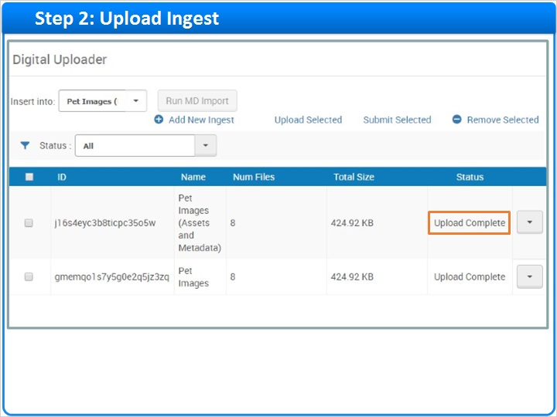

1.12 Editing an Ingest before Submitting
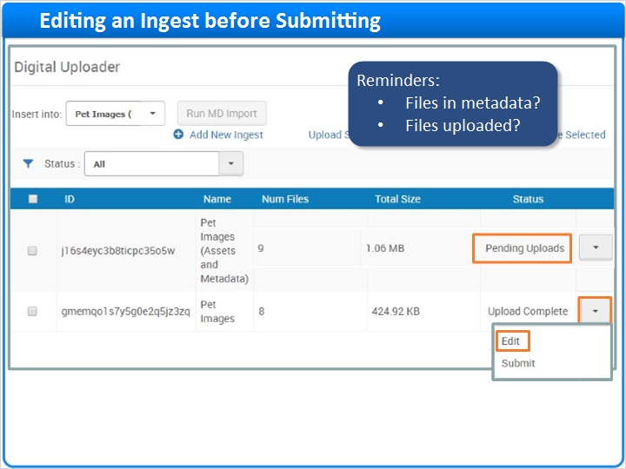
Notes:
If you need to add more files to an ingest, you can use any browser drag and drop files directly onto that ingest.

If you need to remove files from an ingest, click Edit in the row actions list for that ingest. Then, click Delete next to any files you need to delete.

You can also add new files here. Click Add files… to select the files to add.

Just a few things to remember when adding asset files to an existing ingest:
- First, make sure the files are represented in the ingest’s metadata file.
- And, remember to upload the ingest to make sure all the ingest’s files, including the new ones, have been uploaded.

Drag Files (Slide Layer)
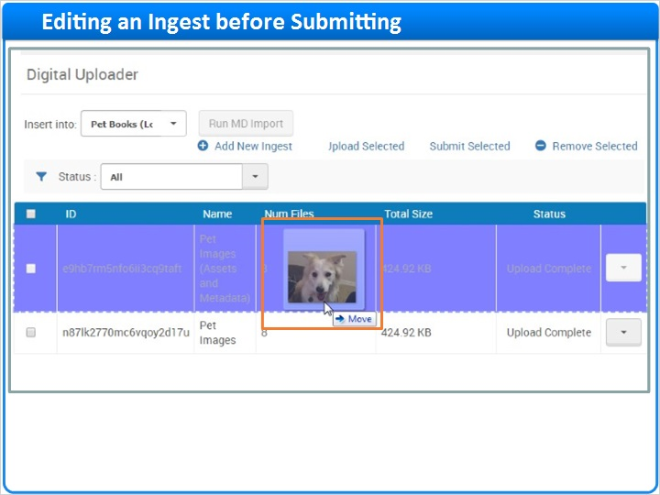

Edit Files (Slide Layer)
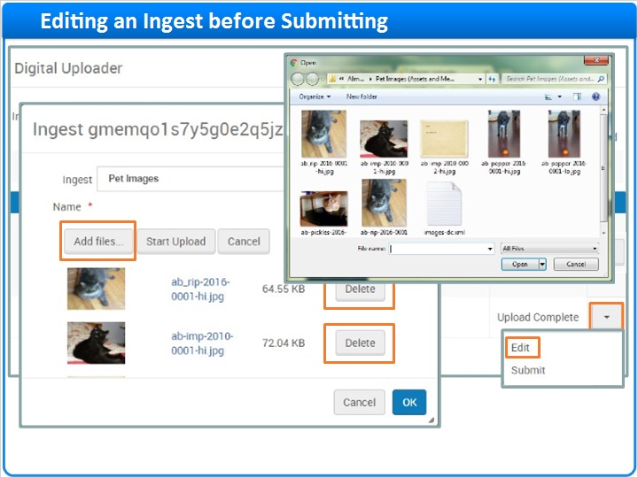

1.13 Step 3: Submit Ingest
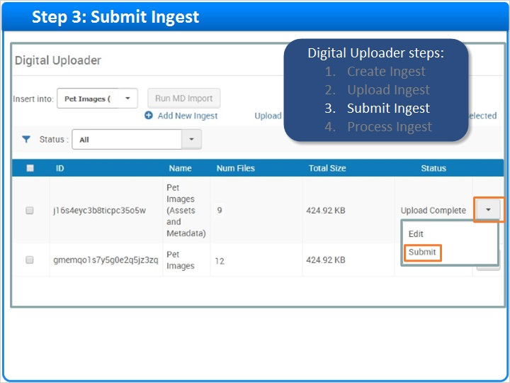
Notes:
Once you’re satisfied that all the files are present for an ingest, it’s time for Step 3, submitting the ingest. Click Submit in the row actions list for that ingest to indicate that it is ready for processing.

1.14 Step 4: Process Ingest (Run MD Import)
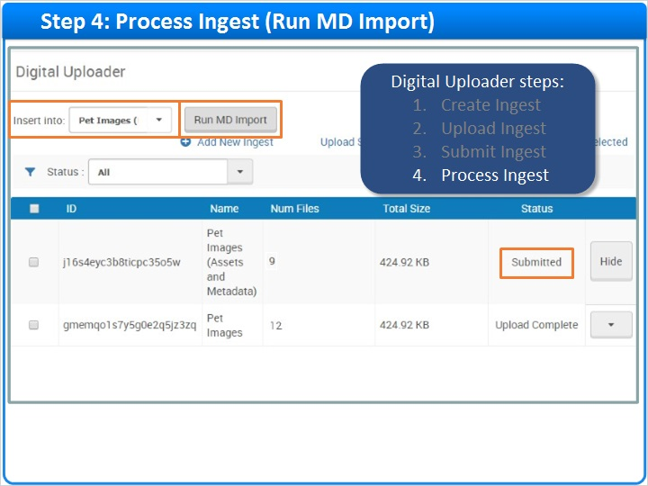
Notes:
Now we are ready for step 4, processing the ingest. When the collection and import profile in the Insert Into field has at least one ingest with the status, Submitted, the Run MD Import button will be enabled.

Click Run MD Import to process all the submitted ingests for that collection and import profile.

Here, you can see that the MD Import job was started successfully, and the processed ingest was removed from the table of open ingests.

MD Import Job Submitted (Slide Layer)
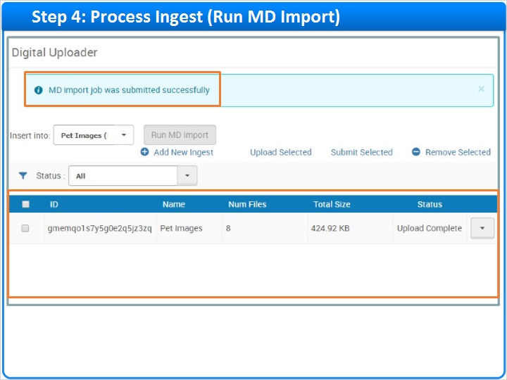

1.15 Scope and Lifespan of Ingests
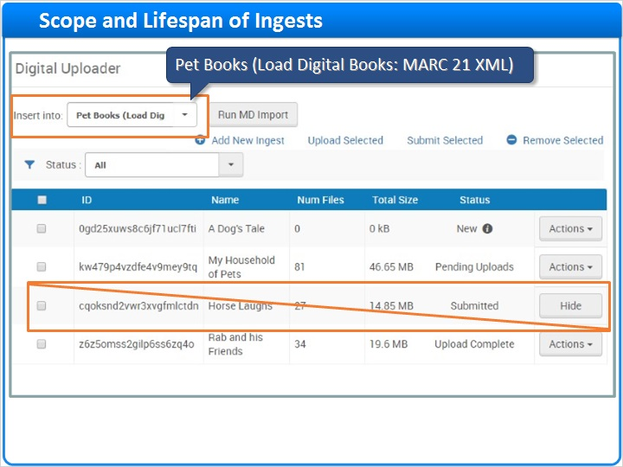
Notes:
Before we move on, we need to consider the scope and lifespan of ingests.

First, keep in mind that, on the Digital Uploader page, you will only see ingests for the selected collection and import profile. If you do not see your ingests, you may need to select a new value from the Insert Into field.

Note also, that information about ingests is stored in your browser. This means you will not see the ingests you created if you:
- Log onto Alma with a different browser.
- Log into Alma as a different user with same browser.
- Or clear your browser’s local storage.

To continue work on the ingests you created, return to the original browser and log in as the user who created the ingests. Otherwise, you will need to create new ingests.

Which brings us to the lifespan of ingests:
- File lists are saved between logins only if the files were added AND uploaded.
- And, an ingest’s uploaded files will be deleted from the AWS S3 staging area if all of the ingest’s files are over 30 days old.

And, there is one more thing to keep in mind specifically for ingests that have been submitted. Even if you no longer see your Submitted ingests in the Digital Uploader, they can still be processed manually or by scheduling. Let's learn how.

Scope (Slide Layer)
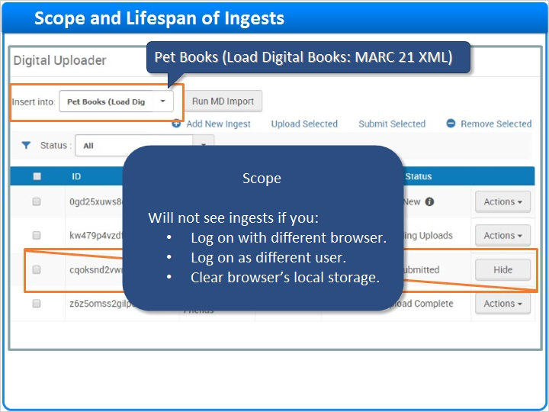

Lifespan (Slide Layer)
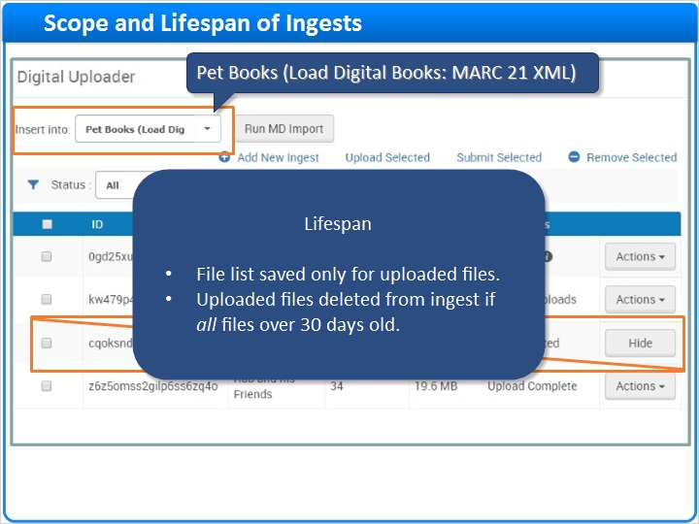

1.16 Manually Process Submitted Ingests
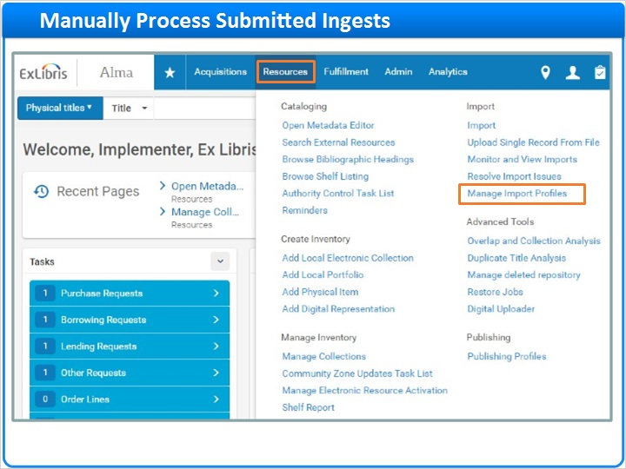
Notes:
To manually process ingests for an import profile, click Resources on the main menu bar. Then click Manage Import Profiles. under the Import section.

Locate the desired profile. Then, to process all the profile’s ingests with the status, Submitted, click Run on the row actions list.

Next, click Submit to start the import job. You will land on the Job History page where you can monitor the job’s progress.

Run Import Profile (Slide Layer)
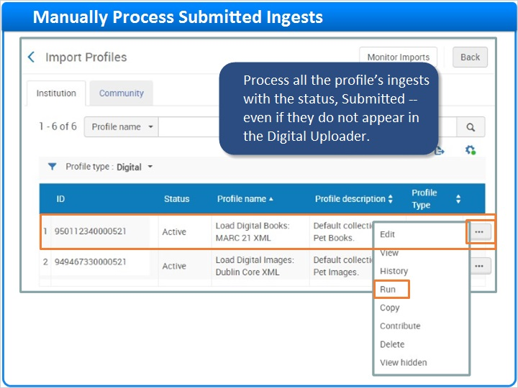

Submit Job (Slide Layer)
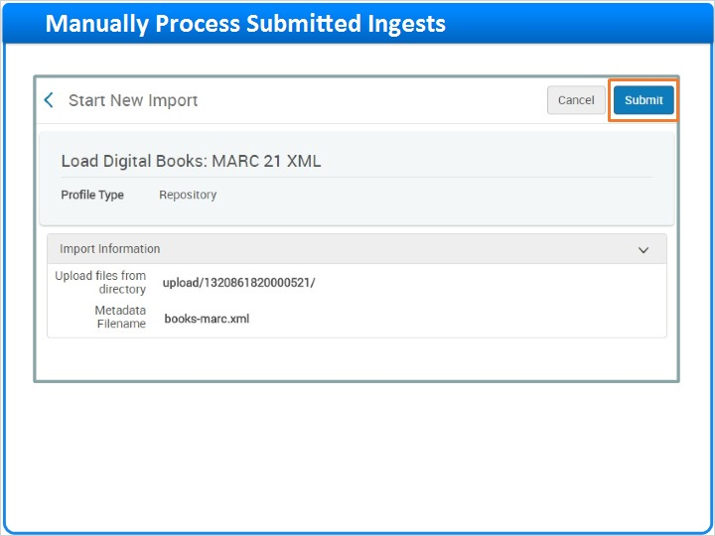

Monitor Job Progress (Slide Layer)
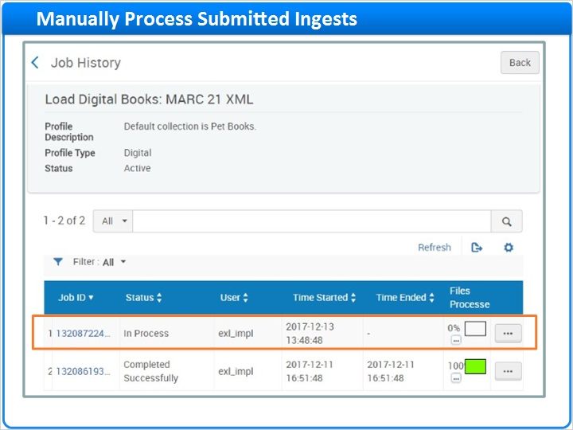

1.17 Schedule Processing of Submitted Ingests
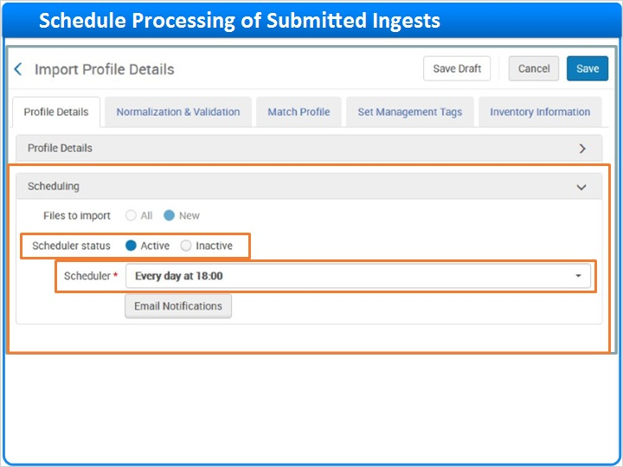
Notes:
Submitted ingests can also be processed automatically if you configured and activated scheduling for a profile. In the import profile shown here, submitted ingests will be processed every day at 6pm.

1.18 How to Monitor and View Imports
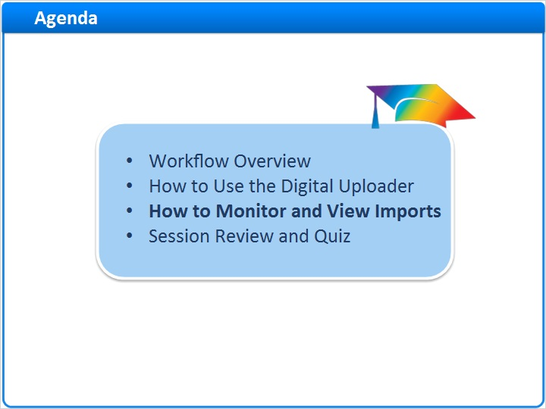
Notes:
Let’s wrap up with some information on how to monitor and view imports.

1.19 Monitor and View Imports: Navigation
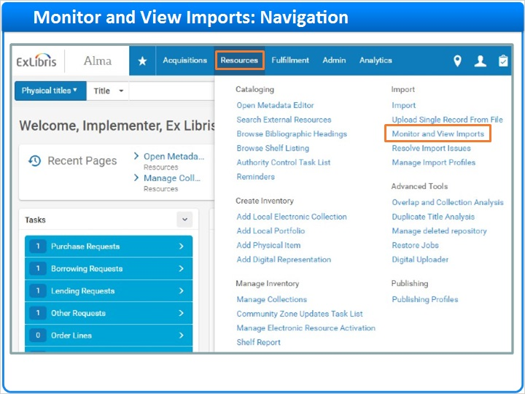
Notes:
Click Resources on the main menu bar. Then click Monitor and View Imports under the Import section.

1.20 Monitor and View Imports Page
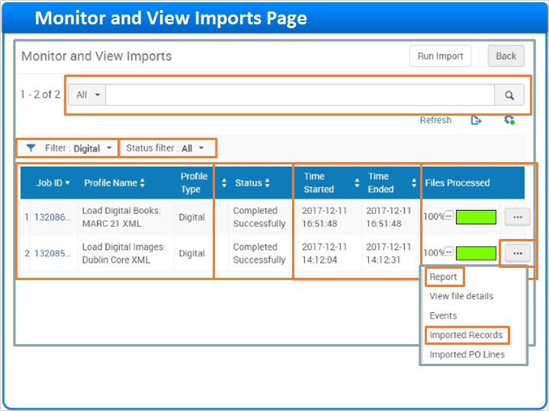
Notes:
Here you can monitor and view all sorts of imports, not just digital imports. Since the list could be quite long, you may want to search on a specific field to find an import. Or, you might filter on a specific type of import, or a specific import status.

In the body of the page, you can see the status of your imports along with start and end times, and the percentage of the imports files that have been processed. The row actions menu exposes quite a few additional tools for each import.

For example, click Imported Records to see the digital resources created by the import we ran earlier in this session.

Or, click Report to see the Job Report.

Search or Filter (Slide Layer)
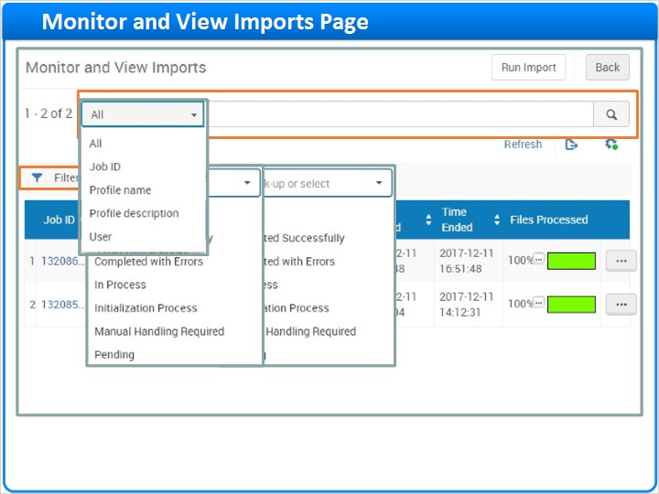

Imported Records (Slide Layer)
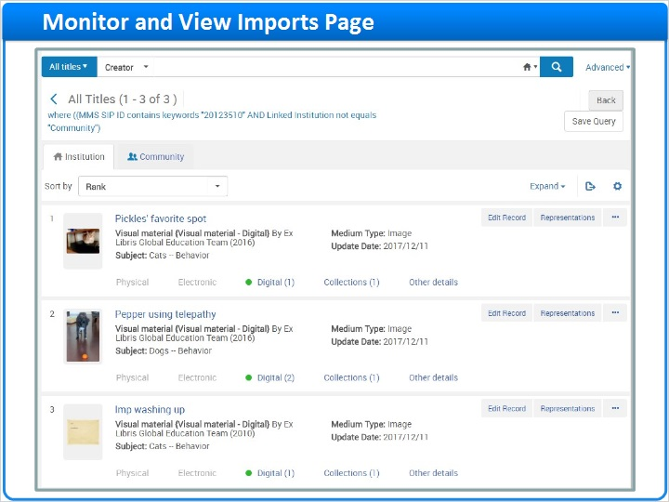

1.21 Job Report
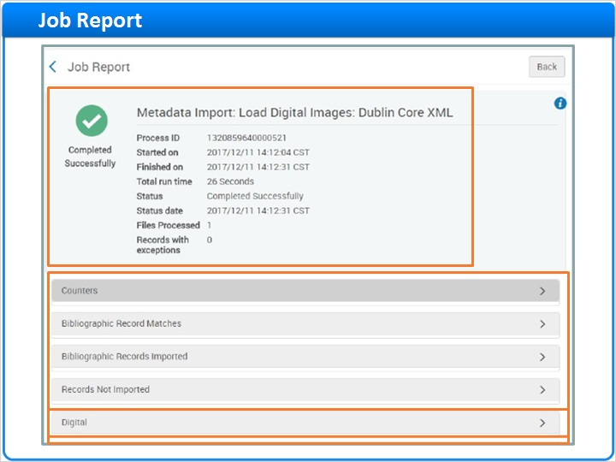
Notes:
At the top of the Job Report is summary information about the job.

Below are several expandable sections with greater detail. For example, the Digital section shows the count of digital items (or representations) imported, the count of bibliographic records added to collections, and more. For each count, a set of row actions provides access to additional information and functionality.

Digital Section (Slide Layer)
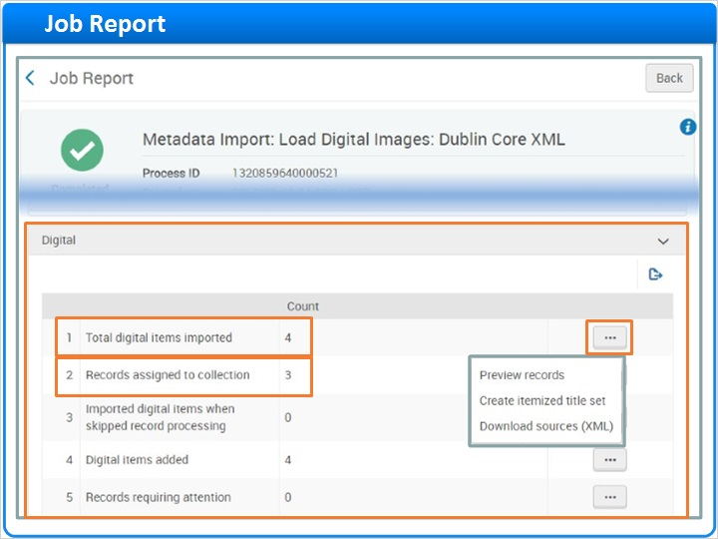

1.22 Session Review and Quiz
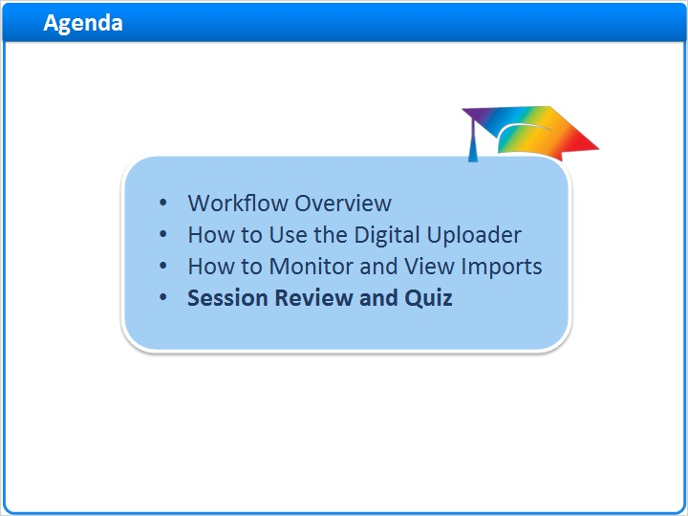
Notes:
That concludes the main portion of this training session. Let’s briefly review what was covered and then proceed to a short quiz.

1.23 Session Review
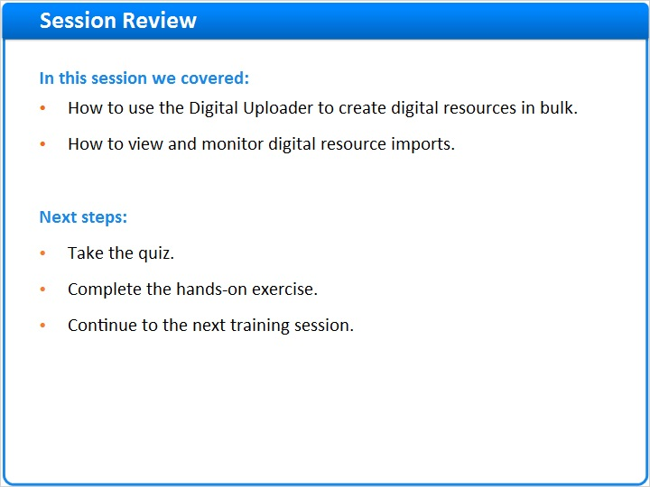
Notes:
In this session, we:
- Learned how to use the Digital Uploader to create digital resources in bulk.
- And, we looked at how to view and monitor digital resource imports.

What are your next steps?

After the short quiz that begins on the next page, complete the hands-on exercise for this session.

Please refer to the Recommended Articles section where you launched this training session for additional information.

1.24 Quiz: Import Profile Steps
(Multiple Choice, 10 points, 1 attempt permitted)
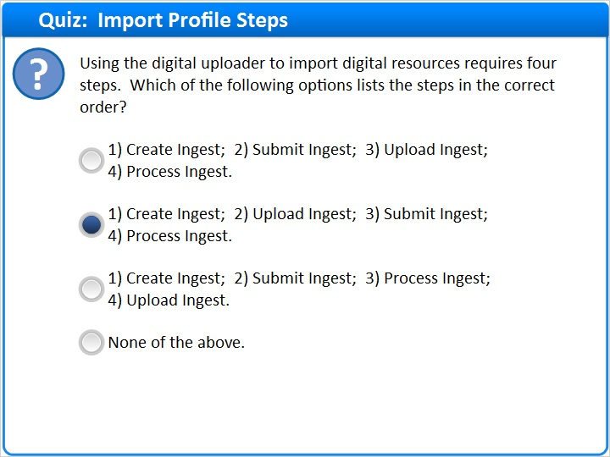
Correct | Choice
 | 1) Create Ingest; 2) Submit Ingest; 3) Upload Ingest; 4) Process Ingest.
X | 1) Create Ingest; 2) Upload Ingest; 3) Submit Ingest; 4) Process Ingest.
 | 1) Create Ingest; 2) Submit Ingest; 3) Process Ingest; 4) Upload Ingest.
 | None of the above.
Feedback when correct:
Right! The correct answer is:

1) Create Ingest; 2) Upload Ingest; 3) Submit Ingest; 4) Process Ingest.
Feedback when incorrect:
The correct answer is:

1) Create Ingest; 2) Upload Ingest; 3) Submit Ingest; 4) Process Ingest.

Notes:

Correct (Slide Layer)
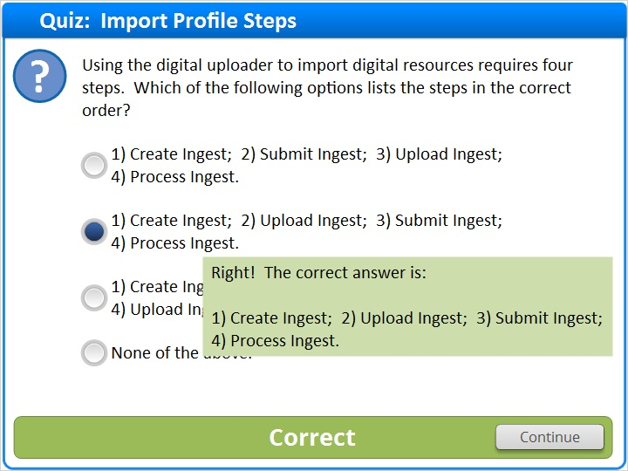

Incorrect (Slide Layer)
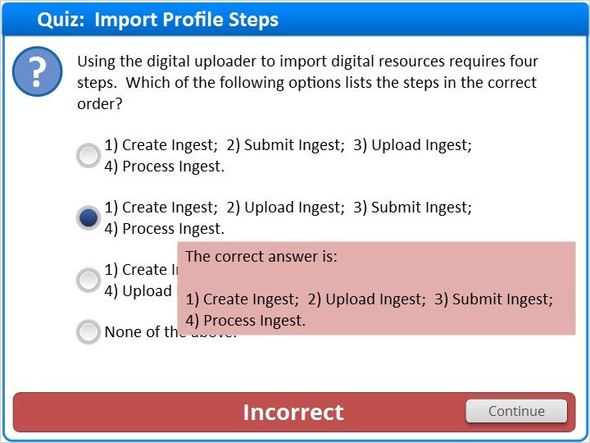

1.25 Quiz: Why Upload and Submit an Ingest
(True/False, 10 points, 1 attempt permitted)
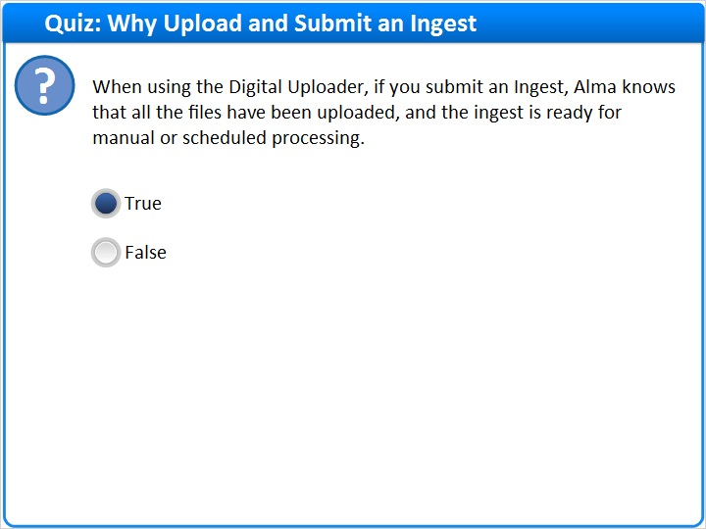
Correct | Choice
X | True
 | False

Feedback when correct:
Right! The correct answer is: True.

The “Submit Ingest" step comes after the “Upload Ingest" step so you can continue adding files without worrying that the ingest will be processed before it is ready.
Feedback when incorrect:
The correct answer is: True.

The “Submit Ingest" step comes after the “Upload Ingest" step so you can continue adding files without worrying that the ingest will be processed before it is ready.

Notes:

Correct (Slide Layer)
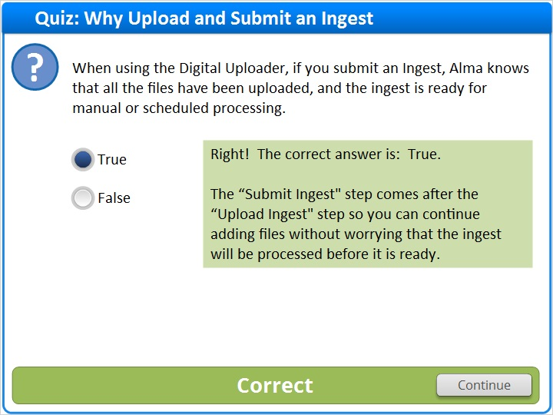

Incorrect (Slide Layer)
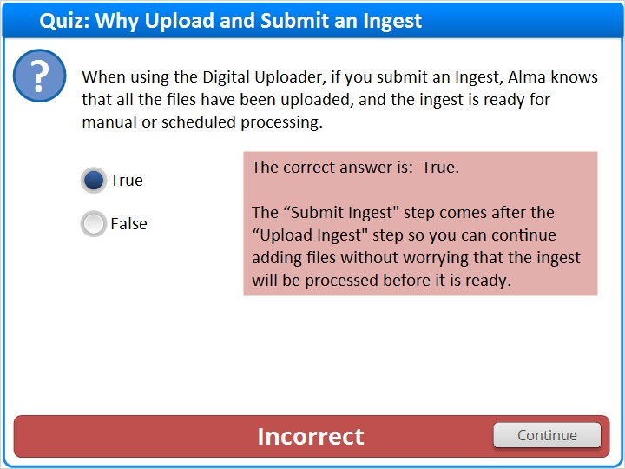

1.26 Quiz: Missing Ingests?
(Multiple Response, 10 points, 1 attempt permitted)
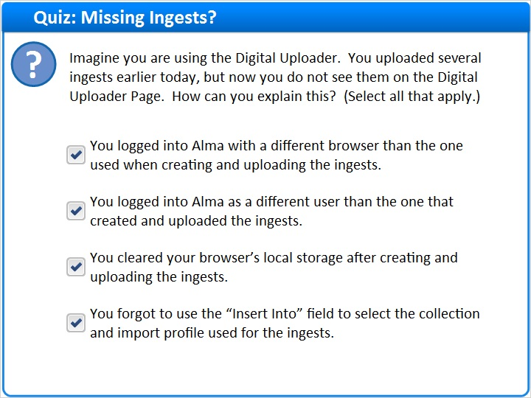
Correct | Choice
X | You logged into Alma with a different browser than the one used when creating and uploading the ingests.
X | You logged into Alma as a different user than the one that created and uploaded the ingests.
X | You cleared your browser’s local storage after creating and uploading the ingests.
X | You forgot to use the “Insert Into” field to select the collection and import profile used for the ingests.

Feedback when correct:
Right! All four selections are correct. You will not see your ingests if:

You logged into Alma with a different browser than the one used when creating and uploading the ingests.
You logged into Alma as a different user than the one that created and uploaded the ingests.
You cleared your browser’s local storage after creating and uploading the ingests.
You forgot to use the “Insert Into” field to select the collection and import profile used for the ingests.
Feedback when incorrect:
All four selections are correct. You will not see your ingests if:

You just logged into Alma with a different browser than the one used when creating and uploading the ingests.
You just logged into Alma as a different user than the one that created and uploaded the ingests.
You cleared your browser’s local storage after creating and uploading the ingests.
You forgot to use the “Insert Into” field to select the collection and import profile used for the ingests.

Correct (Slide Layer)
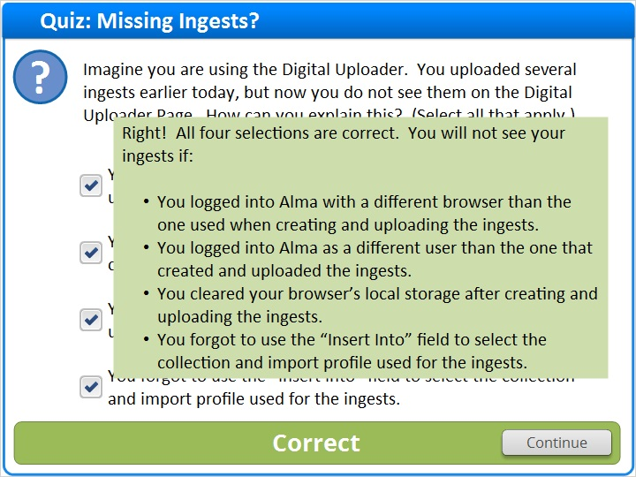

Incorrect (Slide Layer)
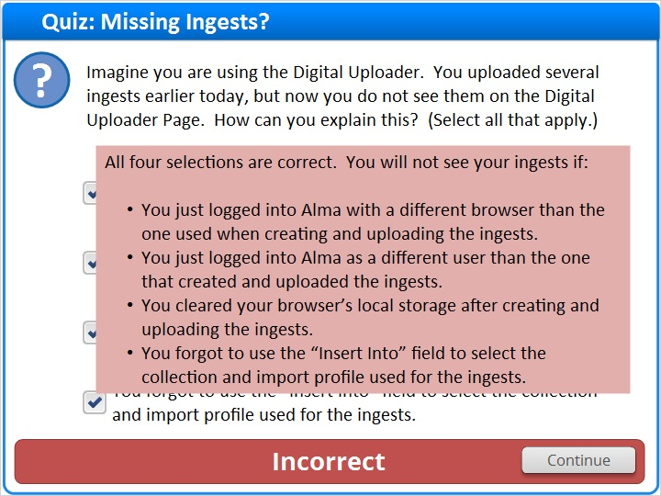

1.27 Thank You!

Notes:
Thank you for joining this session.

1.28 About this Training

Notes:

1 (Slide Layer)
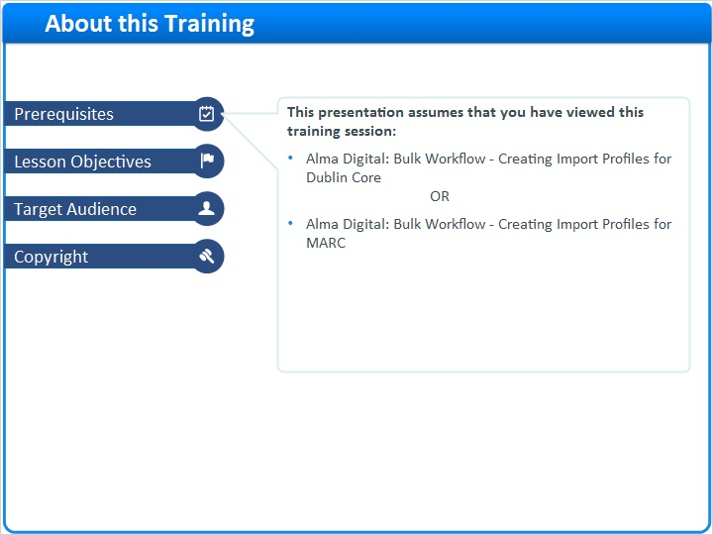

2 (Slide Layer)
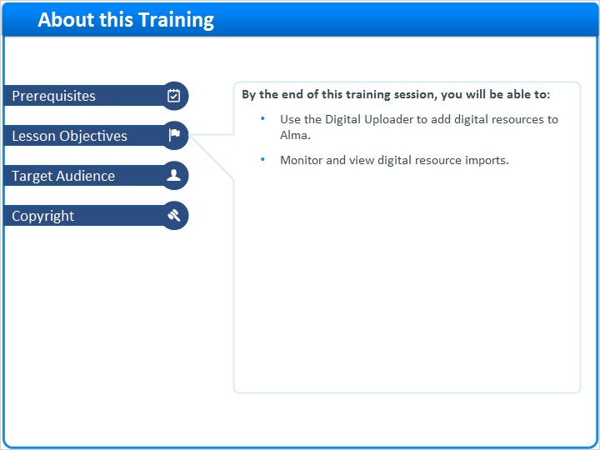

3 (Slide Layer)
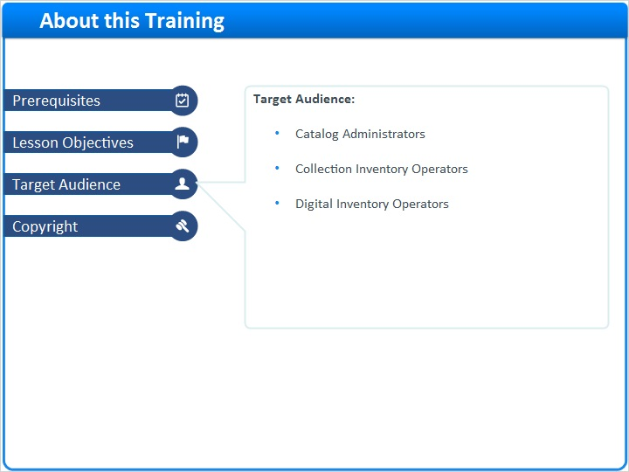

4 (Slide Layer)


