Alma Digital: Approving Patron Deposits

1. Alma Digital: Approving Patron Deposits

1.1 Alma Digital: Approving Patron Deposits
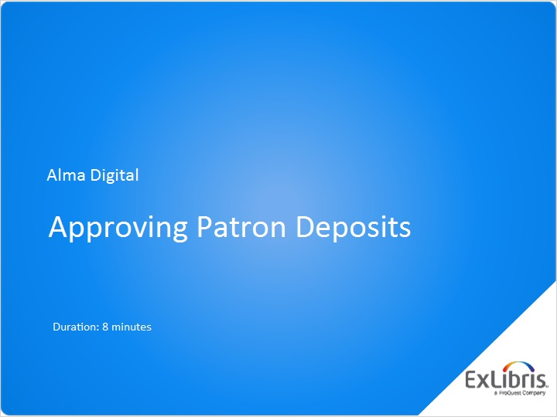
Notes:
Hello, and welcome to this Alma Digital training session about Approving Patron Deposits.

1.2 The Deposit Workbench
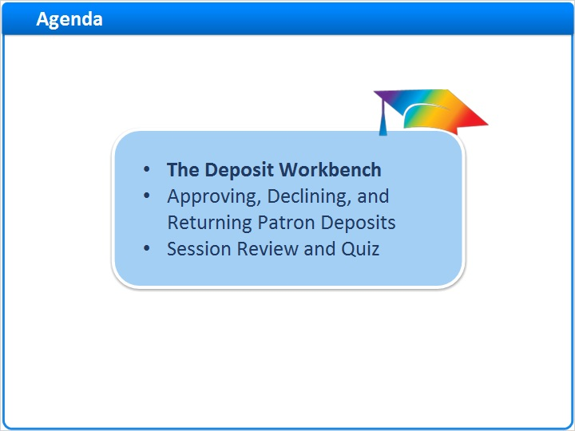
Notes:
In this session, you’ll learn how to use the Deposit workbench to approve, decline, and return Patron Deposits.
After a brief session review, there will be a short quiz to test your knowledge.

1.3 Patron Deposits Sometimes Require Staff Approval
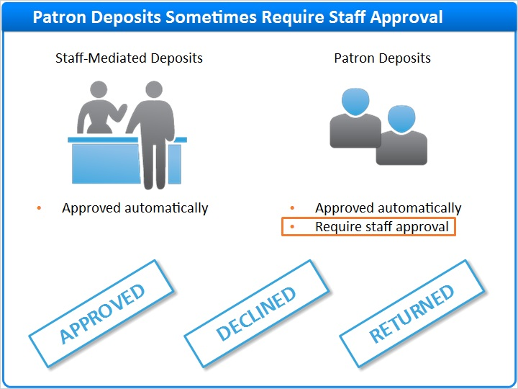
Notes:
In the previous session on Submitting Patron and Staff-Mediated Deposits, you learned that Staff-Mediated Deposits are always approved automatically for inclusion in your repository.

Patron Deposits, however, can be configured for automatic approval or to require staff approval.

For times when staff approval is required, we’ll look at how to use the Deposit workbench to:
- Approve Patron Deposits so the content can be included in your repository and found via your Discovery Service.
- Decline, and thus delete, the Patron Deposit.
- Or return Patron Deposits for correction and resubmission.

1.4 Accessing the Approve Deposits Workbench
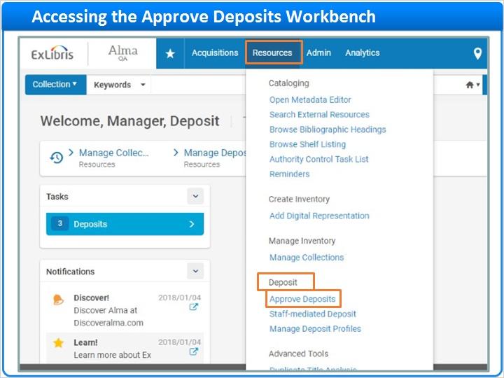
Notes:
To access the Deposit workbench, click Resources on the main menu, then under the Deposit section, click Approve Deposits.

1.5 Approve Deposits Workbench
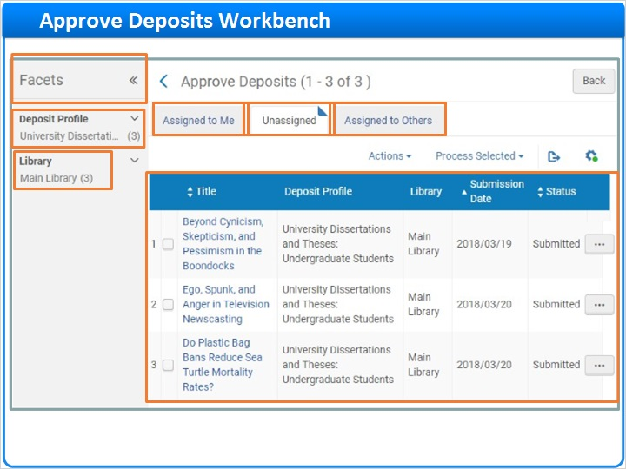
Notes:
Here, you’ll see three tabs listing all deposits that are awaiting approval. Don’t worry if you see more columns on your screen than you see here. I customized my view of the workbench by hiding several columns.

When Deposits are first submitted, they land on the Unassigned tab. Once you start working on a deposit, it will automatically move to the Assigned to Me tab where deposits are assigned to the currently logged in user. And finally, there is the Assigned to Others tab for deposits that have been assigned to someone else.

If there are a lot of deposits to review, use the Facets pane on the left of the screen to filter them based on Deposit Profile or owning Library.

Customize Columns (Slide Layer)
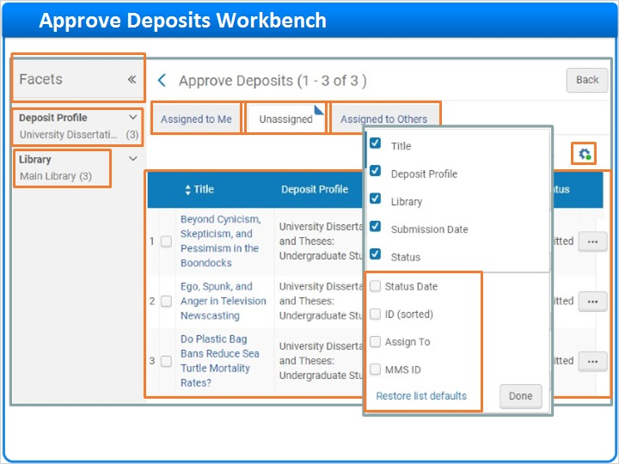

1.6 Assigning Submitted Deposits
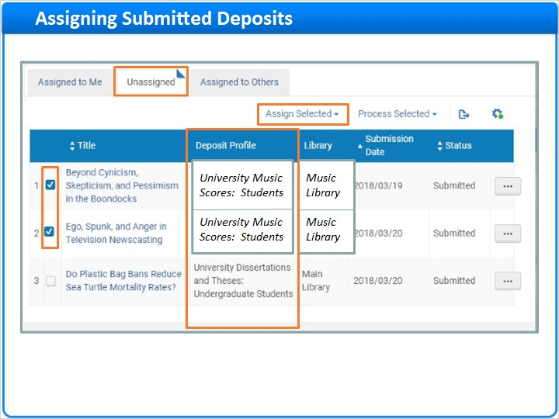
Notes:
All these unassigned deposits were submitted using the same Deposit Profile, the University Dissertations and Theses profile for undergraduate students.

If any of these deposits used a different profile, let’s say one for adding music scores to a collection, or had content belonging to a different Library, for example, the Music Library, you might select those deposits and click to assign them to someone else for approval.

You can select an assignee from the list of staff who have one of the roles required to approve deposits. Then, include an optional Note, decide whether to send an email, and click Assign.

Assign To (Slide Layer)
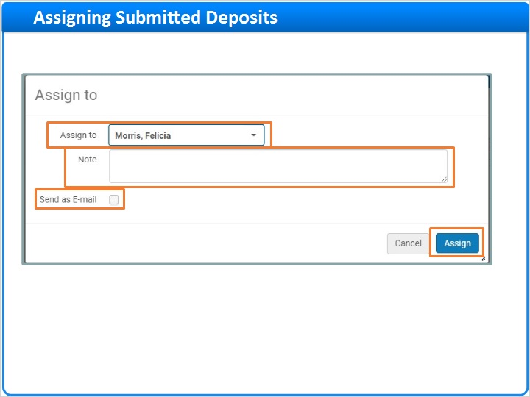

1.7 Edit or View Deposit
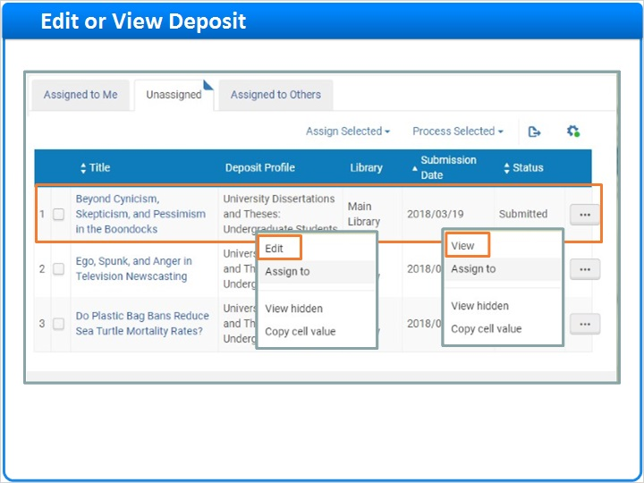
Notes:
But, let’s imagine these deposits all fall into your area of expertise, and you want to view the first item before approving it. Right-click on the row, and select View. If you have a role that allows you to edit digital inventory, you’ll have the option to Edit instead of View.

Clicking Edit or View brings you to the same page, with one difference that we’ll note in a moment.

Toward the top of the page is some general information about the submitted deposit. And, in the body of the page are three tabs that we’ll look at in turn.

Deposit Page (Slide Layer)
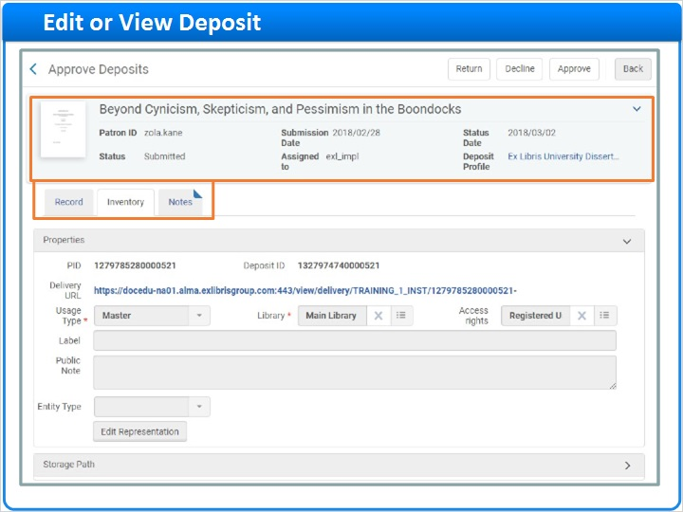

1.8 Review Deposit
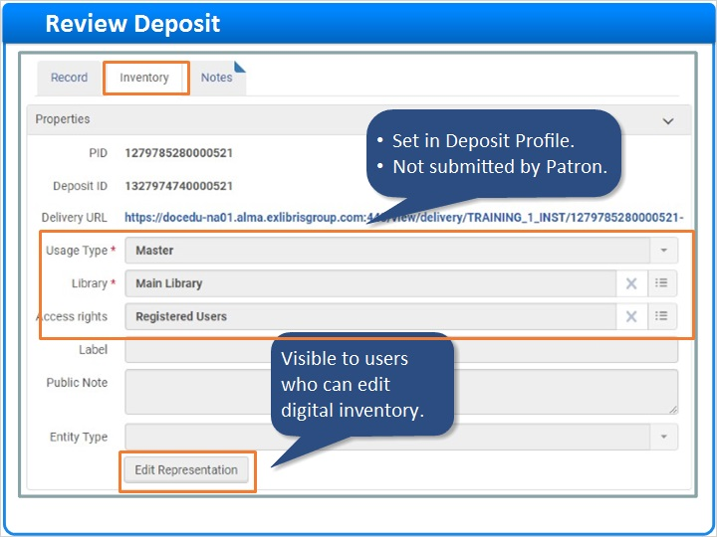
Notes:
The Inventory tab displays representation-level metadata which is determined by the Deposit Profile and is not entered by the patron.

If your role allows you to edit digital inventory, you’ll see an Edit Representation button. To learn about editing representations, watch the training session on managing digital resources manually.

Next, let’s look at the Record tab. Here, you can review the bibliographic-level metadata entered by the patron. If you have a role that allows you to edit bibliographic records, you’ll see an Edit Record link. There are several online training sessions about using the Metadata Editor to edit bib records.

On the Notes tab you can see if the patron entered an optional note like this. You can also add your own internal notes, perhaps to explain your decision to Approve, Decline, or Return the deposit by clicking one of the Action buttons at the top of the page.

Record Tab (Slide Layer)
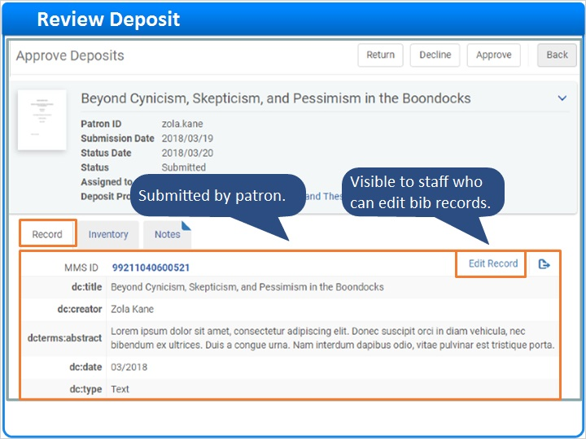

Notes Tab (Slide Layer)
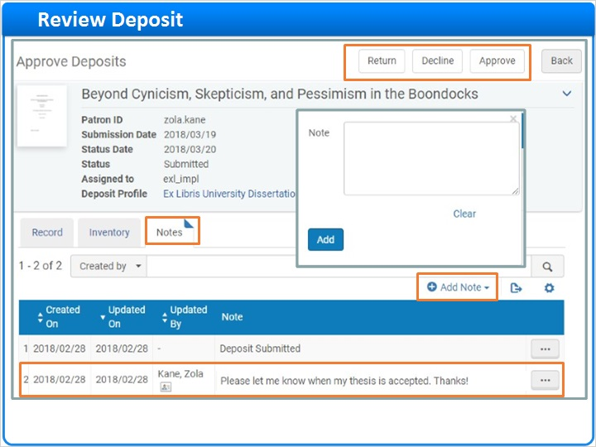

1.9 Approving, Declining, and Returning Patron Deposits
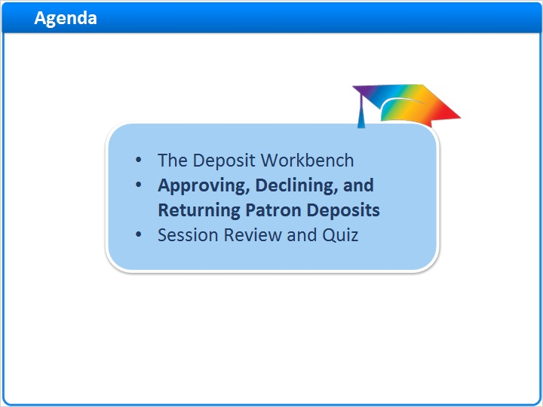
Notes:
Now that you are familiar with the Deposit workbench, we’ll start processing some deposits.

1.10 Approving Deposits
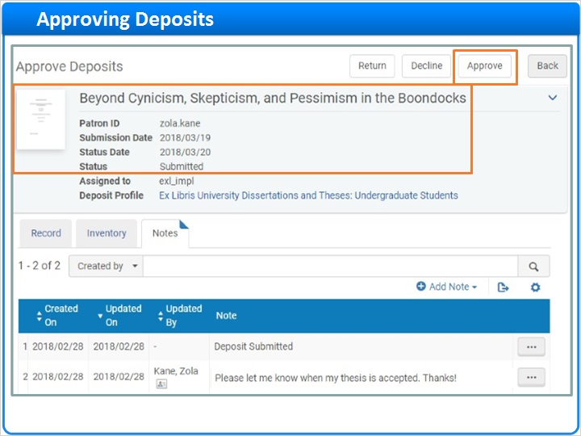
Notes:
We’ll pick up where we left off a moment ago and assume everything on this deposit looks good. So, click Approve.

Here, you can enter an internal Note about the deposit approval. Next, you can decide whether to unsuppress the bibliographic record from discovery.

If you like, edit the Body of the basic deposit approval letter that gets sent to patrons.

When done editing your message, click Send EMail to complete the approval process.

Email Message (Slide Layer)
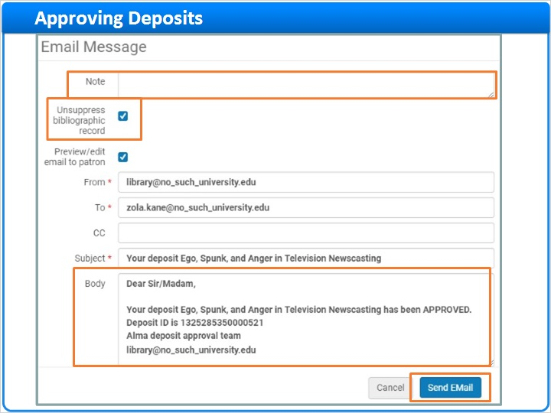

1.11 Approved Deposits
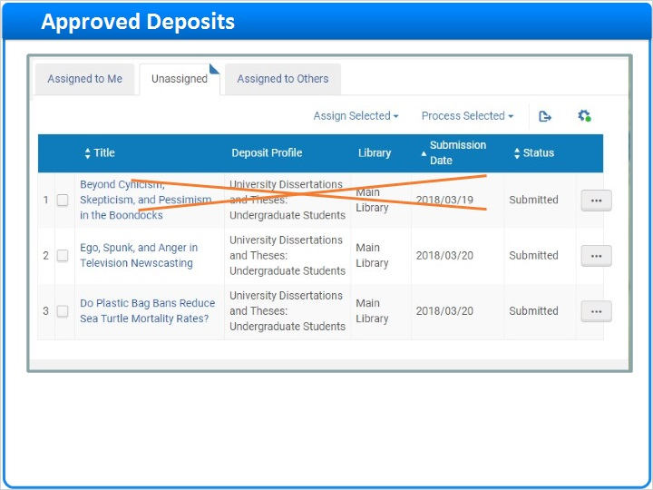
Notes:
Once approved, deposits are removed from the Deposit workbench, but the digital resource stays in the repository.

Approved deposits are removed from the patron’s Deposit interface, but the patron receives the Deposit Approval email you sent so they will know the status of their deposit.

Repository (Slide Layer)
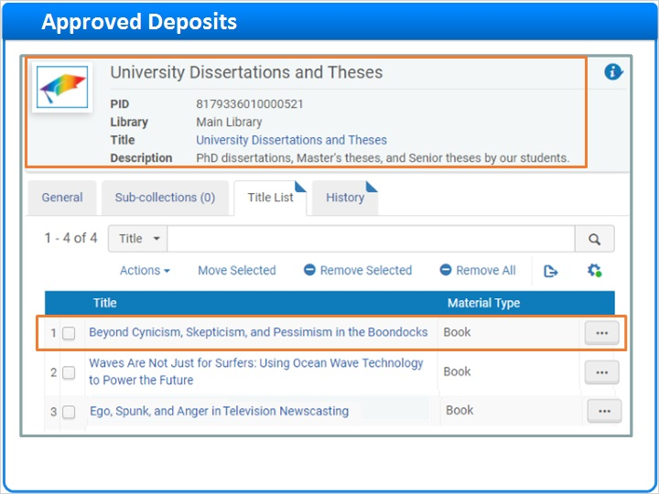

Patron Deposit Interface (Slide Layer)
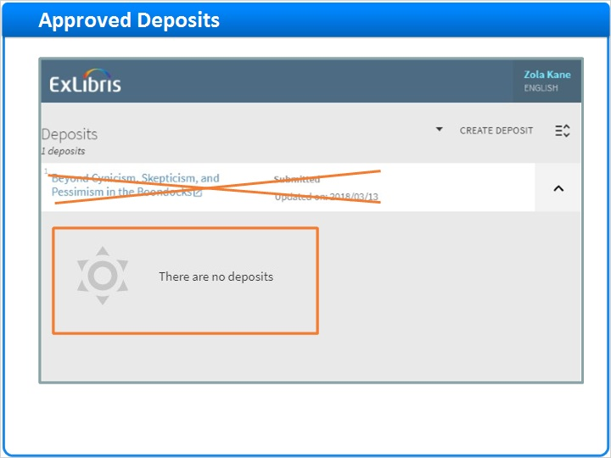

Deposit Approved Email (Slide Layer)
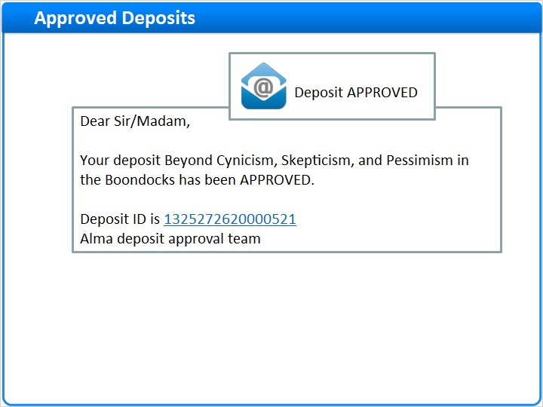

1.12 Declining Deposits
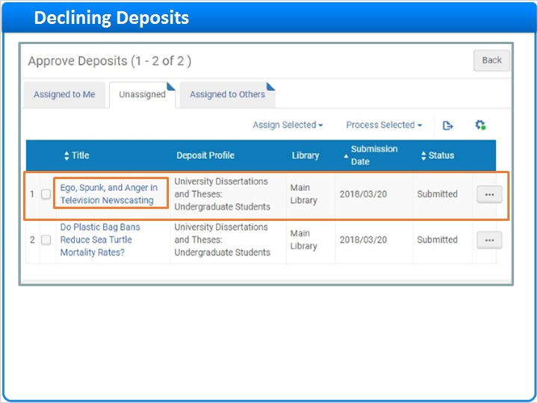
Notes:
Let’s work with the next deposit in the list. This time, instead of right clicking to see a list of row actions, try clicking on the title. And this time you need to decline this deposit, so click Decline.

Now, you can select a Reason for declining the deposit from the list of reasons configured by your institution. In this case, perhaps the thesis is Missing thesis committee approval.

Note that the selected Reason is automatically added to the email message body.

You can make additional edits if you like, then click Send EMail to complete the decline process.

Decline Deposit (Slide Layer)
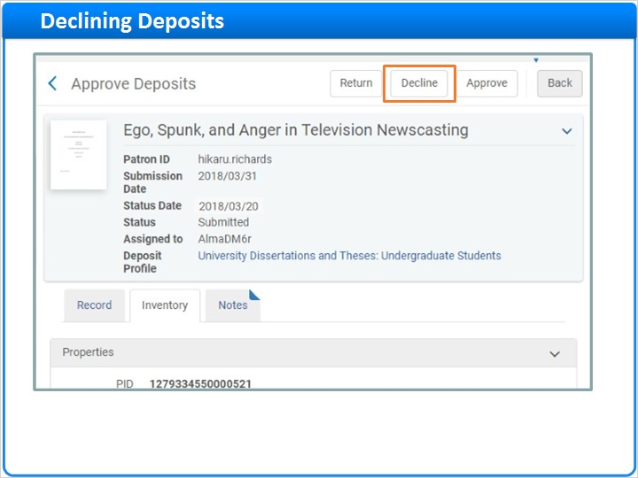

Decline Reason and Email (Slide Layer)
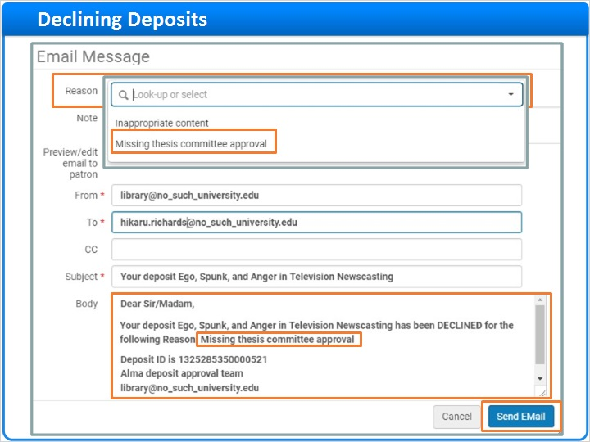

1.13 Declined Deposits
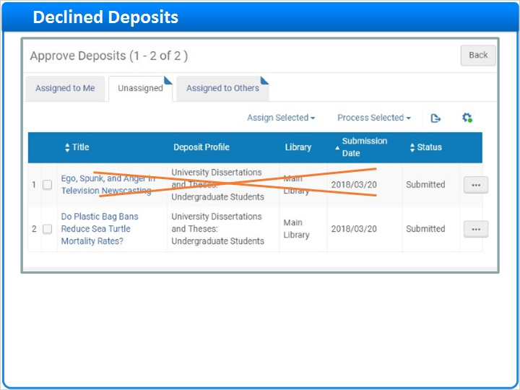
Notes:
Declined deposits are removed from the Deposit workbench, and completely deleted from the repository.

Declined deposits are also removed from the patron’s Deposit interface. And, the patron receives an email explaining why the deposit was declined.

Repository (Slide Layer)
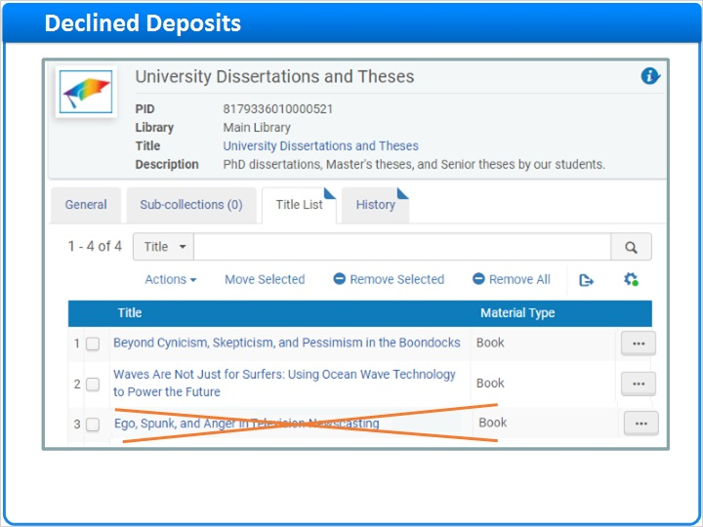

Patron Deposit Interface (Slide Layer)
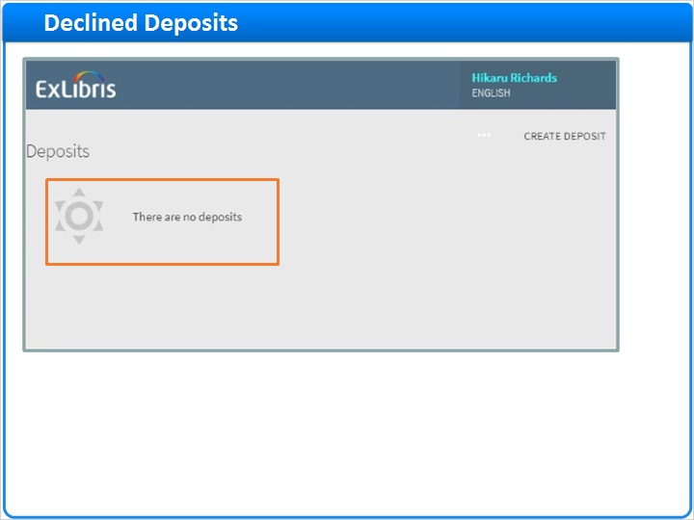

Deposit Declined Email (Slide Layer)
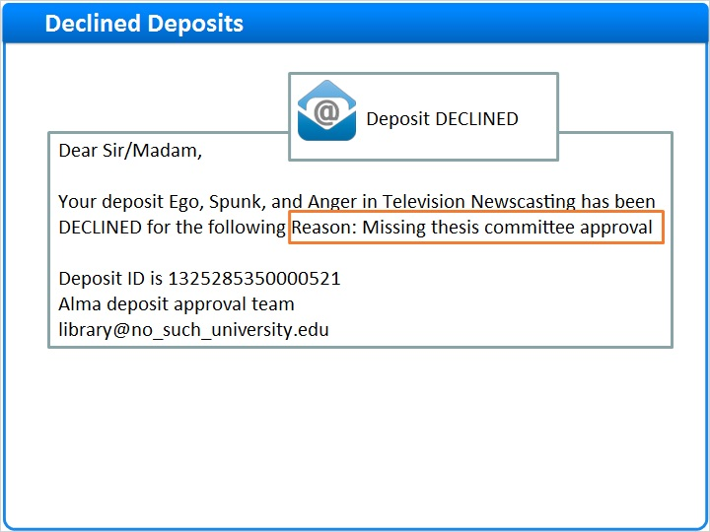

1.14 Returning Deposits
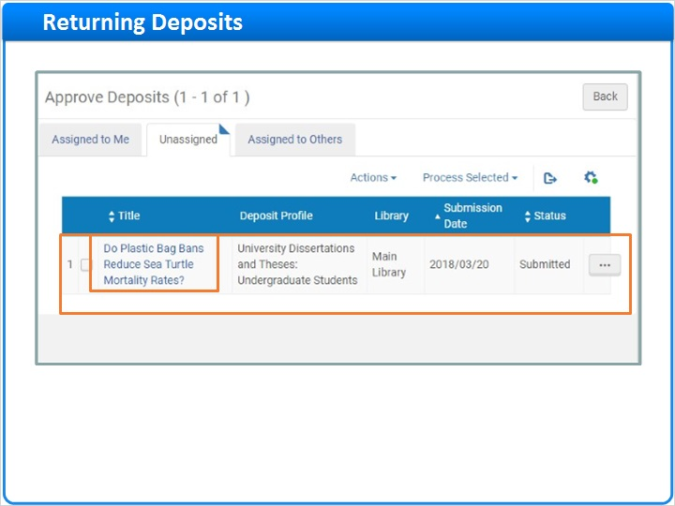
Notes:
Now, there is just one deposit left on the Unassigned tab. Click on the title. Then, on the Inventory tab, click on the Delivery URL to see the file in the Digital Viewer before you approve it. Just to be sure everything is okay, click Download.

It looks like this deposit is a Word Document. But, perhaps your library only accepts PDFs for this collection. Rather than declining the deposit, let’s return it so the patron can resubmit the file in correct format.

Back on the Inventory Tab, click Return. And, from the list of Reasons configured by your institution, select File must be a PDF.

Note that the reason is added to the Body of the email. When done with any edits, click Send EMail to complete the return process.

Inventory Tab - Delivery URL (Slide Layer)
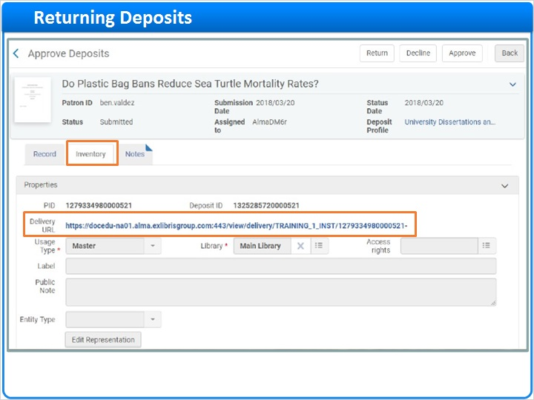

Digital File Viewer (Slide Layer)
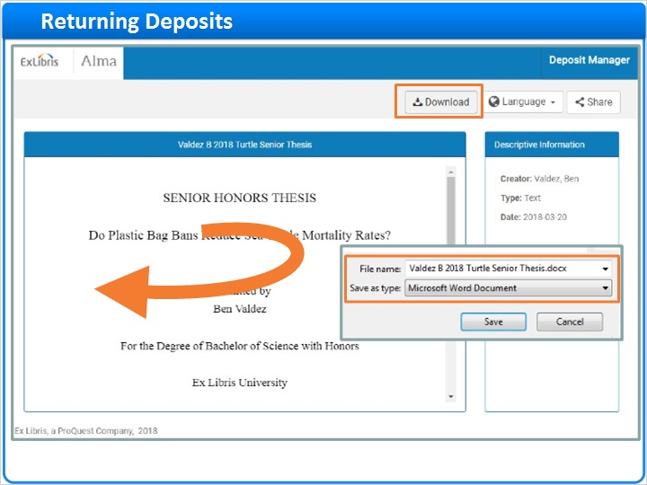

Inventory Tab - Return (Slide Layer)
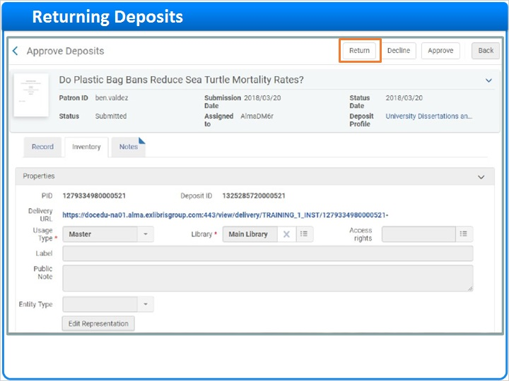

Return Reason and Email (Slide Layer)
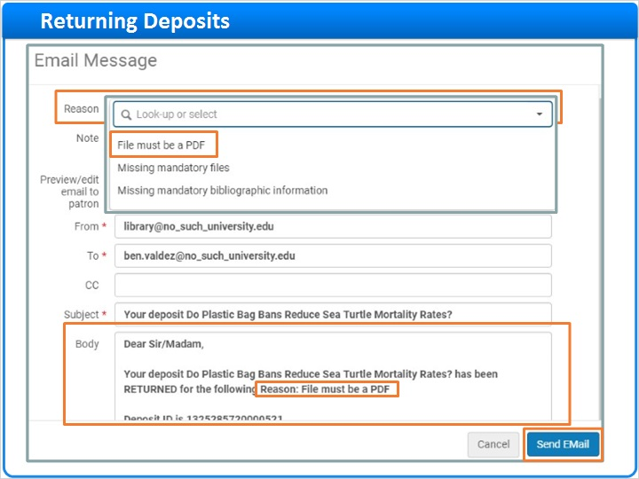

1.15 Returned Deposits
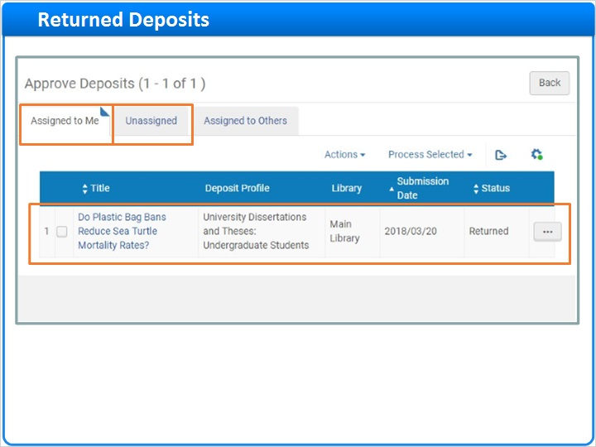
Notes:
The Returned deposit remains on the Deposit workbench because it is still active. But, it has moved from the Unassigned tab to the Assigned to Me tab. It also remains in the repository, but it is still suppressed from discovery because it has not yet been approved.

Meanwhile, the patron will receive the Deposit Returned email letting them know why the deposit was returned.

And, the Patron Deposit Interface also shows that the deposit was returned. The patron can Edit and resubmit the deposit. Or, they can Withdraw the deposit completely.

Repository (Slide Layer)
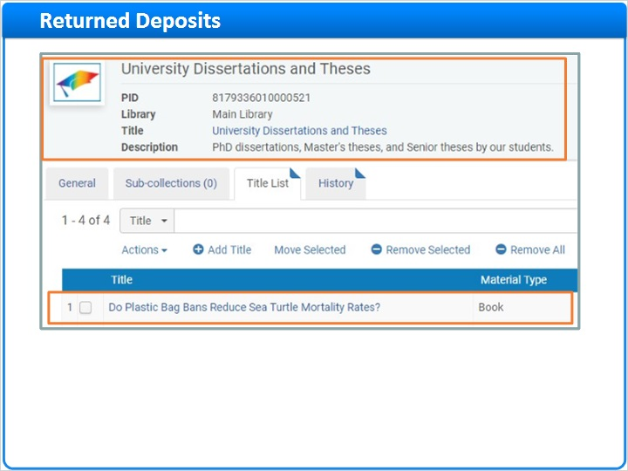

Deposit Returned Email (Slide Layer)
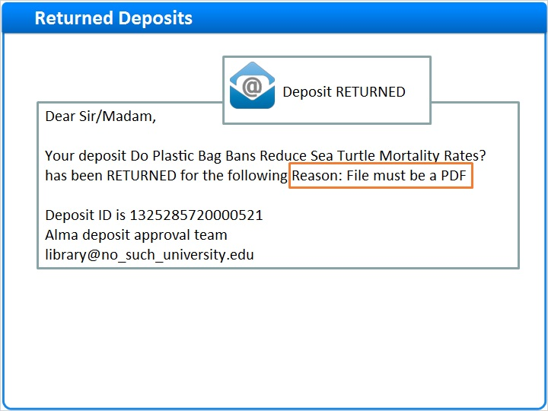

Patron Deposit Interface (Slide Layer)
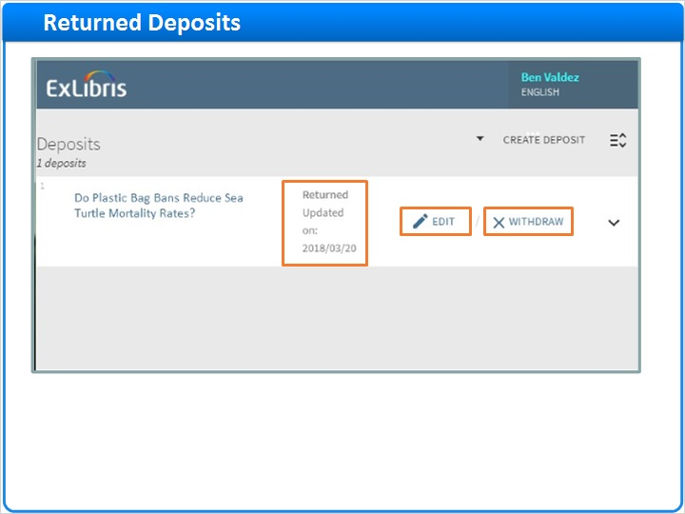

1.16 Processing Multiple Deposits at Once
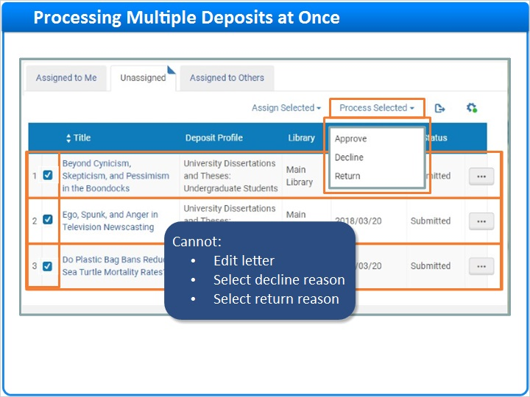
Notes:
Before we wrap up, let’s start over with the three pending Patron Deposits we saw at the start of this session. Instead of reviewing and processing the deposits one at a time, let’s consider processing multiple deposits at once for a greater efficiency.

Simply select the deposits you want to process, click Process Selected and then click Approve, Decline, or Return.

But, before you proceed, note that there are some restrictions with this method. You cannot:
- Edit the approval, decline, or return letter that is sent.
- Select a decline reason.
- Or select a return reason.

1.17 Session Review and Quiz
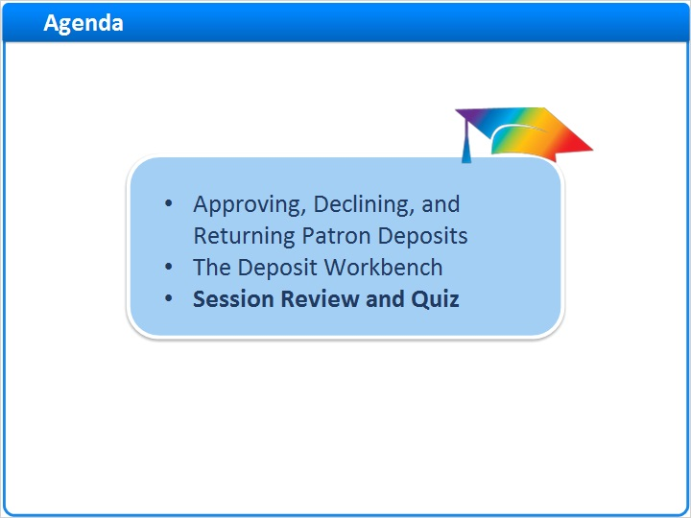
Notes:
That concludes the main portion of this training session. Let’s proceed to a brief review and quiz.

1.18 Session Review
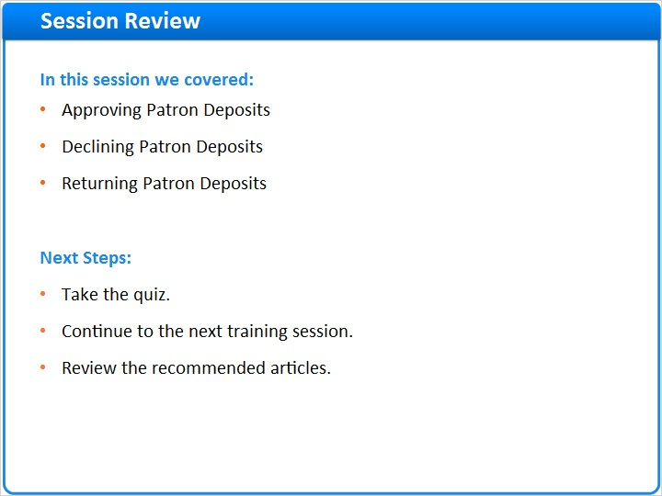
Notes:
In this session we learned how to use the Deposit workbench to approve, decline, or return patron deposits.

What are your next steps?
- After the short quiz that begins on the next page, continue to the next training session in this series.
- Please refer to the Recommended Articles section where you launched this training session for additional information.

1.19 Quiz: Processing Patron Deposits
(Multiple Response, 10 points, 1 attempt permitted)
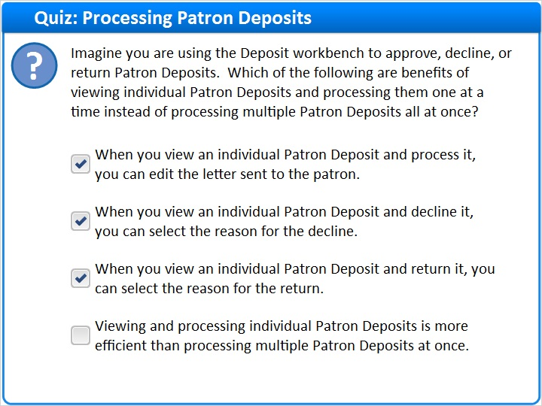
Correct | Choice
X | When you view an individual Patron Deposit and process it, you can edit the letter sent to the patron.
X | When you view an individual Patron Deposit and decline it, you can select the reason for the decline.
X | When you view an individual Patron Deposit and return it, you can select the reason for the return.
 | Viewing and processing individual Patron Deposits is more efficient than processing multiple Patron Deposits at once.
Feedback when correct:
Right! When you view an individual Patron Deposit and process it, you can:
Edit the letter sent to the patron
Select the reason for declining a deposit
Select the reason for returning a deposit

But, viewing and processing individual Patron Deposits is not very efficient if you have many deposits to process in the same way.
Feedback when incorrect:
When you view an individual Patron Deposit and process it, you can:
Edit the letter sent to the patron
Select the reason for declining a deposit
Select the reason for returning a deposit

But, viewing and processing individual Patron Deposits is not very efficient if you have many deposits to process in the same way.

Correct (Slide Layer)
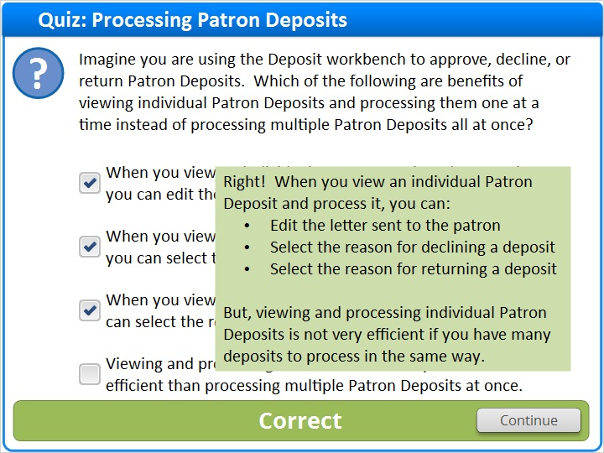

Incorrect (Slide Layer)
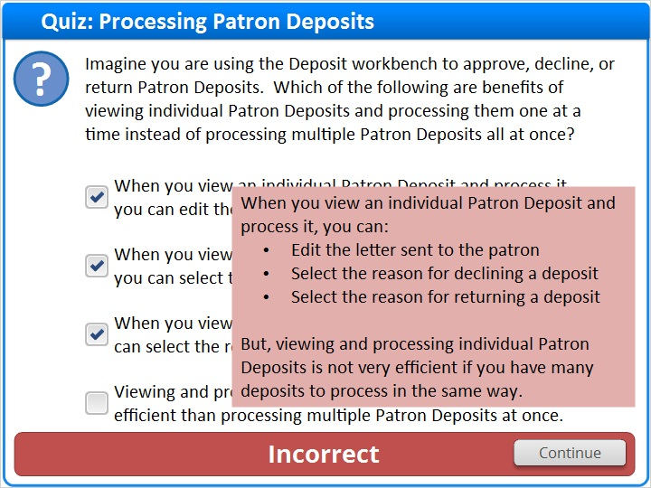

1.20 Quiz: Deposit Workbench Actions
(Multiple Choice, 10 points, 1 attempt permitted)
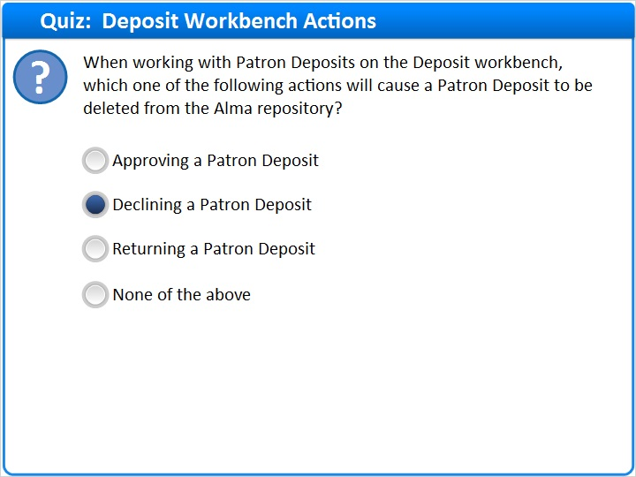
Correct | Choice
 | Approving a Patron Deposit
X | Declining a Patron Deposit
 | Returning a Patron Deposit
 | None of the above

Feedback when correct:
Right! The correct answer is: Declining a Patron Deposit.

Approved Patron Deposits remain in the repository and can be made available to discovery.
Declined Patron Deposits are deleted from the repository.
Returned Patron Deposits remain in the repository but are suppressed from discovery.
Feedback when incorrect:
The correct answer is: Declining a Patron Deposit.

Approved Patron Deposits remain in the repository and can be made available to discovery.
Declined Patron Deposits are deleted from the repository.
Returned Patron Deposits remain in the repository but are suppressed from discovery.

Notes:

Correct (Slide Layer)
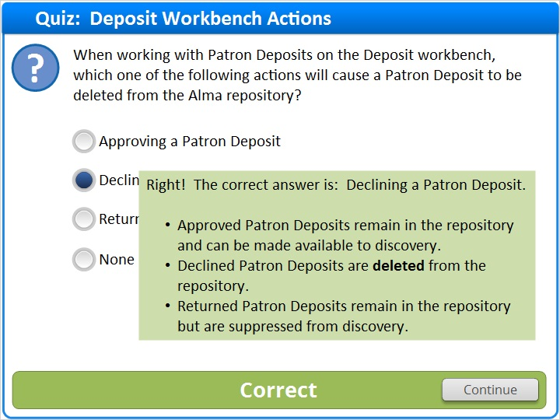

Incorrect (Slide Layer)
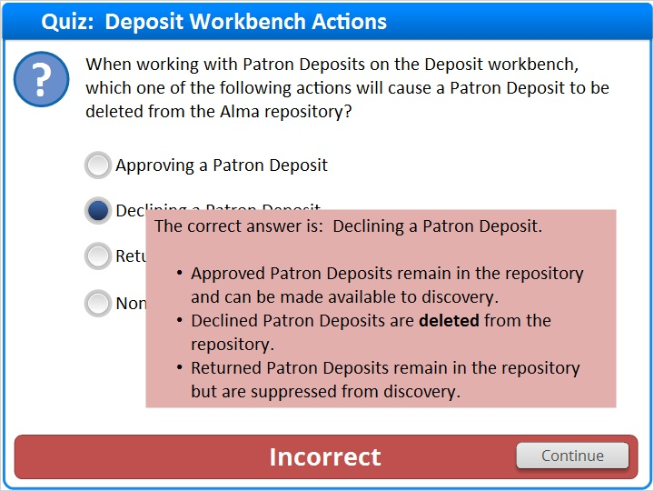

1.21 Thank You!

Notes:
Thanks for joining this session!

1.22 About this Training

Notes:

1 (Slide Layer)
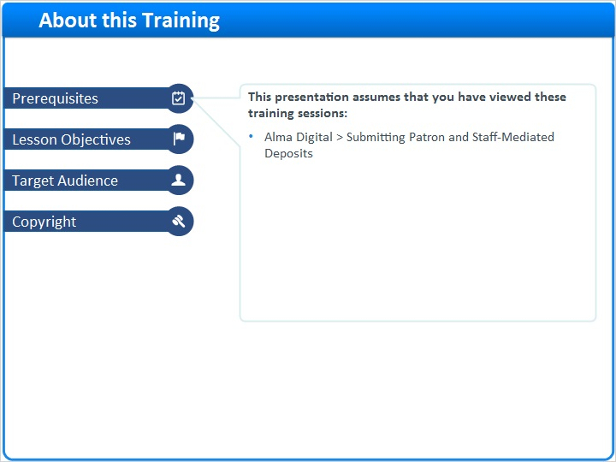

2 (Slide Layer)
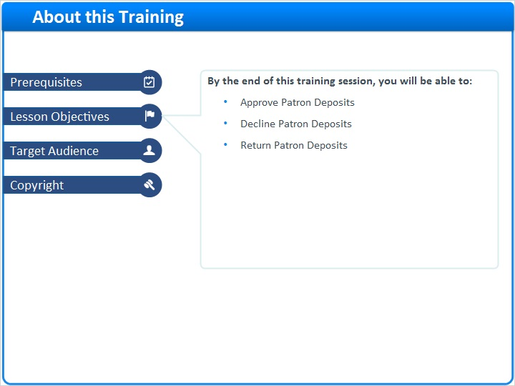

3 (Slide Layer)
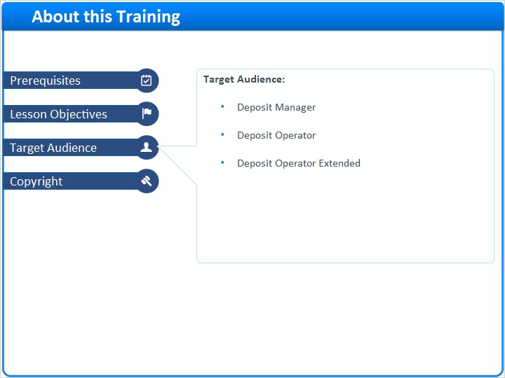

4 (Slide Layer)
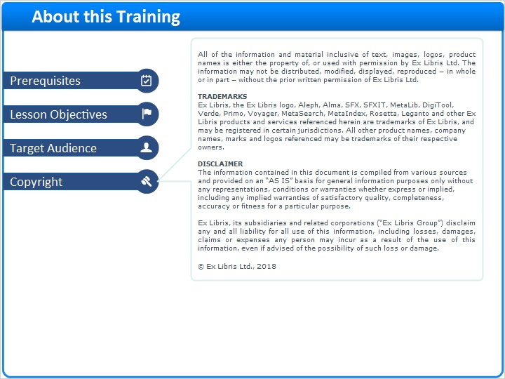

1.23 Results Slide
(Results Slide, 0 points, 1 attempt permitted)
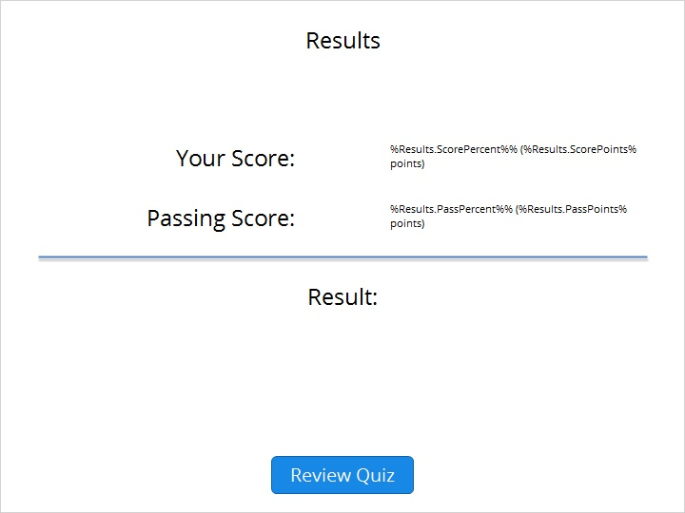

Results for
1.19 Quiz: Processing Patron Deposits
1.20 Quiz: Deposit Workbench Actions

Result slide properties
Passing  Score | 80%

Success (Slide Layer)
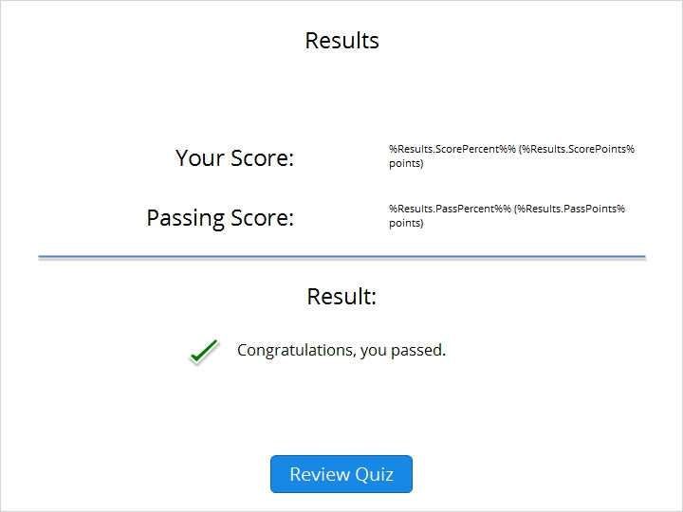

Failure (Slide Layer)


