Alma Digital: Creating Deposit Profiles

1. Alma Digital: Creating Deposit Profiles

1.1 Alma Digital: Creating Deposit Profiles and Customizing Labels
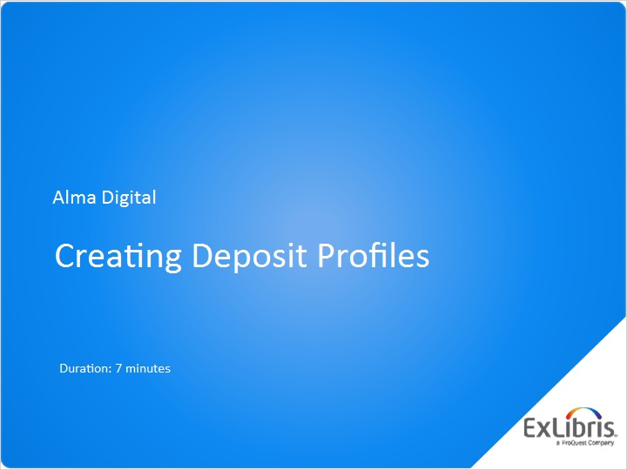
Notes:
Hello, and welcome to this Alma Digital session on creating Deposit Profiles.

1.2 What are Deposit Profiles?
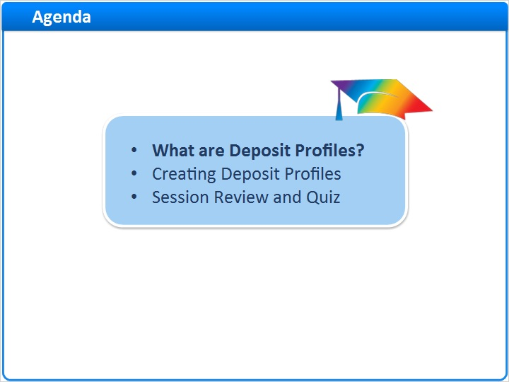
Notes:
In this session, we’ll start by considering what Deposit Profiles are. Then, we’ll demonstrate how to create and activate Deposit Profiles.

After a session review, there will be a short quiz to test your knowledge.

1.3 Patron and Staff-Mediated Deposits
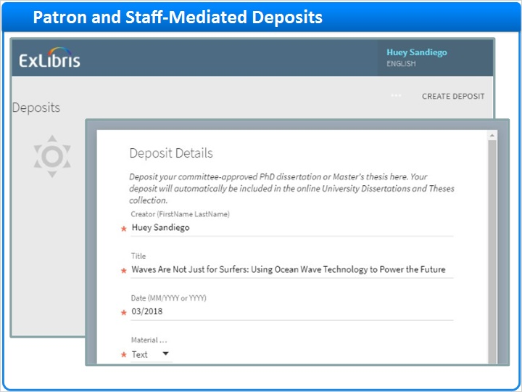
Notes:
In the training session on submitting Patron and Staff-Mediated Deposits, you saw how patrons use a Patron Deposit Interface to submit deposits for inclusion your Alma repository.

And, you saw how library staff can use the Alma interface to submit deposits on behalf of patrons.

Staff-Mediated Deposit (Slide Layer)
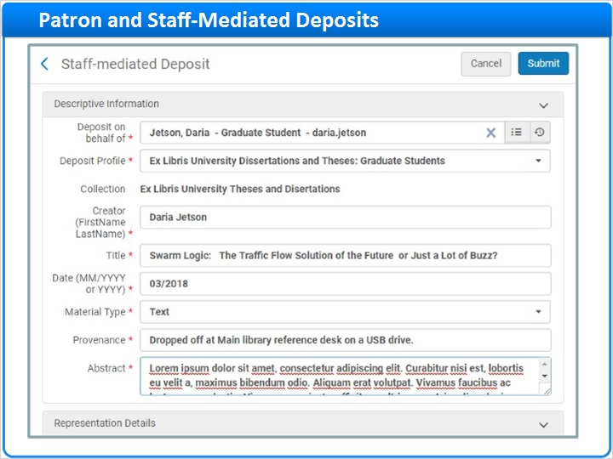

1.4 Instructions for Processing Deposits
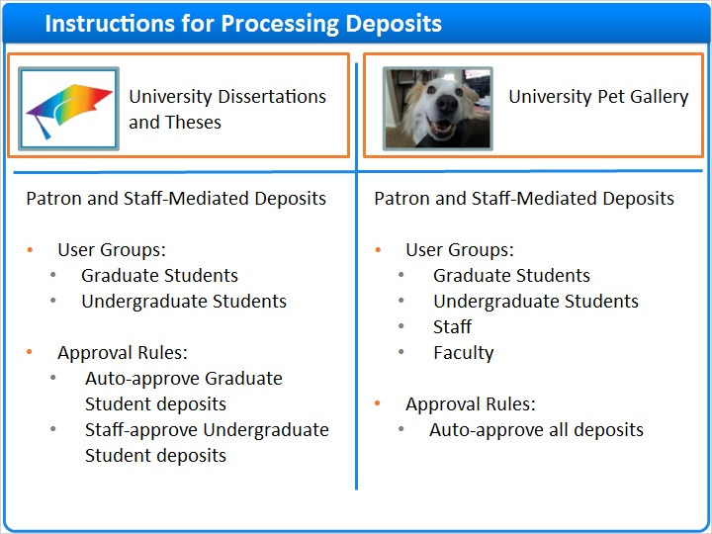
Notes:
To demonstrate these activities, we considered two example collections:

- A University Dissertations and Theses collection which allowed deposits from: graduate students, and undergraduate students. Patron Deposits from graduate students were auto-approved, but Patron Deposits from undergraduates required approval.
And we looked at the University Pet Gallery collection, which allowed deposits from even more user groups. And, all Patron Deposits were auto-approved for this collection.
So, how does Alma know which user groups can make deposits into which collections? And, what determines whether or not patron deposits are automatically approved?
It’s all controlled in special sets of instructions called Deposit Profiles.

Deposit Profiles! (Slide Layer)
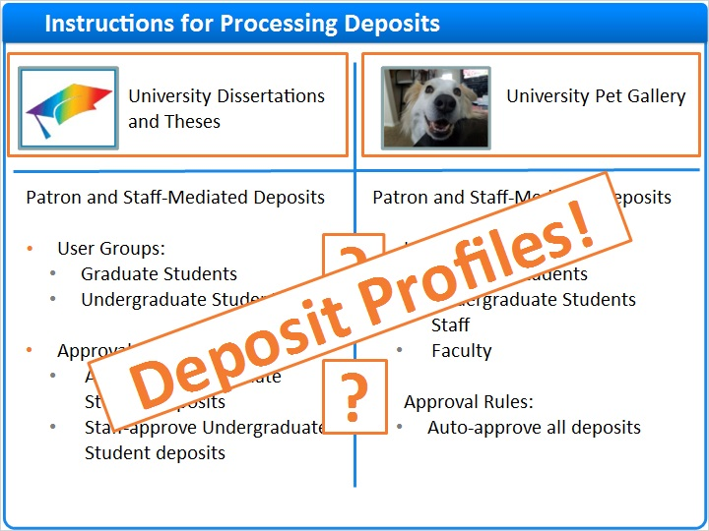

1.5 Creating Deposit Profiles
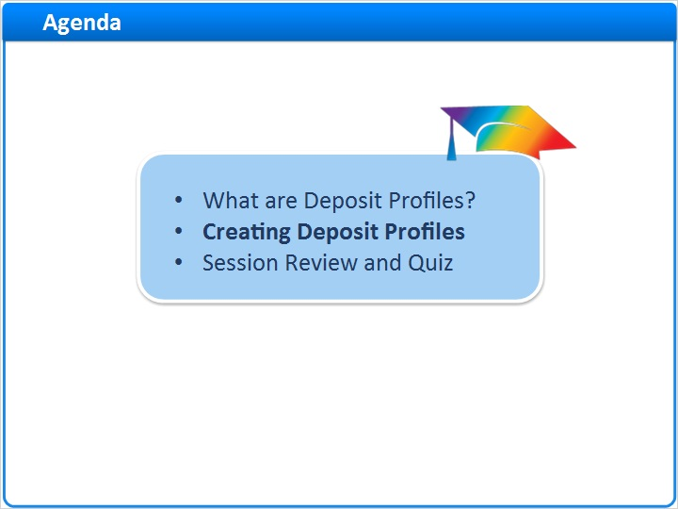
Notes:
Let’s learn how to create deposit profiles!

1.6 Manage Deposit Profiles Navigation
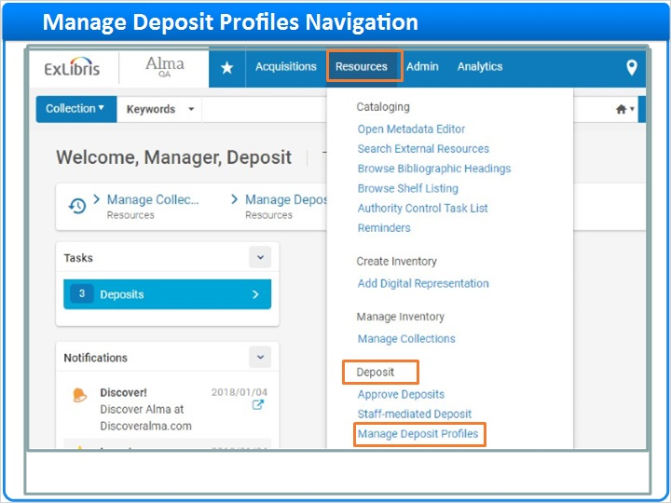
Notes:
To get started, click Resources on the main Alma menu. Then, under the Deposit section, click Manage Deposit Profiles.

1.7 Deposit Profiles List
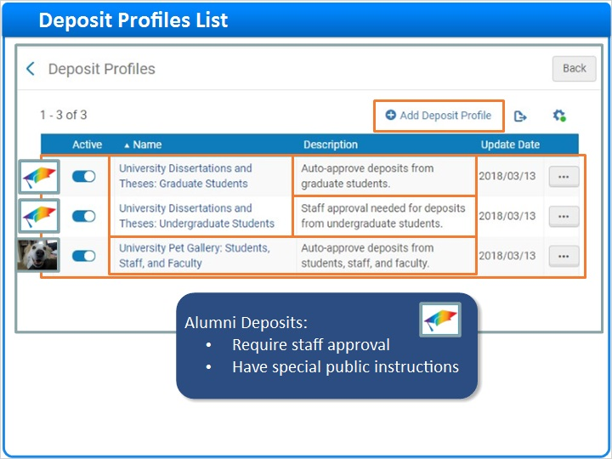
Notes:
In this example, we see three Deposit Profiles that have already been set up to handle deposits into the two collections we just discussed.

The Deposit Profile Name indicates that the first two profiles process Deposits into the University Dissertations and Theses Collection.

The Descriptions indicate that the first Profile accepts and auto approves deposits from graduate students. And, the second Profile accepts deposits from undergraduate students with staff approval required.

The third Deposit Profile is for the University Pet Gallery which accepts and auto-approves deposits from several user groups.

Let’s imagine you want to start accepting Patron Deposits into the University Dissertations and Theses collection from Alumni. Just as with undergraduate students, staff approval will be required. But, you want the public instructions at the top of the Patron Deposit Interface to be different for alumni than for undergraduates.

So, you decide to create a new Deposit Profile by clicking Add Deposit Profile to open the Deposit Profile editor.

Deposit Profile Editor (Slide Layer)
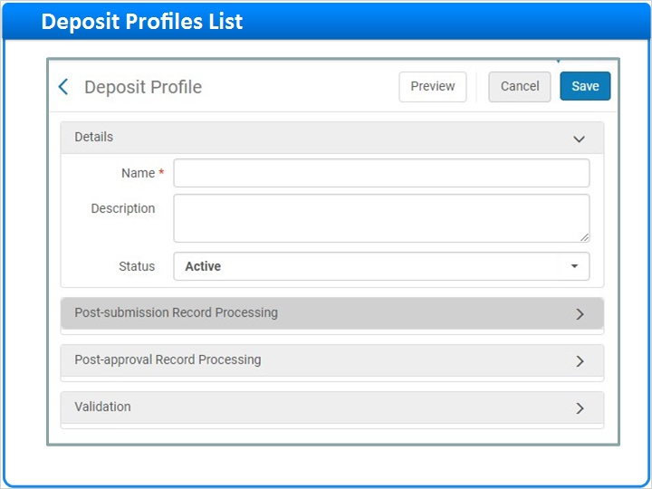

1.8 Deposit Profile Editor
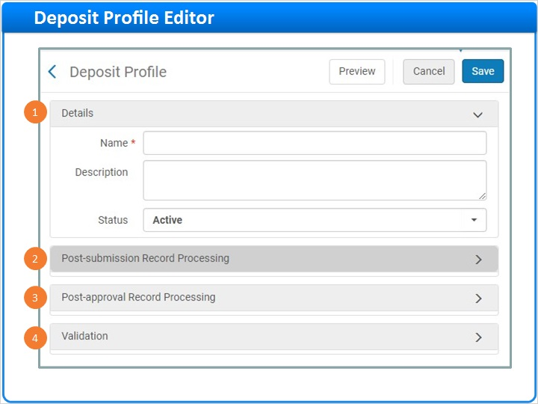
Notes:
The page is broken into four collapsible sections. You could go through each of these sections and configure your new Deposit Profile from scratch, but there is an easier way.

Go back to the Deposit Profile list and right click on the Deposit Profile called University Dissertations and Theses: Undergraduate Students to see the list of actions you can take on this profile. If the requirements for the alumni profile were identical to the requirements for undergraduates, you could choose Edit and add alumni to the existing profile.

But, since there are some differences, click Copy instead.

Copy Profile (Slide Layer)
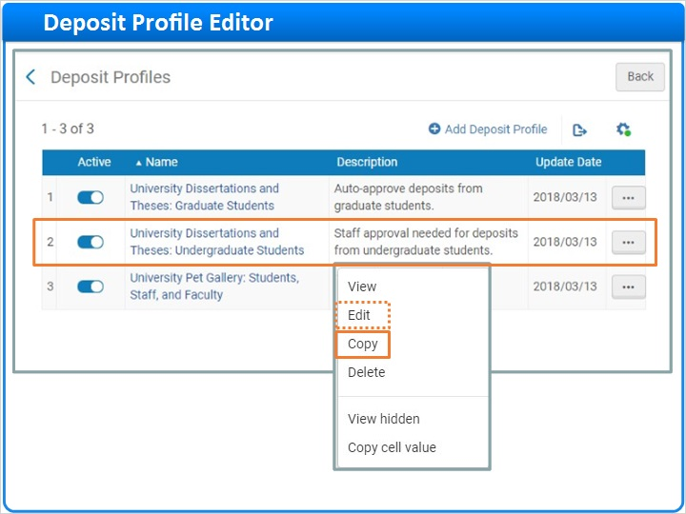

1.9 Deposit Profile: Details
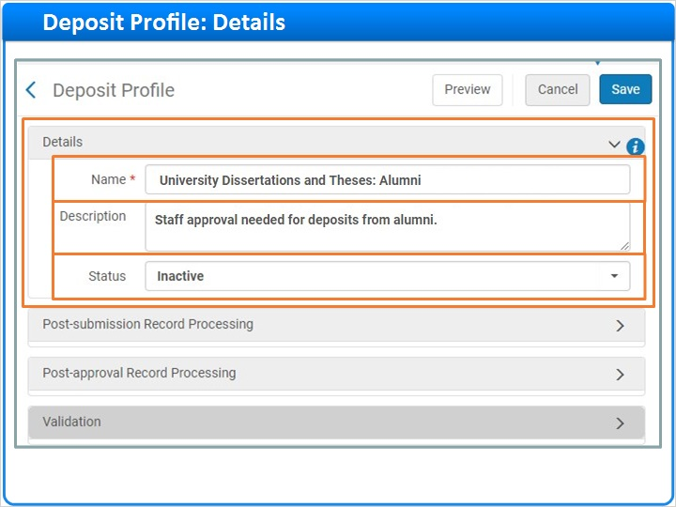
Notes:
Now, you can make whatever changes are necessary. Begin in the details section, where basic information about the Deposit Profile is captured.

First, update the mandatory Profile Name to something more appropriate, perhaps University Dissertations and Theses: Alumni. Be sure to choose the name carefully because patrons will see the name on the Patron Deposit Interface when they click CREATE DEPOSIT.

And, when library staff submit a deposit on behalf of a patron, the Profile name will appear in the list of options applicable to that patron.

Next, update the optional Description which appears on the Deposit Profile list.

For now, leave the Status set to Inactive. You can come back and activate the Profile when you’re ready.

Profile Name Patron Deposit (Slide Layer)
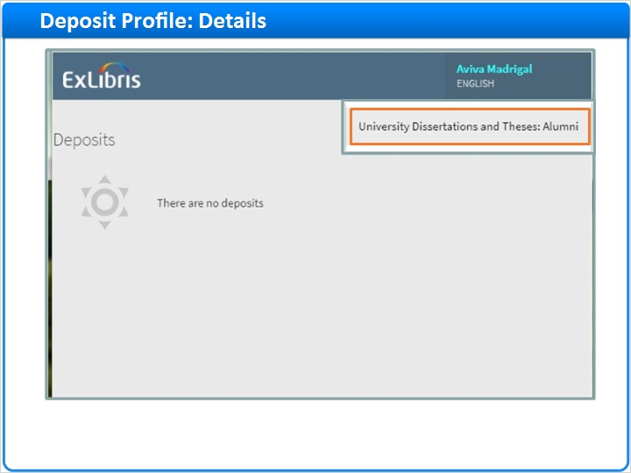

Profile Name Staff-Mediated Deposit (Slide Layer)
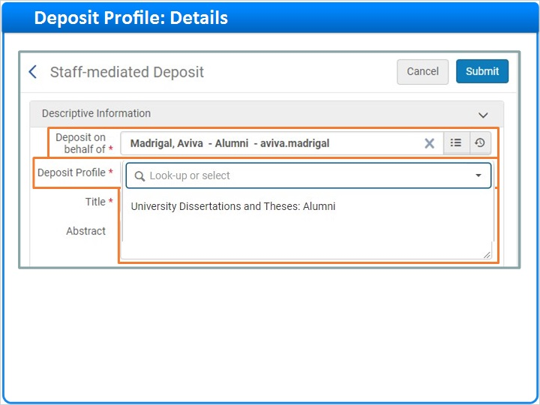

1.10 Deposit Profile: Post-submission Record Processing
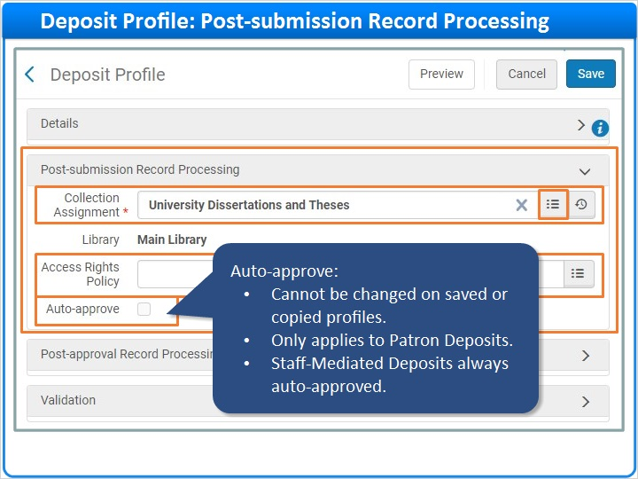
Notes:
The Post-submission Record Processing Section, controls what happens right after deposits are submitted.

The first setting is mandatory. You must select the collection to which the deposits are assigned. For our example, keep the University Dissertations and Theses collection that came along when you copied the profile.

But, if you needed to change the collection, you could click on the List icon and search the repository for another collection.

Next, select an Access Rights Policy. If you leave the field blank, Alma will use the default Access Rights policy set by your institution.

And finally, decide whether to Auto-approve Patron Deposits made using this profile or if you want library staff to approve the deposits. For this Profile, you want staff to approve all deposits, so leave the box unchecked. This is convenient because, the Auto-approve setting cannot be changed on saved or copied profiles. If you want to change this setting, you’ll need to create a new Profile instead.

One last note, the Auto-approve setting only applies to Patron Deposits. Staff-Mediated deposits are automatically approved regardless of this setting.

Access Rights Policy (Slide Layer)
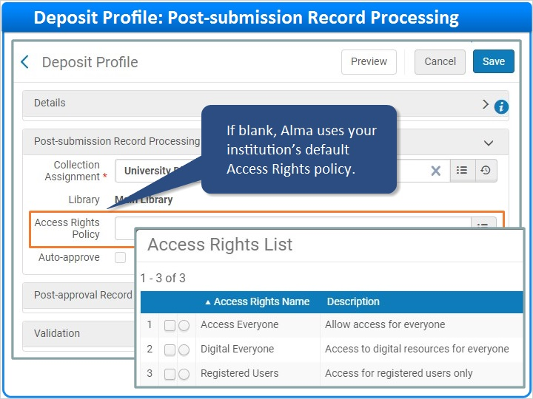

1.11 Deposit Profile: Post-approval Record Processing
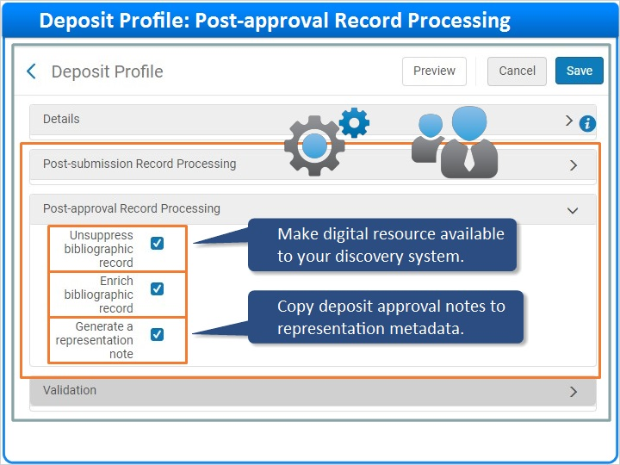
Notes:
The Post-approval Record Processing section controls what happens when a deposit is approved either automatically or by library staff.

Check Unsuppress bibliographic record to make the digital resource available to your discovery service when the deposit is approved.

Check Enrich bibliographic record if you want these Dublin Core fields and values added to the bib record for this digital resource.

And, check Generate a representation note if you want any deposit approval notes entered by staff to be added to the representation level metadata for the resource.

Enrich Bibliographic Record (Slide Layer)
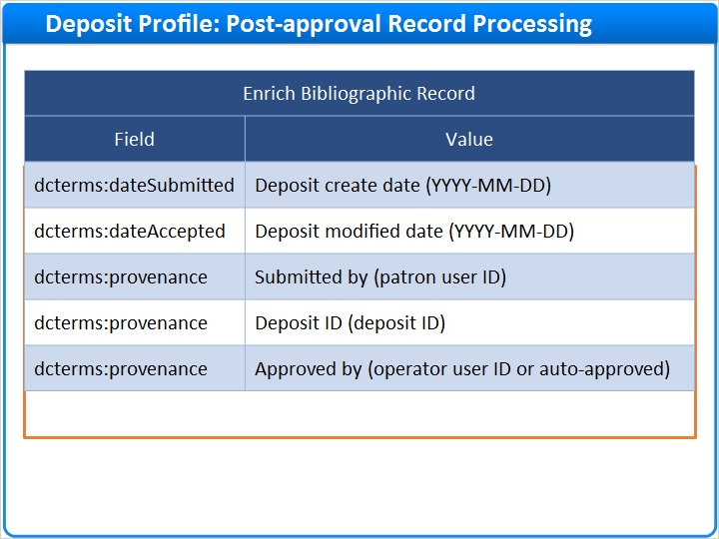

1.12 Deposit Profile: Validation
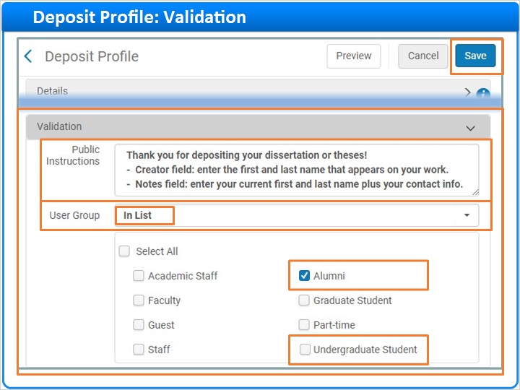
Notes:
And finally, we arrive at the Validation section where you enter the Public Instructions that appear at the top of the Patron Deposit Interface. For this example, change the undergraduate instructions to something more appropriate for alumni.

More importantly, select the User Group or Groups who will see this Deposit Profile offered when they log into the Patron Deposit Interface.

If you wanted all patrons to see the profile, you could select Any from the User Group drop-down. Since you only want Alumni to submit deposits via this profile, keep In List selected.

Then, uncheck Undergraduate Student and check Alumni instead.

When done, click Save.

Public Instructions (Slide Layer)
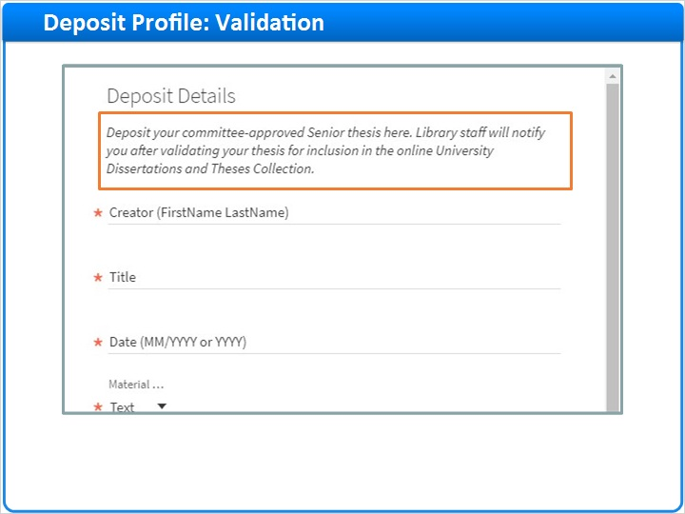

User Groups (Slide Layer)
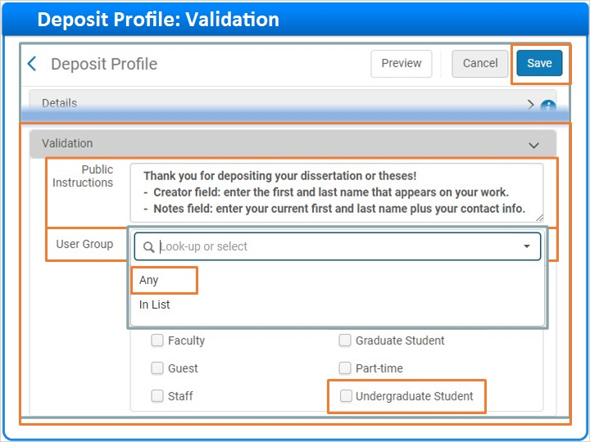

Patron Deposit Interface (Slide Layer)
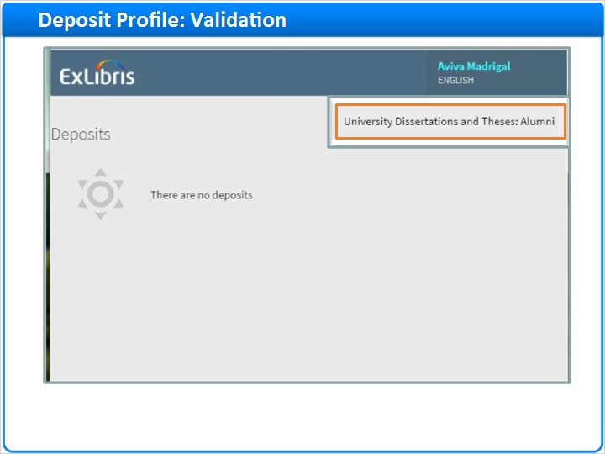

1.13 Saved Deposit Profile
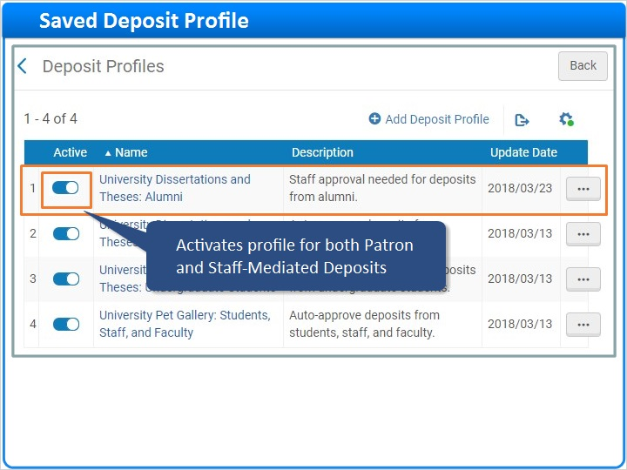
Notes:
And here’s your new Deposit Profile which is inactive at this point. When you’re ready to start accepting deposits from alumni, click the toggle to activate the profile for both Patron and Staff-Mediated Deposits.

1.14 Session Review and Quiz
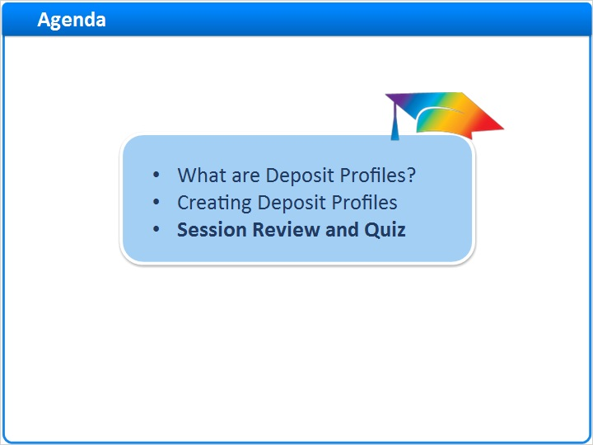
Notes:
That concludes the main portion of this training session. Let’s briefly review what was covered and then proceed to a short quiz.

1.15 Session Review
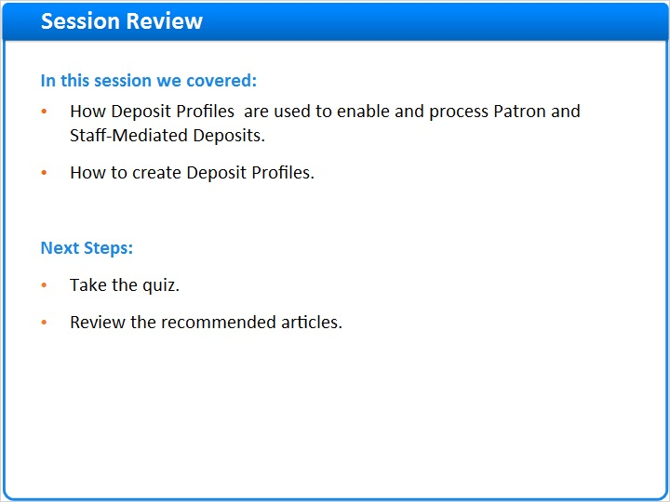
Notes:
In this session we:
- Began by discussing how Deposit Profiles are used to enable and process Patron and Staff-Mediated Deposits.
- Then we demonstrated how to create Deposit Profiles.

What are your next steps?
- First, take the short quiz that begins on the next page.
- Then, for additional information about Deposit Profiles, see the Recommended Articles section where you launched this training session.

1.16 Quiz: Deposit Profiles
(Multiple Response, 10 points, 1 attempt permitted)
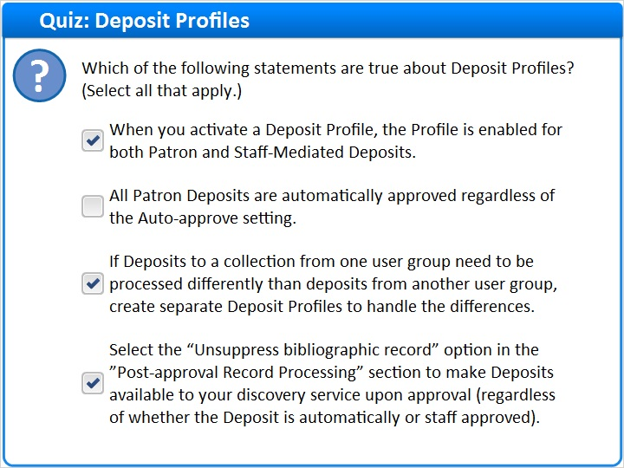
Correct | Choice
X | When you activate a Deposit Profile, the Profile is enabled for both Patron and Staff-Mediated Deposits.
 | All Patron Deposits are automatically approved regardless of the Auto-approve setting.
X | If Deposits to a collection from one user group need to be processed differently than deposits from another user group, create separate Deposit Profiles to handle the differences.
X | Select the “Unsuppress bibliographic record” option in the ”Post-approval Record Processing” section to make Deposits available to your discovery service upon approval (regardless of whether the Deposit is automatically or staff approved).
Feedback when correct:
Right! All the statements are true except for this one:
All Patron Deposits are automatically approved regardless of the Auto-approve setting.

The Auto-approve setting applies to Patron Deposits.

On the other hand, all Staff-Mediated Deposits are automatically approved regardless of the Auto-approve setting.
Feedback when incorrect:
Right! All the statements are true except for this one:
All Patron Deposits are automatically approved regardless of the Auto-approve setting.

The Auto-approve setting applies to Patron Deposits.

On the other hand, all Staff-Mediated Deposits are automatically approved regardless of the Auto-approve setting.

Correct (Slide Layer)
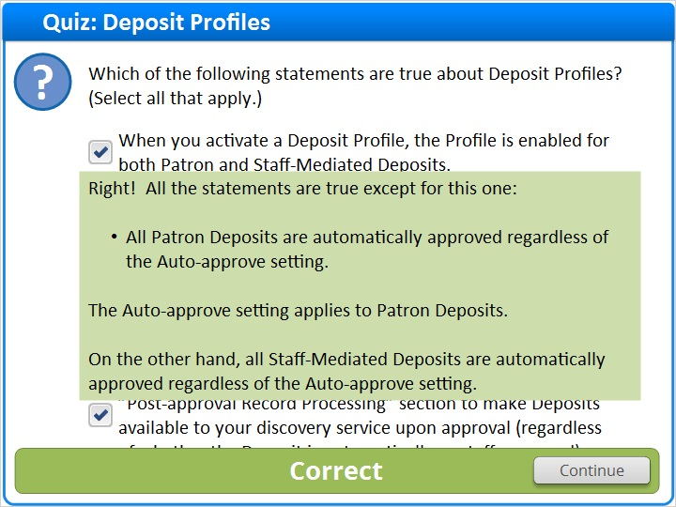

Incorrect (Slide Layer)
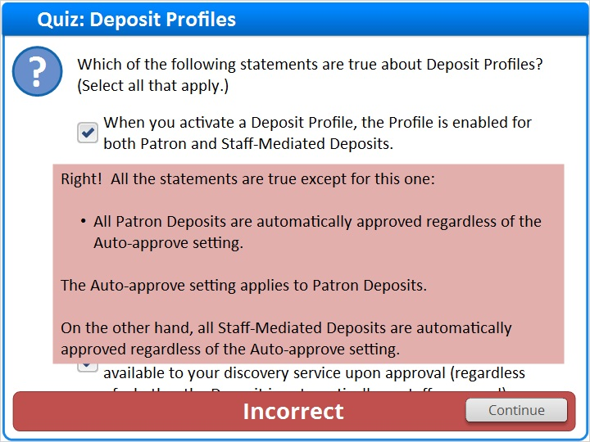

1.17 Thank You!

Notes:
Thanks for joining this session!

1.18 About this Training

Notes:

1 (Slide Layer)
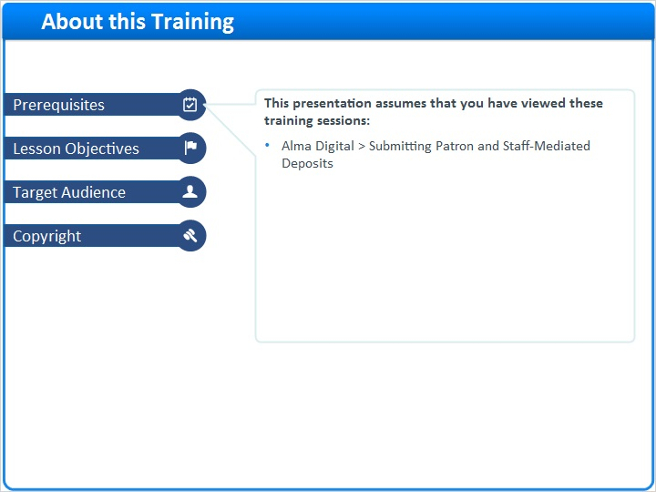

2 (Slide Layer)
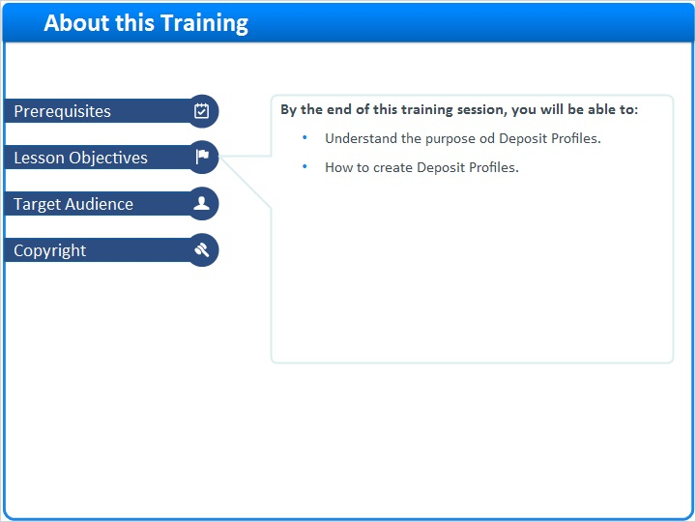

3 (Slide Layer)
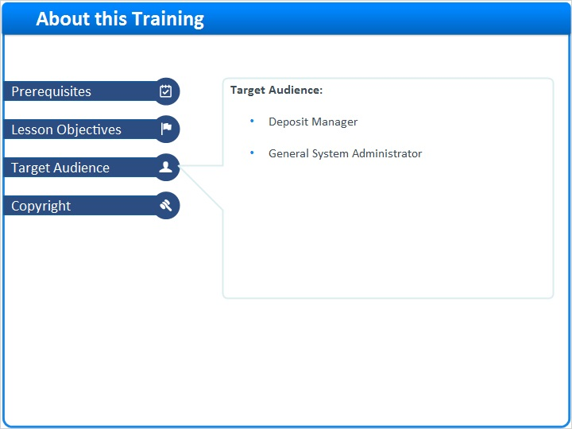

4 (Slide Layer)
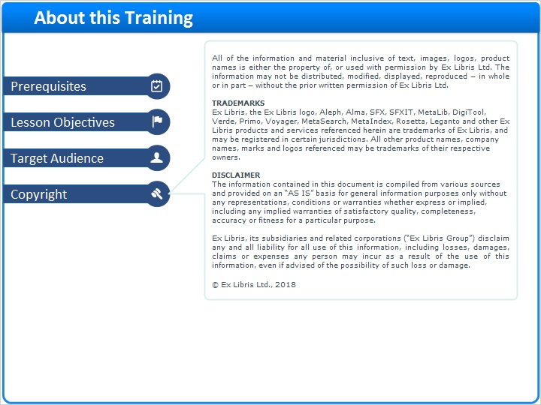

1.19 Results Slide
(Results Slide, 0 points, 1 attempt permitted)
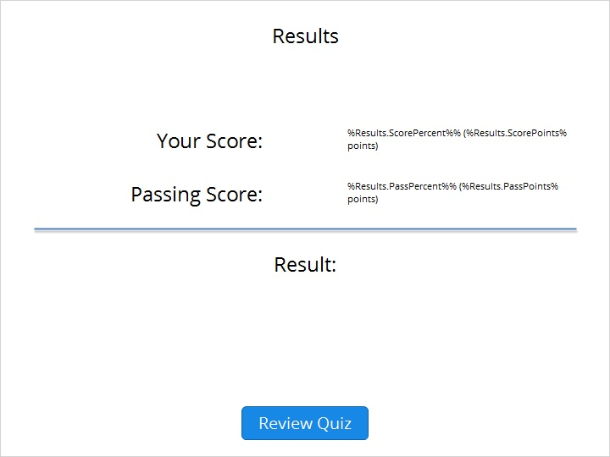

Results for
1.16 Quiz: Deposit Profiles

Result slide properties
Passing  Score | 80%

Success (Slide Layer)
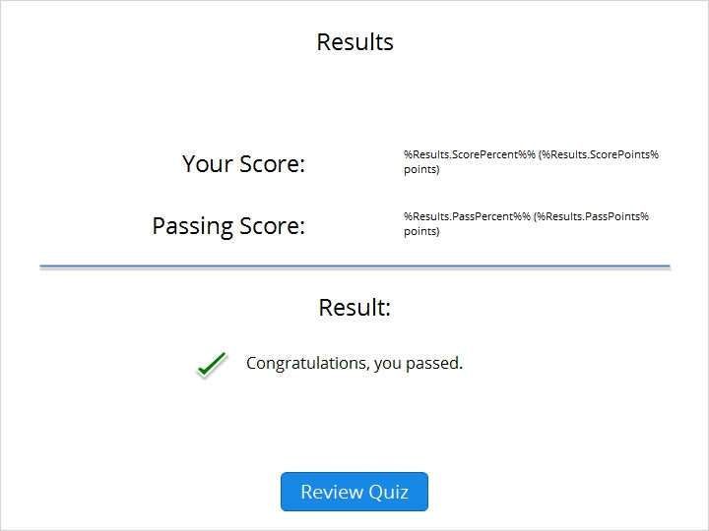

Failure (Slide Layer)


