Alma Digital: Configuring Dublin Core Forms

1. Alma Digital: Configuring Dublin Core Forms

1.1 Alma Digital: Configuring Dublin Core Forms
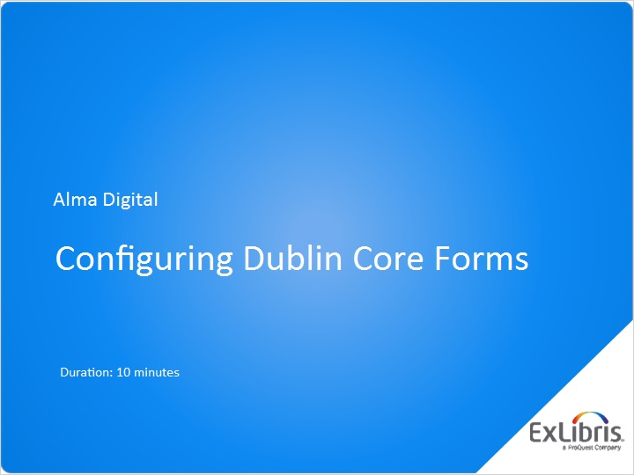
Notes:
Hello, and welcome to this Alma Digital session about Configuring Dublin Core Forms.

1.2 Why Use Dublin Core Forms?
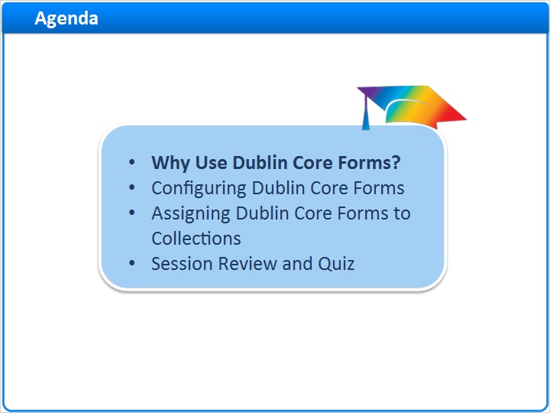
Notes:
In this session, we’ll start by discussing why you might want to configure Dublin Core Forms. Then, we’ll look at how configure Dublin Core forms and how to assign the forms to specific collections.
After a brief session review, there will be a short quiz to test your knowledge.

1.3 Patron and Staff-Mediated Deposits
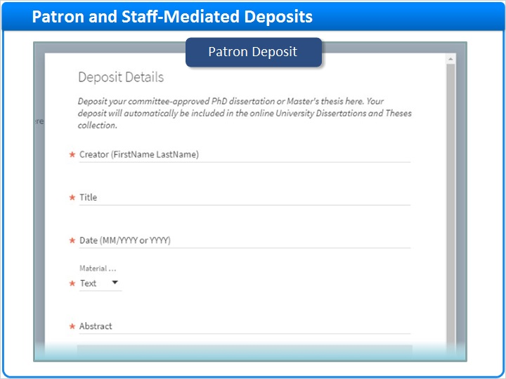
Notes:
In the training session on submitting Patron and Staff-Mediated Deposits we showed how patrons can use the Patron Deposit Interface to submit their own Deposits. And, we demonstrated how library staff can use the Alma interface to submit Deposits on behalf of patrons.

Staff-Mediated (Slide Layer)
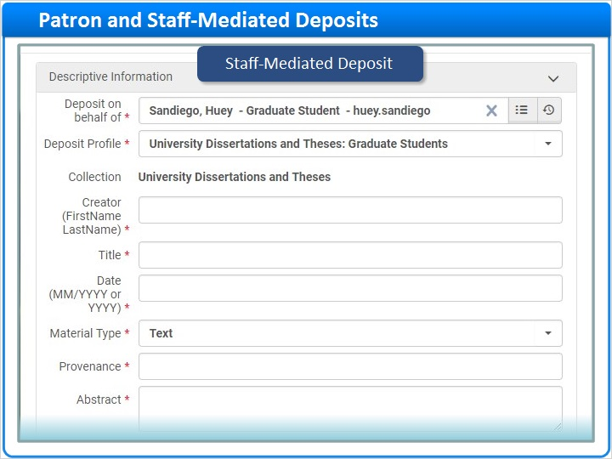

1.4 Bibliographic Metadata: Patron Deposits
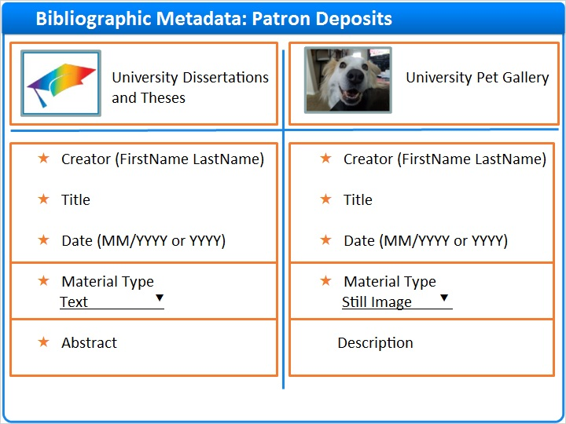
Notes:
We also considered the Patron Deposit Interface for two different collections: a Dissertations and Theses collection, and a Pet Gallery collection. Along the way, we noticed that the bibliographic metadata fields were different for each of these collections.

Both collections included a Creator, Title, Date, and Material Type field. But, the Material Type default value was different for each collection.

And, the Dissertations and Theses Collection included a mandatory Abstract field, whereas the Pet Gallery had an optional Description field.

1.5 Bibliographic Metadata: Staff-Mediated Deposits
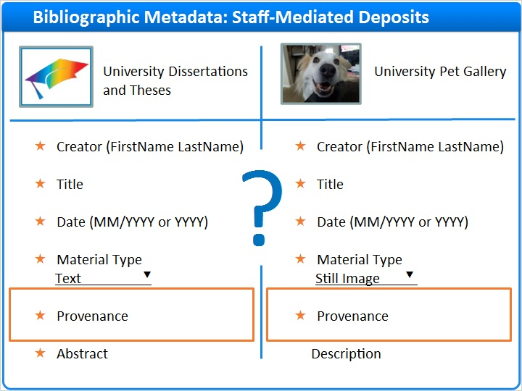
Notes:
When we looked at Staff-Mediated Deposits for these two collections, we noticed that the bibliographic metadata fields were almost the same as they were for the Patron Deposits. But, both collections included an extra field just for use by staff, a mandatory Provenance field.

So how did Alma know to display different data entry fields for each of these circumstances?

1.6 Dublin Core Forms
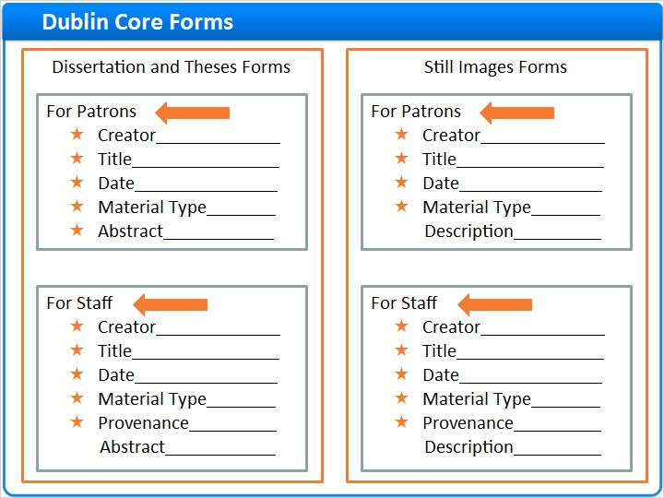
Notes:
The answer is Dublin Core Forms. You can create and configure Dublin Core Forms to include just the data entry fields you want for a given circumstance. Here we see a set of forms that can be use for any Dissertation and/or Thesis collection. One form is for patrons, and the other is for staff.

And, here’s a set of forms for collections containing still images.

After you create your Dublin Core Forms, you can assign them to your Alma collections as needed. You might, for example, use the same set of audio recordings forms for both Spoken Word and Music collections.

Or, you might have a set of forms that are just right for Short Stories.

Assigning Forms (Slide Layer)
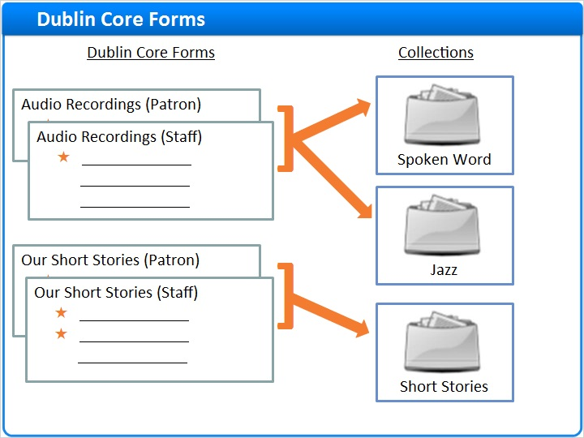

The Answer is... (Slide Layer)
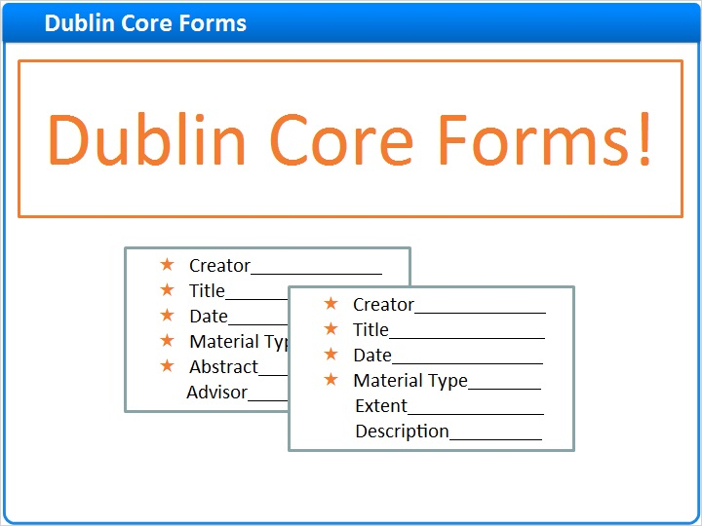

1.7 Configuring Dublin Core Forms
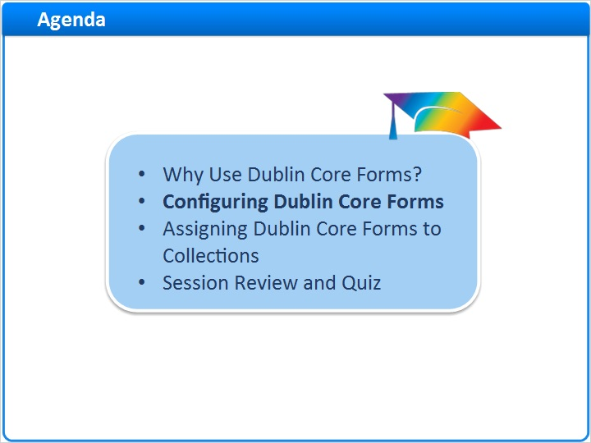
Notes:
So, let’s configure some Dublin Core Forms.

1.8 Dublin Core Forms Navigation
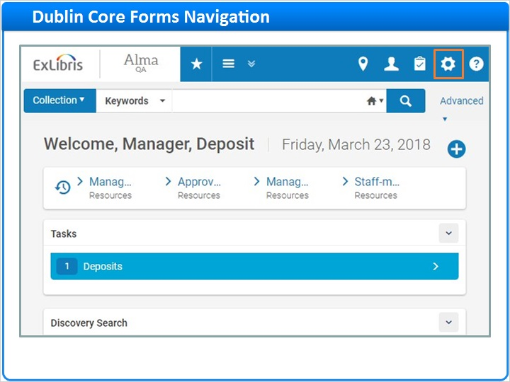
Notes:
Navigate to Alma Configuration and make sure you are working at the Institution level.

Then, go to the Resources tab, and under the Cataloging section, click Metadata Configuration.

If you do not see the Metadata Configuration option, you’ll need to coordinate with a colleague who has either the Catalog Administrator or the General System Administrator role. Let’s assume you have one of those roles and continue.

On the Metadata Configuration List, in the Active Profiles Section, click on the Qualified Dublin Core profile. You’ll land on the Fields tab for the profile, where you can see over 100 Qualified Dublin Core terms that can be included as fields on the Dublin Core Forms.

Click on the Forms tab to get started.

Alma Configuration - Resources Tab (Slide Layer)
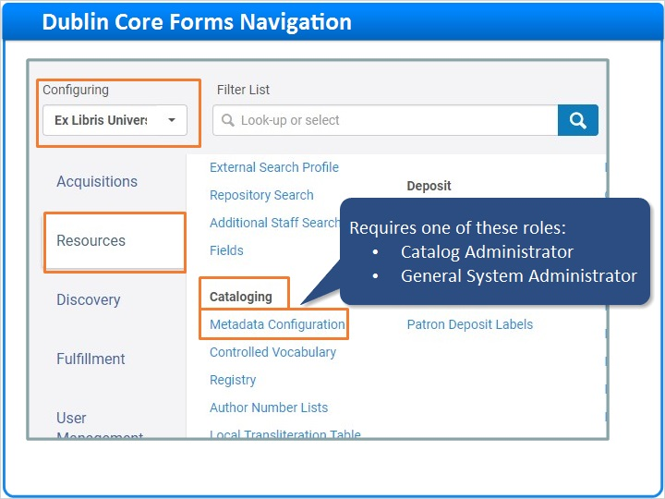

Metadata Configuration List (Slide Layer)
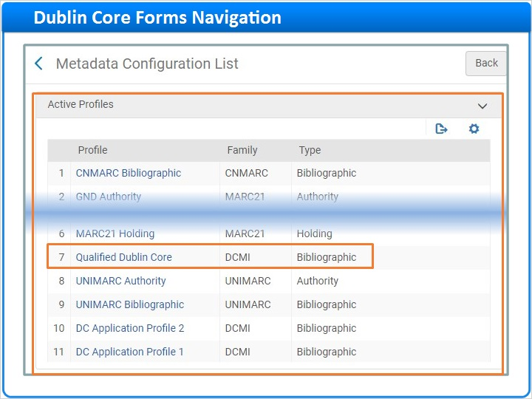

Qualified Dublin Core (Slide Layer)
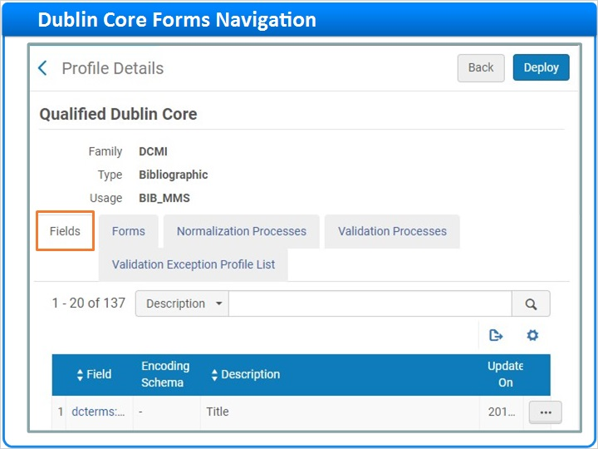

Fields Tab (Slide Layer)
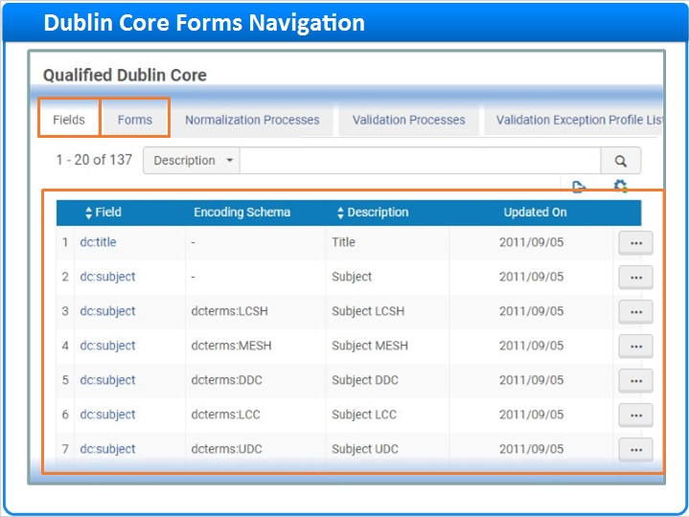

1.9 Dublin Core Form Example
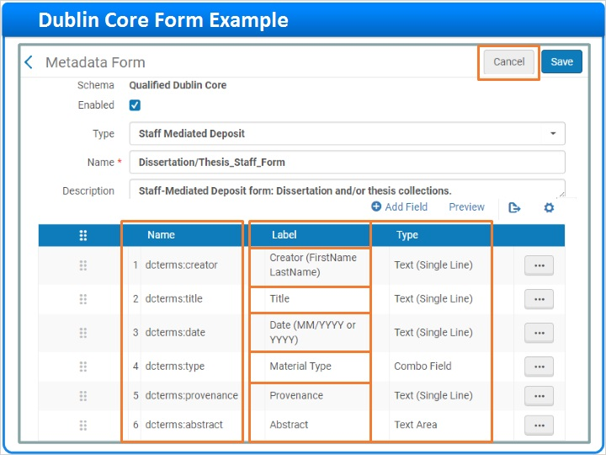
Notes:
Here’s the list of Dublin Core forms already created by this institution. Click on the Dissertation/Thesis_Staff_Form to view the form.

This is the list of Dublin Core terms selected to appear as fields on this form. And, here are the Labels that appear next to the selected fields. As you can see, the Name and Date labels were customized to include formatting instructions for the depositor. And the default label for dc:terms:type was changed to Material Type.

The Type column indicates what type of data entry field needs to be presented on the data entry form.

Click Cancel, and go back to the list of forms.

Open the Form (Slide Layer)
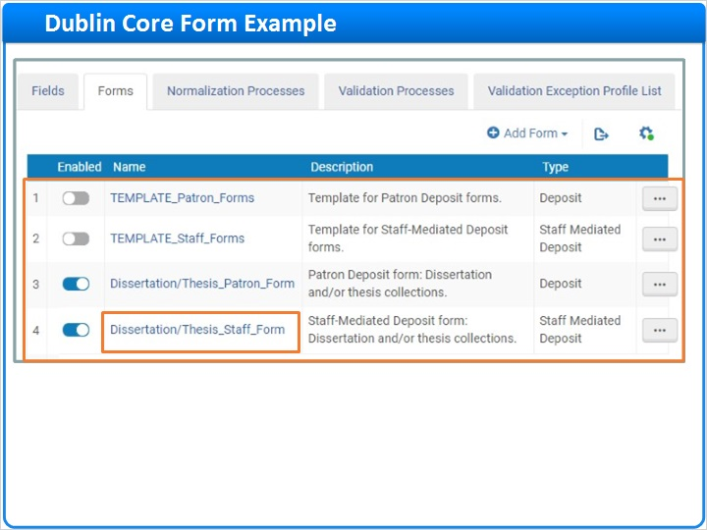

1.10 Add New Dublin Core Form
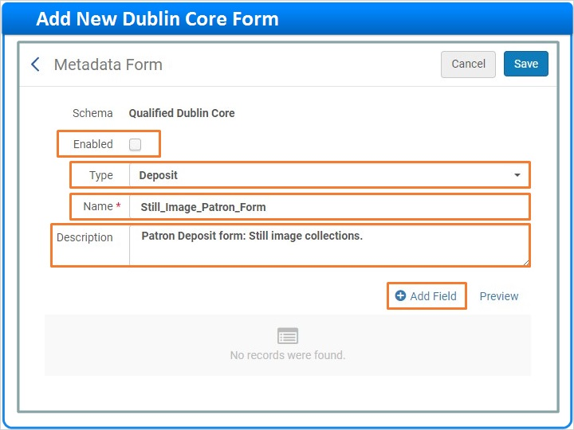
Notes:
Suppose you want to create a new Dublin Core form for patrons to use for depositing still images such as photographs.

Click Add Form, and since this form is for patron deposits, select the Deposit option. Note that the Add Representation option is not used with Deposits, so we won’t be discussing it today.

Let’s start building the form. We’ll leave the form disabled, but you can always enable it later. You already selected the right Type, so skip down and enter a mandatory Name, and optionally, a Description. Next, click Add Field to start adding fields to your form.

Choose Patron Deposit Form (Slide Layer)
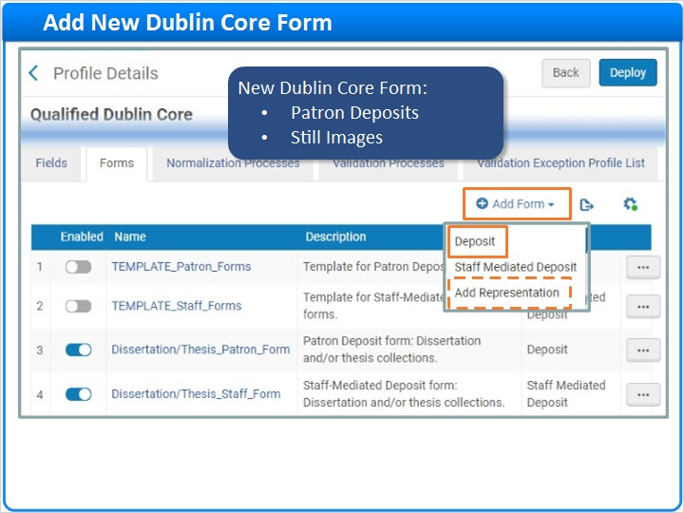

1.11 Add Fields to Dublin Core Form
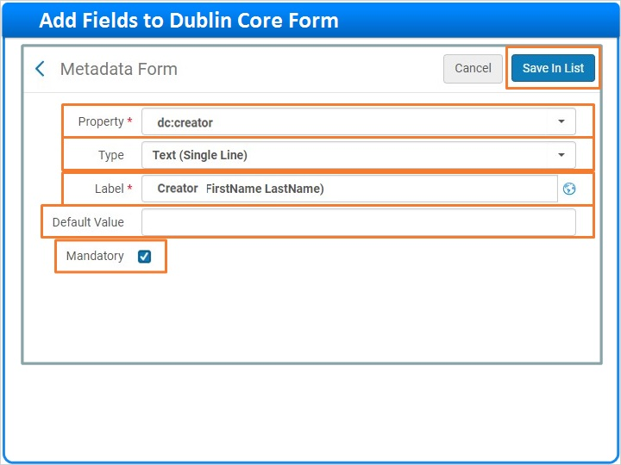
Notes:
In the Property selector, start typing the name of the Dublin Core term you want to add, for example, creator. Then, click your selection. The Label will automatically populate. But, you can change it as needed, for example, add formatting tips like this.

Then, select the Type of data entry field to display on the Patron Deposit Interface. A single line of text should be ample for the creator field.

Enter a default value if you like.

And finally, decide if this field should be mandatory. For creator, this is probably a good idea.

Click Save in List when done.

And, here’s your newly added field. You could repeat the Add Field process for each of the fields you want to add to the form, and then click Save, but there’s an easier way. So, click Cancel instead.

Select Property (Dublin Core Term) (Slide Layer)
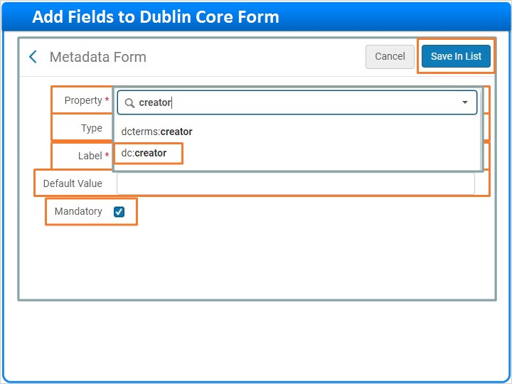

Select Data Entry Field Type (Slide Layer)
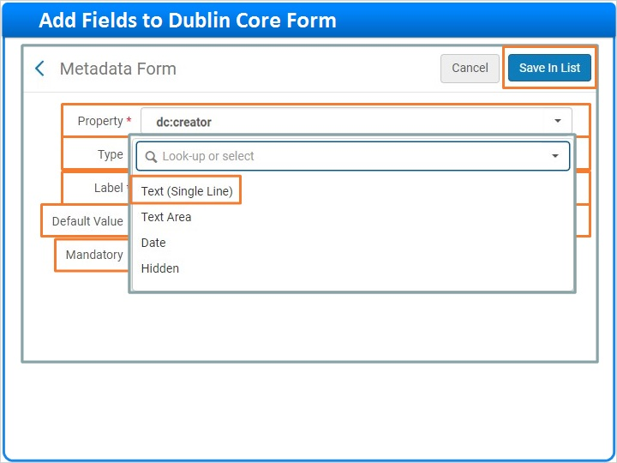

Field Added (Slide Layer)
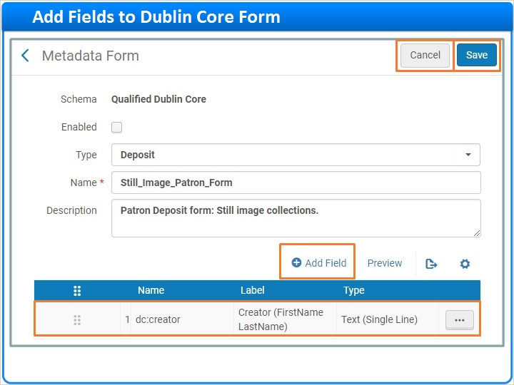

1.12 Duplicate Dublin Core Form for Patron Deposits
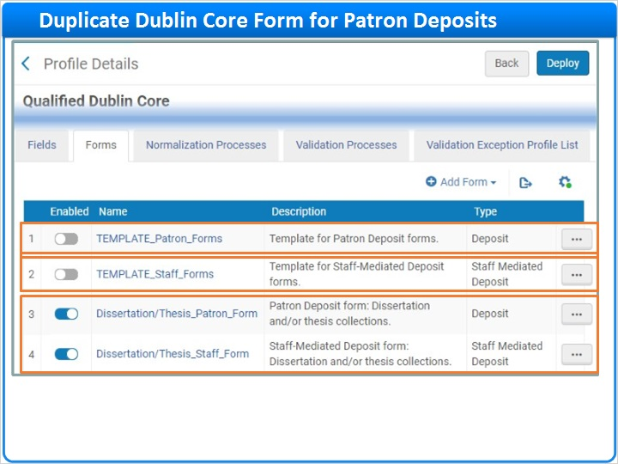
Notes:
Back on the Forms tab, notice that two forms are enabled. But, there are also two disabled forms.

This library planned ahead and created templates containing all the standard fields they want on every Dublin Core form, regardless of the collection or content type. One template is for Patron Deposits and the other is for Staff-Mediated Deposits.

With this strategy, any time you need to create a new form, you can start with a clean template. Right click on the template for patron deposit forms, and select Duplicate.

Row Action List (Slide Layer)
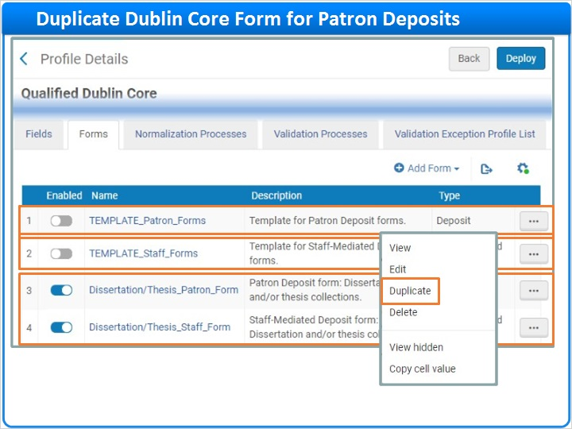

1.13 Edit Duplicated Dublin Core Form
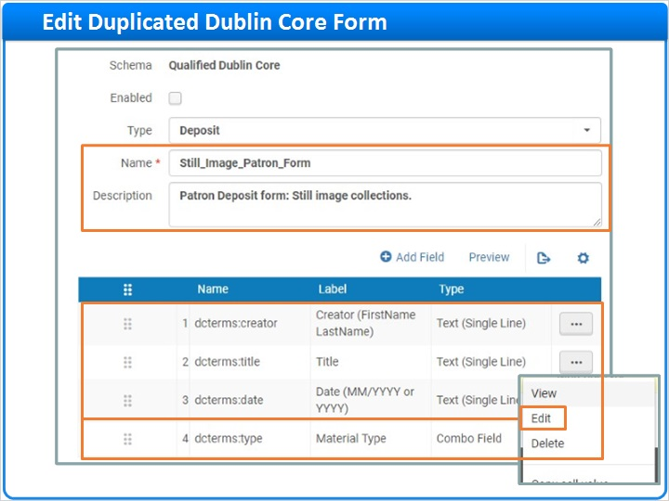
Notes:
Update the Name and Description toward the top of the page. Then scroll down and consider the set of fields. They look pretty good for any collection, but it’s a good idea to check the default Material Type. So right click on that row to edit the field. You can change the Label if you like.

And more importantly, change the Default Value from Text to Still Image. When done, click Save In List.

Edit Existing Field (Slide Layer)
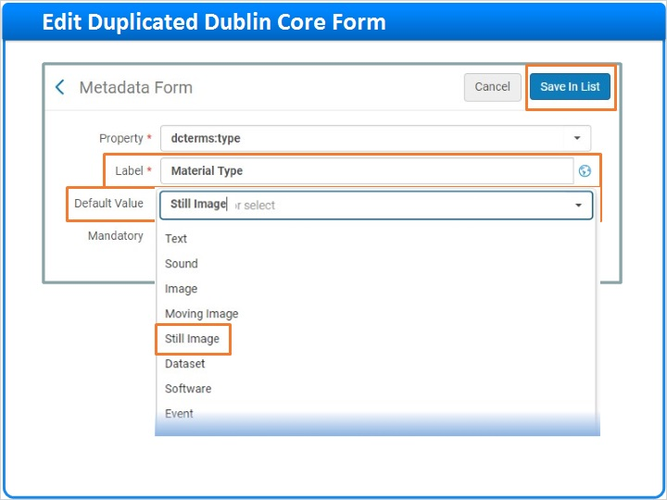

1.14 Add Fields to Duplicated Dublin Core Form
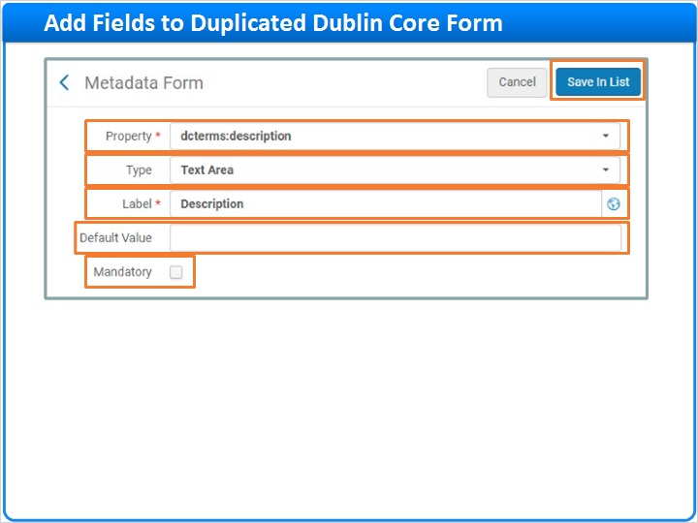
Notes:
Next, add any fields you want specifically for still images.

Click Add Field, and search the Property selector for the field you want to add, for example, dcterms:description as shown here. Remember to select the Type of data entry field you want displayed on the Patron Deposit Interface.

Everything else looks good. The Label is clear, no Default Value is needed, and itps fine for this field to be optional, so Mandatory is not checked. Click Save In List.

And, here’s your newly added Description field. You can continue to edit or add more fields if you like. If you’re ready to start using the form, you can enable it before you click Save.

Add Field (Slide Layer)
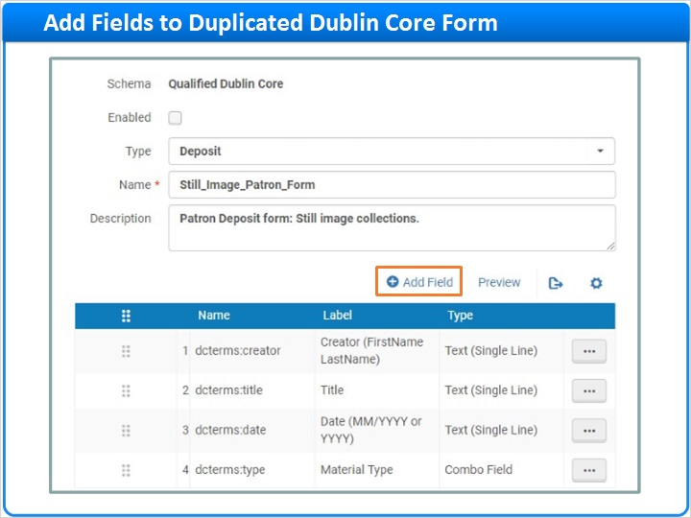

Field Added (Slide Layer)
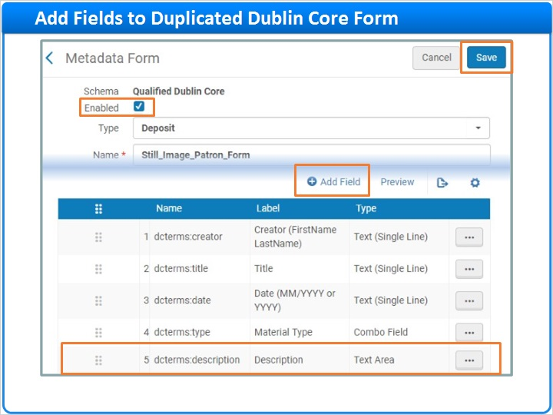

1.15 Duplicate Dublin Core Form for Staff-Mediated Deposits
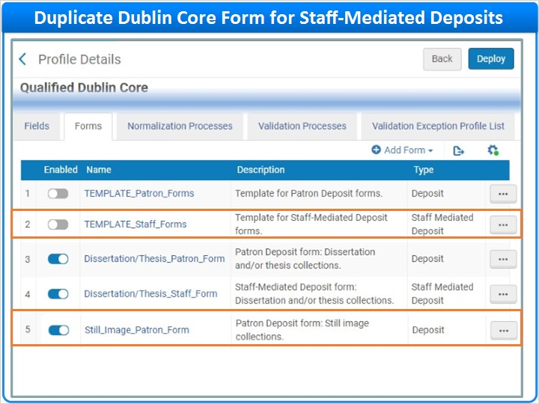
Notes:
Here’s the Patron Deposit version of your Dublin Core Form for still images. Next, Duplicate the template for Staff Mediated Deposit forms and edit the duplicated template as needed to create a Staff-Mediated Deposit form for still images.

Duplicate (Slide Layer)
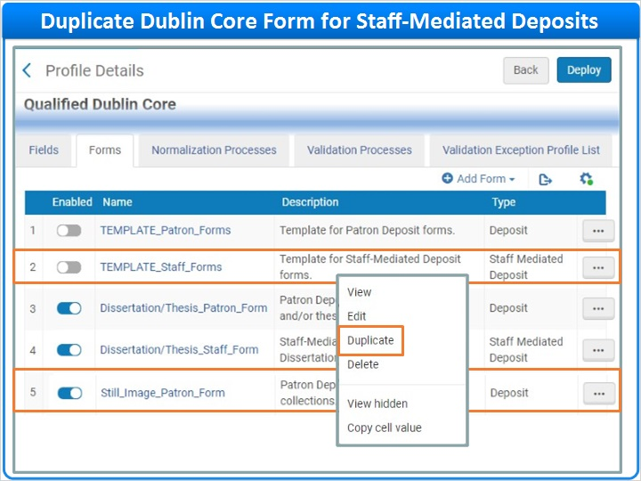

Dupicated Form (Slide Layer)
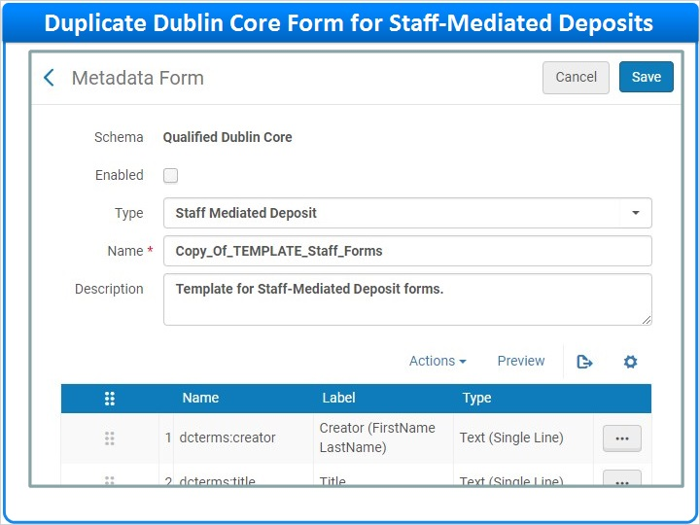

1.16 Beyond Qualified Dublin Core Terms?
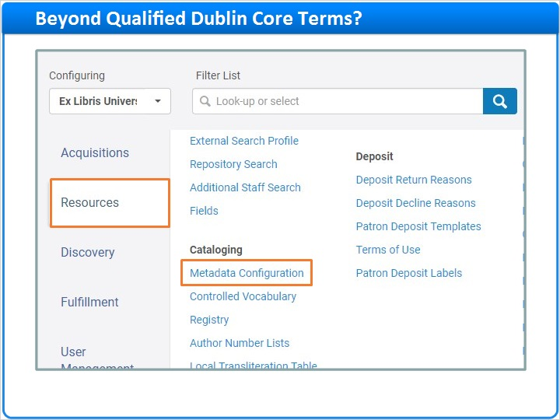
Notes:
Let’s consider one more scenario before we move on to our next topic. Go back to the Resources tab, and click on Metadata Configuration again. Then, click on the Qualified Dublin Core profile and consider terms the available for inclusion on Dublin Core Forms.

What happens if you need a Dublin Core Form that includes fields not defined in any of the Qualified Dublin Core terms?

Metadata Configuration List (Slide Layer)
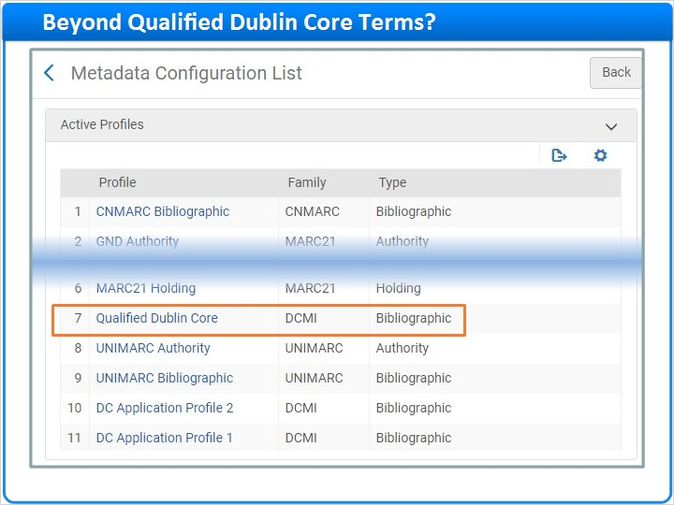

Dublin Core Terms (Slide Layer)
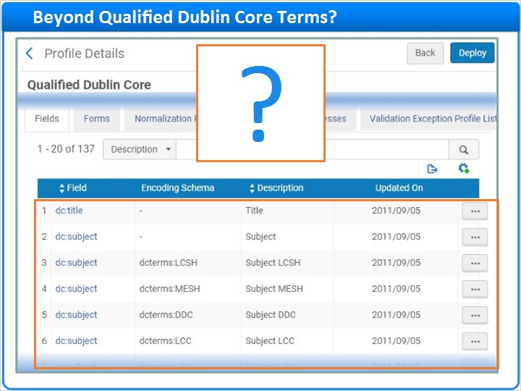

1.17 Dublin Core (DC) Application Profiles
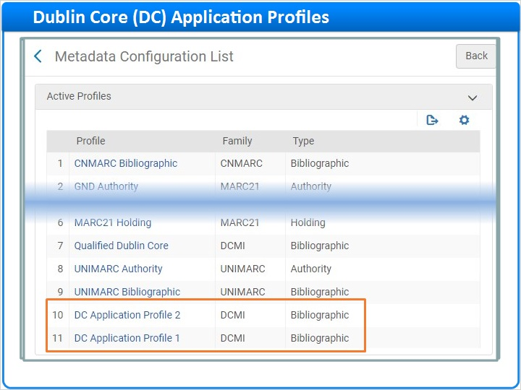
Notes:
No problem! Alma provides two customizable Dublin Core Application Profiles to which you can add your local fields. Click on either one of these profiles to get an idea of how these special metadata profiles work.

Use the Fields tab to add your local fields to the profile. Then, go to the Forms tab where you can configure Dublin Core forms that use your local fields along with any Qualified Dublin Core fields that you like.

It’s beyond the scope of this session to go into detail about adding local fields, but you can find more information in the Recommended Articles area of the page where you launched this training session.

Fields Tab (Slide Layer)
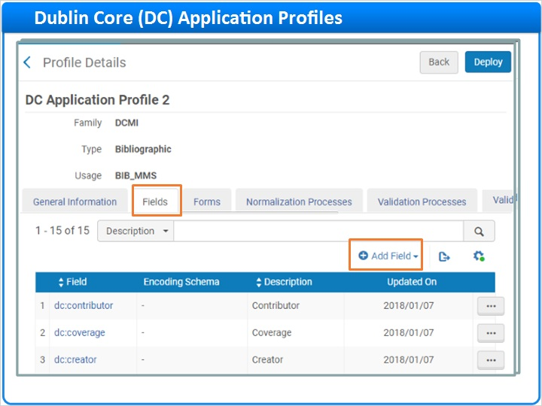

Forms Tab (Slide Layer)
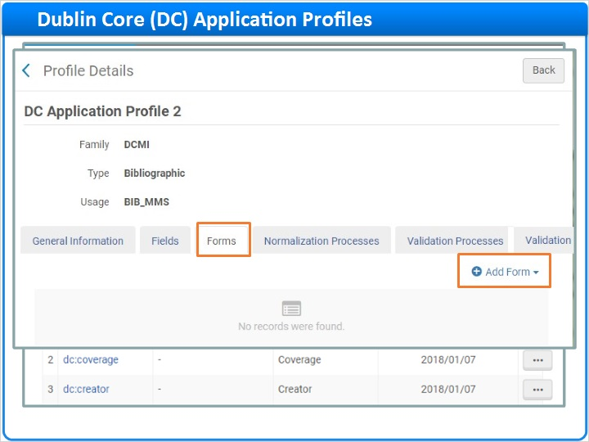

Form with Local Field (Slide Layer)
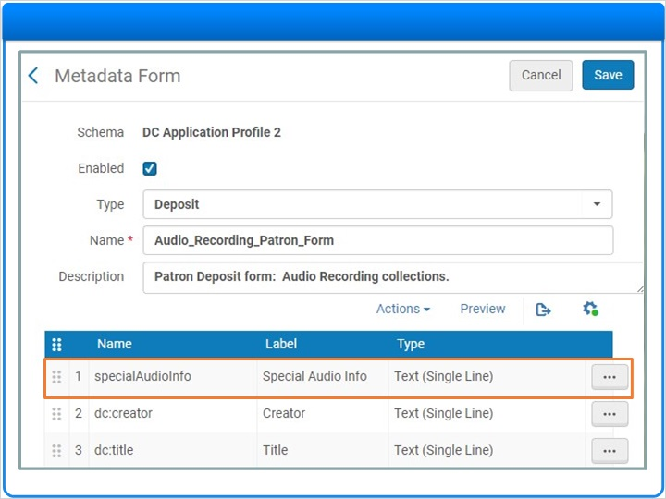

1.18 Assigning Dublin Core Forms to Collections
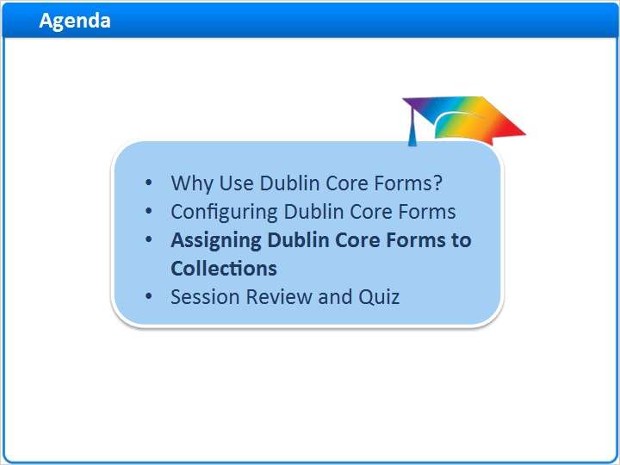
Notes:
Now that you know how to configure Dublin Core Forms, let’s learn how to add them to collections.

1.19 Collection Resource Editor Navigation
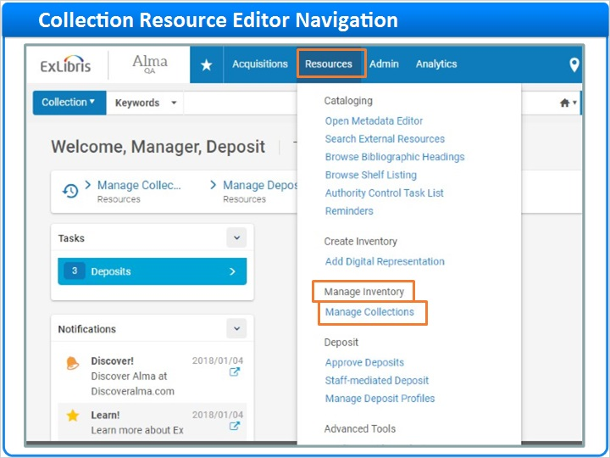
Notes:
To get started, click Resources on the main Alma menu, then under the Manage Inventory section, click Manage Collections.

Here’s the list of existing top-level collections in the institution’s repository. Let’s assign some Dublin Core Forms to the collection called University Dissertations and Theses. Click on the collection’s name to launch the Collection Resource Editor where you’ll land on the Title List tab. Go to the General tab instead.

The General tab is broken into two collapsible sections, the Properties section where you can see information such as the collection’s Name and owning Library…

Top Level Collections (Slide Layer)
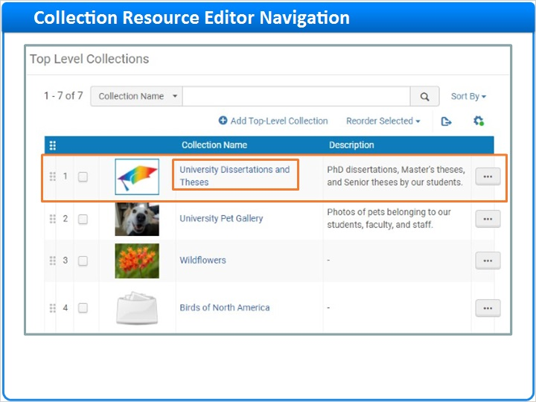

Title List Tab (Slide Layer)
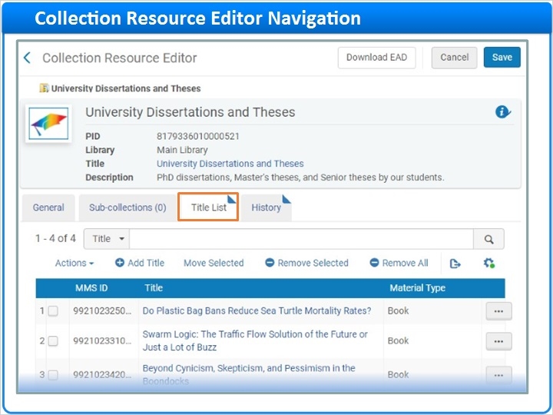

General Tab (Slide Layer)
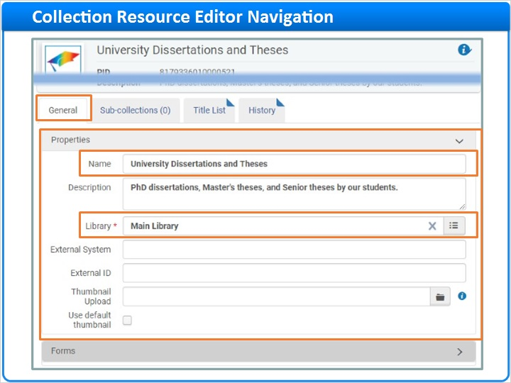

1.20 Forms for Patron and Staff-Mediated Deposits
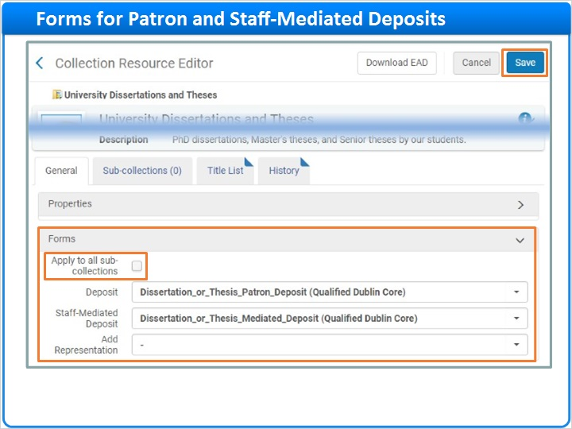
Notes:
…and the Forms section where you assign Dublin Core forms to your collection. You can choose to apply the same forms to sub-collections if any exist.

Use the Deposit field to select the form you want to use for Patron Deposits. Select one called Dissertation or Thesis Patron Form.

Then, use the Staff-Mediated Deposit field to select the form you want for Staff-Mediated deposits. And finally, click Save.

Select Patron Deposit Form (Slide Layer)
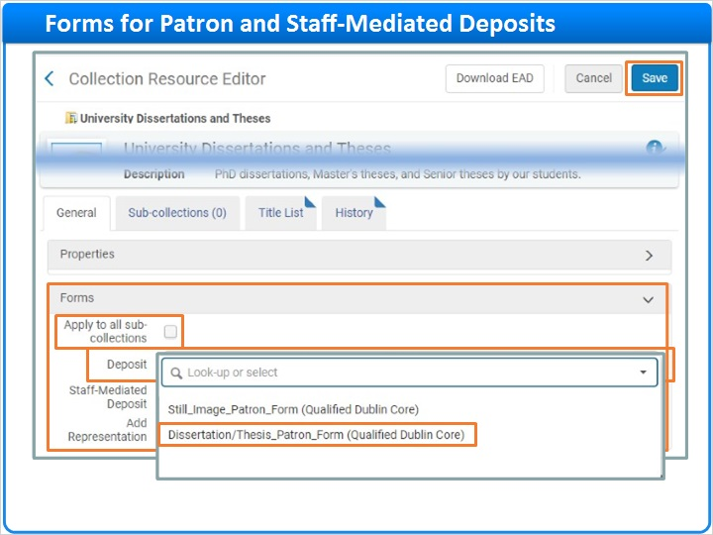

Select Staff Mediated Deposit Form (Slide Layer)
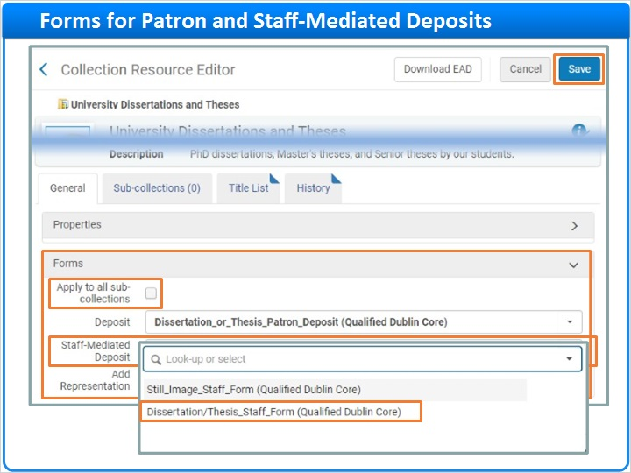

1.21 Basic Default Forms
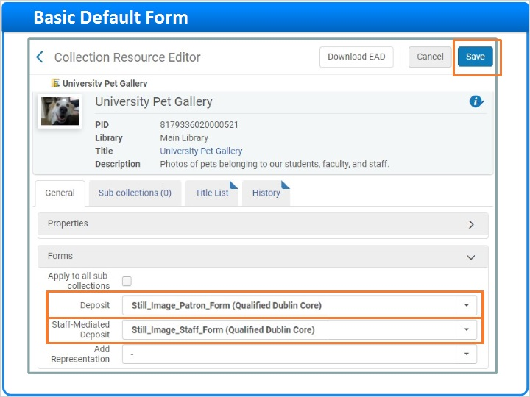
Notes:
Now, you can repeat the process for additional collections such as the University Pet Gallery.

If you leave the Deposit field blank, Alma will display this basic default form on the Patron Deposit Interface. Behind the scenes, Alma adds three other Dublin Core fields to the bib record and populates them automatically.

If you leave the Staff Mediated Deposit field blank, Alma will display this default form on the Alma interface, also with a few pre-populated fields in place as shown here.

But, since this is digital photo collection, select the Patron and the Staff-Mediated Deposit forms for still images created earlier in this session. Then, click Save.

Collections (Slide Layer)
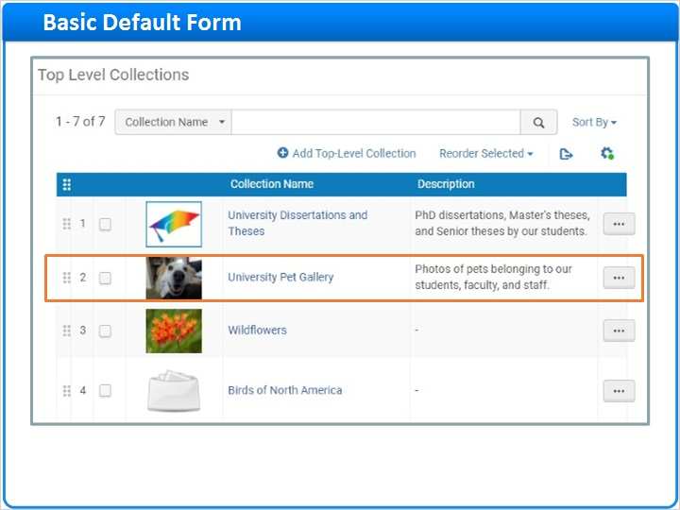

Patron Deposit Default Form (Slide Layer)
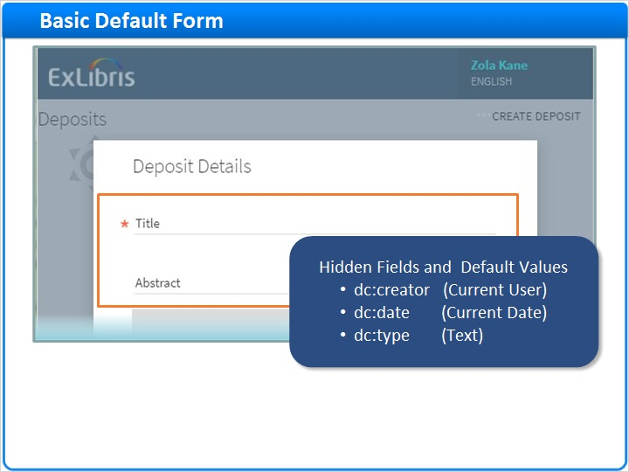

Staff-Mediated Deposit Default (Slide Layer)
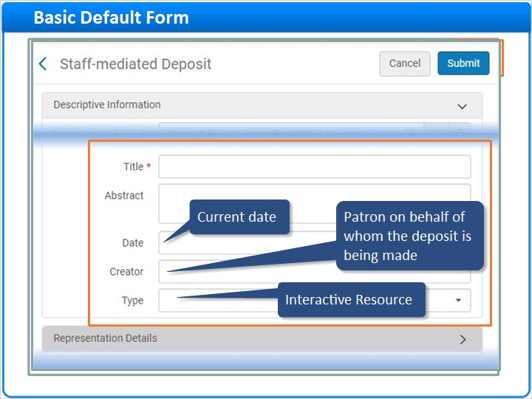

1.22 Session Review and Quiz
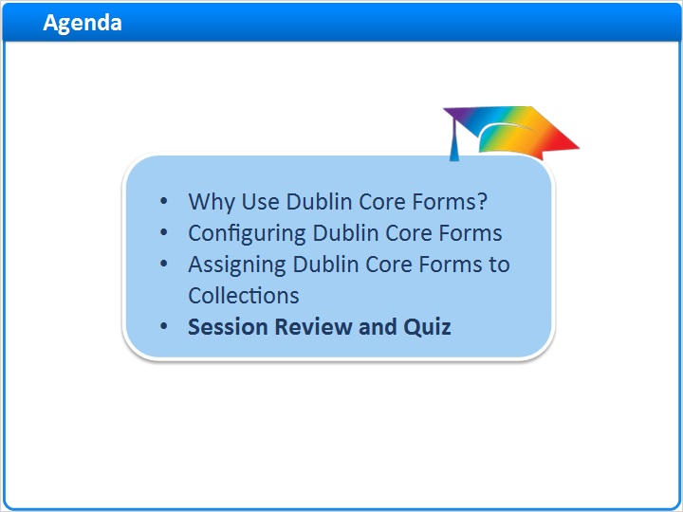
Notes:
That concludes the main portion of this training session. Let’s briefly review what was covered and then proceed to a short quiz.

1.23 Session Review
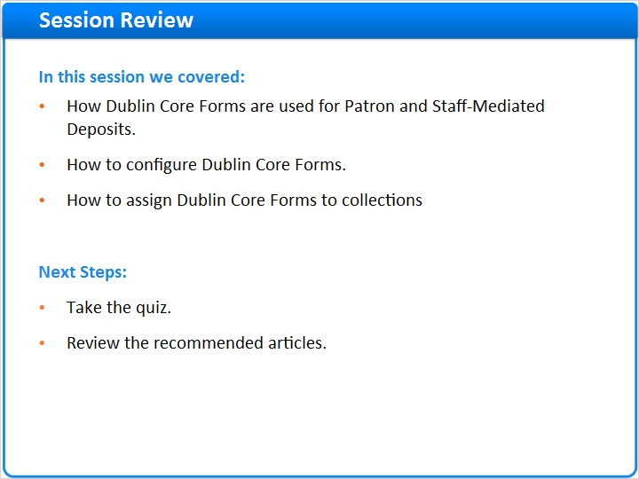
Notes:
In this session we:
- Looked at how Dublin Core Forms are used for Patron and Staff-Mediated Deposits.
- Demonstrated how to configure Dublin Core Forms.
- Showed how to assign Dublin Core Forms to collections.

What are your next steps?
- First, take the short quiz that begins on the next page.
- Then, for additional information about Dublin Core Forms, see the Recommended Articles section where you launched this training session.

1.24 Quiz: About Dublin Core Forms
(True/False, 10 points, 1 attempt permitted)
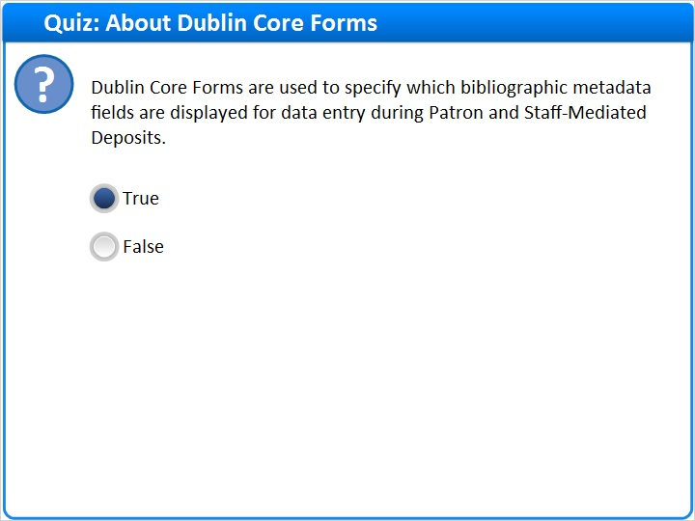
Correct | Choice
X | True
 | False
Feedback when correct:
Right! The correct answer is: True.

When you configure Dublin Core Metadata Forms, you can specify which bibliographic metadata fields will display for data entry when users make Patron or Staff-Mediated Deposits.
Feedback when incorrect:
The correct answer is: True.

When you configure Dublin Core Metadata Forms, you can specify which bibliographic metadata fields will display for data entry when users make Patron or Staff-Mediated Deposits.

Notes:

Correct (Slide Layer)
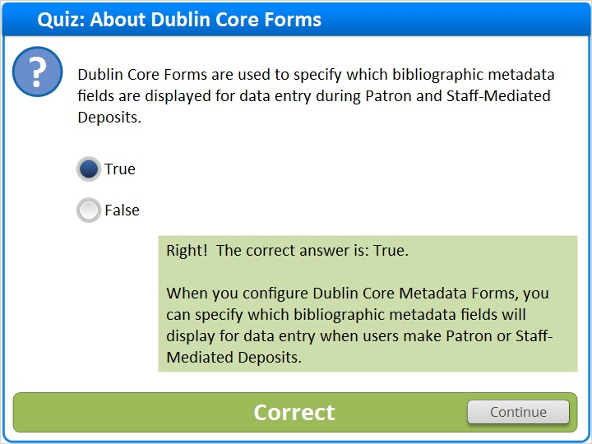

Incorrect (Slide Layer)
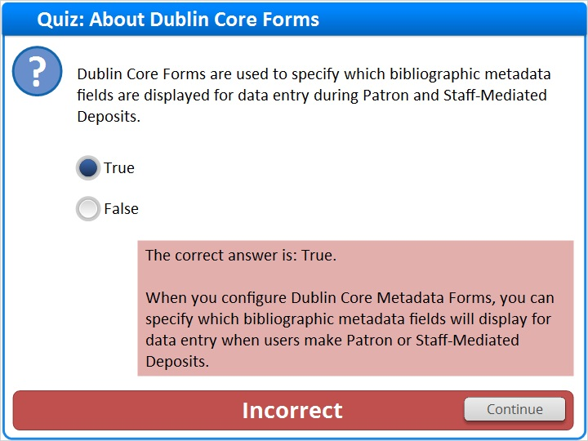

1.25 Quiz: Configuring and Assigning Dublin Core Forms
(Multiple Response, 10 points, 1 attempt permitted)
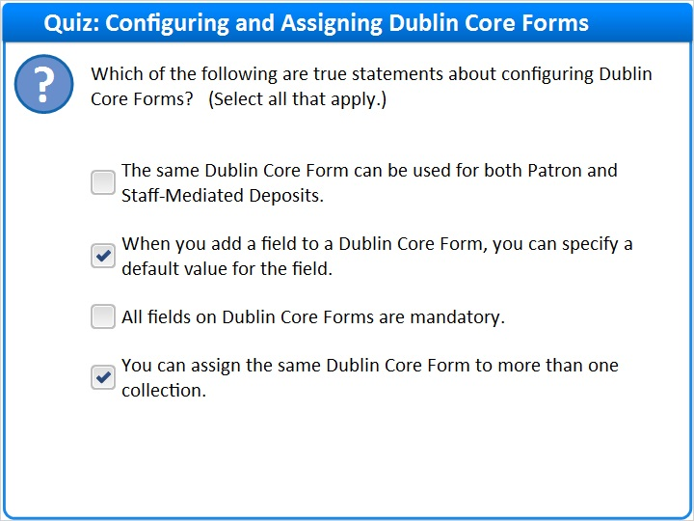
Correct | Choice
 | The same Dublin Core Form can be used for both Patron and Staff-Mediated Deposits.
X | When you add a field to a Dublin Core Form, you can specify a default value for the field.
 | All fields on Dublin Core Forms are mandatory.
X | You can assign the same Dublin Core Form to more than one collection.

Feedback when correct:
Right! These two statements are true:
When you add a field to a Dublin Core Form, you can specify a default value for the field.
You can assign the same Dublin Core Form to more than one collection.

These two statements are false:
The same Dublin Core Form can be used for both Patron and Staff-Mediated Deposits. Explanation: When you create a Dublin Core Form, you specify the applicable deposit type: Patron OR Staff-Mediated, not both.
All fields on Dublin Core Forms are mandatory. Explanation: You can choose whether or not to make a field mandatory.
Feedback when incorrect:
These two statements are true:
When you add a field to a Dublin Core Form, you can specify a default value for the field.
You can assign the same Dublin Core Form to more than one collection.

These two statements are false:
The same Dublin Core Form can be used for both Patron and Staff-Mediated Deposits. Explanation: When you create a Dublin Core Form, you specify the applicable deposit type: Patron OR Staff-Mediated, not both.
All fields on Dublin Core Forms are mandatory. Explanation: You can choose whether or not to make a field mandatory.

Correct (Slide Layer)
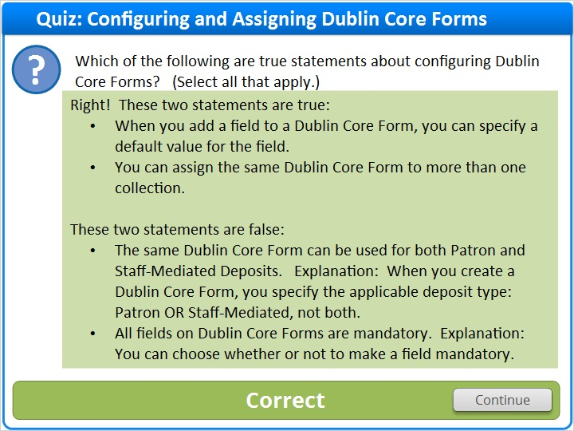

Incorrect (Slide Layer)
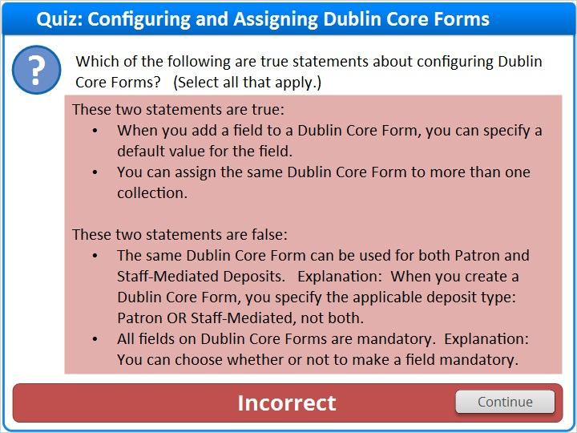

1.26 Quiz: Beyond Qualified Dublin Core
(True/False, 10 points, 1 attempt permitted)
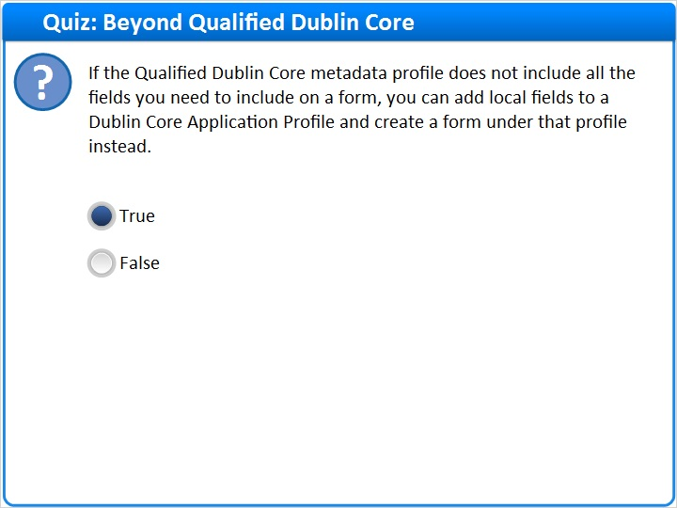
Correct | Choice
X | True
 | False

Feedback when correct:
Right! The correct answer is: True.

When you configure Dublin Core Metadata Forms, you can specify which bibliographic metadata fields will display for data entry when users make Patron or Staff-Mediated Deposits.
Feedback when incorrect:
The correct answer is: True.

When you configure Dublin Core Metadata Forms, you can specify which bibliographic metadata fields will display for data entry when users make Patron or Staff-Mediated Deposits.

Notes:

Correct (Slide Layer)
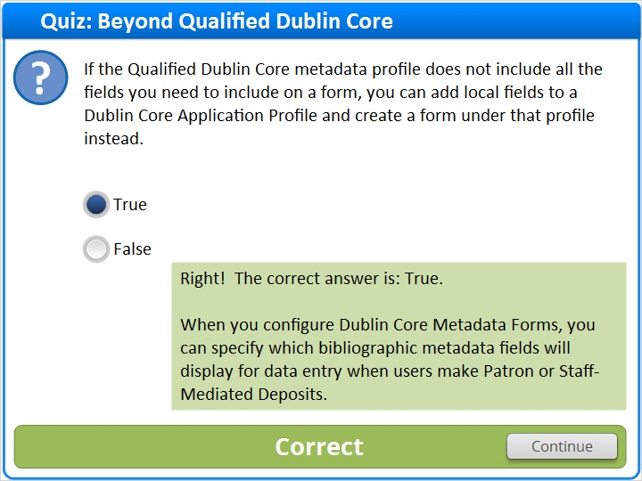

Incorrect (Slide Layer)
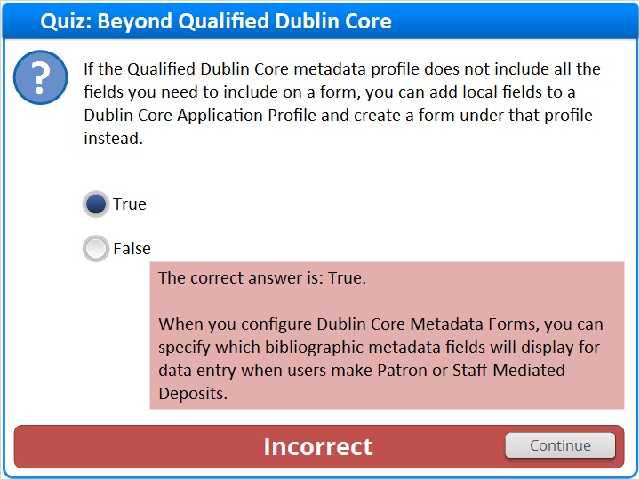

1.27 Thank You!

Notes:
Thanks for joining this session!

1.28 About this Training

Notes:

1 (Slide Layer)
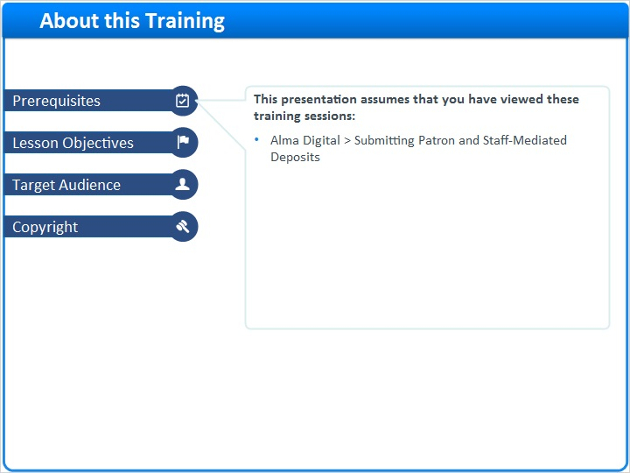

2 (Slide Layer)
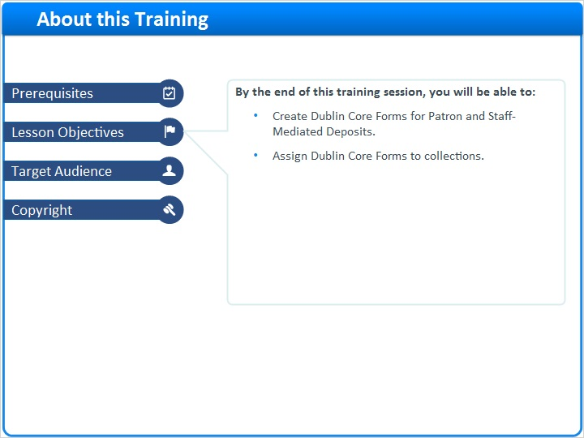

3 (Slide Layer)
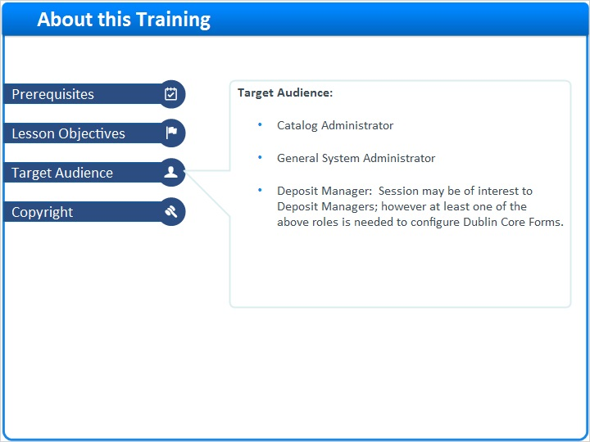

4 (Slide Layer)
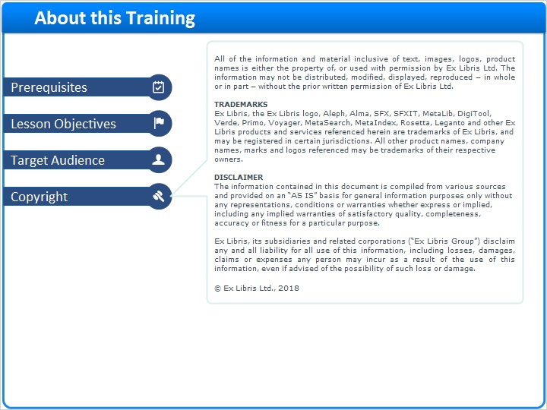

1.29 Results Slide
(Results Slide, 0 points, 1 attempt permitted)
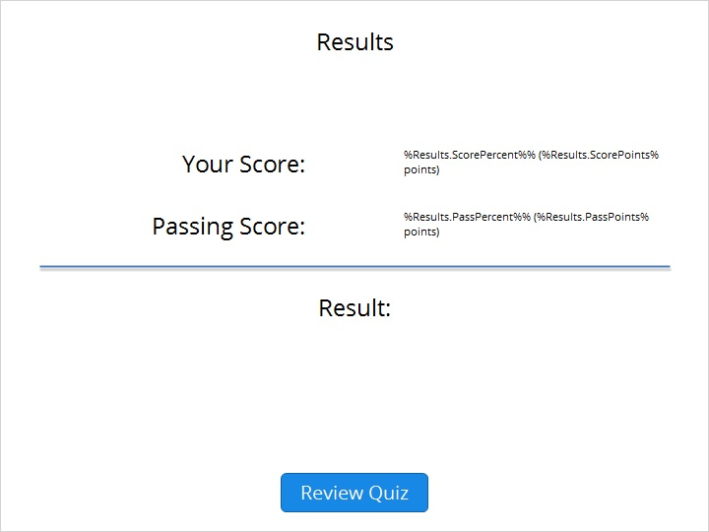

Results for
1.24 Quiz: About Dublin Core Forms
1.25 Quiz: Configuring and Assigning Dublin Core Forms
1.26 Quiz: Beyond Qualified Dublin Core

Result slide properties
Passing  Score | 80%

Success (Slide Layer)
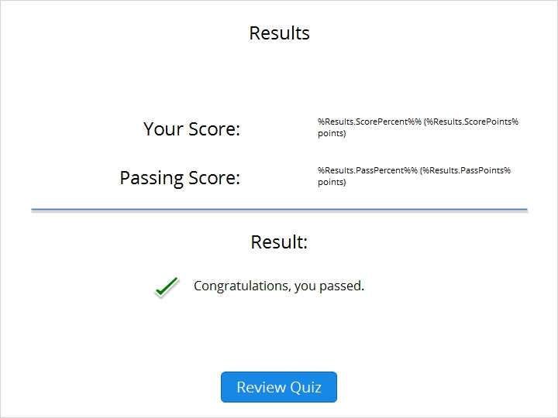

Failure (Slide Layer)


