Acquisitions Workflows: Using Import Profiles to Upload Bib Records Handout

1. Using Import Profiles to Upload Bib Records

1.1 Using Import Profiles to Upload Bibliographic Records
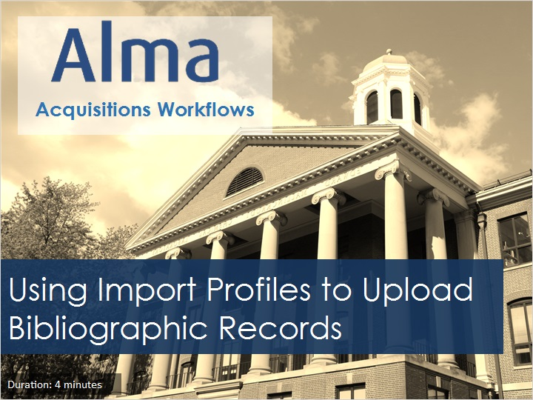
Notes:
Welcome to this tutorial, Using Import Profiles to Upload Bibliographic Records.

1.2 Acquisitions Workflows Tutorials
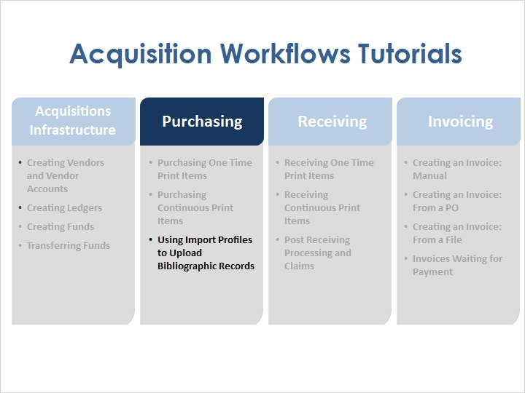
Notes:
After the acquisitions infrastructure is in place, it is possible to start creating purchase orders in Alma. It is possible to create purchase orders manually for either print or continuous items. It is also possible to create purchase orders by creating an import profile and using that profile to upload bibliographic records with Embedded Order Data, or EOD.

1.3 Objectives
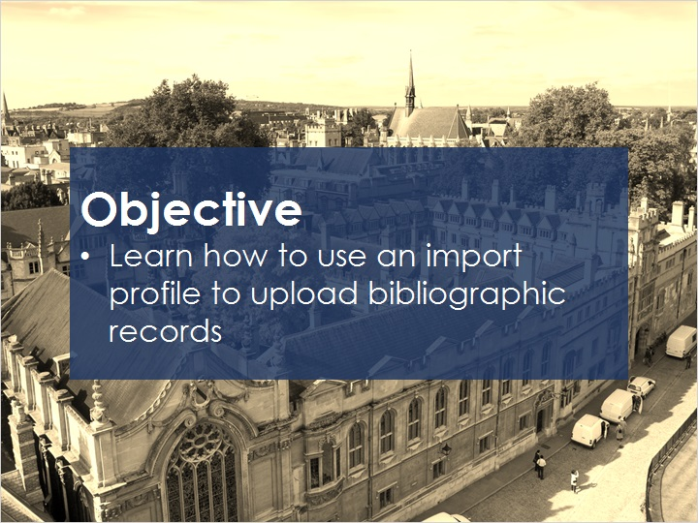
Notes:
In this session, you will learn how to use an import profile to upload bibliographic records.

1.4 New Order Import Profiles
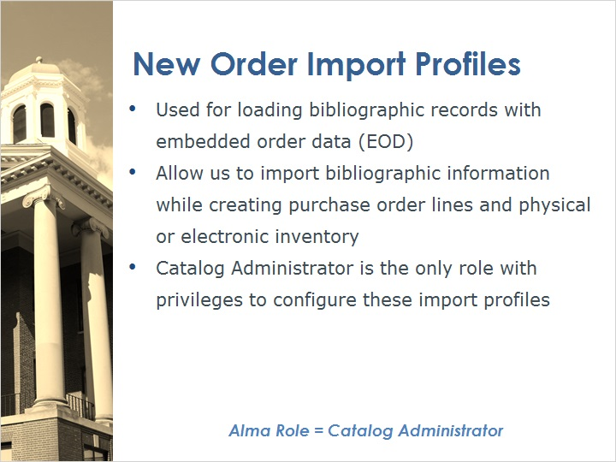
Notes:
New Order import profiles are used for loading bibliographic records with embedded order data (EOD)
Loading records using this profile allows us to import bibliographic information while creating purchase order lines and physical or electronic inventory.
In order to add or edit New Order import profiles, you will need to have the Catalog Administrator role in Alma. This is the only role with privileges to configure these import profiles.

1.5 New Order Import Profiles
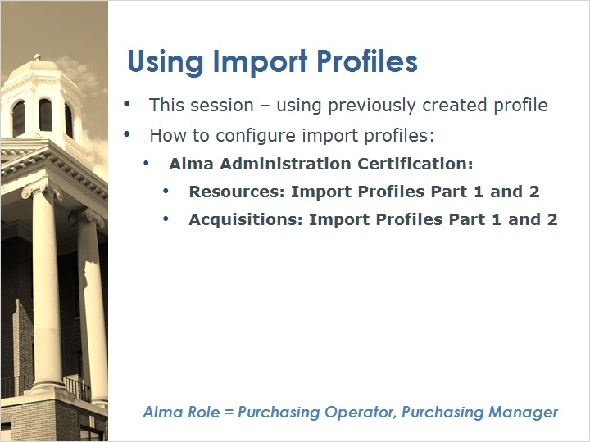
Notes:
For this session, we will be using a previously created import profile to demonstrate the uploading process.

To learn how to configure import profiles, please see the following sessions in the Alma Administration Certification Training Series.

While the Catalog Administrator role is needed to create or edit import profiles, the Purchasing Operator and Purchasing Manager roles can use them to load inventory and create purchase order lines associated with that inventory.

1.6 Accessing Import
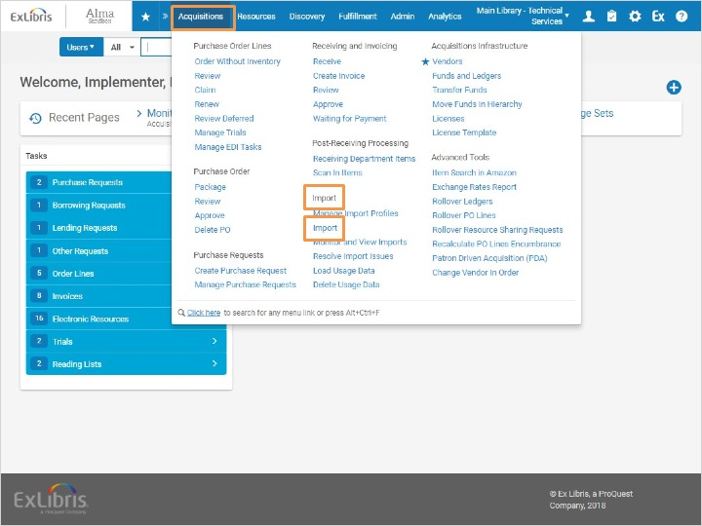
Notes:
To begin uploading bibliographic records, go to Acquisitions > Import > Import

1.7 Select Import Profile
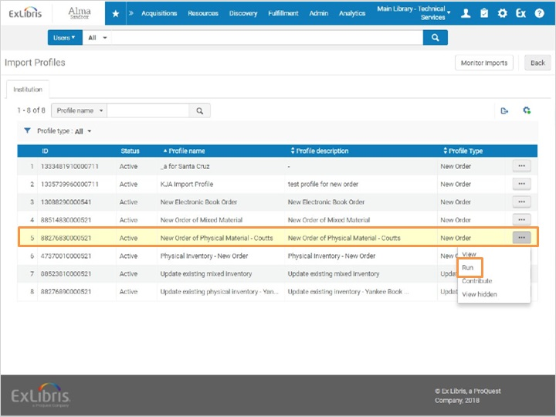
Notes:
Choose the import profile that will be used to load the data, then click Run on the row actions list.

1.8 Select and Submit File
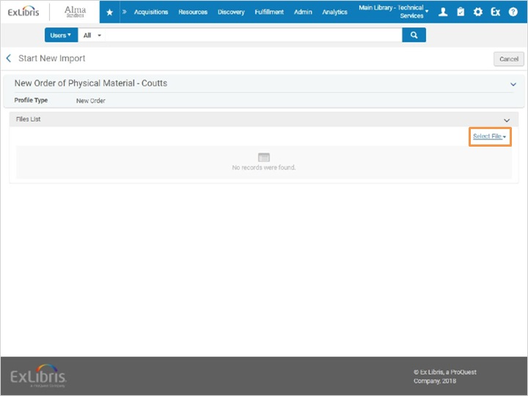
Notes:
Click Select File, select the file to upload, then click Add. It’s possible to include additional files if needed.
Next, click Submit at the top right of the screen.

Select File (Slide Layer)
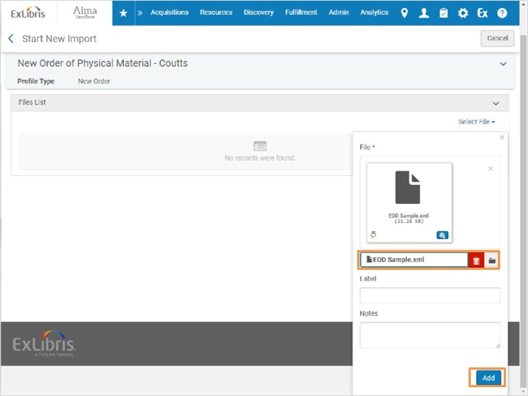

Submit (Slide Layer)
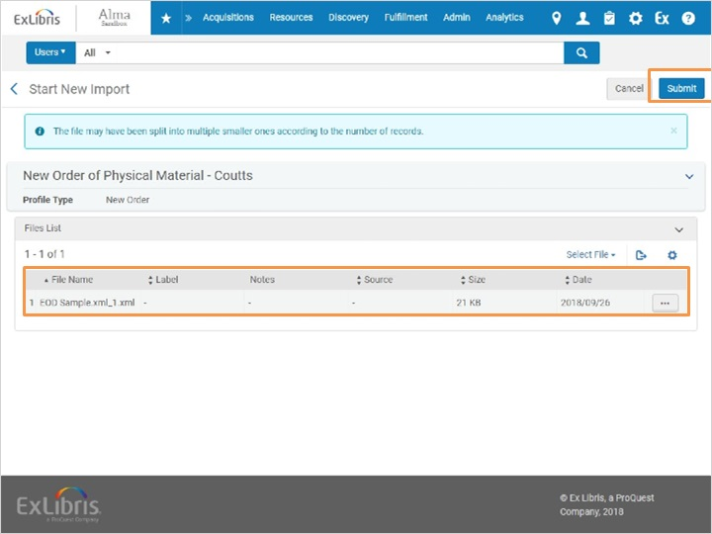

1.9 Monitor and View Import Screen
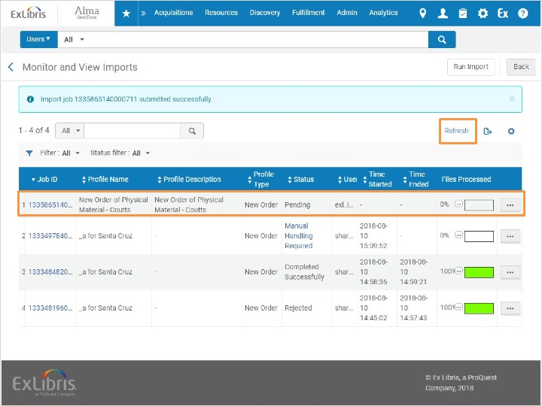
Notes:
This opens the Monitor and View Imports screen. Here’s the job that was just submitted. If the Files Processed column does not yet say 100%, click Refresh.
There. Now the job has completed successfully.

Refreshed (Slide Layer)
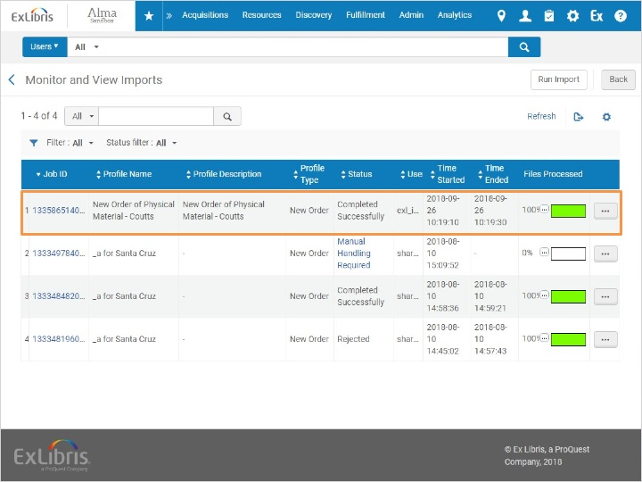

1.10 Imported Records
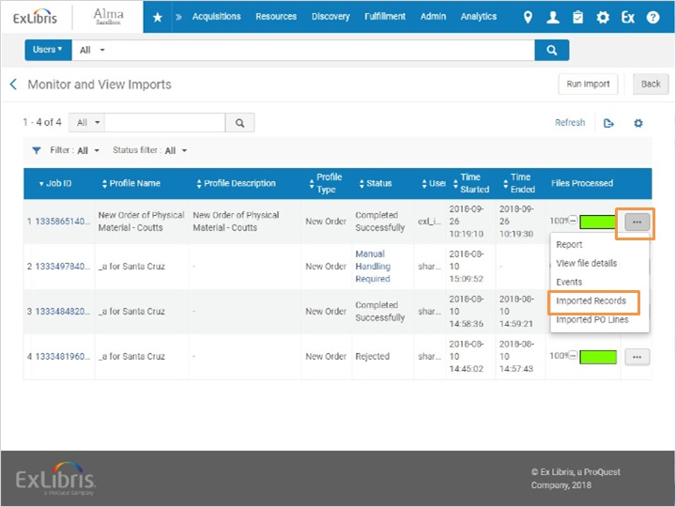
Notes:
When the job is complete, click Imported Records in the row Actions list. Note that there is an order for each record. Let’s go back to the Jobs list.

Imported Records list (Slide Layer)
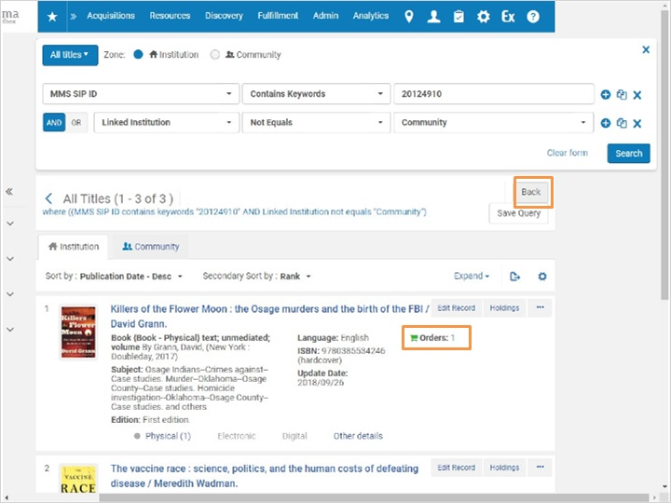

1.11 Imported PO Lines
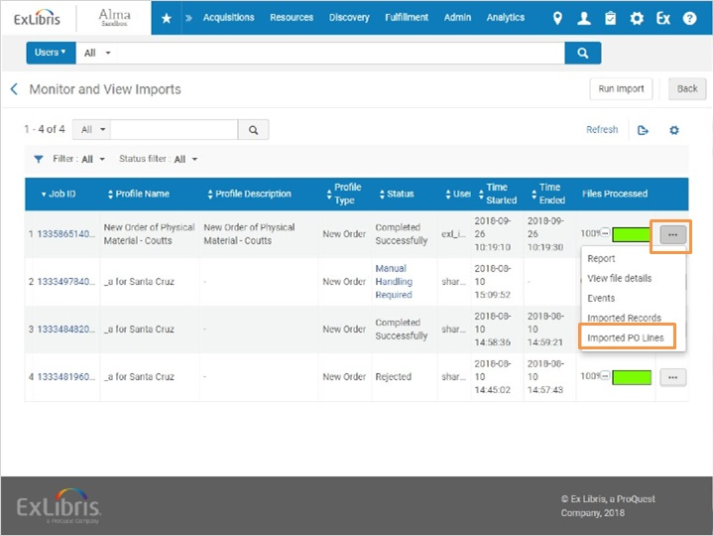
Notes:
In the row actions list, click Imported PO Lines. Note that every line shows as In Review, and that the purchase order has not yet been created.

Imported PO Lines list (Slide Layer)
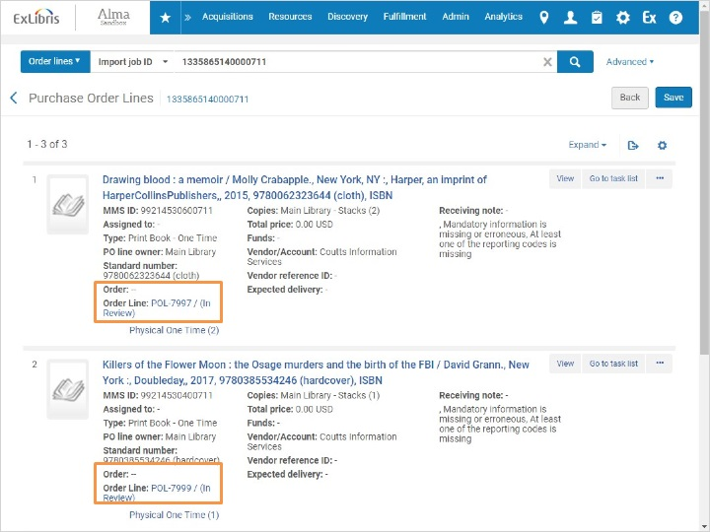

1.12 Review Imported Records
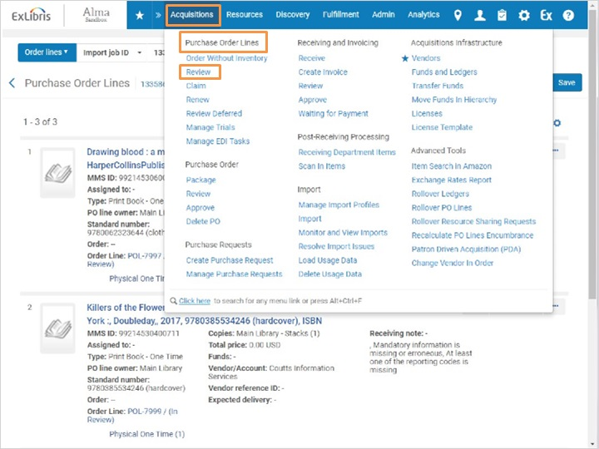
Notes:
To review and order these purchase order lines, go to Acquisitions > Purchase Order Lines > Review

1.13 Unassigned Tab
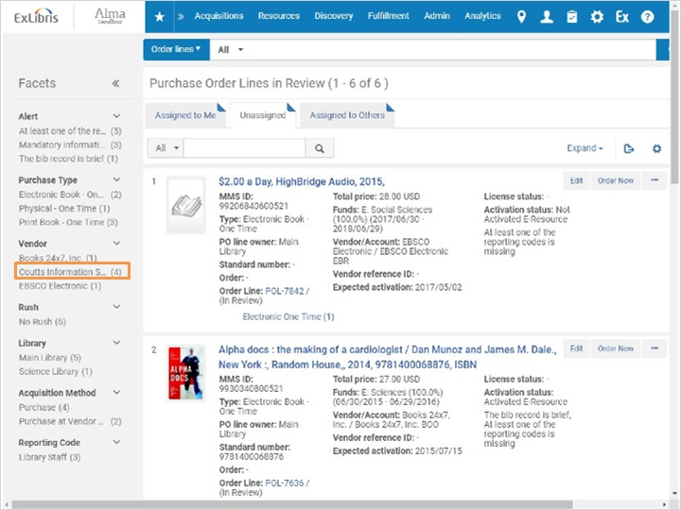
Notes:
Ensure that the Unassigned tab is selected. It is possible to refine the list by using the facets on the left. For this example, I’ll select the Coutts Information Services facet.

1.14 Review Purchase Order Lines
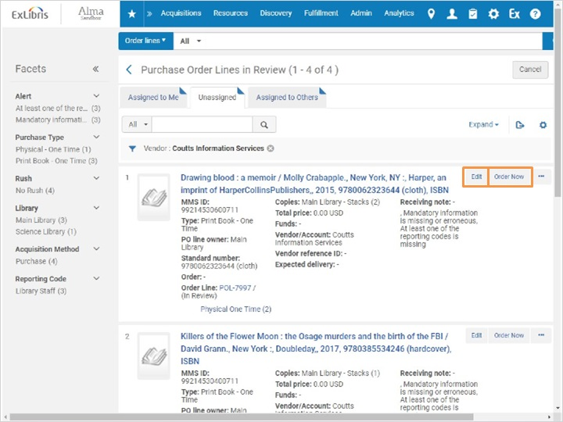
Notes:
There. Now I can review each PO line before packaging them into a purchase order. While it’s possible to click Order Now for each, this will create a separate Purchase order for each item.
For each line, click Edit. Enter in any mandatory or missing data, then click Save and Continue. This moves the PO Line along to the next stage where it will await the nightly Purchase Order packaging job.

Purchase Order Line Details (Slide Layer)
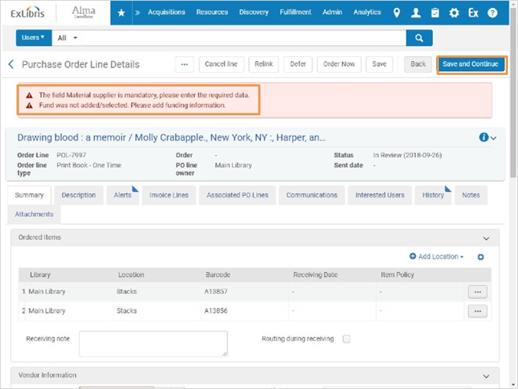

1.15 Monitor and View Imports
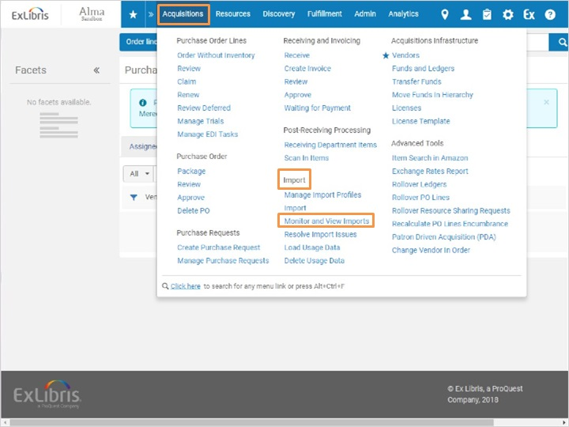
Notes:
Let’s go back to the import and check the status of the purchase order lines now that they’ve been reviewed and edited. To locate the import, go to Acquisitions > Import > Monitor and View Imports.

1.16 Monitor and View Imports screen
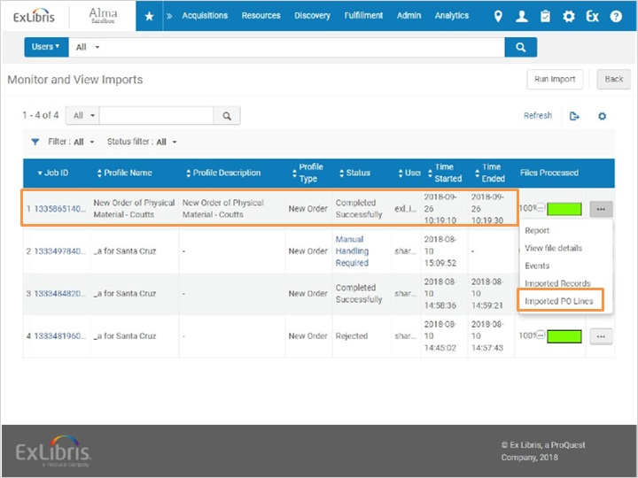
Notes:
Find the import job in the list, then select Imported PO Lines.

1.17 Purchase Order Lines
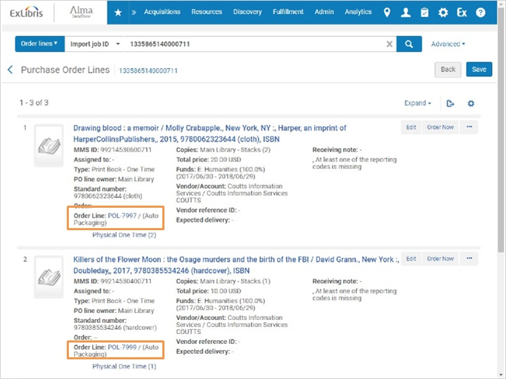
Notes:
Now when we look at the order line status, we can see that it is set to Auto Packaging.

1.18 Review & Quiz
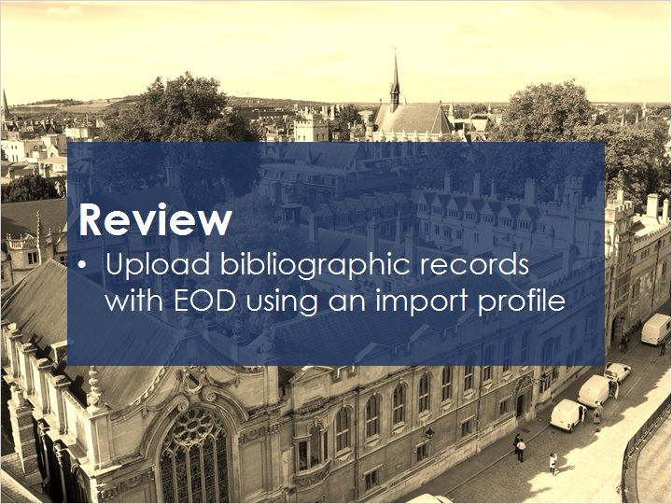
Notes:
Now that you’ve watched this session you should be able to upload bibliographic records with EOD using an import profile.

Please take the short quiz to test your knowledge.

1.19 Quiz: Using Import Profiles to Upload Bib Records with EOD
(True/False, 10 points, 1 attempt permitted)
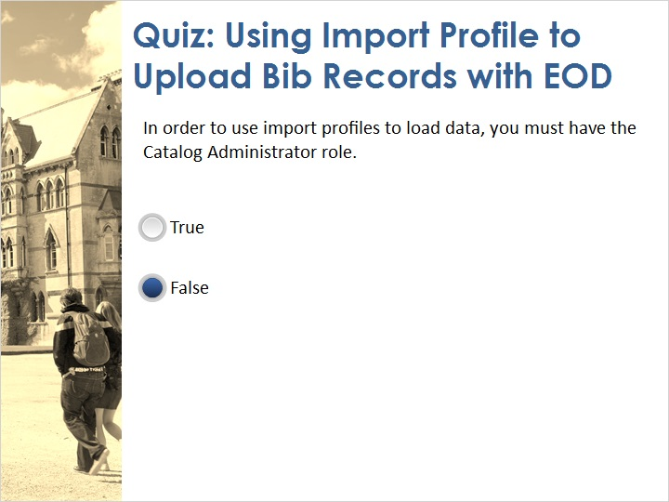
Correct | Choice
 | True
X | False
Feedback when correct:
That's right! You can use import profiles as long as you have the Purchasing Manager or Purchasing Operator roles. You need the Catalog Administrator role to create or edit profiles.
Feedback when incorrect:
No sorry, that’s not right. You can use import profiles as long as you have the Purchasing Manager or Purchasing Operator roles. You need the Catalog Administrator role to create or edit profiles.

Notes:

Correct (Slide Layer)
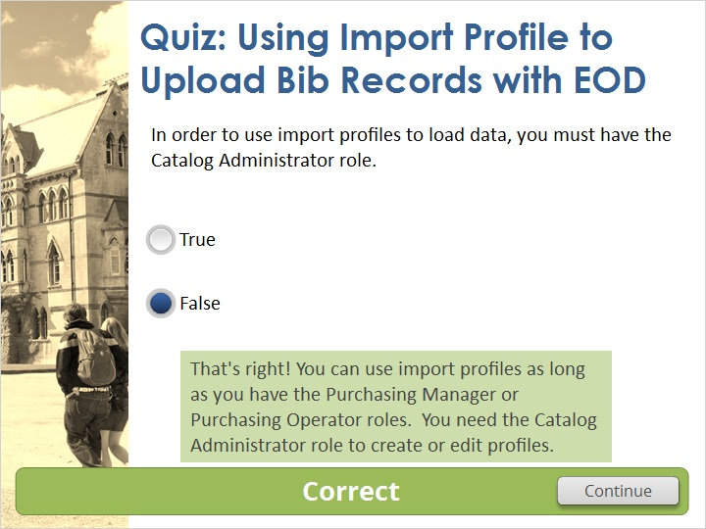

Incorrect (Slide Layer)
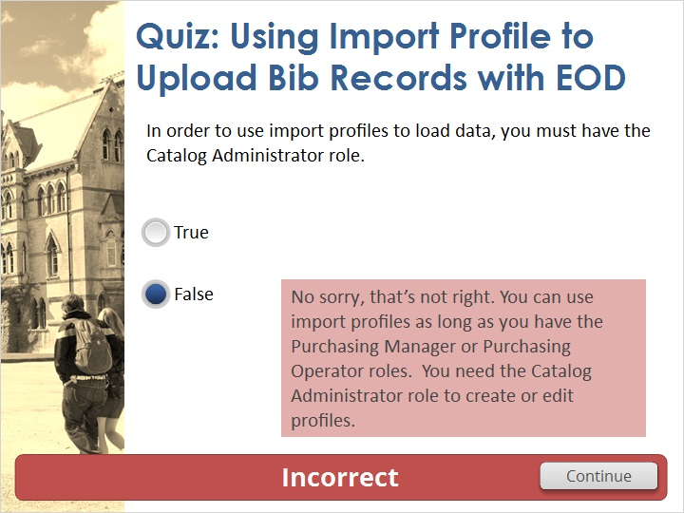

1.20 Thank You!

Notes:
Thank you for joining this session!

1.21 Copyrights

Notes:

2. Quiz Results

2.1 Results Slide
(Results Slide, 0 points, 1 attempt permitted)
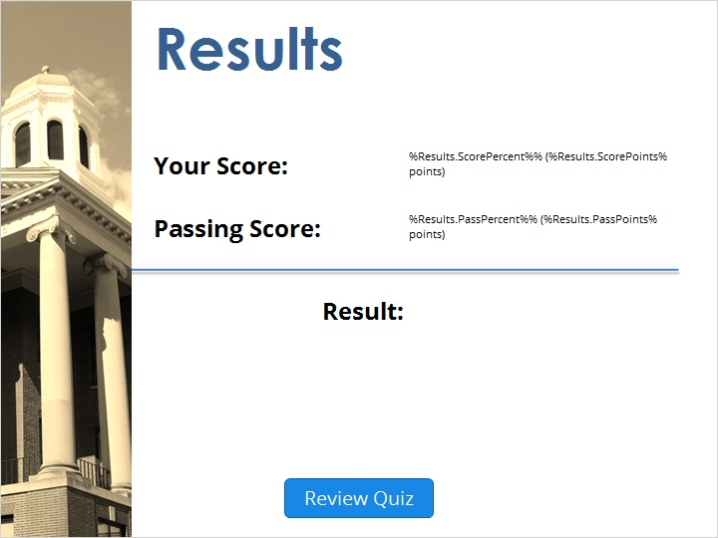

Notes:
fgsfdgsfdgfdg

Success (Slide Layer)
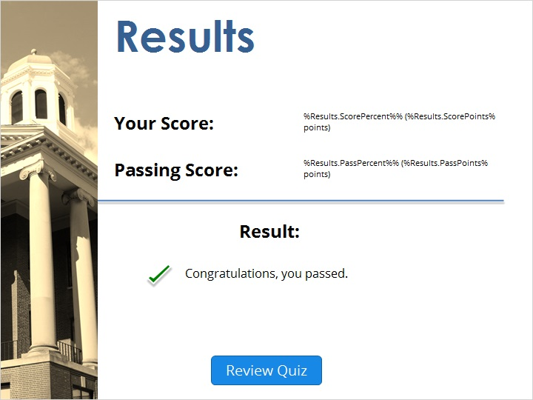

Failure (Slide Layer)


