Acquisitions Workflows: Receiving One Time Print Items Handout

1. Receiving One Time Print Items

1.1 Receiving One Time Print Items
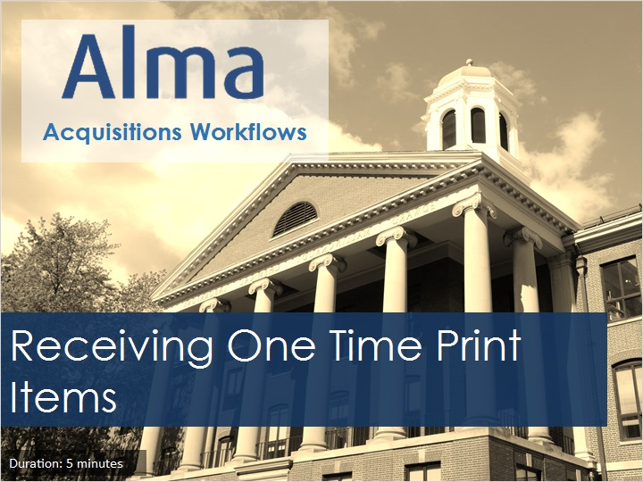
Notes:
Welcome to this tutorial, Receiving One Time Print Items.

1.2 Acquisitions Workflows Tutorials
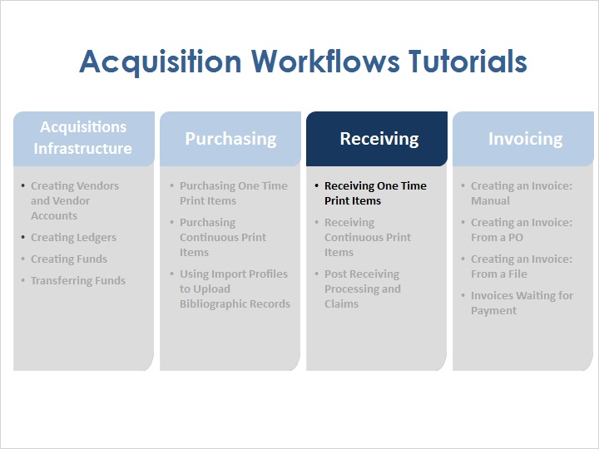
Notes:
Once physical items have been ordered, and the library receives those items, it is possible to mark them as received in Alma.

1.3 Objectives
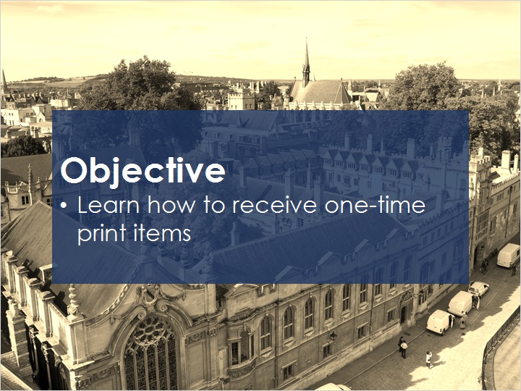
Notes:
In this session, you will learn how to receive one-time print items.

1.4 Receiving Orders in Alma
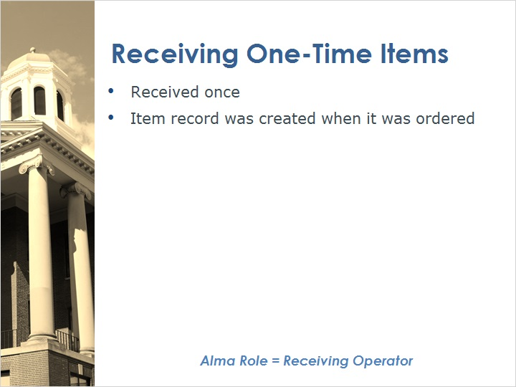
Notes:
When receiving one-time print items, the item is received once, and the item record was created when it was ordered.

In order to receive items in Alma, one must have the Receiving Operator role.

1.5 Receiving Outcomes
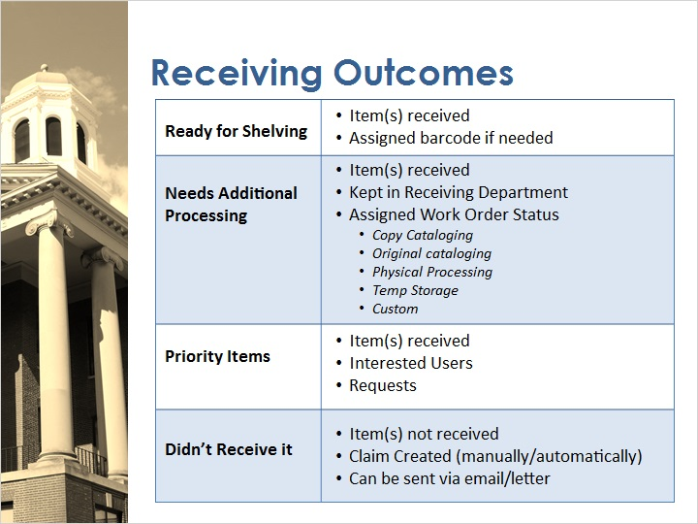
Notes:
There are a few different things that can happen after items are received (or not received) in Alma.

In some cases the item is received and is ready for shelving; in this case, the item is marked as received and assigned a barcode.

In other cases, an item may need additional processing. In Alma it’s possible to mark the item received, but keep it in the Receiving Department and assign a work order to the item. For example, the item may need copy cataloging, original cataloging, or physical processing. Or the item may need to be routed to temporary storage. It’s also possible to create custom work order statuses.

If the item received is a priority item, it will be received, interested users can be notified, and requests can be filled.

If the item has not been received in the expected timeframe, a claim can be created either manually or automatically, and a notification to the vendor could be sent via email or letter.

1.6 Set Location to Technical Services
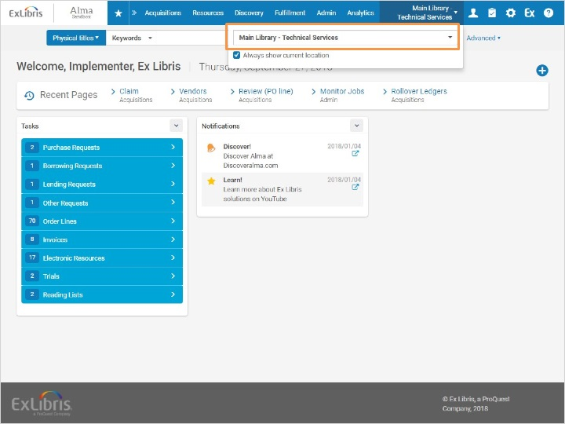
Notes:
To receive items in Alma, first ensure that the correct location is selected. This is the location that is associated with your Technical Services Department. In our training environment, this is the Main Library Technical Services location.

1.7 Access Receiving
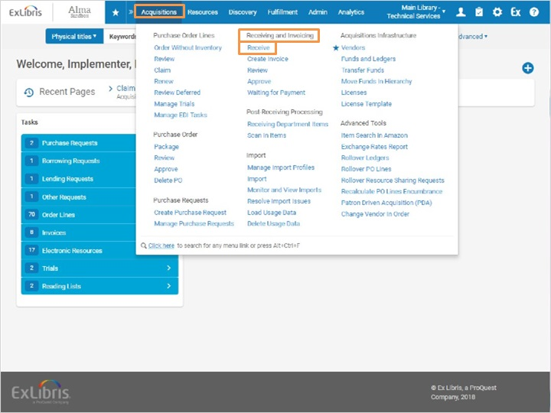
Notes:
To access the receiving area of Alma, go to Acquisitions > Receiving and Invoicing > Receive.

1.8 Receive New Material
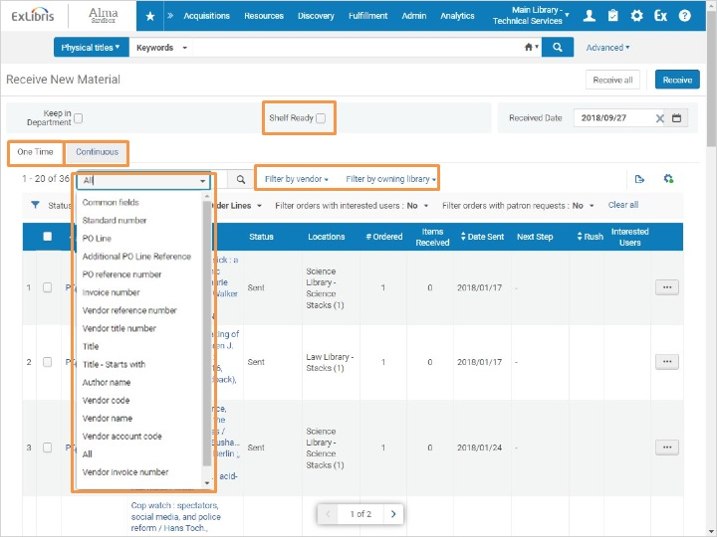
Notes:
This brings us to the Receive New Material screen. Here I have a list of all of the PO lines that are waiting to be received.
I have two tabs - one time orders and continuous orders.
If I click on the All dropdown in the search bar, I can search by my PO Line number, the PO (reference) number, or many other criteria. I can even filter the PO lines by vendor and the owning library.
If the inventory awaiting receipt already has an item barcode, you can select the Shelf Ready check box and scan the barcode in order to locate the relevant PO line.

1.9 Search for Item to be Received
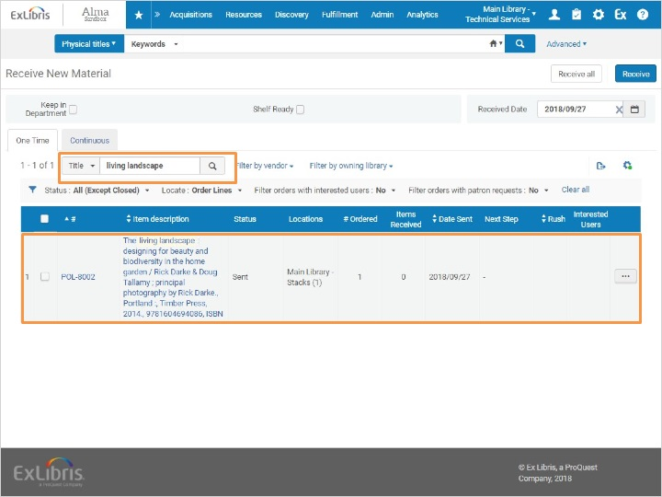
Notes:
I’m going to search for my title in the search bar, then click the magnifying glass icon.
The result here is the item I’m looking for. There are a few different ways we can receive this item.

1.10 Keep in Department Checkbox
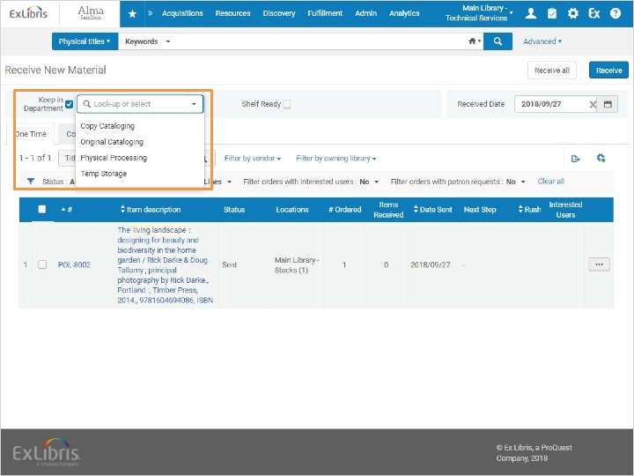
Notes:
With the Keep in Department checkbox, I can control what happens to the book after I mark it received. For example, if I needed to create and attach a barcode label to the material before putting it into circulation, I would select the Keep in Department checkbox, and select ‘Physical Processing’ in the dropdown.

1.11 Receive Item
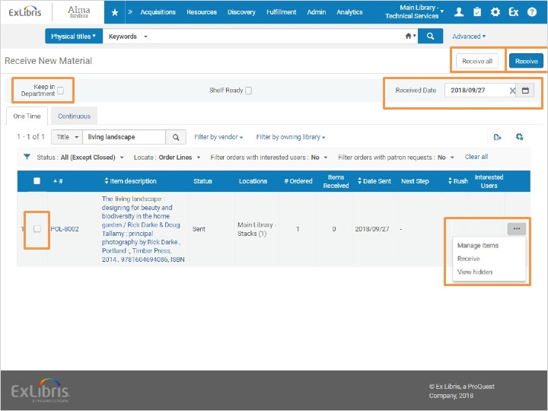
Notes:
For this example, my item is ready to go into circulation. So we’ll keep this checkbox unchecked.
Next, I want to make sure I have the correct received date. By default, the current date will show, but I can adjust this as needed.
If we had multiple items in the list and wanted to receive them all, we could select Receive all at the top of the screen.
If we had multiple items in the list but wanted to receive a subset of them, we could select the checkboxes here and click Receive.
But since we’re just receiving this item, I can also click on the ellipses button and select Receive from here.
If we were assigning a barcode at the same time as receiving, we would want to select Manage so that we could scan in a barcode for the item in the Barcode field, then receive it.
If the record has interested users, the option to Print an interested users list will also appear here.
Today, we are just going to select Receive from the dropdown.

1.12 Search for Received Item
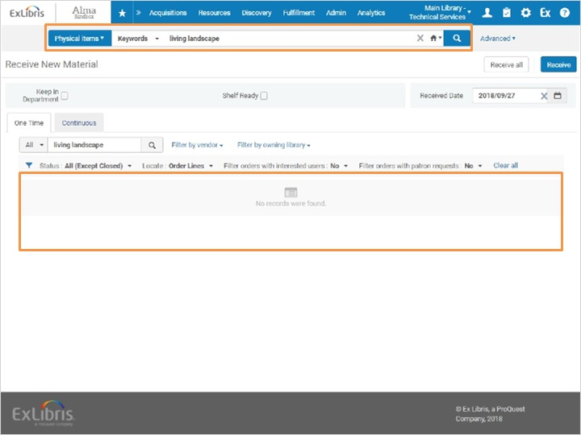
Notes:
Notice that the title disappears from this list because it’s been received. Let’s see where the title is now.
To do this, we go to the top of the screen and conduct a search the Physical Items for my title.

1.13 Search for Item to be Received
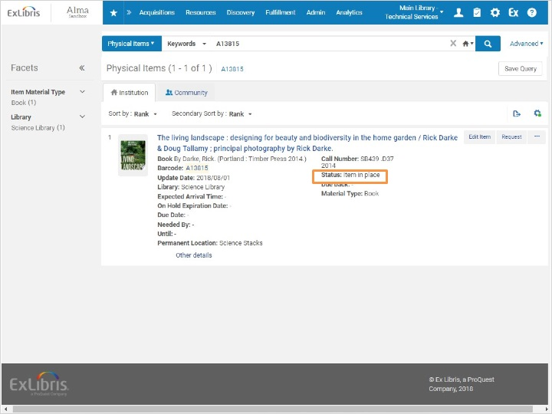
Notes:
And here’s our item. We can see that the status is Item in Place.

1.14 Review & Quiz
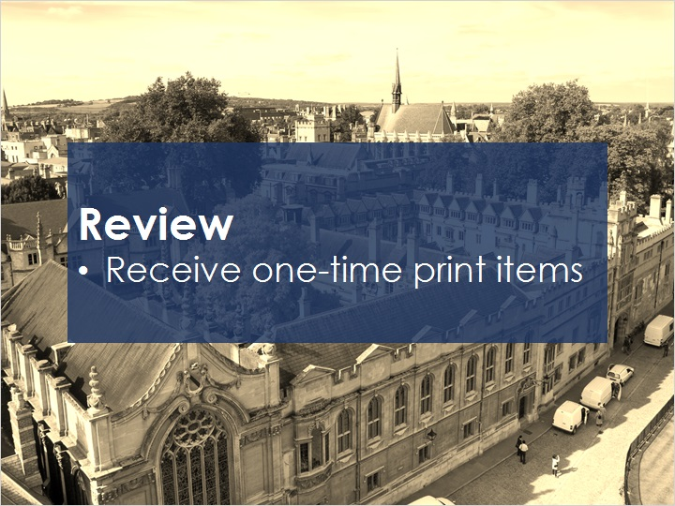
Notes:
Now that you’ve watched this session you should be able to receive one-time print items in Alma.

Please take the short quiz to test your knowledge.

1.15 Quiz: Receiving One-Time Items
(Multiple Choice, 10 points, 1 attempt permitted)
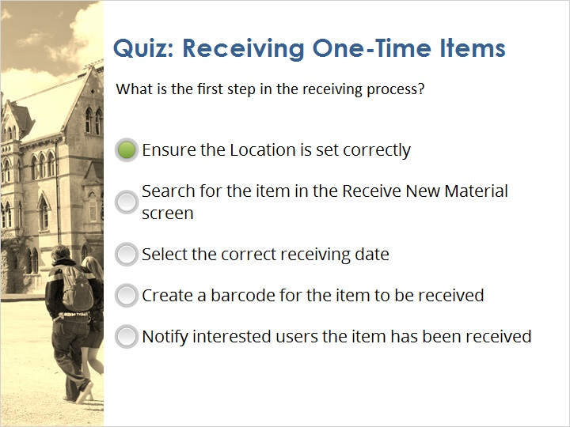
Correct | Choice
X | Ensure the Location is set correctly
 | Search for the item in the Receive New Material screen
 | Select the correct receiving date
 | Create a barcode for the item to be received
 | Notify interested users the item has been received
Feedback when correct:
That’s right! The first step in the receiving process is to ensure that the library location is set correctly.
Feedback when incorrect:
No, sorry that is not correct. The first step in the receiving process is to ensure that the library location is set correctly.

Notes:

Correct (Slide Layer)
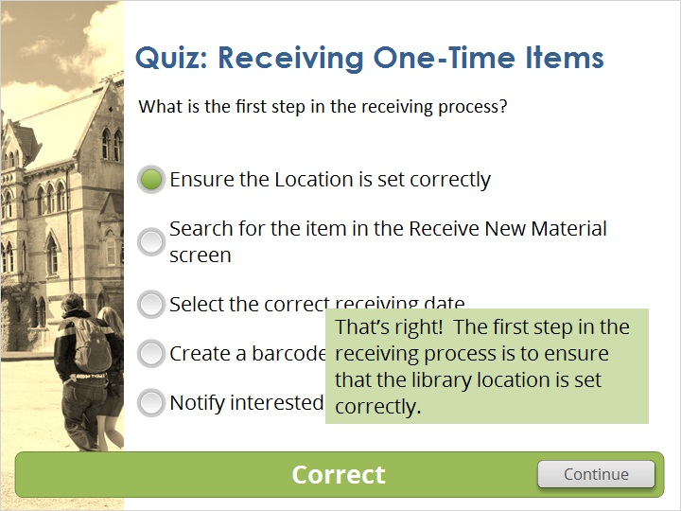

Incorrect (Slide Layer)
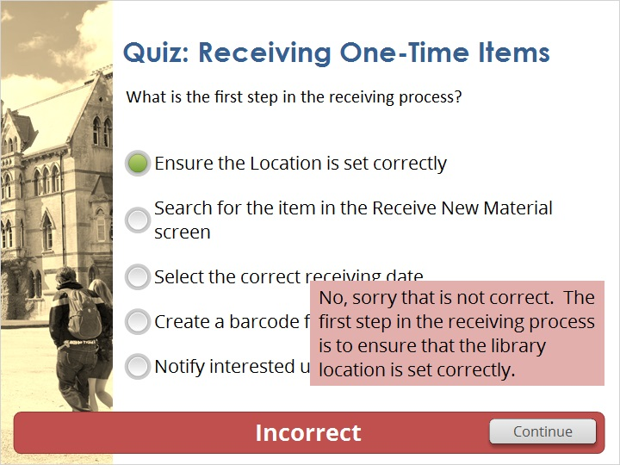

1.16 Thank You!

Notes:
Thank you for joining this session!

1.17 Copyrights

Notes:

2. Quiz Results

2.1 Results Slide
(Results Slide, 0 points, 1 attempt permitted)
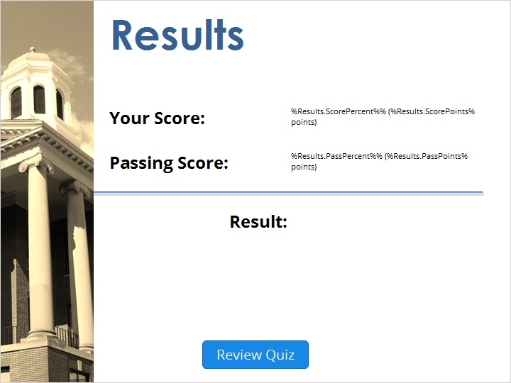

Notes:
fgsfdgsfdgfdg

Success (Slide Layer)
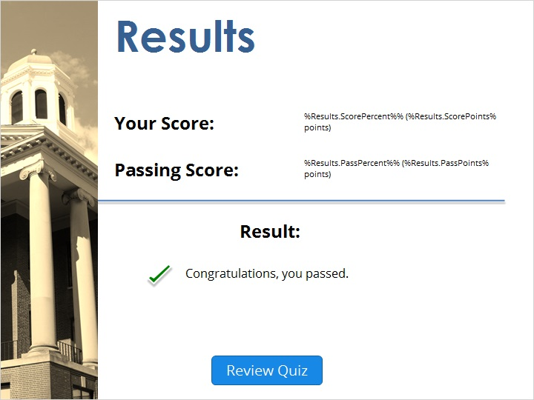

Failure (Slide Layer)


